1a. For the paper prototype, I focused on how to make navigation between pages simple and intuitive. I wanted to make a simple, clean, cart page. I wanted there to be little space between each item in the cart so that users could easily navigate between items on the page. I also made sure that users could easily navigate back to the home page/other product pages.

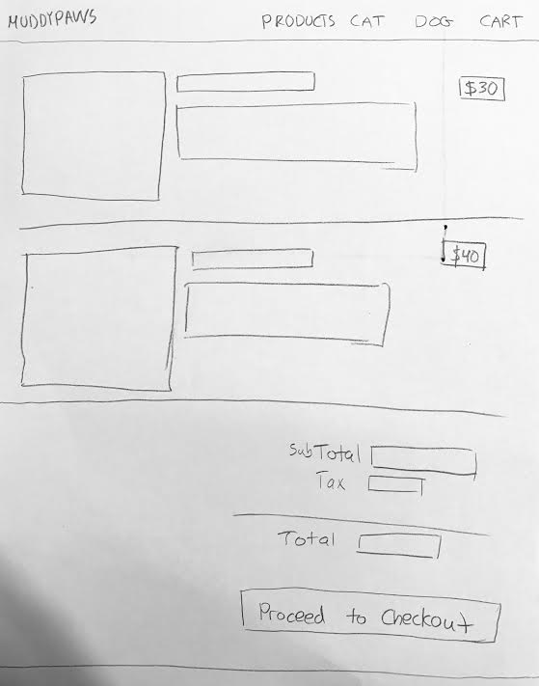

1b. For the high-fidelity mockup, I made the “checkout” and “X” buttons very obvious so that users could easily checkout or remove an item that they no longer want. I made sure that the price of the item was very clearly reflected on the page. I also put the checkout to the left of the items, so that users could checkout without having to scroll to the end of the items in their cart.

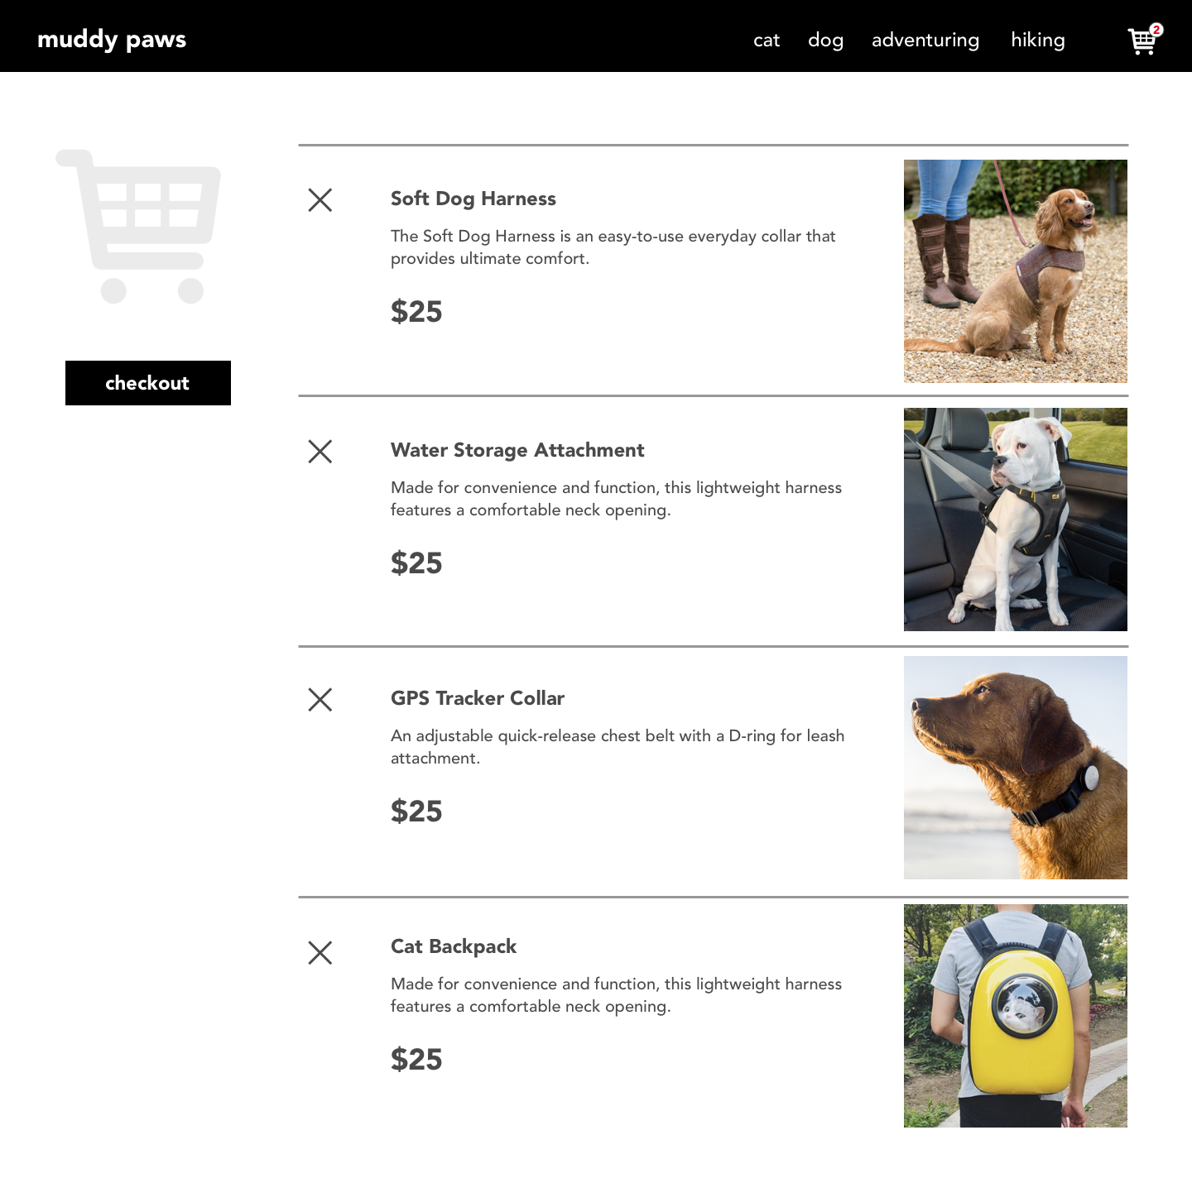

3a. I encountered many challenges when doing this assignment. One challenge was alignment. It was very difficult to get items on my page to align how I wanted them to and how they were shown on my prototype. There were many times where I couldn’t find anything wrong with my code, but the feature I was trying to implement still didn’t work. For example, when selecting specifications on a product detail page, I had difficulty getting my code to work even though it seemed correct. Another major challenge l was using local storage to have items selected and placed in the shopping cart.

3b. Part of overcoming these challenges was just trial and error, especially with getting items to align correctly. I spent a lot of time debugging in order to resolve challenges. For example, for one of my bugs, I realized that I was removing the parent of the item in my cart instead of the actual item. For the local storage issue, I tried to use the information in lab 8 to get my code to work. Unfortunately, even though I used a late day trying to get it to work, I couldn’t resolve the issue.