Deep Learning Based Phishing Email Classifier Using LSTM

Abstract
Phishing emails are fraudulent messages designed to trick users into revealing sensitive information or clicking malicious links. This project develops a Deep Learning-based email classification system that classifies email text as either Legitimate or Phishing. A dataset containing 82,486 labeled emails was used, from which a balanced subset of 5,000 emails was selected for efficient training. The system uses text preprocessing, tokenization, padding, and an LSTM-based neural network for classification. The model was evaluated using accuracy, precision, recall, F1-score, and a confusion matrix.

Dataset
The dataset contains two classes:
- 0 – Legitimate: Normal and genuine emails
- 1 – Phishing: Suspicious or fraudulent emails
For this project, 5,000 emails were selected, consisting of 2,500 legitimate and 2,500 phishing emails. The data was divided into 80% training, 10% validation, and 10% testing sets.

Data Preprocessing
The raw email text was processed before training the model.
- Text Cleaning: Emails were converted to lowercase. URLs, email addresses, special characters, and unnecessary spaces were removed or replaced.
- Tokenization: The cleaned text was converted into numerical word sequences using the Keras Tokenizer.
- Padding and Truncation: All sequences were converted to a fixed length of 200 tokens using padding and truncation.
- Data Splitting: The processed data was divided into training, validation, and testing sets using an 80:10:10 ratio.

Preprocessing Workflow
Raw Email → Text Cleaning → Tokenization → Padding/Truncation → Train/Validation/Test Split

Model Architecture
An LSTM (Long Short-Term Memory) neural network was used because it can learn sequential patterns in textual data. The model receives the padded email sequence and learns important word patterns that help distinguish phishing emails from legitimate emails.
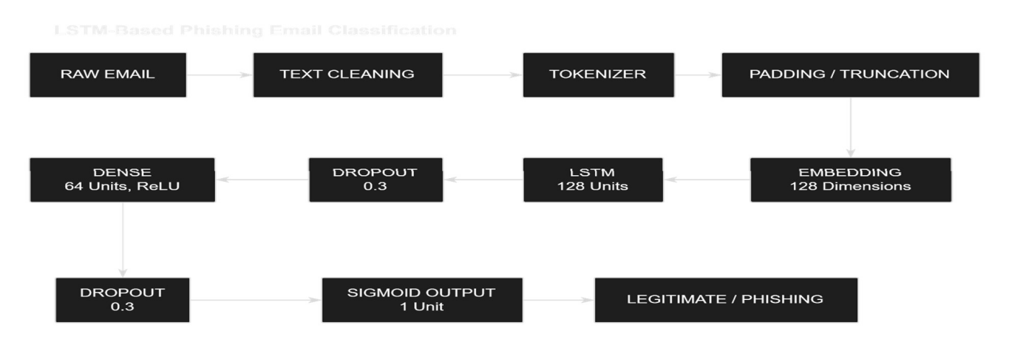

Layer Configuration
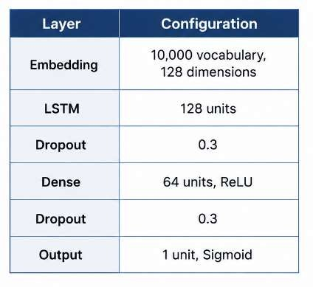
The final Sigmoid layer produces a probability between 0 and 1. A value of 0 represents a legitimate email, while a value of 1 represents a phishing email.

Hyperparameters
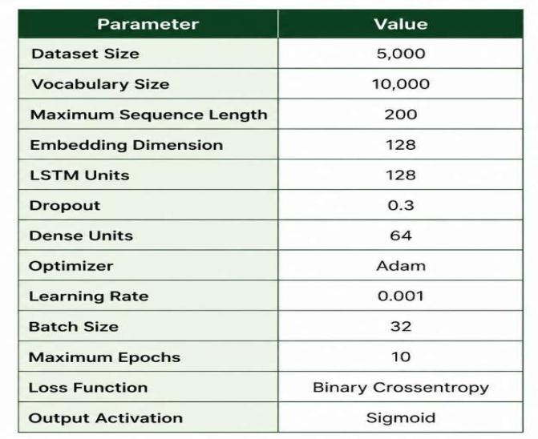
Early stopping was used during training to stop the model when the validation loss stopped improving and to restore the best model weights.

Evaluation and Results
The trained LSTM model was evaluated on the unseen test dataset. The following metrics were obtained:

Metric Result

Test Loss 0.5661

Test Accuracy 68.40%
Precision 61.44%

Recall 98.80%

F1-Score 75.77%

Performance Analysis
The model achieved an overall test accuracy of 68.40%. The recall of 98.80% indicates that the model successfully identifies most phishing emails in the test set. The precision was 61.44%, while the resulting F1-score was 75.77%. These results show that the LSTM model learned useful patterns from email text for phishing detection.

Confusion Matrix
The confusion matrix was used to compare the actual and predicted classes and to identify correct and incorrect classifications.
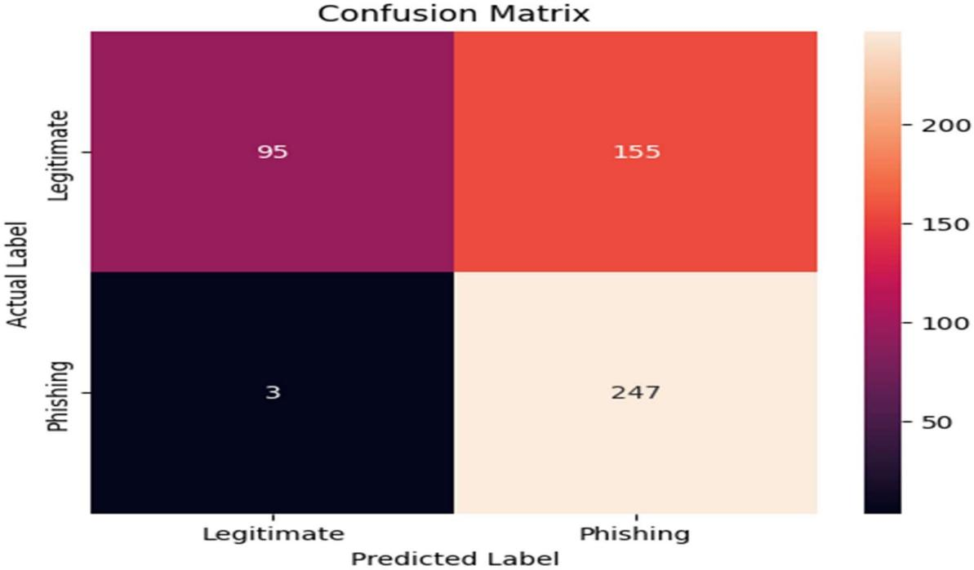

Training and Validation Curves
The training and validation accuracy and loss curves were used to observe the model's learning performance across epochs.

Accuracy Curve:
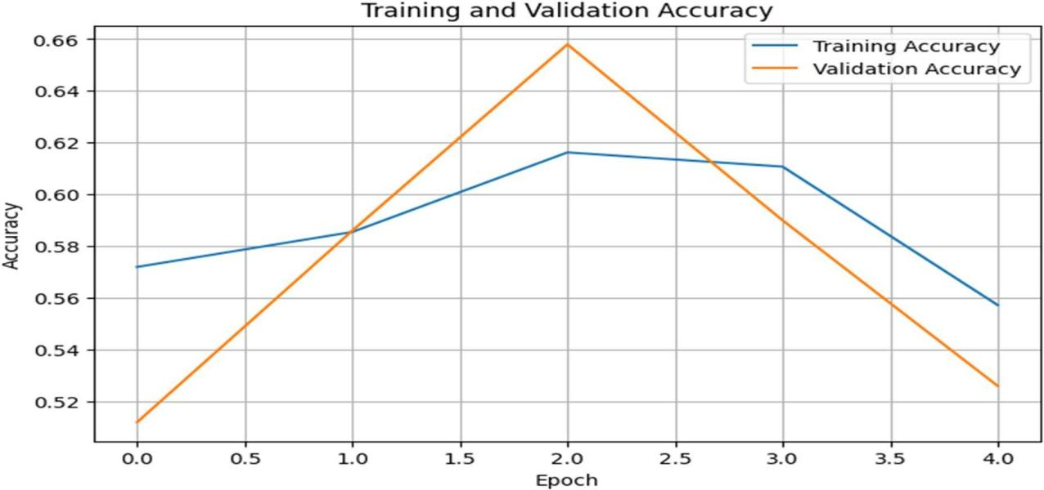

Loss Curve:
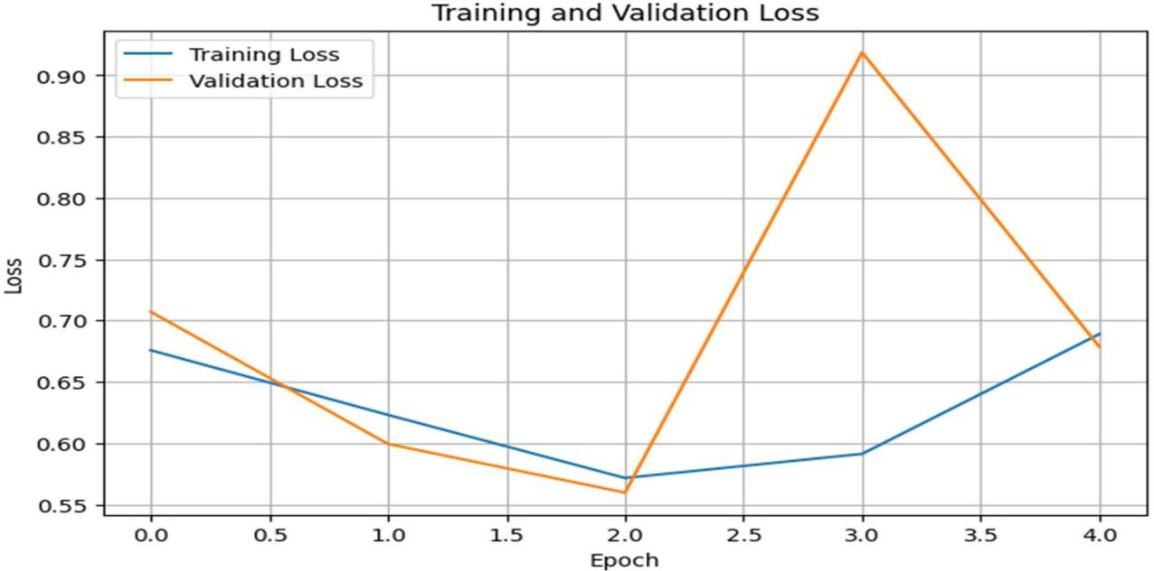

Conclusion
This project demonstrates a complete Deep Learning pipeline for phishing email classification. The system performs text cleaning, tokenization, padding, and LSTM-based classification. The model achieved a 75.77% F1-score and 98.80% recall on the test data, showing that the approach can identify a large proportion of phishing emails. The system can be further improved using a larger dataset, better text preprocessing, or advanced models such as GRU and BERT

