Turbonomic Migration Playbook v0.4 — Summary
Oct 9, 2026 · @Saikat Majumdar
Turbonomic leaves the GEHA datacenter as a Wave 2 RePurchase with cutover on 01/07/27, 52 days ahead of its 02/28/27 contract cliff. The playbook itself is still a thin draft: most target-state, cutover and governance fields are empty.

About the document and the application
The document is a DRAFT for GEHA review, dated 26-Aug-2026, ID GEHA-DCM-TURBONOMIC-v0.4. George Galindo (Cloud Architect, Citius Healthcare Consulting) wrote it on SaaS Migration Playbook Template v4.0. It is addressed to Norris Simmons (Application Owner), John Dean (Director) and Dale Gibson (Admin / Support Manager). No peer reviewer is assigned yet.
What Turbonomic does: it is IBM's resource-optimisation virtual appliance for the VMware estate (formerly VMTurbo; the BIA lists the vendor as "Turbonomics"). It watches vSphere continuously and recommends right-sizing and performance tuning.
Criticality: Tier 3, "2 – Medium", supporting 2 business capabilities. Losing it stops VMware monitoring and optimisation and nothing else.
Disposition: RePurchase in Wave 2 (plan of record BASELINE v2.1). The target is undecided between two routes:
- Turbonomic SaaS, or
- Azure-native tooling: Azure Advisor, Cost Management + Billing, Monitor & Log Analytics, and Autoscale.
GEHA's own note leans toward the second: "Explore Azure options – Turbonomic SaaS may not be worth the $." The playbook records this as awaiting a ruling.

Key dates
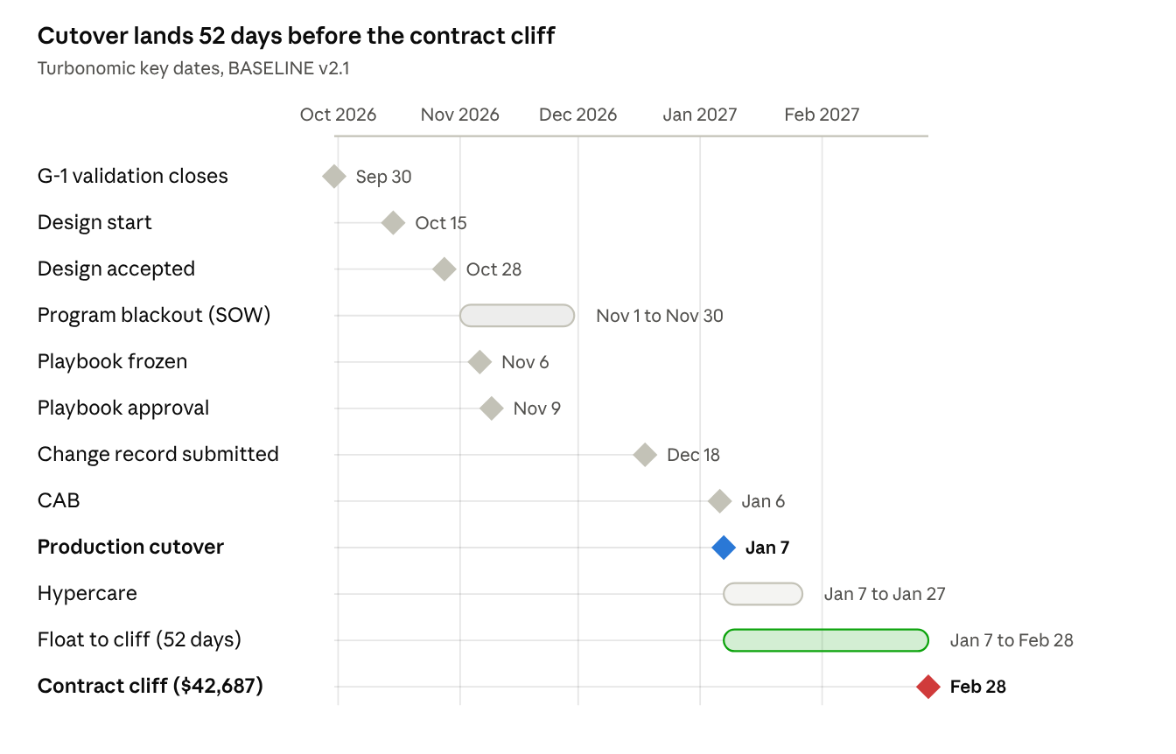
Turbonomic key dates · Sep 2026 to Feb 2027
Cutover on Thu 01/07/27 leaves 52 days of float before the 02/28/27 cliff, when the $42,687 annual renewal falls due.
- The change record moves to Fri 12/18/26, before the Christmas close, because 31 Dec and 1 Jan are holidays; CAB meets Wed 01/06/27.
- The SOW (ZCON-18111, signed 30-Jul-2026) bars production cutovers in Nov-2026 and Nov-2027.
- The biggest schedule threat is GEHA delivering the Appendix B information late.

Current state: what is actually evidenced
One live CentOS 7 appliance in Lenexa runs Turbonomic, with no database, no backup policy and no measured utilisation.
- Host: one live VM, turbonomic (DNS node1), in Lenexa at 10.0.0.80.
  - CentOS 7 64-bit, 8 vCPU, 128 GB RAM, 2 disks of about 1.78 TB, HW v13. GEHA's own answer was "8 vCPU / 128 GB / 1.5 TB".
  - A containerised application inside the VM; single production environment; no HA cluster.
- Stale twin: a powered-off VM of the same name sits in Lee's Summit (CentOS 4/5, HW v7, no IP). It is an old previous-generation appliance, not a standby. Delete versus cold-migrate is an open ruling.
- Data: no on-premises SQL database. Configuration and performance history live in the appliance's internal datastore.
  - Retention period is unknown.
  - Nobody has said whether historical analytics must migrate.
  - The SaaS export or onboarding path is vendor-owned and undocumented.
- Backup: the live appliance has no backup policy in the vCenter export. Only the powered-off twin shows "2WK Backup". There is no verified restore.
- SLA / RTO / RPO: GEHA answered "no" to having any, yet the BIA records RTO 24 hours and no RPO. The mismatch is reported, not resolved.
- Utilisation: peak CPU, memory, IOPS and network are unmeasured; the appliance has no row in the Matilda assessment.
- Automation: none ("nothing is automated at the moment"); recommendations run "constantly".
- Licensing: workload-based and, per GEHA, transferable to cloud.
- Ownership conflict: the Discovery Report (row 75) names Adriane Westhoven; the BASELINE v2.1 Owners tab names Norris Simmons. The Owners tab governs under the 24-Aug ruling, and both names stay on record.
All five integrations are outbound, and none has a named far-side owner yet.
Integration | How it works | Criticality
vCenter / vSphere | Continuous monitoring through vSphere APIs | High
Microsoft Azure | Connection established | Medium
ServiceNow (ITSM) | Event-driven | Medium
Splunk | Monitors the appliance | Medium
LDAP / AD | Login authentication for the UI | Medium

Target state, preparation and cutover
These sections are almost entirely template structure with no content yet.
- Missing: vendor edition and region, shared-responsibility split, contract and SLA, compliance artefacts (SOC reports and similar), SSO design, network allow-lists, functional gaps, rehearsal plan, test entry and exit criteria, training, and the readiness review.
- Vendor obligations log: two entries.
  - G-1 Azure Migrate validation by 09/30/26 — On track.
  - Landing zone and target subscription confirmation by the GEHA cloud platform team — At risk, no date agreed.
- Go/no-go: 13 gate criteria, all ungraded. The only named owner is Dale Gibson, for support and hypercare staffing.
- Decommission: formally outside the SOW, but the playbook keeps closure tasks in scope: revoke access, retire AD groups, remove firewall rules, DNS records, certificates and S2S tunnel entries, and cancel the legacy licence.
The cutover runbook has 15 steps, all without times or owners:
- Pre-window (steps 1–3): prepare, stage the client, confirm the freeze.
- Quiesce (step 4): stop legacy access.
- Migrate (steps 5–6).
- Validate (steps 7–9 and 11–12): check control totals, enable accounts, re-point integrations.
- Release (steps 10 and 13–15): redirect the legacy virtual server to a maintenance notice rather than removing the pool, go live, and remove legacy entry points.

Governance
The Migration Team is Responsible for nearly every task. The App Owner holds most Accountable calls, and two BLOCKING information requests are already past due.
- RACI: the App Owner is Accountable for account build, external partner coordination, go/no-go, cutover, reconciliation, the rollback decision and decommission. Security is Accountable for identity/SSO and operational readiness. Dale Gibson is Accountable for re-pointing integrations.
- Risks: the only live risk is holding the 01/07/27 date. Two older engine flags are closed as superseded by BASELINE v2.1: "cliff missed" and "plan cutover 2028-04-01 past the W4 deadline".
- Assumptions:
  - Effort size L: 16 weeks across 4 parallel tracks. Not yet confirmed by GEHA PMO.
  - Wave window runs from 2026-08-01. Confirmed.
- Sign-off: Norris Simmons and Christy Ammel (DBA / Production Control) are named. Security, Technical Lead, Network and Procurement are still "to be provided by GEHA".
- Appendix C reproduces GEHA's discovery answers word for word; most evidenced facts in this summary come from it.
Open items, as dated in the 26-Aug-2026 playbook:
Open item | Due | State in the playbook
Azure Migrate project access / first discovery export | 08/25/26 | Elapsed, BLOCKING
Formal G-1 gate completion date | 08/18/26 | Elapsed, BLOCKING
Capacity parameters: tracks, freeze calendar, LZ readiness | 08/31/26 | Open, BLOCKING
Cohesity backup policy export and protection groups | 09/30/26 | Open
DNS zone and firewall rule exports (refresh) | 09/30/26 | Open
Ruling on the powered-off Lee's Summit twin | 10/23/26 | Open

Problems to fix before release
Five defects would confuse a GEHA reviewer and should be fixed before the playbook leaves draft.
- Version mismatch: the cover says v0.4, but every page header says v0.3. The v0.4 change note cites BASELINE v1.9, while the body uses v2.1.
- Wrong Appendix B citations: software version, owner contacts and the UI URL cite Appendix B item 05, which is actually "Vendor portal logins: Progress, Cohesity, Archer". Other fields cite item 06 (owner reassignments), item 12 (Cohesity backup) and item 16 (SQL table-level write audit). These are program-wide items, so a reader cannot trace the Turbonomic gaps back to them.
- Boilerplate clutter: the "searched the full evidence pack…" text appears about 400 times. It bloats the PDF to 162 pages and spills across table columns.
- Broken quotes: the identity and network discovery notes cut off mid-sentence ("Octa is no lo…"). The hypercare SOW excerpt pulls in unrelated text ("Software Development Units are registered with Special Economic Zones…").
- Irrelevant entries for a database-free appliance: a DBA / Production Control signatory, and a Dell PowerFlex/Isilon storage dependency.

