SMART DUSTBIN FILL INDICATOR

Abstract
The Smart Dustbin Fill Indicator is an automated electronic monitoring system designed to provide real-time notification when a waste receptacle reaches full capacity. Built around an IR obstacle sensor, dual BC547 NPN bipolar junction transistors configured in an inverter-driver arrangement, and an L7805CV voltage regulator module, the system eliminates the need for microcontroller programming while providing clear visual and audible alerts. When waste blocks the IR sensor's path, the two-stage transistor network triggers a red LED indicator and a 5 V active buzzer. This reliable, low-cost solution minimizes waste overflow, promotes hygiene, and supports modern smart waste management practices in residential, office, and public environments.
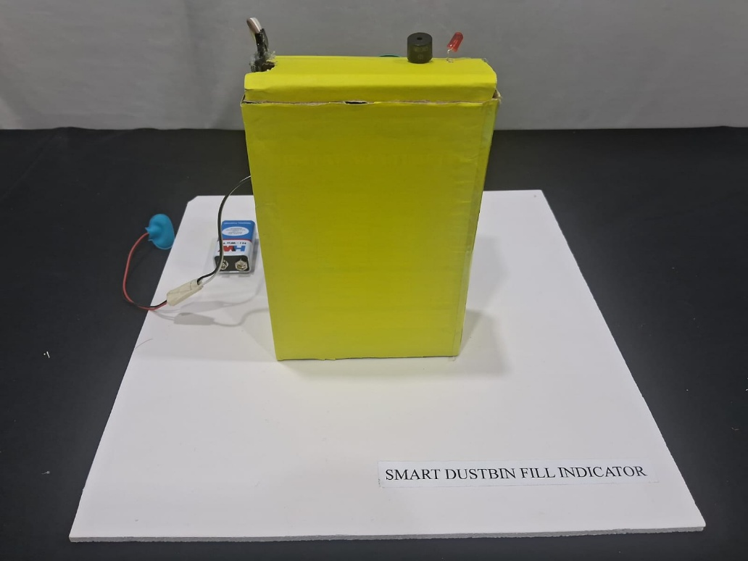

Introduction
Traditional waste management relies heavily on routine manual inspection of dustbins, leading to operational inefficiencies such as premature collection or unhygienic bin overflows. Overfilled waste bins create unsanitary conditions, attract pests, and generate foul odors in residential and commercial spaces.
The Smart Dustbin Fill Indicator resolves these issues by integrating proximity sensing and automated dual-stage switching logic. Operating on a standard 9 V battery step-down regulated to +5 V via an L7805CV regulator, the system utilizes an active IR Obstacle Sensor placed near the top rim of a dustbin. When the accumulated waste reaches the threshold level, the IR signal is reflected back, causing the sensor's output pin to transition to a active LOW state. A primary transistor (T1) inverts this signal, which subsequently drives a secondary transistor (T2) to turn on both a visual LED indicator and a 5 V active audio buzzer. This simple, transistor-logic circuit provides an immediate, zero-latency fill warning.

Objectives
- To eliminate manual monitoring by automating waste-level detection using an active IR obstacle sensor.
- To achieve dual alerting through simultaneous visual (LED) and audible (5 V active buzzer) indicators.
- To implement robust voltage regulation converting an unregulated 9 V DC battery supply into a stable +5 V DC line using an L7805CV IC.
- To design microcontroller-free switching logic using a two-stage BC547 transistor arrangement for signal inversion and load driving.
- To provide a low-cost, energy-efficient, and easily deployable framework for waste management in smart homes and institutions.

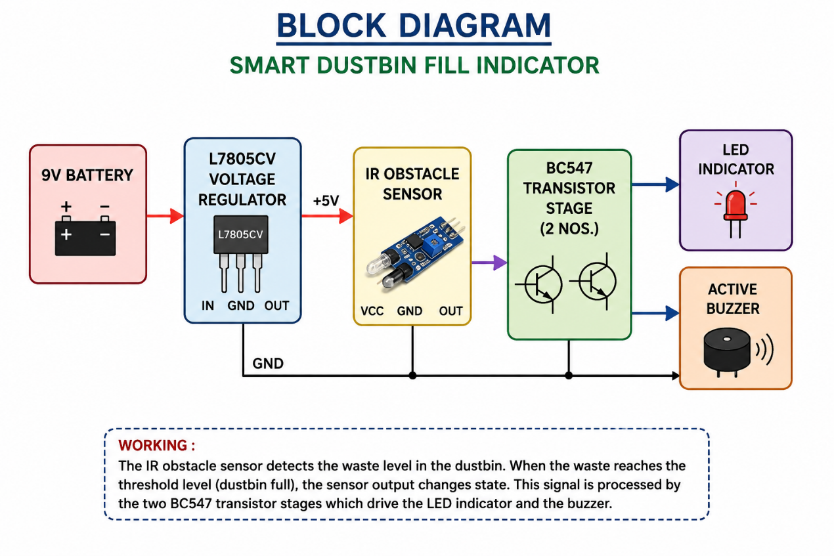
Block Diagram

Components Used
Component | Quantity | Purpose
9 V Battery | 1 | Primary DC power source for the system.
L7805CV Voltage Regulator | 1 | Regulates the input 9 V DC down to a steady +5 V DC rail.
IR Obstacle Sensor | 1 | Detects the presence/level of waste near the top of the dustbin.
BC547 NPN Transistor | 2 | T1: Inverts the active-low IR sensor signal.  T2: Acts as the driver switch for the LED and Buzzer.
LED | 1 | Visual warning indicator for bin status.
Active Buzzer (5 V) | 1 | Audible warning indicator for bin status.
220 Ω Resistor | 1 | Limits forward current to protect the LED.
1 kΩ Resistor | 3 | Base current limiting for T1 and T2, and pull-up resistor for T1 collector.
Jumper Wires & Breadboard | As Required | Circuit layout and interconnections.

Circuit Diagram
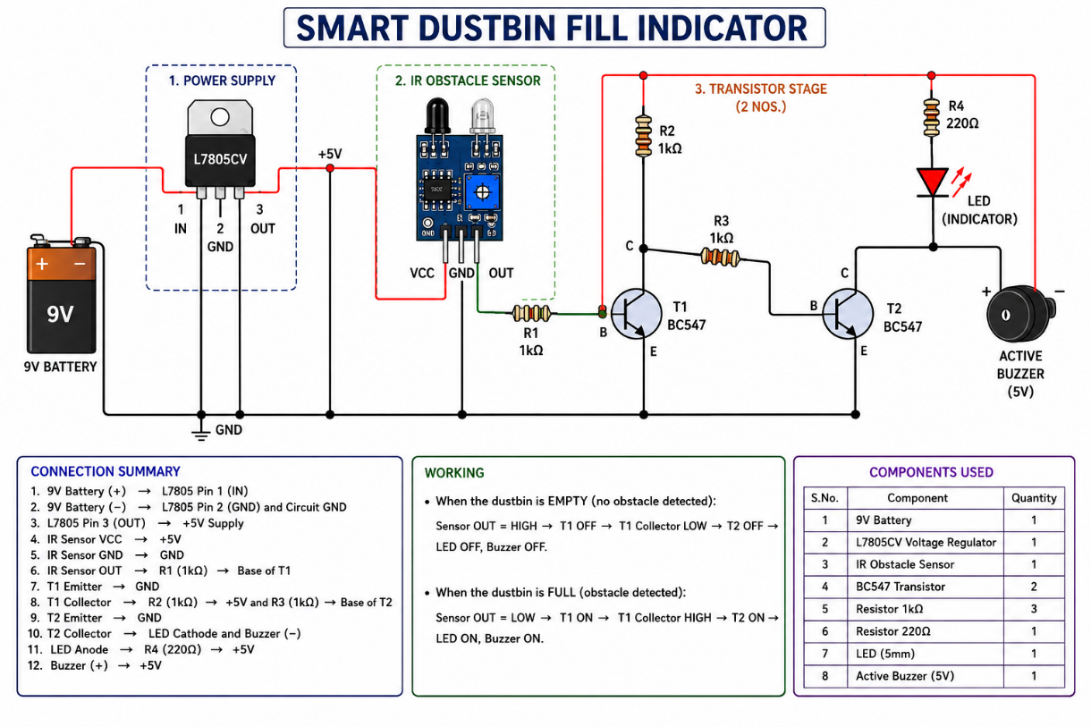

Working Connections
1. L7805CV Voltage Regulator Connections
(With flat side/marking facing towards you)
- Pin 1 (IN): Connects to 9 V Battery (+)
- Pin 2 (GND): Connects to 9 V Battery (−) / Common Ground
- Pin 3 (OUT): Provides +5 V DC supply rail
2. IR Sensor Interface
- VCC: Connects to L7805 Pin 3 (+5 V)
- GND: Connects to L7805 Pin 2 (GND)
- OUT: Connects through a 1 kΩ resistor to the Base of BC547 (T1)
3. First BC547 Transistor (T1) — Inverter Stage
(With flat side facing you)
- Emitter: Connects to GND
- Base: Connects from IR Sensor OUT through a 1 kΩ resistor
- Collector: Connects to two parallel paths:
  - Through a 1 kΩ resistor to +5 V (Pull-up load)
  - Through a 1 kΩ resistor to the Base of BC547 (T2)
4. Second BC547 Transistor (T2) — Output Driver Stage
(With flat side facing you)
- Emitter: Connects to GND
- Base: Connects from T1 Collector through a 1 kΩ resistor
- Collector: Connects to both:
  - LED Cathode
  - Buzzer Negative (−)
5. Output Indicators (LED & Active Buzzer)
- LED Anode (Long Leg): Connects to +5 V through a 220 Ω resistor
- LED Cathode (Short Leg): Connects to Collector of T2
- Buzzer Positive (+): Connects to +5 V
- Buzzer Negative (−): Connects to Collector of T2

Working Principle
The Smart Dustbin Fill Indicator functions via continuous infrared proximity detection coupled with a two-stage logic inversion network:
- Idle State (Dustbin Empty / Not Full):
  - In the absence of waste near the upper rim, the IR Obstacle Sensor does not receive reflected IR light.
  - The sensor's OUT pin maintains a HIGH signal (+5 V).
  - This HIGH signal passes through the 1 kΩ base resistor to Transistor T1, driving T1 into saturation (turned ON).
  - When T1 turns ON, its collector pulls the node voltage down to near-ground (LOW state, ~0.2 V).
  - Since the Base of Transistor T2 is connected to T1's collector, T2 receives a LOW input and remains in cut-off (turned OFF).
  - Because T2 is OFF, the collector circuit remains open; no current flows through the LED or Buzzer, keeping both OFF.
- Alert State (Dustbin Full):
  - When garbage accumulates up to the sensor's mounting level, infrared light emitted by the sensor reflects off the trash back into the sensor's photodiode receiver.
  - The sensor's OUT pin switches from HIGH to LOW (0 V).
  - With a LOW signal applied to its base, Transistor T1 enters cut-off (turns OFF).
  - With T1 turned OFF, current from the +5 V rail flows through the 1 kΩ pull-up resistor directly into the base of Transistor T2, driving T2 into saturation (turns ON).
  - When T2 turns ON, its collector completes the circuit path to GND for both the LED cathode and the Buzzer (−) pin.
  - Current flows from +5 V through the 220 Ω resistor and LED to GND, illuminating the LED. Simultaneously, current flows through the Active Buzzer, generating an audible alert.
- Reset State:
  - Once the waste is emptied, reflection ceases, the sensor OUT pin returns to HIGH, T1 turns back ON, pulling T2's base LOW, which immediately switches both the LED and Buzzer OFF.

Advantages
- Microcontroller-Free: Operates completely on low-cost hardware logic components, eliminating the need for code, microcontrollers, or complex programming tools.
- Dual Warning Mechanism: Features combined audio and visual signaling to accommodate different environmental conditions.
- Stable Operation: Integrated L7805CV voltage regulation prevents sensor false-triggering as the 9 V battery voltage naturally drains over time.
- Low Cost & Energy Efficient: Utilizes inexpensive, easily available transistors and standard resistors, drawing minimal standby power when idle.
- Compact & Modular: Easily fits into any existing dustbin design or container enclosure.

Disadvantages
- Line-of-Sight Limitations: Highly reflective or transparent materials (e.g., clear plastic bags) near the sensor can occasionally cause false readings or detection failures.
- Fixed Detection Height: Threshold level detection depends entirely on the physical mounting height of the IR sensor on the bin wall.
- Active Power Consumption During Alerting: Continuous activation of both the LED and active buzzer drains the 9 V battery faster during prolonged full states.

Applications
- Smart Home & Residential Waste Bins: Automated alerts for kitchen and indoor bins to ensure timely trash disposal.
- Office Buildings & Workstations: Reduces maintenance check intervals for janitorial staff in commercial offices.
- Hospitals & Clean Rooms: Non-contact monitoring prevents overfilling of medical waste and hazardous disposal containers.
- Public Restrooms & Institutions: Ideal for high-footfall areas requiring frequent sanitation maintenance.
Future Scope
- IoT & Wireless Connectivity: Integrating a low-power ESP8266 or LoRa module to send real-time fill notification alerts to a centralized facility dashboard or mobile app.
- Solar-Powered Operation: Adding a small solar panel with a rechargeable lithium-ion cell for self-sustaining outdoor dustbin deployments.
- Latching / Delay Circuitry: Adding a 555 timer or flip-flop circuit to debounce false alerts caused by temporary blockages (e.g., trash falling past the sensor).
- Multi-Level Fill Detection: Utilizing multiple IR sensors or an ultrasonic sensor array to display percentage levels (e.g., 25%, 50%, 75%, 100% full).

Results
The Smart Dustbin Fill Indicator circuit was fully assembled and validated. During functional testing, when no object was within range of the IR obstacle sensor, Transistor T1 remained active, keeping Transistor T2 OFF, and keeping both the LED and Active Buzzer silenced. Upon placing an object/waste item in front of the IR sensor, the sensor's output switched to LOW, successfully toggling T1 OFF and T2 ON. This immediately activated both the visual LED indicator and the 5 V active buzzer. The L7805CV regulator provided a constant +5 V supply to all sub-circuits throughout testing, proving the system reliable, accurate, and ready for deployment.


