CLAP CONTROLLED SWITCH

Abstract
The Clap-Controlled Switch is an electronic circuit designed to automate the toggling of an output (such as an LED or relay) based on sound detection. The system utilizes a 555 Timer configured to create a timing window and a CD4017 Decade Counter to handle the toggle logic. This project provides a simple, low-cost, and non-contact solution for controlling household devices or lighting, demonstrating basic principles of pulse generation and digital counting.
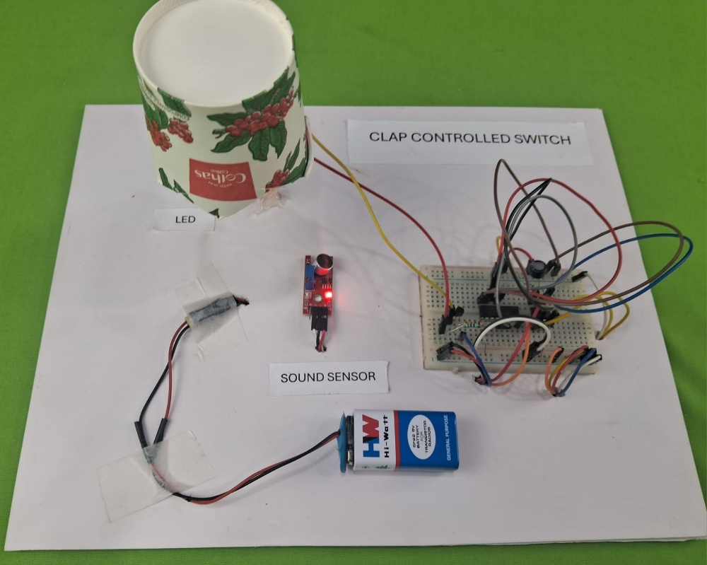

Introduction
In many applications, hands-free control of electrical devices offers significant convenience. Traditional manual switches require physical contact, which may not always be ideal. This project addresses the need for simple automation by using sound—specifically, the sound of a clap—as a trigger mechanism. By integrating a sound sensor with a 555 Timer and a CD4017 counter, the system converts acoustic input into a binary state change, allowing a user to turn a device ON or OFF remotely.

Objectives
- To design a circuit that detects sound input using a microphone sensor module.
- To utilize a 555 Timer as a pulse generator to define the trigger timing.
- To implement a CD4017 Decade Counter to function as a toggle switch.
- To control an output (LED or Relay) based on the clap-detected signal.
- To demonstrate the integration of analog timing and digital logic in embedded electronics.

Block Diagram
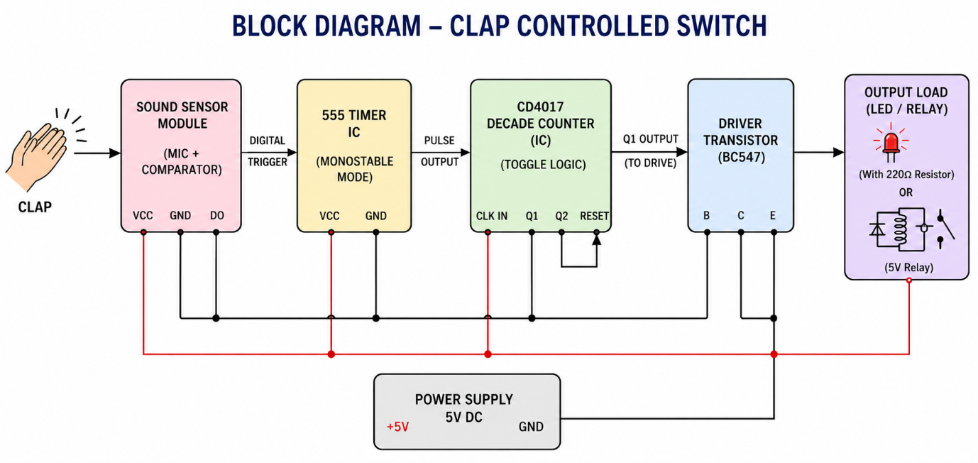

Components Used
Component | Quantity | Purpose
555 Timer IC | 1 | Pulse timing/triggering
CD4017 Counter | 1 | Toggle logic
Sound Sensor Module | 1 | Sound detection
BC547 Transistor | 1 | Output driver
LED | 1 | Visual status indication
$10\text{ k}Ω$ Resistor | 2 | Timing/Pull-up configuration
$1\text{ k}Ω$ Resistor | 1 | Transistor base protection
$220 Ω$ Resistor | 1 | LED current limiting
$100 μ\text{F}$ Capacitor | 1 | Timing window
Breadboard | 1 | Circuit assembly
Jumper Wires | As Required | Electrical connections
5V Power Supply | 1 | Power source

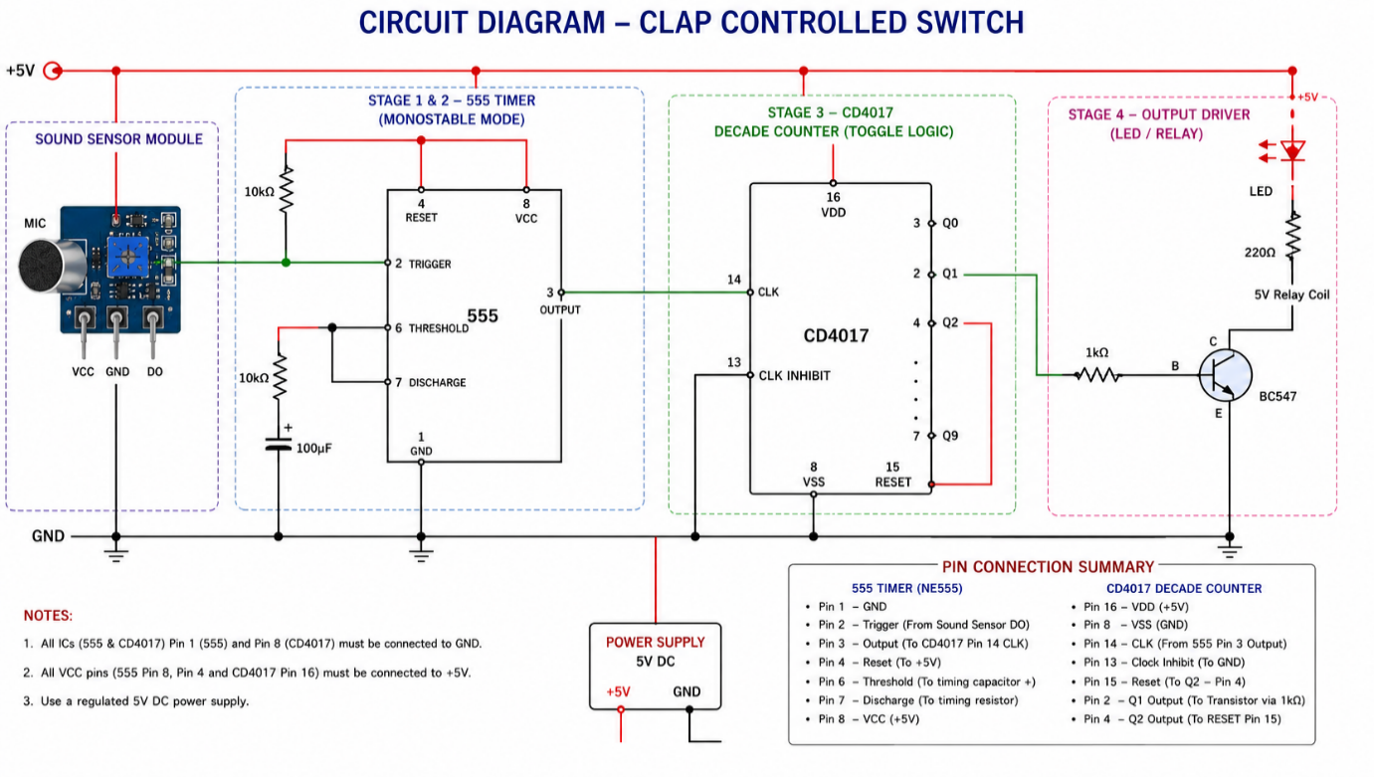
Circuit Diagram

Working Connections
Power & Ground Setup
- 555 Timer: Pin 8 to VCC ($5\text{V}$), Pin 1 to Ground.
- CD4017 Counter: Pin 16 to VCC ($5\text{V}$), Pin 8 to Ground.
- Sound Sensor: VCC to VCC ($5\text{V}$), GND to Ground.
Stage 1: Sound Input to 555 Timer
- Connect Pin 4 (Reset) of the 555 Timer directly to VCC.
- Connect the DO (Digital Output) pin of your Sound Sensor to Pin 2 (Trigger) of the 555 Timer.
- Connect a $10\text{ k}Ω$ resistor from Pin 2 of the 555 Timer to VCC (this functions as a pull-up resistor).
Stage 2: Your Custom 555 Timing Window
- Connect Pin 6 (Threshold) and Pin 7 (Discharge) of the 555 Timer together with a jumper wire.
- Connect your second $10\text{ k}Ω$ resistor from VCC to Pin 7.
- Connect the positive leg (longer lead) of your $100 μ\text{F}$ capacitor to Pin 6.
- Connect the negative leg (shorter lead with the stripe) of the $100 μ\text{F}$ capacitor to Ground.
Stage 3: 555 Timer to CD4017 Counter (Toggle Logic)
- Connect Pin 3 (Output) of the 555 Timer to Pin 14 (Clock Input) of the CD4017.
- Connect Pin 13 (Clock Inhibit) of the CD4017 to Ground.
- Connect Pin 15 (Reset) of the CD4017 directly to Pin 4 (Output 2) of the CD4017.
Stage 4: Output Driver (LED or Relay)
- Connect Pin 2 (Output 1) of the CD4017 to a $1\text{ k}Ω$ resistor.
- Connect the other side of that resistor to the Base of your BC547 transistor.
- Connect the Emitter of the BC547 to Ground.
- Connect your LED (with a protective resistor) or your 5V Relay coil between VCC and the Collector of the BC547.

Working Principle
The system monitors sound levels through the sensor module. When a clap is detected, the sensor sends a digital signal to the 555 Timer, which triggers a timing pulse. This pulse is sent to the CD4017 counter. Each incoming pulse causes the CD4017 to advance its state. By connecting the reset pin to the second output, the counter effectively toggles between two states. When the output goes HIGH, the BC547 transistor is biased to conduct, allowing current to flow and lighting the LED.

Advantages
- Provides hands-free, convenient operation.
- Uses low-cost, readily available electronic components.
- Highly effective for simple ON/OFF control tasks.
- Does not require complex programming or microcontrollers.

Disadvantages
- The system may be triggered by ambient noise other than a clap.
- Requires a stable 5V power supply to operate consistently.
- Limited to simple toggle functionality without additional logic.

Applications
- Hands-free control for bedside lamps.
- Automated switching for home lighting.
- Demonstrative educational tool for electronic circuits.
- Prototyping non-contact switch systems.

Future Scope
- Integration with a relay to control AC appliances.
- Implementation of an adjustable sensitivity threshold for the sound sensor.
- Addition of a secondary filter circuit to distinguish claps from other background sounds.
- Miniaturization of the circuit onto a custom Printed Circuit Board (PCB).

Results
The Clap-Controlled Switch was successfully designed and assembled on a breadboard. Upon testing, the circuit reliably detected acoustic triggers and toggled the state of the output LED. The system demonstrated stable performance and fulfilled the objective of providing a non-contact switching mechanism through simple integrated circuit logic.


