DOOR OPEN ALERT SYSTEM

Abstract
The Door Open Alert System is an electronic security system designed to detect and alert users whenever a door or window is opened. The system uses a magnetic reed switch paired with inverted switching logic driven by a BC547 NPN transistor. When a door opens (separating the magnet from the reed switch), the system immediately triggers a dual visual and audio alarm using an LED indicator and a buzzer. By replacing complex microcontrollers with basic discrete semiconductor components, this project offers a highly responsive, power-efficient, and low-cost security solution ideal for home safety, cabinets, and modern security applications.


Introduction
Conventional home security systems often depend on expensive microcontrollers or complex digital setups. However, basic intrusion and entry monitoring can be accomplished effectively using fundamental analog circuits.
The Door Open Alert System addresses this requirement using an inverted-logic transistor circuit. Built around a BC547 NPN transistor, a magnetic reed switch, a 9V power supply, and an alarm network, the system activates automatically when magnetic contact is broken. When the door remains closed, the magnet keeps the reed switch closed, pulling the transistor's base to ground and keeping the alarms silent. Upon opening the door, the switch opens, allowing the base pull-up resistor to turn ON the BC547 transistor, activating both the LED and buzzer. This setup demonstrates how simple discrete electronics can provide efficient and practical security monitoring.

Objectives
The primary objectives of the Door Open Alert System project are:
- To eliminate the need for microcontrollers by using an inverted-logic NPN transistor circuit.
- To implement a magnetic sensing mechanism using a reed switch for reliable door position detection.
- To provide simultaneous visual (LED) and audible (buzzer) alerts upon door opening.
- To ensure current protection for circuit components using pull-up and current-limiting resistors.
- To create an energy-efficient security system operating on a standard 9V battery.
- To deliver a affordable, easily reproducible DIY framework for basic entry detection.

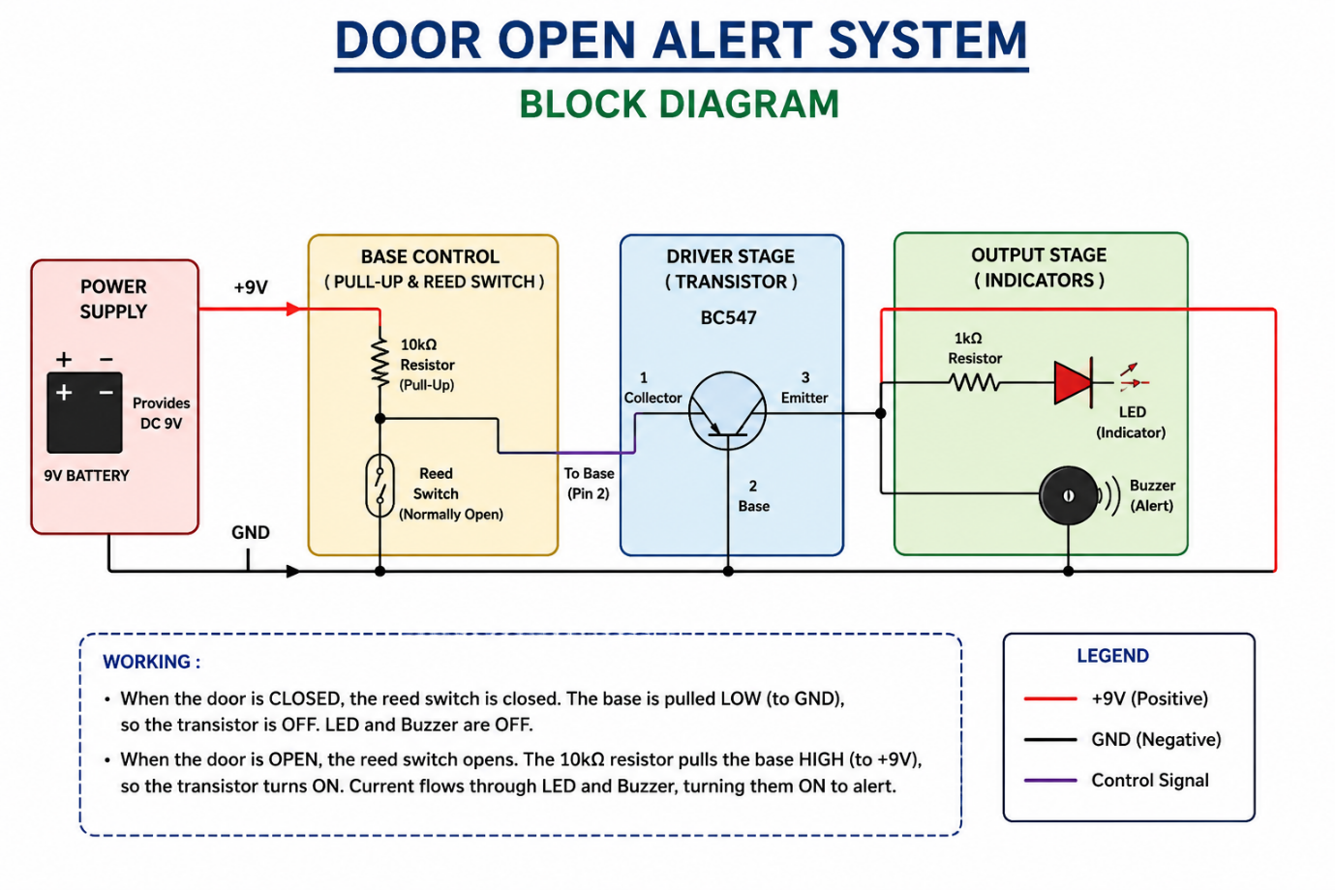
Block Diagram

Components Used
The following table details the hardware required for the assembly of the system:
Component | Quantity | Purpose
BC547 NPN Transistor | 1 | Acts as an electronic switch to drive the LED and buzzer outputs.
Magnetic Reed Switch | 1 | Detects the presence of a magnet attached to the moving door frame.
10k $Ω$ Resistor | 1 | Serves as a base pull-up resistor (Brown-Black-Orange) to activate the transistor when the switch opens.
1k $Ω$ Resistor | 1 | Limits forward current (Brown-Black-Red) to protect the indicator LED.
LED | 1 | Provides visual alarm indication when the door is opened.
Buzzer | 1 | Emits an audible warning sound upon security breach.
9V Battery | 1 | Primary power source for the entire circuit.
Breadboard & Wires | As Required | Provides the physical layout and electrical pathways for interconnections.

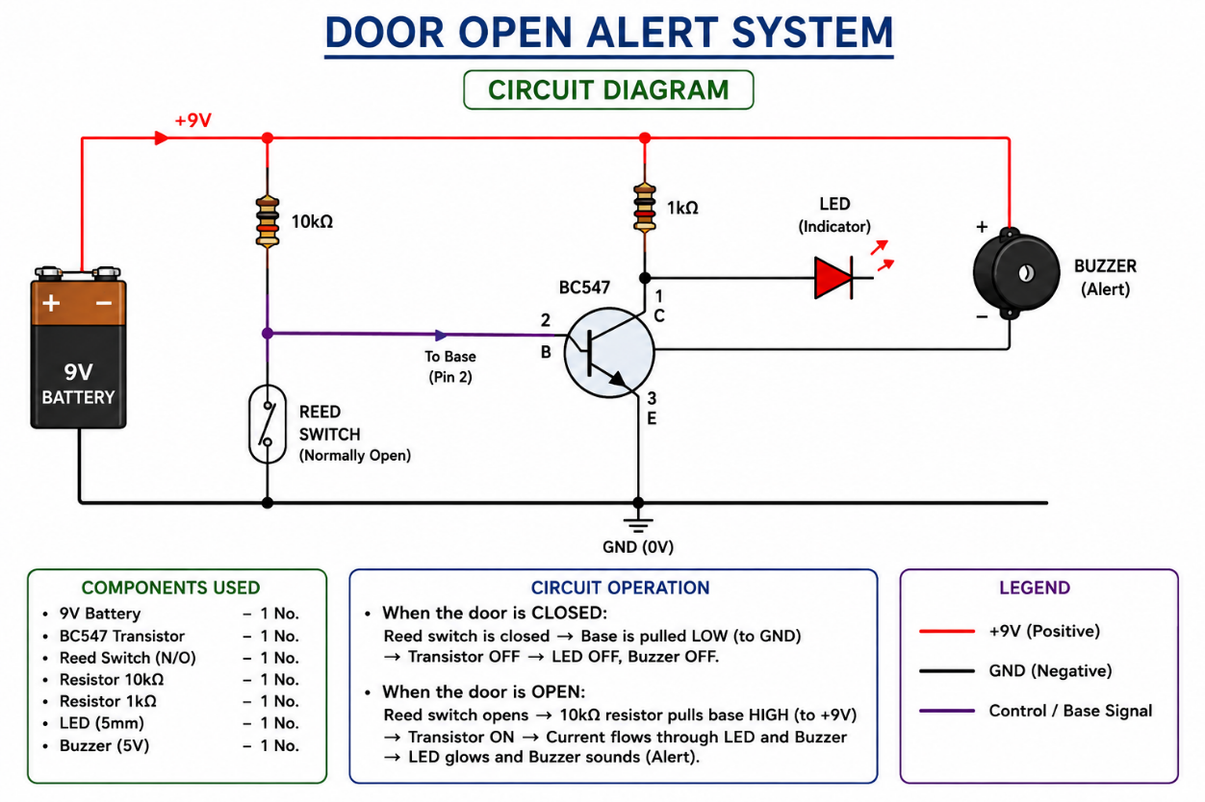
Circuit Diagram

Connection Summary
Complete Wire-by-Wire Connections
1. Power Rails
- 9V Battery Positive (+ / Red): Connect to Red (+) Rail.
- 9V Battery Negative (- / Black): Connect to Blue/Black (-) Rail.
2. Base Control & Reed Switch (Inverted Logic)
- 10k $Ω$ Resistor (Brown-Black-Orange):
  - One leg to Positive (+) Rail.
  - Other leg to BC547 Pin 2 (Middle / Base).
- Reed Switch:
  - One terminal to BC547 Pin 2 (Middle / Base).
  - Other terminal to Negative (-) Rail.
3. LED & Buzzer Outputs (Collector Side)
- 1k $Ω$ Resistor (Brown-Black-Red):
  - One leg to Positive (+) Rail.
  - Other leg to LED Anode (Long Leg).
- LED Cathode (Short Leg): Connect to BC547 Pin 1 (Left / Collector).
- Buzzer Red Wire (+): Connect to Positive (+) Rail.
- Buzzer Black Wire (-): Connect to BC547 Pin 1 (Left / Collector).
4. Grounding (Emitter Side)
- BC547 Pin 3 (Right / Emitter): Connect to Negative (-) Rail.

Working Principle
The system operates based on inverted transistor switching logic:
- Door Closed State (Idle / Secured): When the door is closed, the magnet attached to the door rests close to the magnetic reed switch. The magnetic field closes the reed switch contacts. This connects BC547 Pin 2 (Base) directly to the negative ground rail. Current from the positive rail flows through the 10k $Ω$ resistor directly to ground, keeping the transistor base-emitter voltage ($V_{BE}$) at 0V. Because $V_{BE}$ is below $0.7\text{V}$, the BC547 transistor remains turned OFF (Cut-off region). No current flows through the collector, keeping the LED and Buzzer silent and unlit.
- Door Open State (Triggered / Alert): When the door is opened, the magnet moves away from the reed switch, causing the contacts to snap open. With the path to ground broken, current from the positive rail flows through the 10k $Ω$ pull-up resistor directly into BC547 Pin 2 (Base). This turns the transistor ON (Saturation region), creating a conductive pathway from BC547 Pin 1 (Collector) to BC547 Pin 3 (Emitter / Ground).
- Alert Activation: The current flows through the 1k $Ω$ resistor and the LED, as well as through the buzzer to ground. The LED lights up and the Buzzer emits an audible alarm simultaneously, alerting nearby occupants of the breach.

Advantages
- Instantaneous Alerting: Analogue switching yields near-zero response lag compared to software-driven systems.
- Low Idle Power Consumption: Very minimal standby current is consumed while the door remains closed.
- No Programming Required: Eliminates software bugs, firmware updates, or complex code setup.
- Highly Cost-Effective: Uses minimal standard discrete parts, making it inexpensive to build.
- Compact & Easy to Install: Simple form factor allows easy attachment to doorframes, drawers, and window sashes.

Disadvantages
- No Built-in Latching: The alert turns off automatically if the door is pushed closed again, unless a latching relay or SCR component is added.
- Magnet Alignment Dependence: Physical displacement or misaligned door frames can lead to false triggers.
- Limited Wireless Range: Operates as a localized alert without native smartphone or Wi-Fi notifications.

Applications
- Home and apartment primary entry door intrusion monitoring.
- Security monitoring for sensitive storage cabinets, safes, and medicine chests.
- Restricted area entry warnings in commercial offices or laboratories.
- Basic reference project for STEM students learning NPN transistor logic and inverted switching principles.

Future Scope
- Latching Alarm Configuration: Integrating a 555 timer or SCR to ensure the alarm continues ringing even if the door is closed after an intrusion.
- Wireless Notification: Adding an ESP8266/ESP32 Wi-Fi module or GSM module to send SMS or app push notifications to a user's phone.
- Power Supply Backup: Implementing an onboard Li-ion battery charging module (TP4056) for continuous operation during power outages.
- Aesthetic Enclosure: Designing a 3D-printed enclosure to neatly conceal the battery, breadboard, and sensor assembly on door jambs.

Results
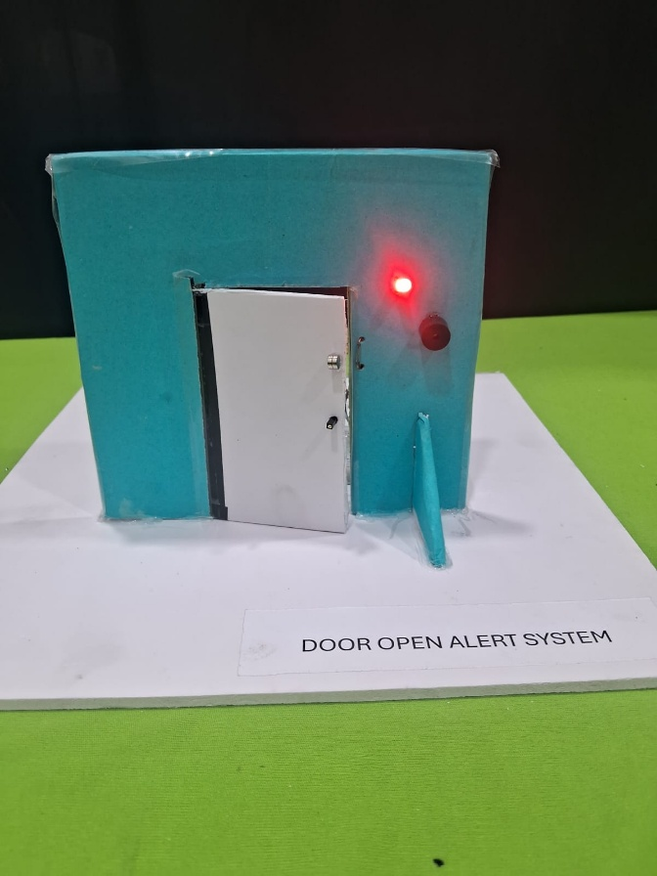
The Door Open Alert System was successfully built, wired, and tested. During validation, opening the door (removing the magnet from the proximity of the reed switch) instantly triggered both the visual LED indicator and the sound alarm. Realigning the magnet with the reed switch turned off the alarms, verifying that the inverted logic circuit performed reliably according to design specifications.


