BATTERY VOLTAGE INDICATOR

Abstract
The Battery Voltage Indicator is an embedded electronic diagnostic system designed to provide real-time, stabilized telemetry for electrical power storage units. The system utilizes an LM358 operational amplifier integrated circuit (IC) configured as a dual window comparator to continuously monitor fluctuating supply lines against a fixed reference network. By utilizing a custom 5-resistor configuration alongside a precision tuning potentiometer, the design eliminates the unstable, flickering transitions common to basic comparator circuits when resting on voltage thresholds. This clean, non-blinking 3-LED interface offers a highly responsive, low-cost power management solution ideal for portable electronics, custom power banks, and DIY home automation frameworks.
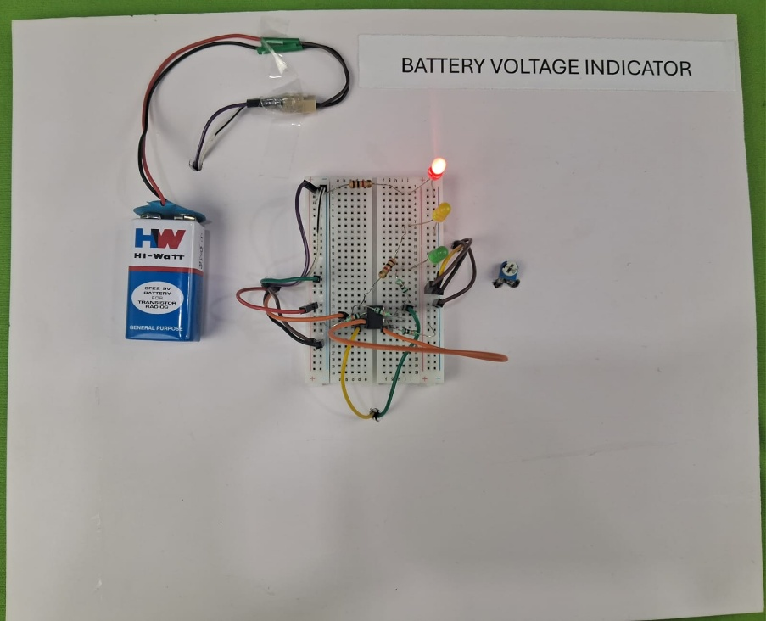

Introduction
Conventional battery-powered systems often lack intuitive, real-time visual tracking of their remaining capacity, leading to unexpected device shutdowns or deep-discharge cell damage. Grid or battery monitoring circuits frequently suffer from boundary noise: when the battery voltage hovers precisely between two status levels, the corresponding indicator LEDs flicker or blink rapidly, creating visual distraction and ambiguous readings.
The Battery Voltage Indicator addresses these challenges by implementing a stabilized window comparator array using the ubiquitous LM358 dual operational amplifier. Built around the LM358 IC, a 5-resistor network, and a calibration potentiometer, the system maps real-time voltage levels to static thresholds. A three-resistor voltage reference ladder splits the system floor to lock down accurate logic triggers. Combined with dedicated anti-blinking isolation resistors on the intermediate output lines and a solid-state base rail indicator, this integration provides clean, distinct, and reliable battery health status updates.

Objectives
The main objectives of the Battery Voltage Indicator project are:
- To eliminate boundary indicator flicker by implementing an anti-blinking resistor configuration.
- To lock precise, predictable switching levels using a balanced 3-resistor reference voltage ladder.
- To protect tracking telemetry indicators using dedicated current-limiting protection.
- To provide immediate, zero-latency visual power diagnostics for low-voltage battery configurations.
- To design a lightweight, low-power standalone tracking module capable of running directly off the monitored source using the LM358 IC.
- To deliver a low-cost, reliable DIY framework for fundamental battery management systems.

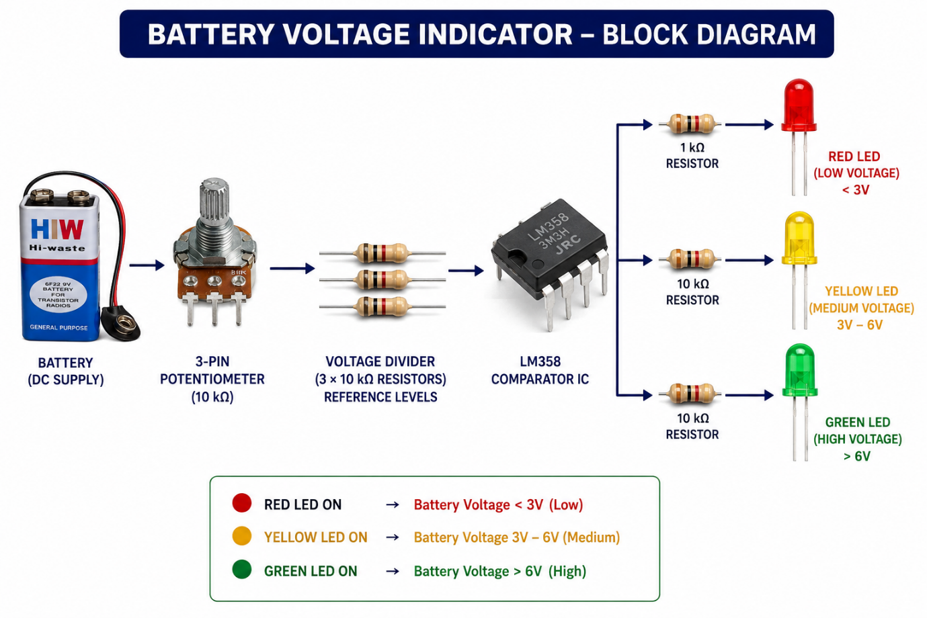
Block Diagram

Components Used
The following table details the hardware required for the assembly of the system:
Component | Quantity | Purpose
LM358 Operational Amplifier IC | 1 | Dual op-amp chip that processes real-time input levels against fixed reference values.
10k Resistor | 3 | 3x for the voltage reference ladder; 2x for stabilizing Yellow and Green LED lines.
1k Resistor | 3 | Limits forward current for the solid-base LEDs
10k Potentiometer | 1 | Tunes the real-time input signal entering the comparator circuit.
Red LED | 1 | Serves as the continuous, solid base power-on floor indicator.
Yellow LED | 1 | Indicates a mid-level battery state.
Green LED | 1 | Indicates a fully charged battery state.
Power Supply / Battery to Monitor | 1 | Supplies the operating and sampling voltage to drive the circuit.
Jumper Wires & Breadboard | As Required | Provides the physical layout and electrical pathways for connection.
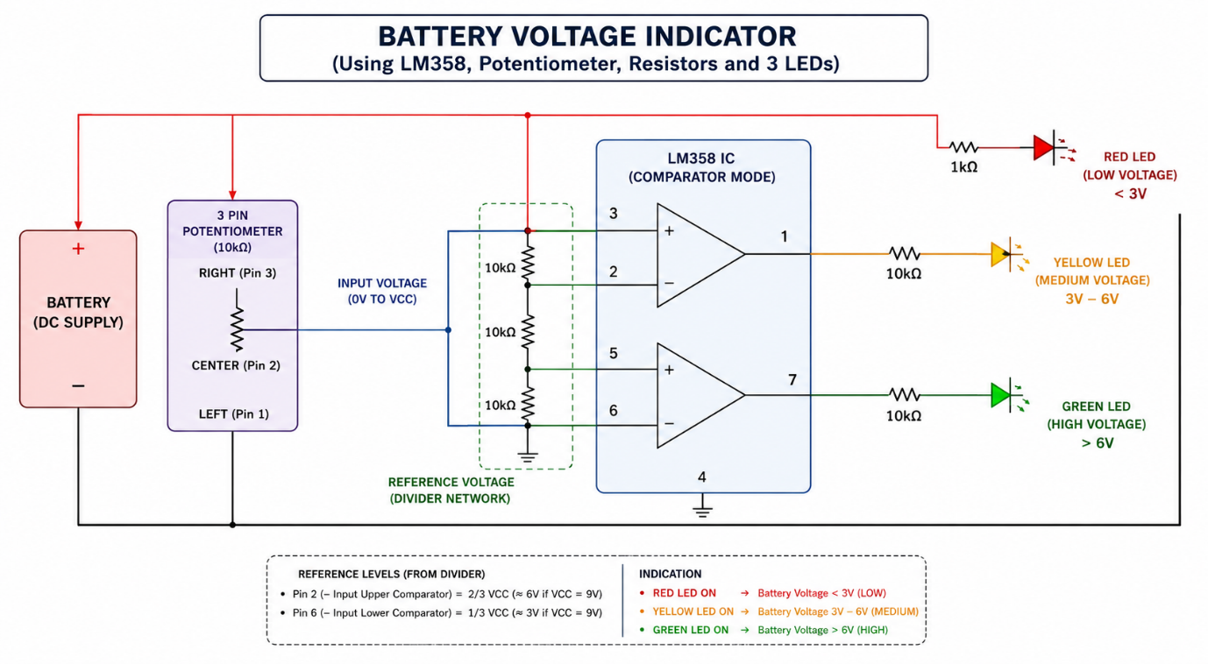
Circuit Diagram

Working Connections
1. Power Setup
- Battery (+) $→$Pin 8 (VCC) of the LM358 IC AND the Right Pin (Pin 3) of the potentiometer.
- Battery (-) $→$Pin 4 (GND) of the LM358 IC AND the Left Pin (Pin 1) of the potentiometer.
2. The Reference Ladder (Locks Triggers at 3V and 6V)
- 10k Resistor 1: Connect from Battery (+) to Pin 6 (Inverting Input B) of the LM358 IC.
- 10k Resistor 2: Connect from Pin 6 down to Pin 2 (Inverting Input A) of the LM358 IC.
- 10k Resistor 3: Connect from Pin 2 straight down to Battery (-).
3. The Input Signal
- Jumper Wire: Tie Pin 3 (Non-inverting Input A) directly to Pin 5 (Non-inverting Input B) of the LM358 IC.
- Signal Wire: Connect from the Center Pin (Pin 2) of the potentiometer straight into Pin 3.
4. The LEDs (The Anti-Blinking Wiring)
- Red LED: Connect a 1k resistor from Battery (+) to the Anode (+). Connect the Cathode (-) to Battery (-). (Stays solid).
- Yellow LED: Connect a 1k resistor from Pin 1 (Output B) of the LM358 to the Anode (+). Connect the Cathode (-) to Battery (-).
- Green LED: Connect a 1k resistor from Pin 7 (Output A) of the LM358 to the Anode (+). Connect the Cathode (-) to Battery (-).

Working Principle
The system functions dynamically based on dual operational amplifier window comparator logic and output stabilization:
- Baseline Power Indication: The Red LED bypasses the op-amp logic entirely. It is tied straight to the main positive rail through a 1 k$\Omega$ current-limiting resistor, meaning it illuminates continuously as long as the battery has a baseline charge, verifying system power-on status.
- Reference Setting: The three-resistor ladder evenly divides the total supply voltage across its symmetric 10k segments. This locks stable comparison tracking points inside the LM358 internal comparator nodes, establishing fixed proportional thresholds at Pin 6 and Pin 2.
- Signal Sampling: The calibration potentiometer samples the active line voltage through its center wiper pin, feeding the real-time power signature concurrently into both non-inverting inputs (Pin 3 and Pin 5) of the LM358 IC.
- Anti-Blink Suppression: When the sampled voltage approaches a switching threshold, standard raw comparator outputs experience high-frequency oscillation (flickering). In this circuit configuration, the high-value 10k resistors placed on Output A (Pin 1) and Output B (Pin 7) damp the output transitions. They absorb boundary noise and clamp floating voltage values, ensuring the Yellow and Green LEDs switch decisively and remain solid without blinking.

Advantages
- Zero-Flicker Presentation: The 5-resistor configuration dampens electrical transition noise, preventing distracting LED blinking cycles near threshold points.
- Locked Voltage Benchmarks: A symmetric reference ladder removes floating logic variables, keeping tracking nodes steady at fixed ratios.
- Highly Standardized IC Architecture: Utilizing the industry-standard LM358 operational amplifier yields excellent project reproducibility, widespread component availability, and low cost.
- Low Current Draw: High-resistance value selections draw minimal operating current, conserving the battery resource it monitors.

Disadvantages
- Passive Power Footprint: The resistor divider ladder and base indicator loop maintain a continuous, passive standby draw on the power line.
- Manual Tuning Requirement: The potentiometer requires manual tool calibration to sync the indicator array precisely with specific battery types.
- Thermal Drift: Extreme environmental temperature shifts can subtly adjust resistance values, altering the precise switching threshold bounds of the internal op-amps.

Applications
- Embedded power state telemetry for custom lithium-ion or lead-acid battery packs.
- Benchtop electronics laboratory test benches and DIY power distribution modules.
- Low-latency dashboard status arrays for standalone systems like portable smart devices and robotics platforms.
- Educational reference platforms for engineering students learning window comparator networks, op-amp configurations, and analog noise filtering.

Future Scope
- Active Zener Referencing: Replacing the top section of the ladder with a precision Zener diode to maintain accurate threshold points even during sharp voltage drops.
- Microcontroller Interface: Multiplexing the stabilized LM358 outputs directly into an Arduino or ESP module to enable automated low-power shutdown scripts or audible warnings.
- High-Current Latching Relays: Integrating an isolated electronic switch module down-line from the critical low threshold to auto-disconnect external loads if the battery enters a deep-discharge state.

Results
The Battery Voltage Indicator system utilizing the LM358 IC was successfully wired, deployed, and validated. During functional validation testing, the 3-resistor reference ladder locked the threshold points accurately without unexpected shifts. The tuning potentiometer reliably adjusted the input profile through the comparator stages, lighting the status array cleanly based on real-time voltage variations. Thanks to the custom 5-resistor stabilization network, the transition boundaries between the Red, Yellow, and Green LEDs remained entirely free of flicker or blinking behavior. The module delivered clear, solid visual telemetry, proving that all hardware elements performed reliably up to design specifications.


