VISITOR COUNTER SYSTEM

Abstract
The Bidirectional Visitor Counter System is an automated electronic system designed to track room occupancy by counting individuals entering and exiting a specific area. The system utilizes two Infrared (IR) sensors positioned at the entry and exit points to detect human movement and determine the direction of travel. A microcontroller processes these sensor inputs to dynamically update the live count, which is displayed in real time on an I2C Liquid Crystal Display (LCD). This project provides an efficient, low-cost, and non-contact solution for smart building automation, crowd management, and energy conservation by monitoring room occupancy.

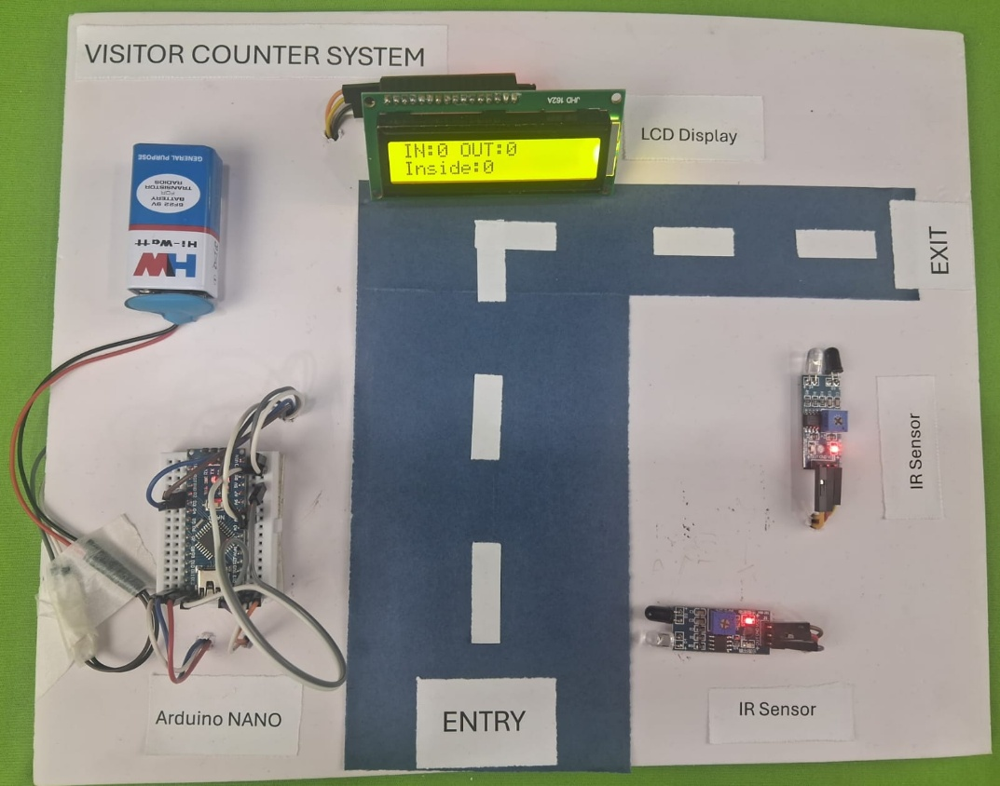

Introduction
In modern smart buildings, managing room capacity and automating environmental controls (such as lighting and HVAC systems) based on occupancy offers significant energy savings and operational convenience. Manual monitoring is impractical and prone to human error. This project addresses the need for automated occupancy tracking by using two strategically placed IR sensors to monitor bidirectional traffic. By interpreting the sequence of sensor interruptions, the system calculates the exact number of people currently inside a room and displays the information instantaneously, eliminating the need for manual oversight.

Objectives
- To design an automated circuit capable of detecting bidirectional human traffic using dual IR sensors.
- To implement a microcontroller-based logic system that distinguishes between an entering and an exiting visitor.
- To integrate an I2C 16x2 LCD module to cleanly display incoming, outgoing, and total present counts.
- To maintain an accurate, real-time calculation of total room occupancy.
- To demonstrate practical applications of embedded systems, sensor interfacing, and digital logic.

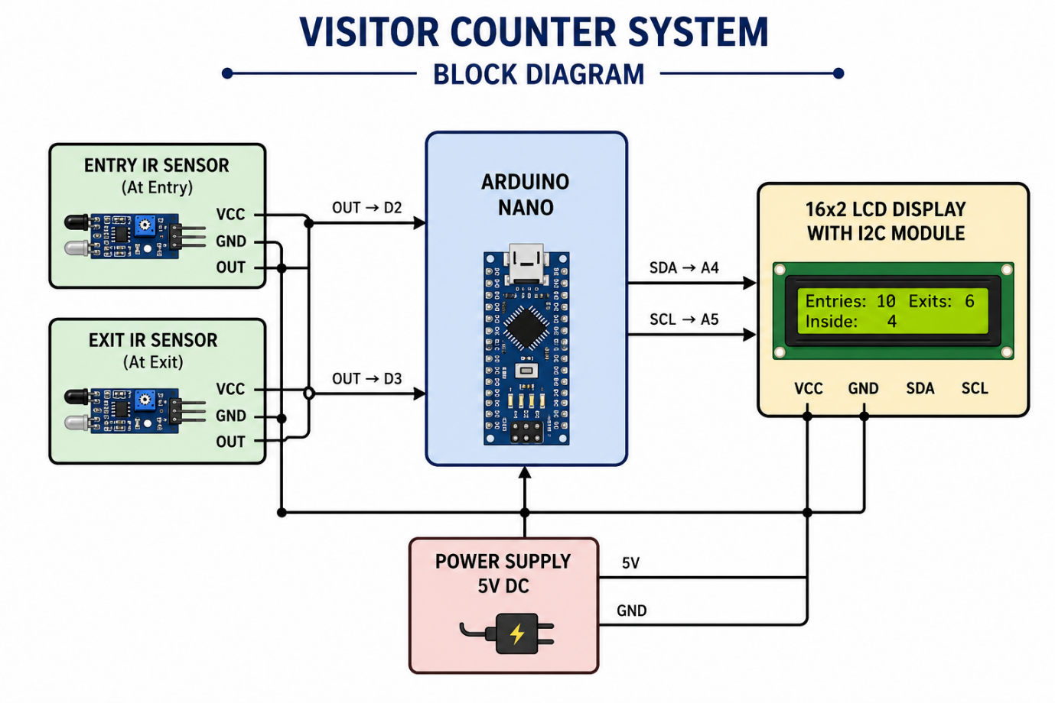
Block Diagram

Components Used
The following table details the hardware required for assembly:
Component | Quantity | Purpose
Microcontroller (Arduino Uno/Nano) | 1 | Processes sensor signals and manages count logic
IR Sensor Modules | 2 | Detects presence at entry and exit thresholds
I2C 16x2 LCD Display | 1 | Displays the visitor metrics visually
5V Power Supply / USB Cable | 1 | Provides regulated power to the system
Breadboard | 1 | Facilitates solderless circuit assembly
Jumper Wires | As Required | Establishes electrical connections between components

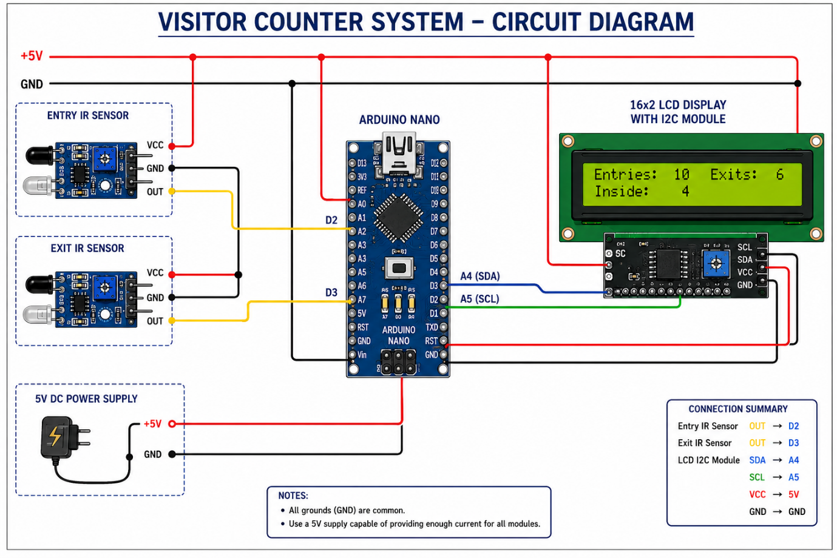
Circuit Diagram

Working Connections
1. Power & Ground Setup (Bus Lines)
- Microcontroller: Connect the Arduino GND to the breadboard Ground rail, and the 5V pin to the VCC rail.
- IR Sensors: Connect the VCC pins of both the Entry and Exit IR sensors to the 5V rail, and their GND pins to the Ground rail.
- I2C LCD: Connect the VCC pin of the display to the 5V rail, and the GND pin to the Ground rail.
2. Stage 1: Input Sensor Interfacing
- Entry IR Sensor: Connect the OUT (Digital Output) pin of the Entry IR sensor directly to Digital Pin 2 of the Arduino.
- Exit IR Sensor: Connect the OUT (Digital Output) pin of the Exit IR sensor directly to Digital Pin 3 of the Arduino.
3. Stage 2: I2C Display Interfacing
- SDA Connection: Connect the SDA (Serial Data) pin of the I2C LCD to the A4 (Analog 4) pin of the Arduino.
- SCL Connection: Connect the SCL (Serial Clock) pin of the I2C LCD to the A5 (Analog 5) pin of the Arduino.

Working Principle
The system continuously monitors the digital output states of both IR sensors. Under normal conditions, the sensors emit a constant infrared beam that keeps their output pins HIGH.
When a person passes through the doorway:
- Entry Sequence: If the person interrupts the Entry Sensor (Pin 2) first followed by the Exit Sensor, the microcontroller registers an inward movement. The total entry count increments by 1, and the "Total Inside" count increases.
- Exit Sequence: If the person interrupts the Exit Sensor (Pin 3) first followed by the Entry Sensor, the microcontroller registers an outward movement. The total exit count increments by 1, and the "Total Inside" count decreases.
The microcontroller instantly updates its internal variables after a verified sequence and pushes the refreshed text formatting onto the I2C LCD screen via the $I^{2}C$ serial bus communication protocol.

Programming Code
#include <Wire.h>
#include <LiquidCrystal_I2C.h>

LiquidCrystal_I2C lcd(0x27, 16, 2);

const int entrySensor = 2;
const int exitSensor = 3;

int inCount = 0;
int outCount = 0;
int inside = 0;

bool entryFlag = false;
bool exitFlag = false;

void setup() {
pinMode(entrySensor, INPUT);
pinMode(exitSensor, INPUT);

lcd.init();
lcd.backlight();

displayCount();
}

void loop() {

// ENTRY SENSOR
if (digitalRead(entrySensor) == LOW && !entryFlag) {
inCount++;
inside++;
displayCount();
entryFlag = true;
}

if (digitalRead(entrySensor) == HIGH) {
entryFlag = false;
}

// EXIT SENSOR
if (digitalRead(exitSensor) == LOW && !exitFlag) {
outCount++;

if (inside > 0)
inside--;

displayCount();
exitFlag = true;
}

if (digitalRead(exitSensor) == HIGH) {
exitFlag = false;
}
}

void displayCount() {
lcd.clear();

lcd.setCursor(0, 0);
lcd.print("IN:");
lcd.print(inCount);
lcd.print(" OUT:");
lcd.print(outCount);

lcd.setCursor(0, 1);
lcd.print("Inside:");
lcd.print(inside);
}

Advantages
- Provides fully automated, hands-free tracking of room occupancy.
- Features a clean, scannable user interface using an I2C LCD to minimize wiring complexity.
- Cost-effective system built using highly accessible, standard hobbyist components.
- Does not require complex computer vision algorithms or expensive camera hardware.

Disadvantages
- High-speed overlapping movement (two people walking exactly side-by-side) may read as a single person.
- Environmental infrared interference (such as direct, harsh sunlight) can desensitize the IR receivers.
- Relies on sequential timing windows; if someone stands directly in front of one sensor without crossing, it could create a false trigger queue.

Applications
- Smart Classrooms/Offices: Automating lights and fans so they turn off completely when the inside count reaches zero.
- Retail Stores: Tracking foot traffic analytics to observe busy hours and customer conversion rates.
- Restricted Zones: Monitoring capacity limits in public spaces, safety vaults, or conference rooms for safety compliance.

Future Scope
- Relay Automation: Integration with a relay module to directly cut power to appliances when the room becomes vacant.
- IoT Cloud Logging: Adding an ESP8266/ESP32 web server to sync visitor counts to a live online dashboard.
- Laser-Gate Upgrades: Upgrading from standard IR modules to laser diodes to span wider entry gates effectively.
- Custom PCB Assembly: Compacting the prototype from a loose breadboard layout onto a permanent, professional Printed Circuit Board.

Results
The Bidirectional Visitor Counter System was successfully designed and assembled on a prototype board. Upon testing, the logic cleanly differentiated between entry and exit directions based on sensor interruption order. The system accurately added and subtracted room occupancy counts and dynamically refreshed the I2C LCD display without lag, fulfilling all fundamental project objectives.


