SOUND ACTIVATED LIGHT SYSTEM

Abstract
The Sound Activated Light System is an embedded electronic system designed to automate lighting control through acoustic triggers. The system utilizes a sound sensor module as the input mechanism, which interfaces with a BC547 NPN transistor to switch a light-emitting diode (LED) load. By replacing traditional mechanical toggle switches with a sensitive, solid-state acoustic interface, the project reduces mechanical wear and tear, modernizes home automation setups, and provides a highly responsive, low-cost lighting solution suitable for hands-free applications, decorative displays, and modern smart-home environments.
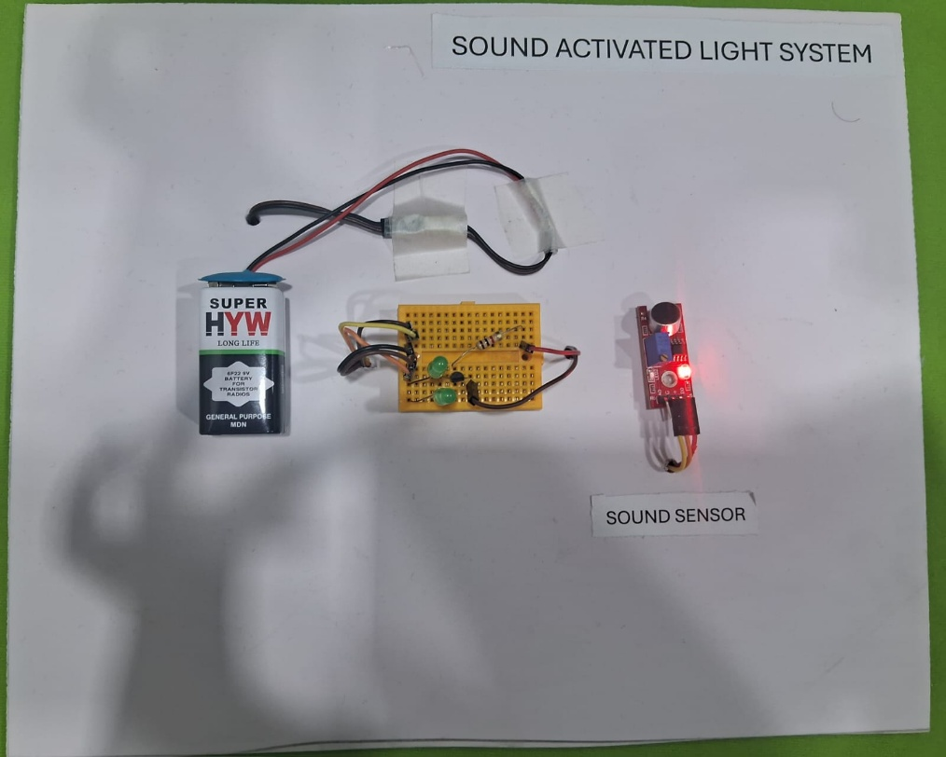

Introduction
Conventional household lighting relies heavily on mechanical switches, which are prone to physical wear over time, require tactile force to operate, and lack adaptation for hands-free convenience. Furthermore, operating standard mechanical switches can sometimes pose difficulties or minor safety concerns in dark or damp environments.
The Sound Activated Light System addresses these issues by introducing an acoustic sensing mechanism. Built around a responsive sound sensor, a BC547 transistor acting as a solid-state switch, and a base-protecting resistor network, the system activates seamlessly upon detecting ambient sound events (such as a clap or a loud voice). When the sensor registers a sound, it outputs a digital signal to the base of the transistor. The transistor acts as an electronic switch, closing the circuit to illuminate the LEDs. This integration demonstrates how basic semiconductor components and sensors can effectively modernize daily-use appliances.

Objectives
The main objectives of the Sound Activated Light System project are:
- To eliminate mechanical switches by implementing an acoustic control interface.
- To switch an output load using a low-cost, solid-state BC547 transistor.
- To protect the semiconductor interface by implementing a base current-limiting resistor.
- To provide a highly responsive, hands-free switching experience for users.
- To design a portable, energy-efficient system capable of running on standard battery power.
- To deliver a low-cost, reliable DIY framework for fundamental home automation.

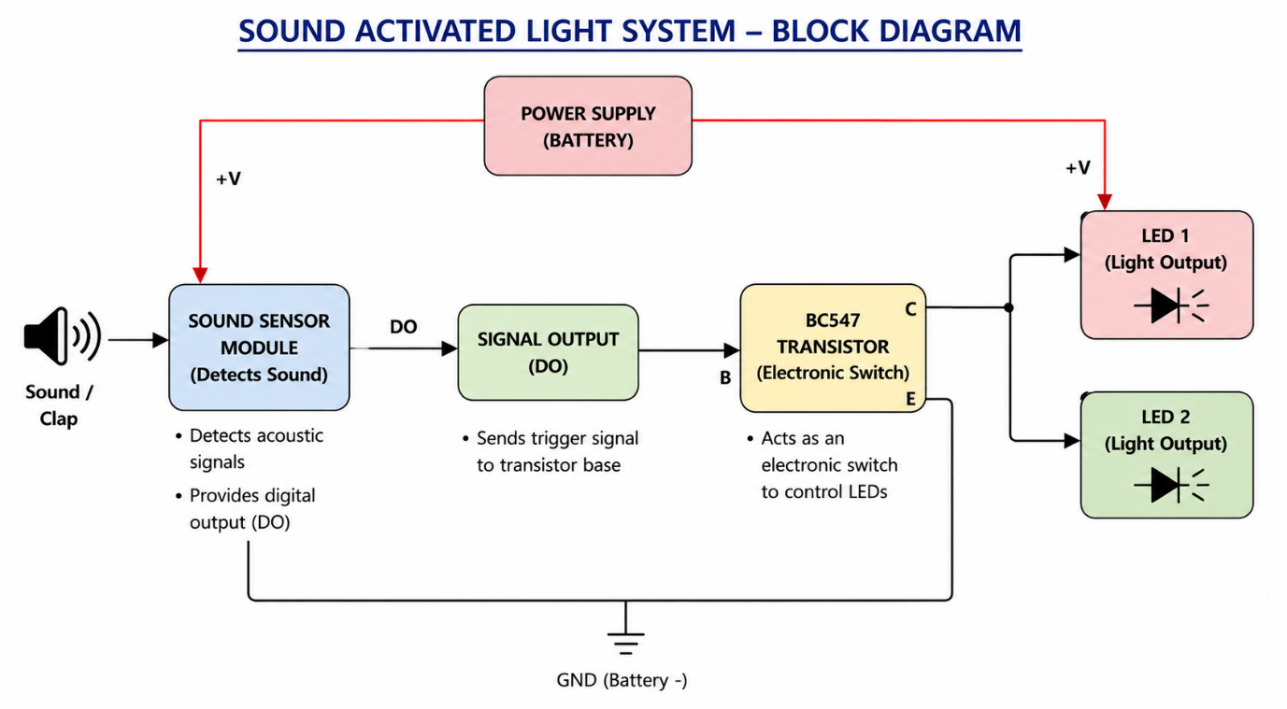
Block Diagram

Components Used
The following table details the hardware required for the assembly of the system:
Component | Quantity | Purpose
Sound Sensor Module | 1 | Detects acoustic signals and sends out a digital control trigger (DO).
BC547 Transistor | 1 | Acts as an electronically controlled solid-state switch to toggle the LEDs.
LED (Light Emitting Diode) | 2 | Serves as the primary lighting output source.
$1\text{ k}Ω$ Resistor | 1 | Limits current entering the transistor base to prevent component damage.
Battery / Power Supply | 1 | Supplies the electrical power to drive the sensor and the LED load.
Jumper Wires & Breadboard | As Required | Provides the physical layout and electrical pathways for connection.

Connection Summary
- Battery (+) $→$ Sound Sensor VCC AND LED Anodes (Long Legs / +)
- Battery (-) $→$ Sound Sensor GND AND BC547 Emitter (Right Pin)
- Sound Sensor DO $→$ $1\text{ k}Ω$ Resistor $→$ BC547 Base (Middle Pin)
- BC547 Collector (Left Pin) $→$ LED Cathodes (Short Legs / -)
Step-by-Step Connections
- Trigger the Transistor Base: Connect the sensor output to the transistor. Connect your $1\text{ k}Ω$ resistor from the DO (Digital Output) pin of the sound sensor directly to the Middle pin (Base) of the BC547 transistor.
- Ground the Emitter: Give the transistor a ground path. Connect the Right pin (Emitter) of the BC547 transistor directly to the Negative ($-$ / Ground) rail of your battery.
- Connect the LEDs to the Collector: Wire the lights into the power loops. Cluster your 2 LEDs together. Connect all of their long legs (Anodes / $+$) together and wire them directly to the Positive ($+$) rail of the battery. Connect all of their short legs (Cathodes / $-$) together, and wire them directly to the Left pin (Collector) of the BC547 transistor.

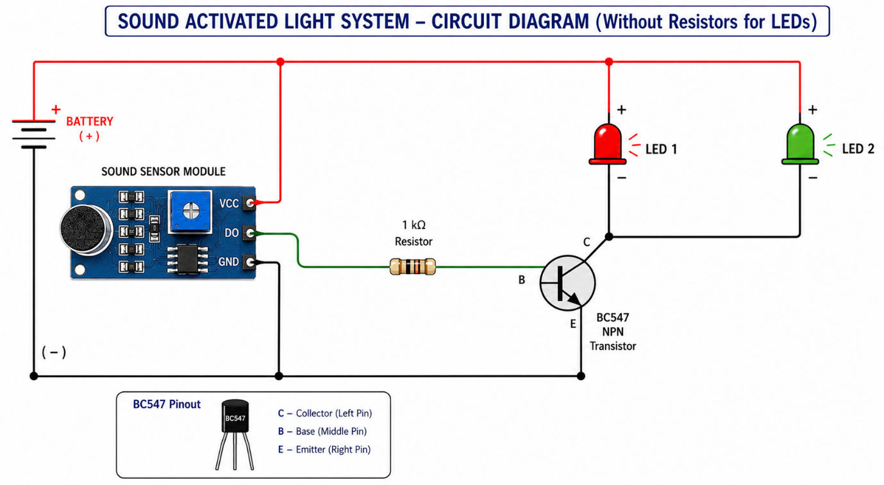
Circuit Diagram

Working Principle
The system functions dynamically based on acoustic variance and semiconductor switching:
- Idle State: In its default state, the ambient sound level is low, and the sound sensor does not register a trigger. The sensor's digital output pin (DO) remains low. Because no voltage is applied to the base of the BC547 NPN transistor, it stays in its cutoff state, acting as an open switch. The circuit path from the LED cathodes to the ground rail is broken, keeping the LEDs turned off.
- Sound Detection: When a distinct sound—such as a clap or sharp noise—occurs near the microphone, the sound sensor module processes the acoustic wave. If the sound exceeds the threshold level (often set via an onboard potentiometer), the module shifts its DO pin to a high state.
- Transistor Activation: The high signal travel from the DO pin through the current-limiting $1\text{ k}Ω$ resistor and into the base pin of the BC547 transistor. This forward-biases the base-emitter junction, driving the transistor into saturation. The transistor now acts as a closed switch, creating a direct pathway from the collector to the emitter.
- Load Illumination: With the transistor turned on, the ground path closes. Current flows from the positive battery rail, down through the parallel pair of clustered LEDs, enters the collector (Left pin), exits the emitter (Right pin), and returns to the negative battery terminal. This illuminates the 2 LEDs instantly.
- Release State: As soon as the sound pulse ends, the sensor drops its output back to a low state. The transistor loses its base drive, goes back into cutoff mode, opens the circuit path, and instantly turns off the LEDs.

Advantages
- Hands-Free Operation: Eliminates physical strain and allows control from a distance, offering an effortless user experience.
- No Mechanical Arcing: Using a solid-state transistor instead of a mechanical relay eliminates audible clicking noise and internal contact degradation.
- High Sensitivity: The acoustic trigger system can pick up light sound cues, optimizing it for interactive or responsive applications.
- Simplicity & Efficiency: The project uses minimal parts, draws very small standby currents, and handles high response speeds.
- Compact Form Factor: Without a bulky relay housing, the circuitry occupies very little physical space on a breadboard or custom PCB.

Disadvantages
- Momentary Response: Without an added flip-flop latch circuit or a microcontroller, the LEDs blink only for the brief duration of the sound pulse.
- Environmental Noise Sensitivity: Background chatter, music, or accidental drops can trigger false activations.
- No High-Voltage Isolation: A single transistor shares a common ground link, meaning it cannot natively isolate high-power AC mains appliances without additional driving circuitry.

Applications
- Hands-free accent lighting for dark hallways or staircases.
- Sound-reactive novelty displays and interactive party lighting setups.
- Assistive technology switches for individuals with limited mobility.
- Fundamental reference kits for STEM students learning basic transistor switching configurations.

Future Scope
- Latching / Toggle Configuration: Introducing a 555 timer IC or a T-flip-flop circuit to ensure one clap turns the lights indefinitely ON, and a second clap turns them OFF.
- Microcontroller Integration: Introducing an Arduino Nano or ESP8266 to support complex sound patterns, delay timers, or smart network alerts.
- AC Mains Scaling: Interfacing the transistor output with a 5V relay module or a optocoupler-driven Triac to transition from low-power DC LEDs to standard household AC lighting profiles safely.

Results
The Sound Activated Light System was successfully wired, deployed, and validated. During functional validation testing, the microphone sensor responded instantly to local acoustic signals without needing physical contact. The sensor sent clean, high-level control triggers through the protective resistor to the base of the BC547 transistor smoothly. The transistor responded by immediately driving into saturation, closing the ground loop to illuminate the 2 clustered LEDs brightly. The circuit reset instantly upon the cessation of sound, verifying that all system components performed up to the design specifications reliably.


