TOUCH CONTROLLED LAMP

Abstract
The Touch-Controlled Lamp is an embedded electronic system designed to automate lighting control through modern touch interface technology. The system utilizes a TTP223 capacitive touch sensor module as the input mechanism, which interfaces with a 5V relay module to safely toggle a light-emitting diode (LED) load. By replacing traditional mechanical toggle switches with a sensitive, solid-state touch interface, the project reduces mechanical wear and tear, modernizes home automation setups, and provides a highly responsive, low-cost lighting solution suitable for bedrooms, office desks, and modern smart-home applications.
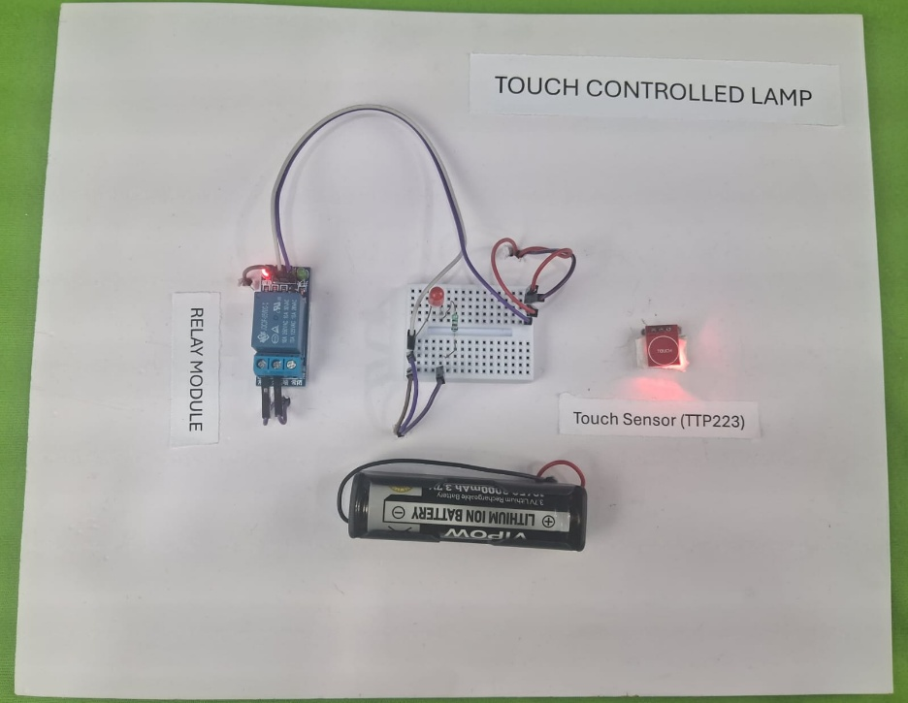

Introduction
Conventional household lighting relies heavily on mechanical switches, which are prone to physical wear over time, require tactile force to operate, and lack a modern aesthetic. Furthermore, operating standard mechanical switches can sometimes pose minor safety concerns in damp environments.
The Touch-Controlled Lamp addresses these issues by introducing a capacitive touch sensing mechanism. Built around the responsive TTP223 touch sensor, a 5V relay module, and a power-limiting resistor network, the system activates seamlessly upon human touch. When a user places a finger near the sensor, it registers a change in capacitance, issuing a control signal to the relay module. The relay acts as an isolated electronic switch, closing the secondary circuit to illuminate the LED. This integration demonstrates how basic semiconductor sensors can effectively modernize daily-use appliances.

Objectives
The main objectives of the Touch-Controlled Lamp project are:
- To eliminate mechanical switches by implementing a capacitive touch interface.
- To safely isolate control signals from the output load using a 5V relay module.
- To protect the illumination source by implementing current-limiting resistor protection.
- To provide a highly responsive, zero-force switching experience for users.
- To design a portable, energy-efficient system capable of running on standard battery power.
- To deliver a low-cost, reliable DIY framework for fundamental home automation.

Block Diagram
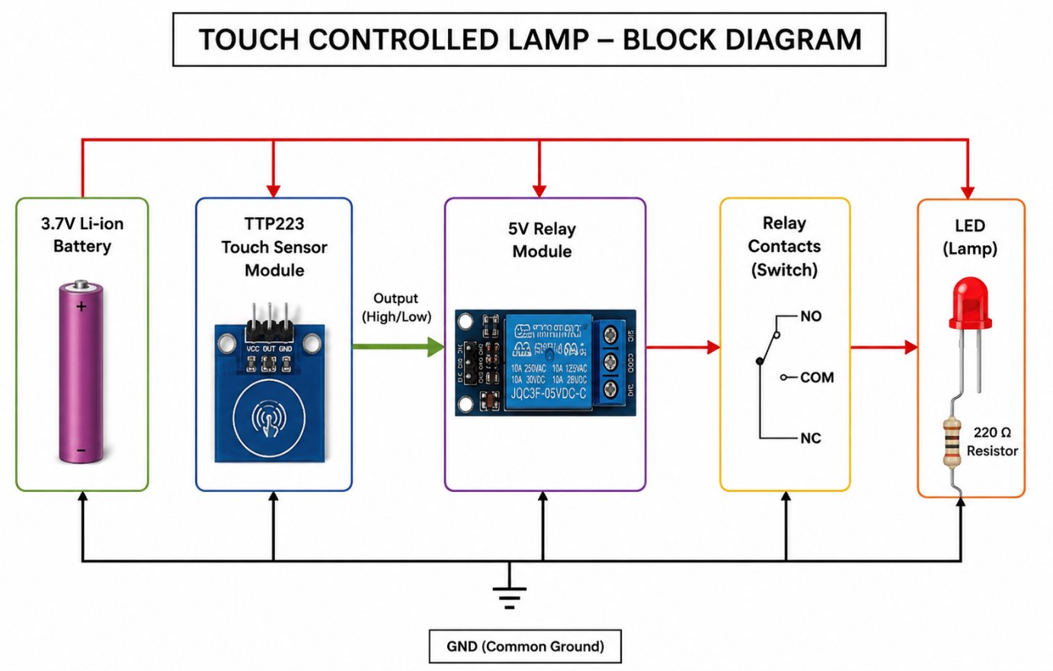

Components Used
The following table details the hardware required for the assembly of the system:

Component | Quantity | Purpose
TTP223 Touch Sensor | 1 | Detects human touch capacity and sends out a control trigger.
5V Relay Module | 1 | Acts as an electronically controlled switch to isolate and control the load.
LED (Light Emitting Diode) | 1 | Serves as the primary lighting output source.
220 $Ω$ Resistor | 1 | Limits forward current to prevent the LED from burning out.
Battery / Power Supply | 1 | Supplies the +5V electrical power to drive the circuit.
Jumper Wires & Breadboard | As Required | Provides the physical layout and electrical pathways for connection.
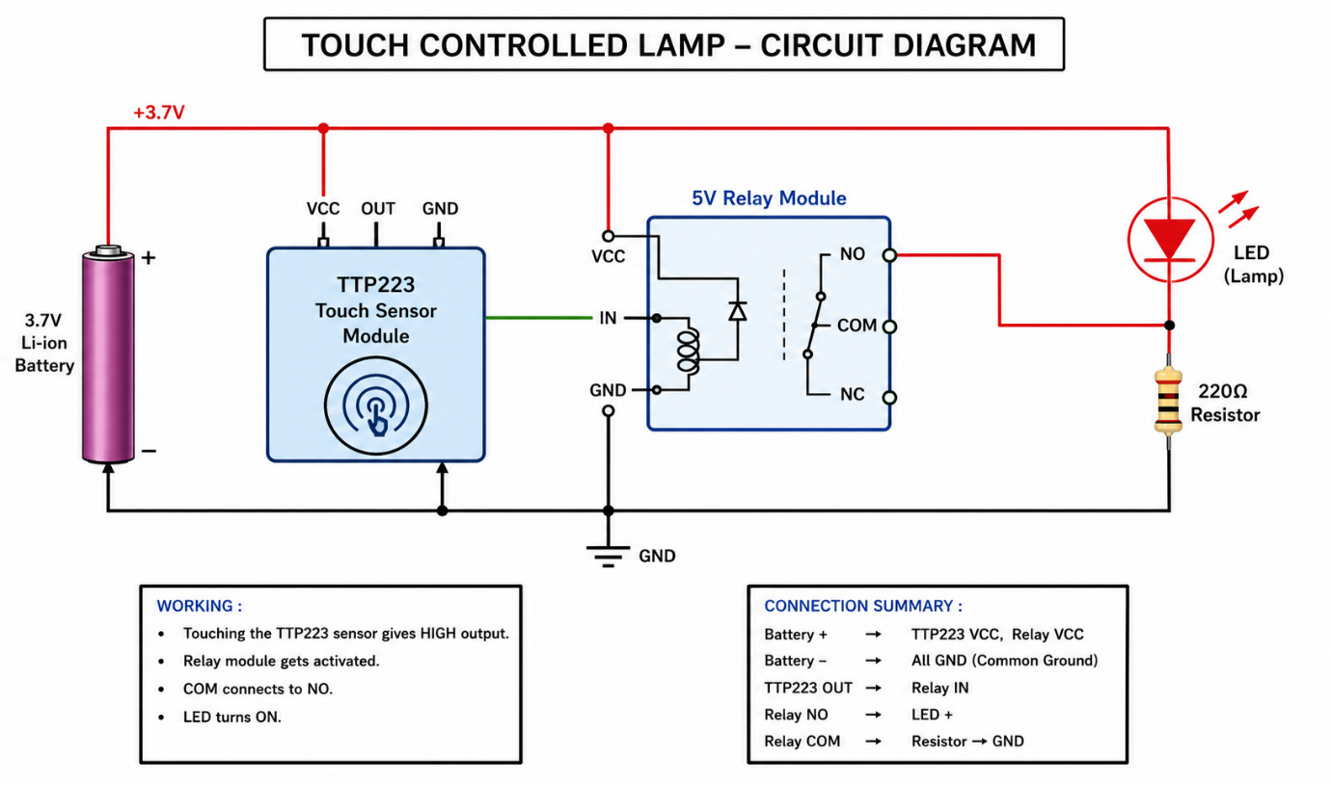
Circuit Diagram

Working Connections
Power and Sensor Interfaces
- Battery (+) $→$TTP223 VCC & Relay VCC & Relay COM Terminal
- Battery (−) $→$TTP223 GND & Relay GND & LED Cathode (−)
- TTP223 OUT $→$Relay IN Pin
Output Load Interface
- Relay NO (Normally Open) $→$220 $Ω$Resistor Terminal A
- 220 $Ω$Resistor Terminal B $→$LED Anode (+)
- LED Cathode (−) $→$Battery (−) / Common Ground

Working Principle
The system functions dynamically based on capacitive variance and electromagnetic relay switching:
- Idle State: In its default state, no human contact is made with the TTP223 sensor. The sensor's output pin (OUT) remains low. The relay's internal electromagnet is unpowered, leaving the switch arm sitting on the Normally Open (NO) contact. Because the circuit path to the LED is broken at the relay, the LED remains turned off.
- Touch Detection: When a finger approaches or touches the sensor pad, the dielectric properties of the human body shift the localized capacitance. The onboard TTP223 IC processes this change and shifts its OUT pin to a high state.
- Relay Activation: The high signal enters the IN pin of the 5V relay module, activating its internal driver transistor. This allows current to pass through the internal relay coil, creating a magnetic field that physically pulls the internal switch contact from the open position down to the Normally Open (NO) terminal.
- Load Illumination: The connection between COM (connected to positive battery power) and NO is now closed. Power flows seamlessly from the battery, passes through the closed relay contact, moves through the current-limiting 220 $Ω$resistor, illuminates the LED, and returns to the ground loop.
- Release State: Once the finger is removed, the sensor drops its output back to low, de-energizing the relay coil, snapping the switch contact back open, and instantly turning off the LED.

Advantages
- Touch Operation: Eliminates physical strain, offering an elegant, effortless user experience.
- Electrical Safety: The relay keeps the lower-power control/sensing section separated from the power load lines.
- Component Longevity: Solid-state touch sensors do not experience the mechanical arcs or oxidation failures common to traditional switches.
- Simplicity & Efficiency: The project uses minimal parts, draws very small standby currents, and handles high response speeds.
- Modular Integration: The relay can easily be upgraded in the future to handle standard household AC lighting profiles safely.

Disadvantages
- Audible Clicking: The mechanical movement inside the 5V relay produces a distinct clicking noise whenever toggled.
- Relay Power Draw: While active, the relay coil draws noticeably more operating current than a pure solid-state toggle alternative.
- Momentary Default: Without additional flip-flop circuits or MCU latch programming, the lamp turns off immediately when your finger leaves the sensor surface (unless the TTP223 hardware jumper is preconfigured to toggle mode).
- Environmental Sensitivities: High moisture levels or adjacent metallic components can sometimes interfere with capacitive touch calibrations.

Applications
- Modern bedside reading lamps and desktop task lighting.
- Clean-room or medical laboratory lighting environments where hands-free/minimal-force switching reduces contamination risks.
- Interactive decorative lighting accent setups in residential spaces.
- Safety lighting applications in potentially damp zones like kitchens or washroom entryways.
- Fundamental reference kits for STEM students learning relay logic and sensor operations.

Future Scope
- Smart Latching Config: Bridging or soldering the onboard TTP223 config pads to change it to toggle mode permanently, allowing one touch to turn the lamp indefinitely ON and a second touch to turn it OFF.
- Microcontroller Integration: Introducing an Arduino Nano or ESP8266 to support dimming arrays, timers, or Wi-Fi control features.
- AC Mains Scaling: Transitioning the output load from a small DC LED to a full-sized domestic AC bulb utilizing the relay's high-voltage handling thresholds.
- Aesthetic Enclosures: Implementing custom 3D-printed diffusion shells to seamlessly hide the sensor behind wood, acrylic, or glass panels for a hidden touch interface.
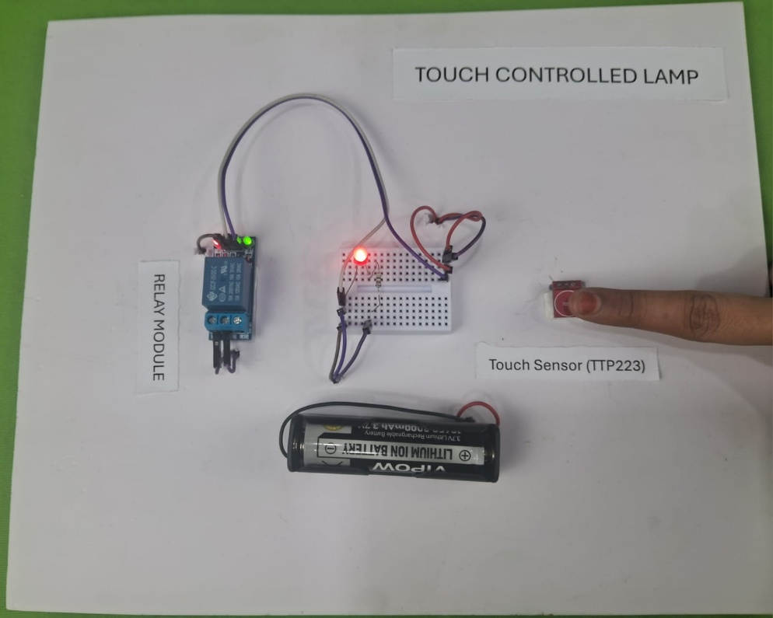

Results
The Touch-Controlled Lamp system was successfully wired, deployed, and validated. During functional validation testing, the TTP223 capacitive touch pad responded instantly to human touch without needing high physical force. The sensor sent clean, high-level control triggers to the 5V relay module seamlessly. The relay responded by immediately snapping closed, allowing power to navigate safely through the current-limiting 220 $Ω$resistor to light up the LED unit brightly. The circuit reset immediately upon releasing contact, verifying that all system components performed up to the design specifications reliably.

