AMS OS
Atomic Management System
Mini Operating System Simulator
CREATORS: M Saim Naveed(24f-3043), Mohsin Ali Shah (24f-0014), Ahmed Naeem(23f-3113)
Final Project Report
Operating Systems Lab · Spring 2026
Phase 3 / Final Submission
Target Platform: Ubuntu Linux · Language: C++17 · Build: GNU Make
Generated: May 10, 2026

Table of Contents

Table of Contents 2
1. Executive Summary 3
2. Project Scope 4
3. System Requirements 5
3.1 Target Environment 5
3.2 Installation Commands 5
3.3 Build and Run 5
4. System Architecture 6
5. Source Organization 7
6. Kernel Module Design 8
6.1 Main Kernel Controller (main.cpp) 8
6.2 Resource Manager 8
6.3 Process Manager 8
6.4 Task Catalog 8
6.5 Ready Queue Manager 8
6.6 Scheduler 9
6.7 Sync Manager 9
6.8 Deadlock Manager 9
6.9 Scheduler Terminal (SFML GUI) 9
6.10 Logger 10
7. Task Inventory 11
8. Ready Queue Design 12
9. Resource Allocation Strategy 12
10. User Interface 13
11. User Mode and Kernel Mode 13
12. Interrupt and Process Control 13
13. Manual Compliance Matrix 15
14. Build Configuration 17
15. Testing Plan 17
16. Known Limits 18
17. Submission Checklist 18
18. Role-Based Responsibilities 25

1. Executive Summary

AMS OS (Atomic Management System) is a Linux terminal application that simulates core operating-system responsibilities. It accepts hardware resources at startup, displays a named boot screen, creates task processes using fork() and exec(), grants or denies resources through IPC pipes, tracks processes in a PCB table, and schedules ready tasks with multilevel queues. The system exposes both User Mode and Kernel Mode controls and ships with an SFML-based graphical scheduler visualizer.
The implementation is organized into kernel subsystems at the project root and independent task executables compiled into the build/ directory. Runtime state is recorded in data/system_log.txt, and file-oriented tasks operate on a virtual disk under data/virtual_disk/.

2. Project Scope

AMS OS demonstrates the following operating-system concepts:
- Multitasking through multiple child processes and multilevel ready queues
- Process creation using fork() and program replacement using exec()
- Inter-process communication using anonymous pipes (IPCResourceRequest / IPCResourceResponse)
- Resource allocation for RAM, hard drive space, and CPU cores with first-fit memory layout
- Process lifecycle management through PCB state transitions (NEW → READY → RUNNING → BLOCKED / MINIMIZED → TERMINATED)
- Context switching with scheduler dispatch and POSIX signals (SIGSTOP / SIGCONT)
- Multilevel queue scheduling with FCFS at the system and background levels and Round Robin at the interactive level
- Priority aging to prevent starvation
- Synchronization using semaphore, mutex, condition variable, and background monitor thread
- User Mode and Kernel Mode separation with password authentication
- Interrupt simulation through minimize, block, resume, and close operations
- Deadlock detection through a circular wait-for graph with DFS cycle detection
- SFML graphical scheduler terminal for visual event monitoring
- Runtime logging for all process and resource events

3. System Requirements

3.1 Target Environment
- Ubuntu 22.04 or newer (recommended)
- GNU Make
- g++ with C++17 support
- GNOME Terminal, x-terminal-emulator, or xfce4-terminal
- SFML 2.x libraries (required for the graphical scheduler terminal)

3.2 Installation Commands
sudo apt update
sudo apt install build-essential gnome-terminal libsfml-dev
Optional lightweight terminal fallback:
sudo apt install xfce4-terminal

3.3 Build and Run
make check
make
./OS 2 256 8
The command above starts AMS OS with the recommended configuration: 2 GB RAM, 256 GB hard drive, and 8 CPU cores. Task executables are compiled into build/ by the same Makefile.

4. System Architecture

The diagram below shows the high-level subsystem layout of AMS OS. All kernel modules reside at the project root alongside the Makefile. Task executables are compiled from matching .cpp source files into build/.
Kernel Subsystem Map
Layer | Module | Responsibility
Entry Point | main.cpp | Boot, menus, IPC, process controls, mode switching, shutdown
Resource | resource_manager | RAM / HDD / CPU counters and first-fit memory block allocation
Process | process_manager | PCB table and full process lifecycle management
Catalog | task_catalog | Static metadata for all 15 task executables
Queues | ready_queue | Multilevel queue: System (FCFS) / Interactive (RR) / Background (FCFS)
Dispatch | scheduler | FCFS and Round Robin dispatch, SIGSTOP / SIGCONT context switching
Sync | sync_manager | Semaphore, mutex, condition variable, background monitor thread
Deadlock | deadlock_manager | Wait-for graph construction and DFS cycle detection
Logging | logger | Timestamped event appending to data/system_log.txt
GUI | scheduler_terminal | SFML graphical window displaying scheduler event log
UI Helpers | console_colors.h | ANSI color utilities for terminal table rendering

5. Source Organization

All source files are located at the project root. The Makefile compiles the kernel executable (OS) from the kernel source files and task executables into build/. Runtime directories (data/, data/virtual_disk/) are created automatically.
Kernel Sources (project root)
main.cpp Boot, menus, IPC, process controls
resource_manager.cpp/h RAM, HDD, CPU counters and memory layout
process_manager.cpp/h PCB table and lifecycle operations
task_catalog.cpp/h Metadata for all 15 task executables
ready_queue.cpp/h Multilevel ready queue implementation
scheduler.cpp/h FCFS/RR scheduler and context switching
scheduler_terminal.cpp SFML graphical scheduler event viewer
sync_manager.cpp/h Semaphore, mutex, condition variable, thread
deadlock_manager.cpp/h Circular wait detection
logger.cpp/h System, process, and resource logging
console_colors.h ANSI terminal color utilities
Task Sources → compiled to build/
calculator.cpp delete_file.cpp download_simulator.cpp
file_copy.cpp file_info.cpp minesweeper.cpp
move_file.cpp music_player.cpp notepad.cpp
process_killer.cpp clock.cpp snake.cpp
system_info.cpp task_manager.cpp create_file.cpp
Runtime Directories
build/ Task executable binaries
data/system_log.txt Runtime event log
data/virtual_disk/ Virtual disk for file tasks

6. Kernel Module Design

6.1 Main Kernel Controller (main.cpp)
main.cpp controls startup, boot display, hardware resource input, menu routing, task launch, IPC, process control, mode switching, and shutdown. It creates required runtime directories using C++17 filesystem APIs. The task launch workflow is:
- User selects a task from the catalog.
- Kernel creates request and response pipes.
- Kernel forks a child process.
- Child sends an IPCResourceRequest to the kernel through the pipe.
- Kernel checks RAM, HDD, and CPU availability via the Resource Manager.
- Kernel grants or denies the request through the response pipe.
- If granted, the kernel allocates a simulated RAM block and creates a PCB entry.
- The child waits with SIGSTOP.
- The Scheduler resumes the child with SIGCONT.
- The child replaces itself with the task executable using exec().

6.2 Resource Manager
The Resource Manager tracks total and available RAM (in MB), total and available hard drive space (in MB), and total and available CPU cores. Simulated RAM is laid out as contiguous blocks with startAddress and endAddress fields stored in each PCB. When a process terminates the manager releases its block and merges adjacent free blocks to reduce fragmentation.

6.3 Process Manager
Each process is stored in a PCB record containing:
- PID, process name, process type
- Lifecycle state (NEW / READY / RUNNING / BLOCKED / MINIMIZED / TERMINATED)
- Priority, waiting time, turnaround time
- RAM, HDD, and CPU requirements
- Assigned CPU core ID
- Ready queue label
- RAM block start and end addresses

6.4 Task Catalog
The Task Catalog stores static metadata for all 15 task executables. Each entry holds task ID, name, process type, priority, RAM / HDD / CPU requirements, executable path under build/, and a description. Registration is centralized through a single helper method to enforce consistent metadata and reduce duplication.

6.5 Ready Queue Manager
AMS OS implements a three-level multilevel ready queue:
Queue | Priority | Algorithm | Assigned Tasks
System Queue | 1 (highest) | FCFS | Task Manager, Process Killer
Interactive Queue | 2 | Round Robin (8 s quantum) | Calculator, Notepad, games, file info, Clock, Calendar
Background Queue | 3 | FCFS | Copy File, Move File, Music Player, Download Simulator

Priority aging is applied before each dispatch. If a process waits beyond the aging threshold its numeric priority improves and it may move to a higher-priority queue, preventing starvation.

6.6 Scheduler
The scheduler selects the next process from the System queue first, then Interactive, then Background. Context switching is demonstrated by: acquiring CPU core slots through the Sync Manager; assigning a core ID to the PCB; moving the selected process to RUNNING and sending SIGCONT; waiting for completion or time-quantum expiry; sending SIGSTOP when an Interactive process exhausts its quantum; re-queueing unfinished tasks; and releasing all resources when a task terminates.

6.7 Sync Manager
The following synchronization primitives are implemented:
Primitive | Implementation | Purpose
Semaphore (SimpleSemaphore) | mutex + condition_variable | Controls available CPU core dispatch slots
Mutex | std::mutex | Protects the CPU core ID pool
Condition variable | std::condition_variable | Notifies scheduler when a ready process exists
Thread | std::thread | Background resource monitor logs available resources periodically
Atomic flag | std::atomic<bool> | Stops the monitor thread safely on shutdown

6.8 Deadlock Manager
The deadlock module simulates circular wait between two selected processes. It builds a wait-for graph from DeadlockRecord entries (each recording PID, process name, held resource, and waited-for resource), detects cycles with DFS, and displays the required message: "Deadlock detected among processes". A victim process is then selected and terminated to recover resources.

6.9 Scheduler Terminal (SFML GUI)
scheduler_terminal.cpp implements a graphical window using the SFML library. It reads scheduler event log entries from data/scheduler_event_log.txt and renders them as a scrollable event table. This provides a visual complement to the terminal-based menus and fulfills the graphics library requirement noted as a bonus in the project manual.

6.10 Logger
The Logger appends timestamped events to data/system_log.txt. Recorded event categories include: process creation, resource allocation and release, RAM block assignment, scheduler dispatch, interrupt and state change, process termination, Kernel Mode access, deadlock detection, and shutdown cleanup.

7. Task Inventory

The following 15 tasks are registered in the Task Catalog. Each is compiled from a dedicated source file into its own executable under build/ and launched as a separate child process via exec().

ID | Task Name | Source File | Type | Pri | RAM | HDD | CPU
1 | Create File | create_file.cpp | Interactive | 2 | 80 MB | 20 MB | 1
2 | Delete File | delete_file.cpp | Interactive | 2 | 70 MB | 10 MB | 1
3 | Copy File | file_copy.cpp | Background | 3 | 200 MB | 100 MB | 1
4 | Move File | move_file.cpp | Background | 3 | 150 MB | 60 MB | 1
5 | File Info | file_info.cpp | Interactive | 2 | 90 MB | 20 MB | 1
6 | Notepad | notepad.cpp | Interactive | 2 | 150 MB | 50 MB | 1
7 | Calculator | calculator.cpp | Interactive | 2 | 100 MB | 20 MB | 1
8 | Digital Clock | clock.cpp | Auto-running | 2 | 50 MB | 10 MB | 1
9 | System Info | system_info.cpp | Interactive | 2 | 80 MB | 10 MB | 1
10 | Snake Game | snake.cpp | Interactive | 2 | 250 MB | 40 MB | 1
11 | Minesweeper | minesweeper.cpp | Interactive | 2 | 220 MB | 40 MB | 1
12 | Music Player | music_player.cpp | Background | 3 | 120 MB | 30 MB | 1
13 | Download Simulator | download_simulator.cpp | Background | 3 | 180 MB | 200 MB | 1
14 | Task Manager | task_manager.cpp | System | 1 | 100 MB | 20 MB | 1
15 | Process Killer | process_killer.cpp | Kernel | 1 | 100 MB | 20 MB | 1

8. Ready Queue Design

The multilevel queue uses three priority levels with distinct scheduling algorithms:
Priority 1 — System Queue [FCFS]
Priority 2 — Interactive Queue [Round Robin, 8 s quantum]
Priority 3 — Background Queue [FCFS]

Aging logic applied before each dispatch:
increment waiting time for all queued processes
if waiting_time >= AGING_THRESHOLD:
improve numeric priority
move process to the appropriate higher-priority queue
This design satisfies the manual requirement for multilevel queues with different algorithms at different levels and prevents indefinite starvation of low-priority processes.

9. Resource Allocation Strategy

Resources are checked by the kernel before a child process is permitted to run. The allocation sequence is:
Child Process → IPCResourceRequest (pipe) → Kernel

Kernel checks RAM, HDD, CPU availability:
if available:
allocate counters
allocate RAM block (first-fit)
create PCB entry
add to ready queue
send granted response
else:
send denied response
child exits
The number of concurrently active tasks is therefore bounded by available RAM, hard drive space, and CPU core count. All resources are released and free blocks are coalesced when a process terminates.

10. User Interface

The terminal UI is standardized around an Ubuntu aesthetic using ANSI color codes via console_colors.h:
- Royal blue is the primary accent color for headers and section titles.
- Neutral gray and white are used for base interface text.
- Green, yellow, and red are reserved for success, warning, and error states respectively.
- Fixed-width tables use plain state text to preserve column alignment.
- The terminal launcher prefers GNOME Terminal on Ubuntu and falls back to x-terminal-emulator or xfce4-terminal.
In addition to the terminal menus, the SFML-based scheduler_terminal provides a graphical window that visualizes scheduler events in real time by reading data/scheduler_event_log.txt.

11. User Mode and Kernel Mode

AMS OS starts in User Mode. User Mode allows viewing normal system state and launching tasks. Kernel Mode is protected by password authentication (default password: admin) and unlocks privileged actions:
- View the full system log (data/system_log.txt)
- Force-kill a process
- Remove PCB entries
- Run resource allocation tests
- Run deadlock detection
- Manually update process state

12. Interrupt and Process Control

AMS OS supports the following manual process control operations:
Control | Menu Option | Effect
Minimize | 17 | Sends SIGSTOP, removes from ready queue, keeps resources allocated
Resume | 18 | Moves MINIMIZED or BLOCKED process back to READY
Close | 21 | Terminates process and releases all resources
Switch | 22 | Shows and resumes a selected process when applicable
Input interrupt | 26 | Moves task to BLOCKED state
Complete interrupt | 27 | Moves BLOCKED task back to READY
Kernel kill | 16 | Force-terminates a task (Kernel Mode only)

13. Manual Compliance Matrix

Requirement | Status | Implementation Detail
OS has its own name | ✓ Complete | AMS OS displayed on boot screen
Boot loading with sleep | ✓ Complete | bootScreen() uses sleep(1) with animated dots
User provides RAM, HDD, cores | ✓ Complete | CLI args ./OS <RAM_GB> <HDD_GB> <CORES>
Resource-managed processes | ✓ Complete | Resource Manager checks RAM/HDD/CPU before grant
Minimum 15 tasks | ✓ Complete | 15 task executables registered in catalog
Separate code file per task | ✓ Complete | One .cpp source file per task
Process creation via fork/exec | ✓ Complete | fork() and exec() used for every task launch
IPC resource message | ✓ Complete | Child sends IPCResourceRequest through anonymous pipe
Deny if resources unavailable | ✓ Complete | Parent sends denied response; child exits
Separate terminal per task | ✓ Complete | GNOME Terminal / fallback terminal launcher
Close or minimize task | ✓ Complete | Menu options 17, 18, 21, 22
Multitasking | ✓ Complete | PCB table, ready queues, scheduler, separate processes
User Mode and Kernel Mode | ✓ Complete | OSMode enum with password-protected Kernel Mode
Hardware access in Kernel Mode | ✓ Complete | Kernel Mode process kill and resource tools
Time auto-start task | ✓ Complete | Digital Clock auto-starts after boot
Instruction guide | ✓ Complete | Menu option 23
RAM location and size in PCB | ✓ Complete | Block startAddress/endAddress stored in PCB
Ready queue scheduling | ✓ Complete | ReadyQueueManager and Scheduler modules
Multilevel queue scheduling | ✓ Complete | System, Interactive, Background queues
Different algorithms per queue | ✓ Complete | FCFS and Round Robin
Interrupt moves task to blocked | ✓ Complete | Menu option 26
Resume after interrupt | ✓ Complete | Menu option 27
Process lifecycle removal | ✓ Complete | Scheduler and close/kill release resources
Data saved to virtual disk | ✓ Complete | Virtual disk under data/virtual_disk/
Threads | ✓ Complete | Resource monitor background thread
Semaphore | ✓ Complete | SimpleSemaphore class
Mutex | ✓ Complete | CPU core pool mutex
Condition variable | ✓ Complete | Ready queue notification
Priority with aging | ✓ Complete | ReadyQueueManager::applyAging()
Deadlock detection | ✓ Complete | Wait-for graph DFS cycle detection
Required deadlock message | ✓ Complete | Displays "Deadlock detected among processes"
System log file | ✓ Complete | data/system_log.txt
Graphics library bonus | ✓ Complete | SFML scheduler_terminal graphical event viewer

14. Build Configuration

The Makefile supports standard Linux build practices:
Target | Purpose
make | Build kernel OS executable and all task executables into build/
make run | Build and run with recommended resources (2 GB RAM, 256 GB HDD, 8 cores)
make check | Verify compiler and terminal emulator availability
make install | Run prerequisite checks, then install under /usr/local
make uninstall | Remove installed files
make clean | Remove generated binaries and runtime log
make distclean | Remove generated build/ and virtual disk directories
make help | Show usage summary

The install target creates an ams-os launcher that changes into the installed application directory before executing the kernel so that relative task paths (./build/) continue to work after installation.

15. Testing Plan

Recommended test sequence for academic demonstration:
- Run make check to verify toolchain availability.
- Run make to compile all modules and tasks.
- Start ./OS 2 256 8 and confirm the boot name and loading animation.
- Confirm Digital Clock auto-starts after boot.
- Launch Calculator, Notepad, Music Player, and File Copy.
- Run the scheduler and observe context switch output.
- Open the PCB table and verify PID, state, priority, queue label, and RAM block.
- Open Ready Queues and verify multilevel assignment.
- Minimize an interactive task (option 17) and resume it (option 18).
- Trigger an input interrupt (option 26) and a complete interrupt (option 27).
- Enter Kernel Mode with password admin.
- View data/system_log.txt through menu option 15.
- Run deadlock detection with two active processes.
- Launch the SFML scheduler terminal and verify the graphical event log.
- Close all tasks and verify resources are released.
- Shutdown and confirm cleanup.

16. Known Limits

- AMS OS is a simulator; it does not manage real hardware resources.
- Process execution depends on Ubuntu / POSIX APIs and is not portable to non-Linux platforms without replacing the process model.
- Some terminal emulators handle process groups differently; GNOME Terminal is recommended for the cleanest Ubuntu experience.
- The SFML GUI (scheduler_terminal) requires libsfml-dev to be installed separately before building.

17. ScreenShots

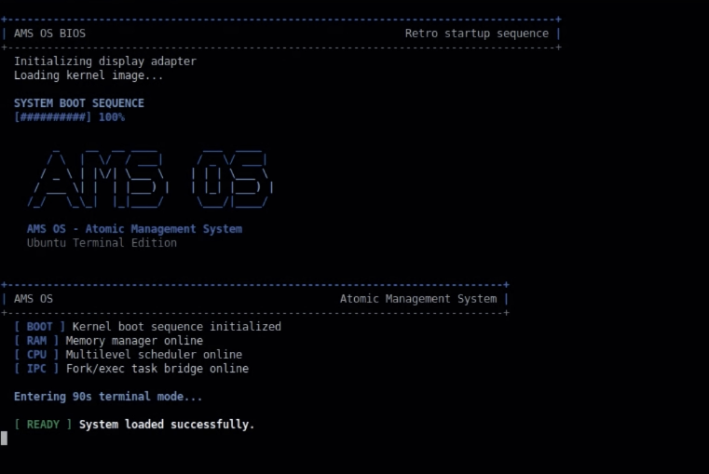

Booting

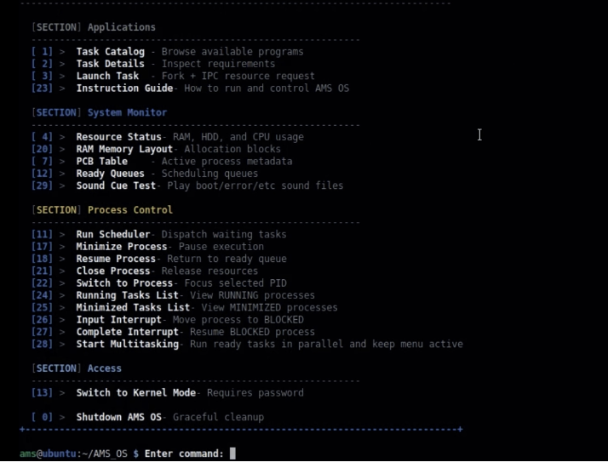

Main menu

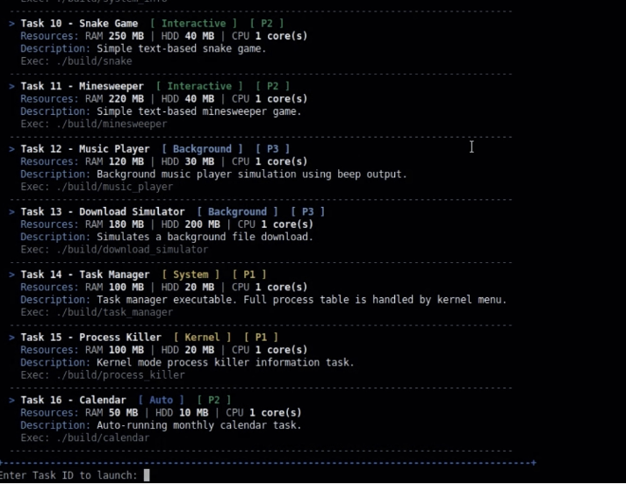

Tasks Tab

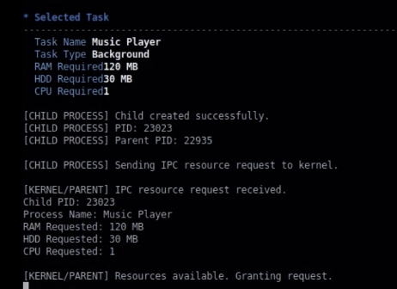

Parent-child communication

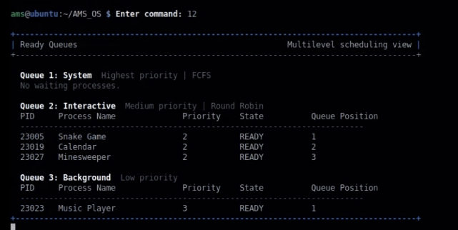

Ready-Queues

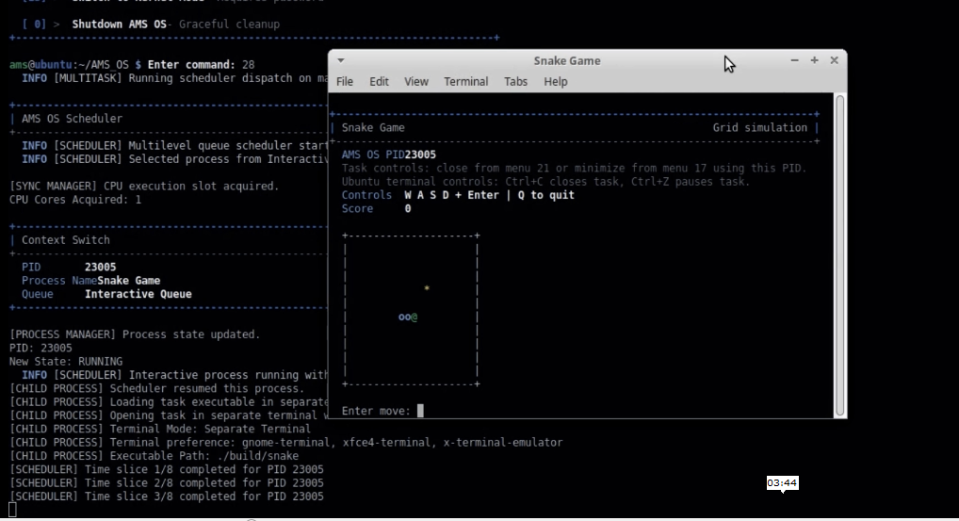

Separate Terminal Execution

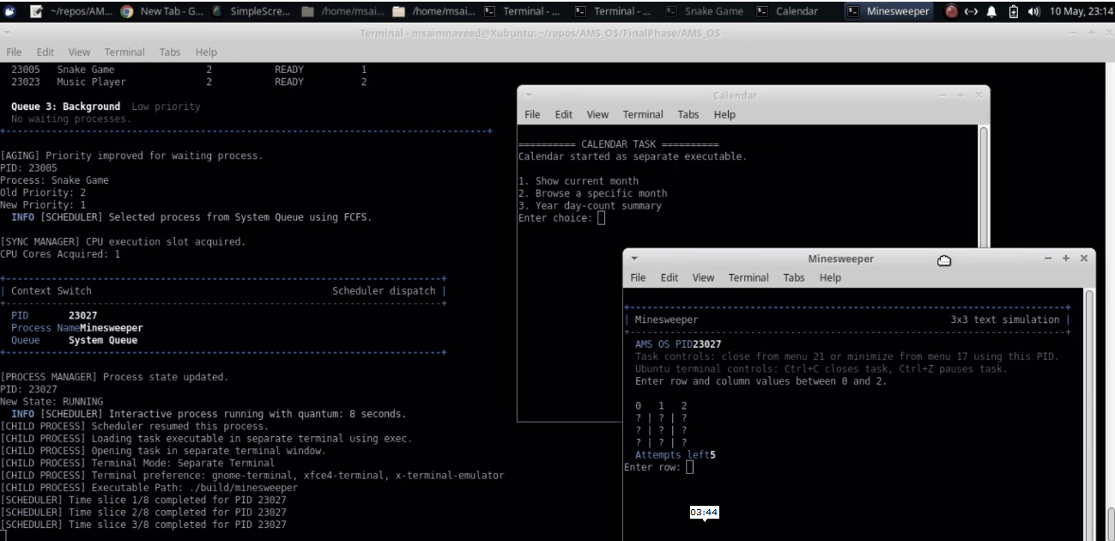

MultiTaskin+Scheduling

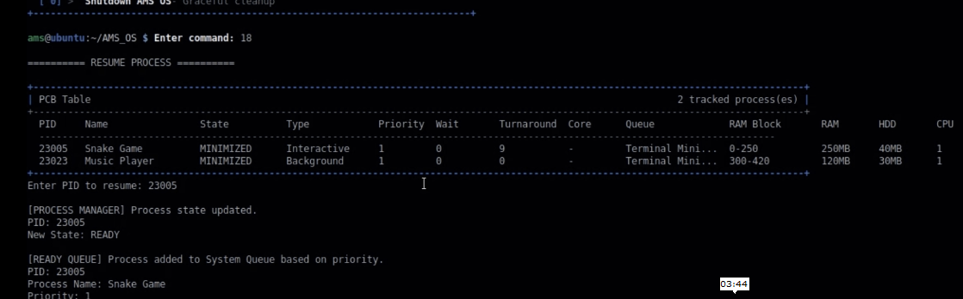

Minimize Queue + Resuming

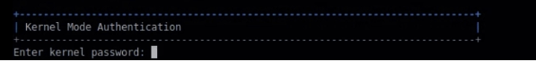

Kernel Authentication

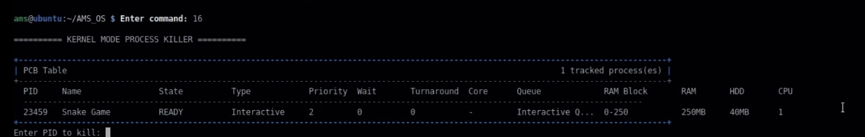

Process Kill by kernel

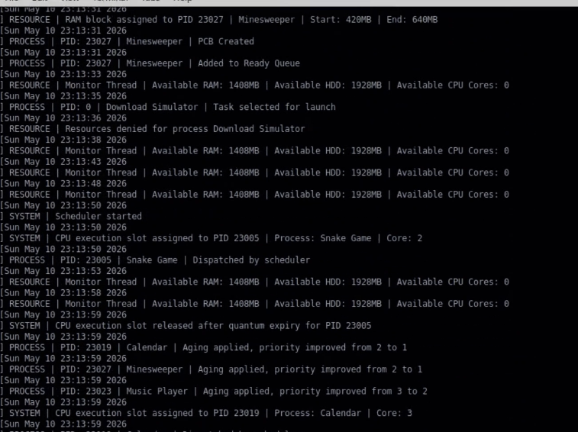

System log by kernel

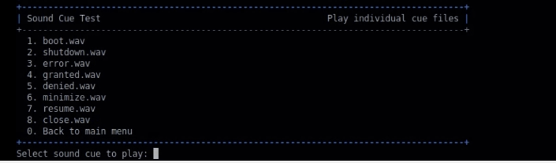

Sound test

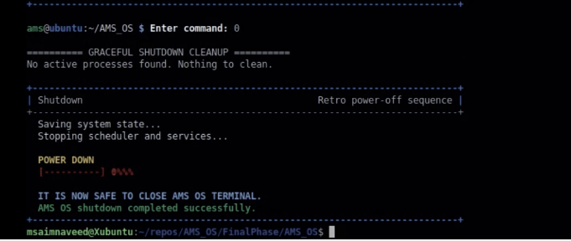

PowerOff

17. Submission Checklist

- Complete source files at project root (kernel modules + task source files)
- 15 task executables defined in the Task Catalog
- Makefile with build, run, install, clean, and uninstall targets
- SFML scheduler terminal source (scheduler_terminal.cpp)
- Professional README.md
- Professional project report (this document)
- Manual compliance matrix (Section 13)
- System log support (data/system_log.txt)
- Virtual disk support (data/virtual_disk/)
- Ubuntu-focused terminal launcher
- No non-Linux source dependencies in kernel or task modules

18. Role-Based Responsibilities

If submitted as a group project, responsibilities can be mapped as follows:
Role | Responsibility
Kernel Developer (Saim) | Boot flow, menu system, fork/exec, IPC, interrupt and process controls
Scheduler Developer(Mohsin) | Ready queues, FCFS, Round Robin, aging, context switching
Resource Developer(Saim) | RAM/HDD/CPU allocation and first-fit memory block layout
Task Developer(Ahmed) | Independent task executables (all 15 source files under tasks/)
M Saim Naveed | SFML scheduler_terminal graphical event viewer
Mohsin Ali Shah | README, project report, screenshots, and demo workflow
Ahmed Naeem | Ubuntu build/run testing and manual compliance verification
Review Note — This report documents the complete AMS OS simulator design, implementation strategy, operating-system concepts, build configuration, manual compliance, and recommended demonstration workflow. For final submission, attach screenshots or demonstration-video frames covering: boot screen, task catalog, IPC resource grant, separate task terminal, PCB table, ready queues, resource layout, scheduler dispatch, SFML event viewer, Kernel Mode authentication, deadlock detection message, and shutdown cleanup.

