FUTURE IMPROVEMENTS
The following roadmap outlines short-term improvements and long-term enhancements planned to further strengthen the platform. These improvements focus on AI capabilities, collaboration, analytics, scalability, and enterprise readiness.
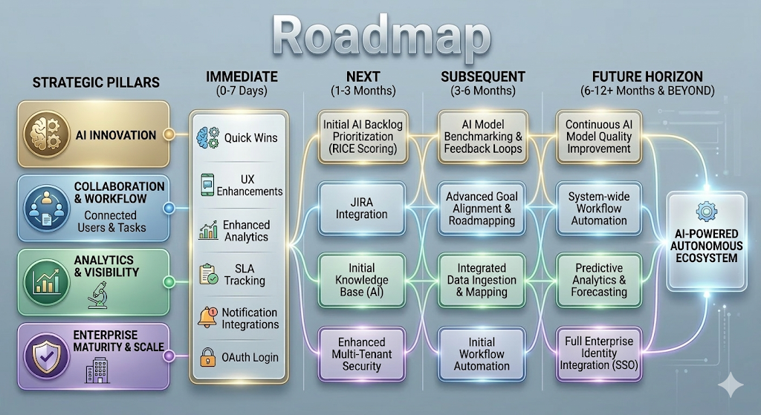

1. Short-Term Improvements (Within 7 Days)
These are quick-win enhancements that can rapidly improve usability, intelligence, and operational visibility.
AI Quick Wins
- Deep Issue Intelligence at Scale
Analyze high-volume task data (for example, 1,000+ tasks across teams over 1–2 months) to detect duplicate issues, identify root-cause clusters, and group related tasks.
The system can also generate consolidated prevention recommendations, reduce repeated work and improve overall efficiency.
- Dependency Intelligence
Automatically detect dependencies between tasks, teams, and services, helping teams better plan releases and avoid blockers.

User Experience
- Mobile-Friendly UI
Improve interface responsiveness to ensure the platform works seamlessly across mobile devices and tablets.
- Add more fields to task management system and make it more attractive
- Dynamic Screen Customization
Allow users to add, remove, or rearrange fields on screens without development changes.
Smart Reporting
- Enhanced Analytics Dashboards & SLA Tracking
Provide actionable insights into team performance, bottlenecks, and service-level compliance.
Notifications
- Notification Integrations (Email / Chat)
Send timely alerts, task updates, reminders, and status changes across multiple channels to improve collaboration.

Authentication & Security
- OAuth Login (Gmail / Facebook)
Enable users to sign in using commonly used accounts, simplifying user onboarding and authentication.

2. Long-Term Roadmap (include 7 Days also)
These improvements focus on enterprise scale, AI automation, integrations, and governance capabilities.

Authentication & Security
- SSO / Enterprise Identity Provider Integration
Enable seamless login through enterprise identity providers for centralized access management.
- OAuth Login (Gmail / Facebook)
Provide additional authentication options to simplify access and onboarding.
- Stronger Multi-Tenant Isolation
Implement improved architecture patterns to ensure secure data separation across organizations.

Analytics & Insights
- Advanced Analytics Dashboards & SLA Tracking
Offer deeper insights into team productivity, workflow bottlenecks, and compliance with service levels.
- AI Model Quality Benchmarking & Feedback Loops
Continuously evaluate AI predictions, measure accuracy, and improve model performance through feedback.
- Roadmapping & Goal Alignment
Link tasks, features, and epics directly to organizational goals to support strategic planning and prioritization.
- Smart Reporting with Completion Metrics
Generate reports at different organizational levels with progress tracking and completion percentages to improve accountability.

AI & Automation
- Deep Issue Intelligence at Scale
Automatically analyze large datasets of issues to identify patterns, root causes, and opportunities for prevention.
- Automatic Backlog Management & Prioritization
Use AI scoring models such as RICE (Reach, Impact, Confidence, Effort) to prioritize backlog items and reduce manual grooming effort.
- Dependency Intelligence
Detect dependencies across teams and services to improve planning and coordination.
- AI Knowledge Base Generator
Automatically generate knowledge articles based on recurring issues, resolutions, and patterns.
- AI Engineering Productivity Insights
Provide insights into development efficiency, cycle time, and delivery performance.
- AI Workload Balancing
Recommend balanced task distribution based on team capacity and workload trends.

Integrations & Data Ingestion
- Integration with External Tools (JIRA, etc.)
Synchronize tasks and workflows with widely used tools such as JIRA, enabling cross-platform collaboration.
- Data Ingestion & Field Mapping
Import tasks and operational data from external systems and map them to internal schemas for analysis and reporting.

Communication & Collaboration
- Notification Integrations (Email / Chat)
Send automated alerts, reminders, and updates to ensure teams remain aligned and informed.

UI / UX Enhancements
- Rich UI/UX Improvements
Provide modern, intuitive interfaces for improved usability and navigation.
- Dynamic Screen Customization
Allow users to add, remove, or rearrange fields on screens without development changes.
- Task Visualization & Interactive Boards
Provide visual representations of tasks, dependencies, and workflow stages to simplify planning and tracking.

Scalability & Efficiency
- Performance Optimization
Ensure smooth system performance as data volume and team size grow.
- Automation of Repetitive Workflows
Reduce manual work by automating recurring tasks, approvals, and processes.
- Proactive Resource & Capacity Planning
Use historical data and predictive insights to anticipate workload trends and optimize team allocation.

Workflow Governance & Service Management
- SLA / OLA Management
Allow organizations to define and monitor Service Level Agreements (SLA) and Operational Level Agreements (OLA).
- Smart SLA Alerting
Automatically generate alerts when tasks are approaching or exceeding SLA/OLA thresholds.
- Escalation Workflows
Automatically escalate unresolved tasks to higher responsibility levels when deadlines are missed.
│

