Chapter 24: Tools for Testing Portals
Marlon Pierce, Marcus Christie, and others

Introduction and Overview
In this book we have focused on portable portal frameworks and plugins for building Grid portals, but obviously portability is not magically obtained by simply using Java and standard frameworks. The software pieces themselves must be testable in reproducible, automated ways. Since Grid portals depend on many backend services, and so are never self-contained in a single virtual machine, frequent, regular post-deployment is absolutely essential. Manual tests are insufficient for providing the consistency and reproducibility.

More generally, various forms of testing (regression, white box, black box, and so on) are essential to any project with numerous inter-dependent components. Methodologies such as Extreme Programming have raised unit testing to the level of a fetish, but any project benefits from an extensive set of tests. These may not guarantee that the code is bug-free or the deployment is correct, but automated test suites do provide an island of code stability when problems do arise. Fortunately, a number of frameworks have emerged that support unit tests for Web sites, and these can be easily adapted to Grid portal environments.

In this chapter we begin with an introduction to general concepts in unit testing, but focus on their application to portal containers and portlets. We then discuss in detail two tools that we have found particularly useful: HttpUnit and JMeter. We describe how to create simple tests of installed Web portals using these tools: how to write tests to login to the portal, get proxy credentials, and perform basic Grid operations. We show how to couple HttpUnit with Maven to automate your tests and make Web page dashboard reports that summarize your tests. With JMeter, we can take these tests a step further by simulating stress tests of multiple users.

Non-Java portal developers take note: although HttpUnit and JMeter are both based on Java and related extensions, they can be used to test any portal deployment, since they are based on HTTP and HTML.

Unit and System Testing
Unit testing (also called regression testing) has come to wide attention because of its prominence in Extreme Programming methodologies. A unit test is a supplemental program that calls a piece of your code and checks to see that the output is expected for a particular input. In general, one should develop at least one test for every method in all classes. Unit tests are often subdivided into the following categories:
- White box tests: these are tests that verify the internal workings of a piece of code are correct. These tests require explicit knowledge of the source code for the programming being tested.
- Black box tests: these tests verify only that the outputs of a software object behave as expected for a given set of inputs. The test developer has no knowledge of the internal workings of the code being tested, however.

But what does this mean to portals? Unit testing obviously makes sense for testing entirely local applications, but Grid portals obviously are not typical: our tests must be able to simulate the user’s experience through the Web browser, and we must be able to verify that backend services were invoked properly. More generally, how does one do unit testing in a service-oriented framework?

Portal deployment testing requirements
As can be seen from the architectural discussions in earlier chapters, portal containers and portlets are classic black-box systems. We (as portlet developers) must develop black box tests that verify various portlet modes: edit, help, and view modes all load correctly.

The actual content and functionality of the portlets must be verified. This is typically a mixture of white and block box testing: the backing code, if structured correctly (as discussed in the Chapter on JSF), can be white-box tested, as can well-constructed Generic and Velocity Portlets, but full testing requires sending ActionRequest and RenderRequest parameters to the GenericPortlet’s doView(), processAction() and other methods (or their Velocity equivalents). We will discuss how to do this in this section.

In this Chapter, we will focus on two “white box” testing tools, HttpUnit and JMeter. Both of these projects, while written in Java, work by emulating Web browsers, so we may use them to test both Java and non-Java portals. We also don’t need explicit knowledge or access to the portal’s source code. Finally, both of these tools allow us to perform functional test that combine many linked, dependent smaller tests, allowing us to verify that our entire portal deployment works as expected.

Using HttpUnit
HttpUnit is free software available from [HttpUnitSite] that implements several useful unit testing methods together with classes for connecting to HTTP servers, processing HTML, and maintaining stateful sessions. We review these capabilities here, but more extensive examples for Grid portals can be found in from the Open Grid Computing Environments project web site [OGCE].

Extended example using portal login and Grid tasks
HttpUnit is best understood by looking at a programming example. We will start by demonstrating how to connect to a portal server and login to a portal container (such as GridSphere or uPortal). We will discuss how to compile this (including required jars) later in the section on Maven. Place the code listings below in a file called BaseTestCase.java. We will extend it later with other test classes.

Begin as usual with your imports (shown explicitly since that is good practice) and a constructor.

import junit.framework.TestCase;
import com.meterware.httpunit.WebConversation;
import com.meterware.httpunit.WebResponse;
import com.meterware.httpunit.WebForm;
import com.meterware.httpunit.WebImage;
import com.meterware.httpunit.WebLink;
import com.meterware.httpunit.ClientProperties;
import com.meterware.httpunit.Button;

public class BaseTestCase extends TestCase {
String portalUrl;
public BaseTestCase(String TestName) {
super(TestName) ;

// Do any additional initialization you want.
portalUrl=”http://localhost:8080/uPortal”;
}
//Test methods will go next.
}

As typical with JUnit tests, we will need to extend the TestCase class and will use reflection to run our tests. The String parameter “TestName” in the constructor is simply used to name the test. As indicated in the comments, you will probably also want to initialize your test case from a properties file, passing in parameters such as the URL of your portal server.

As we discussed in earlier chapters, one of the hallmarks of a portal the login step, so we’ll next add a method to do this to our BaseTestCase class. The code for doing this is shown below. Note that parts of this code are very specific to uPortal and will need minor modifications for other portlet containers. We will draw attention to these uPortal-specific sections in our discussion below.

public WebConversation loginToPortal()
throws Exception {

//WebConversation objects are the cornerstone class.
WebConversation wc = new WebConversation();

//We will need to specify the user agent to simulate
//a browser.
ClientProperties cprops = wc.getClientProperties();
cprops.setUserAgent("Mozilla/5.0");

WebResponse resp = wc.getResponse(portalUrl);

// Find the login form.
// It's not named so we pick it out of an array
String frontPage = resp.getText();

//First make sure we are looking at the right web page.
assertTrue("Failed to get front page",
frontPage.indexOf("Please Login") != -1);
WebForm form = resp.getForms()[1];
assertNotNull("No login form found", form);

// Fill in form and submit
form.setParameter("userName", “admin”);
form.setParameter("password", “admin”);
form.submit();

// Get logged in page
WebResponse resp2 = wc.getCurrentPage();
String page = resp2.getText();
assertFalse("Failed to log in",
page.indexOf("Please Login") != -1);
return wc;
}
There are several things to notice about this code. First, we must construct a WebConversation object. This is the basic “cornerstone” class of the HttpUnit API and give us access to the other useful methods (described below). It will also take care of cookie maintenance, so when we issue subsequent post-login requests, the portal will remember us.

Next, before we go on with the login, we have to trick the portal server into thinking that the request comes from a regular Web Browser, so we must set the HTTP User Agent attribute to “Mozilla/5.0” or similar. This is a known requirement for uPortal 2.4 series and may be required for other portal servers as well.

We next connect to the portal server and establish a session. This is done with the WebConversation object’s getResonse() method. The value of the variable “portalUrl” should be something like “http://localhost:8080/uportal” or “http://your.remote.host:8080/gridsphere”. The returned WebResponse object gives us access to the

This also brings us to our first actual unit test: we want to verify that we have actually connected to the server, have gotten a meaningful response and have not gotten an error message. The simplest way to do this is to inspect the returned HTML for key pieces of text, and to also verify that the HTML contains no known error messages (such as HTTP error codes). The WebResponse’s getText() method gives us access to the entire HTML of the returned page as a single String. We can then use standard Java String methods to check for the presence of expected strings. This is done with the assertTrue() method that our class inherits from the TestCase parent. These tests may be very portal container specific (we have chosen uPortal for our examples), so you should consider using property settings to set the test messages for specific containers.

Next, we need to get access to the <form> elements of the returned Web page. The getForms() method does this, returning an array of all form elements. We are next faced with the problem of finding the WebForm element that corresponds to the one that we want. As we shall show later, portlet forms can be easily processed by adopting naming conventions for their retrieval, but we don’t have any such control over the parent container. This is best handled by inspecting the HTML returned by the WebResponse.

Once we have found the actual login form, we set the required input parameters. These again are container-specific: “username” and “password” are field names from the uPortal login page’s <input type=text> and <input type=password> input fields. After setting this parameters, we call the submit() method for the form object. The WebConversation object is then used to get the resulting page. We are then ready to make additional unit tests on this returned page. As shown in the code above, we can test false as well as true assertions: we want to verify that we did not get a “failed login” message in the returned HTML. The text of the test is again container specific.

We’ll see how to run this test below in the section on Maven.

Getting a Proxy Credential
In earlier chapters, we reviewed several different ways of acquiring a Grid proxy credential, which is the first step before using Globus-based Grid services. We also discussed how to deploy this portlet into GridSphere and uPortal containers. All of these portlets must be session-based to keep them distinct for individual users, which may be done very simply by putting it behind a login page.

We can build up a test for this as follows. Let’s start with a new test class, MyProxyTestCase, that will extend our BaseTestCase above. This will inherit our loginToPortal() method as well as all the JUnit test methods.

public class MyProxyTestCase extends BaseTestCase{
String portalUrl;
public MyProxyTestCase(String TestName) {
super(TestName);
portalUrl=”http://localhost:8080/uPortal”;
}

public testProxy() throws Exception {
//First, login to the portal.
WebConversation wc=loginToPortal();

// Go to "Proxy Manager" tab
WebResponse resp = wc.getCurrentPage();
WebLink pmLink = resp.getLinkWith("Proxy Manager");
assertNotNull("No Proxy Manager link/tab", pmLink);
pmLink.click();
WebResponse pmPortlet = wc.getCurrentPage();

// Select the "Get New Proxy" button and click
WebForm[] forms = pmPortlet.getForms();
assertNotNull("No forms on page", forms);
assertFalse("No forms on page", forms.length == 0);
for (int i = 0; i < forms.length; i++) {
Button[] buttons = forms[i].getButtons();
if (buttons != null && buttons.length > 0) {
for (int j = 0; j < buttons.length; j++) {
if (buttons[j].getValue().equals("Get New Proxy")) {
buttons[j].click();
break;
}
}
}
}

// Fill in myProxy form and submit
WebResponse pmPortlet2 = wc.getCurrentPage();
int pmFormIndex = 1;
WebForm myProxyForm= pmPortlet2.getForms()[pmFormIndex];
assertNotNull("Can't find MyProxy form", myProxyForm);
myProxyForm.setParameter("hostname", props.getProperty(MYPROXY_SERVER,
"rainier.extreme.indiana.edu"));
assertEquals("7512",
myProxyForm.getParameterValue("port"));
myProxyForm.setParameter("username",
props.getProperty(MYPROXY_USERNAME));
myProxyForm.setParameter("password",
props.getProperty(MYPROXY_PASSWORD));
myProxyForm.submit();

WebResponse pmPortlet3 = wc.getCurrentPage();
//System.out.println( pmPortlet3.getText());
assertFalse("Proxy failed to load",
pmPortlet3.getText()
.indexOf(props.getProperty(MYPROXY_DN))
== -1);
return wc;
}
}
}

The credential acquisition step shown above will be required by all Grid actions, so let’s add a new method to our BaseTestCase class that implements both the loginToPortal()method and the credential acquisition. Let’s call the method loginPlusProxy(). This method should be identical to the testProxy()method above, so we don’t repeat the code here. The only difference between the two methods is that loginPlusProxy()should return a WebConversation object, which gives us access to the current state of the remote server. This will be needed by the subsequent tests.

Testing GRAM Job Invocation Portlets
Now that we have written a unit test that gets a credential through the portal, let’s use the credential to submit a job. As with the proxy credential test, this works indirectly: we verify that the portlet correctly returns expected HTML content that indicates the job has returned an expected response (standard output of the remote application, for example) and does not return known error messages.

We assume in this example that you have written a Job Submission portlet. Examples for doing this are described in other chapters. For our purposes here, we don’t need to worry about the code for submitting the job to a remote service like the Globus GRAM so much as the Web form used to collect information from the user.

From the MyProxy example in Section 2.2, we actually have all the background information that we need to write this unit test, so we will not provide specific code but instead outline the steps.
- Extend the BaseTestCase class so that you inherit loginPlusProxy().
- Write a test case (testRunCommand()) that first calls the loginPlusProxy() method. This returns a WebConversation object.
- The test method then uses the WebConversation object to navigate to your Job Submission form. Use assertions to make sure that your job submission page is loaded correctly.
- From the job submission page (represented as a WebResponse object), get the submission form as a WebForm object.
- Set all form parameters using the WebForm setParameter()method. These will typically be the name of the executable to run, the location of the remote host, executable arguments, and similar parameters.
- Submit the form with the WebForm’s submit() method.
- Using assertions, test to make sure that no known errors are reported in the returned portlet content and that the portlet content otherwise looks as expected.

Typically, the job execution for even simple remote UNIX commands will take a few seconds, so it useful to add a second test method that checks to see that the job has been completed successfully. As described in other chapters, portlets built with the Java COG Kit provide a mechanism for monitoring that status of remote jobs. This job status may be reported back to the user through the portlet content. These portlets can also return standard output from the remote command back to the portlet for display.

Both of these methods can be adapted to test the successful completion of the remote command: simply write an additional test that inspects the HTML content of the monitoring portlet. This test should include assertions that both test for expected results (such as “job completion” messages) as well as known failure conditions. This test should allow the remote job sufficient time to complete. The simplest way to do this is by polling: write your test so that it reloads your monitoring page and resubmits the status check a set number of times, sleeping the thread between calls.

One may easily build more stringent job execution tests from the foundations we have given above. Examples also include testing job sequences and workflow executions and testing batch queuing jobs. You may also choose to develop a suite of executable-specific tests for your Grid: these will test not just to make sure that the code is correctly launched, but that the output files match expected results. These executable-specific codes for science applications will quite often depend upon uploading additional data files to the execution host computer. HttpUnit tests for these are covered in the next section.

HttpUnit Tests for Remote File Operation Portlets
Portlets for remotely managing files typically are based (directly or indirectly) on GridFTP operations accessible through client packages like the Java CoG Kit. Minimally, we must test the following capabilities:
- Can the authenticated user, using a Grid certificate, correctly get a listing of remote files on selected computers?
- Does third party transfer (i.e. file transfer between two remote hosts) work?
- Are remote files downloadable to the user’s desktop?
- Can files be uploaded from the user’s desktop to a remote host?

Basic File Operation Testing
The HttpUnit testing procedure for the first test should be familiar by now: you should write a test that starts with the loginPlusProxy()method and navigate to the File Operation portlet. Specify any form parameters (such as the remote host to contact and the remote directory to load) and submit. Test to verify that the remote directory listing is correct and that no common error messages are returned. All of this can be done with techniques we have covered above.

Similarly, testing third party transfer (a GridFTP capability) can be done with techniques previously described. Implementing this in portlets is described in Chapter XX. Testing is simply a matter of verifying through the user interface that the file listings of the destination host are correctly updated.

File Download Testing
File download portlets typically are implemented as popup windows. A user clicks the link of the desired remote file. Since we don’t want this to override the current browser window, we instead direct the output to a popup. This may be done, for example, using

<a href=”[the download action]” target="_blank">MyFile.out</a>

As described elsewhere, the download action is a portlet method for getting the remote file and writing it to the response stream. The details of this are not important here, but we do need to know how to write our test so that it moves to the popup window and inspects the response stream. Luckily, HttpUnit provides convenient methods for this:
- After navigating to your file download portlet using (by now) familiar techniques, use a WebLink object to click the MyFile.out link.
- The newly opened window is available from the WebConversation object using the WebWindow object. WebConversation will actually return an array of WebWindow objects. The main portlet browser window will have an index 0, and the newly opened window will have index 1.
- Get this window’s WebResponse object.
- The WebResponse will include your downloaded file, which you can inspect. Useful methods here include the HTTP header elements, accessible through WebResponse’s getHeaderFieldNames() and getHeaderField() methods. Fields like Content-Disposition, Content-Type, and Content-Length are useful checks. The file itself can be inspected through the java.io.InputStream.

The following code fragment illustrates how to program the above steps in your unit test.

//Get the proxy as usual.
WebConversation wc = loginPlusProxy();
...

// Find a file name and click on its Download link.
// findTheLink() is a local method for looping through
// the WebLinks[] array.
WebResponse resp = wc.getCurrentPage();
WebLink[] allLinks = resp.getLinks();
WebLink downloadLink = findTheLink(allLinks);
downloadLink.click();

// Get access to the popped up window.
// Check the headers for
// the filename.
WebWindow[] openWindows = wc.getOpenWindows();
WebResponse resp2 = openWindows[1].getCurrentPage();
String header = resp2.getHeaderField("Content-Disposition");
assertTrue("Filename not present in header field",
header.indexOf(“MyFile.out”) >= 0);

Additional assertions can test that the content is as expected.

File Upload Testing
File upload typically is done in two stages: the file is uploaded first to the portal server and then to the selected remote computer. The browser-to-portal stage makes use of the browser’s file browser and upload popup box.

<form name="upload1" action="..."
enctype="multipart/form-data" method="post">
<input type=”file” name=”uploadfilename”>
...
</form>

HttpUnit supports this through the WebForm class’s isFileParameter() method. The code for testing the upload is

//Login and get the proxy credential.
WebConversation wc = loginPlusProxy();

//Navigate to the File Operation page and get the form.
...
WebResponse resp = wc.getCurrentPage();
WebForm uploadForm = resp.getFormWithName("upload1");

//Do the file upload.
assertNotNull("\"upload1\" form not found", uploadForm);
assertTrue("Missing file upload parameter", uploadForm.isFileParameter("uploadfilename"));
uploadForm.setParameter("uploadfilename", uploadFile);
uploadForm.getSubmitButton("actionMethod_doUpload")
.click();

This will test the file upload. You must next write assertion tests to make sure that the file shows up correctly on the remote host’s file listing, but this can be done with techniques that we have covered earlier. The specific unit test code will depend upon the HTML of your portlet.

One common issue is that you need to make sure that your uploaded file (or a file of the same name) is not already on the remote host. Typical techniques for doing this include using a fixed file name and deleting it on the remote host before testing the upload, creating a unique file name on the client, and creating a unique destination directory name on the remote host. The java.io.File createTempFile() static method is a useful utility for making unique file names. You may also use time-honored technique of appending a time-stamp (from the java.util.Date getTime() static method) to the file or destination directory name.

Running HttpUnit Tests with Maven and Ant
As we have discussed in previous chapters, Apache’s Ant and Maven projects provide many useful command-line build and deployment tools. We have advocated the use of Maven in several examples since it conveniently encapsulates many common compilation, packaging, and documentation generation steps into individual goals. Maven’s trump card, however, may be it’s easy integration of JUnit and HttpUnit tests into your source distributions.

In our previous sections in this chapter, we have provided some starter examples for writing tests for several different types of portlets (Grid credential retrieval, job submission, and remote file operations). In Chapter 14, “Writing a Portlet”, we showed how to write a basic portlet for retrieving a proxy credential and also showed how to organize our build process with Maven.

Our test code for our Grid credential portlet can also be placed in the Maven directory structure. In your portlet’s /src/ directory, add a child called /src/test/ (to accompany /src/java/ and /src/webapp/). Place your Java test code here and then configure Maven to find it.

Our test code depends upon two third party jars to support JUnit and HttpUnit, so add these to your project dependencies:
<dependency>
<groupId>junit</groupId>
<artifactId>junit</artifactId>
<version>3.8.1</version>
<type>jar</type>
</dependency>
<dependency>
<groupId>httpunit</groupId>
<artifactId>httpunit</artifactId>
<version>1.6</version>
<type>jar</type>
</dependency>

Note we don’t need to include either of these in our WAR bundle, so we omit the <war.bundle>true</war.bundle> property.

We have one additional configuration property: we don’t actually want Maven to run our HttpUnit tests during the build process, since these tests are actually deployment tests. We instead want to build first, fire up our portal, and then run the tests. Set the Maven property maven.test.skip=true initially to avoid running the tests, then change this property to “false” to run the tests. Put this property in your project.properties file or set it on the command line with the –D option.

You can now run your tests and generate HTML dashboard reports with the command

[unix-shell> maven junit-report:report
[unix-shell> maven xdoc

The second command will create an HTML dashboard page showing the results of your tests. Find this page in your project’s /target/docs directory.
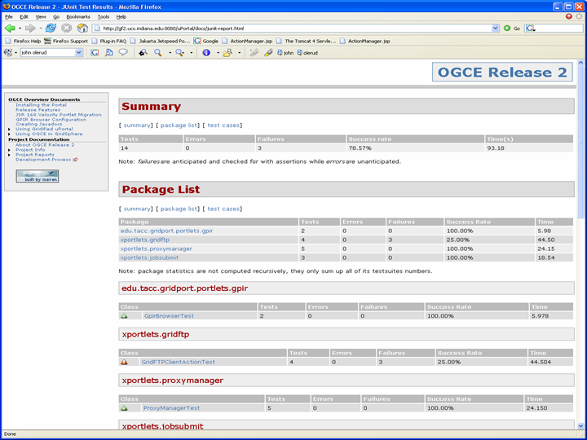
Figure 1 Maven's xdoc goal can generate dashboard reports of unit tests.

You may also choose to copy the generated HTML pages from Maven’s /target/ directory to a web server. These tests may be easily run offline using scheduling tools like UNIX’s cron command.

Apache Ant partisans can also take heart: Ant’s <junit> task also works with HttpUnit tests and also has an HTML report generator, <junitreport>. To use these optional tasks, place junit.jar and httpunit.jar in the ${ANT_HOME}/lib directory. A simple build script example is shown below:

<target name="junittest">

<!-- Run the tests as a batch -->
<junit printsummary="true"
errorProperty="test.failed"
failureProperty="test.failed">

<!-- Set the classpath -->
<classpath>
<fileset dir="${basedir}/lib">
<include name="*.jar"/>
</fileset>
<dirset dir="./classes"/>
</classpath>

<!-- Create both text and XML formatted reports -->
<formatter type="plain" usefile="false"/>
<formatter type="xml"/>

<!-- Run all tests -->
<batchtest todir="${report.dir}">
<fileset dir="classes">
<include name="**/Test*.class"/>
</fileset>
</batchtest>
</junit>

<!-- Generate reports -->
<junitreport todir="${report.dir}">
<fileset dir="${report.dir}">
<include name="TEST-*.xml"/>
</fileset>
<report format="noframes" todir="${html.report.dir}"/>
</junitreport>

<!—- The test set failed -->
<fail message="Tests failed." if="test.failed"/>
</target>

This simple target runs all the tests in the fileset using the <batchtest> element and formats the reports in both text and XML. The latter can then be transformed to HTML using the <junitreport> task. The <batchtest> element has the advantage that it won’t exit on failure of one test. It will run all tests and report all successes, failures, and errors.

JMeter testing
HttpUnit tests provide a useful way to verify that your portal is initially deployed and running correctly. The testing framework’s integration with both Apache Ant and Maven makes this useful for initial testing, and it is also a useful way to verify that your entire Grid is running and working correctly.

The HttpUnit advantages are strong enough for you to use them, especially if you are preparing download packages for other users. However, HttpUnit has some drawbacks.
- It is not designed for load testing of many simultaneous users.
- It is tedious to write the code for a comprehensive set of unit tests, or to customize tests to a local deployment.
- Test assertions are ultimately based on matching text content using Java Strings, but it would be better if we could easily compare the entire browser response to a complete expected page.
These drawbacks don’t disqualify HttpUnit (or similar) testing, but they do mean that we must supplement them with other tools. The Apache JMeter is one such tool that we have found useful.

JMeter overview
JMeter is an interactive, extensible Java-based testing engine for Web applications. It provides a graphical desktop user interface and uses XML to script tests. These latter two attributes contrast with HttpUnit since they allow a user (even one without Java programming proficiency) to develop, modify, and run tests. The XML scripts can be exported and shared with other JMeter users. JMeter’s other hallmark is its ability (through multiple threads) to simulate heavy usage loads on Web sites and portals.

As we shall see in the next section, JMeter has a unit test-like structure similar to HttpUnit: it allows us to make assertions about the content of the entire HTML page. One can easily set up JMeter to verify that returned pages match exactly the expected HTML. This greatly improves the reliability of HTML-based tests.

A full description of JMeter is available from [JMeterSite]. Our purpose here is to demonstrate how to use it in conjunction with portlet-based Grid portals and compare it to HttpUnit, but interested readers may want to examine additional capabilities, such as Web Service testing and plugin extensions.

JMeter can be downloaded and installed as described at [JMeterSite]. To start the user interface, simply use $JMETER_HOME/bin/jmeter. You are now ready to create a test plan.

Building JMeter Test Plans for Logging In
Let’s get started now by setting up a JMeter test plan. This is can be used initially to script an interaction with the portal, after which we can apply stress tests and measure performance. Our first step is simply to point our JMeter test client at the portal and login. After starting the JMeter client and clicking “Test Plan” in the upper left corner, you should see the following screen.

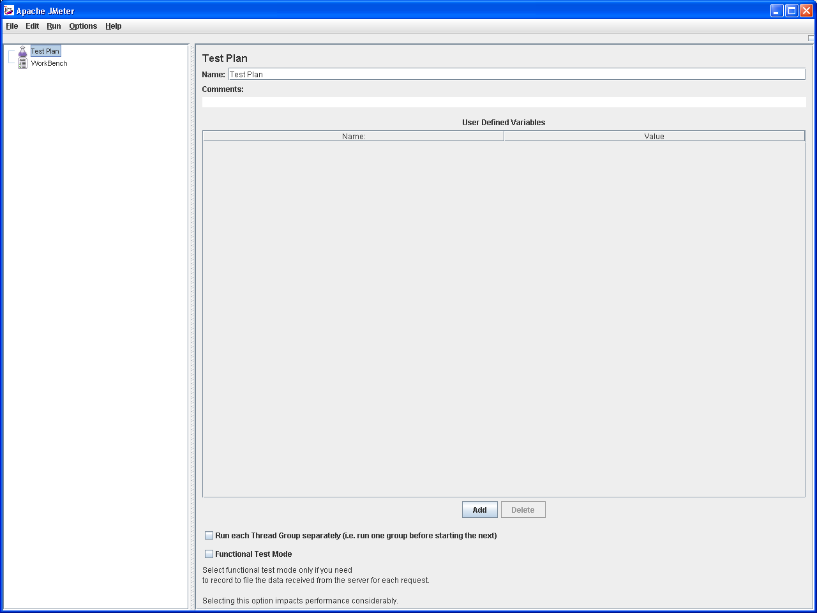
Figure 2 The JMeter Console.
We are now ready to add components to our plan. We’ll start as usual by logging into our portal. We’ll anticipate things a little by starting with a thread group. Click the “Edit” option and add a “Thread Group”. The thread group’s default values (Figure 3) are fine for now.

Next, add components to your test group: click “Edit->Add-Config Element” to see a list. We’ll start with “HTTP Header Manager”, “HTTP Request Defaults” and “HTTP Cookie Manager”. The former will be useful for our requests, and the latter is needed to maintain state between the JMeter test client and the remote portal. Sample values are shown in Figures 3 and 4. The HTTP Header Manager is required by any container, such as uPortal, that detects the “User-Agent” field of the incoming request and bases it’s response on this value. This value is not set by JMeter by default, so we uPortal (for example) will return an error: it will not recognize JMeter as a known browser type. Set this value to “Mozilla/4.0” to simulate a standard browser.

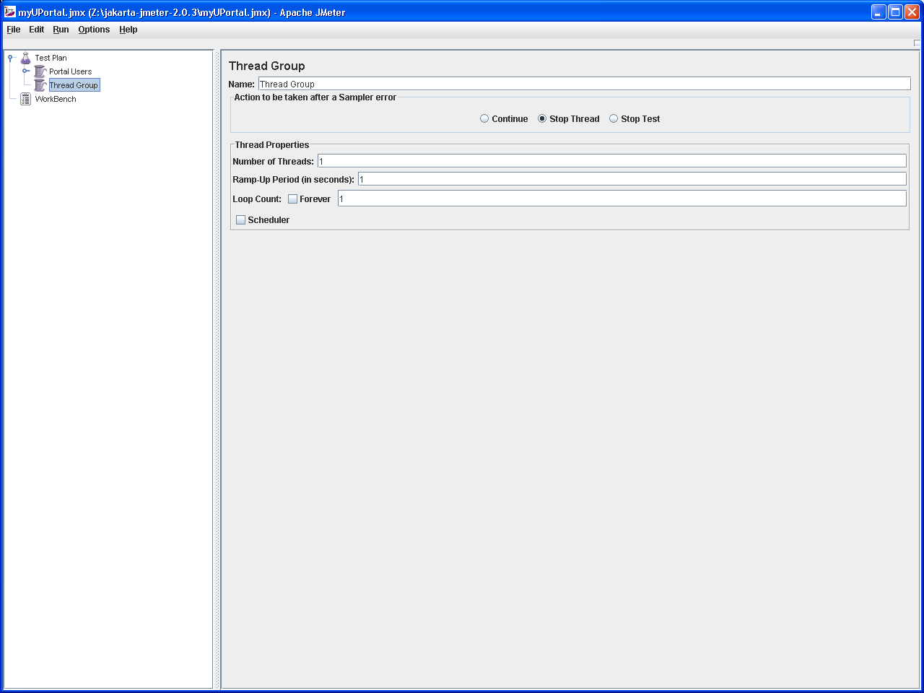
Figure 3 The Thread Group collects related tests.

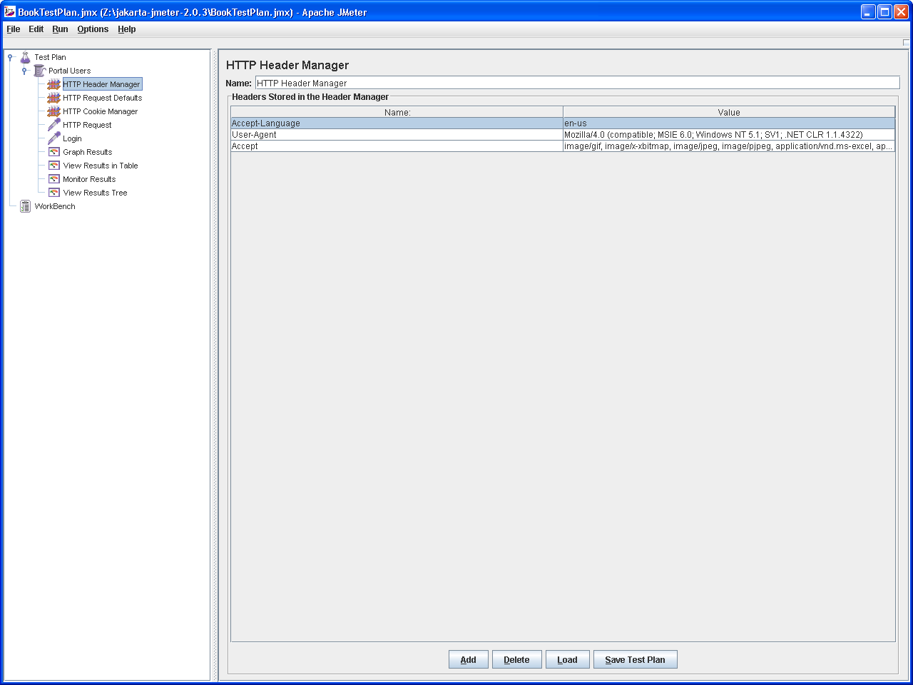
Figure 4 JMeter HTTP Header Managers are needed to connect to some portal containers.
Finally, add two HTTP Requests that will connect to the portal and run the login process Do this by clicking “Edit->Add->Sampler->HTTP Request” from the top left menu. Edit these parameters to values similar to those shown in Figures 5 and 6. Create two requests: the first (“Load Portal”) should simply point to the portal, and the second (“Login”) should send the login parameters. In particular, you should specify the “Path” parameter to point to the login page. For uPortal, the full path may be something like

http://gf2.ucs.indiana.edu:8080/uPortal/Login

JMeter’s “Path” element is the relative part of this URL: /uPortal/Login. You may also need (depending on the container) to select the “Follow Redirects” checkbox. This is required for uPortal.

You should also specify the login parameters to use. These can be determined by inspecting the HTML source of the login page and will be dependent on the portal container that you use. Simply look for the <FORM> element’s <input> parameters in the login page’s source. For uPortal, for example, these are “Login”, “username”, “password”, and “action”. Provide also values for these parameters. For example, the uPortal username and password parameters for the portal administrator are “admin” and “admin”. See Figures 5 and 6.

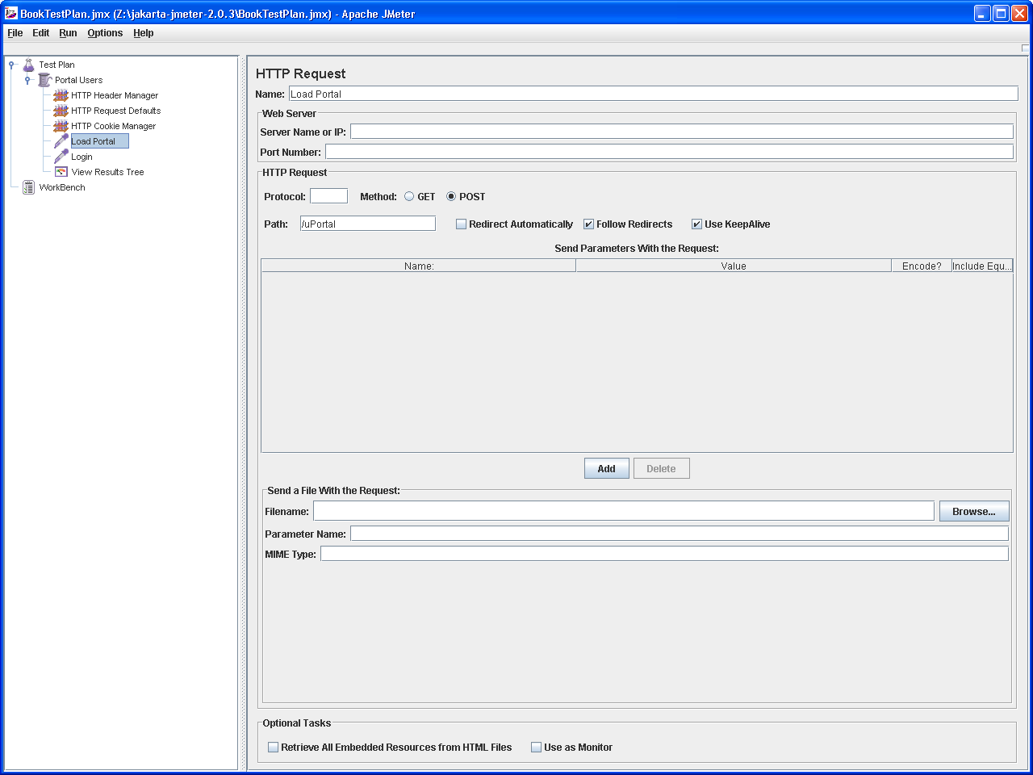
Figure 5 Set the JMeter HTTP Request defaults to point to your portal server.
Finally, you can add JMeter Listeners to your test plan. These will allow you to check the results of your test plan. We’ll use “View Results Tree” for our first test plan.

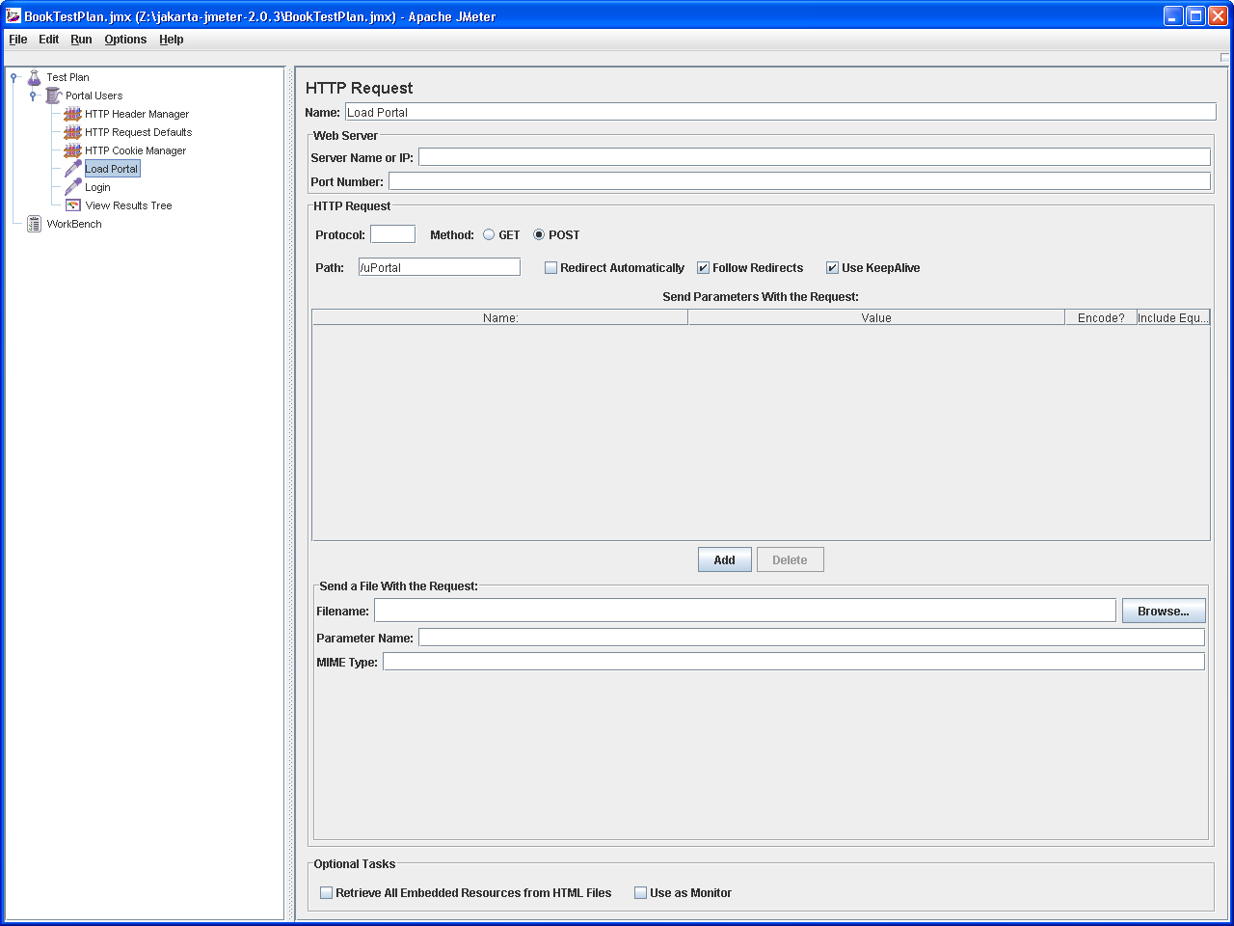
Figure 6 Use the HTTP Request object to specify the login page's path and request parameters.
You are now ready to run the test plan. Click “Run->Start” and click “View Results Tree” to see results. JMeter will not otherwise tell you that the test is running or has completed, so in general use listeners to monitor progress. A successful test execution should resemble Figure 7. The “View Results Tree” is obviously helpful here since you can check the actual HTML sent in response to your queries.
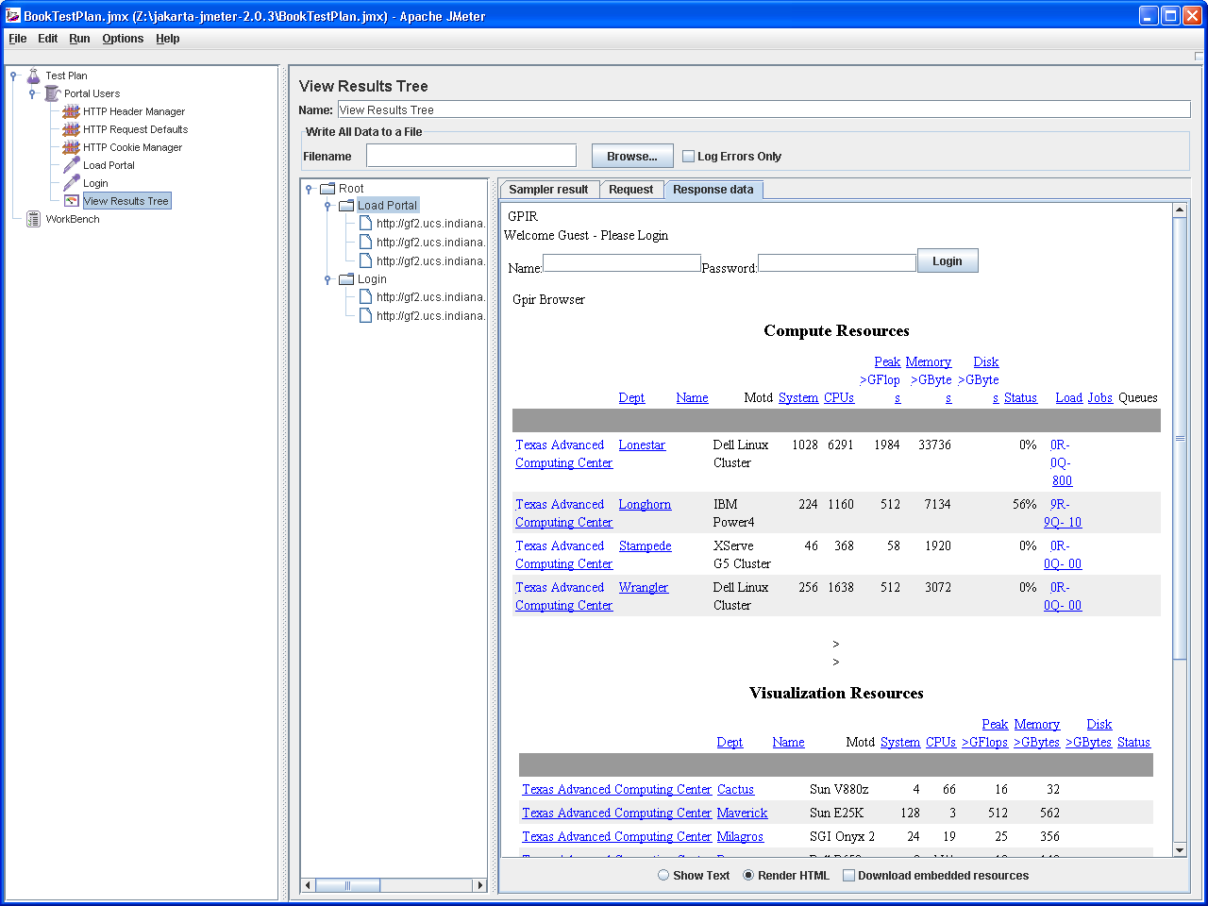
Figure 7 View the results of your test plan's execution.

Using JMeter as an HTTP Proxy Server
Setting up JMeter’s HTTP Request pages can require a lot of trial and error as you attempt to decipher your container’s redirections, input form parameters, HTTP Headers, and so on. Fortunately, JMeter can also run as an HTTP Proxy Web Server. In this mode, we must configure our browser to use JMeter as a proxy server. This is browser-specific but is a standard feature on all major browsers. For Mozilla Firefox, you can find the proxy settings under “Tools->Options->General->Connection Settings” from the top menu bar. Assuming you run JMeter on your desktop, set your browser to use “localhost” as the HTTP Proxy, with the port set to 8080.

Next, set JMeter to run as a proxy server. On the left hand menu, click “WorkSpace” and then click “Edit->Add->Non-Test Elements->HTTP Proxy Server”. You should see a screen similar to Figure 8. The default settings are fine, so start the server.

Now point your browser to the portal’s URL and begin interacting with the server: login, navigate different portlets, get Grid credentials, run remote jobs, and so forth. You should see these added to your Test Plan. Note that the JMeter proxy server will capture everything that goes through it, and will treat each image download as separate HTTP Request components, so you will probably want to clean up your test plan to keep it manageable.
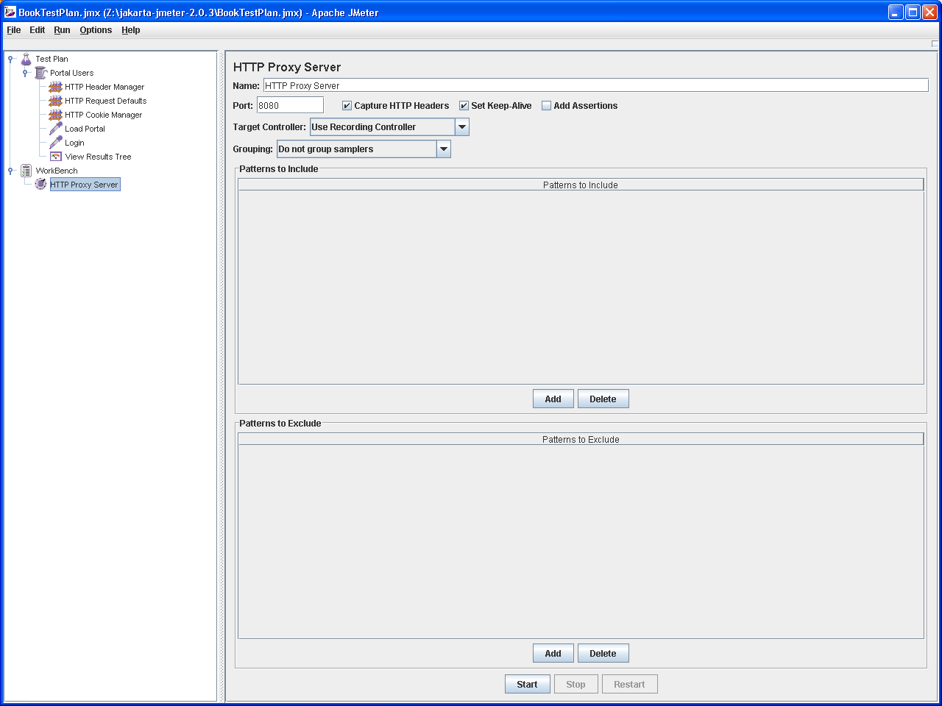
Figure 8 Set up JMeter as a proxy server to capture browser interactions.
Figure 9 shows a sample of the results after some clean up. These will appear automatically in your JMeter window as you navigate your portal with your browser. Add another “View Results Table” at the end of the set and re-run your test. By inspecting these results, you should see your previous browsings repeated. The request object names will correspond to the relative paths of each page that you load.

Used in this mode, JMeter will capture and record all traffic that it proxies, so you will get many more HTTP Requests added to your test plan than you need. Typically these will include separately downloaded images and stylesheets, but you may also find some additional, unexpected requests: the latest Google Toolbars with auto-complete matching is one relatively benign example.

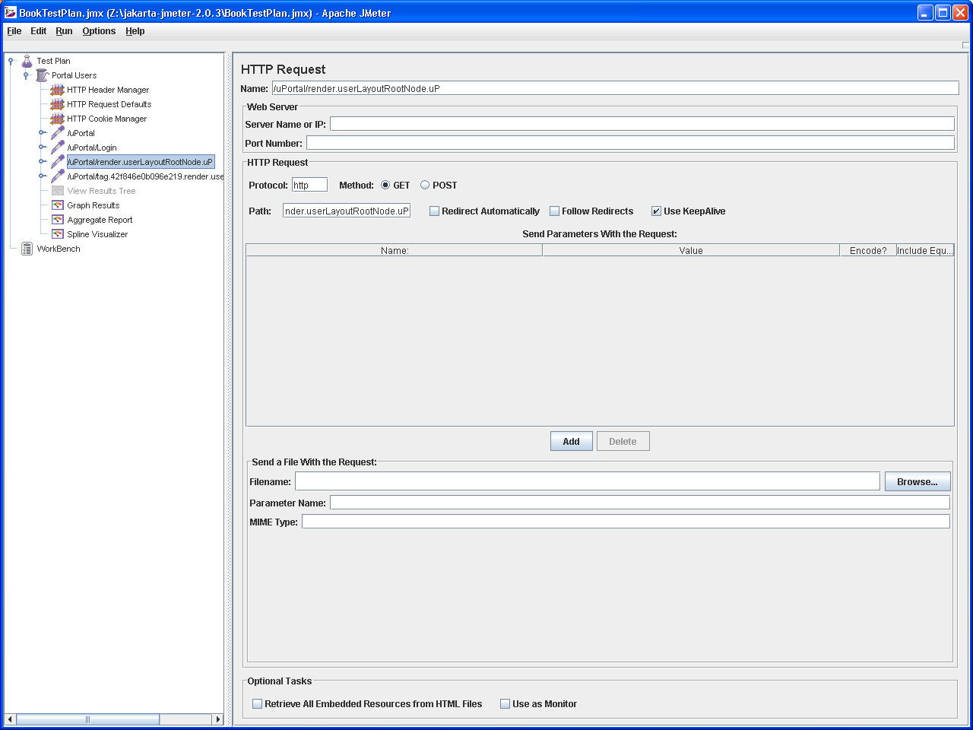
Figure 9 Some captured HTTP Request interactions obtained using JMeter as a proxy server.

Using JMeter to Test Loading and Throughput
In the previous section, we set up a simple test plan for logging into a portal and verifying the results. We may additionally decorate our test plan with test assertions and more complicated interactions, like running remote jobs. We have covered enough of the basics, so these steps are left as exercises for the reader.

Instead, we will quickly cover some useful load testing features. Recall when we created our test plan that we placed it within a thread group, “Portal Users.” Click this link and examine the parameters. By modifying these, we can simulate many simultaneous users of the portal performing the same set of actions. “Number of Threads” is the number of simulated users and “Ramp Up Period” is the total amount of time JMeter will take to start all of our threads. That is, if we choose 5 simulated users with a ramp-up time of 50 seconds, we will start one thread every 10 seconds. You can also set the loop count, or you can choose to let the test run until you stop.

JMeter provides several useful listeners for thread tests, including “Graph Results”, “Aggregate Report”, and “Spline Visualizer”. Graph Results creates some pretty picture plots of the current (i.e time evolving) average response time, response standard deviation time, and throughput. This last measures the rate at which requests/responses are actually handled. Sample results are shown in Figure 10 for five simultaneous users, separated by one second, contacting a uPortal 2.4.2 portal running on a Tomcat 5.5.9 server on a Linux host on the same subnet. These settings are typical recommended values for modest production servers. You may want to experiment with other settings to find the optimum values.

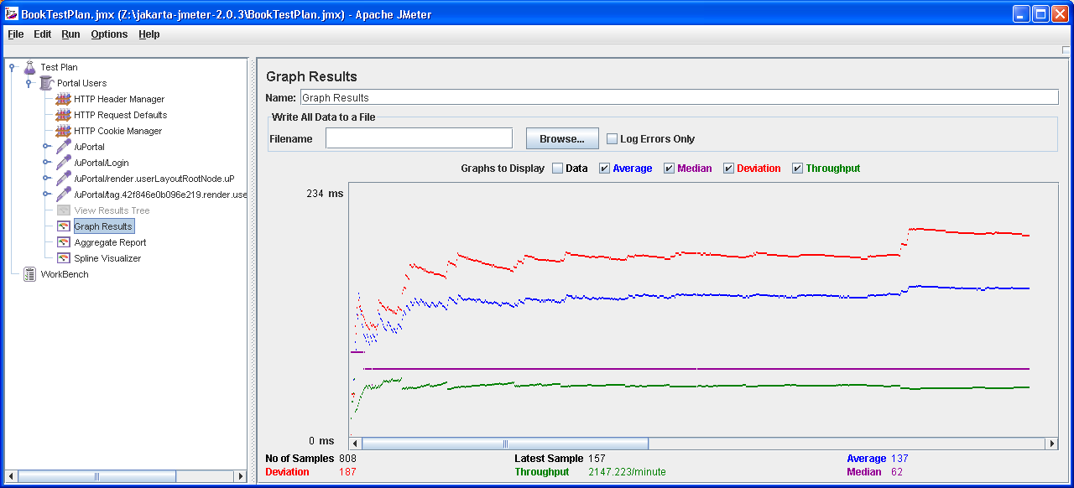

Figure 10 Sample graph results of average request times, standard deviations, and throughput.
It may take a few iterations for your tests to reach a steady state, so you may find it useful to clear the displays occasionally (under the “Run” menu). The graphed results may be supplemented by the tables in the “Aggregate Reports” listener, which gives a more precise picture of your test results.

Conclusion
We have provided an overview of two general purpose tools for testing Grid portals. As we noted, the main purpose of portal testing is to verify that expected results are returned in the HTTP response.

HttpUnit and JMeter provide complementary testing capabilities. HttpUnit extends the JUnit testing framework, and allows us to develop Java test code that can verify assertions about the HTML content in our test. HttpUnit tests can be integrated easily into both Apache Maven and Ant and is thus an excellent tool for testing portal software builds and releases. Both Ant and Maven have HTML dashboard tools that provide summary reports of test successes and failures.

HttpUnit provides useful verification testing: does the portal nightly build or installation behave as expected? However, what works for a single user may fail for many simultaneous users, so we need to supplement the binary testing of HttpUnit (works/doesn’t work) with the grayer testing criteria of load testing. JMeter is one such load testing tool that can be used to test the breaking point of your portal and dependent services when multiple simultaneous users are logged in and actively using the portal. This is useful when trying to determine if your Java Virtual Machine’s parameters should be tweaked, if Tomcat load balancing tools should be used, if simple in-memory databases like HSQLDB should be replaced with more powerful database software, and so on.

Other Testing Tools
Several other tools are available for software testing. First and foremost for Java programmers is JUnit [JUnitSite]. As we have noted, HttpUnit supplements JUnit by simulating HTTP requests and responses, but if you are following the Java Server Faces development strategy, you can incorporate standard JUnit unit tests into your backing Java Beans. This provides an excellent way to perform “white box” testing.

The Jakarta Cactus project is an extension of JUnit that also supports “white box” testing of server-side code that runs in Tomcat. As with JUnit, Cactus allows us to test our portal code directly, although you should expect integration issues when trying to test JSR 168 portlets.

Although we have emphasized Grid portal testing in this chapter and have pointed out that well written HttpUnit and JMeter tests are excellent, if indirect, ways of testing your backend Grid installation as well as your portal, you should also consider direct Grid testing methods. The Inca project [IncaWebSite] can be used to test, benchmark, and monitor your Grid services.

There are of course numerous testing frameworks and tools that support many different development environments. For a clearinghouse set of links to testing tools great and small, see the XProgramming.com website’s software download page [XPSoftwareSite] for an extensive list.

References
[HttpUnitSite] The HttpUnit Web Site: http://httpunit.sourceforge.net/.

[IncaWebSite] Inca Web Site: http://inca.sdsc.edu/

[JMeterSite] The Apache JMeter Project Web Site: http://jakarta.apache.org/jmeter/

[JUnitSite] The JUnit Project Web Site:

[OGCE] The Open Grid Computing Environments Web Site: http://www.collab-ogce.org/.

[XPSoftwareSite] XProgramming Software Downloads Web Site: http://www.xprogramming.com/software.htm.

