PHASE 5 — PROJECT DEVELOPMENT

INTRODUCTION :
Team ID : SWTID-2026-1655
Team Leader : SAKTHI.M
MAIL ID: msakthi6126@gmail.com
Team members :
NAME | MAIL ID
SAKTHI.M | msakthi6126@gmail.com
SOFIYA.M | sofiyamanikandan2007@Gmail.Com
SUMITHRA.E  SANGEETHA.M | sumithraelumalai172@Gmail.Com  sangeethamurugann01@gmail.com

Development Procedure
- Create the project root folder and src folder.
- Initialize the Node.js project using npm init -y.
- Install Express, Mongoose, dotenv, cors, jsonwebtoken, bcrypt and @google/genai.
- Configure environment variables and MongoDB connection.
- Implement server.js, app.js, authentication middleware and error middleware.
- Implement User and FAQ Mongoose schemas.
- Implement authentication, FAQ and AI routes.
- Run the development server and verify API endpoints.

Implemented API Functions
- POST /api/auth/register — register a user.
- POST /api/auth/login — authenticate a user and return a token.
- POST /api/faqs — create a protected FAQ.
- GET /api/faqs/search?q=configure — search FAQs.
- POST /api/ai/generate-faq — generate an FAQ pair using AI.

Development Evidence
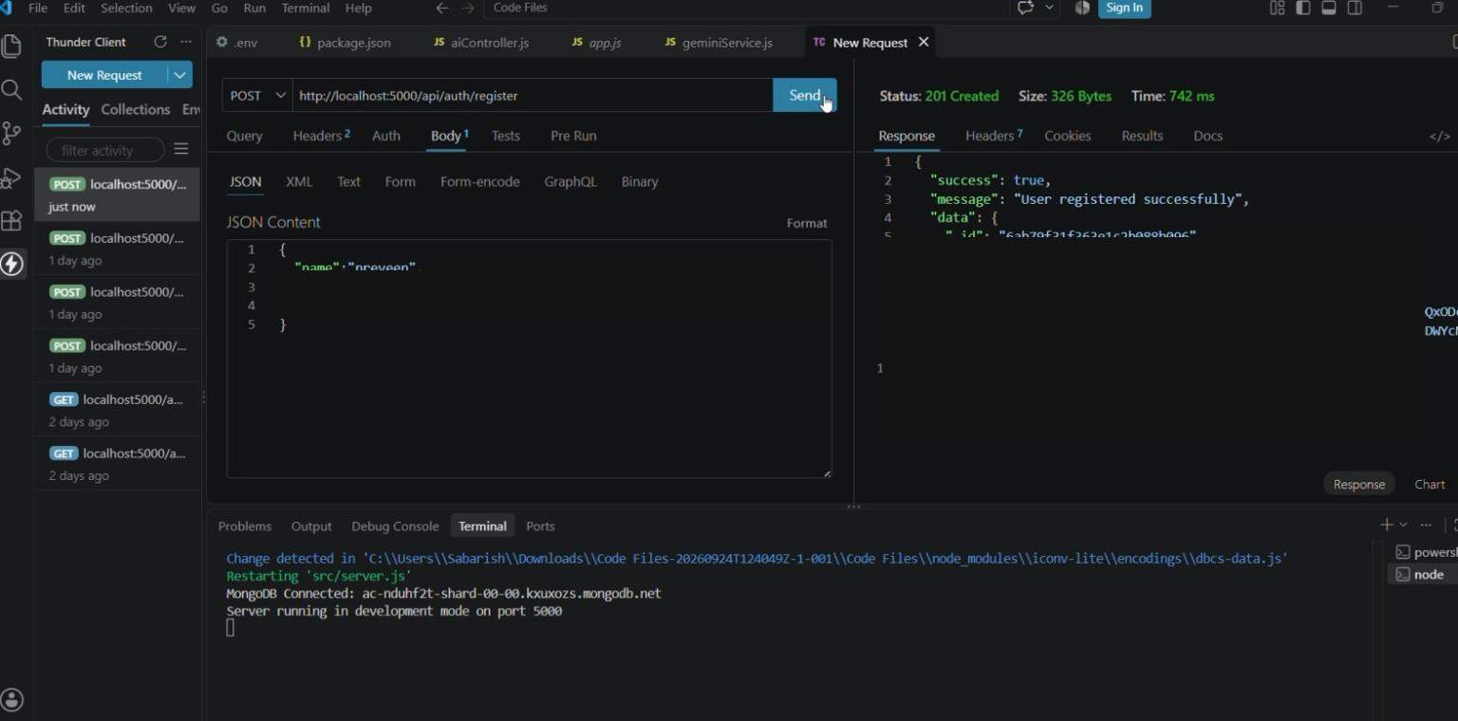
Registration API — 201 Created
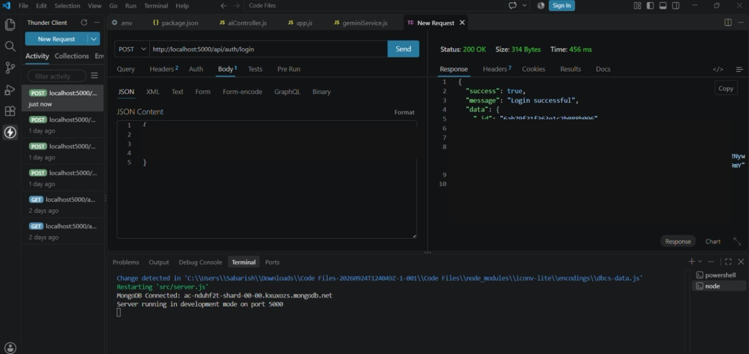
Login API — 200 OK
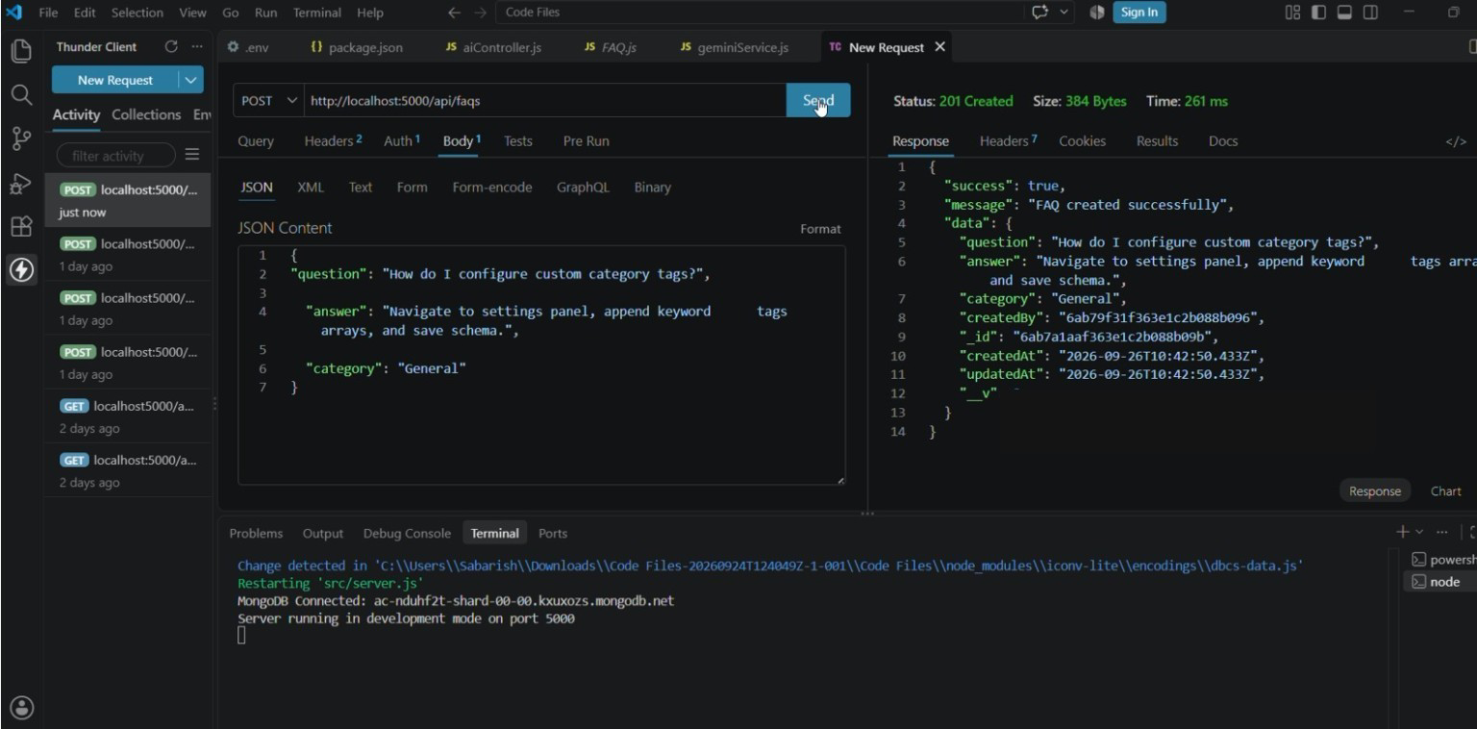
FAQ creation API — 201 Created

