PHASE 7 — PROJECT DOCUMENTATION

INTRODUCTION :
Team ID : SWTID-2026-1655
Team Leader : SAKTHI.M
MAIL ID: msakthi6126@gmail.com

Team members :

NAME | MAIL ID
SAKTHI.M | msakthi6126@gmail.com
SOFIYA.M | sofiyamanikandan2007@Gmail.Com
SUMITHRA.M  SANGEETHA.M | sumithraelumalai172@Gmail.Com  sangeethamurugann01@gmail.co

7.1 Purpose of the Documentation
This phase brings the complete AnswerBot implementation into one readable project report. It records the project idea, requirements, architecture, setup, development, database, API testing, evidence, results and submission information so that another person can understand the project and reproduce the basic workflow.

7.2 Project Overview
AnswerBot is a secure REST API platform for FAQ creation, user authentication, FAQ management, search and AI-assisted content generation. The documented technology stack includes Node.js, Express.js, MongoDB/Mongoose, JWT, bcrypt and Google Gemini AI.
The project addresses repetitive customer-support questions, time-consuming manual answer drafting, FAQ maintenance and controlled access to private documentation.

7.3 Complete Technology Stack
Area | Technology / Tool
Runtime | Node.js v18 or above
Backend | Express.js
Database | MongoDB with Mongoose ODM
Authentication | JWT
Password Security | bcrypt
AI Integration | Google Gemini SDK / Gemini AI
API Testing | Thunder Client / Postman
Development Environment | Visual Studio Code
Configuration | dotenv / environment variables

7.4 Project Architecture & Design Summary
- API tools send requests to the Express server.
- Express routes map HTTP requests to the appropriate controller workflow.
- Authentication middleware validates protected JWT-based requests.
- Controllers/services handle FAQ and AI business logic.
- Mongoose connects the application to MongoDB collections.
- Google Gemini AI is used for automated FAQ generation.
- Centralized error handling provides standardized API responses.

7.5 File and Folder Structure
The following structure represents the project files and folders described in the original AnswerBot documentation.
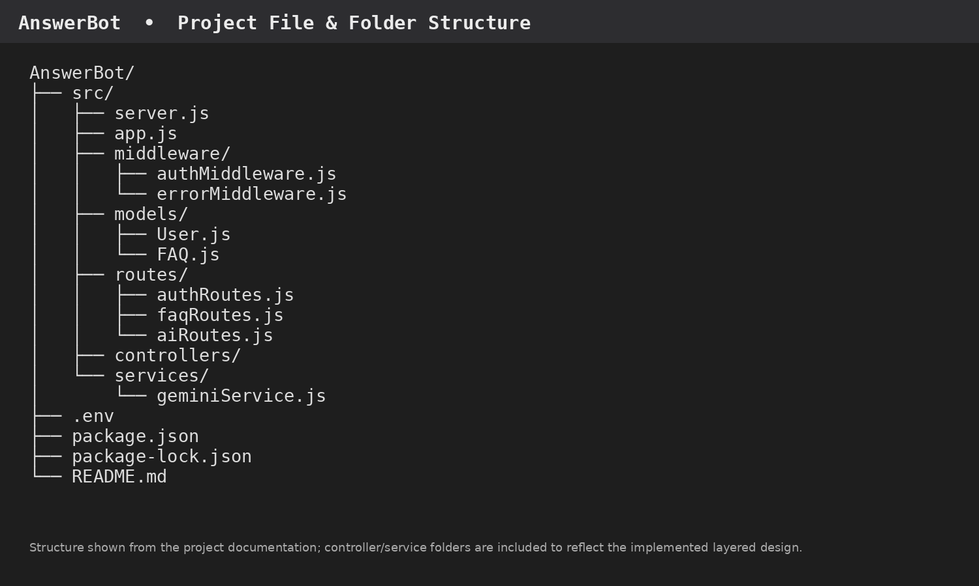
Figure 7.1 — AnswerBot project file and folder structure (documentation-based structure)

7.6 Main File Responsibilities
File / Folder | Purpose
src/server.js | Main server entry point; starts the application and database connection.
src/app.js | Express application configuration and middleware/route setup.
src/middleware/authMiddleware.js | Validates authentication tokens for protected routes.
src/middleware/errorMiddleware.js | Centralized error handling.
src/models/User.js | User schema and password-related model logic.
src/models/FAQ.js | FAQ schema and relationship to the creating user.
src/routes/authRoutes.js | Registration and login API routes.
src/routes/faqRoutes.js | FAQ resource routes.
src/routes/aiRoutes.js | AI FAQ-generation route.
src/services/geminiService.js | AI service integration for Gemini-based generation.
package.json | Project dependencies and npm scripts.
.env | Environment configuration such as database/API secrets; should not be publicly exposed.

7.7 Database Documentation
Entity | Important Fields | Purpose
User | _id, name, email, password, role, createdAt, updatedAt | Stores authenticated user accounts.
FAQ | _id, question, answer, category, createdBy, createdAt, updatedAt | Stores FAQ records and creator reference.
AI Generation (logical) | topic, generatedQuestion, generatedAnswer, generatedCategory, generatedAt | Represents dynamically generated AI content before persistence.
Category (logical) | categoryName, description, totalFAQs | Organizes FAQ records by category.
Key relationship: one User can create multiple FAQ records. FAQ search returns matching FAQ documents based on the supplied query.

7.8 API Documentation
Method | Endpoint | Access | Purpose
POST | /api/auth/register | Public | Register a user.
POST | /api/auth/login | Public | Authenticate a user and return a token.
POST | /api/faqs | Private | Create an FAQ.
GET | /api/faqs/search?q=configure | Public | Search FAQ records.
POST | /api/ai/generate-faq | Private | Generate an FAQ pair with AI.

7.9 Implementation & Execution
- Create the project folder and src folder.
- Initialize the Node.js project with npm.
- Install the documented dependencies.
- Configure environment variables and MongoDB connection.
- Implement server, app, middleware, models, routes and services.
- Run the development server using npm run dev.
- Verify the API using Thunder Client/Postman.

7.10 API Testing Evidence
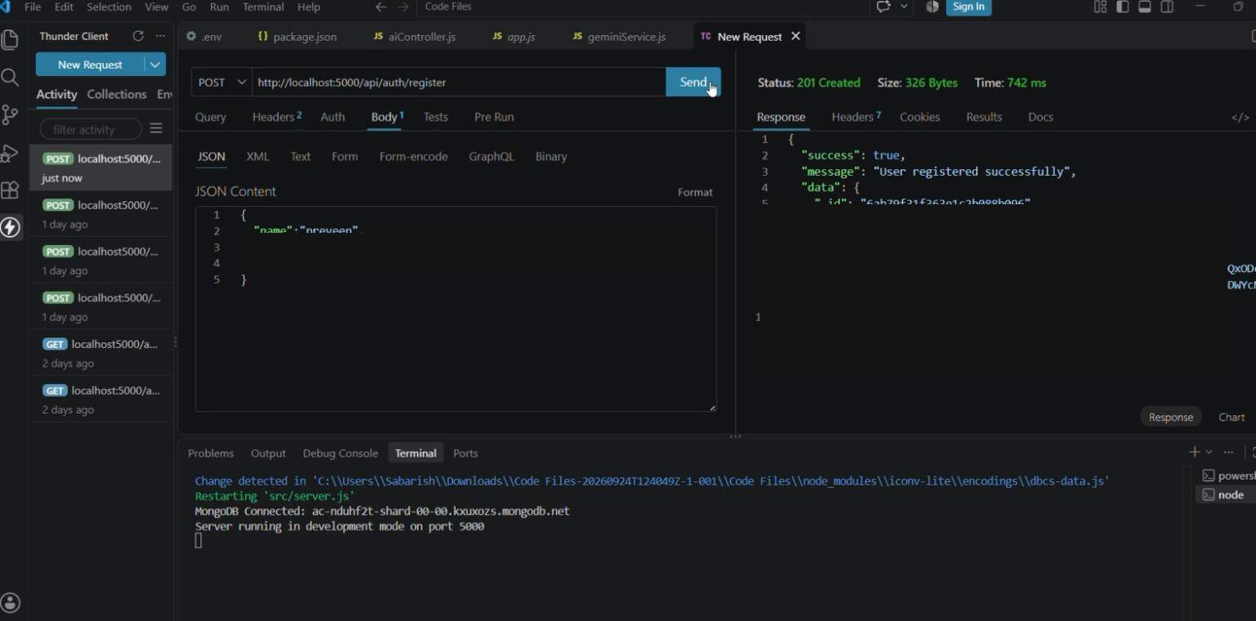
Figure 7.2 — Registration API test evidence
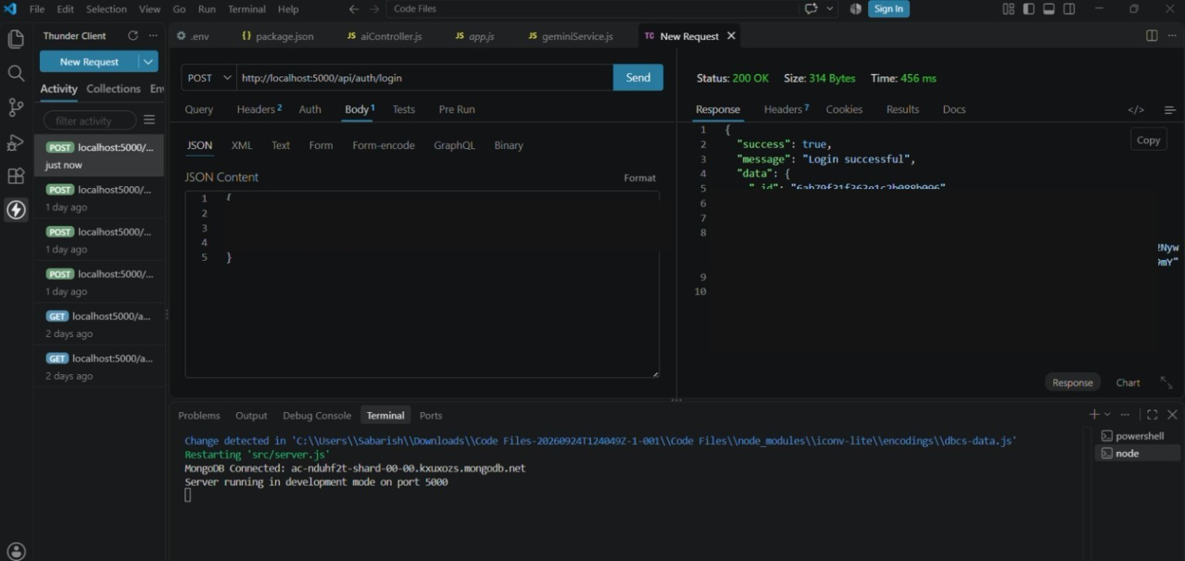
Figure 7.3 — Login API test evidence
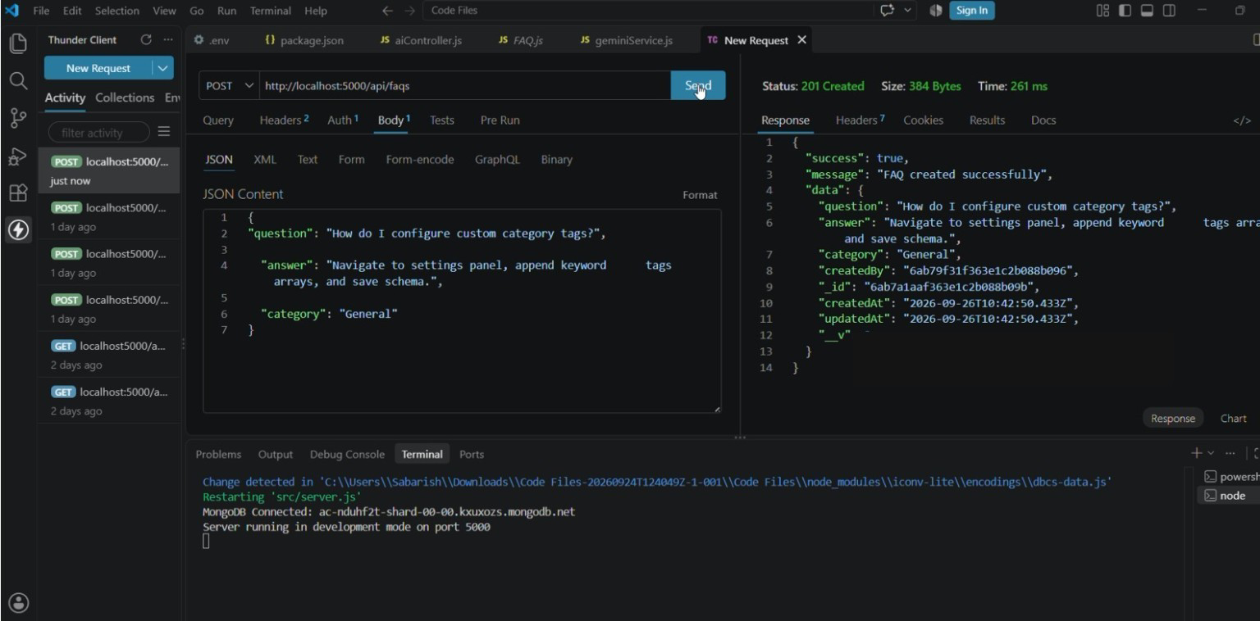
Figure 7.4 — FAQ creation API test evidence
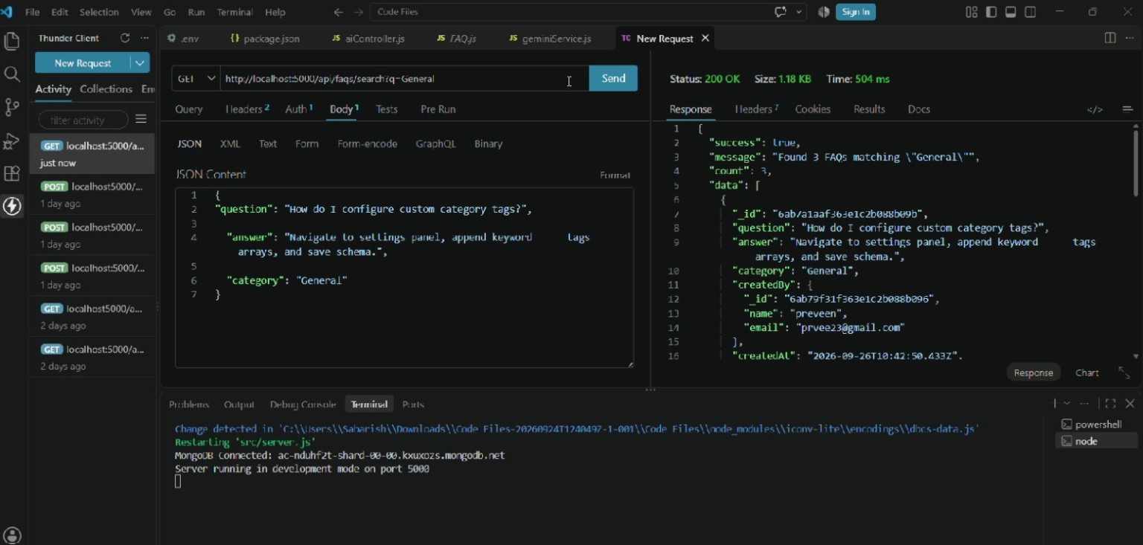
Figure 7.5 — FAQ search API test evidence
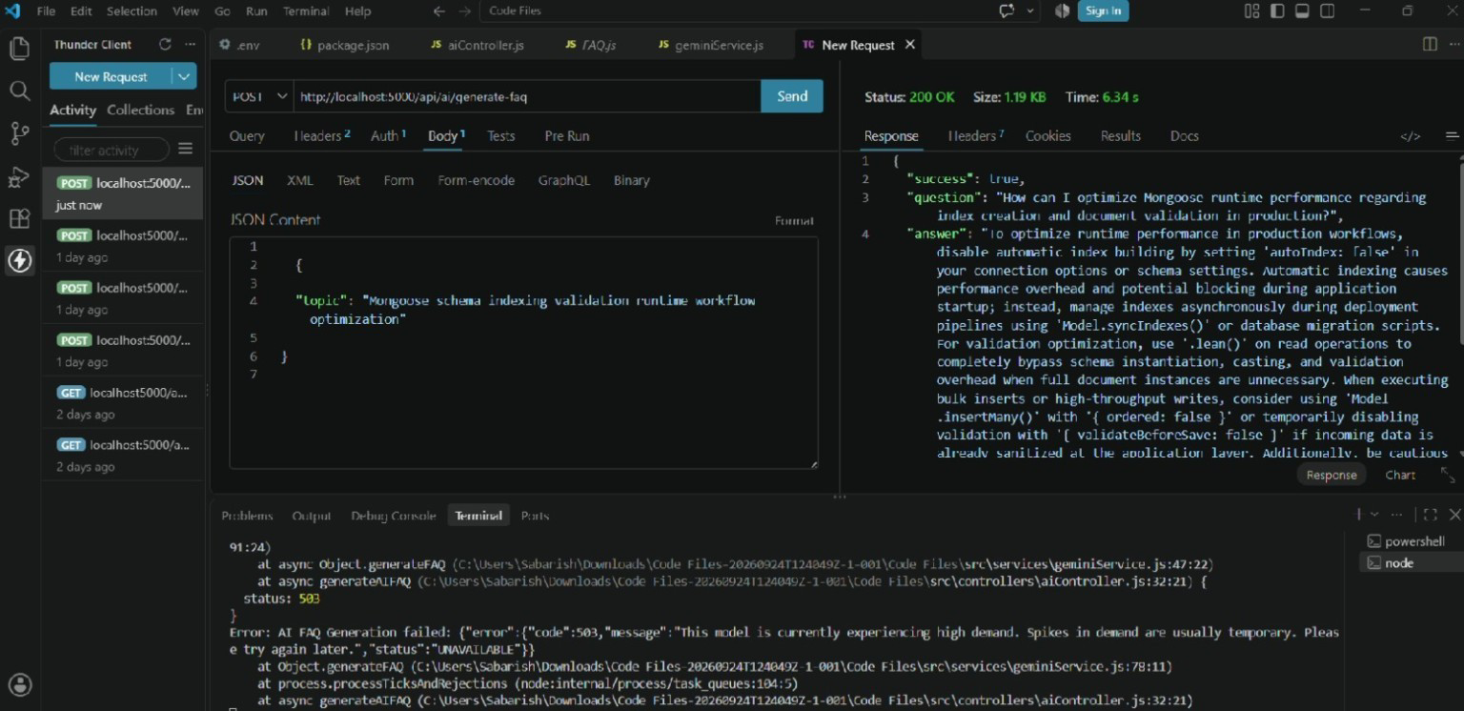
Figure 7.6 — AI FAQ generation API test evidence

7.11 Testing Results Summary
Test | Result
User registration | PASS — 201 Created
User login | PASS — 200 OK; token returned
FAQ creation | PASS — 201 Created
FAQ search | PASS — 200 OK; matching records returned
AI FAQ generation | One recorded attempt returned HTTP 503/high-demand service unavailable; retry required
The 503 result is retained as project evidence because it was the observed service-availability response during testing; it should not be described as a validation failure.

7.12 Security Documentation
- JWT is used to protect private API endpoints.
- bcrypt is used for password protection.
- Mongoose schema validation helps maintain data integrity.
- Role-based access separates Admin, Content Creator, Authenticated User and Public User permissions.
- Environment variables should be used for sensitive configuration.

7.13 Project Features
- JWT Authentication & Authorization
- AI FAQ Generation
- FAQ Search
- FAQ CRUD operations
- Category organization
- Password encryption
- Centralized error handling
- Schema validation
- RESTful API architecture
- MongoDB integration

7.14 Additional Documentation Points
- Project assumptions and environment requirements
- API endpoint table and access level
- Database/entity description
- Source-code folder structure
- Implementation procedure
- Testing evidence and observed results
- Known service-availability issue during AI testing
- Security and data-protection notes
- Future enhancement opportunities
- Final submission checklist

7.15 Future Enhancements
- Improve AI generation retry/fallback handling for temporary service unavailability.
- Add richer semantic search and indexing where required.
- Add a dedicated frontend dashboard for FAQ management.
- Expand analytics for FAQ usage and search trends.
- Add automated API test suites and continuous integration.

7.16 Final Submission Checklist
- Public GitHub repository.
- Eight phase-wise project folders.
- Complete source code and supporting project files.
- Project documentation with relevant screenshots.
- Testing evidence and results.
- Google Drive API testing/demo video links.
- Demo video with screen sharing and student voice-over.
- Final output and working process clearly demonstrated.

7.17 Conclusion
AnswerBot combines secure authentication, FAQ management, search, MongoDB persistence and AI-assisted FAQ generation in a modular REST API architecture. This documentation phase consolidates the implementation and evidence required for project submission.

