

**INTELLIGYM WEBSITE AND APPLICATION**

Prepared by:

**Mohammad Bilal Al-Salahat**

**Abdelrahman Abdallah Basheer**

**Mohannad Ibrahim Jaber**

**Dana Saleem Abu Zenah**

Supervisor By:

**Dr.Ahmed sharadqah**

**Presented to the Department of Electrical Engineering**

**Computer and Network Engineering**

**At Al-Balqa'a Applied University**

**September, 2023**

# ABSTRACT

For years, health professionals have warned that there is a global obesity epidemic. The difficulty in getting to the gym didn’t make the situation any better. Many people encounter challenges when attempting to join up for a gym membership, especially those who do not stay in one place for a long period of time, such as travelers, tourists, and people whose jobs require them to travel frequently.

Heavy workloads at certain times, the preference for using E-payment, the pressure of mandatory commitment, and the lack of time that makes it feel like a waste of money, are all barriers that face a notable portion of people when they decide to join a gym.

Although some gyms accept E-payments and daily fees, they are often pricey and difficult to locate, so this doesn't completely fix the issue.

Our approach to solve this problem is a platform that is geared toward those who wish to work out in the gym and lead healthier lives without the previously mentioned hassle, by swapping the membership approach for a pay-per-minute one and the possibility of entering any gym nearby.

**INTELLIGYM WEBSITE AND APPLICATION**

By:

**Mohammad Bilal Al-Salahat**

**Abdelrahman Abdallah Basheer**

**Mohannad Ibrahim Jaber**

**Dana Saleem Abu Zenah**

**Approved by:**

**Dr.Ahmed sharadqah**

**Supervisor:**

**Dr.Ahmed sharadqah**

# ACKNOWLEDGMENTS

We would like to express our deep and sincere gratitude to our research supervisor, Eng. Nawal Al-Zaben, and Dr. Ahmed Sharadqah, for their valuable and constructive suggestions and guidance during the planning and development of this project. Their willingness to give their time so generously is greatly appreciated. Also, we would like to thank our families and friends for their continued encouragement that made this project possible and for giving us the opportunity to conduct research and providing invaluable guidance throughout this research. Their dynamism, vision, sincerity, and drive inspired us to produce a valuable project. They taught us the methodology for conducting research and presenting the research work as clearly as possible, we are very grateful for what they have given us.

We are also extremely grateful to our parents for their love, prayers, care, and sacrifices to educate us and prepare us for our future.

Finally, our thanks go to all the people who have directly or indirectly supported us to complete the research work.

# DEDICATION

We dedicate this humble project to all our instructors who have supported us throughout our work, especially our supervisor, and of course to our families. We also dedicate this project to our beloved university, and to all the workers there.

# TABLE OF CONTENTS

ABSTRACT I

ACKNOWLEDGMENTS III

DEDICATION IV

TABLE OF CONTENTS V

TABLE OF FIGURE VII

LIST OF TABLES VIII

CHAPTER ONE: INTRODUCTION 1

**1.1** **Overviews** 1

**1.2** **Background** 2

**1.3** **Problem Statement** 5

CHAPTER TWO: RELATED WORK 6

**2.1** **ClassPass** 6

**2.2** **Yoma** 7

**2.3** **GetMuv** 9

**2.4** **Comparison With our Work:** 10

CHAPTER FOUR: REQUIREMENTS 12

**1.1** **Reactjs:** 12

**1.2** **JSX** 12

**1.3** **Node.js** 13

**1.4** **Flutter** 13

**1.5** **Dart** 14

**1.6** **UI/UX Design Tools** 14

**1.7** **Firebase** 14

**1.8** **API Integration** 14

**1.9** **Testing Frameworks** 15

**1.10** **Performance Optimization** 15

CHAPTER THREE: EXPECTRD WORK 16

**4.1** **Proposed Work** 16

4.1.1 Proposed work for Application: 16

4.1.2 Proposed work for website: 19

**4.2** **Deliverables** 21

**4.3** **Functional Requirements:** 22

4.3.1 Functional Requirements for IntelliGym application: 22

4.3.2 Functional Requirements for IntelliGym Website: 24

**4.4** **Non-Functional Requirements:** 26

CHAPTER FIVE: IMPLEMENTATIONS AND RESULTS 27

**5.1** **Software Implementation** 27

**5.1.1** **Overall Software Design for the App** 27

**5.1.2** **The Selection of Flutter and Dart** 27

**5.1.3** **The Selection of Firebase** 28

**5.1.4** **The Selection of GitHub for Version Control and Teamwork** 28

**5.1.5** **The Usage of React.js for the Website** 28

**5.1.6** **Overall Software Design for the Website** 28

**5.2** **Application Screens** 30

**5.2.1** **Log In Screen:** 30

**5.2.2** **Sign Up screen** 31

**5.2.3** **Forget Password Screen** 32

**5.2.4** **Dashboard screen** 33

**5.2.5** **Coach Screen** 34

**5.2.6** **Profile screen** 35

**5.2.7** **App setting screen** 36

**5.2.8** **Edit profile screen** 37

**5.2.9** **Session history screen** 38

**5.2.10** **Your balances screen** 39

**5.2.11** **Payment screen** 40

**5.2.12** **QR Code screen** 41

**5.2.13** **Timer screen** 42

**5.3** **Website Screen** 43

**5.3.1** **Home Screen** 43

**5.3.2** **Sign in & signup Screen** 45

**5.3.3** **Main User Screen** 46

**5.3.4** **Setting Screen** 48

**5.3.5** **Upgrade Screen** 50

CONCLUSION 51

REFERENCES 52

# TABLE OF FIGURE

Figure 1:ClassPass Website and Application 7

Figure 2:Yoma application 8

Figure 3:GetMuv Application 10

Figure 4: Reactjs advantages 24

Figure 5: JSX 24

Figure 6: Node.js features 25

Figure 7: flutter platform 25

Figure 8: Firebase features 26

Figure 9 :Login Screen 31

*Figure 10: Sign Up Screen* 32

*Figure 11: Forgot Password Screen & one-time password Screen (OTP)* 33

*Figure 12: Coach* 35

*Figure 13: Coach* 36

*Figure 14: App setting* 37

*Figure 15: Edit profile* 38

*Figure 16: Session History* 39

*Figure 17: Your balance* 40

*Figure 18: Payment* 41

*Figure 19: QR code* 42

*Figure 20: QR code* 43

*Figure 21:Home Screen* 45

*Figure 22:Sign in Screen* 46

*Figure 23: Join us screens* 46

*Figure 24: Main User Screen* 48

*Figure 25:Setting Screen* 50

*Figure 26:Upgrade Screen* 51

# LIST OF TABLES

Table 1: Features of IntelliGym with other 12

# CHAPTER ONE: INTRODUCTION

## **Overviews**

Our platform, IntelliGym, is designed to make the gym-going experience more efficient and convenient for trainees, while also providing a powerful management tool for gym staff, coaches, and nutritionists. There are two main components to the platform:

**mobile application:** Say goodbye to time-consuming check-ins and enjoy seamless gym sessions. A session timer that can be started and ended with a simple QR code scan is the main function of the program, simplifying the process of checking in and out. Pay for services with ease using Intelicoins, the app's unique currency. You can purchase coins online or at the front desk of the gym, and you can use them to access a range of services.. Track your progress and stay motivated with the app's history feature, which logs all sessions. Plus, compete with other users on the leaderboard.

**website:** This platform feature focuses on management and is intended for gym employees, coaches, and nutritionists., Gym owners, coaches, and nutritionists, rejoice! This website is your ultimate hub for efficient management and thriving business. Easily register your gym or showcase your expertise, create attention-grabbing posts and announcements, and specify costs and service details for all to see. Promote your offerings and attract clients with targeted ads, all things considered, the IntelliGym platform offers a variety of features to enhance the effectiveness and convenience of going to the gym, making it a complete solution for both gym employees and new members.

## **Background**

The proliferation of technology in modern society has led to numerous benefits and advancements, however, it has also been associated with various negative consequences. The overuse of technology has been linked to physical and psychological health issues.

On the physical side, a study published in the journal "Applied Ergonomics" observed a correlation between prolonged mobile phone usage and neck or upper back pain in young adults. Furthermore, a study conducted on young adults aged 19-32 years found that individuals who frequently used social media were more than three times as likely to feel socially isolated than those who did not use social media as often.

On the psychological side, research has shown mixed results on the relationship between social media usage and mental health. A systematic review published in 2016 found that people who had more positive interactions and social support on social media platforms had lower levels of depression and anxiety. On the other hand, some research indicates that an elevated risk of anxiety and depression is linked to excessive usage of social media.. Additionally, using technology too close to bedtime can also disrupt the body's natural circadian rhythm, leading to sleep disturbances.

The overuse of technology also has a sedentary lifestyle effect on people, making them lazy and less active. This can lead to an increase in health problems like obesity and heart disease.

It's important to note that not all the effects of technology overuse are negative, and that the key is to find a balance in technology usage. One way to counteract the negative effects of technology overuse is through regular physical activity and exercise. These activities not only improve physical health but also have a positive impact on mental well-being.

According to guidelines established by the World Health Organization, adults aged 18-64 years should engage in a minimum of 150-300 minutes of aerobic exercise at a moderate intensity, or 75–150 minutes of aerobic exercise at a high intensity, or an equivalent mix of moderate and high intensity activity spread out over the course of the week. Additionally, because they offer extra health benefits, muscle-strengthening exercises that involve all major muscle groups at a moderate to high intensity should be done two or more days a week. To further enhance general health, it is advised to reduce the amount of time spent inactive and substitute it with any level of physical activity, even little exercise. All individuals, especially older ones, should strive to engage in more moderate-to-intense physical activity than the prescribed amounts in order to lessen the negative consequences of excessive sedentary behavior on health. Regular physical activity is a crucial component of a healthy lifestyle and has been shown to have a wide range of beneficial effects on both physical and mental health. It plays an important role in preventing and managing non-communicable diseases such as cardiovascular diseases, cancer, and diabetes. In addition, regular physical activity has been shown to reduce symptoms of depression and anxiety. Furthermore, physical activity has been shown to enhance cognitive function, including thinking, learning, and judgment skills.

Despite the numerous benefits of physical activity, a significant proportion of the global population does not meet the recommended levels of physical activity. According to the World Health Organization, approximately 25% of adults worldwide do not engage in sufficient levels of physical activity. This lack of physical activity has been associated with an increased risk of death, with individuals who are insufficiently active having a 20-30% increased risk of death compared to those who are sufficiently active. The situation is even more alarming among adolescents, with more than 80% of the world's adolescent population being insufficiently physically active.

In conclusion, regular physical activity is a vital aspect of maintaining overall health and well-being. It can play a critical role in preventing and managing chronic diseases, reducing symptoms of depression and anxiety, and enhancing cognitive function. Despite the numerous benefits of physical activity, a significant proportion of the global population does not meet the recommended levels of physical activity, highlighting the need for increased awareness and efforts to promote physical activity across all age groups.

Our platform seeks to improve convenience of the gym admissions process, which in turn will help more people meet their recommended training times weekly. Numerous features are available on the platform, including bill payment systems and session timers, and prompts to assist users in staying on course and getting the most out of their gym visit. It also has a map function that displays neighboring gyms, making it simple for users to locate new facilities and meet their suggested training schedules By making it easier for people to visit the gym and offering resources to keep them on track, our platform is designed to help people achieve their recommended levels of physical activity and improve their overall health and well-being.

The traditional gym system can present a number of challenges for individuals who engage in regular travel or experience instability in their lives. One of the major issues is the requirement to register for a minimum period of one month, which can be inflexible for those who frequently travel or move to different locations. Furthermore, individuals who have chronic health conditions that prevent them from being able to attend the gym on consecutive days may also face difficulties in maintaining their gym membership.

To address these challenges, our system employs a new payment system, "pay per minute," which allows individuals to pay for their gym usage on a minute-by-minute basis. This eliminates the need for traditional, long-term registration and allows for greater flexibility in gym usage. Our system also utilizes a QR code scanning system for registration, where the trainee scans the QR code at the gym to start the timer and scans it again when their session is finished.

A healthy diet is essential for the overall well-being of an individual and plays a critical role in preventing malnutrition and a variety of non-communicable diseases (NCDs). However, with A change in dietary patterns has resulted from the increased production of processed foods, fast urbanization, and changing lifestyles. This has led to an increase in the consumption of foods high in fats, energy, free sugars, and salt/sodium, and a decrease in the intake of fruits, vegetables, and other dietary fibers like whole grains.

We also understand the importance of a balanced diet in achieving overall health and fitness goals. That is why our app offers consulting services from certified dietitians. These dietitians are experts in the field of food and nutrition and can provide personalized guidance and recommendations based on an individual's specific needs and goals.

Our goal is to provide a supportive environment for individuals looking to lead healthier lives. By offering a gym membership that is tailored to meet the needs and preferences of each individual, we hope to attract new members and keep them engaged in their physical fitness journeys. This, in turn, will allow us to generate more revenue and establish ourselves as the top gym in the area.

Our system employs a unique currency, named Intelicoins, for payments within the application. This allows for greater flexibility in terms of pricing, as the cost per minute may vary between different gyms and allows for the potential for offers and rewards in the future. With this system, trainees can join any gym at any time, without having to worry about long-term registration or inflexible payment systems.

Electronic payment, or e-payment, is the term used to describe the process of conducting financial transactions via electronic devices. The term "e-payment" or "electronic payment" describes the process of conducting financial transactions using electronic devices., such as credit cards, debit cards, or mobile payment apps. E-payment is becoming increasingly popular as it offers a number of advantages over traditional payment methods. One of the most significant benefits of e-payment is its convenience. E-payment eliminates the need for physical cash or checks, which can be lost or stolen. Additionally, it allows users to make payments from anywhere and at any time, as long as they have an internet connection.

## **Problem Statement**

The problem that IntelliGym app aims to solve is the lack of accessible and convenient fitness and wellness resources for individuals. Many people struggle to maintain a consistent exercise routine or have limited access to quality gym facilities and nutrition advice. The current options for finding a gym or a personal trainer can be time-consuming, confusing, and overwhelming. Additionally, many people are looking for a more personalized and efficient way to track their fitness progress and receive advice from experts in the field. IntelliGym app aims to address these pain points by providing a comprehensive platform that combines gym facilities and fitness classes with personal training and nutrition services, all in one place and accessible through a mobile app.

# CHAPTER TWO: RELATED WORK

In the development of the gym website and application, it is important to review and consider previous projects and applications that have focused on similar goals. This section provides an overview of some notable related works in the field of gym websites and applications:



## **ClassPass**

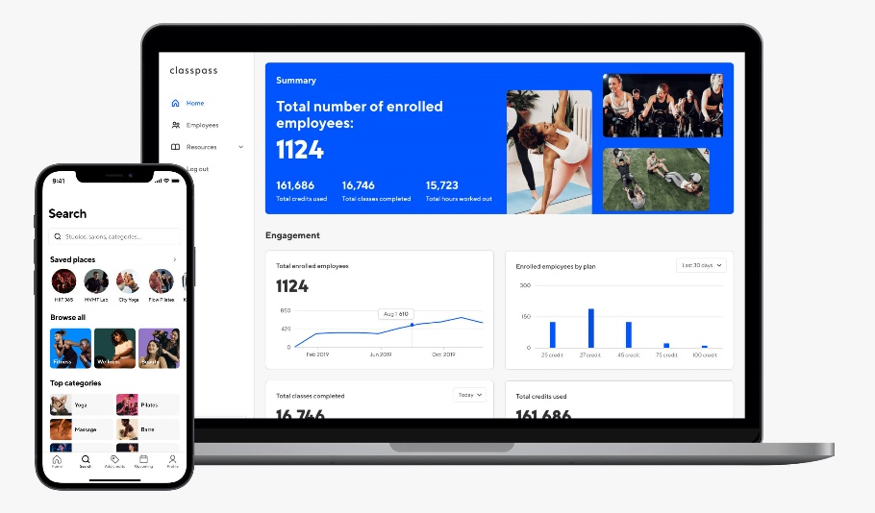ClassPass is revolutionizing the fitness and wellness industry by bringing together the world’s best experiences into one app. their mission to motivate people to live inspired lives every day by introducing and seamlessly connecting them to soul-nurturing experiences. [1]

Figure 1:ClassPass Website and Application



**Features offered of ClassPass:**

* **Affordability:** ClassPass is a more affordable way to try out different fitness classes and studios. You can save money compared to paying for individual classes or memberships.
* **Convenience:** ClassPass is easy to use. You can book classes directly through the app or website, and you can see your upcoming classes and credits in one place.
* **Community:** ClassPass has a vibrant community of fitness enthusiasts. You can connect with other users, get workout advice, and find motivation.
* **Variety:** ClassPass offers a wide variety of fitness classes, including yoga, Pilates, barre, spin, boxing, and more. You can also find classes that focus on specific goals, such as weight loss, strength training, or flexibility.

**Here are some of the cons of ClassPass:**

* **Limited availability:** ClassPass classes can sell out quickly, especially popular ones. You may not always be able to get the class you want, especially if you are on a tight schedule.
* **Hidden fees:** ClassPass charges a monthly membership fee, as well as a booking fee for each class. These fees can add up, especially if you are not using ClassPass very often.
* **No commitment:** ClassPass is a month-to-month membership, so you can cancel at any time. However, if you cancel mid-month, you will lose any unused credits.

## **Yoma**

It provides you with the opportunity to practice various sports and exercises through a large network of sports clubs and a group of distinguished trainers. You can search for dozens of exercises and book in advance through our application simply. [2]

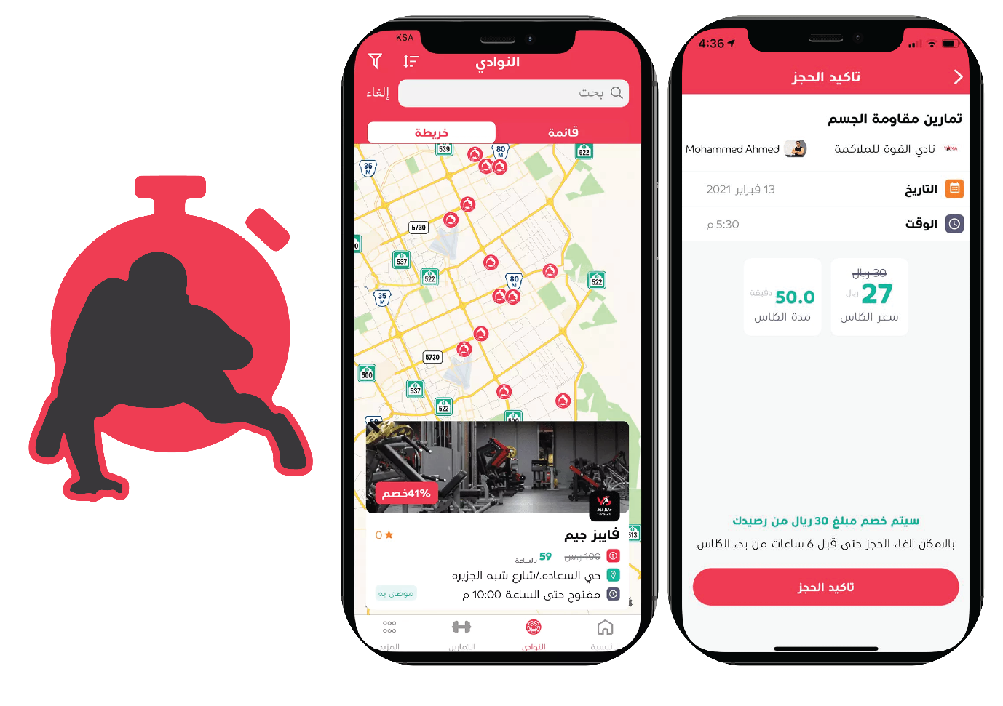

Figure 2:Yoma application

**Features offered of Yoma:**

* **Book gym classes by the minute**: You can book gym classes by the minute, so you only pay for the time you use. This is a great way to save money and only work out when you have time.
* **No long-term contracts or commitments:** There are no long-term contracts or commitments with Yoma, so you can cancel your subscription at any time. This is a great way to try it out without having to worry about being locked in.
* **Easy to use app:** The Yoma app is easy to use and navigate. You can easily find classes, book classes, and track your progress.
* **Safe and secure payments:** Yoma uses safe and secure payments, so you can be confident that your information is protected.
* **To search for gyms**: Users can search for gyms in their area through the Yuma Sports application. The application will provide a list of nearby gyms.

**Here are some of the cons of Yoma:**

* **Limited availability:** Yoma is only available in Saudi Arabia.
* **Limited class selection:** The class selection on Yoma is not as extensive as some other fitness apps.
* **Peak time surcharges:** Yoma charges a surcharge for classes during peak times, such as weekdays during the workday.
* **No cancellation policy:** There is no cancellation policy with Yoma, so you will be charged for any classes that you book, even if you don't show up.
* **Technical difficulties:** There have been some reports of technical difficulties with the Yoma app.

The application does not contain nutrition experts, nor does it contain evaluation of coaches and gymnasiums, and it does not support the feature. The application does not contain nutrition experts, nor does it contain evaluation of coaches and gymnasiums, and it does not support the feature of direct communication with coaches and nutrition experts. of direct communication with coaches and nutrition experts

## **GetMuv**

GetMuv is a good app for users who are looking for an easy way to book gym classes at different gyms in Saudi Arabia. The app provides a range of features that make it easy for users to find suitable gym classes, book them, and track their training progress. [3]

 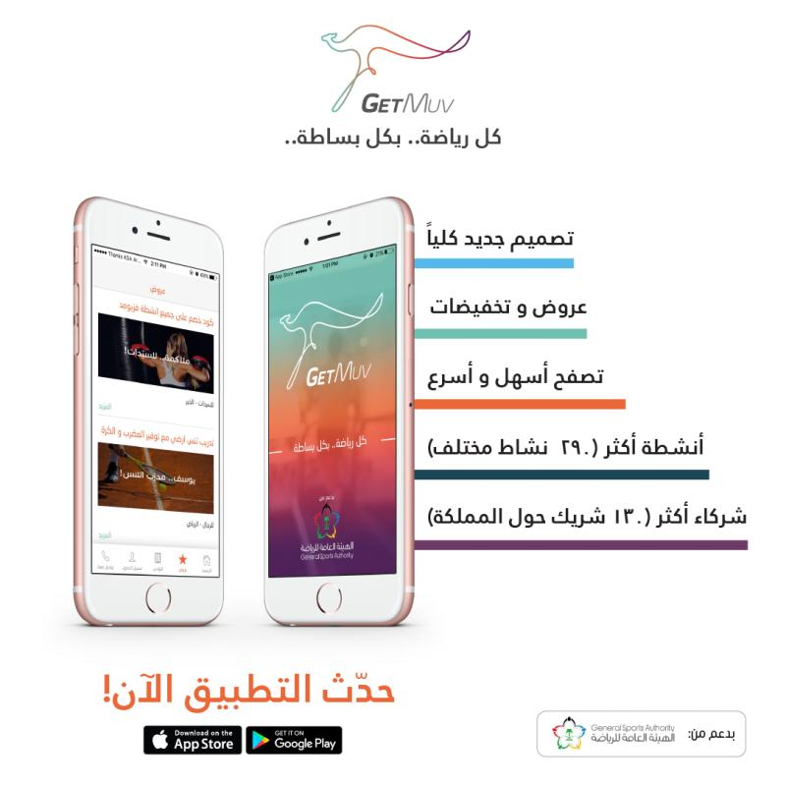

Figure 3:GetMuv Application

**Features offered of GetMuv:**

* **To search for sports and sports centers:** Users can search for different types of sports and sports centers in their area through the GetMuv application. The app will provide a list of nearby sports and fitness centres, including contact information, address and opening hours.
* **Booking sports classes**: Users can book sports classes in different sports centers through the GetMuv application. The application will provide a list of available trainers, as well as information about their experience and specializations.
* **Track Training Progress:** Users can track their training progress through the GetMuv app. The application will provide a record of the exercises performed, as well as comments and tips from the trainers.

**Here are some of the cons of GetMuv:**

* **Price:** The prices of some sports classes in the application may be relatively high. For example, a yoga class might cost 100 SAR.
* **Inaccurate Reviews:** Some reviews and comments posted on the app may be inaccurate or subjective. For example, users may leave negative ratings or comments about a particular gym or trainer based on a single bad experience.
* **Customer support is not always available**: Customer support in the app may not always be available, especially during peak times. Users may have difficulty contacting the customer support team if they face any issues with the app.

## **Comparison With our Work:**

**IntelliGym**

* Aims to revolutionize the fitness industry by providing a comprehensive and convenient platform enabling users to keep track of their fitness objectives, communicate with elite trainers and nutritionists, and monitor their progress.
* Offers innovative features such as QR code scanning, real-time session tracking, and a directory of nearby gyms.
* Focuses on security and ease of use.
* Provides a unique and valuable solution for the modern fitness enthusiast.

**Other fitness apps**

* Typically offer a limited set of features, such as tracking workouts and providing workout plans.
* May not be as secure or easy to use as IntelliGym.
* May not offer the same level of personalization or community support as IntelliGym.

**Here are some specific ways in which IntelliGym stands out from other fitness apps:**

* **QR code scanning:** IntelliGym users can scan QR codes at gyms to automatically check in and start tracking their workout. This is a more convenient and efficient way to track workouts than manually entering the gym name and location.
* **Real-time session tracking:** IntelliGym users can track their workouts in real time, including the number of calories burned, distance traveled, and heart rate. This data can be used to track progress and make adjustments to workouts as needed.
* **Directory of nearby gyms:**IntelliGym users can easily find nearby gyms that offer the classes and amenities they are looking for. This is a great way to find a gym that is convenient and fits their needs.
* **Personalization:** IntelliGym uses data from user workouts to create personalized workout plans and recommendations. This helps users stay on track and achieve their fitness goals.
* Community support: IntelliGym users can connect with other users and coaches to get support and motivation. This can be a valuable resource for people who are new to fitness or who are trying to reach a specific goal.

Table 1: Features of IntelliGym with other

|  |  |  |
| --- | --- | --- |
| **Feature** | **IntelliGym** | **Other** |
| **Affordability** | Book gym classes by the minute, so you only pay for the time you use. | Varies depending on the features and services used. |
| **Convenience** | Easy to use app with a variety of features. | Easy to use and navigate. |
| **Community** | Users can connect with Nutrition experts and coaches to get support and motivation. | No community features. |
| **Personalization** | Uses data from user workouts to create personalized workout plans and recommendations. | No personalization features. |
| **Security** | Uses state-of-the-art security measures to protect user data. | Safe and secure payments. |
| **Availability** | Available in All country | Only available in Specific countries |

# CHAPTER FOUR: REQUIREMENTS

**The application in this project was developed using a variety of tools and technology, which this chapter will highlight**.



## **Reactjs:**

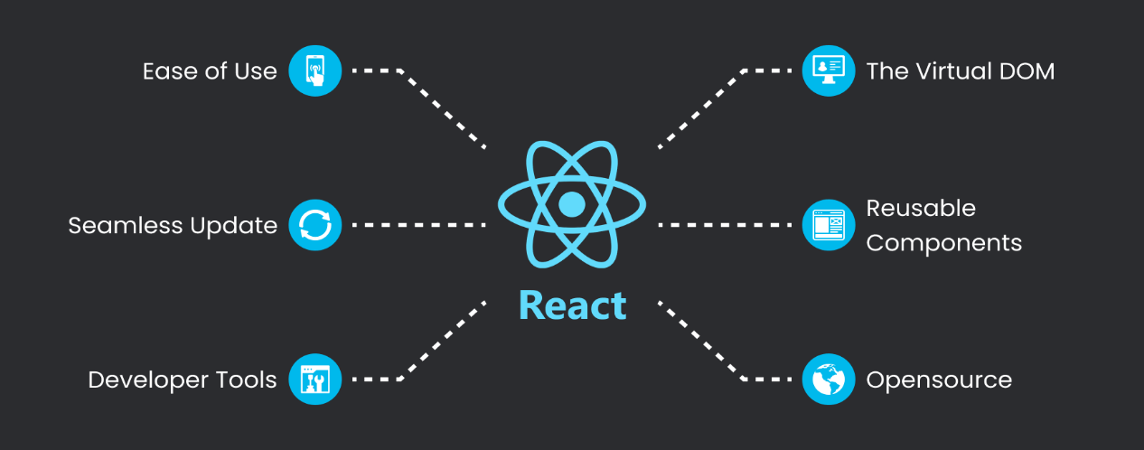ReactJS (often referred to as React) is an open-source JavaScript library for building user interfaces, particularly for single-page applications and reusable UI components. It was developed and is maintained by Facebook, and it has gained significant popularity within the web development community. [4]

Figure 4: Reactjs advantages

## **JSX**

JSX (JavaScript XML) is a syntax extension that allows you to write HTML-like code within your JavaScript. It makes it easier to define the structure and content of your components. [5]

Figure 5: JSX

## **Node.js**

Node.js is an open-source, cross-platform runtime environment that allows developers to execute JavaScript code on the server side. Traditionally, JavaScript was mainly used for front-end web development, running in browsers. However, Node.js extends the use of JavaScript to the server side, enabling developers to build scalable and high-performance applications. [6]

Figure 6: Node.js features

## **Flutter**

Flutter is a cross-platform framework developed by Google that allows you to build native interfaces for iOS and Android using a single codebase. It provides a rich set of pre-built UI components and libraries for building beautiful and responsive user interfaces. [7]

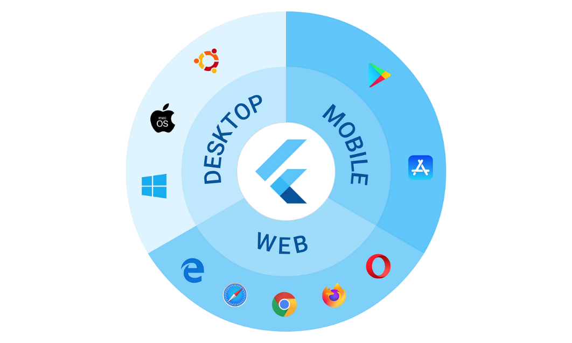

Figure 7: flutter platform

## **Dart**

Dart is the programming language used in Flutter development. It is an object-oriented, class-based language with C-style syntax. Dart is used to write the logic and functionality of the frontend application. [8]

## **UI/UX Design Tools**

To design the user interface of the frontend application, designers often use graphic design tools such as Adobe XD, Sketch, or Figma. Figma has been used as one of these tools, enabling designers to produce wireframes, prototypes, and graphic designs that can be distributed to the development team.

## **Firebase**

Firebase is a Backend-as-a-Service (BaaS) platform developed by Google. It provides a set of tools and services that facilitate backend development, including authentication, real-time database, cloud storage, and cloud functions. Firebase can be integrated with Flutter to handle user authentication, data storage, and serverless functions. [9]

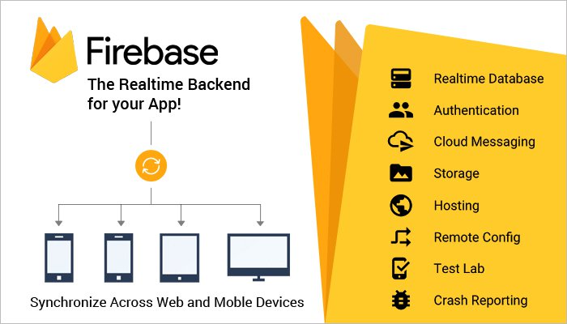

Figure 8: Firebase features

## **API Integration**

Many fronted applications require integration with external APIs to fetch data or interact with external services. For example. Flutter provides libraries and packages for making HTTP requests and handling API integrations. [10]

## **Testing Frameworks**

Software testing is a crucial component of software development that guarantees the application's functioning and quality. To write unit tests and integration tests and automate the testing process, Flutter offers testing frameworks like Flutter Testing and Integration Testing.

## **Performance Optimization**

Optimizing the performance of the front-end application is crucial to provide a smooth and responsive user experience. Techniques like code optimization, image compression, lazy loading, and caching can be employed to improve the application's performance.

**Used Technologies**

The IntelliGym platform leverages the latest in web and mobile technologies to deliver a seamless user experience. The website is built using Node.js and Express for server-side operations, React.js for the front-end, and Bootstrap for styling and responsive design.

The platform's real-time database, provided by Firebase, makes sure that the data is constantly current and available from any location. Flutter, Dart, and Firebase are used in the development of the mobile app to create a native, quick, and intuitive user experience. Both the website and app have been designed to work in harmony with the real-time database, ensuring that the data is always in sync and providing users with a consistent experience regardless of the device they are using.

**UI/UX:**

The IntelliGym mobile application has put a lot of thought into the UI and UX design to ensure the best user experience. By following the six common UI design principles such as structure, simplicity, visibility, feedback, tolerance, and reuse, the app is able to provide an organized, clear, and user-friendly interface. All these design elements work together to create a professional and beautiful experience for the user.

# CHAPTER THREE: EXPECTRD WORK



## **Proposed Work**

### Proposed work for Application:

**login**

The IntelliGym mobile application serves as the primary portal for clients to access the app and its offerings. This page has been designed with comprehensive authentication and security measures to ensure the confidentiality and protection of client data.

The interface typically includes two fields: a username field and a password field. After entering their password and username in the appropriate spaces, users click a button to log in.

When a user enters their username and password into the login interface and clicks the login button, the application sends the username and password to the application server for authentication. If the username and password are valid, the application server grants the user access to the application.

**Sign up.**

The application signs up interface that contains a username field, an email address field, a password field, and password configuration options:

* **Username:** The username is a unique identifier for the user. It is typically a string of characters, but it may also be an email address or another type of identifier. The username should be easy to remember and type, but it should also be unique enough to prevent other users from choosing the same username.
* **Email address:** The email address is used to verify the user's identity and to send them important account information, such as password reset instructions. The email address should be a valid email address that the user has access to.
* **Password:** The password is a secret string that the user uses to authenticate themselves to the application. The password should be at least 8 characters long and should include a mix of uppercase and lowercase letters, numbers, and symbols. The password should be difficult to guess, but it should also be easy for the user to remember.
* **Password configuration:** Retype the password again to confirm it
* **Create account:** When a user signs up for an application, they will typically be required to enter all of the information in the sign-up interface. The application will then verify the user's information and create an account for them. The user will then be able to log in to the application using their username and password.

**Forget password.**

The forget password interface is a user interface that allows users to reset their passwords when they have forgotten them. The interface typically consists of a field for the user to enter their email address, and a button to send a password reset link to the user's email address.

When the user clicks the "send link to your email" button, the application sends a password reset link to the user's email address. The password reset link contains a unique code that the user can use to reset their password.

The user clicks the password reset link in their email to change their password. They can input their new password on the password reset page that appears after clicking the link. After that, the user will be able to use their new password to get into the application.

**Dashboard**

The dashboard interface is the main screen of the application that users see after they log in. It typically contains your profile at the top of screen and a search bar that users can use to search for nearby gyms.

The dashboard may also include categories of popular coaches and nutrition.

When you find a nearby gym, its name, rating, and location will appear to you, and you can know its status open or closed, working hours, days, and communication with the gym.

And we can see the profile of the coaches, his working hours in the gym, his rating, and his private accounts to communicate with him.

**Notifications**The Notifications page, accessible from the bottom navigation bar, displays read and unread notifications in a clear and intuitive manner. Users can quickly identify the status of their notifications, ensuring that they stay informed and up to date on important updates from the IntelliGym app. The page provides an organized and user-friendly way to manage notifications, helping users to stay in the loop without feeling overwhelmed by excess information.

**Profile**

The profile page of the IntelliGym mobile application is designed to offer users easy access to their personal information and settings within the app. The page features the user's name and email, providing a comprehensive overview of the user's profile. The page includes a range of buttons and links that allow users to modify their profile settings.

**Coaches and nutritionists’ screens**

The Coaches and Nutritionists screens within the IntelliGym app provide detailed information about individual coaches and nutritionists. These screens display their status, ratings, and availability in terms of scheduling. Users can also easily contact these professionals, as well as view and write reviews about their experiences. This allows users to make informed decisions about which coaches and nutritionists are best suited to meet their needs.

**Scan QR code**

The QR Scanner is a feature in the IntelliGym mobile application that allows users to easily track and record their gym sessions. This is a button that the user clicks to scan the QR code. When the user clicks the scan button, the camera preview will be activated, and the user will be able to scan a QR code. The QR Scanner then calculates the coins consumed based on the time elapsed during the session.

**Payment**

The payment page within the IntelliGym mobile application offers a user-friendly and secure experience for making subscription payments. The subscription page presents options to pay via credit card, PayPal, or Apple Pay. Upon successful payment, a confirmation page is displayed, ensuring users that their payment has been processed. This page is designed to streamline the payment process, making it easy and convenient for users to make their subscription payments.

### Proposed work for website:

**Home**

The IntelliGym system consists of several distinct sections, each serving a specific purpose. The Home page is designed to engage and entice potential users, showcasing the unique aspects of our system. The Services section provides a comprehensive overview of all offerings and features, allowing users to understand the full scope of what IntelliGym has to offer. The Partners section highlights our key partnerships with gyms, companies, and coaches, reinforcing the quality and reliability of our system. The About section provides detailed information about our company and mission, answering any questions or concerns a potential user may have. The Contact Us section offers a convenient form for users to communicate directly with our team, and the Sign in and Join Us sections provide quick and easy access to the system.

**Sign In**

Access to the account is granted through the use of an email address and password, specifically for Gym, Coach, or Nutritionist identification and authentication.

**Join Us Screen**

* Join as a (GYM) organization that connects you to the organization sign up page.
* Join as a coach or nutritionist that connects you to the coach & nutritionist sign up page.

**Registration Form:**

The Registration Form comprises of the following fields, which are applicable to all users seeking to join the system:

* Email
* Password
* Confirm Password
* Name or Organization Name (distinct field for individual and organization registration)
* Phone
* Acceptance of terms and conditions.

**Main User Screen:**

The Main User Screen comprises several elements to provide a comprehensive user experience. The User Info Side features the user's photo, personal information, and access to the settings and logout options. The Navigation Bar includes the Overview and Trainees sections, providing a clear and intuitive navigation system. The Overview section displays the user's status through various statistics, such as trainee activity and performance.

**Trainee Information Screen:**

The displays a comprehensive list of registered trainees. It features the following components:

Trainee Accounts: A comprehensive list of trainee profiles.

Trainee Count: The total number of registered trainees.

Trainee Information and Status: Detailed information about each trainee, including their status.

Add Note Feature: A function that allows coaches or gyms to add notes for each trainee.

**Settings**

**The setting component includes the following sub-sections:**

**Information:** This section allows the user to manage their profile picture, name, password, email, phone, and additional information

**Upgrade:** the provides the option to upgrade the current subscription plan, The screen also displays the current plan and its expiration date.

## **Deliverables**

The IntelliGym project will deliver two applications, a mobile app for trainees and a website for gyms, coaches, and nutritionists. The mobile application provides a number of functions and services, including a sign-up process that grants the user free coins for use in participating gyms. The app also features a QR code scanning system for tracking training sessions, a dashboard with statistics, session history, nearby gym locators, announcements from coaches, nutritionists, and gyms, billing options, and user profiles for trainees, coaches, nutritionists, and gyms. A leaderboard is another feature of the program that encourages competition. The website, designed for gyms, coaches, and nutritionists, features a main page that provides information about the services offered by IntelliGym Users can sign in if they are already members, join as a gym, coach, or dietician, or both. The main screen of the website offers an overview of trainee statistics and individual trainee tracking capabilities. Users can edit their profiles and update their subscription plans. The website will provide a centralized platform for gyms, nutritionists , and coaches to manage their services and trainees in an organized and efficient manner.

## **Functional Requirements:**

### Functional Requirements for IntelliGym application:

* **User Account Management:**

sign up: A process for creating a new user account within the app.

Login: A secure login process for existing users to access their account.

* **Navigation Bar:**

This interface allows users to navigate between different screens in the IntelliGym application.

* **Nearby Gyms:**

Nearby Gyms: A map view of nearby gyms and fitness facilities, allowing users to find and explore new locations.

* **QR Scanner:**

A feature for scanning QR codes at participating gyms for tracking user attendance.

* **Timer:**

A timer to keep track of workout sessions and time spent at the gym.

* **Push notifications:**

This option allows users to turn on or off push notifications from the application.

* **Email notifications:**

 This option allows users to turn on or off email notifications from the application.

* **Location services:**

This option allows users to turn on or off location services for the application. Location services can be used to provide users with more accurate information about nearby gyms and activities.

* **Switch to dark mode:**

 This option allows users to change the appearance of the application to dark mode. Dark mode can be helpful for users who want to reduce eye strain or use the application in low-light conditions.

* **Change password:**

This option allows users to change their password for the application. This can be helpful if users think their password has been compromised or if they simply want to change it for security reasons.

* **Session History:**

A record of past workout sessions, including date, time, and duration.

* **Gyms and Coaches Feed:**

Announcements: A feed of announcements from participating gyms and fitness coaches.

* **Payment:**

In this interface, information is entered on the approved method for paying the session cost and confirming the payment process.

* **Payment status:**

calculate the cost of using the gym will appear in the payment field, and the payment process will be done by visa.

* **About:**

An informational page about the app and its developers.

### Functional Requirements for IntelliGym Website:

* **User authentication:**

Email & password login for existing users.

Email, password, name/organization name, phone, and terms acceptance for new user registration.

* **Home Screen:**

Display the main idea of the system.

Display sections for services, partners, about, contact us, sign in, and join us.

* **Sign In Screen:**

Email & password login for existing users.

* **Join Us Screen:**

Option to join a gym organization or as a coach/nutritionist.

Connects to the relevant registration form.

* **Registration Form:**

Email, password, confirm password, name/organization name, phone, and terms acceptance fields.

Different fields for gym and coach/nutritionist registration.

* **Main User Screen:**

Display user information, including photo, name, email, phone, and setting button.

Navigation bar with options for overview and trainees.

Overview section with status statistics and past posts.

Ability to write new posts or announcements.

* **Trainees Screen:**

Display list of trainee accounts.

Display trainee count and individual trainee information and status.

Ability to add notes for each trainee.

* **Settings:**

Personal information section to update user picture, name, password, email, and phone. Upgrade section to choose or change between 3 available registration plans, display current plan and expiration date.

## **Non-Functional Requirements:**

* Live Data Availability: The IntelliGym is made to give users instant access to their data.
* Security and Authentication: The IntelliGym ensures the protection and confidentiality of user information through secure authentication processes.
* Revenue Generation: The IntelliGym offers in-app purchases and a unique billing system to generate revenue, while still providing a free user experience.
* 24/7 Availability: The IntelliGym is designed for 24/7 availability to accommodate users' schedules and ensure consistent access to the platform.
* Usability: The IntelliGym is user-friendly and intuitive to use, providing a seamless experience for users.
* Cross-Platform Compatibility: The IntelliGym is compatible with multiple platforms and devices, allowing users to access the platform from any device.
* Maintainability: The IntelliGym is designed with maintenance in mind, making it possible to update and evolve the platform over time.
* Manageability: The IntelliGym is easy to manage, with a user-friendly administration interface to allow gym owners and administrators to monitor usage and update the platform.
* Scalability: The IntelliGym is scalable, able to accommodate growth and increase in users, as well as offer new features over time.
* Legal Compliance: The IntelliGym designed and operates in compliance with all relevant laws and regulations.

# CHAPTER FIVE: IMPLEMENTATIONS AND RESULTS



## **Software Implementation**

* + 1. **Overall Software Design for the App**

The mobile application is built using Flutter, which is an open-source UI toolkit developed by Google. The application has a modular and clean structure, with each functionality being isolated into separate screens (e.g., QR Code Scanner, Timer Screen).

The app includes the following features:

* User Authentication: Users can sign up or log in using their credentials. Firebase is used for authentication services.
* QR Code Scanning: Users can scan QR codes to verify their gym membership. This feature is implemented using the QR code scanner package.
* Timer: There is a timer functionality that allows users to keep track of their workouts. This is implemented using a custom stopwatch widget.
* Database Interaction: The app interacts with Firebase to store user data and gym membership information.

The UI is designed to be user-friendly, with a simple and intuitive interface that adheres to modern design principles.

* + 1. **The Selection of Flutter and Dart**

Flutter was chosen as the development framework for several reasons:

Cross-Platform Development: Flutter allows for the development of both Android and iOS applications from a single codebase, saving time and resources.

Rich Set of Widgets: Flutter offers a rich set of pre-designed widgets, which makes it easier to build sophisticated UIs without much effort. [11]

Performance: Flutter's performance is close to that of native apps. It's compiled directly to native code which ensures faster startup times and performance.

Strong Community Support: Flutter has a strong community which means that developers can find libraries and tools for most of the features they need.

Integration with Firebase: Flutter has excellent support for Firebase, making it easier to use various Firebase services including authentication, database, and storage.

Dart was chosen because it is the programming language that Flutter uses. Dart is object-oriented and easy to learn, especially for those who have a background in Java or JavaScript.

* + 1. **The Selection of Firebase**

Firebase was selected for backend services because:

Real-time Database: Firebase offers a real-time database which is very beneficial for an app that requires up-to-date information.

Authentication: Firebase provides a simple way to authenticate users. [12]

Scalability: Firebase scales automatically according to the application's needs.

Ease of Integration: Firebase integrates seamlessly with Flutter.

* + 1. **The Selection of GitHub for Version Control and Teamwork**

GitHub was chosen for several reasons:

Version Control: GitHub uses Git for version control, which is essential for tracking changes, reverting to previous versions of code, and avoiding conflicts between team members’ code. Collaboration GitHub facilitates team collaboration. Team members can work on separate branches and then merge their changes efficiently. [13]

Backup and Accessibility: Code is stored in the cloud, ensuring that it's backed up and accessible from anywhere.

* + 1. **The Usage of React.js for the Website**

The website is built using React.js. React.js is a popular JavaScript library for building user interfaces, especially single-page applications.

React.js was selected:

Component-Based: React enables programmers to design reusable user interface components, which can accelerate and enhance development.

Virtual DOM: React leverages a virtual DOM to speed up and improve the efficiency of the application.

Strong Community Support: Like Flutter, react has strong community support and a wealth of libraries and tools available.

Integration with Ant Design and Bootstrap: React integrates well with Bootstrap, allowing for the creation of responsive and visually appealing websites with ease, offers a powerful combination of React.js and Bootstrap. [14]

* + 1. **Overall Software Design for the Website**

The website is designed with a modular and component-based architecture using React.js. This means that the UI is broken down into reusable components, each responsible for rendering a part of the user interface. Here is an overview based on some components of the code:

Router Component (app.js): The App Router component is responsible for handling the routing in the application. It uses the React Router library to define different routes and associate them with specific components (e.g., Login Screen, Main, SignupScreen, Learn More Screen).

Login Component (login.js): This component is used for user authentication. It has tabs for both login and registration and uses Material Design Bootstrap for styling.

CSS Styling (App.css): The global CSS file defines styles that are used throughout the application. For example, it defines styles for text alignment, logo animation, headers, and links.

State Management: The example code uses Reacts use State hook for state management. This allows components to maintain their state, such as the active tab in the Login component.

External Libraries: The website uses external libraries like Bootstrap for responsive design and Material Design Bootstrap for enhanced UI components.

To sum up, the website's component-based architecture is handled by React.js, navigation is handled by React Router, and styling is handled by Bootstrap. Because the application is modular, each component is in charge of a certain area of the user interface. This architecture makes it easier to maintain and scale the application.

Together, the selection of Flutter and Dart for mobile app development, Firebase for backend services, GitHub for version control and collaboration, and React.js for web development, create a powerful combination of technologies to build, deploy, and maintain a scalable and robust fitness application and website.

* IntelliGym is a feature-rich application developed using Flutter, a popular open-source framework for developing natively compiled applications for mobile, web, and desktop from a single codebase. In this section, we will discuss the software implementation of the different screens and features of the IntelliGym application: -->
  1. **Application Screens**
     1. **Log In Screen:**

**Overview:** The sign-in screen allows users to log in to their existing account by entering their email and password.

**Implementation Details:**

● The screen should include input fields for email and password.

● Upon clicking the login button, verify the user's credentials.

● If the credentials are valid, redirect the user to the profile screen (Profile Screen).

● If the user forgets the password, provide an option to navigate to the forget pass for password recovery.

**Summary:** The sign-in screen verifies user credentials and grants access to the application.

صورة تحتوي على نص, لقطة شاشة, شعار, التصميم

تم إنشاء الوصف تلقائياً

Figure 9 :Login Screen

* + 1. **Sign Up screen**

**Overview**: The sign-up screen is the main interface of the application. It allows users to create an account by providing their name, email, password, and confirming the password.

**Implementation Details:**

● The screen should include input fields for name, email, password, and confirm password.

● Upon clicking the sign-up button, save the user's account information in the database.

● Redirect the user to the profile screen (Profile Screen).

**Summary:** The sign-up screen captures user details and validates the input before creating a new account.

*Figure 10: Sign Up Screen*

* + 1. **Forget Password Screen**

Welcome to our intelligym app's "Forgot Password" page! We've all been there - the moment you can't quite recall your password, and that's where we step in to help you get back on track.

1. **Email Entry:** As you arrive at this page, you'll see a friendly, clean layout. Right at the top, there's a clear, inviting field where you can enter the email address associated with your account.
2. **Check Your Inbox:** Don't forget to check your inbox (and perhaps your spam folder, just in case) for that code. It's your golden ticket to setting a new password and regaining access to your account.

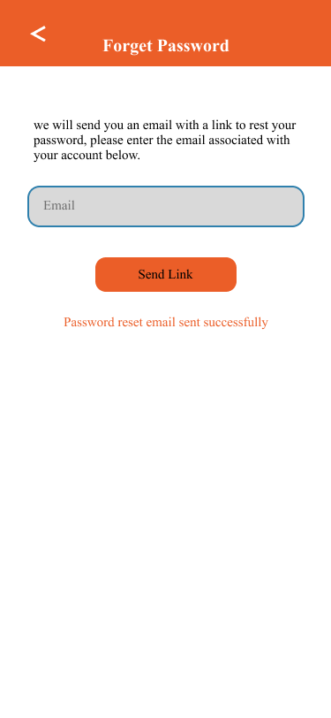

*Figure 11: Forgot Password Screen & one-time password Screen (OTP)*

* + 1. **Dashboard screen**

**Overview:**

● Functionality: Serves as the home screen of the IntelliGym app, displaying an overview of the app's features and allowing users to navigate to various sections such as gyms, coaches, nutrition plans, and reviews.

**Implementation Details:**

* **Dashboard Content:**
  + The dashboard contains several cards or sections that give a brief overview of the different features available in the app.
  + There is a gym Card that shows the nearest gym to the user's location. The card contains an image of the gym, the name of the gym, its address, and the distance from the user's current location. Tapping on this card takes the user to the Gym screen for detailed information.
  + There is a Coaches Card which shows a featured coach. It contains an image of the coach, their name, their specialty, and possibly their rating. Tapping on this card takes the user to the Coaches Screen to see a list of available coaches.
  + A Nutrition Card is also present, which shows a featured nutrition plan or information. It contains an image, the name of the nutrition plan, and a brief description. Tapping on this card takes the user to the Nutrition Screen.
  + There is also a Review Card that shows a summary of a review for a gym, coach, or nutrition plan. It contains the username of the reviewer, their profile picture, the review text, and a star rating. Tapping on this card takes the user to a page with detailed reviews.

*Fig12: dashboard*

* + 1. **Coach Screen**

**Overview:**

● Functionality: Displays brief information about a featured coach on the Dashboard screen of the IntelliGym app.

**Implementation Details:**

* The Gym Card displays an image, which is likely to be fetched from a remote server and displayed using an Image. Network widget.
* The card also displays the name of the gym, its address, and the distance from the user’s current location. These are probably displayed using Text widgets.
* The layout likely includes padding and margins to separate the elements visually.

*Figure 12: Coach*

* + 1. **Profile screen**

**Overview:**

● Functionality: Displays brief information about a featured coach on the Dashboard screen of the IntelliGym app.

**Implementation Details:**

* The Gym Card displays an image, which is likely to be fetched from a remote server and displayed using an Image. Network widget.
* The card also displays the name of the gym, its address, and the distance from the user’s current location. These are probably displayed using Text widgets.
* The layout likely includes padding and margins to separate the elements visually.

*Figure 13: Coach*

* + 1. **App setting screen**

The application settings interface is a screen that displays a set of options that the user can use to change the behavior of the application. The application settings interface consists of the following elements:

Screen Title: The screen title displays the name of the application whose settings are being displayed.

Options Menu: The Options menu displays a set of options that the user can use to change the behavior of the application. The options on the list consist of:

Push Notifications: The user can select whether or not they wish to get push alerts from the application using this option.

Email Notifications: This option allows the user to choose whether they want to receive email notifications from the app.

Location Services: This option allows the user to choose whether they want to allow the app to access their location.

Dark Mode: This option allows the user to change the theme of the application to dark mode.

Change Password: This option allows the user to change the password for his account in the application. Session History: This option allows the user to view their session history in the application. Languages: This option allows the user to change the language of the application.

When you have completed the modifications, click on saving the changes.

*Figure 14: App setting*

* + 1. **Edit profile screen**

The edit profile interface is a screen that allows you to edit your profile information and is divided into several sections:

Top section:

Your photo: This is the photo that appears on your profile. You can change it by clicking the Change Picture button and selecting a new picture from your computer.

Middle section:

Your email address: This is your email address used to register on the site. You can edit it by clicking on the “Email Address” field and typing your new email address.

Your Name: This is your name that appears on your profile. You can edit it by clicking on the "Name" field and typing your new name.

*Figure 15: Edit profile*

* + 1. **Session history screen**

This interface is used to display a list of all sessions that are opened and closed at the current and past time. History sessions can be used to track the time and length of each session.

The interface consists of two parts:

Top section:

Interface Title: Interface Title shows the name of the interface. In this case, the name is “History Sessions.”

“This Week” button: When you click this button, a list of all sessions that have been opened and closed in the current week is displayed.

“Last Week” button: When you click this button, a list of all sessions that were opened and closed in the past week is displayed.

Middle section:

Session Title: The session title shows the name of the program that was used in the session. In this case, the session title is "Gold Gym".

Exact time: Shows the exact time it was opened. In this case, the session was opened at 15:30 on Saturday 16 December 2023.

Duration: Shows how long the session lasted. In this case, the session lasted 1 hour, 12 minutes and 10 seconds.

Location: Shows the location where the session was opened

*Figure 16: Session History*

* + 1. **Your balances screen**

The "Your Balance" interface is a user interface for an electronic payment application. This interface is used to display the user's current balance, including coins and cash. The interface consists of several main sections:

the address:

The title shows the name of the app and in this case, the title shows the name of the app "Your Balance".

Coin Balance:

This section shows how much coins the user has. In this case, the user has 800 coins.

Expiration date:

This section shows the expiry date of the coins. In this case, the coins expire after 350 days.

Subscription packages:

This section shows information about the two available subscription packages. In this case, there is a “Package 1” package that costs 205 coins and a “Package 2” package that costs 305 coins.

*Figure 17: Your balance*

* + 1. **Payment screen**

Payment interface using a credit card. The interface is simple and easy to use, and consists of the following elements: Page title: "Payment by credit card"

Credit Card Image: An image of the credit card, which helps the user enter the card information correctly.

Information entry fields: The following three information entry fields:

Card name: This is the name of the card holder Card Number: The 16-digit card number, which is usually written on the card's magnetic stripe.

Expiry Date: The expiration date of the card, which is usually written on the card's magnetic strip or on the front of the card.

Security Code: The three-digit security code, usually located on the back of the card.

Payment button: A button that is pressed to send information to the store or website to process the payment.

To complete the payment process, the user must enter the following information in the designated fields ,The second interface indicates a payment confirmation form At the top of the screen there is the text “Payment” and the payment amount and in the middle part of the screen there is a text box containing the payment confirmation form. The form consists of a set of numbers or letters, and the user must enter the corresponding numbers or letters in each box.

*Figure 18: Payment*

* + 1. **QR Code screen**

A QR code is a two-dimensional barcode consisting of black and white squares. The QR code can be scanned using a smartphone or other device equipped with a camera.

In order to proceed, the user must scan the QR code. To accomplish this, aim the camera at the code and hit the "Scan" button. A page or app linked to the QR code will open after it has been scanned.

Below is a detailed explanation of the items in the image:

White Frame: A white frame surrounds the QR code. This frame is used to make the symbol more legible.

QR Code: The QR code consists of black and white squares. These boxes are used to represent the information that is stored in the code.

Text: There is text below the QR code. This text is used to explain what the user should do. In this case, the user is prompted to “Scan the QR code to get started.”

*Figure 19: QR code*

* + 1. **Timer screen**

A QR code is a two-dimensional barcode consisting of black and white squares. The QR code can be scanned using a smartphone or other device equipped with a camera.

The user is required to scan the QR code to get started. This can be done by pointing the camera at the code and then pressing the “Scan” button. Once the code is scanned, a page or app associated with the QR code will open.

Below is a detailed explanation of the items in the image:

White Frame: A white frame surrounds the QR code. This frame is used to make the symbol more legible.

QR Code: The QR code consists of black and white squares. These boxes are used to represent the information that is stored in the code.

Text: There is text below the QR code. This text is used to explain what the user should do. In this case, the user is prompted to “Scan the QR code to get started.”

*Figure 20: QR code*

* 1. **Website Screen** 
     1. **Home Screen**

**Overview:**

● File: Main.js.

● Functionality: provides the user an overall picture about our system and company.

**Implementation Details:**

The main screen page is a multi-component react file written in JavaScript language, which means that it has flexible parts.

The main screen uses ‘React Bootstrap’ components , such as navbar, buttons and Carousels

, to achieve its functionality.

**Navigation Bar:**

The user needs to scan the QR code in order to continue. Point the camera at the code and press the "Scan" button to complete the task. Once scanned, the QR code will launch a page or app that is linked to it.

**Content:**

At the middle of the page, there is a multiple part of information split to:

1- Home : contains motivated sentence and 2 buttons (Join us , Learn more)

2- Service: shows the main idea of our products

3- Partners : shows our big partners like gyms, coaches, nutrition, or companies.

4- About : provides information about our system

5- Contact us

**Summary:**

The home page that appears when we enter our website before signing in or signing up includes a brief description of our website. It also features sections for our services, which provide a simple description of the services we offer. Another section is dedicated to our partners, including the companies or coaches who collaborate with us. Additionally, there is an "about" section that provides information about our system and company. Lastly, there is a "contact us" section that allows users to get in touch with us by providing their name, email, subject, and the message they wish to send.

*Figure 21:Home Screen*

* + 1. **Sign in & signup Screen**

**Overview**:

● File: `Joinus.js` and ‘Signin.js'

● Functionality: Provides an overview of the user's profile, posts, trainee statistics, and allows them to make posts and announcements, and displays user information, such as name and photo, and provides buttons for settings and sign out.

**Summary:**

Through our website, users have the option to sign in using an existing account or create a new account if they are using the web platform for the first time. When users click on the "Join Us" button, they are redirected to the Login or Register page. From there, they can enter their email and password to log in. Upon logging in, users will be directed to the User Overview Screen.

*Figure 22:Sign in Screen*

**صورة تحتوي على نص, لقطة شاشة, التصميم

*Figure 23: Join us screens*

* + 1. **Main User Screen**

**Overview:**

● File: `over.js` contains ‘sider.js’ and ‘footer.js'

● Functionality: Provides an overview of the user's profile, posts, trainee statistics, and allows them to make posts and announcements, displays user information, and provides buttons for settings and sign out.

**Implementation Details:**

The `over.js` file is a React component that utilizes various Ant Design components to create the desired functionality.

It uses state hooks such as `use State` and `use Effect` to manage the component's state and handle user interactions.

The component consists of two main sections: the post and announcement section and the trainee statistics section. In the post and announcement section, there is a text input area (`Text Area`) where the user can enter their post or announcement.

There are two buttons, "Post" and "Announce," which trigger the respective event handlers (`handle Post` and `handle Announce`). These event handlers update the Fire store database using Firebase's `updateDoc` and `array Union` functions.

The trainee statistics section displays the number of active trainees and the total number of posts. It also includes two progress circles that visualize the active trainee count and the progress towards a target of 100 posts.

The component fetches data from Fire store using Firebase's `getDoc` function and updates the state variables accordingly.

The `use Effect` hook with an empty dependency array ensures that the data fetching and state updates occur only once during component initialization.

The `sider.js` file is a React component responsible for rendering a sidebar section of the user interface. It fetches user information from Fires tore using Firebase's `getDoc` function and sets the corresponding state variables.

The component uses Ant Design components, including `Avatar`, `Card`, and `Button`, to display the user's photo, name, and information. The user's information is fetched from Fire store and displayed in the card section. The buttons for settings and sign out are implemented as links (`<a>` tags) that navigate to the specified routes.

The `footer.js` file is a React component that renders a footer section at the bottom of the page. It uses the `Facebook’, ‘Twitter`, and `WhatsApp` icons from the `react-icons/fa` library to display social media icons.

**Summary:**

Once users access the User Overview Screen, they will find options to create posts (which are saved on the same page) or view announcements, which are notifications received within our application. The screen also displays the status of active trainees and the number of posts. Additionally, users can navigate to the Settings page or sign out from this screen.

*Figure 24: Main User Screen*

* + 1. **Setting Screen**

**Overview**:

● File: `Setting.js` contains ‘siderr.js’,‘footer.js and ‘personal.js’'

● Functionality: Provides an ability for editing user's profile information like; name, photo, phone, location, costs, available time, and info (about yourself).

**Implementation Details:**

The `Setting.js` file is a React component that utilizes various Ant Design components to create the desired functionality.

’personal.js’ component imports dependencies from the Ant Design library, as well as other modules such as Firebase and Fire store. It declares several state variables using the ‘use State’ hook, including form, pic, ‘edit Mode’, info, and button. The ‘use Effect’ hook is used to fetch the user's data from Firebase when the component mounts. It sets the info state variable with the retrieved data and also sets the corresponding form field values.

The ‘handle Change’ function is responsible for updating the info state object when the input values change. The ‘on Finish’ function is a placeholder for handling the form submission. The ‘handle Edit’ function sets the edit Mode state variable to true, enabling the editing of the form. The handle Cancel function sets the edit Mode state variable to false, canceling the editing process.

The ‘change Photo’ function is called when the user selects a profile picture. It updates the pic state variable with the selected image URL and sets the form field value accordingly. The ‘handle Save’ function is responsible for validating and saving the form data to Firebase. It disables the edit mode, updates the pic state variable in the form data, and triggers a reload of the page.

The component renders a form using the Form component from Ant Design. The ‘form’ consists of several ‘Form. Item’ components representing different fields such as name, location, phone, email, cost, open Default, open Friday, and info. Each ‘Form. Item’ contains an ‘Input’ component for user input.

The profile picture is displayed using an’ Avatar’ component, and the user can upload a new photo by clicking on the "Upload Photo" button. The selected photo is displayed using the profile Pic element and the pic state variable. When in edit mode, the user can click on the "Save" button to trigger the ‘handle Save’ function and save the form data. When not in edit mode, the user can click on the "Edit" button to enable editing. The component is exported as Personal.

The `sider.js` file is a React component responsible for rendering a sidebar section of the user interface. It fetches user information from Fire store using Firebase's `getDoc` function and sets the corresponding state variables.

The component uses Ant Design components, including `Avatar`, `Card`, and `Button`, to display the user's photo, name, and information. The user's information is fetched from Fire store and displayed in the card section. The buttons for settings and sign out are implemented as links (`<a>` tags) that navigate to the specified routes.

The `footer.js` file is a React component that renders a footer section at the bottom of the page. uses the `Facebook’, ‘Twitter`, and `WhatsApp` icons from the `react-icons/fa` library to display social media icons.

**Summary:**

Personal Info Setting page. Here, users can upload a profile picture and provide their username, country, mobile phone number, email, subscription pricing (for gym, coach, or nutrition services), rand additional information about themselves. At the end of the page, users will be asked to specify their field, whether it's gym, coach, or nutrition, and select one of them.

*Figure 25:Setting Screen*

* + 1. **Upgrade Screen**

**Overview:**

● File: `upgrade.js`

● Functionality: Display current plan and expiration date, allow users to choose or modify plans, and update their subscription accordingly. Accessible through settings for easy management.

**Summary**:

This page displays the current plan for the user and the expiration date. There are three types of registration plans, and the user can choose the appropriate plan or make modifications to it. By simply clicking on "Subscribe," the plan will be changed accordingly. The user can access this page through the settings.

*Figure 26:Upgrade Screen*

# CONCLUSION

In conclusion, by offering a thorough and practical platform for users to track their progress, the IntelliGym mobile application seeks to transform the fitness sector, connect with top coaches and nutritionists, and stay on top of their fitness goals. With its innovative features such as QR code scanning, real-time session tracking, and a directory of nearby gyms, the IntelliGym app provides users with everything they need to achieve their fitness goals in one centralized place. Additionally, with its focus on security and ease of use, IntelliGym sets itself apart from its competitors and provides a unique and valuable solution for the modern fitness enthusiast. Overall, the IntelliGym project represents a major step forward in the world of mobile fitness and is poised to make a significant impact on the industry.

# REFERENCES

|  |  |
| --- | --- |
| [1] | classpass, [Online]. Available: https://classpass.com/. [Accessed 10 September 2023]. |
| [2] | Yoma, [Online]. Available: https://www.yomapp.com/. [Accessed 10 September 2023]. |
| [3] | "GetMuv," 1Pass, [Online]. Available: https://www.1pass.app/en. [Accessed 10 September 2023]. |
| [4] | A. Banks and E. Porcello, Learning React: Functional Web Development with React, New York: O’Reilly Media, 2018. |
| [5] | M. Thomas, React in Action, Greenwich: Manning Publications, 2018. |
| [6] | S. Stefanov, React: Up & Running: Building Web Applications, Bern, Switzerland: O'Reilly Media, 2021. |
| [7] | google, "Flutter: Build beautiful, natively compiled, multi-platform applications from a single codebase," [Online]. Available: https://flutter.dev/. [Accessed 31 August 2023]. |
| [8] | M. Pilgrim, Dart: Up and Running, O'Reilly Media, 2013. |
| [9] | Google, "Firebase | Google's Mobile and Web App Development platform," 2023. [Online]. Available: https://firebase.google.com/. [Accessed 31 August 2023]. |
| [10] | M. Biehl, RESTful API Design (API-University Series), CreateSpace Independent Publishing Platform, 2016. |
| [11] | Flutter, "FAQ," Flutter, [Online]. Available: https://docs.flutter.dev/resources/faq. [Accessed 3 January 2024]. |
| [12] | Firebase, "Firebase Authentication," Google, [Online]. Available: https://firebase.google.com/docs/auth. [Accessed 3 January 2024]. |
| [13] | Github, "Github docs," 2023. [Online]. Available: https://docs.github.com/en. [Accessed 15 December 2023]. |
| [14] | medium, "React Bootstrap: Building Beautiful and Responsive Web Applications," 2024. [Online]. Available: https://medium.com/@livajorge7/react-bootstrap-building-beautiful-and-responsive-web-applications-2dbd35e4ffb2. [Accessed 3 january 2024]. |