Mohammad Salahy

Java 411

Lab1

**Snapshot 1 – run #1**

**This snapshot shows an example when a user enters a withdrawal that will drop their balance below $0. It displays that a $35 overdraft fee has reduced the users balance when the balance goes below $0.**

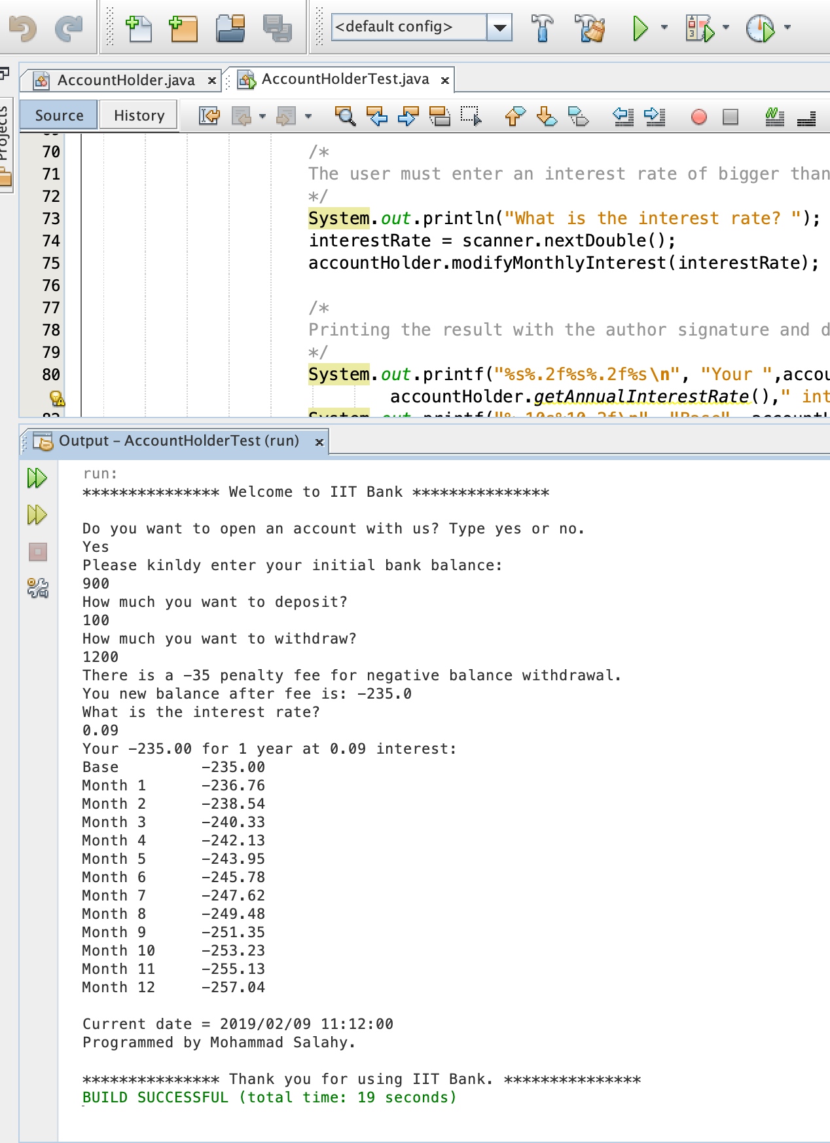

**Snapshot 2 – run #2**

**This snapshot prompt the user for an initial account balance. If the balance is negative, the system will ask the user to reenter a positive amount.**

