PB3 Unpressed (.9 duty cycle)

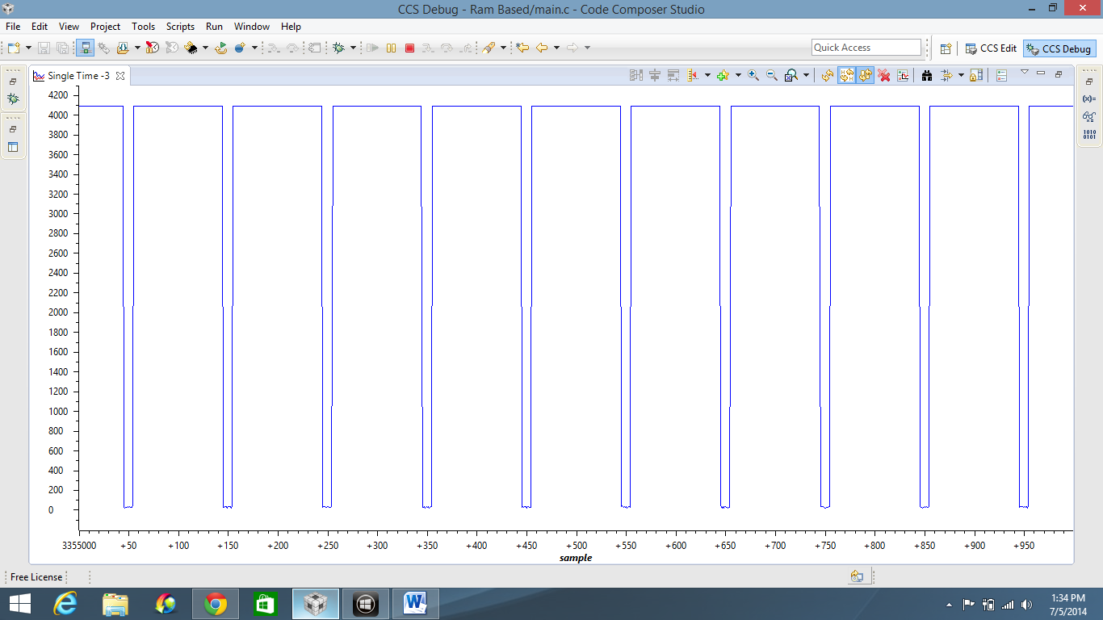

PB3 Pressed (.1 duty cycle)

