**Personal Body Fat Analyzer with Smartphone Integration**

ECE4012-L2A Senior Design Project

Team Quadcopter

Project Advisor, Pamela Bhatti

Marty Alcala

Brandon Bruen

John Bush

Philip Gordon

Submitted

August 28, 2014

**Table of Contents**

**Executive Summary**........... ii

1. **Introduction**..... 1

1.1 Objective...... 1

1.2 Motivation...... 1

1.3 Background...... 2

**2.** **Project Description and Goals**..... 4

**3.** **Technical Specification**..... 6

**4.** **Design Approach and Details**..... 6

4.1 Design Approach........ 6

4.2 Codes and Standards........ 13

4.3 Constraints, Alternatives, and Tradeoffs........ 14

**5.** **Schedule, Tasks, and Milestones**..... 14

**6.** **Project Demonstration**..... 15

**7.** **Marketing and Cost Analysis**..... 16

7.1 Marketing Analysis........ 16

7.2 Cost Analysis........ 17

**8.** **Current Status**..... 20

**9.** **References**.....21

**10.** **Bibliography**.....23

**Appendix A**........... 26

**Appendix B**........... 27

**Appendix C**........... 28

**Executive Summary**

Today’s user is very limited in their ability to have accurate and quick body fat measurements without having to spend extra money for professional grade testing. This experience can be enhanced by adjusting the model that many current on the market devices use and presenting that information in a way that is intuitive and easy to understand for the user. Team Quadcopter will design the FatTracker, a personal body fat analyzer that will be able to achieve accuracy in the range of 5-10% and present the data to the user on their smartphone in a timely manner. The FatTracker is comprised of an Arduino based Ohm meter that will send a signal through the body with the purpose of gathering the information of bodily resistance and reactance. The system will also have probes for this signal to be transmitted through. A Bluetooth modem will be used to then transmit this data to an Android based smartphone where the data acquired for resistance and reactance will be used along with personal info that the user provides to calculate a body fat percentage. Team Quadcopter expects this design to produce a working prototype and accompanying Android application for approximately $107.

**Personal Body Fat Analyzer with Smartphone Integration**

**1. Introduction**

In the interest of personal health and fitness, Team Quadcopter will design a system to calculate an individual’s body fat percentage in a swift and accurate manner. In order to accomplish this, we request funding in the amount of $107 for design hardware, baseline testing and application development.

**1.1** **Objective**

The team will design and implement a system based on bioelectrical impedance analysis to determine the body composition of the user, with specific emphasis on the proportion of weight composed of fatty tissues. By applying a voltage across the body of a subject, and in conjunction with a small known input resistance, a small current will be generated that will be detected by the device hardware. Based on the detected current, the impedance of the body in question will be determined. This impedance will be used in conjunction with a regression equation and other body characteristics to determine the fat free mass (FFM) of the individual. Based on initial input from the user, the most appropriate regression equation will be chosen by the device’s software, ensuring maximum accuracy for the individual in question.

**1.2** **Motivation**

Current body composition technology can be split into 2 categories: those that are accurate but take considerable time or effort, and those that give results quickly but are highly inaccurate [1]. The most easily accessible option for body composition testing is bioelectrical impedance analysis. This technique allows users to quickly determine their body composition alone and in the comfort of their own homes. However, despite the advantages this method allows, the results are often skewed by as much as 12% from the true value [2]. These inaccuracies can be caused by a number of factors including the subjects level of hydration, how recently they have eaten, and the distribution of fat across their body. Additionally, often bioelectrical impedance devices are designed to use a single body composition regression equation that makes assumptions about the subject’s body. While it is always necessary to make some assumptions about the subject for generation of a usable equation, these assumptions proving to be unfounded can lead to a considerable error. Compared to the gold standards of hydrostatic weighing or Dual-Energy X-Ray Absorptiometry which both offer results nearly within 3% accuracy [3], bioelectrical impedance analysis devices have a great deal of room for improvement. Current on market body composition analyzer models can cost anywhere from $20 to $200 [4]. By increasing the accuracy of our product while ensuring it can be economically produced, we will be able to market our device to both those in the fitness community and those seeking to monitor their health. In both cases, an easily accessible body composition analyzer would allow an additional metric concerning the state of the individual’s body.

**1.3** **Background**

While there are many different methods of determining body fat percentage in an individual, some of the most common are skin caliper testing, hydrostatic weighing, Dual-Energy X-Ray Absorptiometry (DEXA), and bioelectrical impedance [1].

Skin caliper testing requires that the subject use a set of calipers to take measurements of the amount of foldable skin on the body at different points including the arms, back, abdominals, and thighs. The measurements taken can then be read into a formula and an estimation of body fat percentage can be calculated. This method is viewed as very low cost, but prone to errors due to the limited amount of testing points.

Hydrostatic weighing requires that the subject be completely submerged in water and weighed. Based on the submerged readings, a calculation can be made for body fat percentage. This is viewed as one of the most accurate methods of obtaining body fat percentage and is viewed as “the gold standard”, but it requires specialized equipment. It is difficult to perform often and at low cost. Additionally, because during the process the person is asked to breathe out as much air as possible, it is often described as uncomfortable.

DEXA testing employs X-ray beams of different strengths. The subject is exposed to the different beams and the absorption of the X-rays by the body is used to determine its composition. DEXA is considered to be at least as accurate as hydrostatic weighing, but is less accessible due to the need for high energy X-ray equipment and a subsequent higher cost.

Bioelectrical impedance analysis (BIA) is conducted using a small electrical current on the order of 500 µA at a high frequency. A voltage is placed across the body and current is conducted from hand-to-foot, foot-to-foot, or hand-to-hand. The signal relies on conductive material to make its way through the body, most notably water. Because the water in the body is laced with conductive components such as sodium and potassium ions, its ability to conduct an electrical charge is further increased. In general, lean tissue is well hydrated, both inside and outside the cell in order to allow for normal operation. This hydration allows signals to be conducted very easily through these regions. However, fat stores are inherently hydrophobic, causing considerably lower levels of water to be found where fat is stored. Because of this lack of conductive material, signals travel more slowly because of the increased resistance of the region. By noting the net resistance that the signal experiences to travel from the source to the receiver, a general proportion of how much lean and fatty mass a subject has can be made [5] [6].

Many of the devices on the market today allow for considerable margins of error when testing body fat, with errors as high as 20%. This inaccuracy is in part due to considerable variations in body composition when considering a large target demographic. To compensate, the devices are limited to specific demographics of people. This allows for an increased accuracy within those groups. The FatTracker will ideally have an accuracy range of 5-10%. Also, we will make the population base for our device as large as possible, but limit our target demographic in ways that allow us to reach our goal in accuracy. Allowing the user to input various information about his-or-her body will allow for a dramatic increase in accuracy. Based on the information provided, the equation can be customized for the individual, and accuracy can be maximized.

The FatTracker will be comprised of an Arduino microcontroller for signal transmission and running the test , probes to attach to the test points on the body, and a Bluetooth modem to communicate with an Android smartphone running the FatTracker application. This design calls for the use of Android as the operating system of choice due to the fact that the permissions necessary for application development, in this case Bluetooth permissions, are easily accessible and can be pulled off of the internet [7].

**2. Project Description and Goals**

The goal of the FatTracker is to allow the user to take accurate body fat measurements on themselves in a way that is safe and intuitive and to be able to view this information on their Android smartphone. This system will be comprised of an Arduino microcontroller, bluetooth modem, probes taken from an existing on the market body fat analyzer, a Low Noise Amplifier (LNA), and an Android smartphone running the FatTracker application. The Goals of this system are as follows:

**Overall**

* Cost under $65
* Body fat measurement results presented to user within 10 seconds of test execution

**FatTracker Hardware**

* Bluetooth connectivity between the FatTracker and an Android Smartphone
* Low profile straps and harnesses for the probes

**Android Application**

* Simple and intuitive navigation for the user
* Initiate the test using the application
* Easy to access the results of the test

**3.** **Technical Specifications**

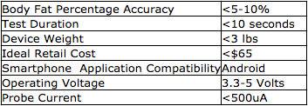

Table 1. Technical Specification

**4.** **Design Approach and Details**

**4.1** **Design Approach**

### 4.1.1 Overall System

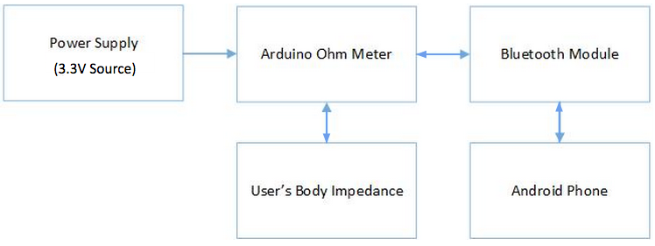

Figure 4.1 - Block Diagram of FatTracker Device

The FatTracker requires three main hardware components to facilitate body fat computation as shown in Figure 4.1:

* Arduino ohm meter
* Bluetooth module
* Android phone

The role of the Arduino will be to transmit sinusoidal AC waveforms via an analog output pin from one part of the body (such as a wrist) and to another (such as an ankle). AC signals will be used so that both resistance and reactance can be measured. During transmission, the Arduino will utilize an internal analog-to-digital module (ADC) to measure the voltage drop developed across the body, which will be then be used to compute the corresponding impedance of the body. Finally, the Arduino will interface with an external bluetooth module to send the resulting impedance measurement to the user’s Android phone.

Upon receipt of the impedance measurement, the Android phone will plug the measured value of the user’s impedance into a regression equation that has been preconfigured by the user to take into account additional factors such as age, height, activity level, etc. The result of the regression equation calculation will yield an estimated body fat percentage, which will then be displayed to the user on the smartphone screen and stored in non-volatile memory for long-term tracking.

### 4.1.2 Arduino Ohm Meter Subsystem

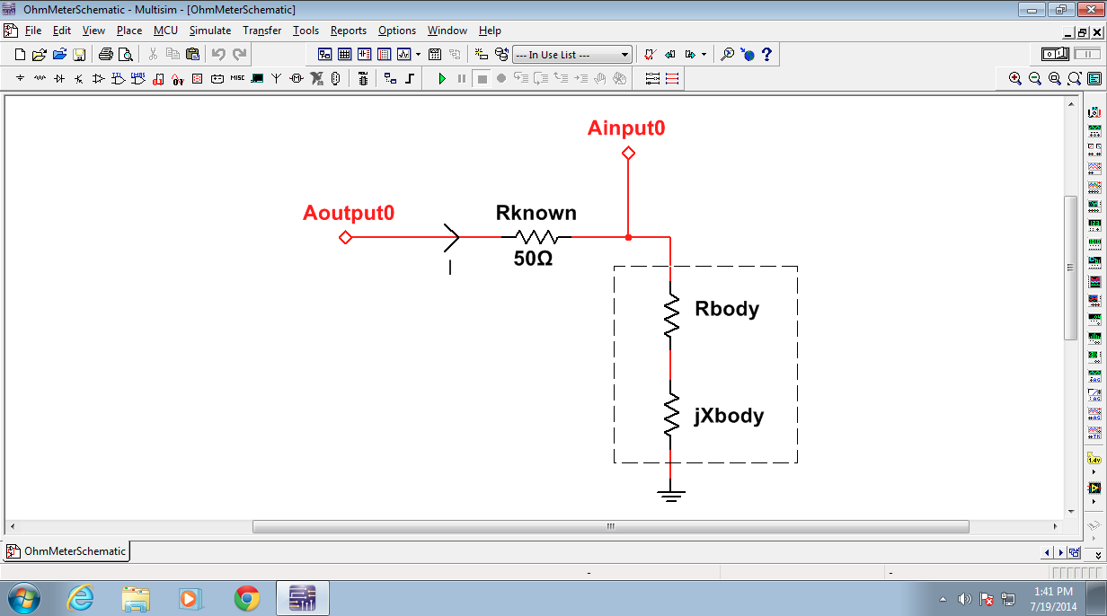

Figure 4.2 - Ohm Meter Schematic (Aoutput0 and Ainput0 correspond to pins on the Arduino)

The Arduino ohm meter subsystem is illustrated in Figure 4.2 and will be comprised of a 50 Ohm resistor (Rknown) in series with the user’s body (represented by the dashed box). The body impedance is modeled as the series interconnection of two components: the real resistance (Rbody) and the imaginary reactance (Xbody). The arduino will drive a high frequency AC sinusoid (to overcome the high-pass filtering effect induced by the cell membranes of the cells under test) through node Aoutput0 and will measure the resulting magnitude and phase of the voltage at node Ainput0. The purpose of Rknown is to enable the calculation of the current (I) flowing through the body via Ohm’s law:

$$I= \frac{(V_{in}-V_{body})}{R_{known}}$$

where

Vin: voltage supplied by the arduino at node Aoutput0

Vbody: measured voltage at node Ainput0

Once the current flowing through the body is known, the body’s impedance can be calculated via Ohm’s law by combining the computed current (I) with the voltage measured at node Ainput0, which is equivalent to the voltage drop across the body (Vbody):

Zbody = Rbody + jXbody = Vbody/I

The FatTracker will include four ohmic contacts (one to be placed on each wrist, and one to be placed on each ankle) to enable the impedance measurement of three unique body cross-sections:

* Upper-body (from right wrist to left wrist)
* Lower-body (from right ankle to left ankle)
* Full-body (from right wrist to left ankle)

By measuring multiple cross-sections, the design team hypothesizes that a more accurate body fat percentage measurement can be obtained than what is achievable from the measurement of only one cross-section. The locations of the ohmic contacts and the current paths through the three cross-sections to be measured are shown in Figure 4.3 below:

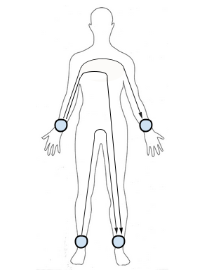

Figure 4.3 - Ohm Meter Contact Point Locations and Current Paths to Be Measured (Diagram created by Team Quadcopter)

### 4.1.3 Android Application

The android application serves as the user interface for the FatTracker. Upon placing each ohmic contact on each wrist and ankle, the user initiates the body fat measurement by tapping a button on the android phone, which sends a signal to the Arduino via bluetooth to begin AC waveform generation. As soon as the Arduino completes impedance measurements for all 3 cross-sections, the arduino transmits the measured impedance values to the android application via bluetooth. The application then plugs the impedance values into an equation that will closely resemble the following:

*FFM (kg) = 0.7\** (**Ht2/Rbody**) +*.18*\***BW** - *.18*\***Age** + *.12*\***Xbody** - *2.5* [8]

Where: FFM is the fat-free mass, Ht2 is height in cm, Rbody is the body resistance in ohms, BW is body weight in kg, age is in years, and Xbody is the body reactance in ohms. The $βn$ parameters are regression coefficients to be computed from experimental data once the first prototype has been built.

Once the fat-free mass has been approximated according to the equation above, the corresponding body fat percentage is computed according to (BW - FFM)/BW. The body fat percentage is then displayed on the smartphone screen and stored in non-volatile memory for long-term tracking.

Figure 4.4 below illustrates the two main screens with which the user will interact. The screen on the left displays the body fat percentage that has been most recently measured and contains a button to initiate a new measurement. The screen on the right depicts what is shown to the user as a measurement is taking place and gives the user the option to cancel the measurement. After the measurement completes, the user is again shown the screen on the left with the body fat percentage now updated to show the result of the latest measurement.

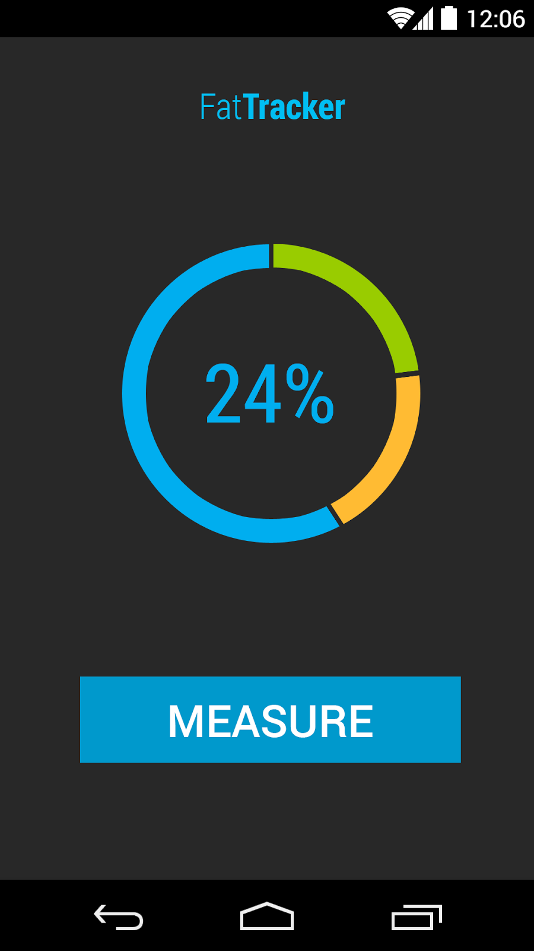 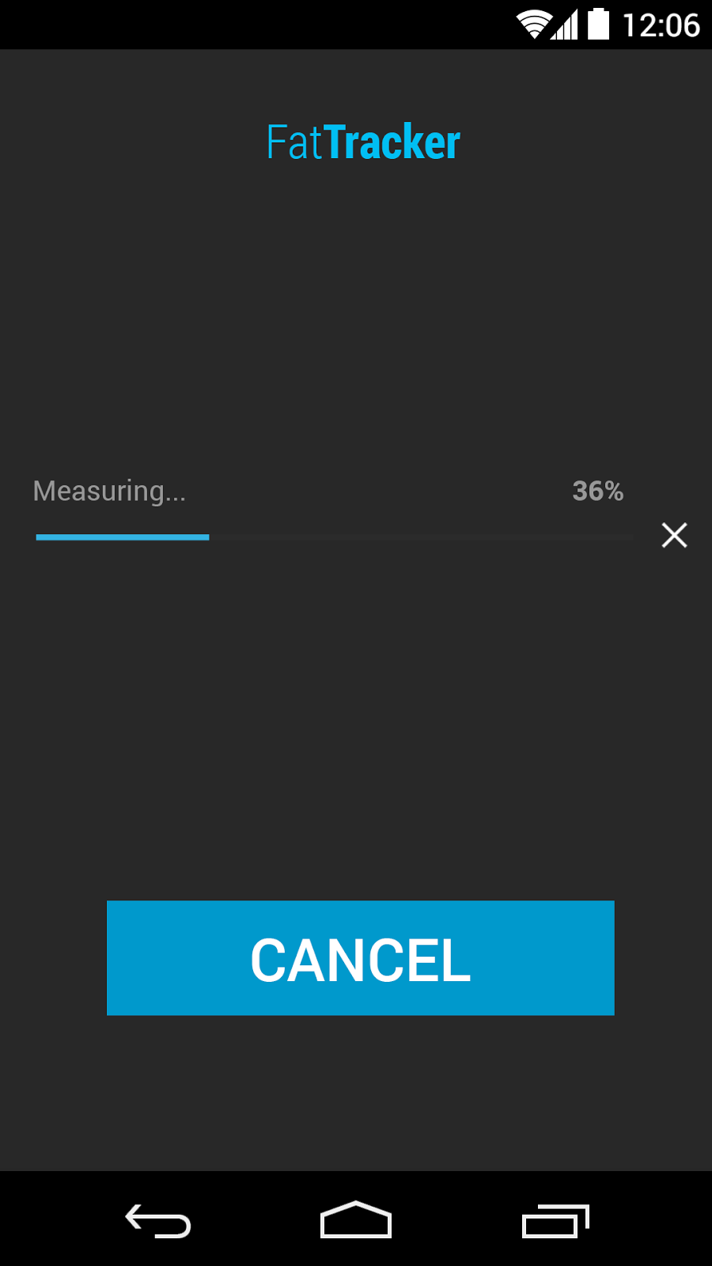

Figure 4.4 - Android App User Interface

#### **4.1.4 Critical Path Items**

The critical path items include:

* The prototyping of a signal generation procedure that produces a signal that is strong enough to be detected by the ADC
* The development of a measurement process that produces results with an accuracy of at least 5-10%.

The other requirements can be met by performing minor adjustments to the prototype after the aforementioned critical path items are successfully completed. Therefore, work on the critical path items will begin immediately at the start of the fall semester.

**4.1.5 Contingency Plans**

In the event that any of the planned designs fail, alternate components and procedures will be used. These are as follows:

* If the signal generated by the Arduino is not large enough to be detected by the ADC, a Low-Noise Amplifier (LNA) will be designed to amplify the signal delivered to Aoutput0
* If the Arduino’s internal ADC module exhibits quantization error in excess of 0.05% due to an inadequate resolution, a higher resolution external ADC module will be interfaced with the Arduino to measure the voltage at node Ainput0
* If the voltage drop across the 50 Ohm resistor is too small to measure body current accurately, a higher resistance value will be used instead
* If the Bluetooth module is not able to transmit data correctly to the smartphone, data can instead be routed to the smartphone’s audio jack via a wired connection

**4.2** **Codes and Standards**

* *Bluetooth (IEEE 802.15.1)*

This is the code and standard for the 2.4GHz range of data communication. It is required for the communication between the processor and any Bluetooth rated device [9]. The standard must be followed to ensure that there is proper communication between devices. The FatTracker will address this standard by interfacing the Arduino with a commercially available Bluetooth module to transmit the user’s body impedance measurements to the smartphone.

* *IEC 60601*

This is the medical standard for electrical devices that are used commercially. It defines safety and efficiency standards for approval for commercial distribution. Its requirements must be met for a product to be sold as a medical device. To meet this standard, the FatTracker must deliver no more than 500uA of current to the body during an impedance measurement [10].

**4.3** **Constraints, Alternatives, and Tradeoffs**

One constraint for the FatTracker will be the battery life of the device. A battery bank large enough to power the device will be needed. Ideally, the bank will allow the FatTracker to be used regularly for a reasonable period of time without needing to change batteries.

From the user’s perspective, the FatTracker needs to be intuitive to use and easy to operate. The user interface of the FatTracker will need to be laid out in a way that will allow the user to easily navigate and initiate testing. The probe with accompanying straps will need to be designed in a way that allows them to be comfortably and easily placed on the hands and feet of the user.

The largest tradeoff for the FatTracker is the accuracy of the model that will be used. The broader the user base, the lower the overall accuracy of the model.

**5.** **Schedule, Tasks, and Milestones**

The FatTracker prototype and application development will be completed between the time period of August to December of this year. Appendix A contains a table, breaking down each task involved, the associated team members leading those tasks, and the expected risk level. Appendix B contains a Gantt chart associated with the major tasks of this project. Appendix C contains a comprehensive Gantt chart for the entire project, including individual tasks.

**6.** **Project Demonstration**

In order to validate the proposed design, 2 areas of testing will be required:

1. Accuracy

2. Speed

In order to validate this system, two rounds of testing will be conducted. The first round will involve a small group being tested via one of the “gold standards” for body composition testing. Here, the most likely option will be hydrostatic weighing. These results will be compared to the results obtained from the FatTracker via statistical analysis. The second phase will involve a larger group being tested via skin calipers. Again, these measures will be compared to the results of the FatTracker. Ideally the first group will be as large as possible since hydrostatic testing will give us the most accurate measure with which to compare findings. However, skin calipers are still considered fairly accurate, and so they will be used as a means of minimizing prototyping costs.

Because the accuracy of this system will be based on a living person and will need to be compared to another method of testing, it will be impractical to truly demonstrate the accuracy to an audience, as that would involve hydrostatic testing. However, it will be practical to allow individuals to be measured by the FatTracker, a Omron Body Fat Analyzer [11], and possibly skin calipers. While this will not demonstrate the true accuracy of the system, it will demonstrate how the designed system compares with previously established, non-invasive measures. This, combined with well reported statistical analysis should serve to establish confidence in system accuracy.

A comparative demonstration as described above will necessitate the use of the FatTracker on individuals in the test. Because it will be in constant use for this demonstration, there will be ample opportunity to demonstrate the time taken for the system to operate. Again, when the speed of the FatTracker is compared to current on market devices, claims made about the speed of the device will be validated.

**7.** **Marketing and Cost Analysis**

**7.1** **Marketing Analysis**

The purpose of the FatTracker is to improve on existing models while keeping the price relatively close to current market prices. Most electronic body fat analyzers currently being used have error percentages that range from 10-20% on an average person. The problems with these analyzers are that they are not useful for those under 18, older than 60, those pregnant or suffering from dehydration, etc [11]. There is a long list of qualifications that are needed for someone to use one, which makes the user base much smaller than it could be. This is coupled with the fact that although there are more accurate ways of calculating body fat such as calipers, BodPods, hydrostatic weighing, the digital fat analyzers have still remained popular over the past decade. The market potential of a faster, more accurate body fat analyzer with a price range within a marginal budget is one that would be in high demand.

**7.2** **Cost Analysis**

It is expected that the cost of the FatTracker prototype will be approximately $107. Below, Table 2 displays the expected costs for each component both in individual costs, as well as what the total cost will be. The Omron body fat analyzer [11] is a current on the market device that will be vital in testing as well as for demonstration purposes, and it is also the most costly item for the development of the FatTracker.

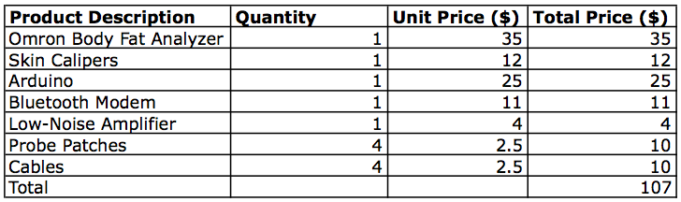Table 2 - Prototype Costs

The costs of development labor shown in Table 3 are assuming that each engineer will be paid an average starting salary of $60,000 per year, which equates to roughly $29 per hour. Team Quadcopter will be splitting task leads into two primary portions, hardware development and software development. The most time consuming task will be Algorithm Development at an expected 90 hours per person for two engineers. The Improvements task will tie heavily into Algorithm enhancement, therefore increasing the cost of this portion of development even further.

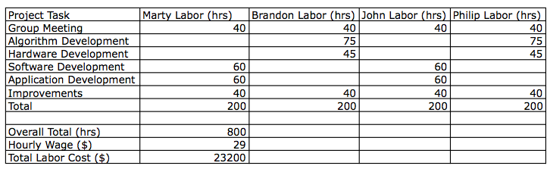

Table 3 - Labor Cost Analysis

Under the assumption of marketing the analyzer for five years and also assuming that sales of the unit are favorable, an estimate for the number of units sold will be 50,000 a year for a total of 250,000 units over five years. This means that the prices for each of the units will need to be the bulk-pricing format. The prices in Table 4 assume that the items were purchased in bulk and assembled by a contracted factory.

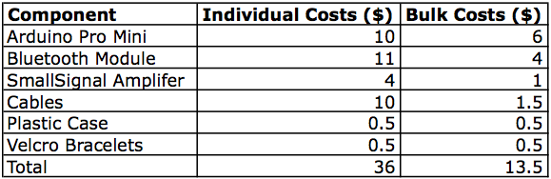

Table 4 - Bulk Component costs

For determining a marketable price, fringe benefits of 30% of labor costs will be included as well as a total overhead of 120% of the overall cost.

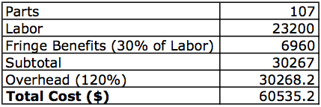

Table 5 - Total Costs of Development

The expected time for assembly is four units per hour per assembler. The expected time for unit testing is eight units per hour per technician. With an hourly wage of $10 per assembler and technician, the tabulated costs are in Table 6. All of the parts for assembly can be purchased at discount rates in bulk and have been totaled in the table below. After calculating fringe benefits, overhead and assuming that advertisements and salesmen will cost 10% of the total input costs, the final selling price will be set at $60.00 per unit. The expected revenue over the total five year production life of the analyzer from 250,000 units is $3,820,000.

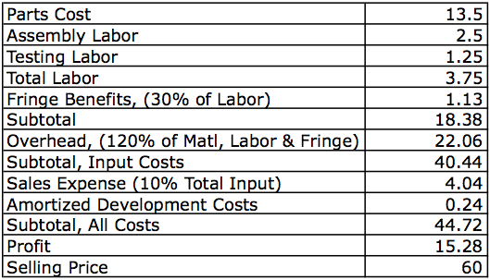

Table 6 - Per Unit Price Calculation

**8.** **Current Status**

Team Quadcopter has a comprehensive plan to begin prototype development as soon as the fall semester begins. We intend to order our parts within a week of our return, and to begin our development as soon as possible. We are hopeful that this approach will give us ample time to complete the FatTracker prototype in a timely manner that will allow for time to improve design and enhance performance.

**9.** **References**

[1] J. Duval, “5 Best Ways to Measure Body Fat Percentage,” Daily Burn, Dec. 2013. Available at: http://dailyburn.com/life/health/how-to-measure-body-fat-percentage/

[2] U. Kyle et al., “Bioelectrical impedance analysis-part 2: utilization in clinical practice,” Clinical Nutrition, Vol. 23, pp 1430-1453, Jun. 2004.

[3] A. Bosy-Westphal et al., “Bioelectrical Impedance Consumer Devices for Measurement of Body Composition in Comparison to Whole Body Magnetic Resonance Imaging and Dual X-Ray Absorptiometry.” European Journal of Obesity, Dec. 2008.

[4] C. Barnes, “Body fat scales reviews.” CHOICE, Dec. 2009, [Online]. Available: http://www.choice.com.au/reviews-and-tests/food-and-health/diet-and-exercise/weight-loss/body-fat-scales-review-and-compare/page.aspx.

[5] J.R. Moon, “Body composition in athletes and sports nutrition: an examination of the bioimpedance analysis technique,” European Journal of Clinical Nutrition, Vol. 67, pp.554-559, Jan 2013.

[6] U. Kyle et al., “Bioelectrical impedance analysis-part 1: review of principles and methods,” Clinical Nutrition, Vol. 23, pp 1226-1243, Jun. 2004.

[7] Android Developers. [2014]. *Bluetooth*. [Online]. Available: <http://developer.android.com/guide/topics/connectivity/bluetooth.html#Permissions>

[8] N. Macias. (2007, Aug. 15). *Body fat measurement by bioelectrical impedance and air displacement plethysmography: a cross-validation study to design bioelectrical impedance   
equations in Mexican adults* [Online]. Available: http://www.ncbi.nlm.nih.gov/pmc/  
articles/PMC2020472/#!po=3.12500

[9] IEEE Standards Association (2013, Aug. 20). *IEEE 802.15™: Wireless Personal Area*

*Networks (PANs)* [Online]. Available: <http://standards.ieee.org/about/get/802/802.15.html>

[10] CUI, Inc. (2013, July 1). *IEC 60601-1 Medical Design Standards - 3rd Edition* [Online].

Available: http://www.cui.com/catalog/resource/iec-60601-1-medical-design-standards.pdf

[11] Omron Healthcare Co. Ltd. *Body Fat Monitor Model BF-306*, Omron Healthcare, 2011.

**10.** **Bibliography**

* M. Mayank. (2011, Jun. 5). *What Is a Microcontroller? And How Does It Differ From a Microprocessor?* [Online]. Available: http://maxembedded.com/2011/06/05/mcu-vs-mpu
* S. [Evanczuk](http://edn.com/user/Stephen.Evanczuk). (2013, Aug. 20). *The Most Popular MCUs Ever* [Online]. Available:http://edn.com/electronics-blogs/systems-interface/4419922/10/Slideshow--The-most- popular-MCUs-ever
* D. Taylor. ECE 4550. Class Lecture, Topic: “Microcontrollers for Feedback Control Applications.” School of Electrical and Computer Engineering, Georgia Institute of Technology, Atlanta, GA, May 15, 2014.
* Spark Labs, Inc. (2014, May 27). *Build Internet-connected Hardware* [Online]. Available: http://spark.io
* J. Casey. (2003). *Body Fat Measurement: Percentage Vs. Body Mass* [Online]. Available: http://www.webmd.com/diet/features/body-fat-measurement.
* C. Kuzontkoski. “Weight Management.” Lecture. HPS 1040. Georgia Institute of Technology. Summer 2011.
* A. Hohm and B.L. Heitmann, “The use of bioelectrical impedance analysis for body composition in epidemiological studies,” European Journal of Clinical Nutrition, Vol. 67, S79-S85, Jan. 2013.
* R. Ramsey, E. Isenring, L.Daniels, “Comparing measures of fat-free mass in overweight older adults using three different bioelectrical impedance devices and three prediction equations,” The Journal of Nutrition, Health & Aging, Vol. 16, No. 1, pp. 26-30, Jan. 2012.
* Jawon Medical, “Bioelectrical Impedance Analysis (BIA).” [Online]. Available: http://www.jawon.com/reng/res/principles-of-bioelectrical-impedance-analysis.html
* Bluetooth Special Interest Group. 2014. *Mobile Telephony Market: Skyrocketing demand for Bluetooth accessories for latest phones.* [Online]. Available: http://www.bluetooth.com/Pages/Mobile-Telephony-Market.aspx
* C. Chung, S. Wang, C. Huang, C. Lin, “Bluetooth-based Android Interactive Applications for Smart Living,” in *Second International Conference on Innovations in Bio-inspired Computing and Applications*, Shenzhan, China, 2011, pp. 309-312
* *Specification of the Bluetooth System*, vol. 1, Bluetooth Special Interest Group, Kirkland, WA, 2013, pp. 17-18
* D. Butler, “What’s the Best Way to Measure Body Fat?” *health.com*, Mar. 13,2013. [Online]. Available: http://news.health.com/2013/03/13/how-to-measure-body-fat/. [Accessed June. 20, 2014].
* M. Jampolis, “Which Test Should I Trust When Measuring My Body Fat?” para. 8 *cnn.com,* Sep. 30, 2011. [Online] Available:http://www.cnn.com/2011/HEALTH/expert.q.a/09/30/body.fat.testing.jampolis/[Accessed June. 22, 2014].
* M. Ross, “Accuracy of Caliper Test for Body Fat” para 5. *livestrong.com* Oct. 20, 2013. [Online] Available: http://www.livestrong.com/article/339058-accuracy-of-the-caliper-test-for-body-fat/ [Accessed June. 21, 2014].
* M. Jampolis, “Which Test Should I Trust When Measuring My Body Fat?” para. 6 *cnn.com,* Sep. 30,2011.[Online]Available:http://www.cnn.com/2011/HEALTH/expert.q.a/09/30/body.fat.testing.jampolis/[Accessed June. 22, 2014].
* Brigham Young University YBeFit, *How the BodPod Works*, Brigham Young University, 2013.
* Lab Explanation. P409. Lab Summary, Topic: “Body Composition: Hydrostatic Weighing.” School of Exercise Physiology, Indiana University,Bloomington, IN, Mar. 3, 2011.
* J. Krieger, “Pitfalls of Body Fat Measurement, Part 4: Bioelectrical Impedance” *Weightology*: July, 2012 Part 4 ,July, 2012. [Online serial]. Available:http://weightology.net/weightologyweekly/?page_id=218. [Accessed June. 22, 2014].
* Amstel Medical, *How to use the Expert Skinfold Caliper*, Amstel Medical, 2013.

**Appendix A: Task List**

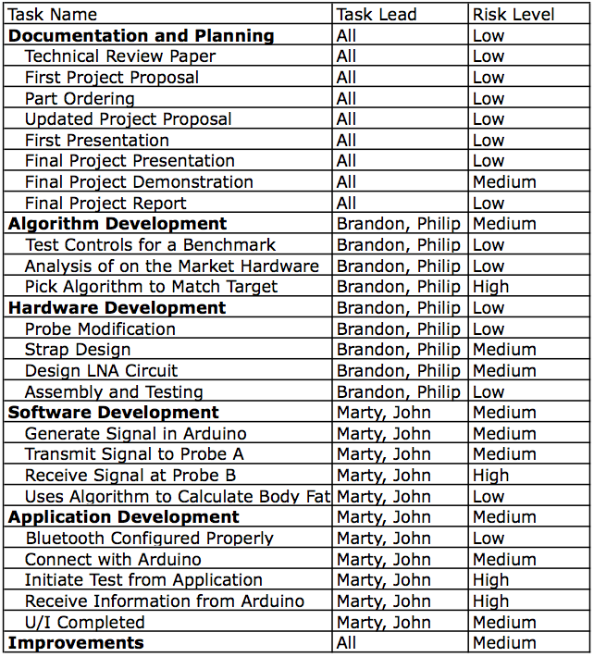

**Appendix B: Project Gantt Chart**

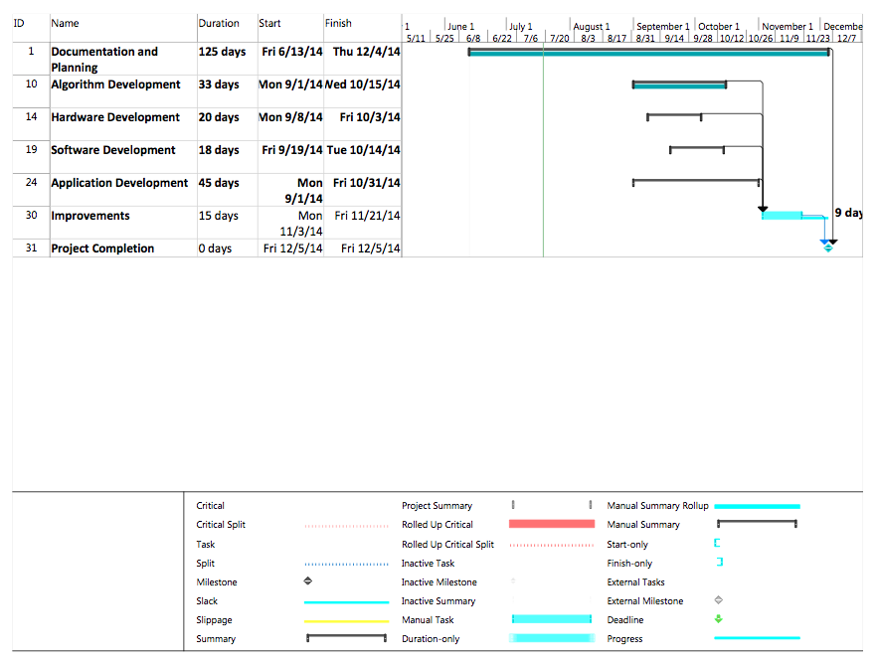

**Appendix C: Comprehensive Gantt Chart**

