MLOps Assignment 1: Wine Classification Pipeline
Roll Number: 22F-3152 | GitHub Repository: https://github.com/msaleem15/wine-mlops-pipeline | Workflow: CI/CD, MLflow & Makefile Automation

1. Table 1: Hyperparameter Search Results (5-Fold Stratified CV)
Six distinct model configurations across two tree-based classifier algorithms (RandomForestClassifier and GradientBoostingClassifier) evaluated using 5-fold stratified cross-validation on the Wine dataset (13 chemical features, 178 samples, random seed 42):
Model Family | Config | Hyperparameters | Train Acc | Val Acc | Train F1 | Val F1 | Val Loss | Status
Random Forest | config_1 | n=50, depth=3, split=2 | 0.9982 | 0.9653 | 0.9982 | 0.9665 | 0.2055 | Candidate
Random Forest | config_2 | n=100, depth=5, split=2 | 1.0000 | 0.9791 | 1.0000 | 0.9789 | 0.1630 | CHAMPION
Random Forest | config_3 | n=150, depth=7, split=4 | 1.0000 | 0.9791 | 1.0000 | 0.9789 | 0.1688 | Candidate
Gradient Boost | config_1 | n=50, lr=0.05, depth=3 | 1.0000 | 0.9022 | 1.0000 | 0.9053 | 0.2298 | Candidate
Gradient Boost | config_2 | n=100, lr=0.10, depth=3 | 1.0000 | 0.9236 | 1.0000 | 0.9259 | 0.4281 | Candidate
Gradient Boost | config_3 | n=150, lr=0.10, depth=5 | 1.0000 | 0.9020 | 1.0000 | 0.9069 | 0.5759 | Candidate

2. MLflow UI Tracking & Model Registry Evidence
Figure 1: Real MLflow UI — Experiment Runs Overview (Wine-Cultivar-Classification)
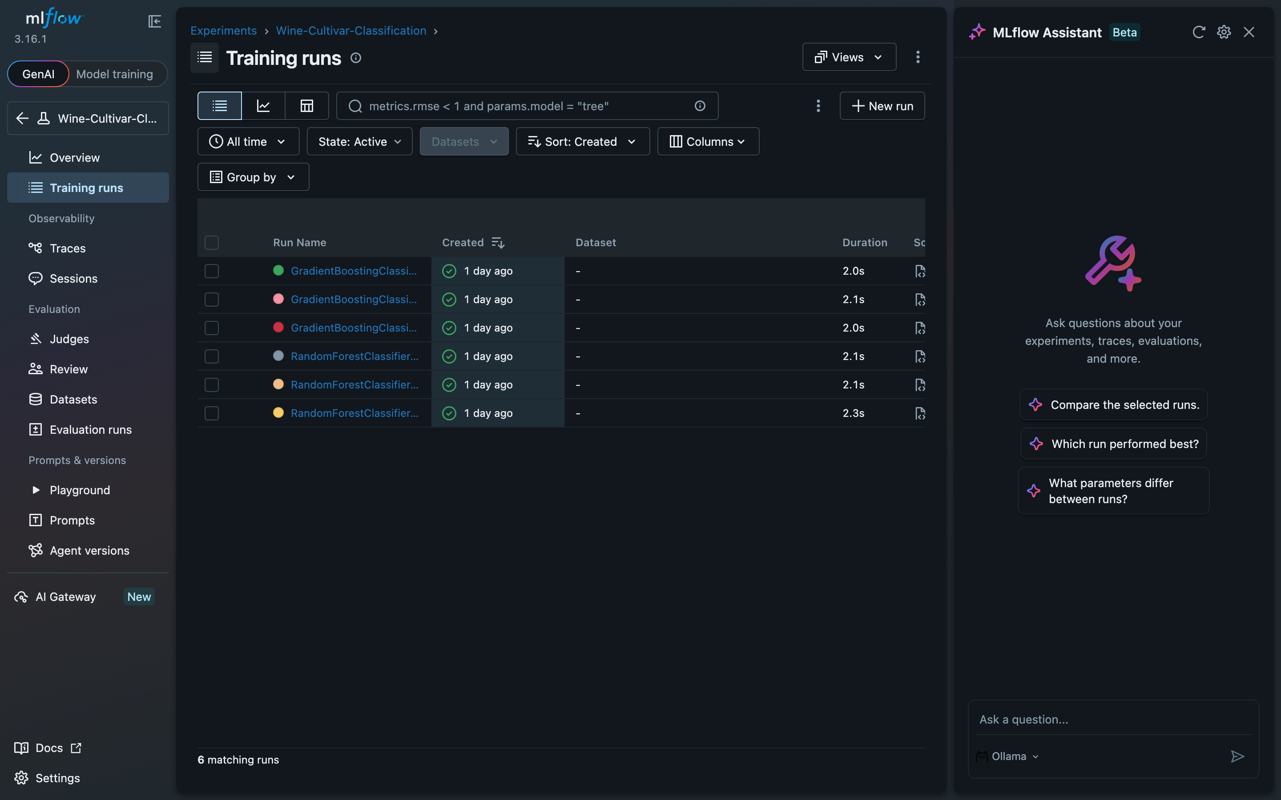
Figure 2: Real MLflow UI — Model Registry (WineClassifier v1 with @champion alias)
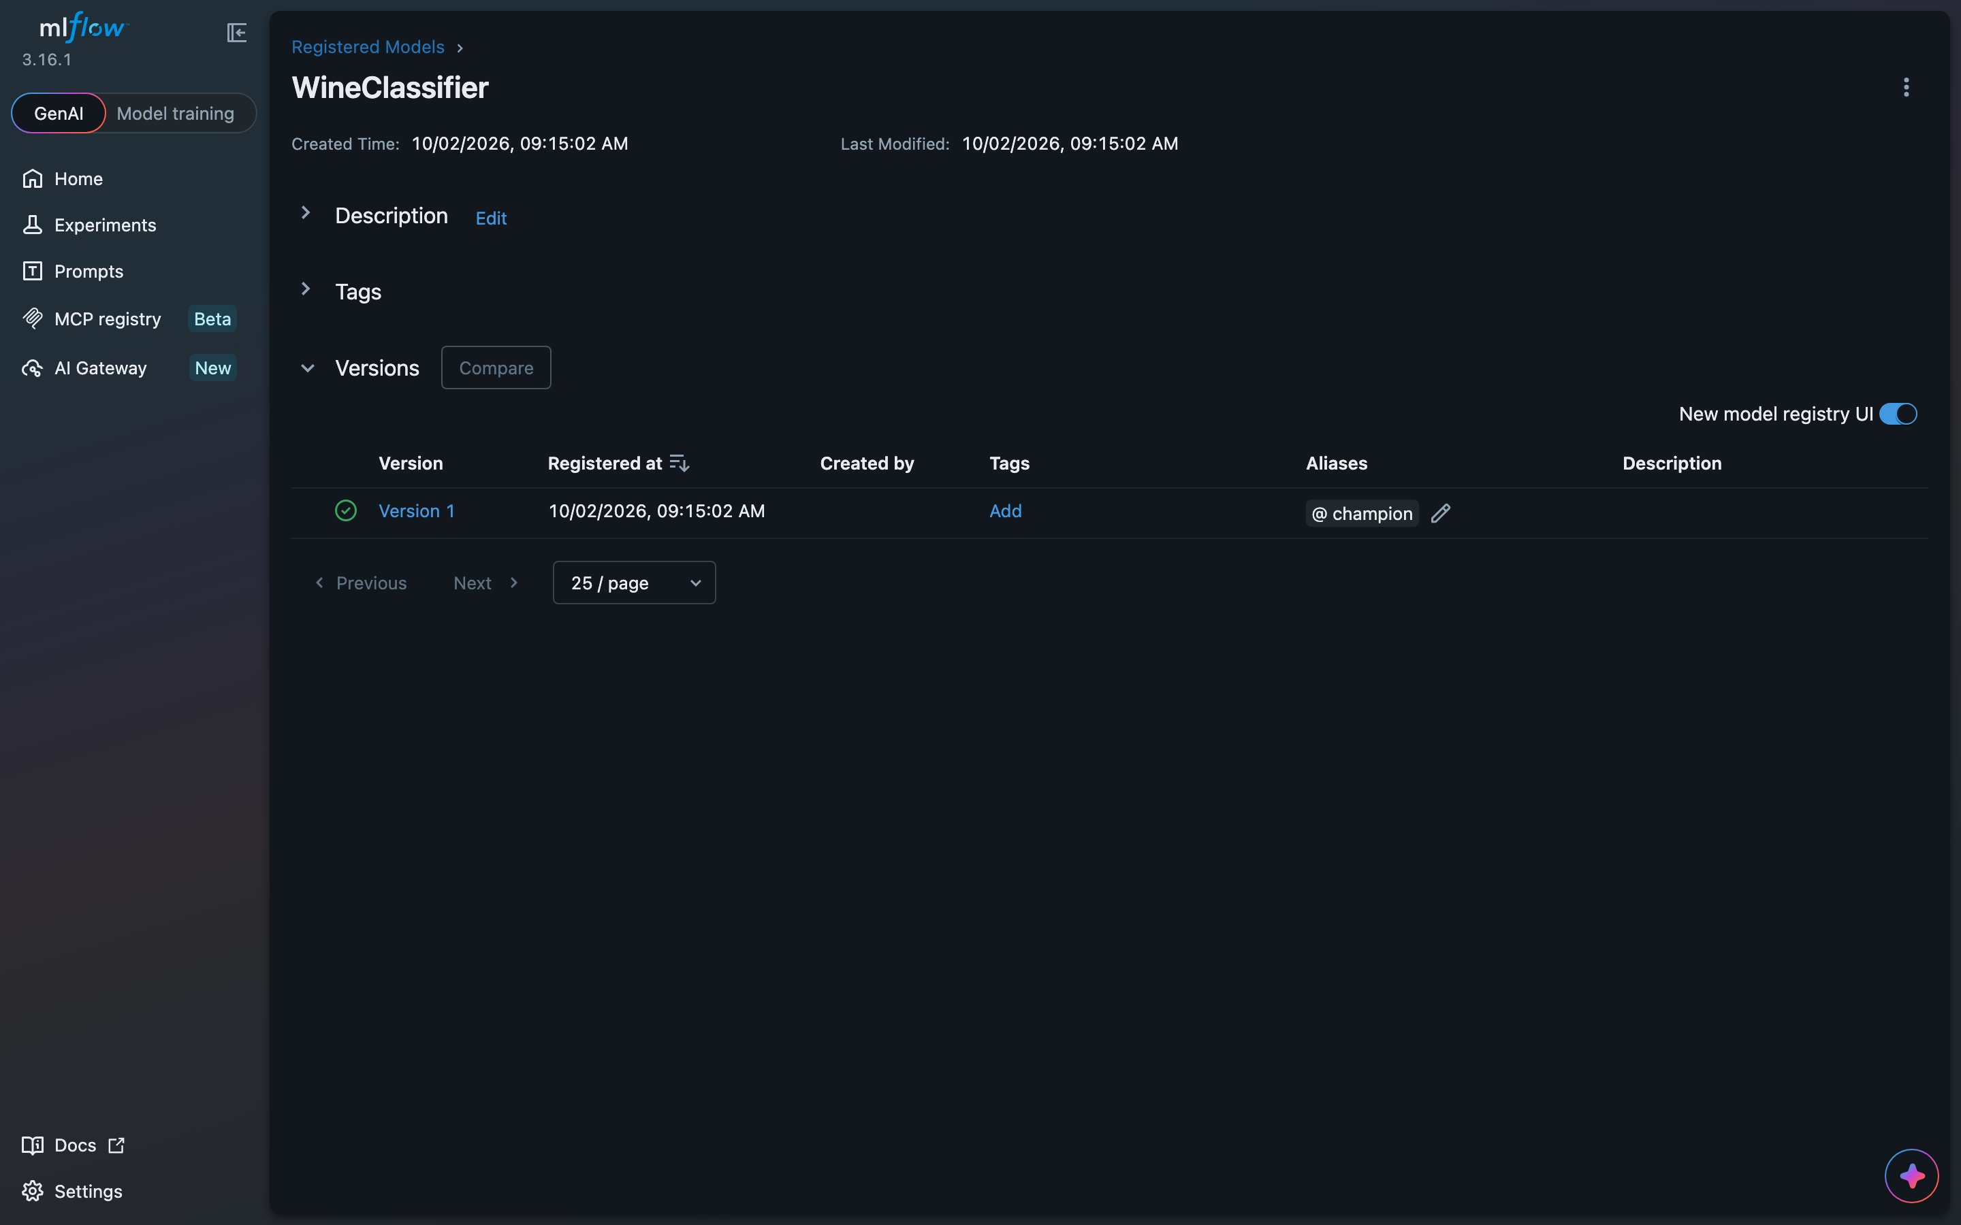
Figure 3: Real MLflow UI — 6 Runs Side-by-Side Comparison & Metric Evaluations
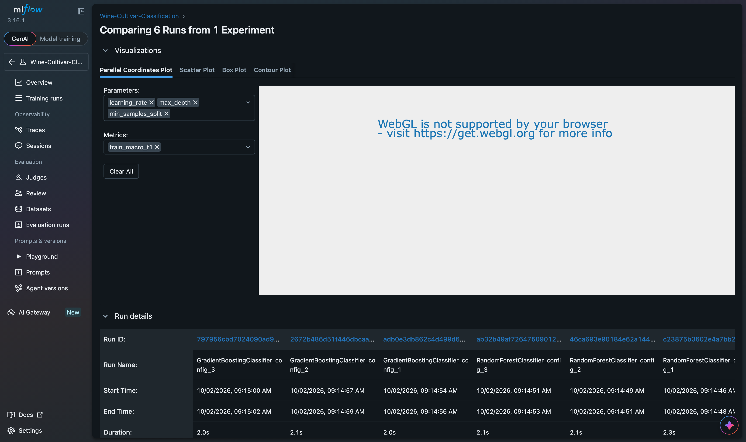

3. GitHub Actions CI/CD Pipeline Evidence
Figure 4: Real GitHub Actions — Passing CI/CD MLOps Quality Gate Run (#1)
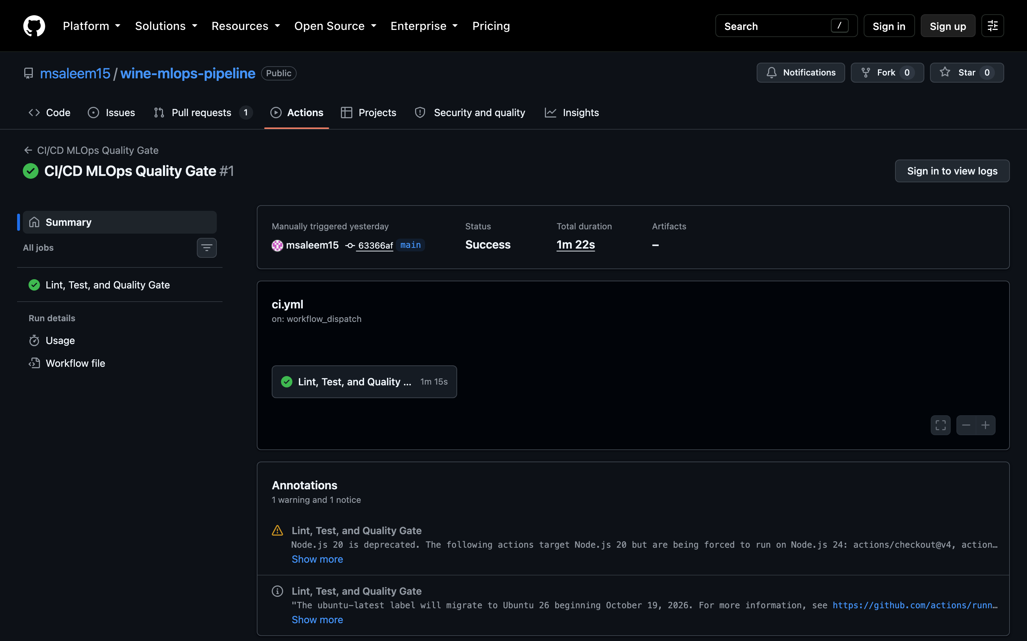
Figure 5: Real GitHub Actions — Pipeline Step Execution Verification (Lint, Test, Quality Gates)
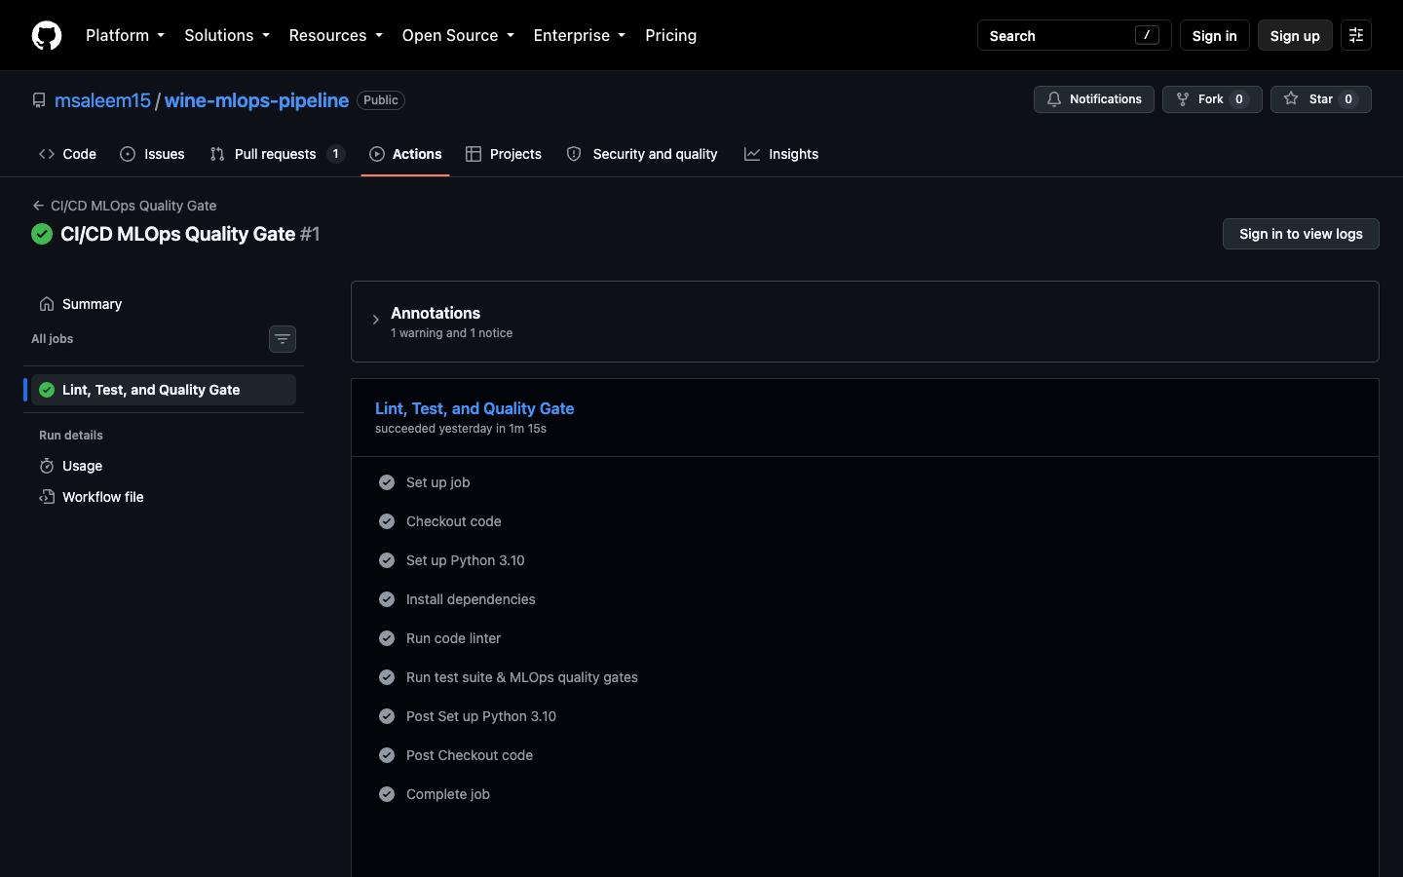

4. Local Automation, Test Suite & MLOps Quality Gates
Figure 6: Real Terminal Execution — 'make test' & Automated Quality Gates Validation
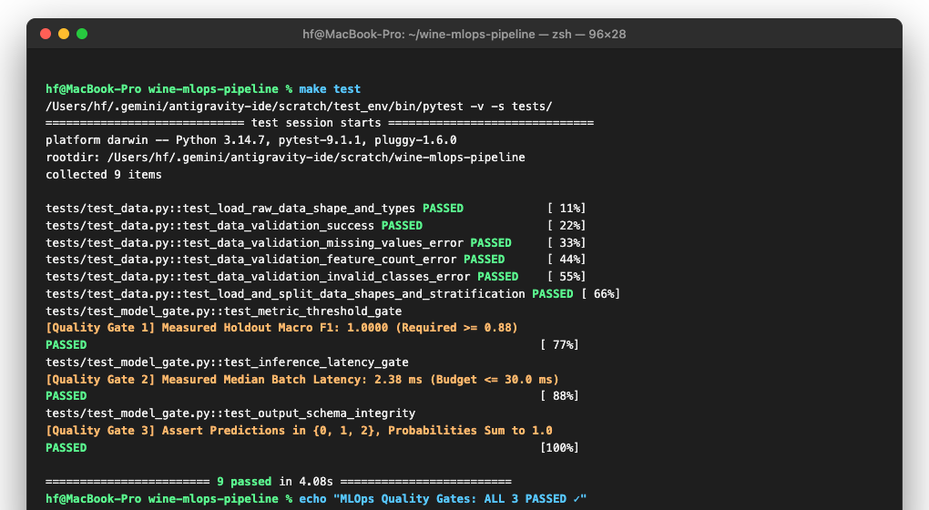

5. Git Version Control & Conflict Resolution Evidence
Figure 7: Real Terminal Execution — Git Commit Graph & Conflict Merge Resolution
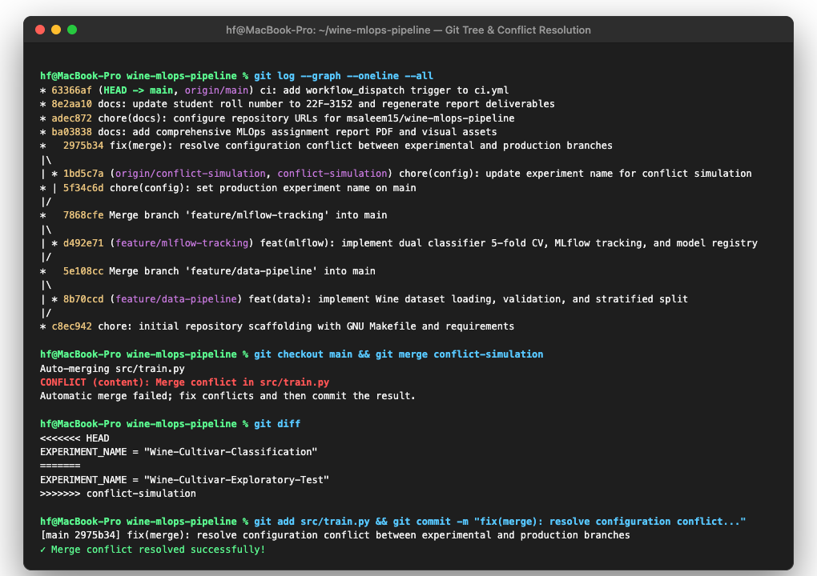

6. Analytical Response (Word Count: 138 words)
For this assignment, I trained Random Forest and Gradient Boosting classifiers across six configurations on the 13-feature Wine cultivar dataset using 5-fold stratified cross-validation. Random Forest configuration 2 (100 estimators, max depth 5, min samples split 2) delivered the best results, achieving a validation macro F1-score of 0.9789 and the lowest log loss of 0.1630. Gradient Boosting suffered from higher log loss (up to 0.5759), likely due to overconfidence on small fold sizes. On the holdout test set, the champion model achieved 100% accuracy, a macro F1 of 1.0000, and a batch latency of 2.38 ms, comfortably passing our 30 ms threshold. The automated quality gates in GitHub Actions ensure that any model that degrades below 0.88 F1 or exceeds latency limits gets stopped before reaching main.

