🤖 Project Title: TechBot – AI Technology Chatbot

1. Project Introduction
🔹 Problem Statement
Many AI chatbots rely on internet-based APIs such as OpenAI or cloud services. These solutions:
- Require constant internet access
- May have usage costs
- Raise privacy concerns
There is a need for an offline AI chatbot that can:
- Run locally
- Provide fast responses
- Work without external APIs

🎯 Objective
The objective of this project is to develop an AI-powered chatbot using .NET that:
- Classifies user queries into predefined categories
- Generates intelligent responses
- Works completely offline using a custom-trained ML model
- Demonstrates full AI lifecycle:
  - Data collection
  - Model training
  - Deployment
  - Integration with UI

2. System Design
🏗️ Architecture Diagram (Conceptual)
User (WinForms UI)
│
▼
ChatbotEngine.cs (C#)
│
▼
Python Script (predict.py)
│
▼
Trained ML Model (TF-IDF + LinearSVC)
│
▼
Predicted Intent + Response (JSON)
│
▼
Back to UI (Displayed to User)

🔄 Workflow
- User enters a question in the UI
- C# application captures input
- Input is sent to Python script
- Python loads trained model
- Text is converted to numerical features (TF-IDF)
- Model predicts intent using LinearSVC
- Response is selected from dataset
- Result is returned as JSON
- UI displays chatbot response

3. Tools & Technologies
Category | Technology
Framework | .NET 8
Language | C#
UI | WinForms
AI Model | TF-IDF + LinearSVC
ML Library | scikit-learn
Python | Python 3.8+
Data Handling | JSON
Serialization | Pickle
Containerization | Docker
Version Control | GitHub

4. Code Snippets
🔹 C# – Calling Python Model
var psi = new ProcessStartInfo
{
FileName = "python",
Arguments = $"predict.py \"{input}\"",
RedirectStandardOutput = true,
UseShellExecute = false,
CreateNoWindow = true
};
Explanation
- Launches Python script
- Sends user input
- Captures output

🔹 Python – Prediction Logic
X_word = word_tfidf.transform([text])
X_char = char_tfidf.transform([text])
X = hstack([X_word, X_char])

intent = clf.predict(X)[0]
Explanation
- Converts text into numerical vectors
- Combines features
- Predicts intent

🔹 JSON Output
print(json.dumps({
"intent": intent,
"response": response,
"confidence": confidence
}))
Explanation
- Sends structured data back to C#
- Enables easy parsing

5. Application Preview
🖥️ UI
- Dark-themed chat interface
- Chat bubbles for user & bot
- Input textbox and send button
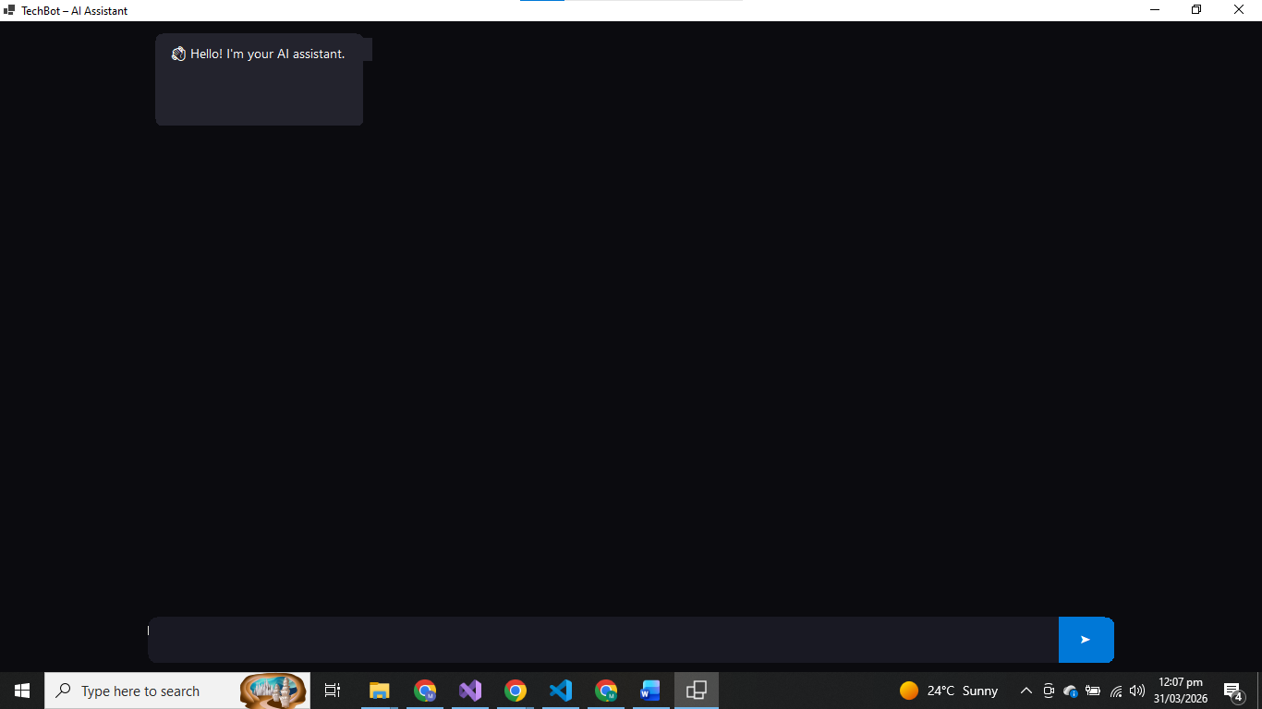
💬 Output
- Displays:
  - Bot response
  - Predicted intent
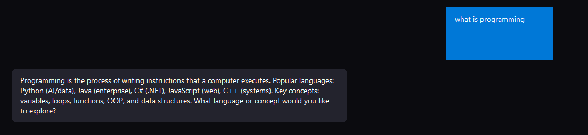
⚙️ Working Process
- User types question
- Bot responds instantly
- No internet required

6. Testing
🧪 Sample Inputs & Outputs
Input | Output Intent | Response
hello | greeting | Hello! How can I help you?
what is AI | artificial_intelligence | AI enables machines to simulate intelligence
what is SQL | database | SQL is used to manage databases
what is GPU | hardware | GPU processes graphics data
bye | farewell | Goodbye!

7. Results & Discussion
✅ What Worked Well
- High accuracy (~95%+)
- Fast response time
- Fully offline functionality
- Clean UI integration
- Stable C#–Python communication

⚠️ Limitations
- Limited to 12 intents
- Cannot handle complex conversations
- No memory of previous chats
- Confidence score is approximate
- Requires Python installed

8. Future Improvements
- Add more intents and training data
- Implement conversation memory
- Convert model to ONNX (remove Python dependency)
- Use advanced models like BERT
- Add voice input/output
- Deploy as web application

9. Docker Requirement
🐳 Dockerfile
FROM mcr.microsoft.com/dotnet/runtime:8.0

WORKDIR /app

COPY . .

RUN apt-get update && \
apt-get install -y python3 python3-pip && \
pip3 install scikit-learn scipy numpy

CMD ["dotnet", "AIChatbot.dll"]

📖 Explanation
Base Image
- Uses .NET runtime image
- Lightweight and optimized
Build Process
- Copies project files
- Installs Python dependencies
Run Command
- Starts the .NET application
- Executes chatbot

10. GitHub Submission
📂 Repository Must Include
- Source Code
- Practical Report
- Theory Report
- Dockerfile

📄 README.md Must Include
- Project description
- Setup instructions
- Screenshots
- How to run project

✅ Conclusion
TechBot successfully demonstrates an AI-based .NET application that:
- Uses machine learning without APIs
- Integrates Python with C#
- Provides real-time chatbot responses
It fulfills all assignment requirements including:
✔ UI
✔ AI Integration
✔ Docker
✔ GitHub

