
LAB REPORT 04+05+06+07
Resistor color coding
Series combination of resistors
Parallel combination of resistors
Series/combnation of resistors

SUBMITTED TO: MAM BUSHRA SHAHEEN

SUBMITTED BY: MUHAMMAD SALEH HAYAT

REGISTRATION_NO: 232201070

CLASS: BSCS-4-B.

SUBJECT: APPLIED PHYSICS(LAB)

SUBMISSION DATE: 03/04/2025

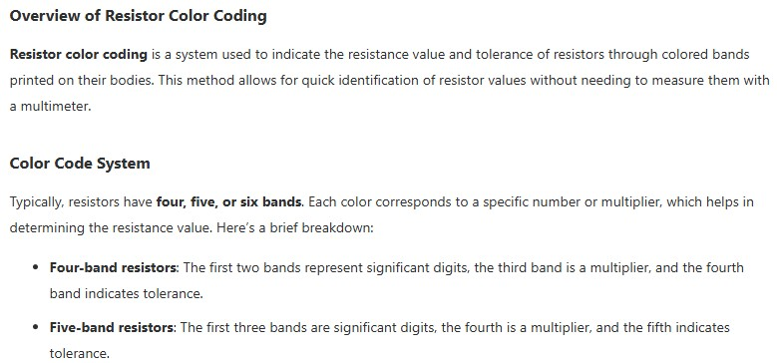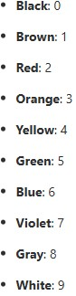

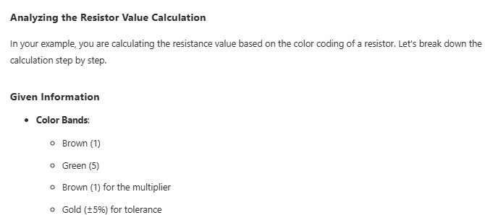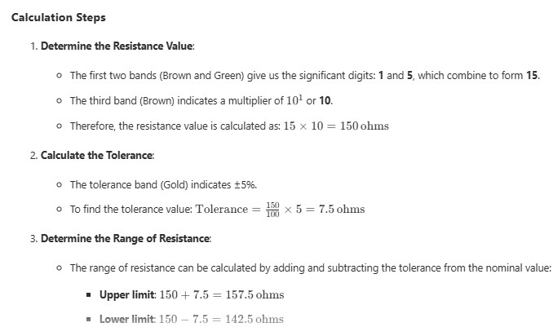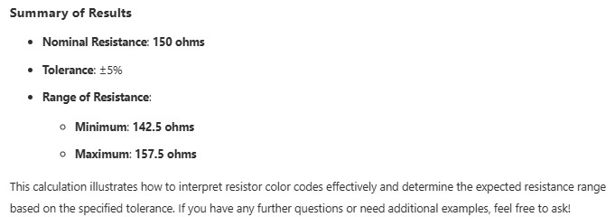

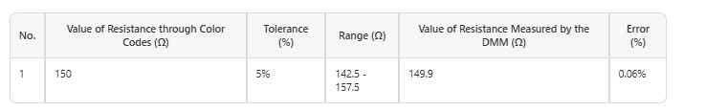

Lab report 05:
Lab Report: Series Combination of Resistors:
In this lab report, we will explore the behavior of resistors when connected in series.
Understanding this concept is crucial for analyzing electrical circuits and their properties.
Objective
The primary objective of this experiment is to investigate how resistors behave when connected in series and to verify the theoretical calculations of total resistance.

Materials
- Resistors of known values (e.g., 100Ω, 220Ω, 330Ω)
- Breadboard or circuit board
- Multimeter
- Connecting wires
- Power supply (battery)

Procedure
- Setup the Circuit: Connect the resistors in series on the breadboard. Ensure that the connections are secure and that the resistors are properly aligned.
- Measure Individual Resistances: Use the multimeter to measure the resistance of each resistor to confirm their values.
- Connect the Power Supply: Attach the power supply across the series combination of resistors.
- Measure Total Resistance: Use the multimeter to measure the total resistance across the series combination.
- Record Data: Document the individual resistances and the measured total resistance

Diagram:
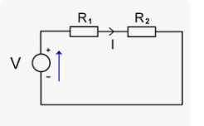

Experiment:
In this diagram we have two resistors and a voltage or power supply.
Analysis of Resistor Combination:
In this analysis, we will verify the calculations for the series combination of two resistors, R-1 and R-2 and the resulting voltage drops across each resistor.

Given Values
- R_1 = 215Ω
- R_2 = 988Ω
- Total Voltage V = 6V

Total Resistance Calculation
The equivalent resistance _{Req for} resistors in series is calculated as follows:
Req = R_1 + R_2 = 215Ω + 988Ω = 1203Ω

Voltage Drop Across Each Resistor
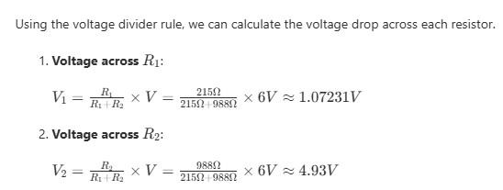
Verification of Total Voltage
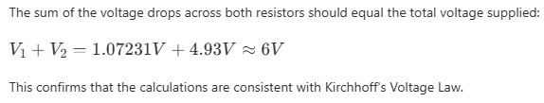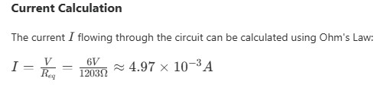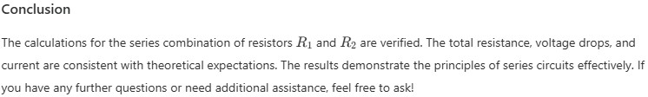

PARALLEL COMBINATION OF RESISTORS
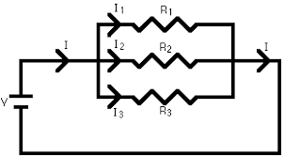

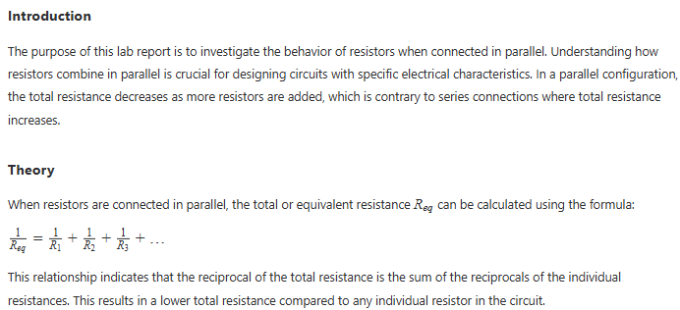
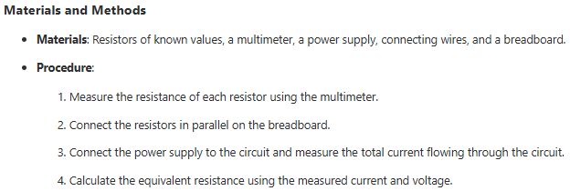

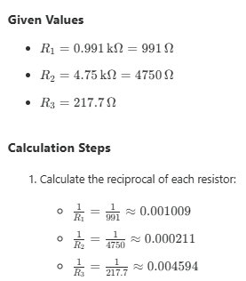
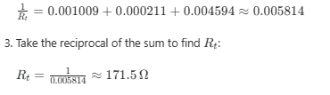
Total current:
