RBF: An R package to compute a robust backfitting estimator for additive models

17 November 2020

# Summary

Although highly flexible, non-parametric regression models typically require large sample sizes to be estimated reliably, particularly when they include many explanatory variables. Additive models provide an alternative that is more flexible than linear models, not affected by the curse of dimensionality, and also allow the exploration of individual covariate effects. Standard algorithms to fit these models can be highly susceptible to the presence of a few atypical or outlying observations in the data. The RBF (Salibian-Barrera and Martı́nez 2020) package for R implements the robust estimator for additive models of Boente, Martı́nez, and Salibian-Barrera (2017), which can resist the damaging effect of outliers in the training set.

# Statement of Need

The purpose of RBF is to provide a user-friendly implementation of a robust kernel-based estimation procedure for additive models that is resistant to the presence of potential outliers.

# Implementation Goals

RBF implements a user interface similar to that of the R package gam (Hastie 2019), which computes the standard non-robust kernel-based fit for additive models using the backfitting algorithm. The RBF package also includes several modeling tools, including functions to produce diagnostic plots, obtain fitted values and compute predictions.

# Background

Additve models offer a non-parametric generalization of linear models (Hastie and Tibshirani (1990)). They are flexible, interpretable and avoid the *curse of dimensionality* which means that, as the number of explanatory variables increases, neighbourhoods rapidly become sparse, and much fewer training observations are available to estimate the regression function at any one point.

If $Y$ denotes the response variable, and $\text{X}=(X_{1},…,X_{d})^{⊤}$ a vector of explanatory variables, then an additive regression model postulates that where the error $ϵ$ is independent of $\text{X}$ and centered at zero, the location parameter $μ∈R$, and $g_{j} : R→R$ are smooth functions. Note that if $g_{j}(X_{j})=β_{j} X_{j}$ for some $β_{j}∈R$ then reduces to a standard linear regression model.

The backfitting algorithm (Friedman and Stuetzle (1981)) can be used to fit the model in with kernel regression estimators for the smooth components $g_{j}$. It is based on the following observation: under the additive components satisfy. Thus, each $g_{j}$ is iteratively computed by smoothing the partial residuals as functions of $X_{j}$.

It is well known that these estimators can be seriously affected by a relatively small proportion of atypical observations in the training set. Boente, Martı́nez, and Salibian-Barrera (2017) proposed a robust version of backfitting, which is implemented in the RBF package. Intuitively, the idea is to use the backfitting algorithm with robust smoothers, such as kernel-based M-estimators (Boente and Fraiman (1989)). These robust estimators solve:

$$\underset{μ,g_{1},…,g_{d}}{\text{min}}E\left[ ρ\left(\frac{Y−μ−\sum_{j=1}^{d}{g_{j}}(X_{j})}{σ}\right)\right] ,$$

where the minimization is computed over $μ∈R$, and functions $g_{j}$ with $E[g_{j}(X_{j})]=0$ and $E[g_{j}^{2}(X_{j})]<∞$. The loss function $ρ:R→R$ is even, non-decreasing and non-negative, and $σ$ is the residual scale. Different choices of the loss function $ρ$ yield fits with varying robustness properties. Typical choices for $ρ$ are Tukey’s bisquare family and Huber’s loss (Maronna et al. (2018)). Note that when $ρ(t)=t^{2}$, this approach reduces to the standard backfitting.

# Illustration

The airquality data set contains 153 daily air quality measurements in the New York region between May and September, 1973 (Chambers et al. (1983)). The interest is in modeling the mean Ozone (${\text{O}}_{3}$) concentration as a function of 3 potential explanatory variables: solar radiance in the frequency band 4000-7700 (Solar.R), wind speed (Wind) and temperature (Temp). We focus on the 111 complete entries in the data set.

Since the plot in suggests that the relationship between ozone and the other variables is not linear, we propose using an additive regression model of the form

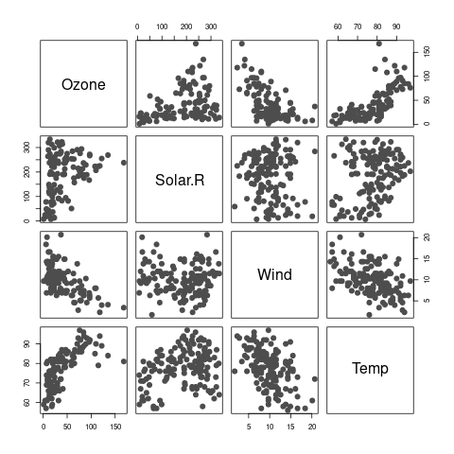

Scatter plot of the airquality data. The response variable is Ozone.

To fit the model above we use robust local linear kernel M-estimators and Tukey’s bisquare loss function. These choices are set using the arguments degree = 1 and type='Tukey' in the call to the function backf.rob. The model is specified with the standard formula notation in R. The argument windows is a vector with the bandwidths to be used with each kernel smoother. To estimate optimal values we used a robust leave-one-out cross alidation approach (Boente, Martı́nez, and Salibian-Barrera (2017)) which resulted in the following bandwidths:

R> bandw <- c(136.7285, 10.67314, 4.764985)

The code below computes the corresponding robust backfitting estimator for :

R> data(airquality)  
R> library(RBF)  
R> ccs <- complete.cases(airquality)  
R> fit.full <- backf.rob(Ozone ~ Solar.R + Wind + Temp, windows=bandw,   
 degree=1, type='Tukey', subset = ccs, data=airquality)

To compare the robust and classical estimators we use the R package gam. Optimal bandwidths were estimated using leave-one-out cross-validation as before.

R> library(gam)  
R> aircomplete <- airquality[ccs, c('Ozone', 'Solar.R', 'Wind', 'Temp')]  
R> fit.gam <- gam(Ozone ~ lo(Solar.R, span=.7) + lo(Wind, span=.7) +   
 lo(Temp, span=.5), data=aircomplete)

contains partial residuals plots and both sets of estimated functions: blue solid lines indicate the robust fit and magenta dashed ones the classical one.

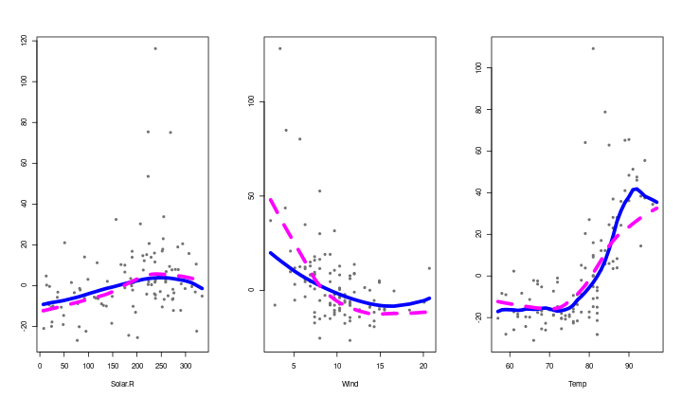

Partial residuals and fits for the airquality data. Robust and classical fits are shown with solid blue and dashed magenta lines, respectively.

The two fits differ mainly on the estimated effects of wind speed and temperature. The classical estimate for $g_{1}(\text{Temp})$ is consistently lower than the robust counterpart for $\text{Temp}≥85$. For wind speed, the non-robust estimate ${\hat{g}}_{2}(\text{Wind})$ suggests a higher effect over Ozone concentrations for low wind speeds than the one given by the robust estimate, and the opposite difference for higher speeds.

Residuals from a robust fit can generally be used to detect the presence of atypical observations in the training data. displays a boxplot of these residuals. We note 4 possible outlying points (indicated with red circles).

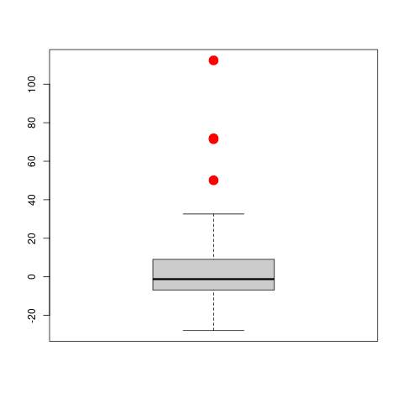

Boxplot of the residuals obtained using the robust fit. Potential outliers are highlighed with solid red circles.

To investigate whether the differences between the robust and non-robust estimators are due to the outliers, we recomputed the classical fit after removing them. shows the estimated curves obtained with the classical estimator using the clean data together with the robust ones (computed on the whole data set). Outliers are highlighted in red. Note that both fits are now very close. An intuitive interpretation is that the robust fit has automatically down-weighted potential outliers and produced estimates very similar to the classical ones applied to the clean observations.

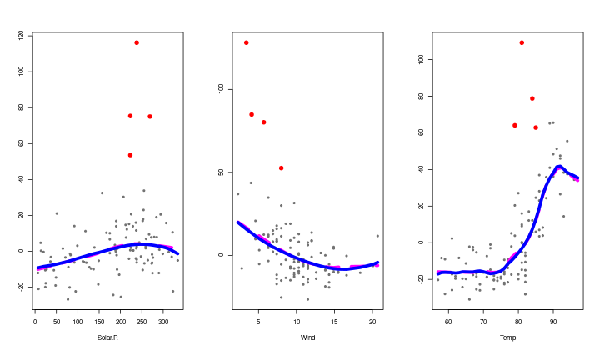

Plots of estimated curves and partial residuals. The solid blue lines indicate the robust fit computed on the whole data set, while the classical estimators computed on the clean data are shown with dashed magenta lines. Larger red circles indicate potential outliers.

# Availability

The software is available at the Comprehensive R Archive Network [CRAN](https://CRAN.R-project.org/) and also at the GitHub repository <https://github.com/msalibian/RBF>. The GitHub repository also contains detailed scripts reproducing the data analysis above.

# Acknowledgements

This research was partially supported by: 20020170100022BA from the Universidad de Buenos Aires; project PICT 2018-00740 from ANPCYT; Internal Projects CD-CBLUJ 301/19 and CD-CBLUJ 204/19 from the Department of Basic Science of the Universidad Nacional de Luján (UNLu); the Researchers in Training Project RESREC-LUJ 224/19 (UNLu); and by the Natural Sciences and Engineering Research Council of Canada (Discovery Grant RGPIN-2016-04288).

# References

Boente, Graciela, and Ricardo Fraiman. 1989. “Robust Nonparametric Regression Estimation.” *Journal of Multivariate Analysis* 29 (2): 180–98.

Boente, Graciela, Alejandra Martı́nez, and Matias Salibian-Barrera. 2017. “Robust Estimators for Additive Models Using Backfitting.” *Journal of Nonparametric Statistics* 29 (4): 744–67. <https://doi.org/10.1080/10485252.2017.1369077>.

Chambers, J. M., W. S. Cleveland, B. Kleiner, and P. A. Tukey. 1983. *Graphical Methods for Data Analysis*. 2nd ed. London: Chapman & Hall.

Friedman, J. H., and W. Stuetzle. 1981. “Projection Pursuit Regression.” *Journal of the American Statistical Association* 76 (376): 817–23.

Hastie, T. J., and R. J. Tibshirani, eds. 1990. *Generalized Additive Models*. London: Chapman & Hall.

Hastie, Trevor. 2019. *Gam: Generalized Additive Models*. <https://CRAN.R-project.org/package=gam>.

Maronna, Ricardo A., R. Douglas Martin, Victor J. Yohai, and Matias Salibian-Barrera. 2018. *Robust Statistics: Theory and Methods (with R)*. 2nd ed. John Wiley & Sons.

Salibian-Barrera, Matias, and Alejandra Martı́nez. 2020. *RBF: Robust Backfitting*. <https://CRAN.R-project.org/package=RBF>.