TCL scripting for Magic Layout

Manuel Salim Maza

January 19th, 2026

1. Overview.

Under Open tools, using Magic for layout generation and editing has proven to be a hard task:
- long learning curve;
- repetitive tasks;
- missing p-cells;
- grid-based layout instead of object/p-cell/hierarchy.

Last two bullets are well covered in commercial tools, flows and pdks as cadence virtuoso and custom compiler synopsys.

Fortunately, Magic have:
- human readable format;
- console that accepts TCL scripting;
- natural visual DRC check.

So, I present a TCL scripts .txt with functions that automate some common structures for Magic, trying to make hard task a little more automated.
Effort is in progress but at thjs point it can help with custom transistors and metal busses.
In short time we can work on Resistances, Capacitors, transistor flavors, rings, cml buffers, cml flip-flops, and scrambling I buses.

2.- How to use.

Scripts are placed at /foss/designs/wlv/design/analog/common_logic/magic_scripts/my1st.tcl.tcl
1.- Open the .tcl in a txt editor and get familiar with the scripts or at least the *_test headers.

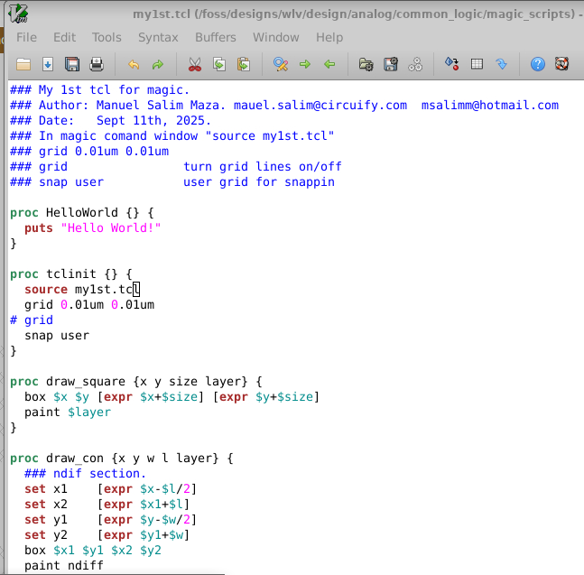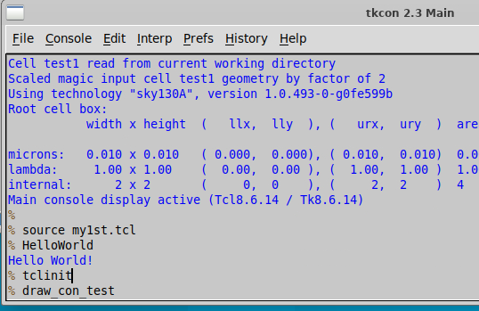
Figure 1.- my1st.tcl header and Magic console.

List of all *_test proc so far:
draw_con_test Test for contacts
draw_tran_test Test for vanilla nmos transistors
draw_tran_jog_test Test for vanilla nmos transistors with W jog
draw_tran_poly_con_test Test for vanilla nmos transistors with poly contacts
draw_busi_hori_test Test for metal bus I horizontal
draw_busesi_hori_test Test for metal buses I horizontal
draw_busi_vert_test Test for metal bus I vertical
draw_busesi_vert_test Test for metal buses I vertical
draw_via_test Test for via matrix
draw_busl_test Test for metal bus L *.
draw_busl_scram_test Test for metal bus L with scrambled order.
draw_busu_busc_test Test for metal bus U and bus C with scrambled order **.

*) Bus L supports negative length for rotations but via in the corners need to manually match metal widths and via coverages. Need to improve that either with metal positions or via coverage.
**) Actually there are 2-4 bus L making the U and C. No real need to make a long parameters line but 2-4 lines/calls.

2.- Run Magic.
3.- Source the .tcl
4.- Check tcl is sourced by entering HelloWorld.
5.- Initialize the grid values and snap by entering tclinit. If you need different grid, we need to develop a strategy in case there is conflict. I can try making it a variable too. Please let me know.
6.- Check entering any proc (procedure) that ends in _test.
Check headers of _test and comment in proc no _test to understand usage of _test and proc.

3.- Running all the test so far.

3.1.- draw_con_test Test for contacts

draw_con_test shows you examples on how to use draw_con proc. It draws a transistor diffusion given x,y coordinates, diffusion width and length, and top metal layer. It draw diffusion, contacts and metal and vias up to layer requested. It calculates and centers number of contacts and vias that fits the transistor width. So far only supports a vertical line of contacts and up to metal 2.

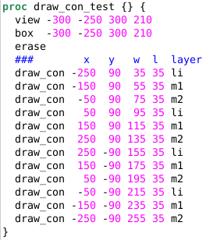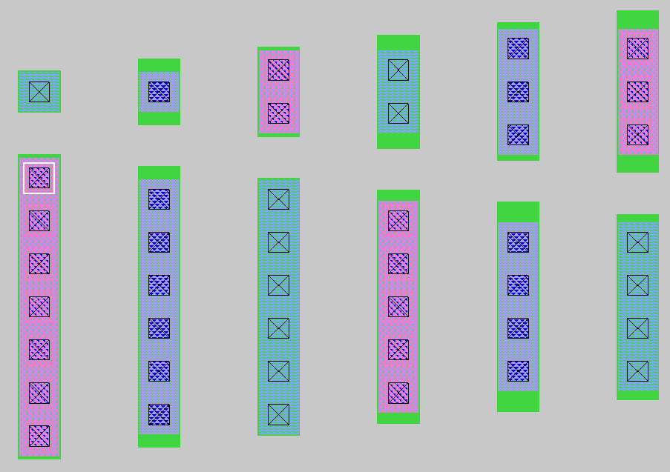
Figure 2.- draw_con_test.

3.2.- draw_tran_test Test for vanilla nmos transistors

draw_tran_test shows you examples on how to use draw_tran proc. It draws a vanilla nmos transistor given x,y coordinates; transistor width, length and number of fingers; and top metal layer for diffusion contacts. It uses draw_con, so it inherits its capabilities and limitations.

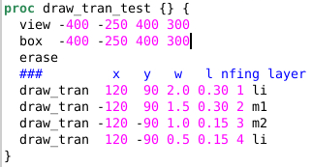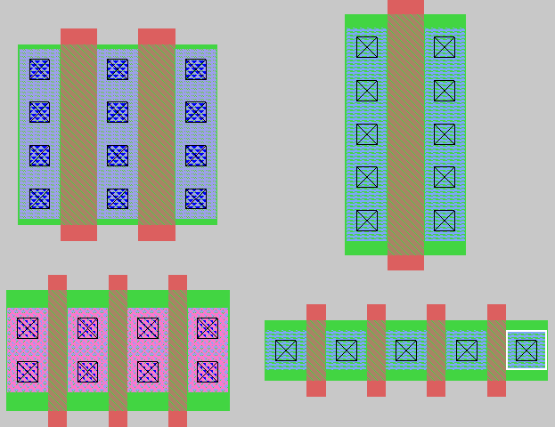
Figure 3.- draw_tran_test.

3.3.- draw_tran_jog_test Test for vanilla nmos transistors with W jog

draw_tran_jog_test shows you examples on how to use draw_tran_jog proc. It draws a vanilla nmos transistor given x,y coordinates; transistor width and length list that support different w and l per finger; and metal layerlist for diffusion contacts. It uses draw_con, so it inherits its capabilities and limitations. The lists follow tcl rules, so it need to be inside “[list <my list>]” syntax.

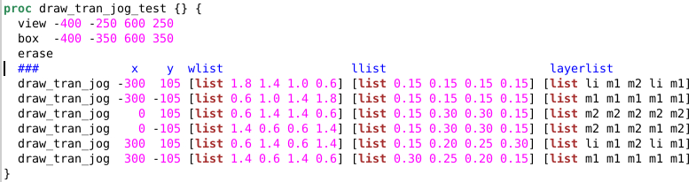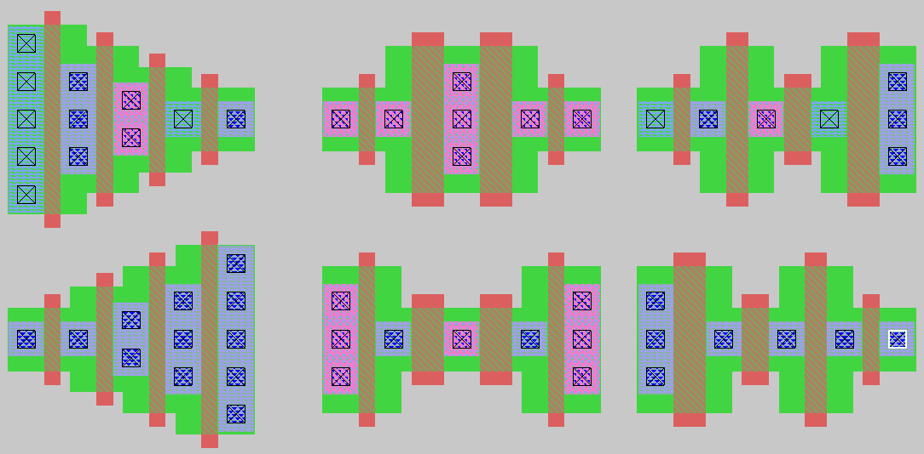
Figure 4.- draw_tran_jog_test.

3.4.- draw_tran_poly_con_test Test for vanilla nmos transistors with poly contacts

draw_tran_poly_con_test shows you examples on how to use draw_tran_poly_con proc. It draws a vanilla nmos transistor given x,y coordinates; transistor width, length and number of fingers; top metal layer for diffusions; numer of poly contacts in the top and bottom region of transistor; and top layer for metal for poly contacts. It supports different number of metal for poly contacts at top or bottom regions but poly contacts top metal is the same. Proc can be changed, or a new proc can be created very easily if needed to be different top metals. Also if list are needed per fingers and/or poly contacts.

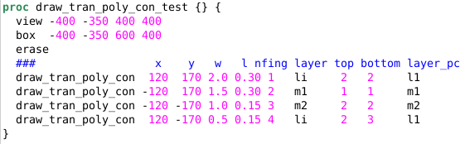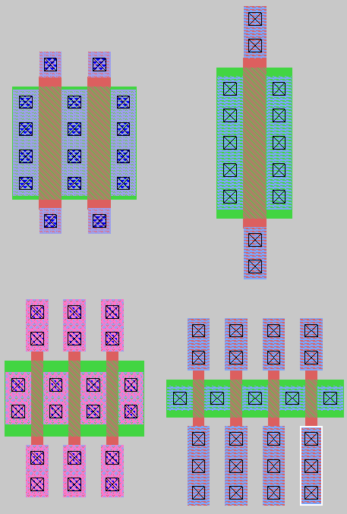
Figure 5.- draw_tran_poly_con_test.

3.5.- draw_busi_hori_test Test for metal bus I horizontal

draw_busi_hori_test shows you examples on how to use draw_busi_hori proc. It draws a single metal horizontal bus. It is straight, so the I name. No vias, no corners, no jogs, no scrambling. You can specify x,y coordinates; metal width, length; number of signals in the bus; spacing between metals and metal layer.

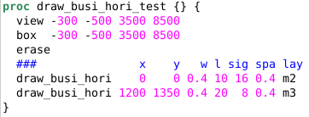
Figure 6.- draw_busi_hori_test.

3.6.- draw_busesi_hori_test Test for metal buses I horizontal

draw_busesi_hori_test shows you examples on how to use draw_busesi_hori proc. It draws nbus metal horizontal buses. It uses draw_busi_hori script style, so it inherits its capabilies and limitations. In addition you can specify numer of buses and space between buses.

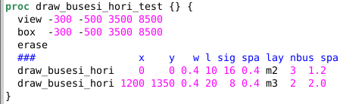
Figure 7.- draw_busesi_hori_test.

3.7.- draw_busi_vert_test Test for metal bus I vertical

Same as hori version but vertical.

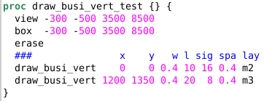
Figure 8.- draw_busi_vert_test.

3.8.- draw_busesi_vert_test Test for metal buses I vertical

Same as hori version but vertical.

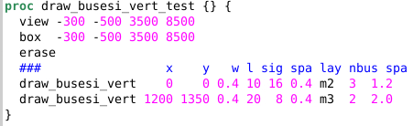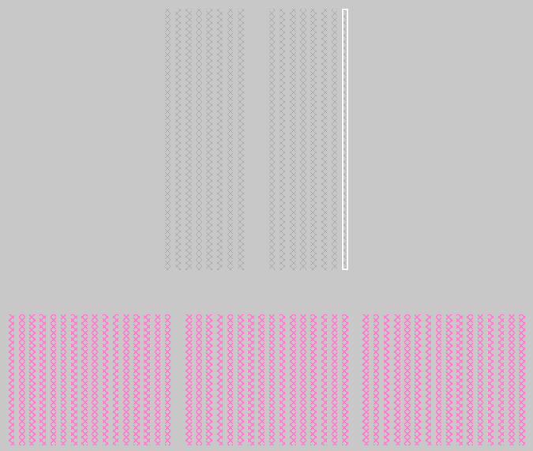
Figure 9.- draw_busesi_vert_test.

3.9.- draw_via_test Test for via matrix

draw_via_test shows you examples on how to use draw_via proc. It draws a matrix of vias with its top and bottom metal. You can specify x,y cordinates, via length (width=height), via spacing, metal coverages, number of vias in x and y directions, top and bottom layers and via layer. So it is fully customizable for different metal/via layersand any size, spacing or coverage.

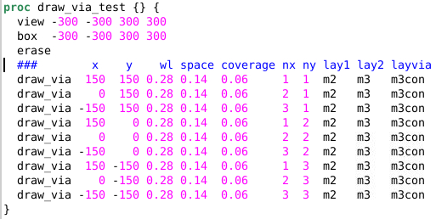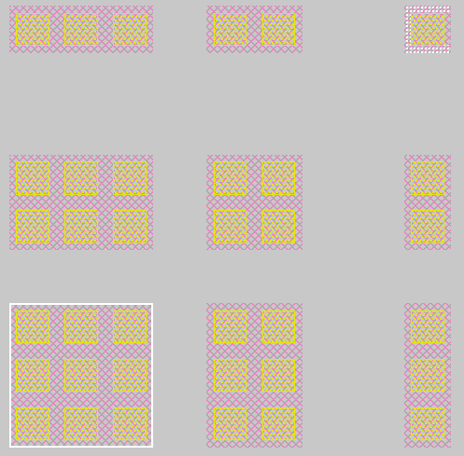
Figure 10.- draw_via_test.

3.10.- draw_busl_test Test for metal bus L *.

draw_busl_test shows you examples on how to use draw_busl proc. It draws a L bus. You can specify x,y coordinates of outmost corner; number of signals in bus; width, length, spacing and metal layers of the two segments of the L; number of vias in x and y direction and via layer.It uses draw_via proc, so it inherints its capabilies and limitations. It is fully customizable in bus metal width, length and spacing, so it can work for any metal. Right now via is focusing in m3con sizes but it can be fully customizable very easily.
Bus lenghts accept negative numbers, so different rotations can be produced. Although need to improve script to match metal width with via width for negative lengths. So far it is ok with widths shown and can be done manually modifying the script or having the via script variables availabel in the L bus. Or with an improved version that fix the x,y position for negative numbers.

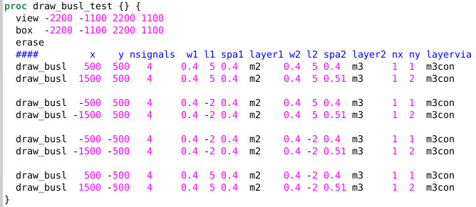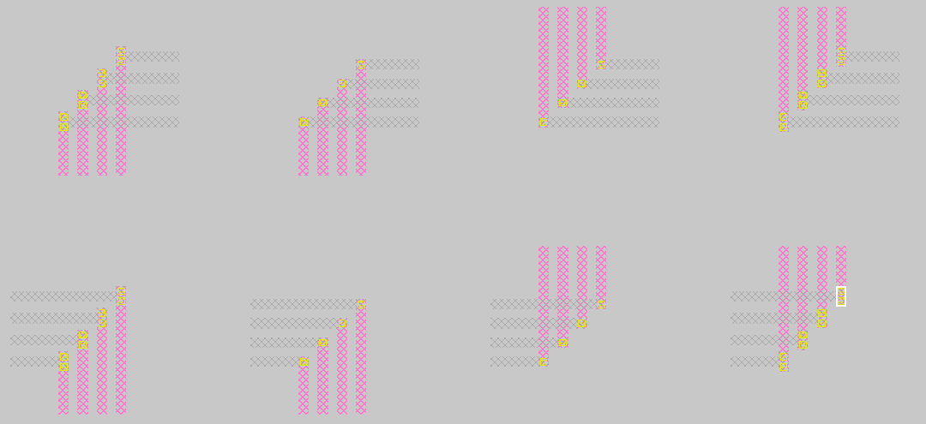
Figure 11.- draw_busl_test.

3.11.- draw_busl_scram_test Test for metal bus L with scrambled order.

draw_busl_scram_test shows you examples on how to use draw_busl_scram proc. It draws a L bus with scrambled positions. It uses the draw_busl proc, so it inherints its capabilites and limitations. In addition it uses an order list to do the scrambling. Notice you can enter and inverter order to change from vias in m=1 to m=-1. Like in the pair of cases in bottom right corner of Figure 12.

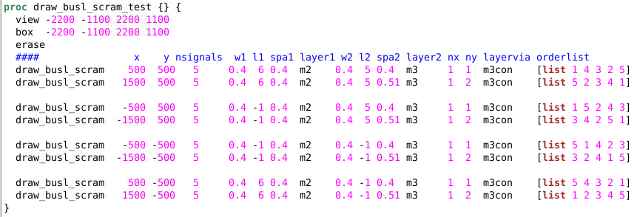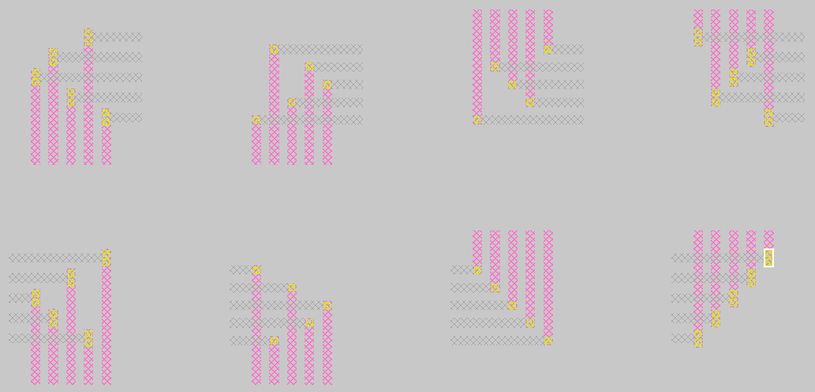
Figure 12.- draw_busl_scram_test.

3.12.- draw_busu_busc_test Test for metal bus U and bus C with scrambled order

draw_busu_busc_test shows you examples on how to use draw_busl proc. You can create an U bus or an C bus with 2 or 4 L buses. You can do different bending (m=1, m=-1 or scrambled) and diferent spacing, vias, etc as you have full control of every L segment. Except in this version I focused in m2 and m3 but it can be upgraded easily.

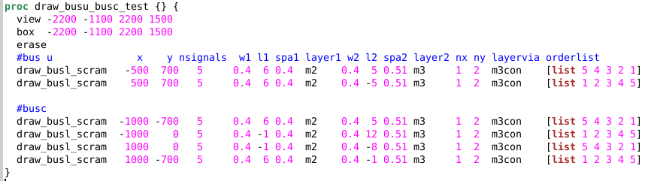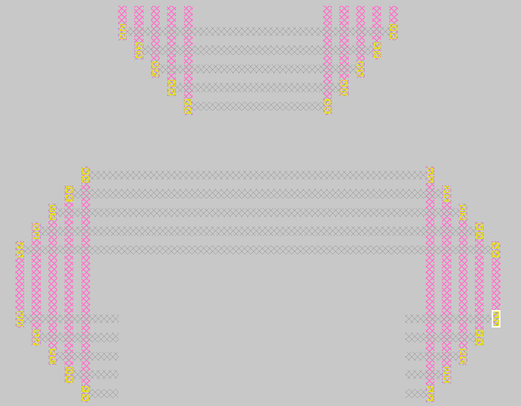
Figure 13.- draw_busu_busc_test.

4.- Conclusions and future work.

Workig with Magic is hard for generating and editing layout.
Fortunately, Magic accept TCL scripting to cope with both tasks.
But we need to learn how to use and generate our scripts and methodologies.
My1st.tcl scripts and procedures were presented to generate diffusion contacts, transistors, vias and busses.

Still need to generate scripts for Resistances, Capacitors, transistor flavors, versions with dummies and/or stubs, rings, cml buffers, cml flip-flops, and scrambling I buses.
Al layouts shown are DRC clean. But not a single LVS has been run. Starting Ressitance I will put lables/pin/ports and run LVS too. Optionally extractions and postL sims are desired too.

