

**Department: Electrical and Computer Engineering**

**Course: Electronics 1**

**Project 2: Audio Amplifier**

**Authors: Michael Sallmen and Kenneth Macleod**

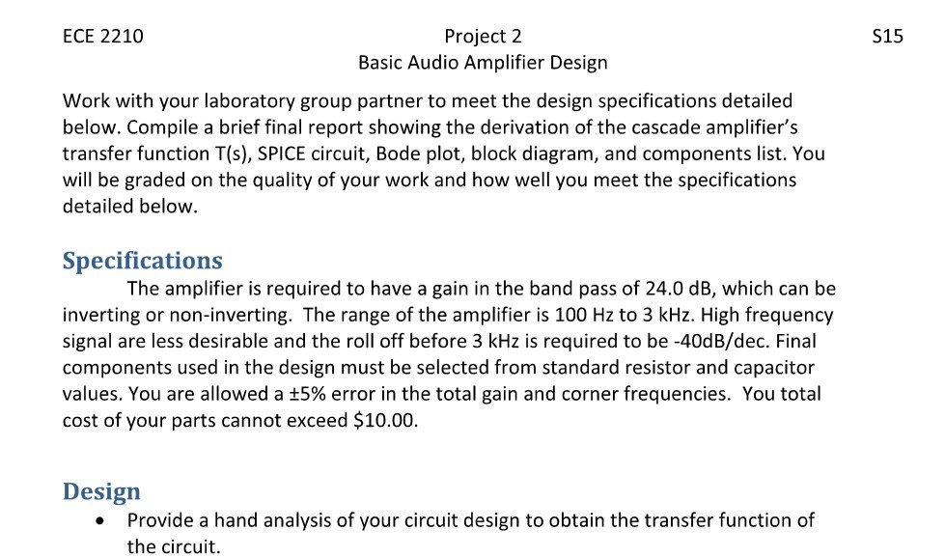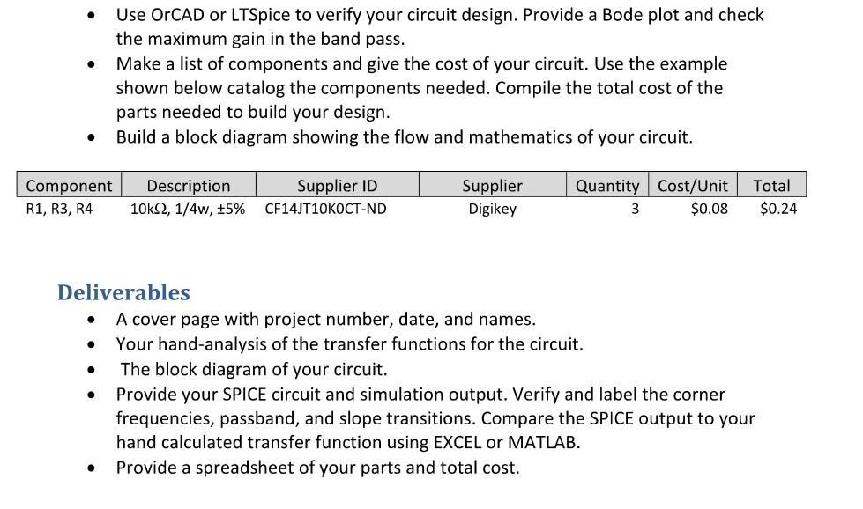

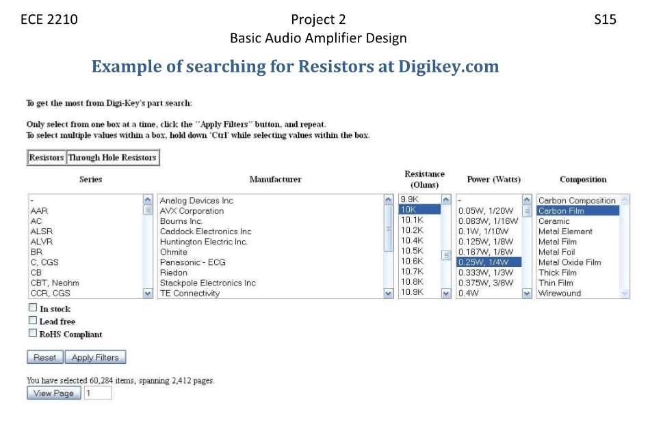

Audio Amplifier Circuit Schematic and Magnitude plot in decibels

Thursday, October 27, 2016 8:44 PM

