n = 395, α = 0.05

H0 = No relationship exists between gender and level of education

H1 = Gender and level of education are related

Giving numerical values to education:

HS = 10

Bachelors = 14

Masters = 16

PhD = 21

Average number of years of education for female = (60 \* 10 + 54 \* 14 + 46 \* 16 + 41 \* 21) / 201

= 14.691

Average number of years of education for male = (40 \* 10 + 44 \*14 + 53 \* 16 + 57 \* 21) / 194

= 15.77

Variance for female population = 15.28

Variance for male population = 15.707

SEM for female = 15.28 / $\sqrt{201}=$ 1.078

SEM for male = 15.707/ $√194$ = 1.127

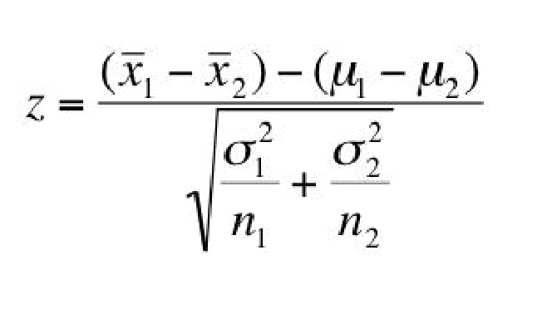

Z = 14.691 – 15.77 / 0.2757 + 0.2845 = -1.079/0.5602 = -1.92

-1.92 lies within the critical range of ±1.96 for α = 0.05

Therefore, the means are almost equal, and education level does not depend on gender.