Script Details

Add Script:
1) Open the sheet which will pull data from Spec.
2) From the menu bar, select Tools > script editor.
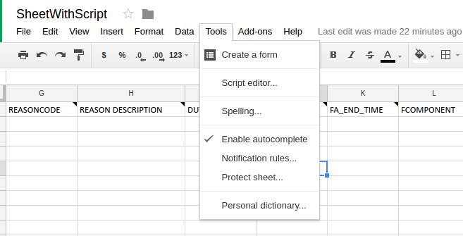

3) In newly opened tab like this:
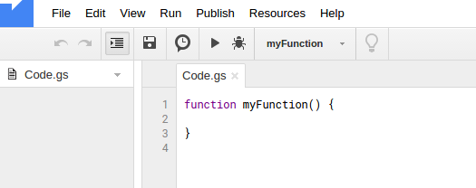

Remove all code and paste the script provided:

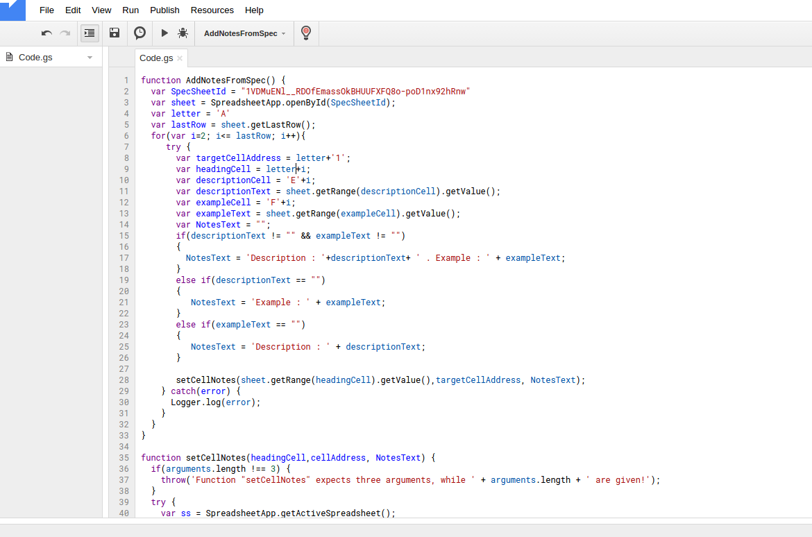

4) Update the SpecSheetId variable in 2nd line of script with your SpecSheetID

5) Save the script by save icon in the toolbar Or by Ctrl+S. This will open a dialog box to ask the name of the script. Enter name and click ok.
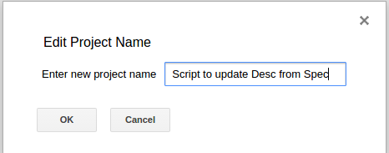

Add Permissions for the script:
1) Remaining in the same window of script, select AddNotesFromSpec from toolbar.
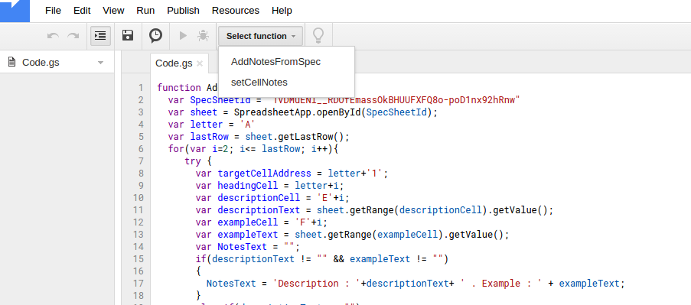
2) Click run icon in the toolbar.

3) In opened dialog box, select review permissions:
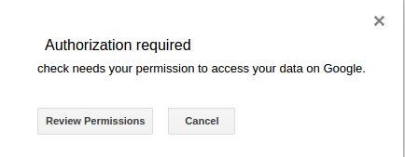

4) Choose your account in opened window and allow permissions for spreadsheet.
Add Trigger for the script:
1) Remaining in the same window of script, from toolbar, go to the Edit > All your triggers

2) Click add new

3) Select AddNotesFromSpec to run, Change Event from Time-driven to From SpreadSheet, Select On open in next dropdown and click Save button:
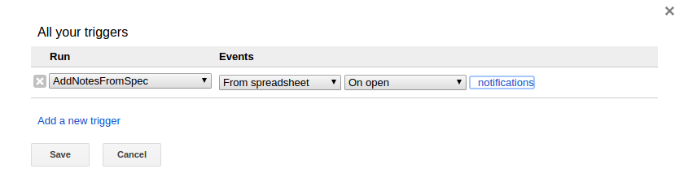
Now close this window after saving and re-open the sheet, now sheet will pull description and example from Spec.

Note: If needed change the descriptionCell and exampleCell alphabets according to their column in Spec.

