JSON Schema Validation Documentation
Before starting, enter your email in gapi.js file. Report of validation will be sent to the email entered there in EmailID:
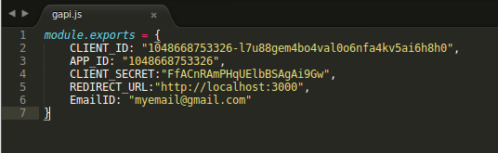
Following steps are to be followed to achieve the objective:
1) Homepage: Go to http://localhost:3000/ and you will be presented the homepage:
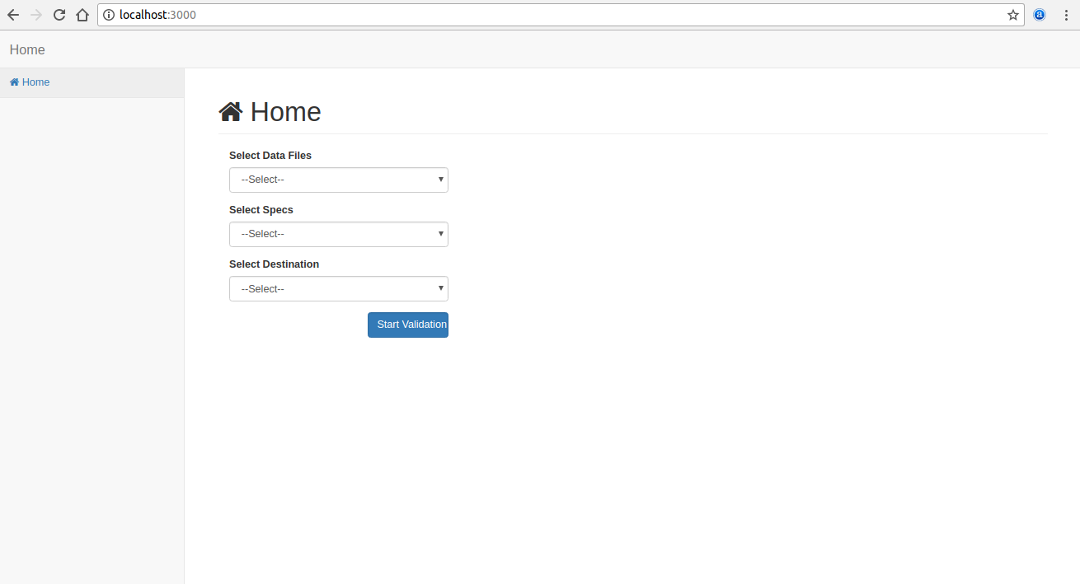

2) Data File:
a) Select Local (only option available for demo 1) for data file:
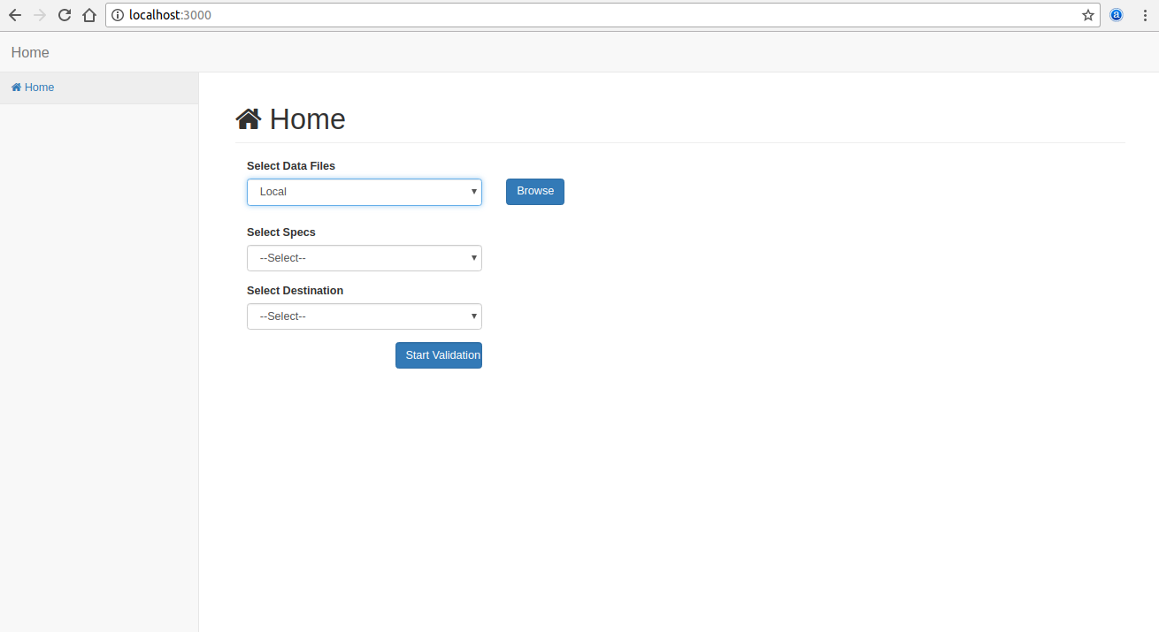
b) Now by clicking Browse button, browse local file from your computer to validate that file.
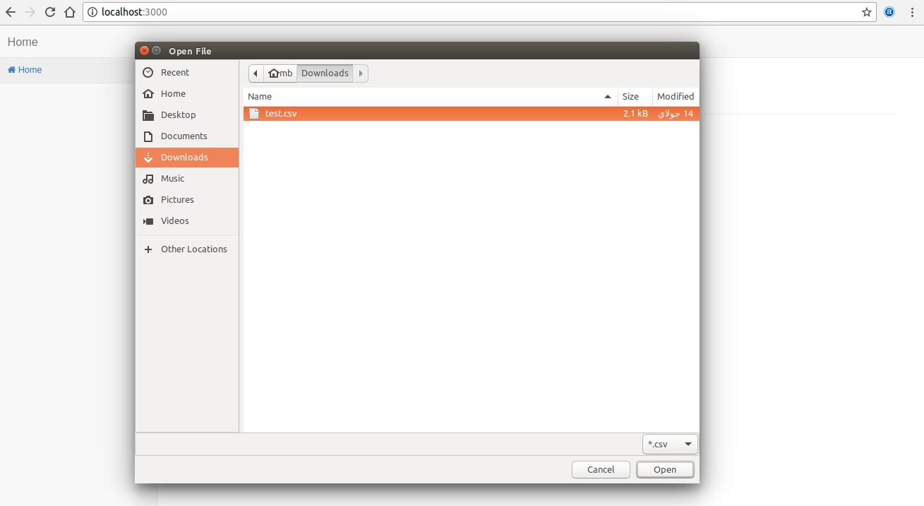
c) Selected file’s filename will be shown:
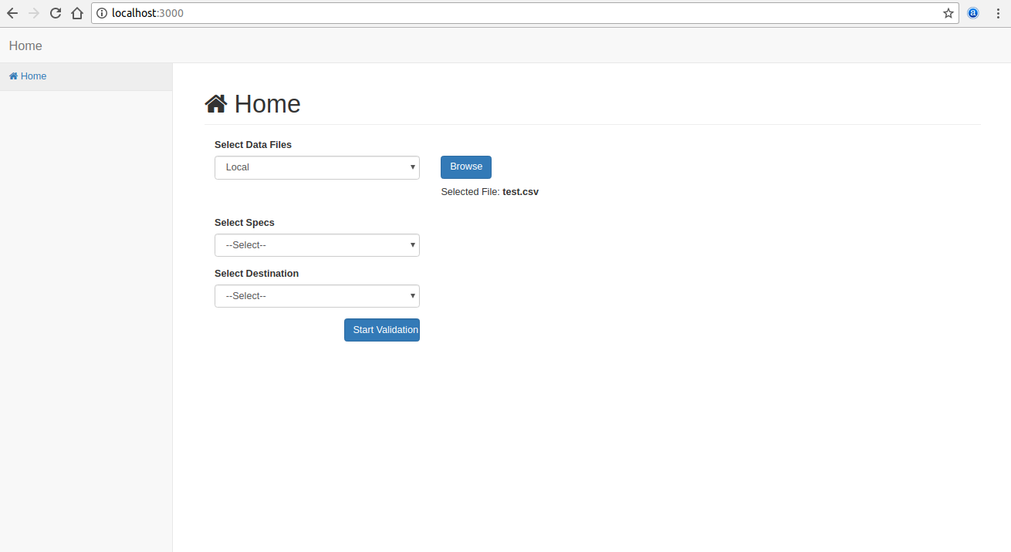
3) Spec File:
a) Select ‘Select From Google Drive’ (only option available for demo 1) for spec file:
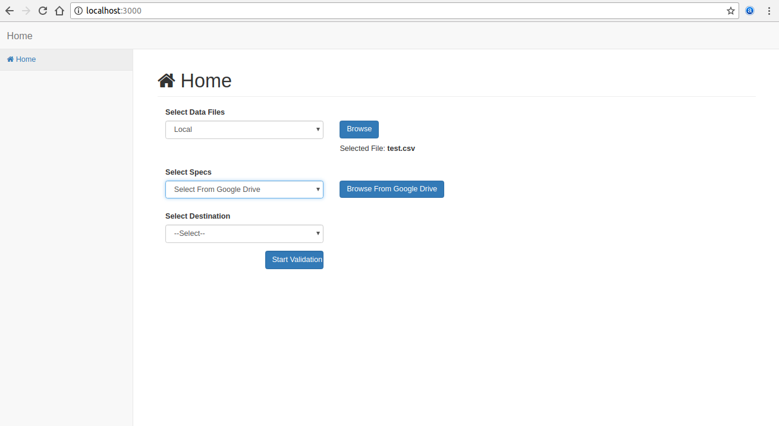
b) When you will press ‘Browse From Google Drive’ button, you will be prompted to sign in to your google account:
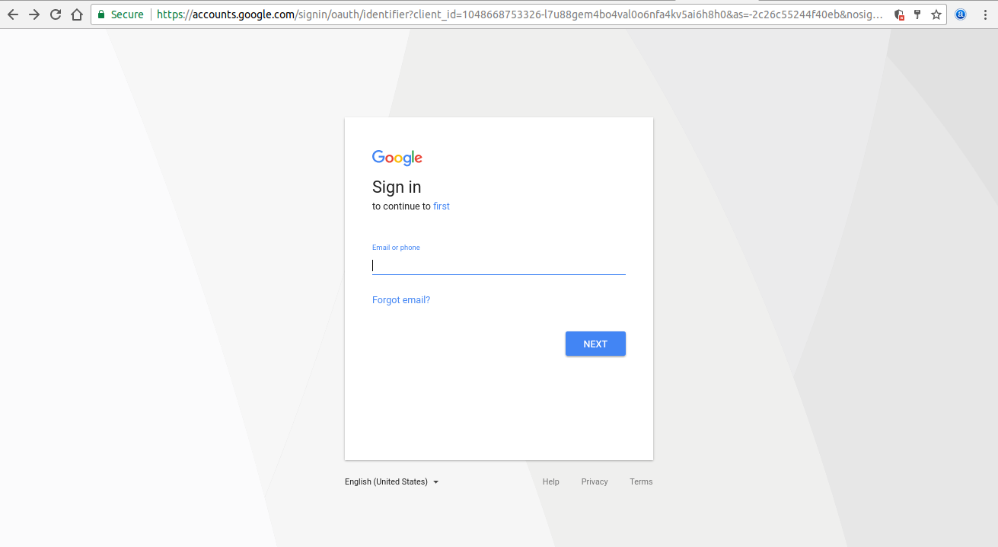
c) Enter your email and password in the above opened wizard. Then it will move you to the permission page to give the application permission to your Google drive. As currently this application is under development and is not verified by the Google, so you may have to face a warning from Google before giving access to your Google drive. Click Advanced button in that warning:
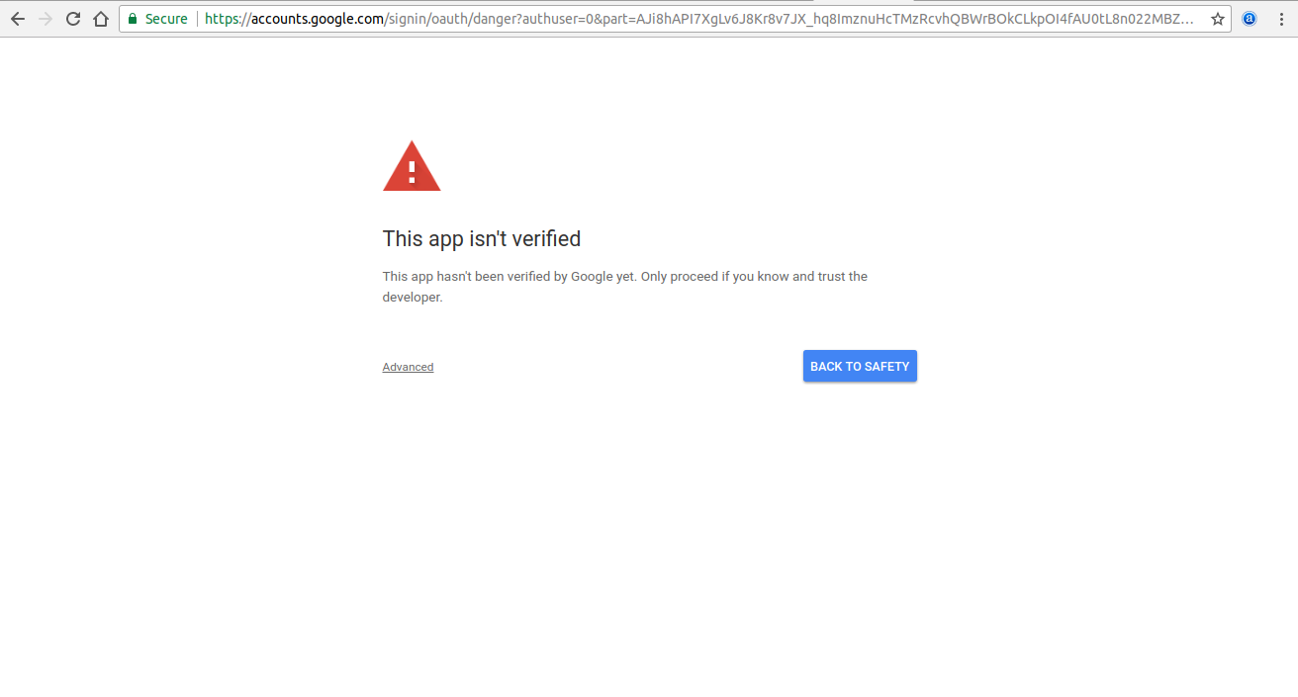
d) Google will tell you that they have not reviewed this app yet. Click on ‘Go to first (unsafe)’ link:
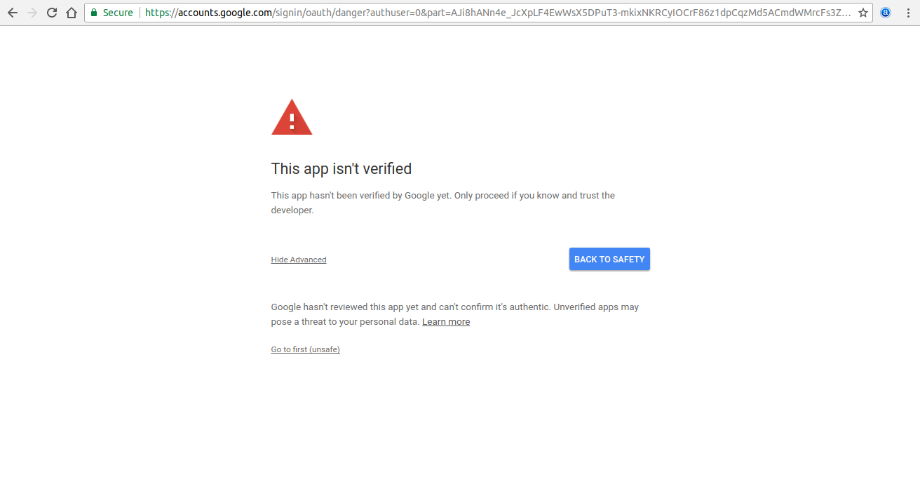
e) Now Google will present you the page to allow the access to your drive:
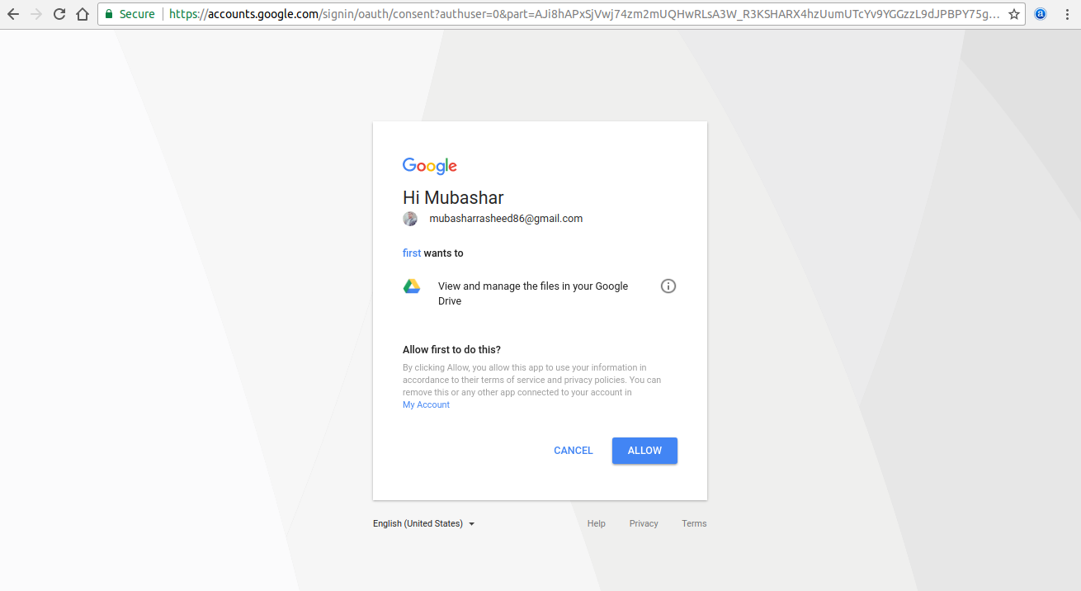

f) Click on allow button to grant the access. After that google will process your request and will browse your google drive’s spreadsheets to select. Select your desired spec and click select:
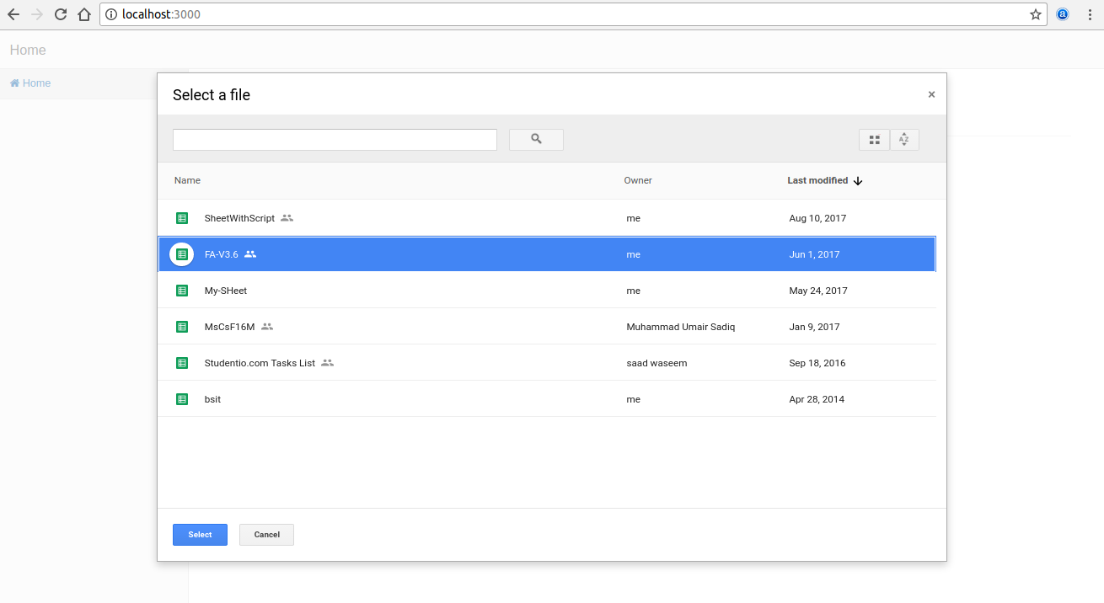
g) Selected file’s filename will be shown below ‘Browse From Google Drive’ button:
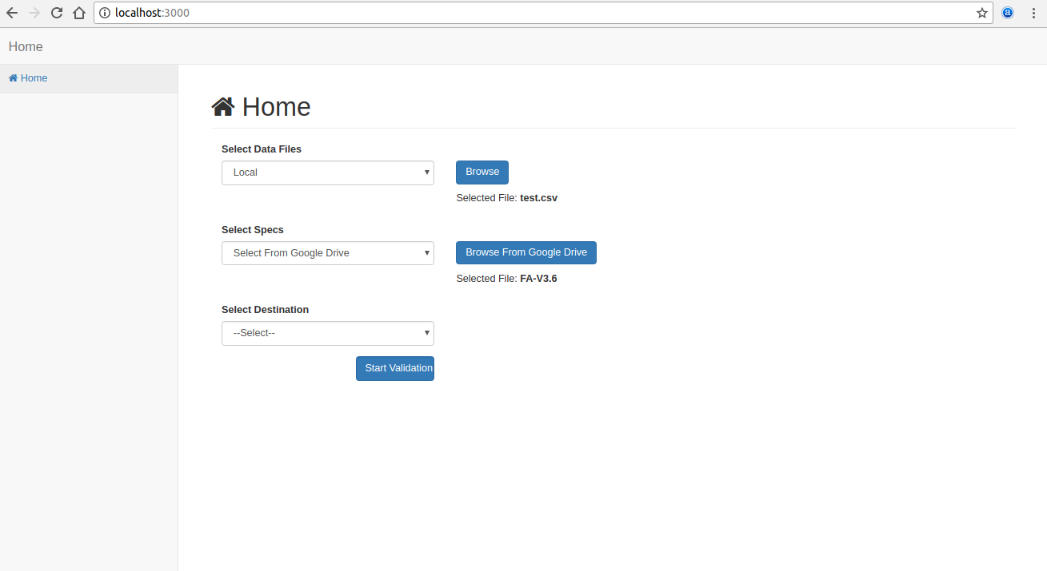

4) Destination:
a) Select ‘Google Drive’ (only option available for demo 1) for destination:
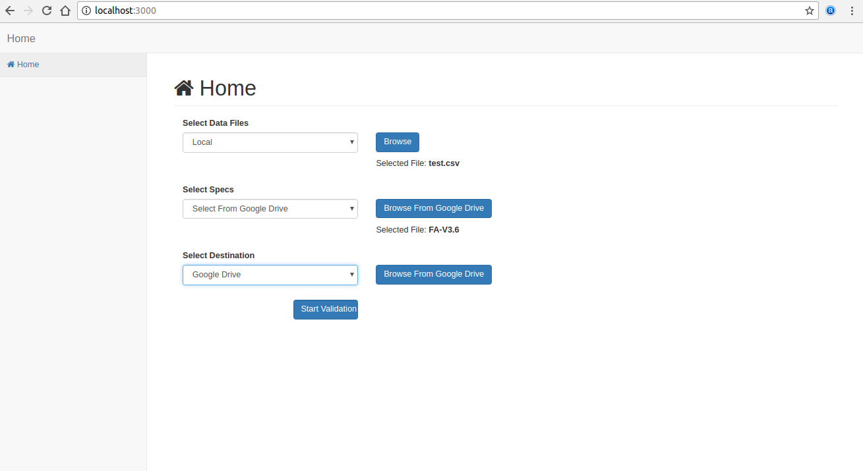
b) Press ‘Browse From Google Drive’ button against destination, then all directories in your drive will be browsed. Select one directory to save the resulted files (bad file, good file, report file).
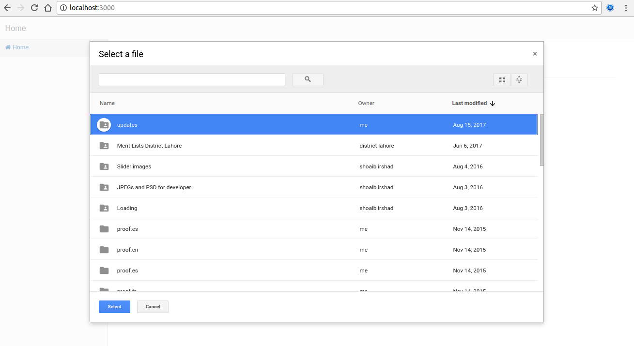
c) Selected folder’s name will be shown below the ‘Browse From Google Drive’ button against destination.
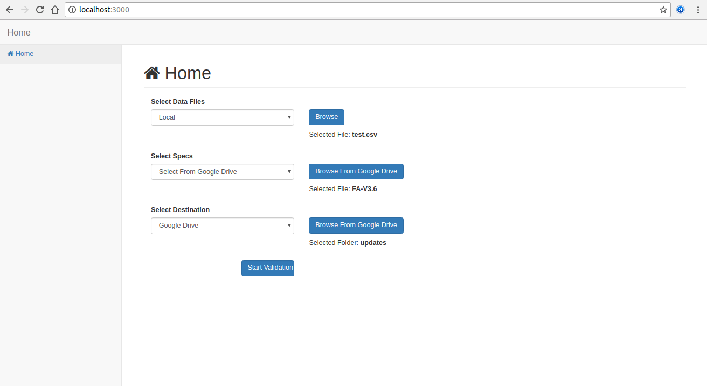
5) Validation: Now click ‘Start Validation’ button in the last. It will start validating you file against spec, will upload the resulted files to the destination selected on the Google drive, and will email you the report generated against this validation. After all process, you will be shown text ‘Done’ in the place of ‘Start Validation’ button:
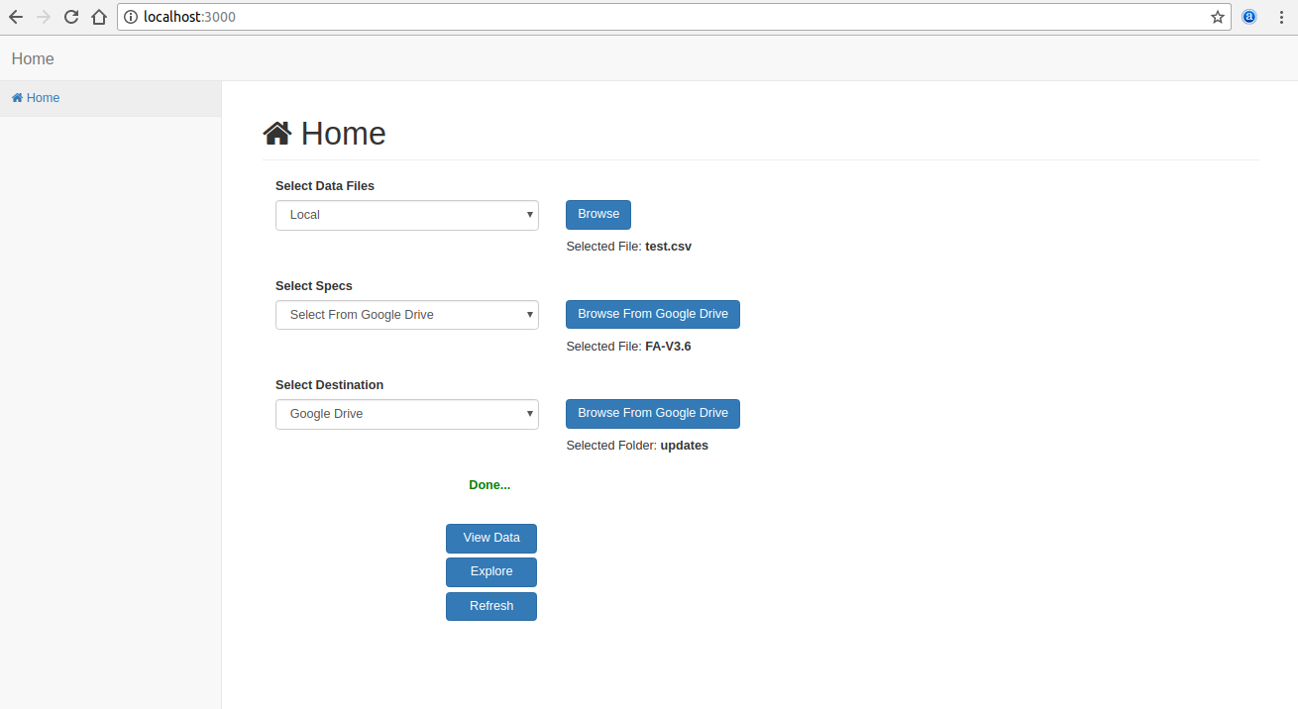
6) View Data: On clicking ‘View Data’ button, you will be directed to the destination folder containing the resulted files:
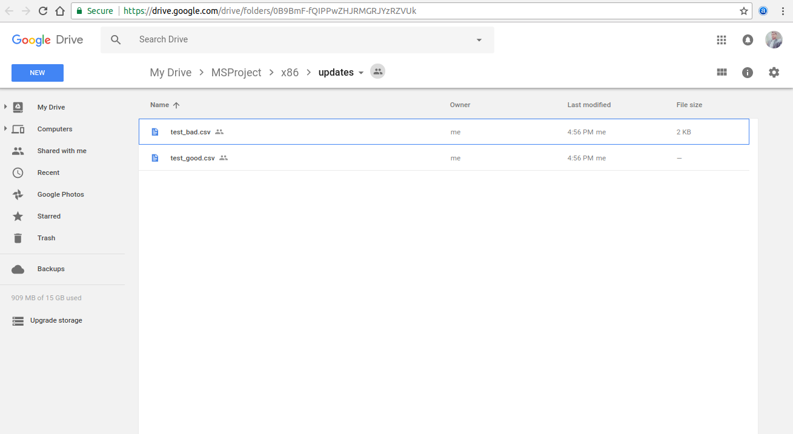
7) Explore: On clicking ‘Explore’ button, you will be shown the sunburst containing Error Summary:
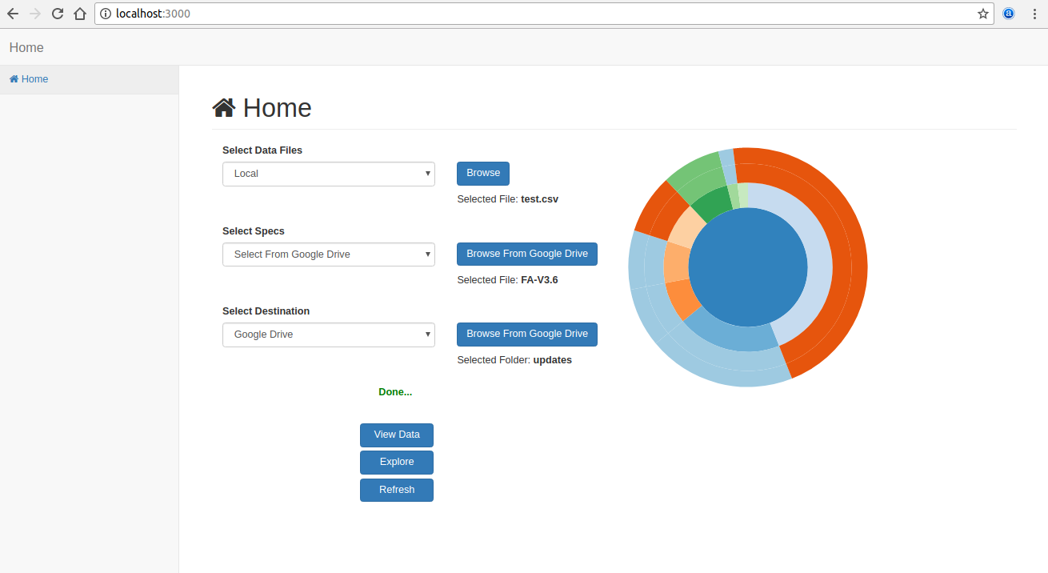

8) Next Validation: To go for another validation, click ‘Refresh’ button and you will be redirected to the http://localhost:3000/ again:
