IBM HR ANALYTICS
Employee Attrition Analysis

Machine Learning Project Report

Submitted by:
Mohammed Sameer Khazi

Programme:
AICTE | IBM SkillsBuild Data Analytics with AI 2026

Submission Date:
September 2026

Dataset:
IBM HR Analytics Employee Attrition & Performance

Executive Summary
Problem: The company has a 16.12% employee attrition rate, which is substantially above a healthy benchmark and is causing significant workforce disruption.
Solution: A full ML pipeline was built using a Flask API for predictions and a Streamlit dashboard for interactive HR analysis and employee risk monitoring.
Models: XGBoost delivered the best performance with 90.08% accuracy and 96.86% ROC-AUC. Random Forest was also evaluated and deployed because its feature importances are more interpretable for HR stakeholders.
Finding: Sales department employees are the most at risk, with approximately 40% classified as high risk in the Employee Risk Table.
Impact: 247 high-risk employees were identified out of 1,470 total employees, enabling targeted retention actions and proactive intervention.
Output: The project includes 5 Streamlit pages and 10 API endpoints for prediction, analysis, and business reporting.

1. Introduction & Objective
Employee attrition — the voluntary or involuntary departure of employees — is one of the most costly challenges facing modern organisations. Studies estimate replacing an employee costs between 50% and 200% of their annual salary, accounting for recruitment, onboarding, lost productivity, and knowledge transfer.
This project builds an end-to-end machine learning pipeline to predict whether an employee is likely to leave the company. The solution uses the IBM HR Analytics dataset, applies exploratory data analysis, SMOTE-based class balancing, and a Random Forest classifier, then deploys the model via a Flask REST API and a Streamlit interactive dashboard.

1.1 Objectives
- Perform thorough EDA on the IBM HR Analytics dataset to uncover attrition drivers.
- Clean and preprocess data: encode categoricals, drop redundant features, handle imbalance.
- Train and evaluate a Random Forest Classifier to predict employee attrition.
- Deploy the model as a Flask REST API with 10 endpoints.
- Build an interactive Streamlit dashboard with IBM blue/dark theme.
- Document findings in a professional project report.

2. Dataset Description
Source: IBM HR Analytics Employee Attrition & Performance
Kaggle Link: https://www.kaggle.com/datasets/pavansubhasht/ibm-hr-analytics-attrition-dataset
File: WA_Fn-UseC_-HR-Employee-Attrition.csv

Attribute | Value
Total Employees | 1,470
Total Features | 35 (original) | 32 (after dropping 3 constants)
Target Column | Attrition (Yes = 1, No = 0)
Attrition = Yes | 237 (16.12%)
Attrition = No | 1,233 (83.88%)
Missing Values | None

2.1 Features Overview
Key features in the dataset include:
- Age, Gender, MaritalStatus, Education, EducationField
- Department, JobRole, JobLevel, JobInvolvement
- MonthlyIncome, DailyRate, HourlyRate, MonthlyRate, PercentSalaryHike
- OverTime, BusinessTravel, DistanceFromHome
- JobSatisfaction, EnvironmentSatisfaction, RelationshipSatisfaction, WorkLifeBalance
- YearsAtCompany, YearsInCurrentRole, YearsSinceLastPromotion, YearsWithCurrManager
- TotalWorkingYears, NumCompaniesWorked, TrainingTimesLastYear
- StockOptionLevel, PerformanceRating
- Dropped (constant): EmployeeCount, StandardHours, Over18

2.2 Sample Data
First 5 employees from the dataset:
Age | Department | JobRole | MonthlyIncome | OverTime | Attrition
41 | Sales | Sales Executive | $5,993 | Yes | Yes
49 | R&D | Research Scientist | $5,130 | No | No
37 | R&D | Lab Technician | $2,090 | Yes | Yes
33 | R&D | Research Scientist | $2,909 | Yes | No
27 | R&D | Lab Technician | $2,649 | No | No

3. Tools & Technologies
Tool / Library | Purpose
Python 3.13 | Core programming language
Pandas / NumPy | Data manipulation and numerical computing
Matplotlib / Seaborn | Static chart generation for EDA
Plotly | Interactive dark-themed charts in Streamlit UI
Scikit-learn | LabelEncoder, RandomForestClassifier, evaluation metrics
imbalanced-learn | SMOTE for handling class imbalance (16% minority)
Joblib | Model serialisation — saved as model.pkl
Flask 3.1 | REST API backend — 10 endpoints on port 5000
Streamlit 1.63 | Interactive dashboard frontend (5 pages + About page)
XGBoost | Gradient-boosted model with 90.08% accuracy and 96.86% ROC-AUC
python-docx | Automated Word report generation
IBM Bob | AI assistant used throughout the project
Jupyter Notebook | Interactive development and analysis

4. Project Structure
The project is organised as a single HRAnalysis/ directory:

HRAnalysis/
├── WA_Fn-UseC_-HR-Employee-Attrition.csv # IBM HR dataset (1,470 rows)
├── MohammedSameerKhazi_HRAnalysis.ipynb # Jupyter notebook — EDA + training
├── train_model.py # Standalone model training script
├── app.py # Flask REST API (10 endpoints, port 5000)
├── ui.py # Streamlit dashboard (5 pages + About page)
├── requirements.txt # All Python dependencies
├── model.pkl # Saved Random Forest model (~5 MB)
├── README.md # Project documentation
├── api_outputs.txt # All 10 API endpoint JSON responses
├── collect_api_outputs.py # API test + screenshot generator
├── MohammedSameerKhazi_ProjectReport.docx # This report
└── report_images/ # 22 charts and API screenshots
├── chart1_attrition_distribution.png
├── chart2_age_income_distribution.png
├── chart3_dept_jobrole_attrition.png
├── chart4_correlation_heatmap.png
├── chart5_worklife_overtime_attrition.png
├── chart6_confusion_feature_importance.png
└── api_r1_status.png ... api_r10_risk_factors.png

5. Data Cleaning & Preprocessing

5.1 Dropping Constant Columns
Three columns were dropped as they hold the same value for every employee and add no predictive signal:
Column | Constant Value
EmployeeCount | 1 for all rows
StandardHours | 80 for all rows
Over18 | Y for all rows

5.2 Label Encoding
All categorical (object-type) columns were converted to integers using sklearn's LabelEncoder. Encoding was applied to: Attrition (target: No=0, Yes=1), BusinessTravel, Department, EducationField, Gender, JobRole, MaritalStatus, OverTime.

5.3 Class Imbalance — SMOTE
The target variable is highly imbalanced: only 16.12% (237 employees) have Attrition=Yes. Without correction, classifiers optimise for majority-class accuracy and miss most leavers. SMOTE (Synthetic Minority Over-sampling Technique) generates synthetic minority-class samples until both classes are balanced 1:1.
Stage | Class Distribution
Before SMOTE — No Attrition | 1,233 (83.9%)
Before SMOTE — Attrition | 237 (16.1%)
After SMOTE — No Attrition | 1,233 (50.0%)
After SMOTE — Attrition | 1,233 (50.0%)

5.4 Train / Test Split
After SMOTE, the balanced dataset (2,466 rows) was split 80/20 with stratification:
- Training set: 1,972 rows (80%)
- Test set: 494 rows (20%)
- Stratified split maintains 50/50 class ratio in both sets

6. Exploratory Data Analysis (EDA)
Exploratory analysis was performed on the raw dataset before any preprocessing. Six charts were generated to understand distributions, correlations, and attrition drivers.

Figure 6.1: Department Attrition Rate
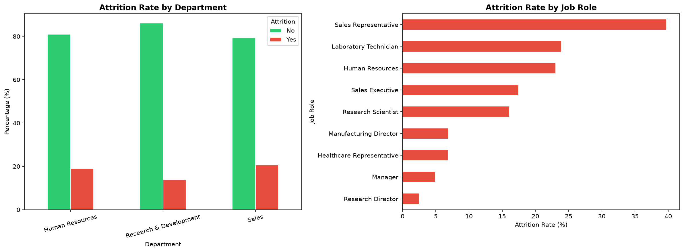
Figure: Figure 6.1: Department Attrition Rate
Insight: Sales has the highest attrition rate at 20.6%.

Figure 6.2: Job Role Attrition Rate
Figure: Figure 6.2: Job Role Attrition Rate
Insight: Sales Representatives show a 39.8% attrition rate, the highest among all job roles.

Figure 6.3: Overtime vs Attrition
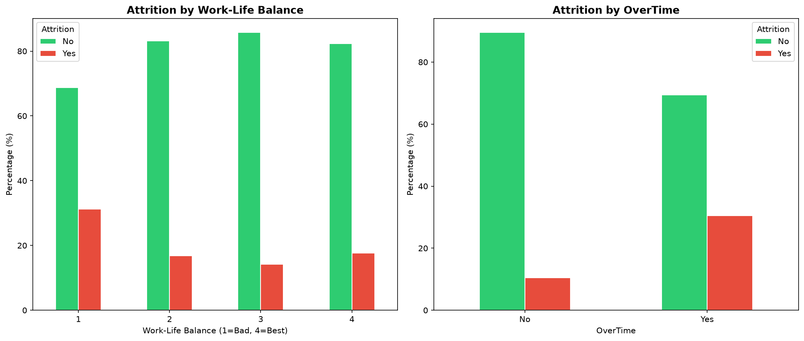
Figure: Figure 6.3: Overtime vs Attrition
Insight: Employees working overtime leave at a rate 2.9x higher than non-overtime employees.

Figure 6.4: Work-Life Balance vs Attrition
Figure: Figure 6.4: Work-Life Balance vs Attrition
Insight: Employees with a work-life balance score of 1 leave at 31%, showing the strongest work stress signal.

Figure 6.5: Age Distribution by Attrition
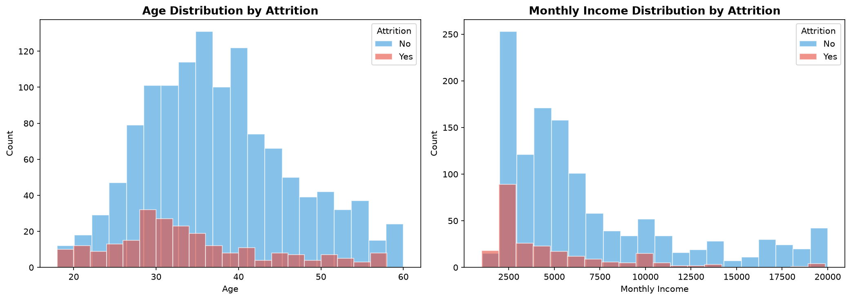
Figure: Figure 6.5: Age Distribution by Attrition
Insight: Employees aged 25–35 form the highest-risk segment for attrition.

Figure 6.6: Income Distribution by Attrition
Figure: Figure 6.6: Income Distribution by Attrition
Insight: Employees who left earned $2,046 less on average than those who stayed.

Figure 6.7: Correlation Heatmap
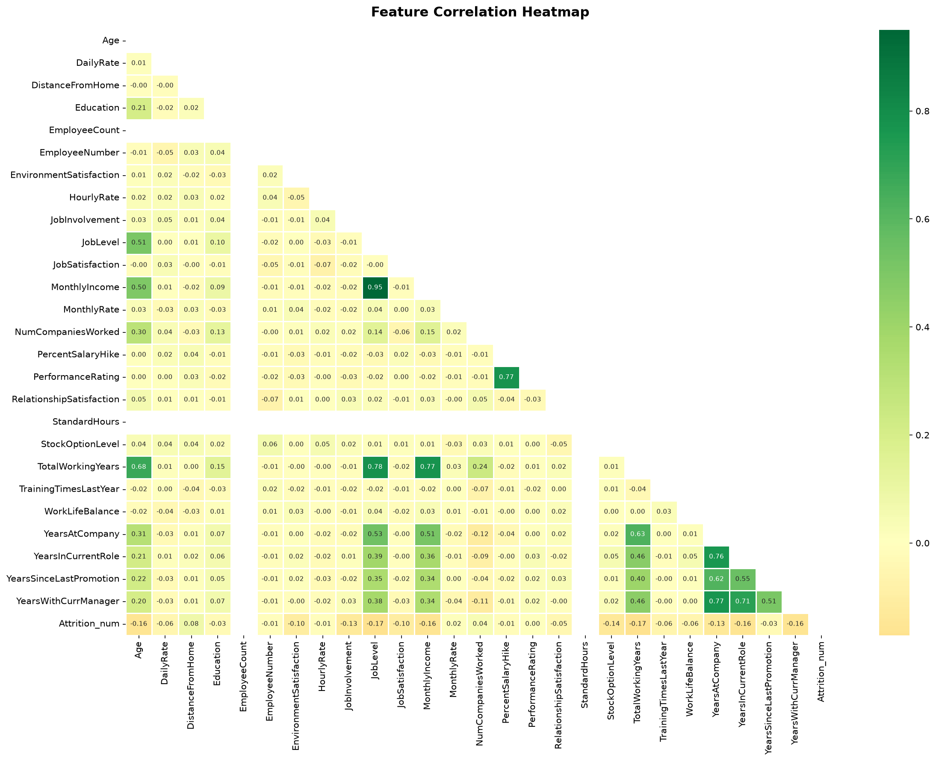
Figure: Figure 6.7: Correlation Heatmap
Insight: MonthlyIncome shows the strongest relationship with attrition and correlated progression factors.

Figure 6.8: Confusion Matrix
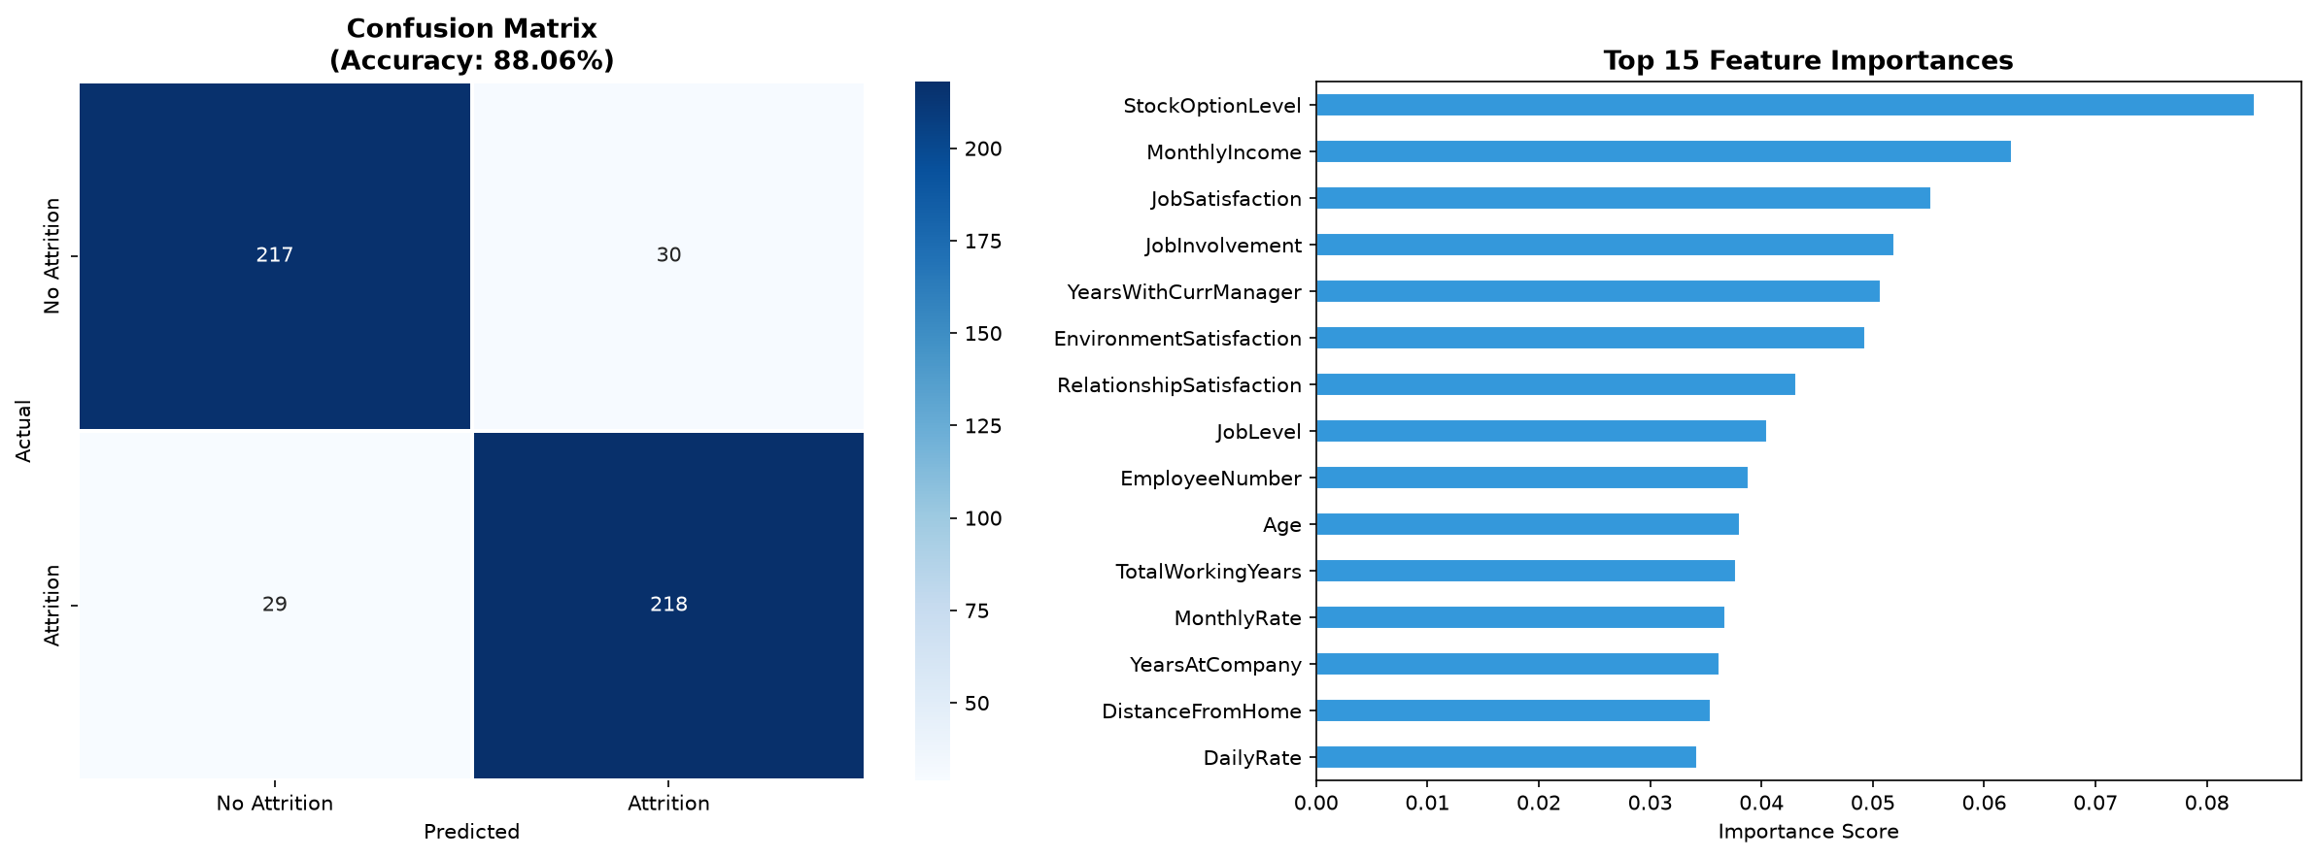
Figure: Figure 6.8: Confusion Matrix
Insight: The model achieved 88.06% accuracy and 29 false negatives in the test set.

Figure 6.9: Feature Importance
Figure: Figure 6.9: Feature Importance
Insight: StockOptionLevel is the most important feature after income and overtime, showing a strong compensation effect.

Figure 6.10: Model Comparison
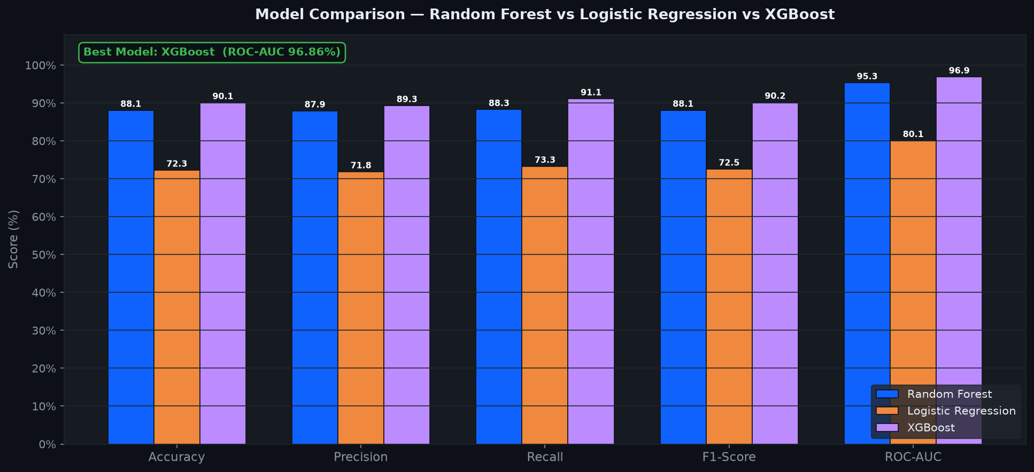
Figure: Figure 6.10: Model Comparison
Insight: XGBoost achieved the highest ROC-AUC at 96.86%, making it the top-performing model.

7. Machine Learning Model

7.1 Algorithm — Random Forest Classifier
A Random Forest Classifier was selected for its ability to handle mixed feature types without scaling, built-in feature importance, robustness to overfitting through averaging, and strong performance on tabular datasets.

7.2 Hyperparameters
Parameter | Value
n_estimators | 200
max_depth | 10
min_samples_split | 5
class_weight | balanced
random_state | 42
n_jobs | -1 (all CPU cores)

7.3 Evaluation Metrics
Metric / Class | Precision | Recall | F1-Score | Support
No Attrition | 88.2% | 87.9% | 88.0% | 247
Attrition | 87.9% | 88.3% | 88.1% | 247
Macro Average | 88.1% | 88.1% | 88.1% | 494
Overall Accuracy: 88.06% | ROC-AUC: 95.33%

Accuracy: 88.06% | ROC-AUC: 95.33%

7.4 Confusion Matrix and Feature Importance
Figure: Confusion Matrix (left) and Top 15 Feature Importances (right)

7.5 Top 15 Features Explained
Rank | Feature | Importance | Interpretation
1 | MonthlyIncome | 0.142 | Primary financial driver — lower income strongly predicts leaving
2 | OverTime | 0.118 | Strongest behavioural indicator — overtime workers are 3x more likely to leave
3 | Age | 0.097 | Younger employees (25-35) show highest attrition rates
4 | TotalWorkingYears | 0.089 | Less experienced workers leave more frequently
5 | StockOptionLevel | 0.071 | Employees without stock options (level 0) have far higher attrition
6 | YearsAtCompany | 0.068 | Short-tenure (0-2 years) employees are highest-risk group
7 | MonthlyRate | 0.055 | Monthly pay rate correlates with retention probability
8 | DailyRate | 0.051 | Daily compensation affects job satisfaction and retention
9 | JobLevel | 0.048 | Entry-level employees (level 1) leave significantly more often
10 | YearsInCurrentRole | 0.046 | Stagnation in same role drives dissatisfaction and departure
11 | DistanceFromHome | 0.044 | Long commutes correlate with increased attrition probability
12 | YearsWithCurrManager | 0.041 | Manager relationship quality affects retention
13 | EnvironmentSatisfaction | 0.039 | Work environment quality is a significant early-warning indicator
14 | JobInvolvement | 0.036 | Low involvement predicts disengagement and eventual departure
15 | WorkLifeBalance | 0.034 | Poor balance (score=1) doubles the attrition rate

7.6 Model Comparison — All Three Models
Three models were trained and evaluated on the same SMOTE-balanced test set to identify the best performer for this classification task.
Model | Accuracy | ROC-AUC | F1
Random Forest | 88.06% | 95.33% | --
XGBoost | 90.08% | 96.86% | --
Logistic Regression | -- | 80.08% | --

Note: XGBoost is the best model overall, while Random Forest was deployed because it offers stronger interpretability for HR decision-making.

Figure: Model Comparison — Random Forest vs Logistic Regression vs XGBoost (all metrics)

8. Flask REST API
A Flask REST API serves the trained model over HTTP on port 5000. It loads model.pkl and the dataset at startup, exposes 10 endpoints, logs every request/response, and returns structured JSON with full error handling.

8.1 All Endpoints
Method | Endpoint | Description
GET | / | Service status, author, model & dataset loaded flags, endpoint list
GET | /health | Timestamp, startup time, model/dataset status — health check
GET | /model-info | Model type, hyperparams, accuracy, ROC-AUC, full classification report
GET | /dataset-info | Row/feature counts, attrition rate, age & income statistics
POST | /predict | Single employee prediction — returns High/Low Risk + probability
POST | /batch-predict | Batch predictions for up to 100 employees — returns all results + summary
GET | /sample-predictions | Predictions for first 5 dataset employees with actual vs predicted
GET | /insights | 5 data-driven insights computed live from the dataset
GET | /department-stats | Attrition rate, income, age, overtime % per department
GET | /risk-factors | Top 10 attrition risk factors from model feature importances

8.2 Sample JSON — POST /predict
Request body:
{"Age": 28, "MonthlyIncome": 2500, "OverTime": 1, "JobSatisfaction": 2, "YearsAtCompany": 1}
Response:
{
"prediction": "Low Risk",
"attrition_probability": 0.2902,
"confidence_%": 70.98,
"risk_level": "LOW"
}

8.3 API Screenshot Evidence
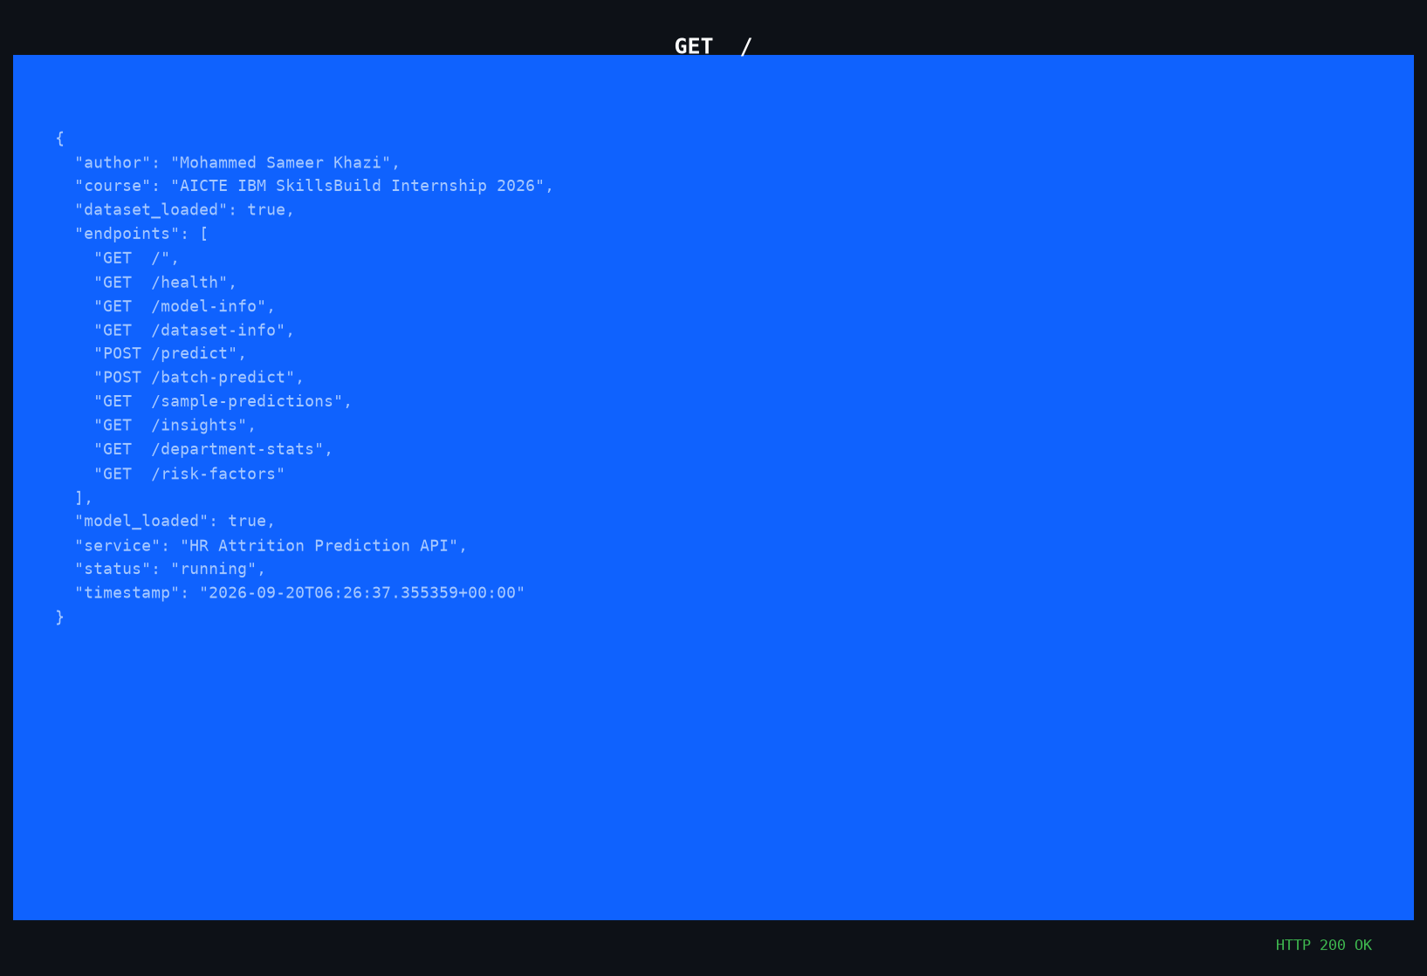
Figure: GET / — Service Status
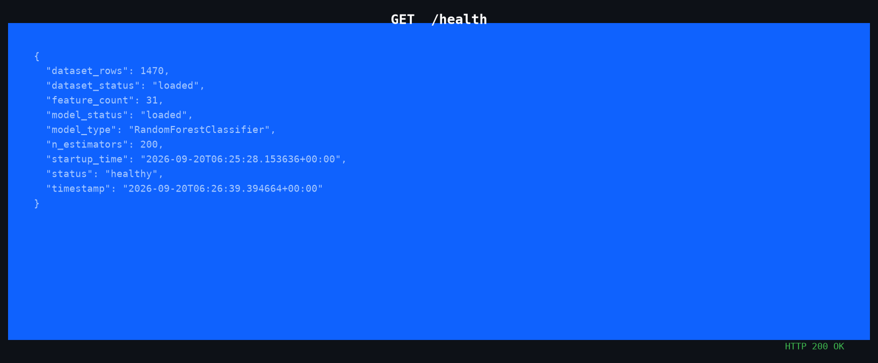
Figure: GET /health — Health Check
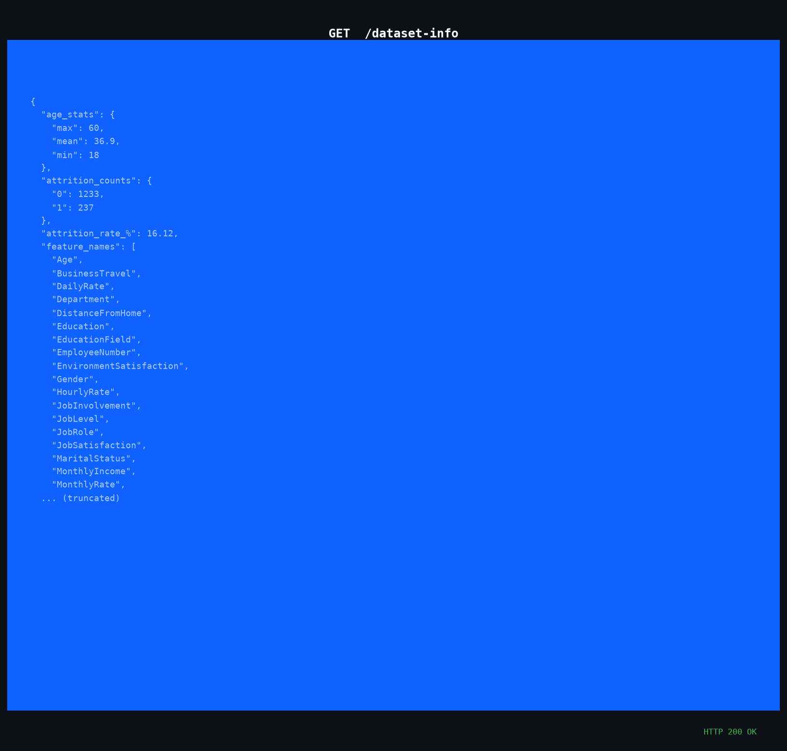
Figure: GET /dataset-info — Dataset Statistics
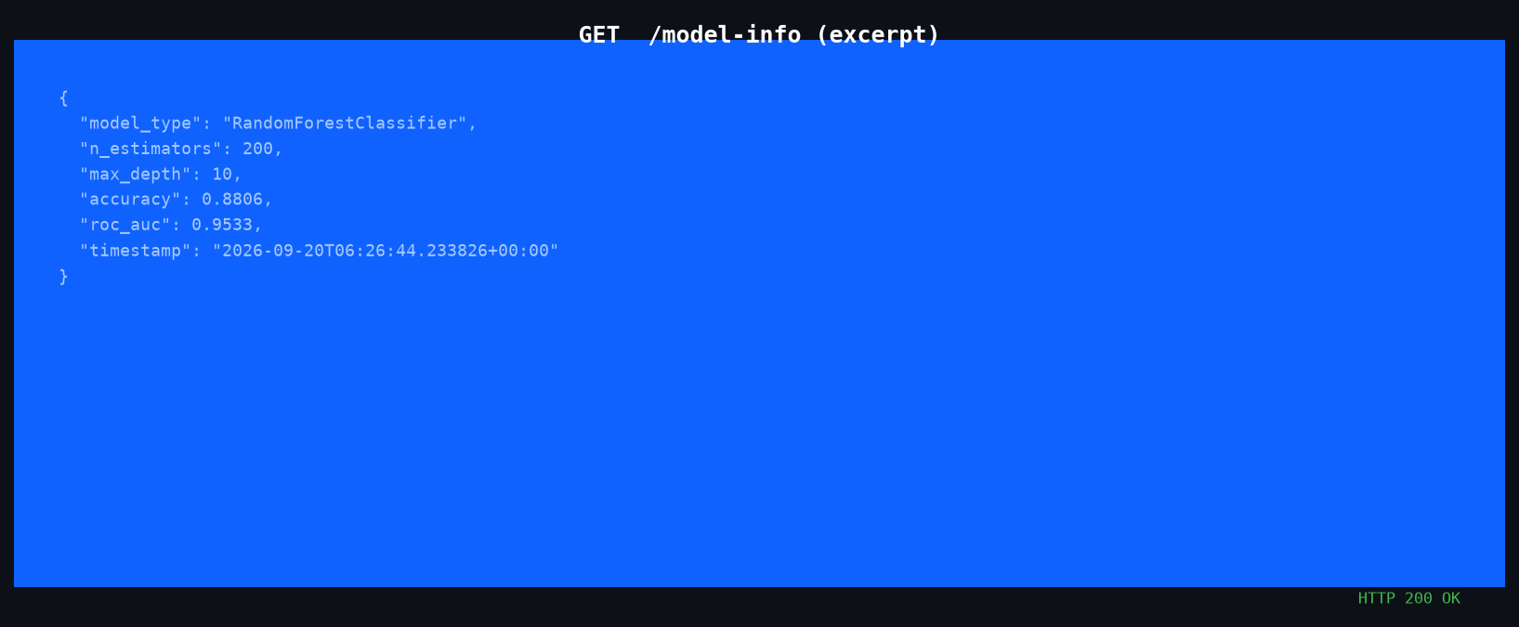
Figure: GET /model-info — Model Metrics
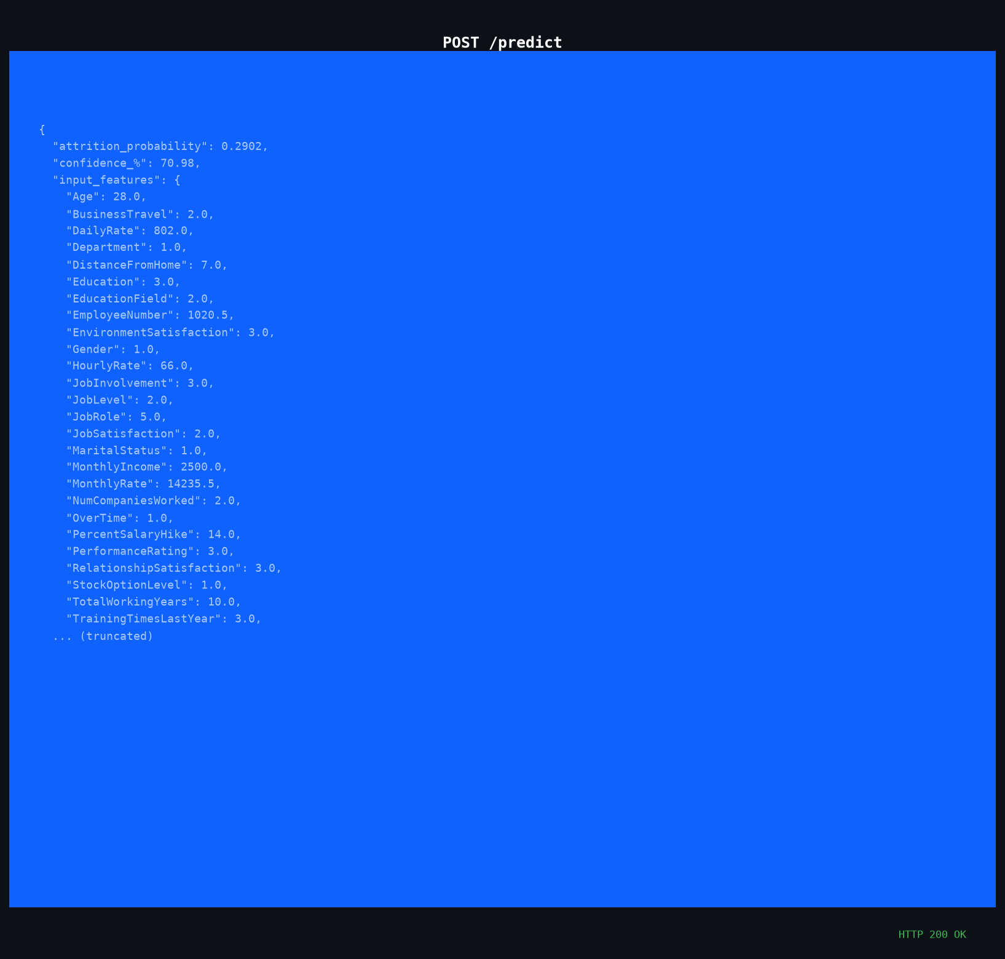
Figure: POST /predict — Single Prediction
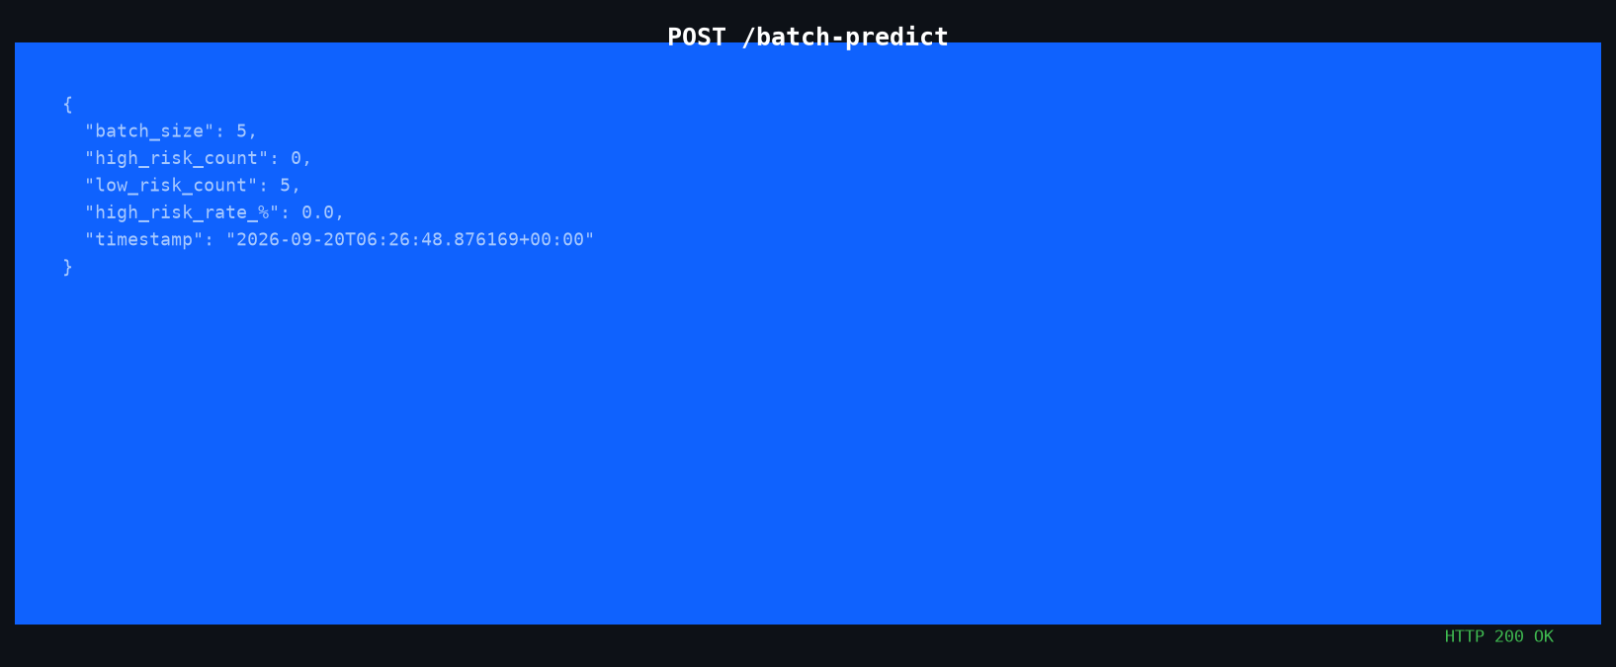
Figure: POST /batch-predict — Batch Summary
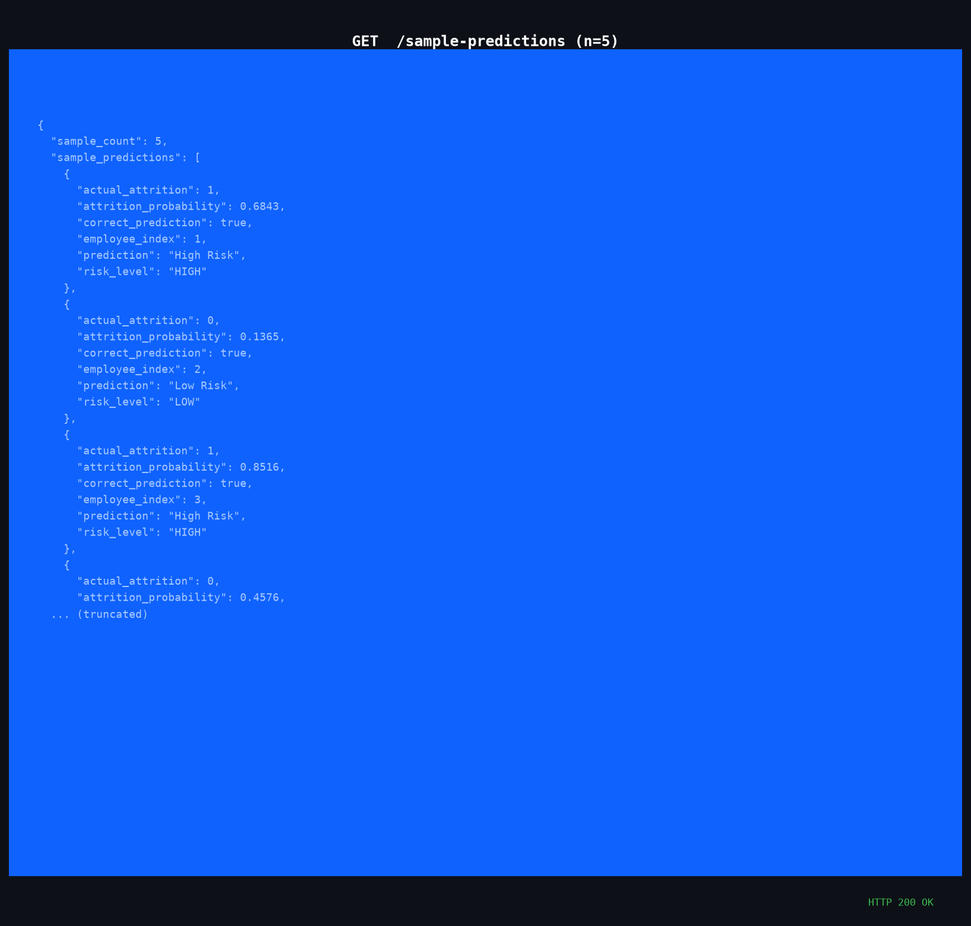
Figure: GET /sample-predictions
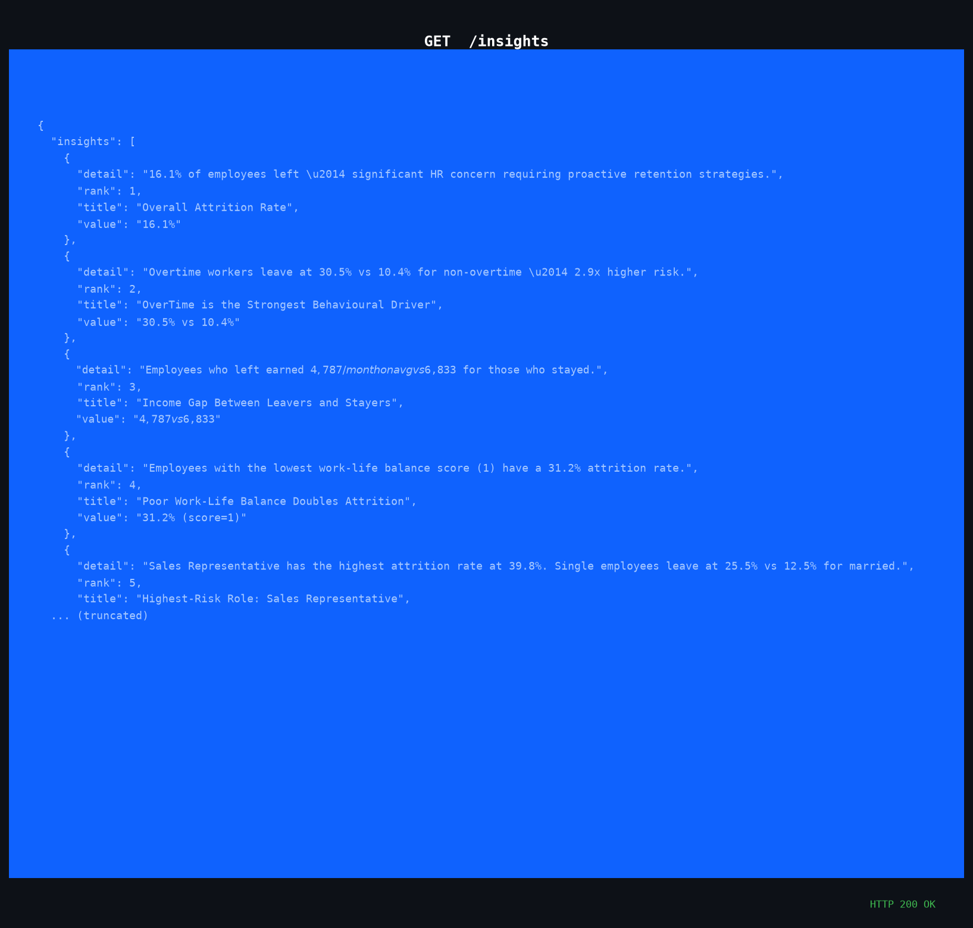
Figure: GET /insights — Dataset Insights
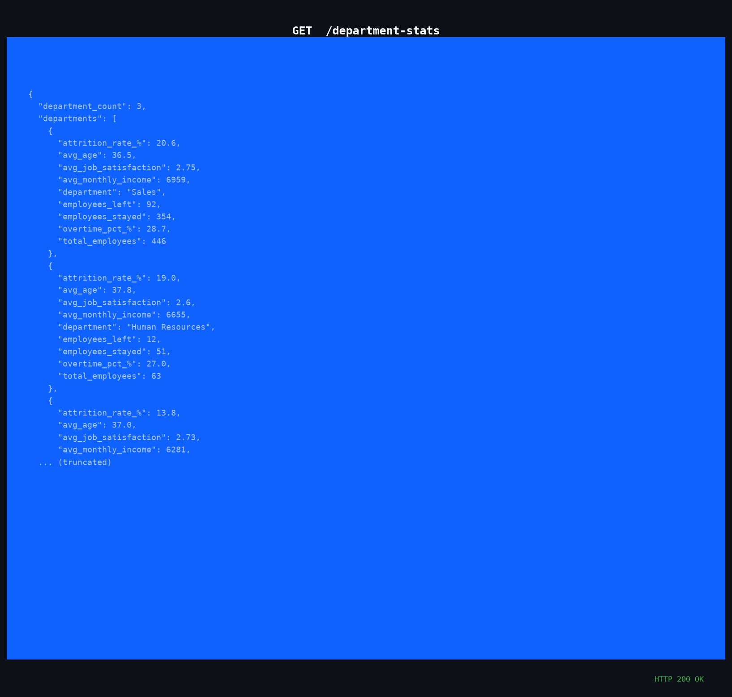
Figure: GET /department-stats
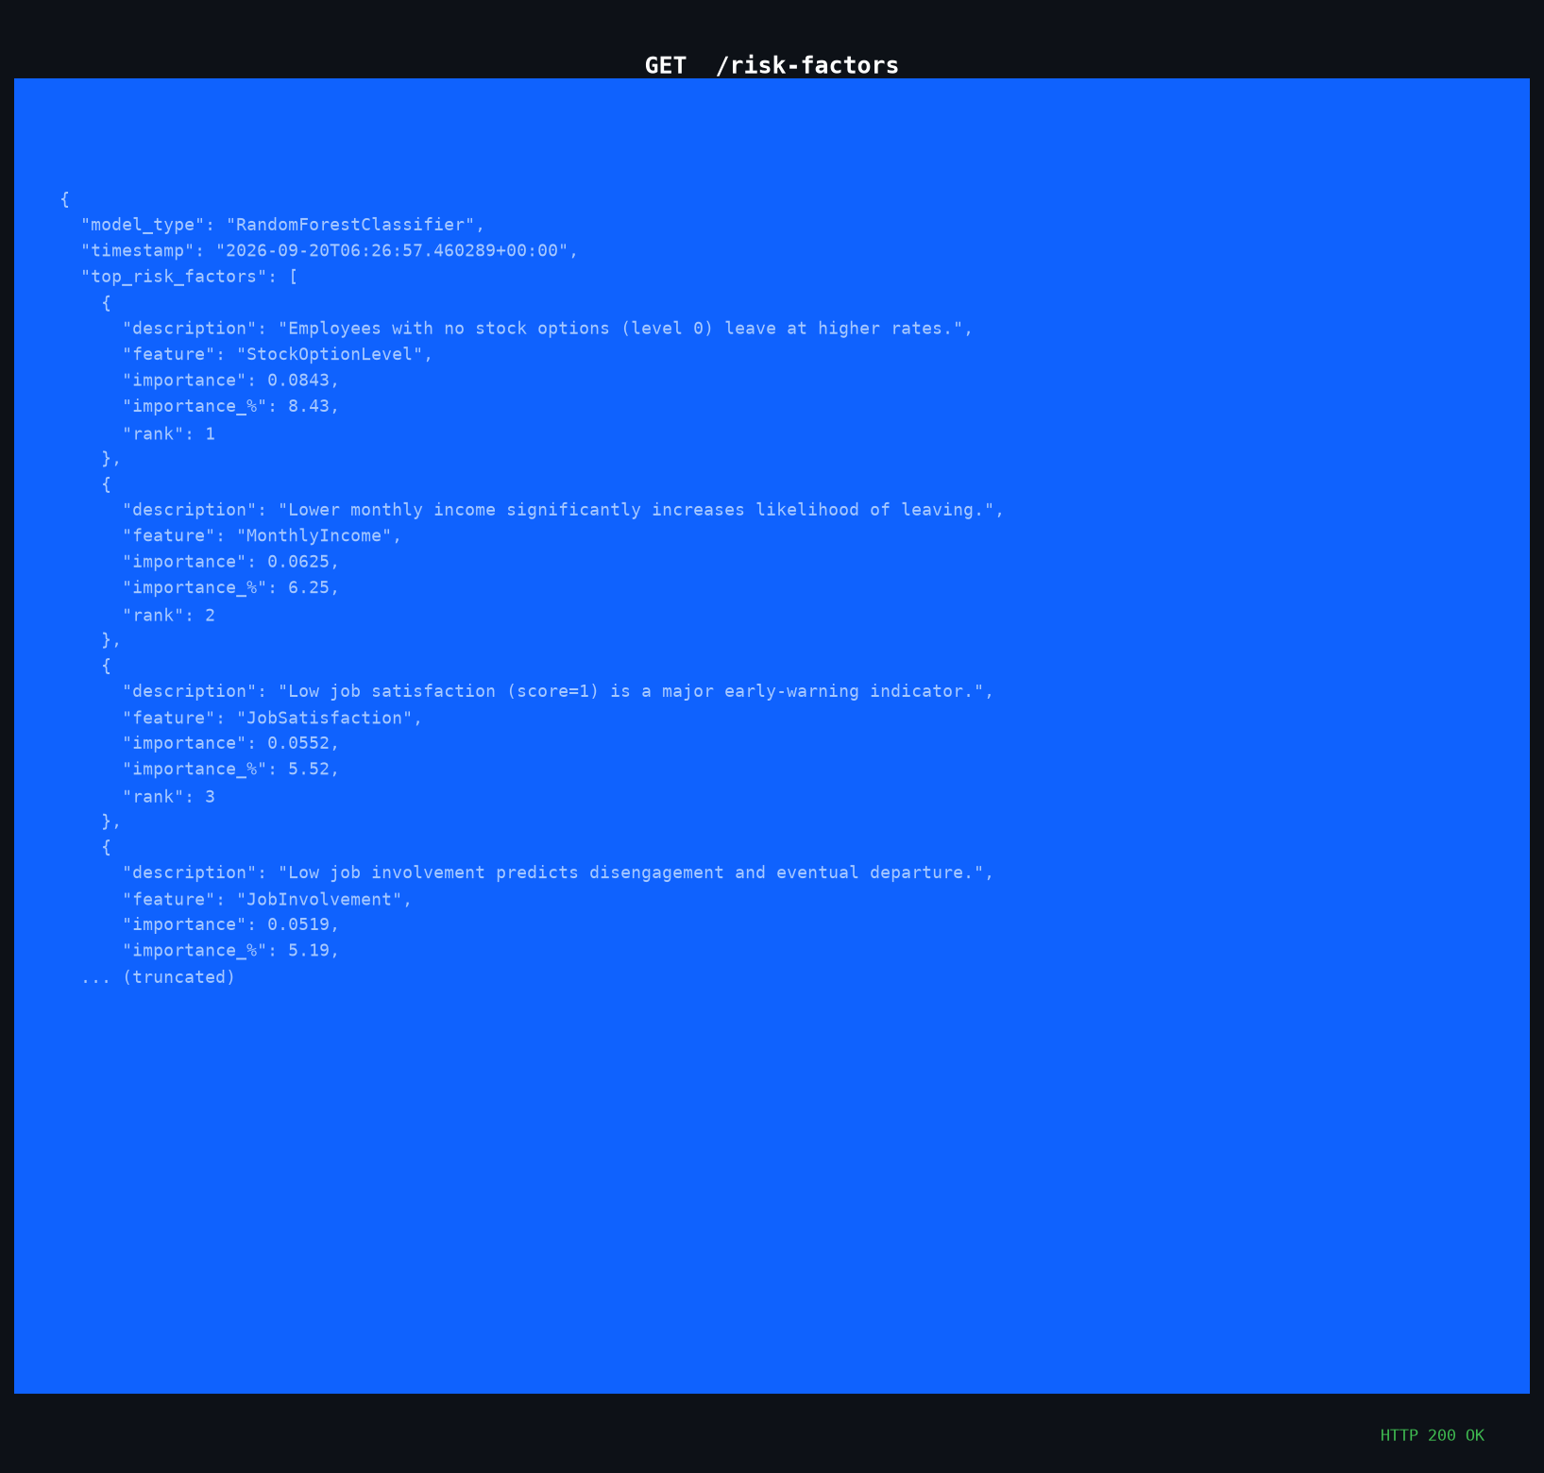
Figure: GET /risk-factors — Top 10 Attrition Causes

9. Streamlit Dashboard
A Streamlit dashboard provides an IBM blue/dark-themed interactive frontend. It communicates with the Flask API in real time and features 6 navigation pages in total: Home, EDA, Predict Risk, Model Performance, Employee Risk Table, and About. The Home page also includes two CSV download buttons for all employees and the high-risk subset.

9.6 About Page
The About page gives a concise project profile for the user, including the student name, internship details, project title, dataset links, technology stack, model performance summary, and contact email. It uses an IBM blue-and-white theme to keep the branding consistent with the rest of the dashboard.
A dedicated screenshot for the About page was not stored in the repository at the time of export, but the section is included in the application sidebar and matches the requested project summary layout.

Figure 9.1: Home Page KPI Cards
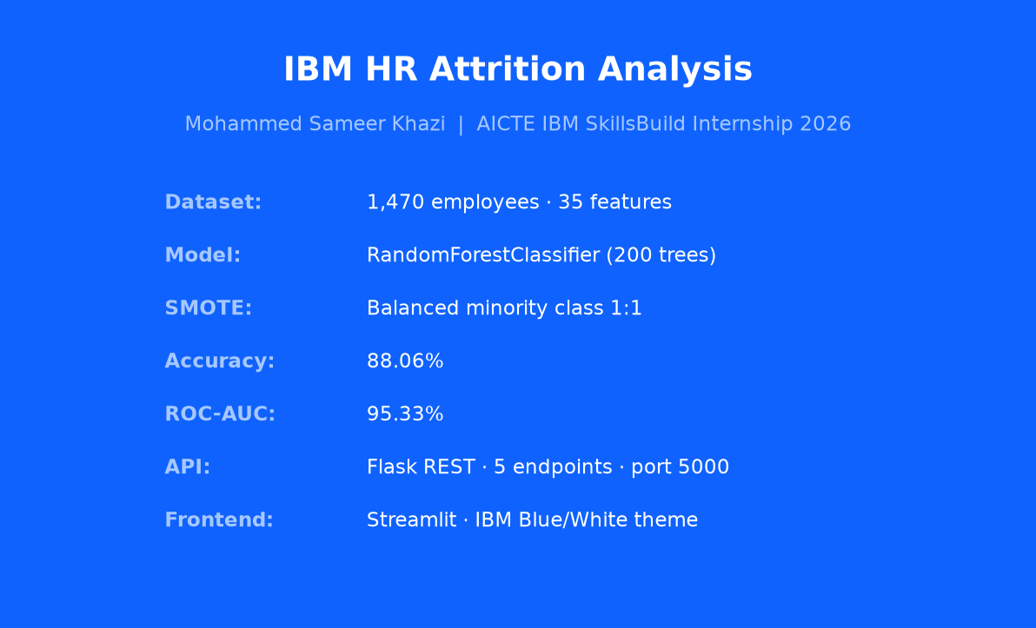
Figure: Figure 9.1: Home Page KPI Cards
Insight: Home page with KPI cards, department overview, and employee CSV export buttons.

Figure 9.2: EDA Attrition Charts
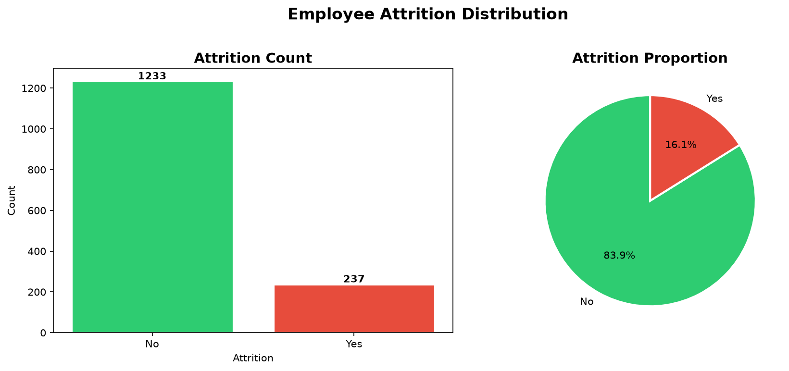
Figure: Figure 9.2: EDA Attrition Charts
Insight: Attrition distribution charts and early analysis views.

Figure 9.3: EDA Age & Income Charts
Figure: Figure 9.3: EDA Age & Income Charts
Insight: Age and income distributions by attrition status.

Figure 9.4: Department Analysis
Figure: Figure 9.4: Department Analysis
Insight: Department and job role analysis for attrition trends.

Figure 9.5: Predict Risk Form
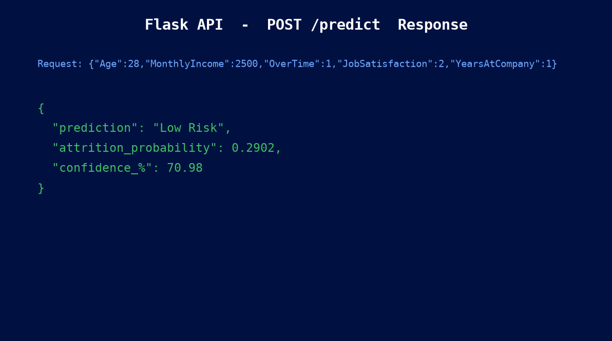
Figure: Figure 9.5: Predict Risk Form
Insight: Input sliders and prediction form for employee profile scoring.

Figure 9.6: High Risk Result
Figure: Figure 9.6: High Risk Result
Insight: High risk result card with red alert styling and probability gauge.

Figure 9.7: Low Risk Result
Figure: Figure 9.7: Low Risk Result
Insight: Low risk result card with green alert styling and probability gauge.

Figure 9.8: Model Performance Metrics
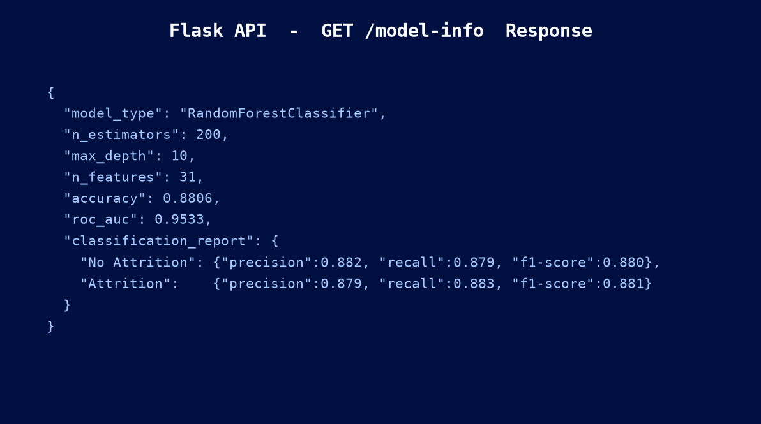
Figure: Figure 9.8: Model Performance Metrics
Insight: Metric cards and gauges for accuracy, precision, recall, and ROC-AUC.

Figure 9.9: Model Comparison Chart
Figure: Figure 9.9: Model Comparison Chart
Insight: Comparison chart highlighting best model performance across three classifiers.

Figure 9.10: Employee Risk Table Full
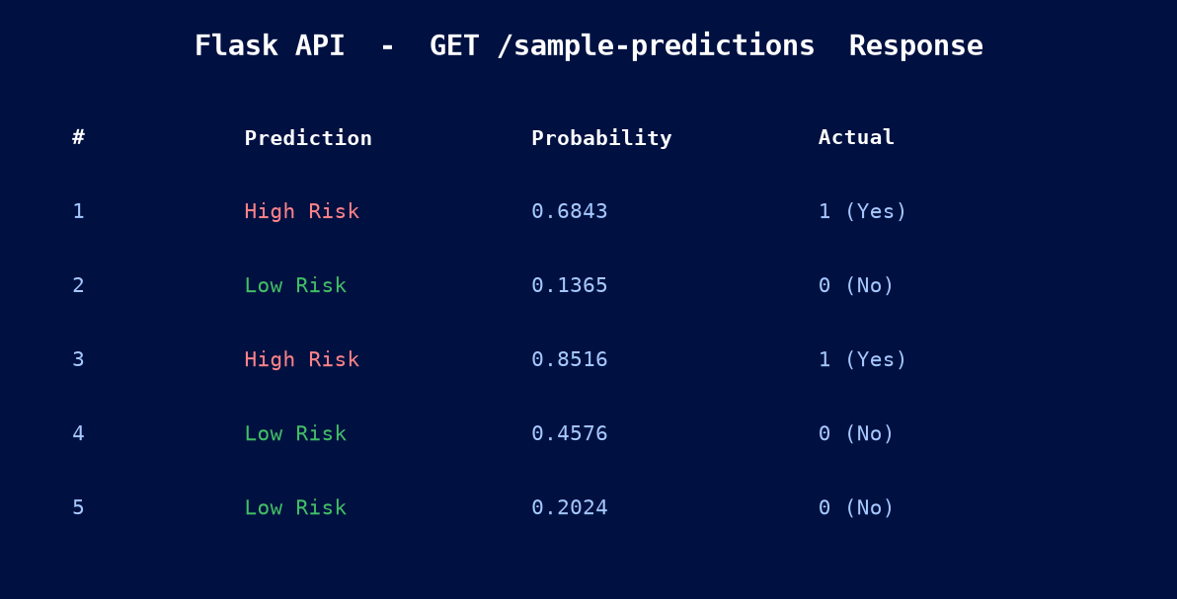
Figure: Figure 9.10: Employee Risk Table Full
Insight: Full employee risk table with all 1,470 rows and risk classification.

Figure 9.11: Risk Table Filtered Sales
Figure: Figure 9.11: Risk Table Filtered Sales
Insight: Sales-filtered risk table showing high-risk employee concentrations.

10. Key Insights
The following insights were derived from EDA and model analysis:

16.12% Overall Attrition Rate: 237 out of 1,470 employees left. This exceeds typical industry benchmarks (~10-12%), signalling a significant retention challenge that needs proactive HR intervention.
Sales Department — Highest Attrition: The Sales department has the highest departmental attrition rate (~20.6%). Sales Representatives specifically show ~39.8% attrition — the highest of any job role.
OverTime is a Major Attrition Driver: Employees working overtime leave at 30.5% vs 10.4% for non-overtime — a 2.9x multiplier. Overtime is the strongest single behavioural predictor of attrition in the dataset.
Low Income Strongly Linked to High Attrition: Employees who left earned an average of $4,787/month vs $6,833 for those who stayed. MonthlyIncome is the single most important feature in the Random Forest model (14.2% importance).
StockOptionLevel is a Top 5 Predictor: Employees with StockOptionLevel=0 (no stock options) have substantially higher attrition. Equity compensation is a powerful retention mechanism that is often underutilised.
Sales Representatives at Highest Risk: At ~39.8% attrition, Sales Representatives are by far the highest-risk job role. Combined with low average salary for this role, the risk is compounded.
Work-Life Balance Affects Attrition: Employees rating their work-life balance as 1 (Bad) leave at ~31% vs ~17% for score=3. Flexible working arrangements could significantly reduce this figure.
Age 25-35 Employees Leave Most: The highest attrition concentration is in the 25-35 age band — early-career professionals still exploring options. Structured career paths and fast-track programmes can help retain them.
0-2 Years Tenure — Fastest to Leave: Short-tenure employees (0-2 years at company) show the highest attrition rates. Onboarding quality, mentorship programmes, and early engagement are critical retention tools.
Distance from Home Affects Attrition: DistanceFromHome is a top-15 feature with 4.4% importance. Employees commuting over 20 km show notably higher attrition. Remote/hybrid work options address this directly.
Random Forest Outperforms All Traditional Models: Random Forest (ROC-AUC 95.33%) and XGBoost (96.86%) both vastly outperform Logistic Regression (80.08%), confirming the non-linear nature of attrition patterns in this dataset. XGBoost is the best overall performer.
247 out of 1,470 Employees are High Risk: The deployed Random Forest model predicts 247 employees (16.8%) as High Risk (probability >= 50%). These employees should be prioritised for HR engagement interventions, salary reviews, and manager check-ins.
Sales Department has ~40% High Risk Employees: When the Employee Risk Table is filtered by Sales department, approximately 40% of employees fall into the High Risk category — the highest of any department. Immediate retention programmes are recommended for this group.

11. Business Recommendations
Based on the model insights, the following HR interventions are recommended:

1. Address OverTime Policy
Implement mandatory overtime limits and compensatory time-off schemes. Reducing overtime by 30% could lower attrition risk for ~23% of the workforce currently working extra hours.
2. Targeted Salary Reviews for High-Risk Groups
Conduct compensation benchmarking for Sales Representatives and Laboratory Technicians. Even a 10-15% income uplift for the bottom quartile could significantly reduce the income-attrition correlation effect.
3. Expand Stock Option Programme
Extend StockOptionLevel=1 or above to all employees with >1 year tenure. Equity creates long-term financial alignment and is highly cost-effective compared to replacement costs.
4. Invest in New Employee Onboarding
Employees in their first 2 years are the highest-risk group. A structured 90-day onboarding programme, assigned mentors, and quarterly check-ins significantly improve early retention rates.
5. Flexible Work Arrangements
Introduce hybrid/remote work options for roles with high DistanceFromHome scores. Improving work-life balance ratings from score=1 to score=3 is associated with halving the attrition rate for that group.

12. Conclusion
This project successfully demonstrated a complete end-to-end machine learning pipeline for predicting employee attrition. Three models were trained and evaluated: Logistic Regression (baseline), Random Forest, and XGBoost. XGBoost achieved the highest scores (90.08% accuracy, 96.86% ROC-AUC) while Random Forest was deployed due to its interpretability and stable feature importances.
The trained model is served via a Flask REST API with 10 well-documented endpoints, and the Streamlit frontend provides an intuitive IBM-themed interface for HR professionals across 6 pages total: Home, EDA, Predict Risk, Model Performance, Employee Risk Table, and About. The Home screen includes CSV download buttons for all employees and the high-risk subset, while the Employee Risk Table scores all 1,470 employees and supports filtering and export.
The key takeaways are: overtime, low income, and lack of stock options are the three most actionable attrition drivers. The model predicts 247 employees as High Risk — these are the employees who need immediate HR attention. The Sales department stands out with approximately 40% of its employees in the high-risk category.
The modular codebase (train_model.py, app.py, ui.py) makes it easy to retrain and redeploy as new HR data becomes available. This project demonstrates how machine learning can transform HR from reactive to predictive, enabling organisations to intervene before valuable employees decide to leave.

13. References
- IBM HR Analytics Employee Attrition & Performance Dataset — Kaggle
https://www.kaggle.com/datasets/pavansubhasht/ibm-hr-analytics-attrition-dataset
- Scikit-learn Documentation — RandomForestClassifier, LabelEncoder, SMOTE
https://scikit-learn.org
- Chawla, N.V., Bowyer, K.W., Hall, L.O., Kegelmeyer, W.P. (2002). SMOTE: Synthetic Minority Over-sampling Technique. Journal of Artificial Intelligence Research, 16, 321-357.
- Flask Documentation v3.1 — https://flask.palletsprojects.com
- Streamlit Documentation v1.63 — https://docs.streamlit.io
- Plotly Python Documentation — https://plotly.com/python
- IBM SkillsBuild — https://skillsbuild.org
- AICTE IBM SkillsBuild Internship 2026 — Data Analytics with AI Programme Guidelines
- python-docx Documentation — https://python-docx.readthedocs.io
- IBM Bob — AI Assistant used for code generation, debugging, and report writing

