

**Alexandria University**

**Faculty of Engineering**

**Computer and Systems Engineering Dept.**

**Systems Programming**

**SIC/XE Assembler**

**Phase 1**

**Name:**

* **Mohamed Samy Mohamed**  (39)
* **Karim Atef Ahmed (31)**
* **Yousef Mohamed Fathy (63)**
* **Abdallah Mohamed Fawzy (25)**

**Requirements :**

The term project is to implement SIC/XE assembler, written in C/C++, producing code for the absolute loader used in the SIC/XE programming assignments.

In this phase (phase 1) of the project, it is required to implement Pass1 of the assembler. The output of this phase should be used as input for subsequent phase.

**Design:**

Each line is read from file passed to parser which check for comments, error, and empty line. Then the line is checked in main to update location counter.

**Main data structures:**

Arrays

Vectors

Unordered maps

**Assumptions:**

Support free-formatted assembly language programs.

On opening the program the user should enter pass1FILENAME.EXE such as pass1prog.txt

Then the result would be found in a file result.txt in the same path of the program containing the instructions after pass1 (list file).

**Sample Run:**

on opening the program the user should enter pass1FILENAME.txt

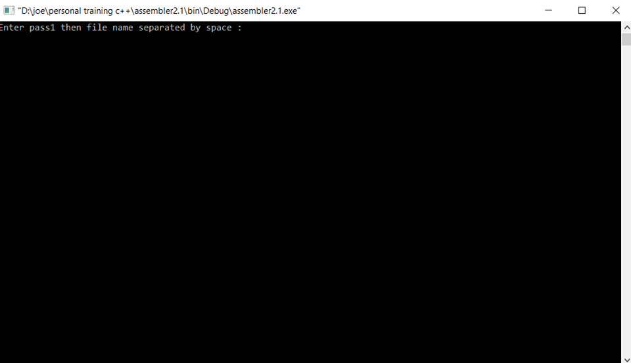

Such as :

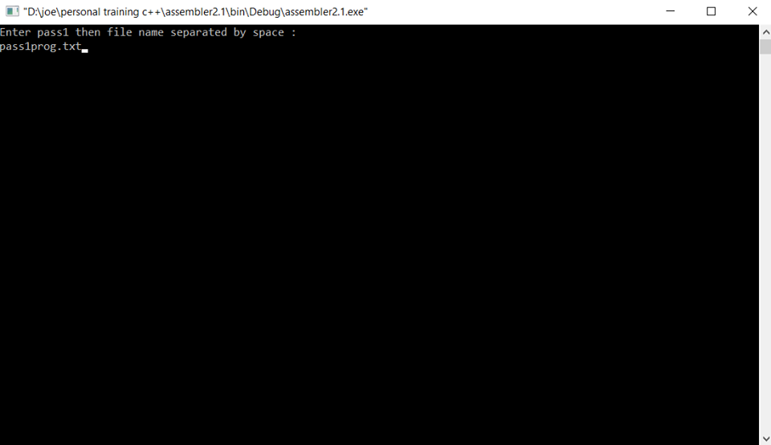

Then on pressing enter :

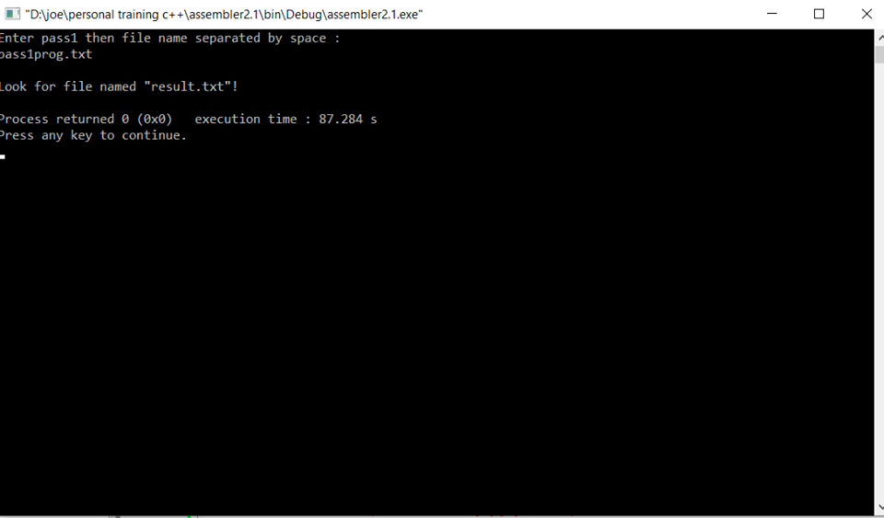

So as shown the result in written in result.txt found in the same path of the program and the filename.txt files.

The prog.txt file :

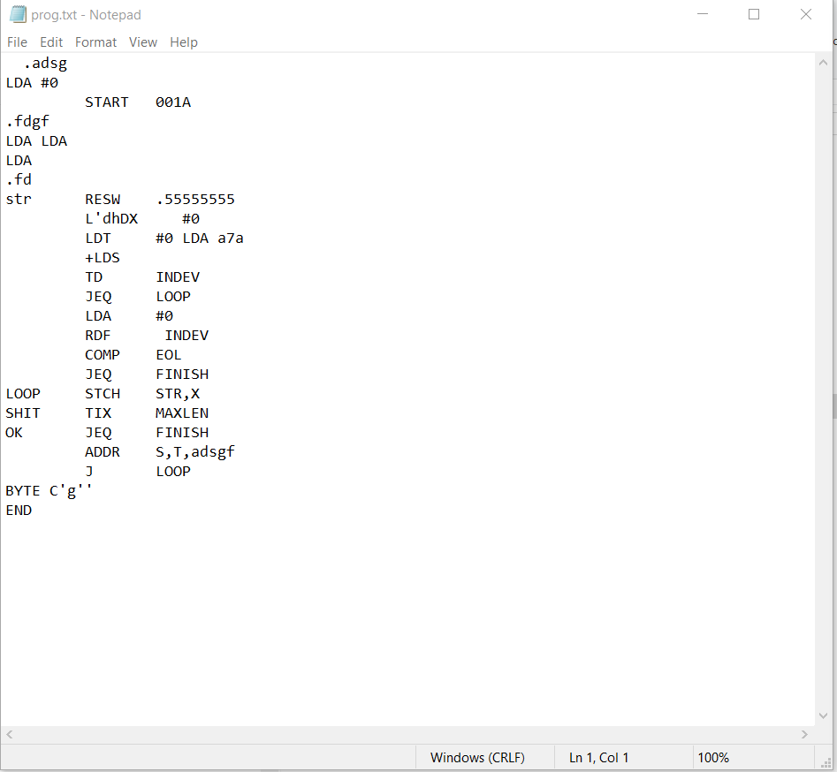

The result file :

