Mr. John Smith  
7849 Anystreet Dr  
Anytown, USA 99999

Re: Jones v. Smith, et al.  
Case No. 00-X-00-000000

Dear Mr. Smith:

As we discussed, this is a very serious injury case. The defendant’s tractor-trailer hit Mr. Jones on May 12, 2025. As a result of the accident, he sustained permanent physical injuries. He had surgery on his leg and needs surgery on his back. Mr. Jones has been unable to work since the accident and has been declared completely disabled by his physicians and is not cleared to work. To date, Mr. Jones has suffered $4,016,586.26 in special damages. They are itemized as follows:

|  |  |
| --- | --- |
| Past Medical Expenses: | $ 465,459.54 |
| Future Medical Expenses: | $ 30,000.00 |
| Past Lost Wages: | $ 255,280.72 |
| Future Loss of Earnings: | $ 1,763,855.00 |
| Future Loss of Benefits: | $ 649,991.00 |
| Pain and Suffering: | $ 890,000.00 (2022 cap) |
| Total Special Damages: | **$4,016,586.26** |

Sincerely,

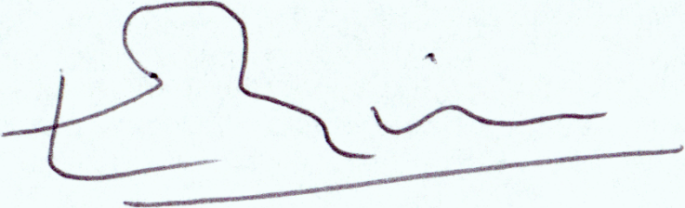

Ronald V. Miller, Jr.