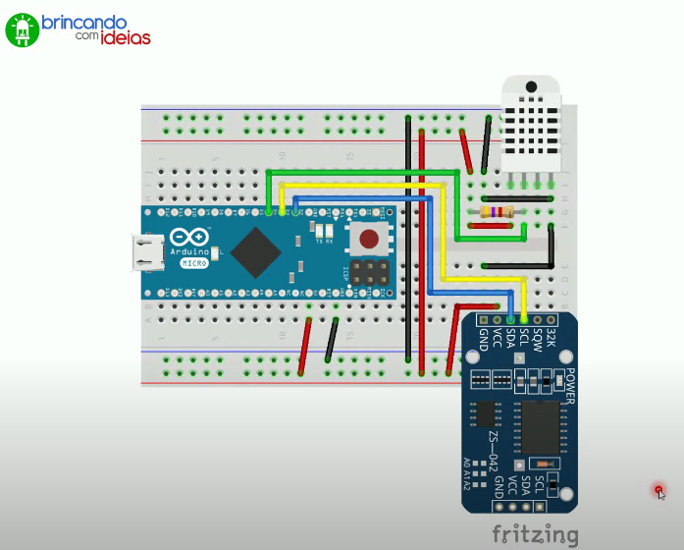

<https://www.youtube.com/watch?v=V8PHw3e-aPo&feature=youtu.be>

