Some comments on the Australian domestic gas market supply

Mike Sandiford

11/02/2020

## East coast gas supply and domestic reservation

The structur and functionong of Australian energy markets have experienced unprecedented changes in recnet years, manifest mot directly in dramatic price rises. There have been numerous drivers for these changes, including, but not limited to, the imperative to decarbosne what is one of the most CO2-intensive energy supply chains in the developed world. Overalid on thes changes has be a highly ractious politccal dyanmic, with contentious energy polciy arguably directly contibuting to the downfall of four prime-ministers within 10 years.

The most significant structural change in eastern Australian markets, which services over 80% of the Australian population, was the transition of the gas market from being solely domestic to export linked via the co-development of LNG exports capacity at Curtis Island and the coal seam gas fields (CSG) in Queensland.

The new CSG fields resulted in a tripling of gas supply, the majority of which was destined for export. At such scale these new developments exposed a risk that production would fall short of targets, and therefore impact domestic availability. As much was acknowledged as early as 2013 in the joint Department of Industry and Bureau of Resources and Energy Economics study into the Eastern Australian domestic gas market[1]. To quote

The current development of LNG in eastern Australia and the expected tripling of gas demand are creating conditions that are in stark contrast to those in the previously isolated domestic gas market. The timely development of gas resources will be important to ensure that supply is available for domestic gas users and to meet LNG export commitments. Such is the scale of the LNG projects that even small deviations from the CSG reserve development schedule could result in significant volumes of gas being sourced from traditional domestic market supplies

With gas market export linkage now some 5 years old, it is timely to review how the markest repsonded, at what polciy actions might have beeen taken to avert some of the deleterious side effects.

The analysis here is based on data sourced from AEMO and the exprt cargo statistics released by Gladstone Port Authority (GPA). [2]

### A brief history of CSG developments in Queensland

The develpoment of csg fields is described in …

### Total gas production by state

The key feature is the ramp up of east coast gas production in 2015 & 2016, from an average of around 1600 TJ/day to ~5000 TJ/day, due to increased production in the Queensland CSG fields.

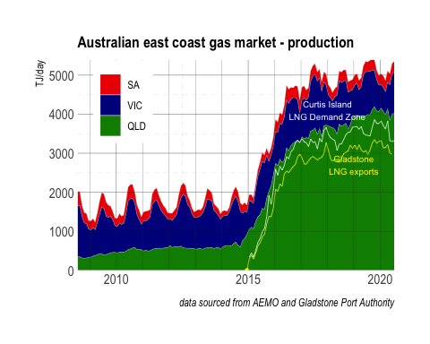

Also illustrated are

* gas exported as reported by the GPA (yellow line), and
* the gas delivered into the Curtis Island demand Zone (white line). Because the GPA exports are reported by month and are “quantised” by cargo departures on a >1 day cycle, monthly averages are approximated by applying a smoothing filter on reported monthly values (namely *1/6*previous.month + 2/3*current.month + 1/6*subsequent.month*).

Note-

* The ratio of demand to export is about 1.155 suggesting a parasitic load of about 16% of LNG processing at Curtis Island.
* while QLD production is relatively constant, the exported flows have tended to be high in summer than winter.

The changes in gas production are reflected in percentage contubutions, with QLD increasing from ~20% in the winter of 2010 to more than ~&5% of gas production in the winter of 2019. Summer contributions of QLD production are typicallly 5-10% higher reflecting the larger industrial demand proportion relative to southern states(see below).

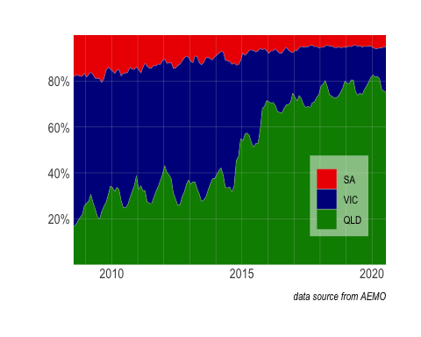

Subtracting the Curtis Island demand from QLD production gives the balance supplied into the domestic market.

Note-

* the restricted domestic supply in late 2016.

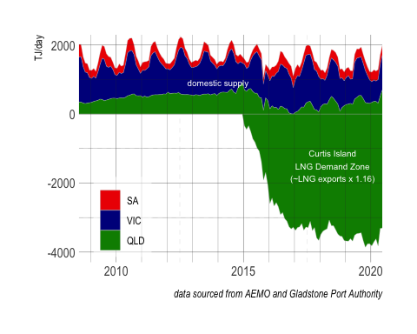

Domestic demand shows a stong seasonal variation reflecting the use of gas for winter heating in the southern states, with peak production historically at slightly aove 2000 TJ/day.

Noted

* steady reduction in the peak supply to < 2000 TJ/day is evident since the winter of 2014, reflecting a significant tightening of the domestic supply.
* neglible contribution of QLD supply to the domestic markets in late 2016.
* a stronger seasonality in QLD domestic supply, due more to variation in exports than to production

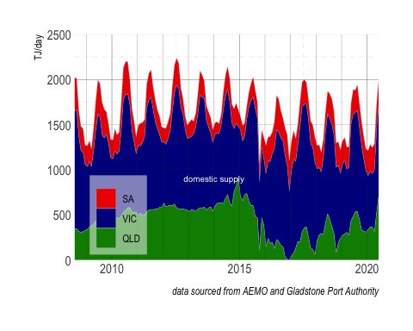

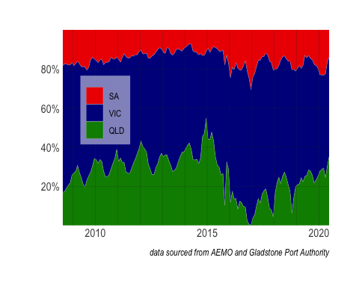

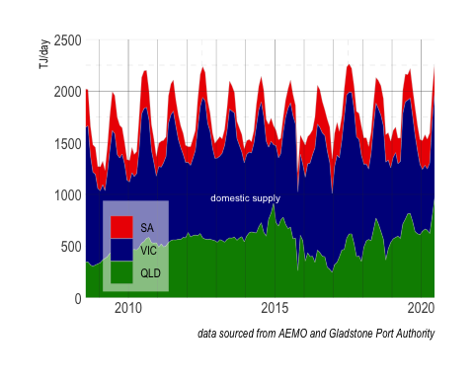

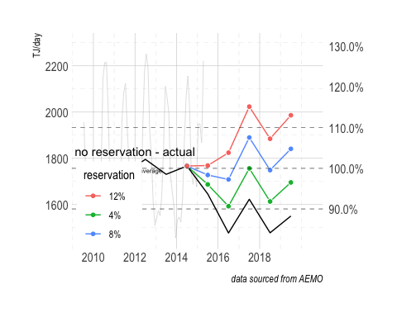

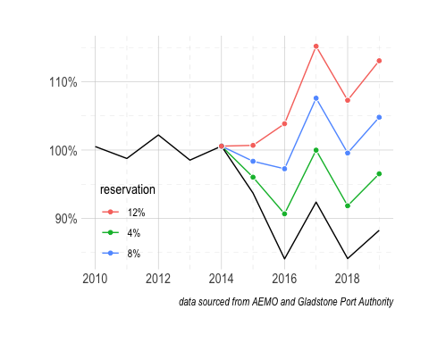

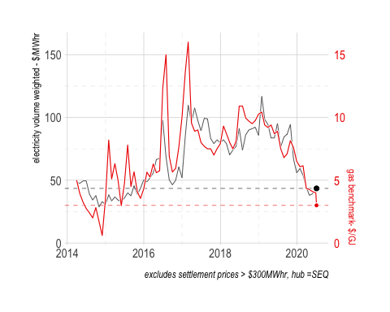

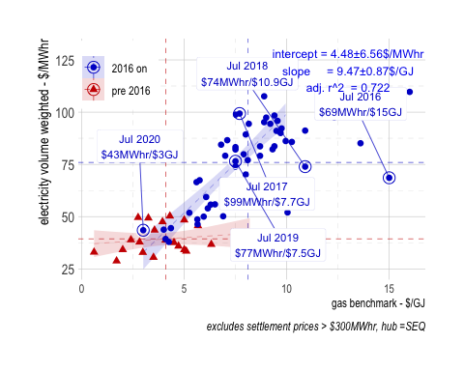

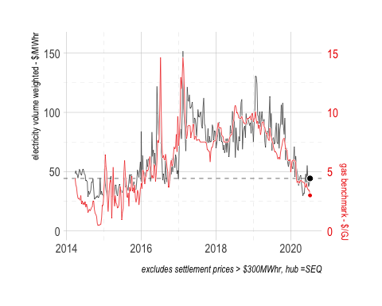

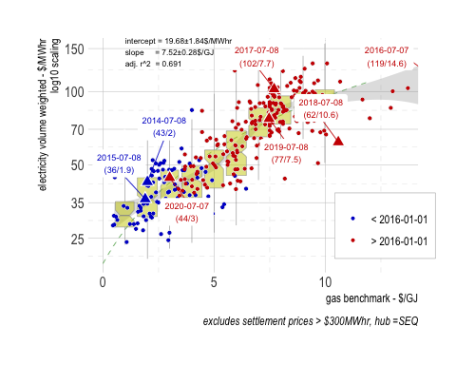

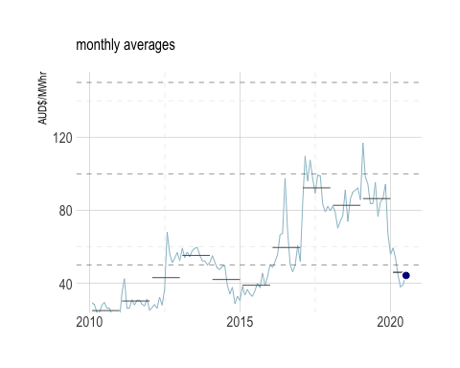

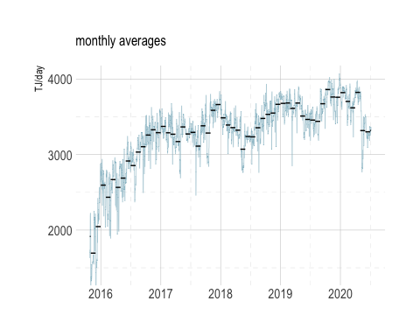

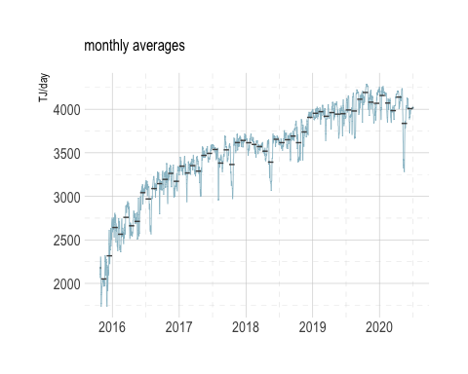

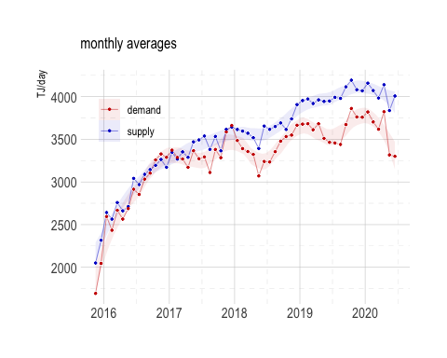

1. Eastern Australian Domestic Gas Market Study, the Department of Industry and the Bureau of Resources and Energy Economics (BREE).https://www.google.com/url?sa=t&rct=j&q=&esrc=s&source=web&cd=1&ved=2ahUKEwjY0_fm74noAhXXxzgGHYoGC3YQFjAAegQIARAB&url=https%3A%2F%2Fwww.aph.gov.au%2F~%2Fmedia%2FCommittees%2Feconomics_ctte%2Festimates%2Fadd_1617%2FIndustry%2Fanswers%2FAI-87_Whish-Wilson_Attachment3.pdf&usg=AOvVaw23Fh1haaQCDPujUQ5j6k38
2. Note that in the figures NSW is neglected since it’s contribution to east coast gas production is very small.