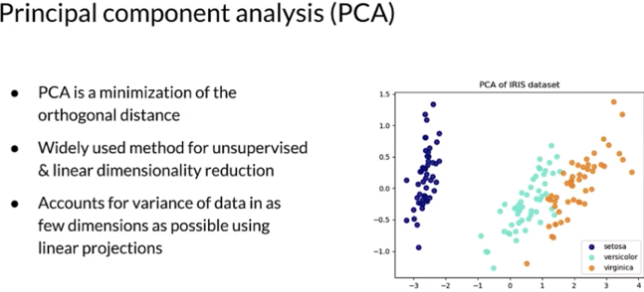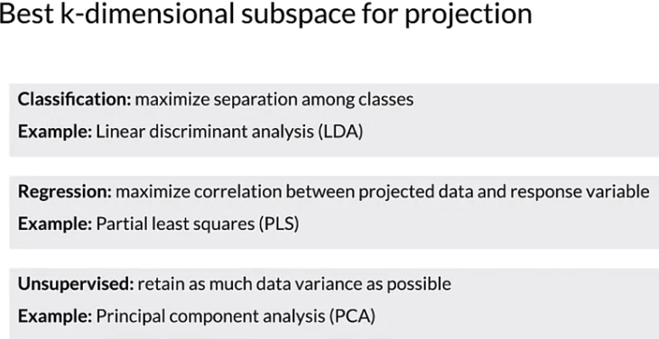

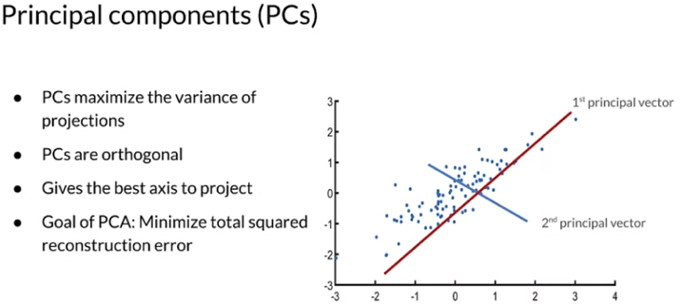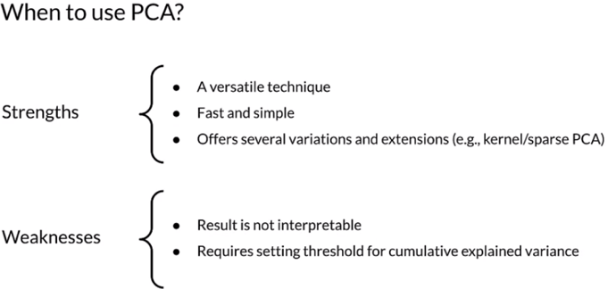

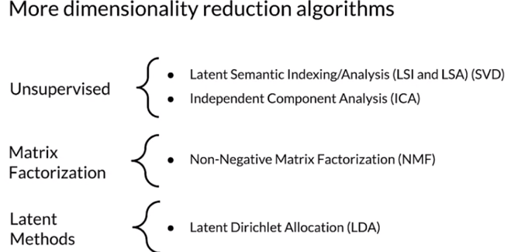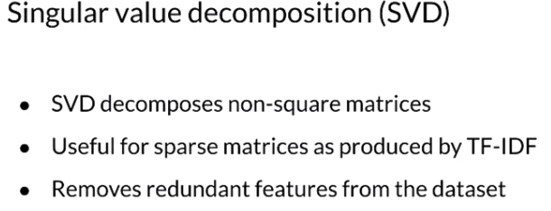

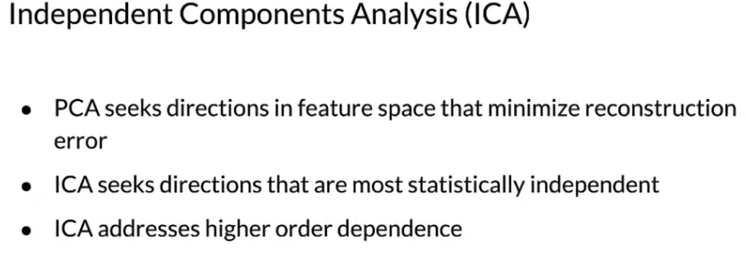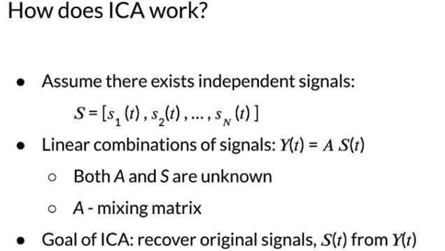

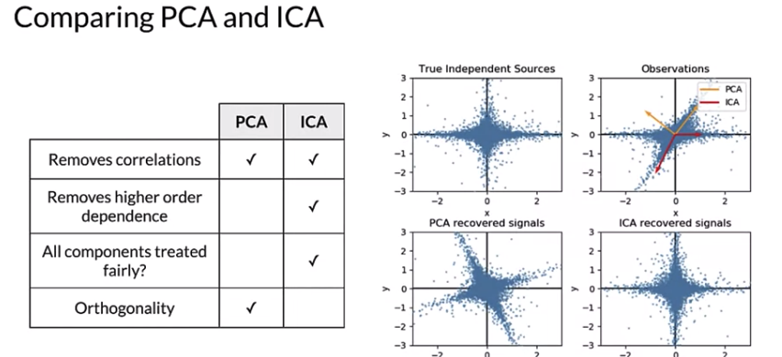

Dimensionality Reduction Techniques

* [Principal Component Analysis (PCA)](https://arxiv.org/pdf/1404.1100.pdf)
* [Independent Component Analysis (ICA)](https://arxiv.org/pdf/1404.2986.pdf)
* [PCA extensions](http://alexhwilliams.info/itsneuronalblog/2016/03/27/pca/)

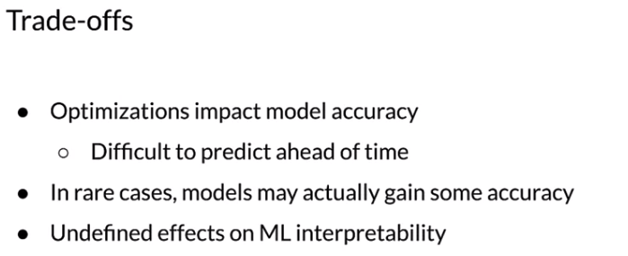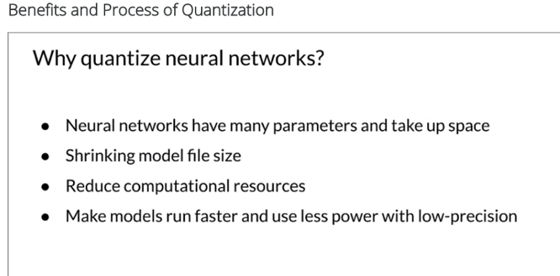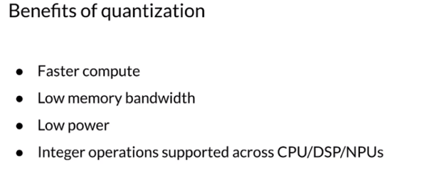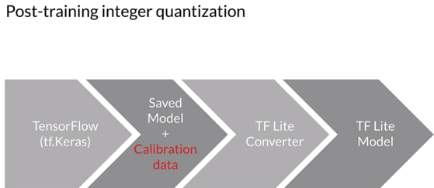

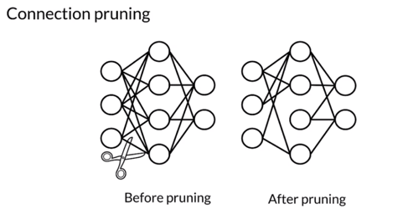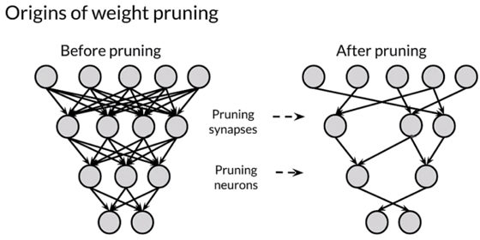

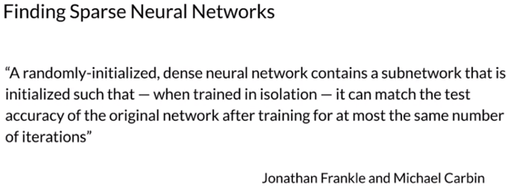

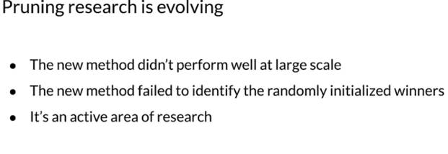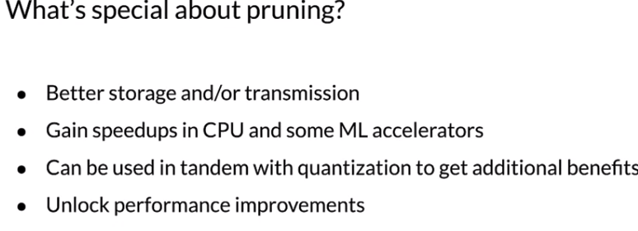

* [Quantization](https://arxiv.org/abs/1712.05877)
* [Post-training quantization](https://medium.com/tensorflow/introducing-the-model-optimization-toolkit-for-tensorflow-254aca1ba0a3)
* [Quantization aware training](https://blog.tensorflow.org/2020/04/quantization-aware-training-with-tensorflow-model-optimization-toolkit.html)
* [Pruning](http://yann.lecun.com/exdb/publis/pdf/lecun-90b.pdf)
* [The Lottery Ticket Hypothesis](https://arxiv.org/abs/1803.03635)