Model Analysis

[TensorBoard](https://blog.tensorflow.org/2019/12/introducing-tensorboarddev-new-way-to.html)

* [TFMA](https://blog.tensorflow.org/2018/03/introducing-tensorflow-model-analysis.html)
* [TFMA architecture](https://www.tensorflow.org/tfx/model_analysis/architecture)

[Explaining and Harnessing Adversarial Examples](https://arxiv.org/abs/1412.6572)

To access the Partial Dependence Plots libraries please check these resources:

* [PDPbox](https://github.com/SauceCat/PDPbox)
* [PyCEbox](https://github.com/AustinRochford/PyCEbox)

The demo shown in the previous video is based on this [Google Colab notebook.](https://colab.research.google.com/github/tensorflow/docs/blob/master/site/en/tutorials/generative/adversarial_fgsm.ipynb)

* [Fairness](https://www.tensorflow.org/responsible_ai/fairness_indicators/guide)
* [Learning fair representations](https://arxiv.org/pdf/1904.13341.pdf)
* [Fairness-aware Machine Learning library](https://github.com/cosmicBboy/themis-ml)
* [AI 360 open source model fairness library](http://aif360.mybluemix.net/)
* [Model remediation](https://www.tensorflow.org/responsible_ai/model_remediation)
* [Model cards](https://modelcards.withgoogle.com/about)
* [Instrumentation, Observability & Monitoring of Machine Learning Models](https://www.infoq.com/presentations/instrumentation-observability-monitoring-ml/)
* [Monitoring Machine Learning Models in Production - A Comprehensive Guide](https://christophergs.com/machine%20learning/2020/03/14/how-to-monitor-machine-learning-models/)
* [Concept Drift detection for Unsupervised Learning](https://arxiv.org/pdf/1704.00023.pdf)
* [Google Cloud](https://cloud.google.com/ai-platform/prediction/docs/continuous-evaluation)
* [Amazon SageMaker](https://aws.amazon.com/sagemaker/model-monitor/)
* [Microsoft Azure](https://docs.microsoft.com/en-us/azure/machine-learning/how-to-monitor-datasets?tabs=python)

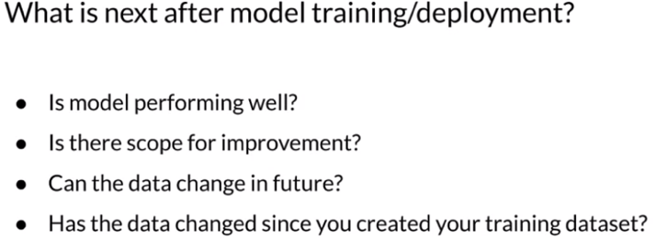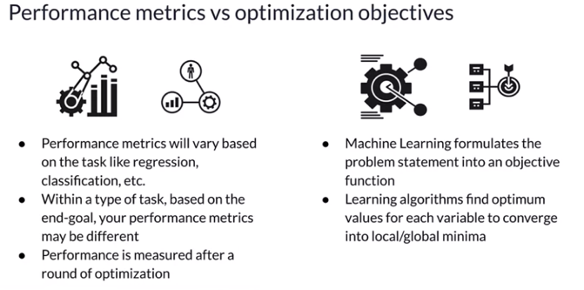

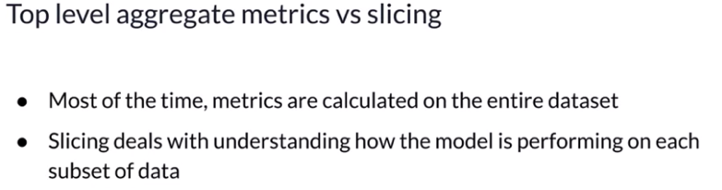

TFMA

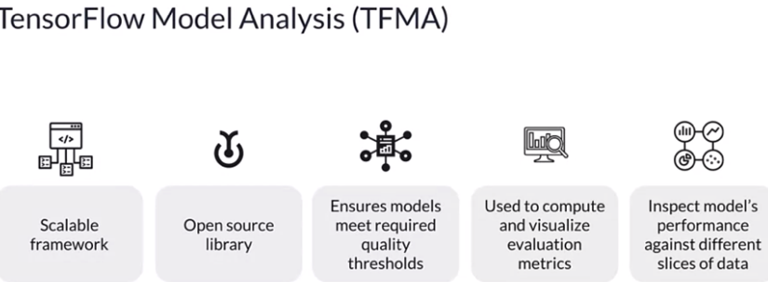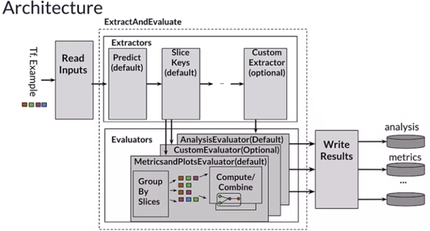

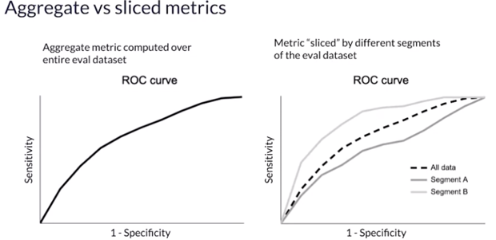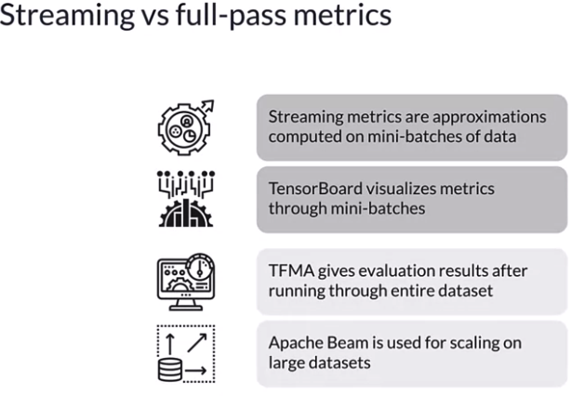

Model Debugging techniques

* benchmark models

* sensitivity analysis

* Cleverhans

* Foolbox

* residual analysis

