**WEEK2**

**Lesson 1: Introduction to Monte-Carlo Methods**

* Understand how Monte-Carlo methods can be used to estimate value functions from sampled interaction
  + Monte Carlo methods require only experience—sample sequences of states, actions, and rewards from actual or simulated interaction with an environment
* 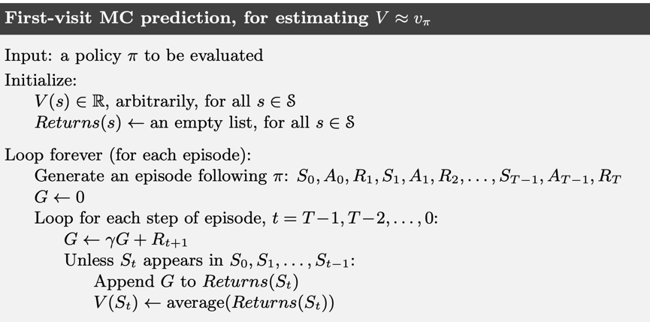
* Identify problems that can be solved using Monte-Carlo methods
* Use Monte-Carlo prediction to estimate the value function for a given policy.

**Lesson 2: Monte-Carlo for Control**

* Estimate action-value functions using Monte-Carlo

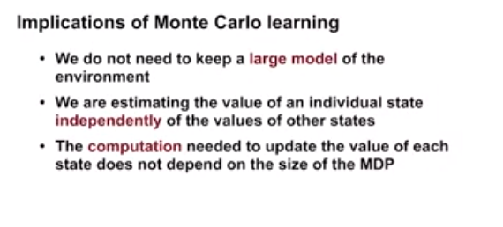

* Understand the importance of maintaining exploration in Monte-Carlo algorithms
* Understand how to use Monte-Carlo methods to implement a GPI algorithm
* 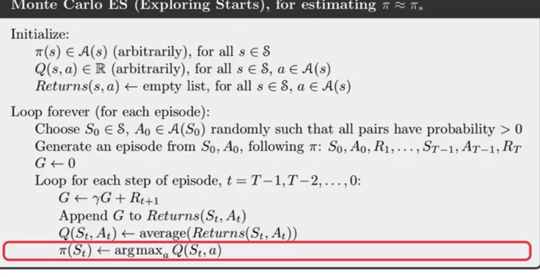
* Apply Monte-Carlo with exploring starts to solve an MDP

**Lesson 3: Exploration Methods for Monte-Carlo**

* Understand why exploring starts can be problematic in real problems
  + - Epsilon greedy policies are a subset of a larger class of policies called Epsilon soft policies Epsilon soft policies take each action with probability at least Epsilon over the number of actions.
* 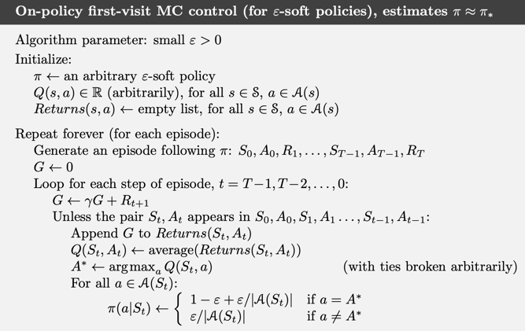
* Describe an alternative exploration method for Monte-Carlo control
  + The disadvantage of Epsilon soft policies is that they are suboptimal for both acting and learning Epsilon soft policies are neither optimal policies for obtaining reward nor are they optimal for exploring to find the best actions

**Lesson 4: Off-policy learning for prediction**

* Understand how off-policy learning can help deal with the exploration problem

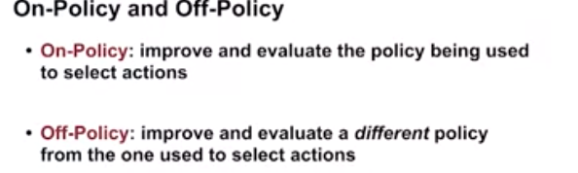

* Produce examples of target policies and examples of behavior policies

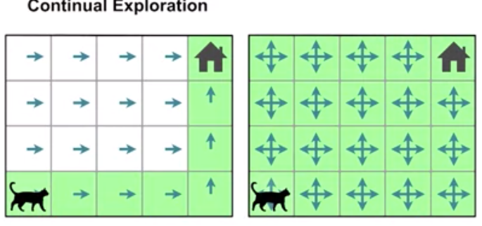

* Understand importance sampling
  + importance sampling allows us to do off-policy learning, learning with one policy while following another.
* Use importance sampling to estimate the expected value of a target distribution using samples from a different distribution

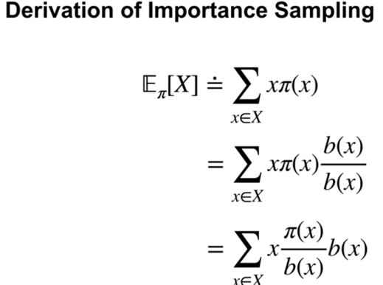

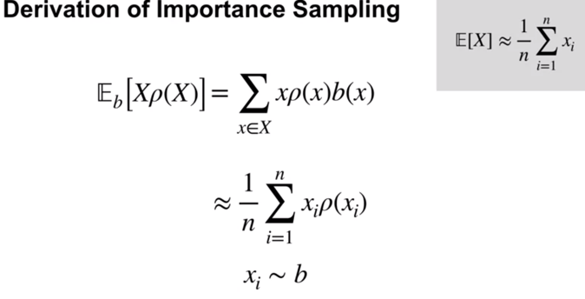

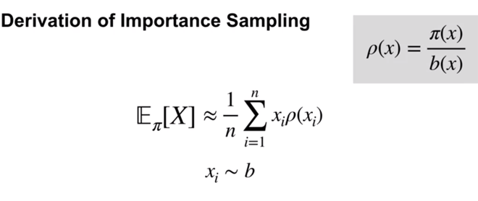

* Understand how to use importance sampling to correct returns
* Understand how to modify the Monte-Carlo prediction algorithm for off-policy learning.