WEEK3

**Lesson 1: Introduction to Temporal Difference Learning**

* Define temporal-difference learning

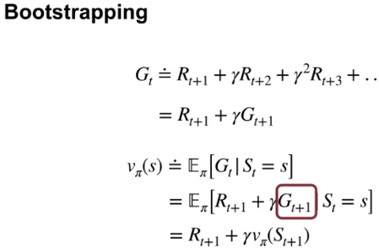

* Define the temporal-difference error

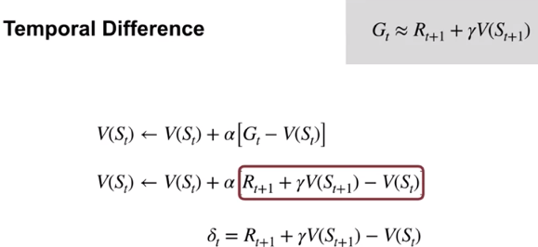

* Understand the TD(0) algorithm

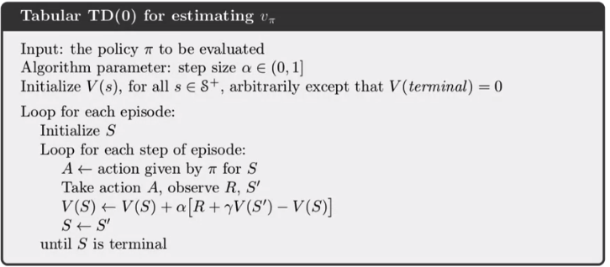

**Lesson 2: Advantages of TD**

* Understand the benefits of learning online with TD

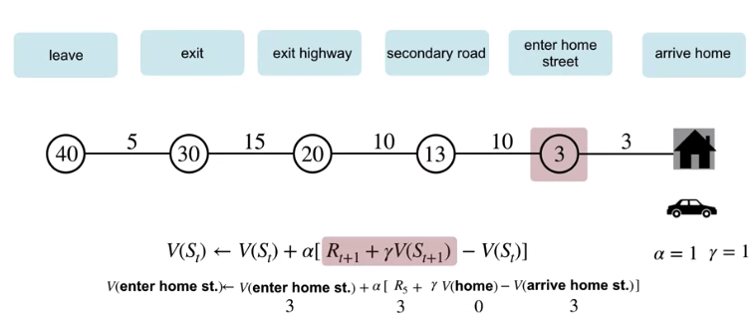

* Identify key advantages of TD methods over Dynamic Programming and Monte Carlo methods
  + Does not require a model of the environment. TD can directly learn from experience.
  + Online and incremental
  + Converges faster than Monte Carlo methods
* Identify the empirical benefits of TD learning

