GenAI-Powered Log Analysis & RCA Chatbot — Architecture Document
Author: Senior GenAI Architect
Purpose: Define architecture, flows, UML diagrams, phased delivery, and infrastructure requirements for client approval of the GenAI Log Analysis & RCA Chatbot POC.

1. Executive Summary
This document outlines the architecture and execution flow for a GenAI-powered Log Analysis and Root Cause Analysis (RCA) chatbot. The system augments the existing observability stack (Spring Boot → Kafka → Logstash → OpenSearch) with a Retrieval-Augmented Generation (RAG) layer and an MCP-based agentic chatbot. End users (support engineers, operations, business analysts) can query in natural language using an order number; the system intelligently retrieves relevant logs, queries the order database, identifies historically similar incidents, and returns a coherent plain-English RCA. The design is additive: existing Spring Boot services and the Logstash pipeline remain unchanged. The GenAI layer is opt-in, independently scalable, and can be disabled at any time without business impact.

2. High-Level Architecture Overview
The system attaches a new Python consumer group to the existing Kafka topic carrying application logs. The consumer parses each log, enriches it with metadata, generates a 1024-dimensional vector embedding using the open-source bge-large-en-v1.5 model, and writes it to a dedicated OpenSearch k-NN index alongside existing log indices. When a user submits a query through the React chatbot UI, a FastAPI orchestrator invokes a LangGraph agent that classifies intent, calls MCP tools to fetch order status (from the operational database) and retrieve relevant logs (via hybrid OpenSearch search), looks up similar past incidents (RAG), and synthesizes a structured RCA using Claude Sonnet 4.5. The response is streamed back to the user via Server-Sent Events.

3. UML – System Component Diagram
+---------------------------------------------+
| EXISTING SPRING BOOT APPS |
| (Order, Payment, Inventory, etc.) – |
| UNCHANGED |
+----------------------+----------------------+
|
v
+---------------------------------------------+
| Kafka Topic: app-logs |
+----------+---------------------+------------+
| |
cg: logstash-cg cg: genai-ingestor-cg
| |
v v
+--------------------+ +---------------------+
| Logstash | | Python Ingestor |
| (Shipper) | | (aiokafka) |
+---------+----------+ +----------+----------+
| |
v v
+--------------------+ +---------------------+
| OpenSearch | | Embedding Model |
| logs-* | | (bge-large-en-v1.5)|
| (existing logs) | +----------+----------+
+--------------------+ |
^ v
| +---------------------+
+---------+----------+ | OpenSearch |
| OpenSearch | | logs-vectors-* |
| Dashboards (UI) | | (k-NN, HNSW, |
+--------------------+ | cosine, dim=1024)|
+----------+----------+
^
|
+---------------------------------------------+
| MCP Server (Python) |
| Tool 1: analyze_order_logs (RAG) |
| Tool 2: get_order_status (SQL DB) |
| Tool 3: find_similar_incidents (RAG) |
+----------------------+----------------------+
^
|
+---------------------------------------------+
| FastAPI Orchestrator + LangGraph |
| (Agent + Memory + Streaming) |
+----------------------+----------------------+
^
|
+---------------------------------------------+
| React Chatbot UI (SSE Streaming) |
+---------------------------------------------+
Rendered View:
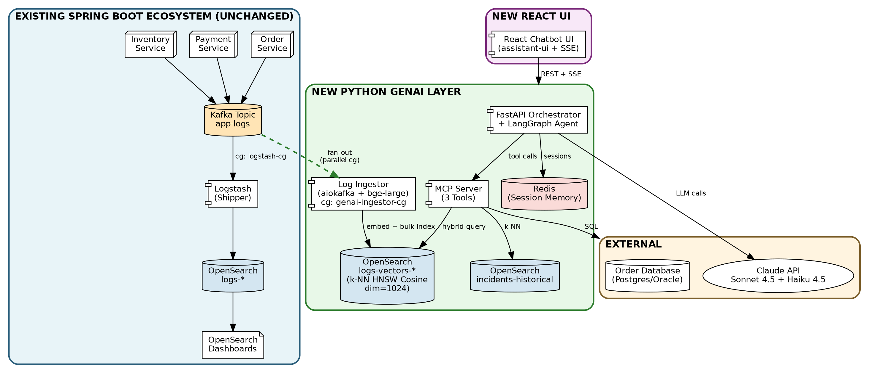

4. UML – Sequence Diagram (Execution Flow)
User -> React UI : ask "Why did order 12345 fail?"
React UI -> FastAPI : POST /api/v1/chat (SSE)
FastAPI -> Redis : get session history
FastAPI -> LangGraph : invoke(query, session_id)
LangGraph -> Claude Haiku : classify intent
Claude Haiku -> LangGraph : "order_inquiry"
LangGraph -> MCP : get_order_status(12345) [parallel]
LangGraph -> MCP : analyze_order_logs(12345) [parallel]
MCP -> Order DB : SELECT JOIN orders/payments
Order DB -> MCP : structured status
MCP -> Embedding Service : embed(query)
Embedding Service -> MCP : 1024-dim vector
MCP -> OpenSearch (k-NN) : hybrid query (BM25 + kNN + filter)
OpenSearch (k-NN) -> MCP : top 20 relevant log chunks
MCP -> LangGraph : evidence (status + logs)
LangGraph -> MCP : find_similar_incidents(signature)
MCP -> OpenSearch (incidents) : k-NN search top 3
OpenSearch (incidents) -> MCP : past RCAs + resolutions
MCP -> LangGraph : historical context
LangGraph -> Claude Sonnet : synthesize RCA
Claude Sonnet -> LangGraph : streaming tokens
LangGraph -> FastAPI : streaming RCA
FastAPI -> React UI : SSE token stream
React UI -> User : progressive RCA display
FastAPI -> Redis : save updated session
Rendered Sequence Diagram:
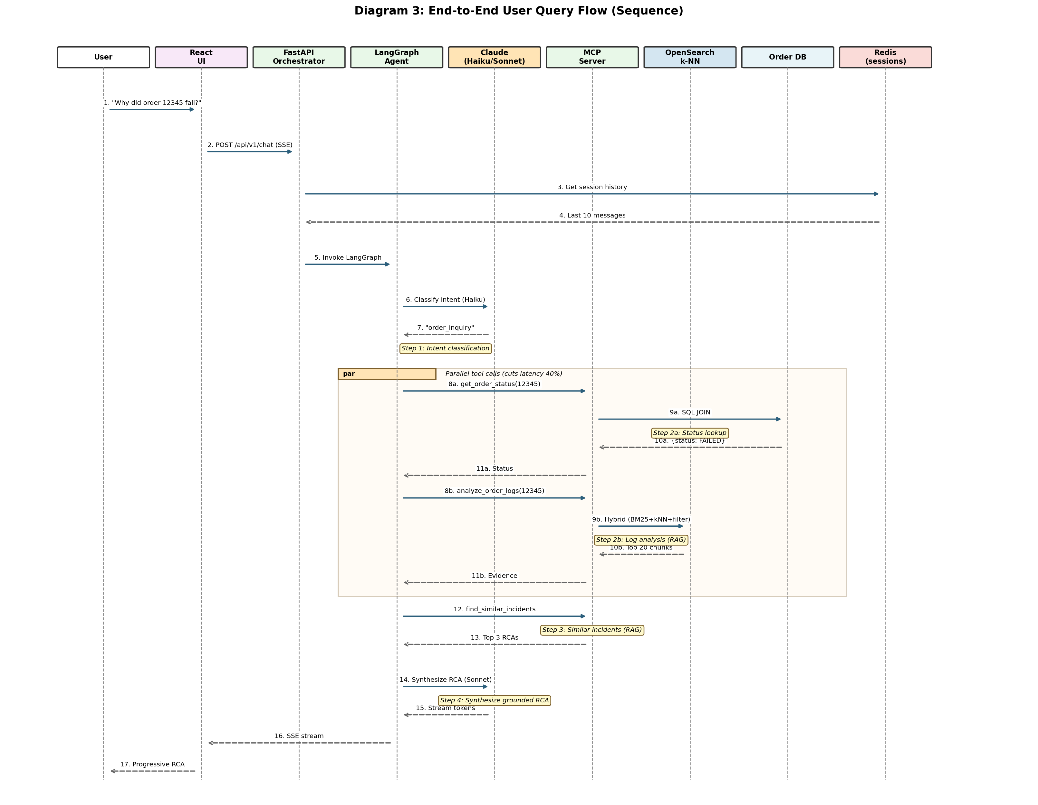

5. Detailed Node-Level Explanation

5.1 Kafka Ingestor (Python, aiokafka)
Consumes the existing app-logs Kafka topic using a new consumer group (genai-ingestor-cg). Operates in parallel with the existing Logstash consumer group with zero impact on it. Buffers messages and flushes when the batch reaches 500 logs OR 30 seconds elapse — whichever comes first. Implements at-least-once delivery by committing Kafka offsets only after successful OpenSearch indexing. Malformed messages are routed to a dead-letter queue topic for later inspection.

5.2 Log Parsing, Enrichment & PII Masking
Each log message is parsed as JSON, and key metadata is extracted: order_id, trace_id, service_name, timestamp, log_level, user_id. Configurable regex patterns mask emails, phone numbers, and credit card numbers BEFORE the log is embedded — sensitive data never enters the vector store. DEBUG and TRACE logs are dropped to reduce noise.

5.3 Chunking by Transaction
Logs are grouped by trace_id within 60-second rolling windows. Each chunk represents one logical transaction story (e.g., the full lifecycle of one order from creation through payment failure). Chunking improves retrieval quality: a single chunk gives the LLM the full context of a transaction rather than isolated log lines.

5.4 Embedding (bge-large-en-v1.5)
Open-source embedding model from BAAI, self-hosted to ensure log data does not leave the enterprise boundary. Produces 1024-dimensional L2-normalized vectors, ideal for cosine similarity. Batches of 32 chunks per inference call for GPU efficiency. Optionally cached by content hash to avoid recomputation.

5.5 OpenSearch k-NN Vector Store
Dedicated index pattern logs-vectors-* with monthly rolling indices. Uses the HNSW algorithm via the Lucene engine, cosine similarity space, dimension 1024, m=16, ef_construction=256. Three primary shards with one replica each. Same OpenSearch cluster as existing log indices — no new infrastructure required. Index State Management policy: hot 7 days → warm 30 days → delete 90 days.

5.6 MCP Tool: analyze_order_logs
Receives an order_id and optional natural-language context. Generates an embedding of the query, then performs a hybrid OpenSearch search combining: (1) hard filter on order_id, (2) BM25 keyword match, (3) k-NN vector similarity. Returns the top 20 most relevant log chunks as evidence — NOT analysis. The separation is intentional: the tool retrieves; the LLM reasons.

5.7 MCP Tool: get_order_status
Read-only access to the operational order database via a parameterized SQL query joining the orders, payments, and shipments tables. Returns a structured representation of the order's current state, including which transactional step succeeded or failed and any failure reason captured by the source application.

5.8 MCP Tool: find_similar_incidents
Performs a k-NN search against a separate OpenSearch index (incidents-historical) that stores embeddings of past resolved RCAs. Retrieves the top 3 most similar past incidents along with their root cause and resolution. This is the institutional-memory component: the system gets smarter as more incidents are resolved.

5.9 LangGraph Agent Orchestration
Models the RCA flow as a deterministic state machine rather than a free-form ReAct loop. Stages: (1) classify intent using Claude Haiku 4.5 for speed and cost; (2) fork parallel tool calls for status lookup and log retrieval; (3) look up similar past incidents; (4) synthesize the final RCA using Claude Sonnet 4.5 with strict grounding prompts. Parallel execution reduces overall latency by approximately 40%.

5.10 FastAPI Orchestrator + Session Memory
Exposes a single REST endpoint (POST /api/v1/chat) returning Server-Sent Events for token-by-token streaming. Maintains short-term conversational memory in Redis (last 10 messages per session, 1-hour TTL). Wraps every LangGraph run with LangSmith tracing for observability — every prompt, every tool call, every token is captured for debugging and evaluation.

5.11 React Chatbot UI
Built on React 18, TypeScript, and the assistant-ui component library for streaming chat. Consumes SSE from FastAPI for progressive token display. Includes an evidence side-panel showing the source logs cited by the RCA — full transparency for the user. Provides 👍 / 👎 feedback buttons captured for evaluation. Integrates with the existing enterprise IdP via OAuth2/OIDC.

6. Requirements from Client for POC

6.1 OpenSearch Cluster Access
Confirmation that the OpenSearch cluster (currently the migration target from ELK) has the k-NN plugin enabled. Permission to create new indices matching patterns logs-vectors-* and incidents-historical. Service account with write access on these indices.

6.2 Kafka Consumer Group Permissions
Permission to register a new consumer group (genai-ingestor-cg) on the existing app-logs topic. This is non-invasive: Kafka tracks offsets independently per consumer group, so the existing Logstash flow is untouched.

6.3 Order Database Read Access
A read-only service account or replica connection to the order database. Used solely by the get_order_status MCP tool. No writes; ideally a database view exposing only the required tables and columns.

6.4 LLM API Access (Claude)
Approval for outbound network connectivity to Anthropic's Claude API endpoints (or AWS Bedrock if AWS-native deployment is preferred). API key management via the enterprise secret store. Use of Claude Sonnet 4.5 for synthesis and Haiku 4.5 for intent classification.

6.5 Compute Hosting
Approval for hosting the Python services (ingestor, MCP server, orchestrator) and React UI in the enterprise environment — Kubernetes namespace or equivalent. A GPU node (T4 or A10 class) for the embedding model, or approval to use a managed embedding API.

6.6 Security & Compliance Approval
Approval to process log data through GenAI pipelines with the documented PII masking applied pre-embedding. Confirmation that the cloud region used (LLM API + compute) complies with enterprise data residency requirements. Penetration test sign-off prior to production rollout.

6.7 Identity & Authentication
Integration with the enterprise IdP (Okta, Keycloak, Azure AD, or equivalent) for end-user authentication into the React UI. Role definitions for ops, support, and admin tiers — used by the MCP server to enforce RBAC on each tool call.

6.8 Observability Tooling
Approval for LangSmith (or Langfuse self-hosted equivalent) for LLM observability — capturing every prompt, tool call, and token for debugging and evaluation. This is non-negotiable for production GenAI workloads; without it the system cannot be debugged safely.

7. Phased Delivery Roadmap
Delivery proceeds in six phases over approximately 10 weeks, plus 2 weeks for UAT and phased production rollout.
Phase | Duration | Focus | Key Deliverable
0 | Week 1 | Setup | Provision environments, repos, CI/CD; obtain credentials; finalize architecture sign-off
1 | Weeks 2–3 | Vector Ingestion | Kafka consumer + embedding + OpenSearch k-NN index writes (500-log batching)
2 | Weeks 4–5 | MCP Server | Three MCP tools (analyze_order_logs, get_order_status, find_similar_incidents)
3 | Weeks 6–7 | Agent + Orchestrator | FastAPI + LangGraph state machine + Redis sessions + LangSmith tracing
4 | Weeks 8–9 | React UI | Streaming chatbot, evidence panel, feedback capture, IdP integration
5 | Week 10 | Hardening | Ragas eval harness, prompt-injection defense, cost controls, load testing, security audit
6 | Weeks 11+ | UAT & Rollout | Pilot with 10–20 ops/support users; phased 10% → 50% → 100% production rollout

8. Business Value
- Reduced Mean Time To Resolution (MTTR) for production incidents — RCA in seconds instead of minutes of manual log digging
- Lower cognitive load on support and ops engineers — natural language interface replaces complex query syntax
- Knowledge reuse — every resolved incident enriches the historical RCA store, making future similar incidents trivial to diagnose
- Zero workflow disruption — existing Spring Boot, Kafka, Logstash, and OpenSearch components are unchanged
- Cost-controlled — two-model strategy (Haiku for routing, Sonnet for synthesis) plus semantic caching keeps per-query cost predictable
- Platform foundation — once logs are vector-indexed, future use cases (anomaly detection, alert triage, automated summarization) can be built on the same substrate
- Transparent — every RCA cites the specific log timestamps and service names it relied on; users can verify the AI's reasoning

9. Risk Mitigation
The POC is additive and reversible. The GenAI layer reads from Kafka and the order database; it does not write to either. Disabling the Python services has zero impact on existing applications. Sensitive data is masked before embedding. Every MCP tool call enforces JWT authentication and role-based access control, and is logged to a Kafka audit topic. LLM hallucinations are mitigated by strict grounding prompts that require evidence citation for every claim and explicit declarations of insufficient evidence rather than speculation. The evaluation harness with Ragas metrics provides continuous quality monitoring; if faithfulness drops below the threshold, the system can be paused while prompts are tuned.

10. Conclusion
This architecture provides enterprise-grade GenAI-powered RCA capability that integrates with the existing Spring Boot, Kafka, and OpenSearch stack without modifying any existing system. The design leverages the open-source bge-large-en-v1.5 embedding model and OpenSearch's native k-NN plugin to avoid introducing a separate vector database, keeping operational complexity low. Approval for the eight requirements listed in Section 6 is needed to proceed with the 10-week POC delivery.

GenAI Log Analysis & RCA Chatbot — Access Justification Addendum
This addendum supplements the GenAI Log Analysis & RCA Chatbot architecture document. It explains why each requested access or approval is required to successfully execute the POC and the operational impact if any item is not provided.

1. OpenSearch Cluster Access & k-NN Plugin Enablement
Why Required:
- To create and write to dedicated vector indices (logs-vectors-*) alongside existing log indices
- To leverage the existing OpenSearch cluster as the vector store — avoiding a separate vector database (Pinecone, Chroma, etc.)
- To enable hybrid retrieval (BM25 + k-NN + metadata filter) in a single atomic query
- To consolidate operational tooling: same backup, monitoring, security, and cost model as existing log indices
Impact if Not Provided:
- Forced to introduce a separate vector database, increasing operational complexity and licensing/hosting cost
- Loss of hybrid query capability; multi-stage retrieval would be required, increasing latency

2. Kafka Consumer Group Permission (genai-ingestor-cg)
Why Required:
- Allows the new Python ingestor to consume the existing app-logs topic in parallel with Logstash
- Kafka tracks offsets per consumer group, so the existing Logstash pipeline is completely unaffected
- Provides at-least-once delivery semantics and replay capability if the embedding pipeline needs to reprocess history
Impact if Not Provided:
- Cannot consume logs from Kafka directly; alternative (reading from OpenSearch via scroll queries) would add read load to the cluster and lose Kafka's replay capability

3. Read-Only Order Database Access
Why Required:
- The get_order_status MCP tool queries the order, payment, and shipment tables to provide authoritative current state to the RCA
- Read-only access ensures the GenAI system cannot accidentally modify operational data
- A dedicated database view limits exposure to only the columns needed for RCA — least privilege
Impact if Not Provided:
- Loss of authoritative order state — RCAs would rely on logs alone, missing critical context like current payment status or shipment progress

4. Outbound LLM API Connectivity
Why Required:
- Calls to Claude Sonnet 4.5 for RCA synthesis and Claude Haiku 4.5 for cost-efficient intent routing
- Alternative: AWS Bedrock for an AWS-native deployment if outbound public-internet calls are restricted
- API keys stored in the enterprise secret store, never in code or environment variables
Impact if Not Provided:
- No RCA synthesis possible — without an LLM, the system can only retrieve raw logs, not reason about them
- Alternative: self-hosted open-source model (Llama, Mixtral) on enterprise GPU — significantly higher infrastructure cost

5. Compute Hosting (Python + GPU + React UI)
Why Required:
- Hosts the three Python services (ingestor, MCP server, FastAPI orchestrator) inside the enterprise network boundary
- Hosts the React chatbot UI behind the enterprise IdP
- A modest GPU node (T4 or A10) for the self-hosted embedding model — ensures log data never leaves the enterprise
Impact if Not Provided:
- POC cannot be deployed; alternative is fully managed embeddings (OpenAI, Voyage AI), which would require sending log data to external providers — typically not acceptable for security/compliance

6. Identity Provider Integration
Why Required:
- End users authenticate into the React UI using the same SSO as other enterprise tools
- JWT tokens propagate user identity to the MCP server for role-based access control
- Audit logs link every tool invocation to a specific user — required for compliance
Impact if Not Provided:
- Cannot enforce per-user RBAC; cannot produce audit logs that link RCA queries to individuals — failing compliance review

7. LangSmith / Langfuse Observability
Why Required:
- Captures every prompt, tool call, token, and LLM response for debugging and evaluation
- Enables nightly Ragas evaluation against a golden dataset to detect quality regression
- Provides cost-per-query telemetry — essential for staying within LLM budget
Impact if Not Provided:
- Cannot debug LLM behavior in production; cannot measure RCA quality objectively
- Industry experience shows GenAI projects without LLM observability fail in production within months

8. Security & Data Governance Approval
Why Required:
- Confirms that log data may be processed through embedding models and LLMs for RCA
- Confirms permitted cloud regions for LLM API calls and data residency
- Approves the documented PII masking applied pre-embedding
- Pen-test sign-off before production rollout
Impact if Not Provided:
- Project cannot proceed beyond design stage
- Compliance and audit risk — uncontrolled data flow into external LLM providers

