**Problem Statement: Choose the Best chart for any 30 scenario-based questions from Superstore Dataset.**

**Dataset Link:**

<https://community.tableau.com/s/question/0D54T00000CWeX8SAL/sample-superstore-sales-excelxls>

**Questions:**

1. Which product categories have the highest total sales in the "Superstore" dataset?

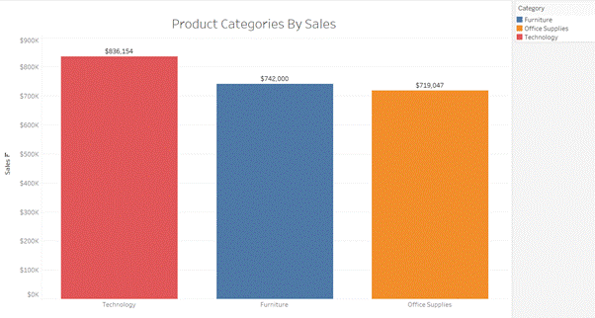

**Chart Used:**

Bar charts are easy to read and understand. They provide a clear comparison of total sales across different product categories. They are ideal for displaying and comparing categorical data. In this case, each bar represents a distinct product category.

**Insights:**

The highest-selling category is Technology, with total sales of $836,154, while the lowest-selling category is Office supplies, with total sales of $719,047. Office supplies and Furniture have almost similar sales values. Technology category products are high in demand.

2. How do the monthly sales amounts change over the course of a year?

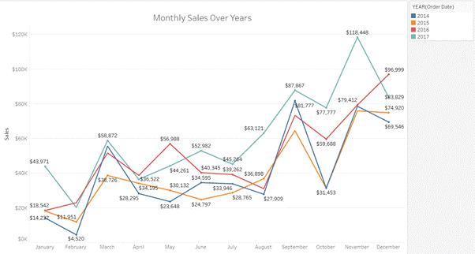

**Chart Used:**

The line chart provides trends over time, in this case, monthly trends of sales for each year. They display how values change month-to-month, making it easy to identify patterns and peaks.

**Insights:**

Sales tend to increase towards the end of the year, especially in October, November, and December, likely due to holiday shopping.

From 2014 to 2017, sales at the Superstore have steadily grown, with 2017 having the highest sales, particularly in October ($118,447) and December ($96,999). Each year, September and November also see high sales, probably because of back-to-school and holiday shopping. In contrast, February always has the lowest sales, with a significant low in 2014.

3. How is the total sales amount distributed among different product categories?

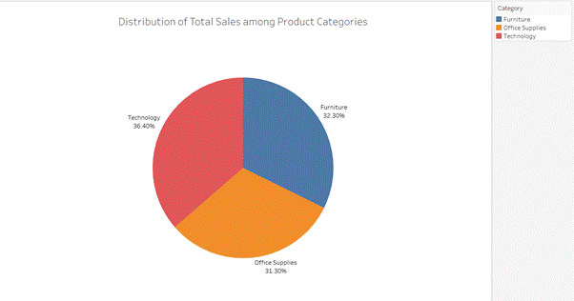

**Chart Used:**

A pie chart is used to show the total sales distributed among product categories because it clearly shows the proportion each category contributes to the total. This makes it easy to quickly see which categories have the highest and lowest sales.

**Insights:**

The pie chart shows the sales of furniture (32.3%), office supplies (31.3%), and technology (36.4%). The distribution suggests that technology products are currently the most popular category in terms of sales. Additionally, while each category contributes significantly to overall sales, technology stands out with the largest share.

4. Can we analyze the sales performance of individual customers over time?

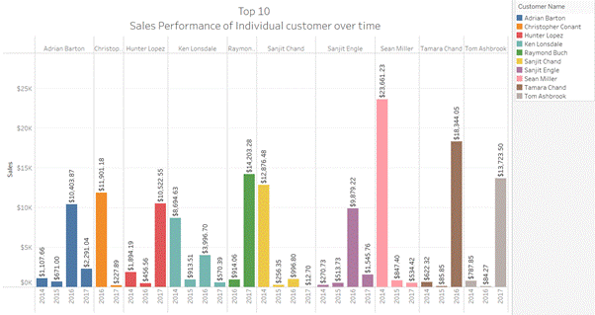

**Chart Used:**

A side-by-side bar chart shows how different customers did in sales over several years. This way, you can easily see how each customer's sales compare to others year by year. It's great for spotting trends, like who's consistently selling the most, or who's improving their sales over time.

**Insights:**

There are many customers in the dataset so I have used top 10 customers performance for better understanding.

This chart shows the sales performance of the top 10 customers from 2014 to 2017. Sean Miller had the highest sales in 2014 ($23,661.23), and Tamara Chand had a big purchase in 2016 ($18,344.05). Customers like Hunter Lopez and Ken Lonsdale bought consistently over the years, while others like Adrian Barton had fluctuating sales, peaking in 2016 ($10,403.87). New or one-time big spenders, such as Sanjit Chand in 2017 ($14,208.28), also stand out. This variety in customer spending helps stabilize the business's revenue by maintaining a diverse customer base.

5. How do sales vary based on different days of the week and product categories?

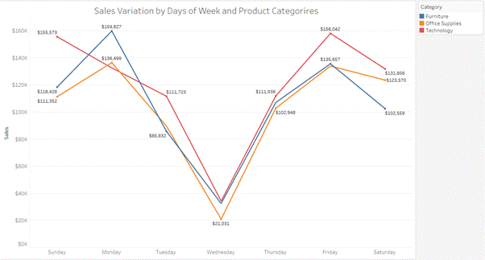

**Chart Used:**

A line chart is used to show how sales change across different days of the week and product categories because it presents this information in a clear and organized way. Each line on the chart represents a category of products, and the horizontal axis shows the days of the week.

It allows us to easily see which days are busier or quieter for sales, and how each product category performs over time. It's useful for spotting trends like which days see the most sales or if certain categories consistently sell better on specific days.

**Insights:**

The sales are lowest on Wednesday for all the categories indicating a midweek slump.

Sunday, Monday, and Friday have higher sales across all the product categories indicating these days are popular for shopping, likely because people have more free time or just got paid. Customers seem to prefer buying tech items on weekends when they have more time to research. Technology has the highest sales among all the weekdays and weekends. Technology has consistent demand among customers.

6. Can we visualise the sales growth of different product categories over time?

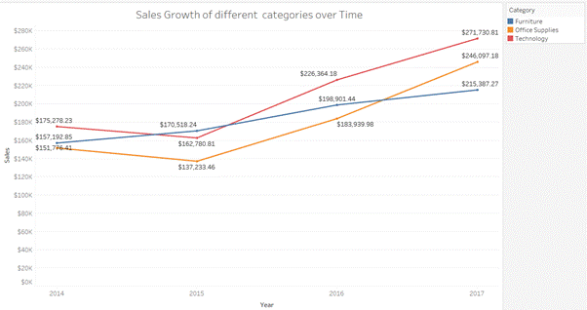

**Chart Used:**

Line charts effectively display changes in data over a period, making it easy to see upward or downward trends. Multiple lines can be plotted on the same chart, allowing for direct comparison of different product categories. Line charts can show specific data points for each period, providing detailed insights into sales fluctuations.

**Insights:**

The line chart shows that furniture sales have been consistently high and increasing every year. Office supplies and furniture also show sales growth, but first, it declined in year 2015 then again it suddenly started to increase which can by various factors like marketing, and changes in consumer behaviour. The technology category maintains the highest sales compared to other categories over time, which indicates consumer demand for technology-related products

7. How does the sales distribution vary across different regions in the "Superstore" dataset?

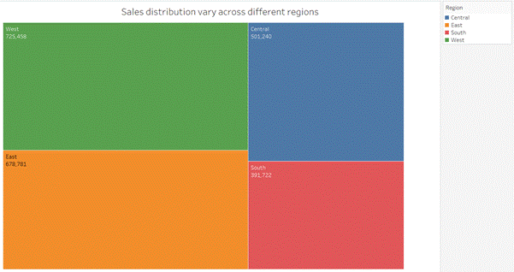

**Chart used:**

Heat maps are like visual thermometers for sales. They use color intensity to show high (hot) and low (cool) sales in different regions. This makes it easy to spot trends at a glance. You can quickly see which regions are burning up sales for a product.

**Insights:**

With a sales figure of $725,458 the West region has the highest sales compared to all other regions. The East region follows closely behind the West with sales of $ 678,781. The West and East regions are the strongest markets, potentially offering the best opportunities for growth and investment.

Central and South regions have the lowest sales figures at $ 501,240 and $391,722 respectively. Efforts might be needed to boost sales in the Central and South regions, such as targeted marketing campaigns or improving distribution channels.

8. Can we visualise the composition of profits across various subcategories within different customer segments?

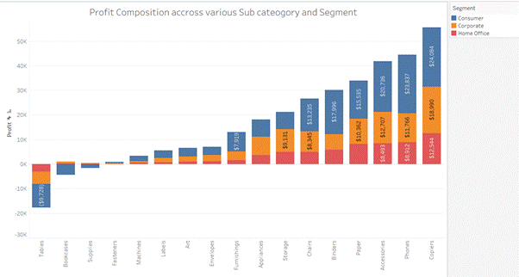

**Chart Used:**

A stacked bar chart effectively displays both the total and relative contributions of each subcategory to the profits within each segment. Dual representation provides a comprehensive view of both the whole (total profits) and its parts (subcategory contributions).

**Insights:**

The chart reveals that the Consumer segment generates the most profit, followed by Corporate and Home Office. In the Consumer segment, Copiers generate the most profit, followed by Phones and Accessories.

In the Consumer segment, bookcases and supplies subcategories are in the loss.

Tables are also in the loss for all the segments.

9. What is the percentage contribution of each region to the overall sales?

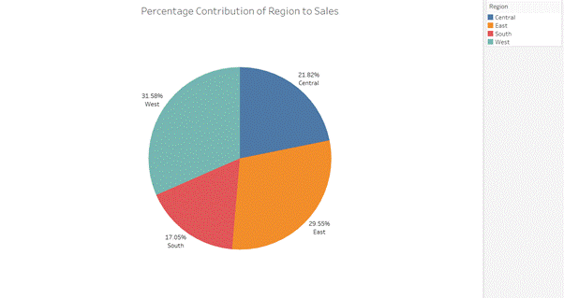

**Chart Used:**

A pie chart is used. The entire pie represents the total sales, and each slice of the pie represents the sales contribution of a specific region. The size of each slice directly reflects its percentage share of the total sales, making it straightforward to identify which regions contribute the most and the least to overall sales.

**Insights:**

The west region has the highest sales with 31.58%, indicating it is the strongest performing region in terms of revenue generation then the central region, then the east, and the south with the lowest sales of 17.05%.

10. Can we visualise the profit margins associated with different shipping modes and customer segments?

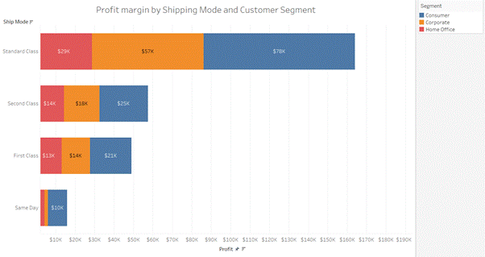

**Chart Used:**

A horizontal stacked bar chart enables easy comparison of profit margins between different shipping modes and customer segments. This visual comparison helps stakeholders quickly understand how profit margins vary across these categories. By observing the relative heights of the bars, one can easily find which shipping modes or customer segments yield higher or lower profit margins.

**Insights:**

Standard class shipping mode shows the highest profit margin across all customer segments. Same-day shipping mode shows the lowest profit margin across all customer segments. First-class and Second-class shipping modes show almost similar profit margins across all customer segments.

11. How long does it take to process orders for different product categories?

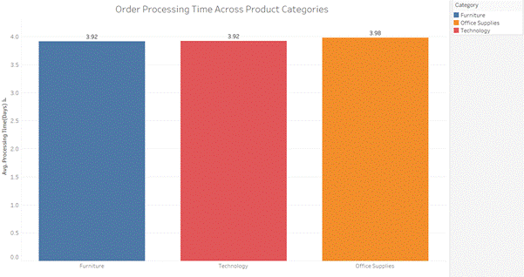

**Chart used:**

Bar charts allow for a direct comparison of processing times across multiple product categories. By visualizing processing times for different product categories, stakeholders can identify areas where orders are processed more efficiently or where improvements are needed.

**Insights:**

On average, orders across all categories take about four days from the order date to the ship date. This information shows how quickly orders are processed in the business.

12. How do discounts affect overall profit?

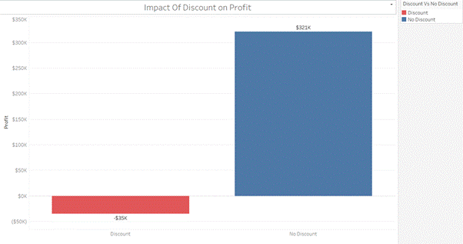

**Chart Used:**

Bar charts can show the impact of discounts on profit margins by comparing profits with and without discounts. Each bar can represent a different discount making it easy to see how profits vary.

**Insights:**

A discount of $35K was given on the overall profit of $321K, resulting in a net profit of $286K.

This demonstrates how discounts directly lower the total profit earned, highlighting their substantial influence on the financial results of business activities.

13. Can we visualise the relationship between product sales and profitability for different product categories?

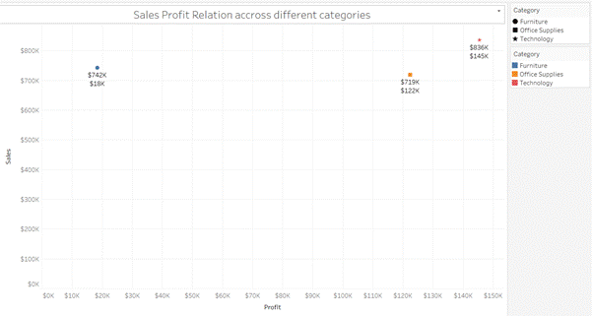

**Chart Used:**

A scatter plot is used to visualize the relationship between product sales and profitability for different product categories because it allows us to examine how these two variables are related to each other across multiple categories. Scatter plots show individual data points for each category, where each point represents a combination of sales and profitability. By plotting sales on one axis and profitability on the other, scatter plots help in recognizing patterns or trends.

**Insights:**

The sales of furniture are high, but its profitability is very low compared to sales. The sales of office supplies and the technology category are high, and also their profitability is high.

The technology category has the highest sales ($836K) and the highest profitability ($145K). It’s doing well!

While furniture has high sales ($742K), its profitability is quite low ($18K). So, even though people are buying furniture, it’s not making as much profit. Office supplies also have high sales ($719K) and good profitability ($122K). So, it’s a solid performer.

14. What is the distribution of order quantities for products in the dataset?

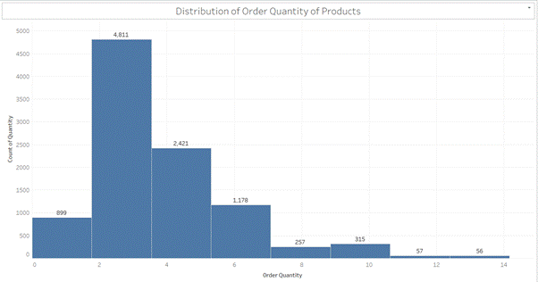

**Chart Used:**

A histogram is used here to show the pattern of order sizes in a way that’s easy to see and compare. It helps us quickly see which order sizes are most common.

**Insights:**

The most common order size is between 2 to 3 items, with 4811 orders in this range. This shows that people often buy a few items together per order. There are also some large orders with more than 10 items indicating variability in customer purchasing behaviours. Only 899 orders have just one item, indicating single-item orders are less common compared to orders with multiple items, they still constitute a notable portion of transactions.

15. How do the profit distributions vary across different product categories?

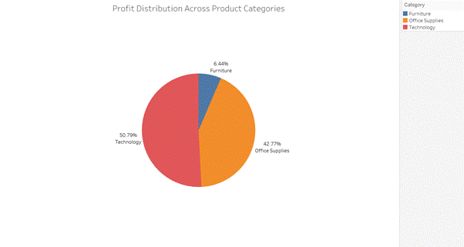

**Chart Used:**

A pie chart is used. The entire pie represents the total profit and each slice of the pie represents the profit contribution of a specific product category. The size of each slice directly reflects its percentage share of the total profit, making it straightforward to identify which category contributes the most and the least to overall profit.

**Insights:**

With 50.79% of total earnings, technology products are the profit leaders. This suggests that investing in technology-related items is a smart business move. Office Supplies contributing 42.77% to profits, hold a significant share. Businesses can continue to focus on this category to maintain profitability. Although furniture only adds 6.44% to the profit share, it still contributes. However, there’s room for improvement in its profitability.

16. Can we compare the shipping time distributions for different shipping modes?

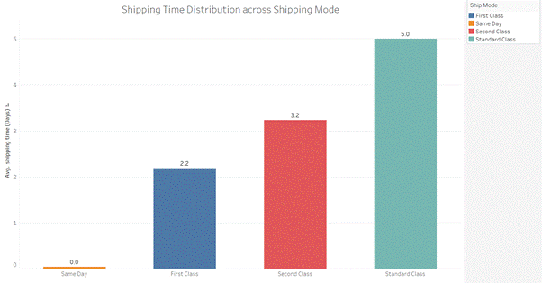

**Chart Used:**

Bar charts provide a clear visual representation of data, making it easy to compare quantities or distributions. Each shipping mode can be represented by a bar, where the height of the bar represents the average or median shipping time for that mode.

**Insights:**

Same-day delivery has the fastest average shipping time. This suggests that most Same Day deliveries arrive on the same day they are shipped. First Class shipping has an average shipping time of 2 days. Second Class shipping has an average shipping time of 3 days.

Standard Class shipping has the slowest average shipping time, at 5 days.

17. What is the monthly trend in the number of orders shipped?

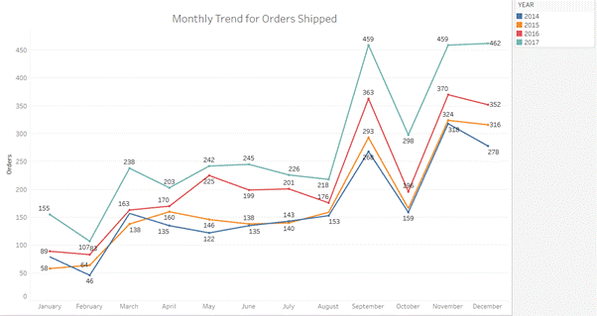

**Chart Used:**

A line chart is used here because it’s good at showing how the number of shipped orders changes each month over the years. It makes spotting trends and patterns in the data simple.

**Insights:**

Order peaks in September, November, and December might be due to Sales events or promotions during these months that could attract more buyers. Orders declined in February, August, and October due to seasonal variations.

18. How do different customer segments perform in terms of sales and discount rates?

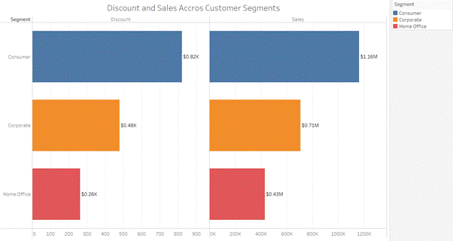

**Chart Used:**

A horizontal bar chart is suitable for comparing how different customer segments perform in terms of sales and discount rates. These horizontal bar charts allow easy comparison of performance metrics (sales and discount rates in this case) across multiple customer segments placed side by side.

**Insights:**

Customers in the consumer segment received the highest average discount at $820. They also generated the most sales at $1.16 million. This suggests that offering a higher discount may lead to increased sales for this segment. Customers in the corporate segment received an average discount of $480. They generated $710,000 in sales. Customers in the home office segment received the lowest average discount at $260. They also generated the least amount in sales at $430,000.

19. What are the sales and profit trends across different product subcategories and regions in the Superstore dataset?

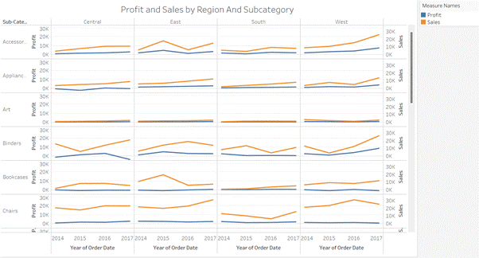

**Chart Used:**

A Dual Lines Chart would be the most suitable chart to properly visualize the trends of sales and profit over the period further it can be visualized for different product subcategories and regions, and filters facilitate the choice of selecting the required subcategory, for analysis of sales and profit trends for different regions.

**Insights:**

The visualizations reveal that Copiers and Phones show steady growth in both profit and sales across most regions, while Machines and Tables exhibit more profit fluctuations, especially in specific regions. Envelopes, Fasteners, and Labels remain stable with minimal growth. Overall, the Central and East regions tend to demonstrate more pronounced growth trends compared to the South and West regions, indicating areas and products for potential strategic focus.

20. What is the average delivery duration for different regions and ship modes?

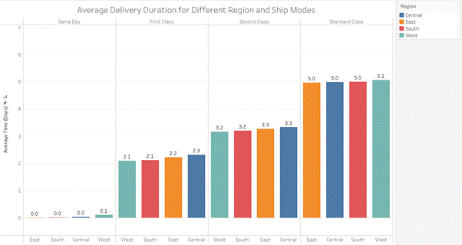

**Chart Used:**

Side by Side Bar Chart provides a side-by-side comparison of different regions & Shipping modes simultaneously providing a quick and clear analysis of the time duration taken by the delivery process.

**Insights:**

Same-day shipping is the fastest shipping method across all regions and delivers in less than 1 day, though the western region has the highest delivery time. Standard class is the slowest shipping method averaging over 5 days for all regions. Second-class shipping takes an average of over 3 days for all regions. For First Class shipping, it takes an average of over 2 days for all regions, the central region has the longest average delivery duration, followed by the east, south, and then West being the quickest one to get the delivery.

21. How has the average order quantity changed over the years for various product categories?

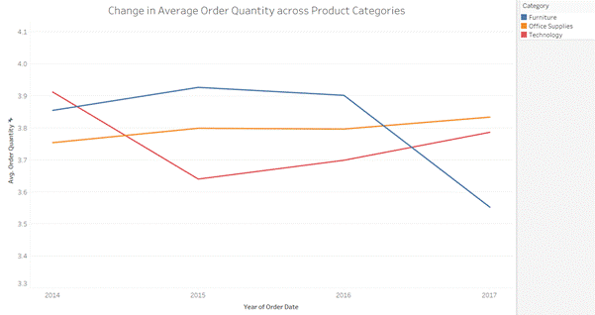

**Chart Used:**

A line graph was chosen for this visualization because it effectively shows the change in average order quantity over time for various product categories. A line plot is suitable for showing the progression of a numeric variable (Avg. Order Quantity) across a continuous axis (years).

**Insights:**

For the ‘Technology’ category, a decrease in the order quantity was observed in 2015, but it increased after that, which shows a potential recovery in demand for technological products following a temporary decline, possibly due to market trends or product innovations. Interestingly, ‘Office Supplies’ has maintained a consistent trend over the years and is following an increasing route, which can be attributed to factors such as steady consumer demand, effective marketing strategies, or the introduction of new office supply products. Whereas, the category ‘Furniture’ initially started with similar order quantities as other product categories. It remained stable for 2015 and 2016, but then gradually decreased with time.

22. Can we visualise the correlation between discount rates and order quantities for different customer segments?

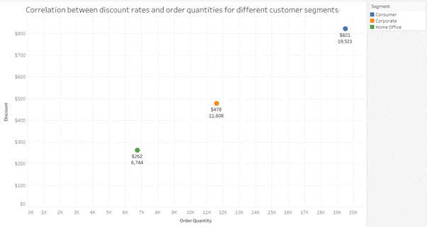

**Chart Used:**

Scatter plots are used. They are ideal for showing the relationship between two quantitative variables. In this case, the variables are discount rates and order quantities.By plotting each order as a point on the graph, you can easily identify trends, patterns, and correlations between the discount rates and the number of orders.

**Insights:**

A discount of $262 was given for the 6,744 order quantities in the home office segment. The average discount per order in the Home Office segment is quite small, indicating either a low discount rate or that discounts are given infrequently. A discount of $478 was given for the 11,608 order quantities in the corporate segment. A discount of $821 was given for the 19,521 order quantities in the consumer segment. The Consumer segment, even though it got the most total discounts, has a low average discount per order.

23. What is the proportion of orders returned in each region within the Superstore dataset?

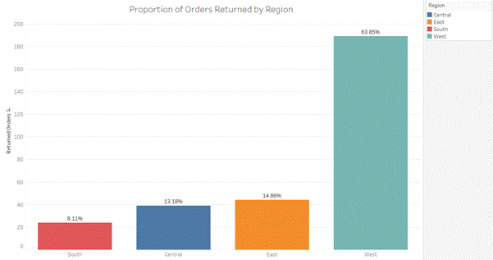

**Chart Used:**

A bar chart was chosen for this visualization because it effectively compares the number of orders returned across different regions, with each region represented by a bar and the height of the bar corresponding to the returned orders.

**Insights:**

In the Central region, 39 returned orders are observed, contributing to 13.18% of the total orders returned. This indicates a moderate level of returns in this region, suggesting potential areas for improvement or investigation into customer satisfaction and product quality. In the East region, 44 returned orders are observed, contributing to 14.86% of the total orders returned. This indicates a similar trend of returns as observed in the Central region, highlighting the need for attention to customer experience and order fulfillment processes. In the South region, 24 returned orders are observed, contributing to 8.11% of the total orders returned. This indicates a relatively lower proportion of orders being returned within the South region compared to other regions, which may indicate more favorable customer experiences or operational efficiencies in this area. In the Central region, 189 returned orders are observed, contributing to 63.85% of the total orders returned.

24. Can you compare the profits of different products for different subcategories?

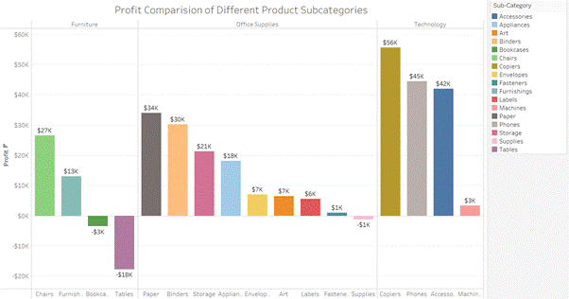

**Chart Used:**

Bar Chart is used to compare profits for different product categories and subcategories, it provides an easy and detailed comparison of profits and is supported with the color toning to show the segregation of the profit-making categories to the loss-making categories

**Insights:**

Technology is the top-performing category having profit across all subcategories, with the Copiers subcategory earning the most profit $56K, and machines at the lowest profit of $3K. In the furniture category Tables are the worst-performing with an $18k loss, followed by Bookcases with a $5k loss. In the Office Supplies Category, Paper is the most profitable making $34k and Supplies is the only one at a loss of $1k.

The company should continue to invest in and support the Technology category, especially the Copiers subcategory, as it shows strong profitability. The Furniture category needs attention, particularly the Tables and Bookcases subcategories, to address the losses and improve performance.

25. Which shipping mode is the most commonly used in the Sample Superstore dataset?

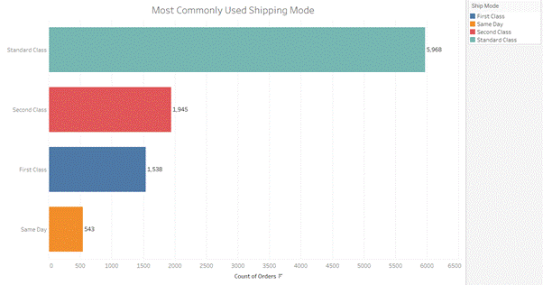

**Chart Used:**

A horizontal bar chart shows how often different shipping modes are used. It’s great for comparing how much each shipping mode is used in the Sample Superstore data. The length of each bar shows the number of times a shipping mode is used, making it easy to spot the most popular one.

**Insights:**

Standard class is the most used shipping mode with 5,968 orders, indicating most customers prefer it for its balance of cost and delivery time. The second class is the next most popular with 1,945 orders, showing many customers choose it for slightly faster delivery. First class has 1,538 orders, suggesting a good number of customers are willing to pay more for quicker delivery. Same-day shipping is the least used, with 543 orders, likely because it costs more or customers don't often need items that urgently.

26. How does the sales performance of different regions evolve throughout the quarters of a year?

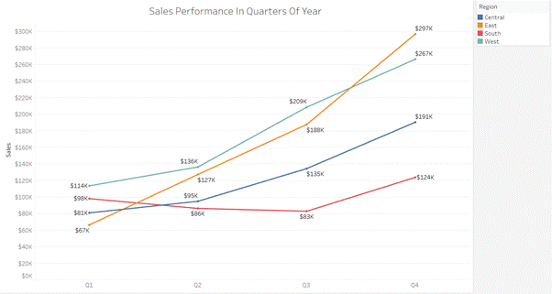

**Chart Used:**

Line Chart to show how sales in different regions change over the year. It’s good for spotting trends and seeing how sales go up or down each quarter. This chart makes it easy to see any regular patterns or changes in sales over time.

**Insights:**

Sales in different regions grow over the year, with the highest sales in the fourth quarter for all regions. This suggests a strong seasonal trend, likely due to increased spending during the holiday season.

Only the south region has a decline in the second quarter and third quarter. This could be due to various factors such as regional economic conditions, competition, or marketing effectiveness.

East, west, and central regions grow every quarter indicating steady demand and successful sales strategies in these areas. East region had the highest sales of $297k in the fourth quarter and south having the lowest sales of $124 among all the regions.

27. What is the distribution of order priorities across different product categories?

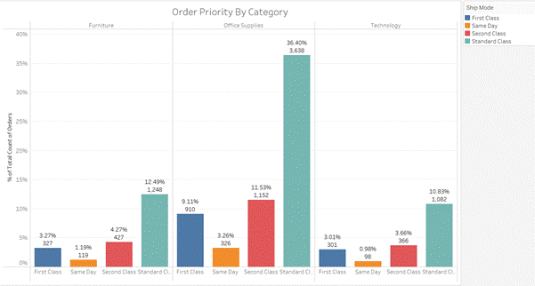

**Chart Used:**

Side by Side Bar Chart is used to visualize the distribution of order priorities across different product categories. A Side-by-side bar chart effectively illustrates the total value (total orders) and its components (order priorities), making it suitable for comparing the distribution of priorities across categories.

**Insights:**

Standard Class shipping dominates across all categories, particularly in Office Supplies (36.40%). Second Class is the next most common, with significant usage in Furniture (12.49%) and Office Supplies (11.53%). First Class and Same Day are less frequent but are more prevalent in Office Supplies compared to other categories. Overall, the data highlights a clear preference for more economical shipping methods, especially for Office Supplies.

28. What is the relationship between discounts and sales?

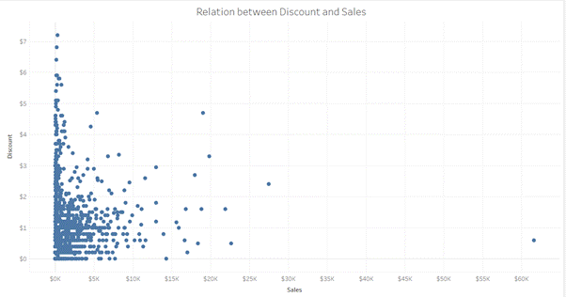

**Chart Used:**

Scatter plots are perfect to see if discounts drive sales. They show a positive correlation (upward trend) if sales rise with discounts, negative (downward trend) if discounts hurt sales, and no correlation if discounts have little effect. This helps identify trends and even outliers that might require further investigation.

**Insights:**

There is a noticeable inverse relationship between discount amounts and sales amounts. Higher discounts tend to correspond with lower sales amounts.

Most of the data points are concentrated in the lower range of sales (under $10K) and discounts (under $2). This suggests that smaller discounts are more common for lower sales amounts.

There are a few outliers with relatively high sales amounts (over $20K) and varying discount levels. One extreme outlier is observed at around $60K in sales with a low discount.

Discounts above $4 are rare and are mostly associated with lower sales amounts.

This means that as the discount offered increases, the total sales tend to increase as well.

29. How does the average order value differ between repeat customers and new customers?

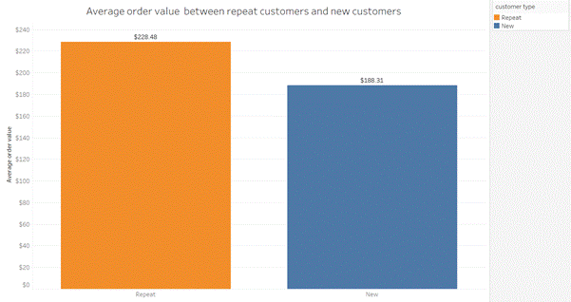

**Chart Used:**

A bar chart is chosen to compare the average order values of new versus repeat customers. It’s great for showing and comparing numbers across categories.

**Insights:**

The average order value for repeat customers is higher, at $228.48. Repeat customers tend to spend more per order compared to new customers. This suggests that loyal customers have a higher level of trust, satisfaction, or engagement with the business.

The average order value for new customers is lower, at $188.31. Lower average order values from new customers could indicate that initial marketing efforts, discounts, or incentives used to acquire new customers are effective but result in lower initial transaction sizes.

30. What is the geographical distribution of returns and its impact on overall profitability?

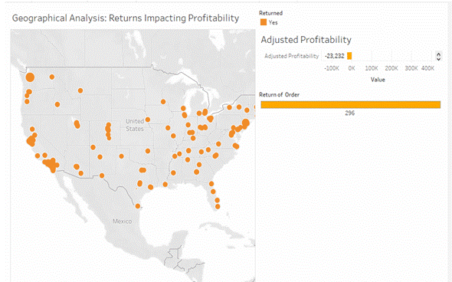

**Chart Used:**

The map and bar chart provide a clear visual representation of where returns are happening and how they impact profitability. This helps in identifying problem areas quickly. By plotting the returns on a map, it is easier to see geographical patterns that might not be evident from tabular data. For instance, certain regions might have higher return rates due to specific local issues or customer preferences.

**Insights:**

The geographical analysis reveals that product returns are widespread across the United States, with notable concentrations in California, the Midwest, and the East Coast. This widespread distribution significantly impacts profitability, resulting in an adjusted loss of $23,232 due to 296 returned orders. Key areas such as California, Texas, and the East Coast show higher densities of returns, indicating these regions have a more substantial negative effect on overall profitability.