Ladrillo Sea Level Rise Emulator
Ladrillo is a derivative of Tony Wong's BRICK2.0 model. Ladrillo was developed by Marcus C Sarofim using the Claude model. The primary goals for Ladrillo were to add additional observational data, update the glacier module to better match observations and to halt melting for stabilization scenarios, update the Antarctic calibration approach to better match observations prior to 1980, and update the Greenland model to incorporate the different responses of surface melt balance and ice discharge.
Ladrillo compares well relative to the other models and sits in a unique space. Unlike MAGICC, Ladrillo is designed to work with the FaIR model. Unlike FACTS, Ladrillo has a simplified structure. Ladrillo does a good job matching historical observations, with the primary weakness being thermal expansion, though that is inherited from FaIR and does not appear when running with OHC from observation. For future projections, Ladrillo matches physical expectations and is comparable to the other models despite different structural approaches. BRICK's design philosophy is to calibrate on historical data products rather than to emulate projections from process-based models, which is what makes it a line of evidence relatively independent of the large Earth system and ice sheet models. Ladrillo extends that philosophy where the data reach — the Antarctic likelihood now runs from 1900 rather than IMBIE's 1992–2017 window, and Dangendorf, GlaMBIE, GRACE and Mouginot are added — but departs from it for the two parameters described below, both in regimes with no observational constraints. Ladrillo is also less independent of MAGICC on glaciers than BRICK 2.0 is, having adopted the Nauels 2017 transient.
There are two key parameters not constrained by observations that are included in Ladrillo. The first is a Greenland tap that triggers above a threshold temperature and is informed by SICOPOLIS. The second is the use of local temperature amplification relative to global that is informed by CMIP6 in addition to historic observations, and is relevant for Antarctic melt.
Vintage. This document describes posterior L24. Units are cm. Two baseline windows are used: 1995-2005 for the hindcast section (FIG 1, the RMSE table, and the 2024 levels); and 1995-2014 for the projection sections. Model version FaIR 2.2.4 (fair-calibrate 1.6.0). Observational vintages are given in the calibration-data table below. Both hindcast arms are reproducible: every random seed is fixed and is recorded inside the output file each figure reads, so any number here can be regenerated from the artifact alone.

Ladrillo Structural Updates

GSIC
BRICK 2.0's glacier model uses a Wigley-Raper equation that is always melting when above its equilibrium temperature. Ladrillo replaces it with a Mengel-style equilibrium volume S_eq driven by a Nauels-ν transient, which separates how much ice is committed at a given warming from how fast it gets there, and splits the world into three reservoirs on regional temperature.
SLOWP — RGI regions 03, 09, 07, 06 (Arctic Canada North, Russian Arctic, Svalbard, Iceland). Large, high-latitude, long relaxation time, and strongly amplified relative to global mean temperature (prior 2.50). This block dominates the glacier contribution in both the hindcast and the projections.
FAST — 13 other RGI regions. Smaller, faster-responding bodies with weak amplification (prior 1.45). It equilibrates quickly enough that its committed volume is close to its realised volume through most of the record.
R19 — Antarctic and Subantarctic periphery. This block exists because the historical glacier target (Frederikse) assumes zero Antarctic-periphery melt, while the GlaMBIE series spliced in from 2019 onward includes it. Folding R19 into either SLOWP or FAST would leave the model's hindcast scope mismatched. Keeping it separate lets the hindcast be evaluated on SLOWP + FAST while R19 still contributes to projected totals. Its amplification prior (0.72) is also far below the other two, so it is not physically interchangeable with them either. (The three blocks cover 18 of the 19 RGI regions; RGI 05, Greenland Periphery, is excluded — Frederikse's glacier target excludes it and it falls inside the Greenland ice-sheet mask.)
Compared with BRICK 2.0 and MAGICC. BRICK 2.0 and Ladrillo now have completely different glacier modules. MAGICC and Ladrillo both use the formulation from Nauels 2017 Eq. 3; where they differ is the three regions used in Ladrillo. MAGICC's committed 1850 melt is 28–136 mm, Ladrillo's 63–146 mm.
Regrowth potential. Neither BRICK nor FACTS can regrow glacial ice, but MAGICC and Ladrillo can. The law is
S_eq = max( a·(1 − exp(−b·(T − T_off))), 0 )
dS = min( κ·|T − T_eq|^ν, 1 ) · (S_eq − S)
Regrowth limits. MAGICC assumes that once ice committed to melt in 1850 has gone, it can't be regrown, but ice lost past that point can be. In theory, Ladrillo can regrow up until its 1850 ice extent (though no further), but that would require temperatures to drop below 1850 levels.

Greenland
BRICK 2.0 treats Greenland as one body with one response channel. Ladrillo replaces that with a two-channel, two-basin sheet.
Two channels (fast / slow). Greenland melt occurs through surface-mass-balance response (fast) and outlet/dynamic discharge (slow). Two channels allow for that partition. "Fast" names which physics the channel carries, not a short time constant — the surface-mass-balance channel drains a multi-millennial commitment, and at the optimum its response time is 86 years.
Two basins. The sheet is split into an active basin (SW+CW+CE+SE+NW) and a high basin (NO+NE), each carrying its own fast/slow channel pair, with sector shares scored against Mouginot.
Amplification. The ratio of Greenland warming to global warming is itself a function of temperature.
High-basin volume tap. A post-2100 commitment above a threshold: V = 5.64 m, τ = 800 yr, onset 4.69 K, two stages, whole-sheet. The tap does not fire until temperatures exceed the onset. It cannot be calibrated on observations, so the parameters were informed by ISMIP6 at 2100 and SICOPOLIS at 2300 and 3001. It is included in every projection here, contributing 35.1 cm to the SSP5-8.5 total at 2300 on the joint arm this document reports throughout, and nothing at SSP1-2.6 (exactly zero) or SSP2-4.5 (+0.04 cm).
Compared with BRICK 2.0 and MAGICC. Greenland is the component where the hindcast gain over BRICK 2.0 is largest. MAGICC similarly splits Greenland into SMB and SID and parameterises against SICOPOLIS, but with 17 parameters between the two, of which 9 vary and each of those takes only 4 distinct values.

Ladrillo Calibration Data Updates
Additional or replaced observational inputs, relative to BRICK 2.0:
data source | vintage / version as used | what it constrains
Dangendorf 2024 GMSL | Zenodo 10.5281/zenodo.10621070; GMSL derived from Fields.nc, not the record's Global.nc (mis-written upstream), and validated against a corrected _v2.nc supplied by S. Dangendorf, pers. comm. 2026-08-07 | The total, replacing the previous GMSL reconstruction.
GlaMBIE glacier series (2019 onward) | Dataset 1.0.0, DOI 10.5904/wgms-glambie-2024-07; acquired 2026-06-13; paper 10.1038/s41586-024-08545-z | The modern glacier rate, spliced onto Frederikse. It includes Antarctic-periphery melt where Frederikse excludes it, which is why R19 is a separate block.
JPL GRACE / GRACE-FO mascons | Release RL06.3Mv04 CRI, DOI 10.5067/TEMSC-3JC634, granule 200204_202606 | Land-water storage. Real data run 2019–2023; 2024 is held flat from 2023 (GlaMBIE, which is subtracted, ends 2023) and 2025–2026 are blank. The closure σ is trend-extended to the file horizon — the data are not.
Mouginot Greenland sector shares | 10.1073/pnas.1904242116, Supplementary Dataset S2 (pnas.1904242116.sd02.xlsx, sheet "(2) MB_GIS"). No dataset version is published | The basin split, as a shares term rather than a level.
Rignot 2019 Antarctic SMB, area-corrected ×0.888 | PNAS 116:1095; 2098 ± 133 Gt/yr over the 1979–2008 climatology. No DOI or dataset version is recorded — the values enter as typed constants, not a data file | The absolute Antarctic flux scale. SMB minus discharge is well constrained at −145 ± 15 Gt/yr but each flux individually has high uncertainty (±505/±509), so Rignot anchors the pair.
Glacier inventory likelihood + a 19th-century flow constraint, S(1900) − S(1850) ~ N(0.020, 0.009) m SLE | Inventory: Farinotti 2019 (Nat. Geosci. 12:168) reconciled per Hock 2023, at the RGI ~2000 outline epoch — no DOI or archive version recorded; region polygons GTN-G Glacier Regions 2023, DOI 10.5904/gtng-glacreg-2023-07, on the RGI6 scheme. 19th-c flow: Leclercq/Oerlemans/Cogley 2011, DOI 10.1007/s10712-011-9121-7 | The absolute inventory and the pre-observational flow, neither of which the 20th-century transient identifies on its own.
CMIP6 regional amplification (34–41 models) | Streamed from the live Pangeo/Google-Cloud CMIP6 zarr catalogue. No catalogue snapshot date and no per-model ESGF dataset versions are recorded; what is pinned is the member ID per model, a fixed 40-model panel so a drifted catalogue cannot swap the ensemble, and a git commit hash in the derived priors | Priors on the per-block glacier amplification and on Antarctic amplification.
Paleo constraints on DAIS geometry, in a standardised correlation form | DAISfastdyn_calibratedParameters_gamma_29Jan2017.nc (sha256[:16] 0b53b45e2422563b), the 16-parameter / 800,000-member ensemble shipped with MimiBRICK; extracted 2026-08-24 | The seven freed geometry parameters (below).
(not a calibration target) IGCC 2025-indicators GMSL | Tag v2026.06.02, data DOI 10.5281/zenodo.20499280, md5 8ae5ac0041e26351b9f497f969bd0dab; paper Forster et al. 2026, 10.5194/essd-18-3889-2026 | Shown on FIG 1 as an independent consensus check on the total. It is not fitted; the fitted total is Dangendorf 2024.
Where a cell says a version is not recorded, that is the actual state of the provenance, not an omission from this table: those sources enter the calibration as typed constants or as a live catalogue query, and no version string exists in the repository to cite.
Deliberately removed: IMBIE, dropped from the Antarctic likelihood to avoid double-weighting the same mass-balance information already entering through other terms.
Forcing. FaIR 2.2.4 (fair-calibrate 1.6.0), driven by CMIP7 historical emissions 1750–2023 spliced at 2023.5 to MESSAGE-GLOBIOM SSP2-4.5 and harmonized per species. The calibration's own fit window runs to 2026, so its last three years sit on scenario rather than observed forcing — a difference bounded at about 0.002 W/m².
Sampler. Over-dispersed chain starts.

Ladrillo Calibration Approach Updates
58 parameters are sampled: 17 Antarctic, 9 Greenland, 19 glacier, 13 remaining (thermal expansion, two discrepancy bases, and four AR(1) noise pairs). Four Antarctic changes distinguish Ladrillo's calibration from BRICK 2.0's — the three described below, plus an SMB likelihood term anchoring the Antarctic flux scale to Rignot 2019. They have not been ablated individually against the hindcast, so no single one is credited here.
The seven DAIS geometry parameters (ais_mu, ais_bedheight0, ais_slope, ais_iceflow0, ais_precip0_LOG, ais_runoff_Ton, ais_c) are freed under a joint paleo prior. Ladrillo's pre-1990 Antarctic hindcast is far closer to the record than BRICK 2.0's — 1920–1949 bias −0.0096 cm against −1.9579 cm, and 1950–1992 +0.0027 cm against −0.7053 cm. BRICK 2.0 also samples its DAIS geometry; a key difference is the constraint, since its Antarctic likelihood is IMBIE 1992–2017 while Ladrillo fits an Antarctic series from 1900.
The runoff line is sampled in its identified direction. h0 and c enter only as hR = h0 + c·T_ant with a correlation ridge. Ladrillo samples T_on = −h0/c, the runoff onset temperature, which is what the data constrain.
Antarctic amplification is a key parameter. Stock DAIS hard-codes 1.196. Ladrillo samples it under N(1.09, 0.180), the measured CMIP6 between-model spread. The parameter is not strongly constrained by observation and its leverage is strongly scenario-dependent: across the posterior draws, a one-sigma change moves Antarctic sea level at 2300 by about 58 cm on SSP2-4.5 (roughly 23% of that scenario's total) but only about 24 cm on SSP5-8.5 (under 5%), because by SSP5-8.5 the Antarctic response is already past the thresholds where amplification matters.
Criterion matching. L24 is accepted under the deliverable criterion: 39 parameters pass. While 19 parameter marginals fail R̂ < 1.05, these primarily involve the Antarctic-geometry ridge and compensate for each other. Projected sea level converges (R̂ = 1.008 at 2100, 1.011 at 2150; with 1050 statistically independent draws in the final sample).

Ladrillo Observational Comparison
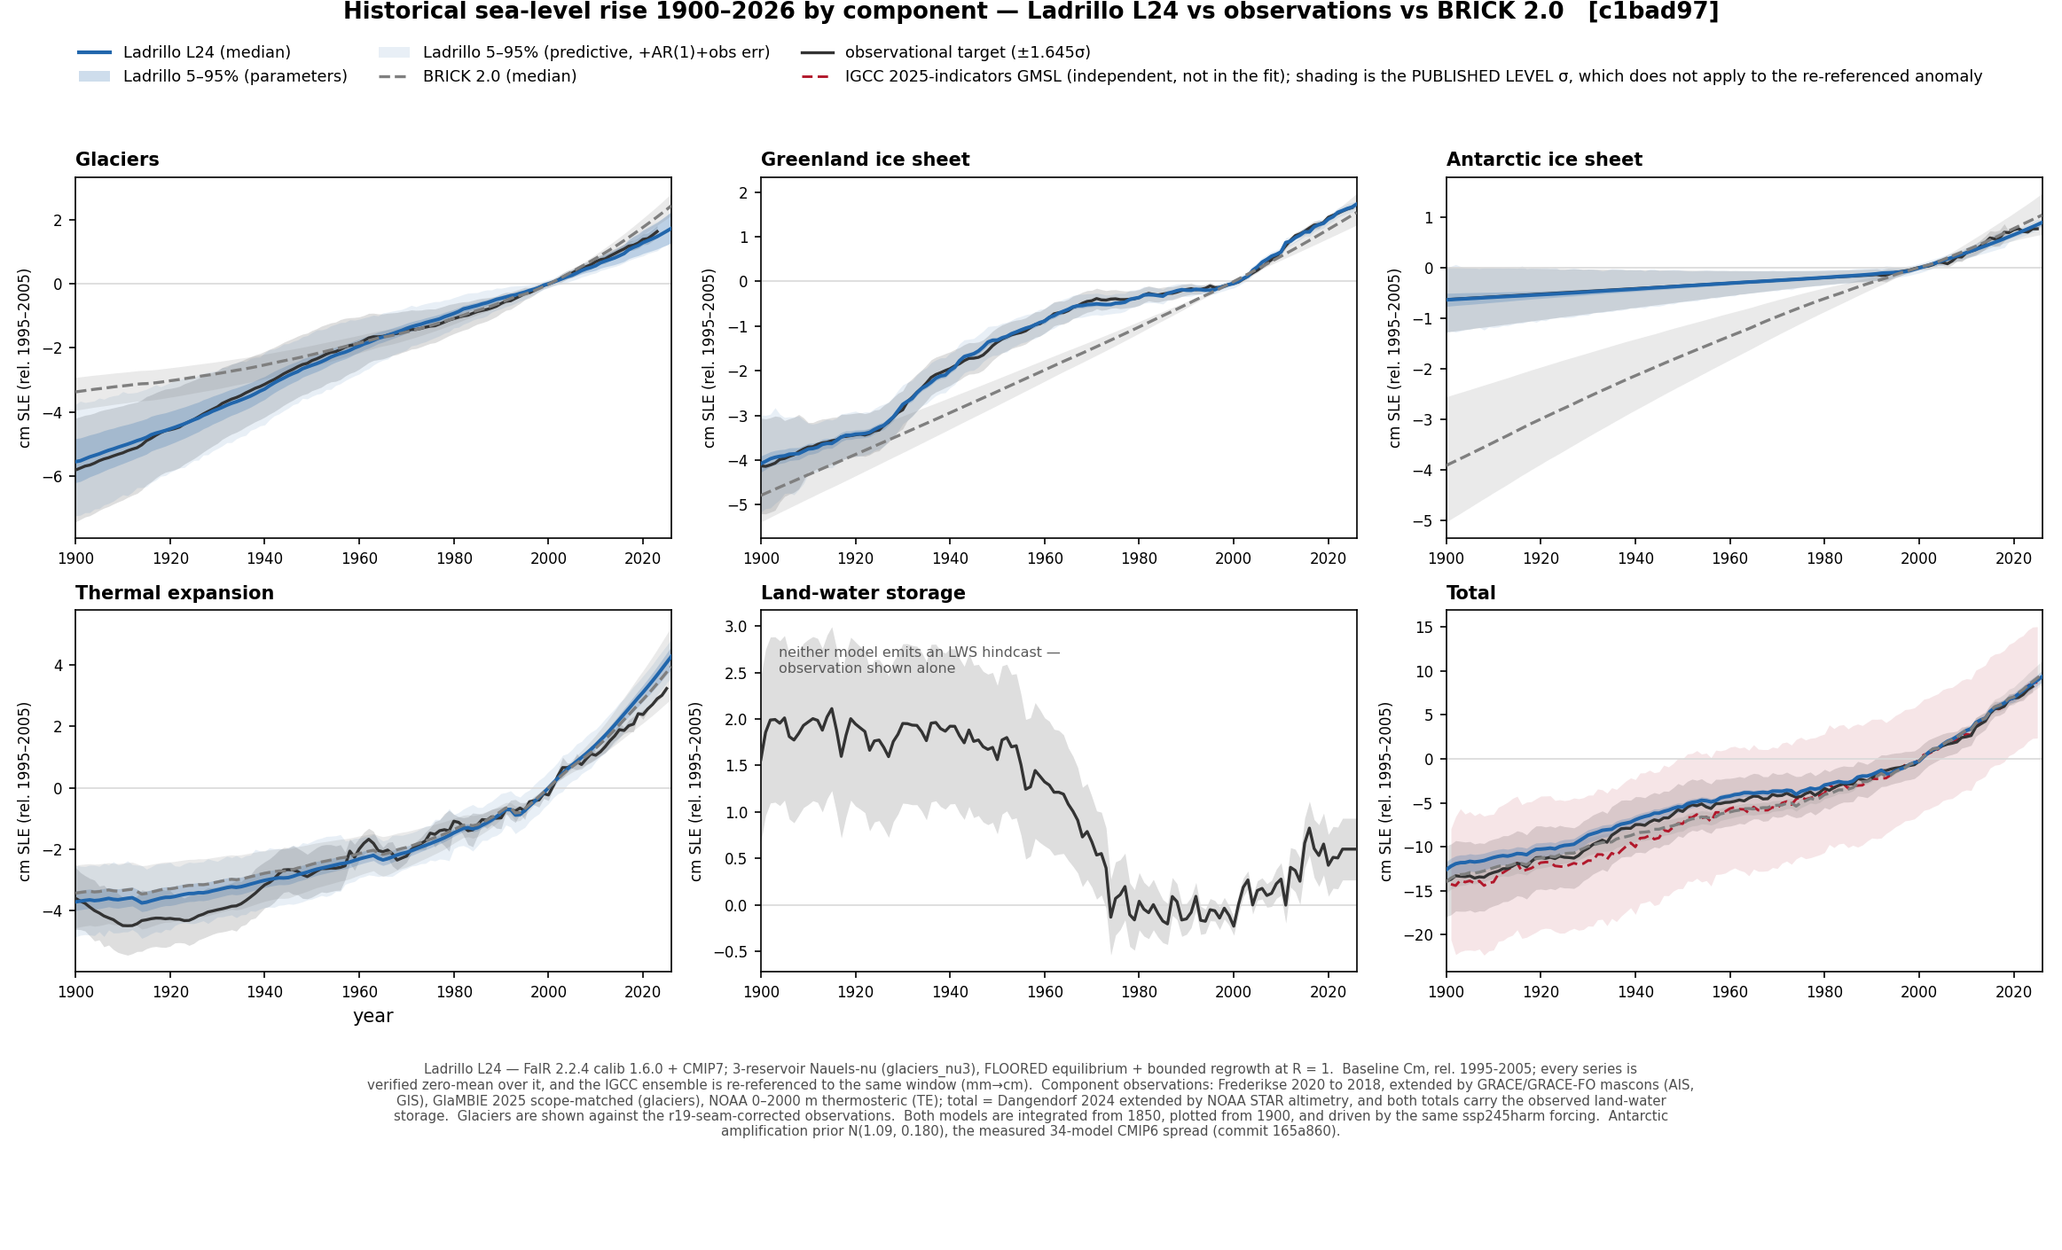
FIG 1. Component hindcasts against the observations, 1900–2026, in cm relative to a 1995–2005 baseline. Ladrillo L24 (solid, with its 5–95% band) and BRICK 2.0 (dashed) are both integrated from 1850, plotted from 1900, and driven by the same ssp245harm forcing. The total panel also shows IGCC 2025-indicators GMSL (tag v2026.06.02) as an independent consensus check, not a calibration target. Land-water storage is observational — neither model predicts it, so panel (e) shows the observed series alone and both totals carry it.
RMSE ratio against BRICK 2.0 — below 1 means Ladrillo is closer to the observations:
component | 1900–1919 | 1920–1949 | 1950–1992 | 1993–2026 | full
Antarctica | 0.003 | 0.005 | 0.010 | 0.676 | 0.019
Greenland | 0.110 | 0.102 | 0.054 | 0.263 | 0.085
Glaciers | 0.431 | 0.371 | 1.061 | 0.408 | 0.419
Thermal expansion | 0.703 | 0.723 | 1.107 | 1.519 | 0.820
Total | 4.138 | 1.369 | 0.519 | 0.892 | 1.172
Ladrillo uses the observed LWS time series directly, whereas native BRICK subtracts LWS prior to calibration, so its components represent sea level excluding LWS; the observed series is added to both totals to put them on the same basis as the LWS-inclusive observational total. Both arms are also driven by the same ssp245harm forcing, so a Ladrillo-minus-BRICK reading is a module difference. Separately, BRICK 2.0 runs on its own published posterior against our extended targets, so part of its bias is target vintage — a caveat that carries more weight in the earliest, sparsest-observation window than anywhere else.
Thermal expansion in both models is driven by FaIR's full-depth ocean heat against a 0–2000 m target, so this row measures Ladrillo's fit relative to BRICK 2.0, not absolute accuracy — see the depth-scope discussion below.
Ladrillo is closer to the observations than BRICK 2.0 on every ice component, particularly in early eras. Cumulative total sea level rise, comparing the 1900–1904 mean with the 2020–2024 mean: observed +21.00 cm, Ladrillo +19.84, BRICK 2.0 +21.34 — Ladrillo undershoots by 1.2 cm, BRICK overshoots by 0.3. Over the shorter, more recent window — the level at 2024 relative to the 1995–2005 baseline — both models still run high, but only slightly: observed +7.81 cm, Ladrillo +8.16 (+0.36) and BRICK 2.0 +8.34 (+0.54), with IGCC's independent GMSL estimate between them at +8.21. Each of those means is taken over the three years 2022–2024, the years for which the observational total exists.
For thermal expansion Ladrillo overshoots, and the cause is FaIR. In both Ladrillo and BRICK thermal expansion is exactly proportional to the ocean heat they are given. When given the FaIR driver, both models overestimate recent thermal expansion (BRICK 2.0 misses the 1993-2026 thermal expansion rate by 1.17× compared to Ladrillo's 1.27×). However, when using observed OHC Ladrillo reproduces steric changes within 4% at every era. Roughly half the apparent miss is depth scope: FaIR's ocean heat is full-depth while the steric target is 0–2000 m, and correcting on IGCC's own >2000 m layer narrows the 1993–2026 rate ratio from 1.27× to as little as 1.15× — an upper bound on the correction, not a point estimate, since deep water expands less per joule than the heat ratio implies. A depth-resolved coefficient was tested and failed, though that may reflect observational uncertainty — the two spliced observed-OHC series we use, Zanna+Cheng and Zanna+IGCC, differ by 51% on 1950–1993 ocean heat gain (35% on five-year mean endpoints).

Ladrillo Projection Comparison
The van Vuuren markers are the primary comparison; the SSPs are a secondary set and the control, being the only scenarios with a prior result to check the pipeline against. All Ladrillo bands are the joint (posterior × FaIR-forcing) arm, width-comparable to MAGICC and FACTS; BRICK 2.0's joint band uses the same cubes, splice pivot and pair seed. Bars are 17–83% (thick) and 5–95% (thin). All four sources carry climate uncertainty — Ladrillo from 841 FaIR configs, MAGICC-SLR from its 600-member AR6 drawnset, FACTS from its own internal ensembles — so the widths are the same kind of object and are comparable; they are not the same ensemble, and both joint arms are prior propagations rather than refits, since each posterior was calibrated under fixed forcing. FACTS is reported relative to baseyear 2005, treated as comparable to the 1995–2014 mean, which is the standing convention for this comparison. In the trajectory figure the two arms share cubes, splice pivot, re-reference and pairing seed, so their widths are directly comparable, but Ladrillo is thinned to 8000 draws against BRICK 2.0's 1000 and fine width differences carry the coarser arm's Monte-Carlo noise. On glaciers, Ladrillo and MAGICC-SLR share the Nauels 2017 transient, so that panel compares reservoir count, driver and posterior within one formulation family rather than two independent methods; BRICK 2.0 and FACTS are independent of us there, and at Greenland all four formulations differ.
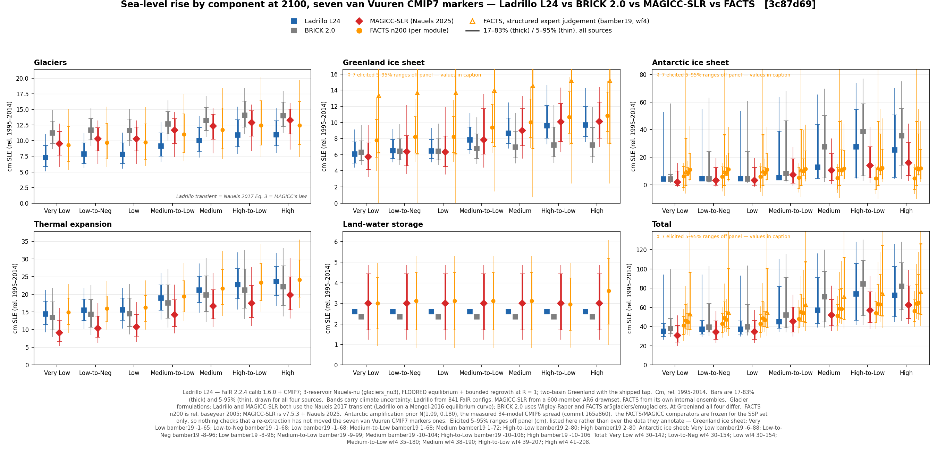
FIG 2. Ladrillo L24 compared against BRICK 2.0, FACTS and MAGICC-SLR across the seven van Vuuren markers at 2100, by component.
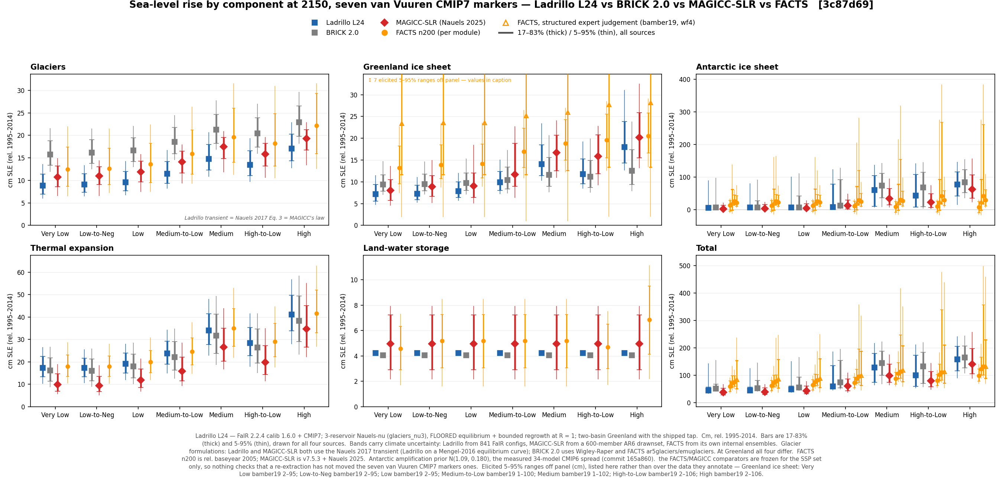
FIG 3. The same comparison at 2150.
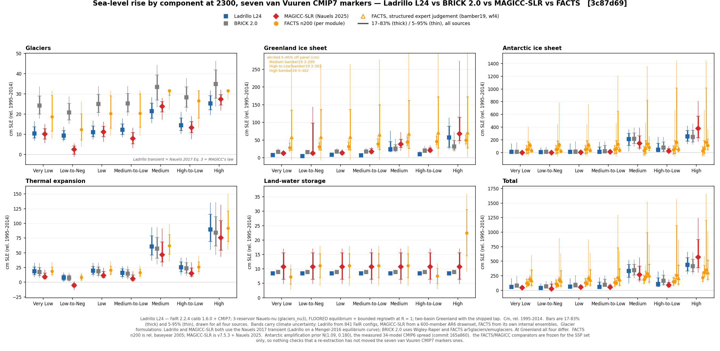
FIG 4. The same comparison at 2300.
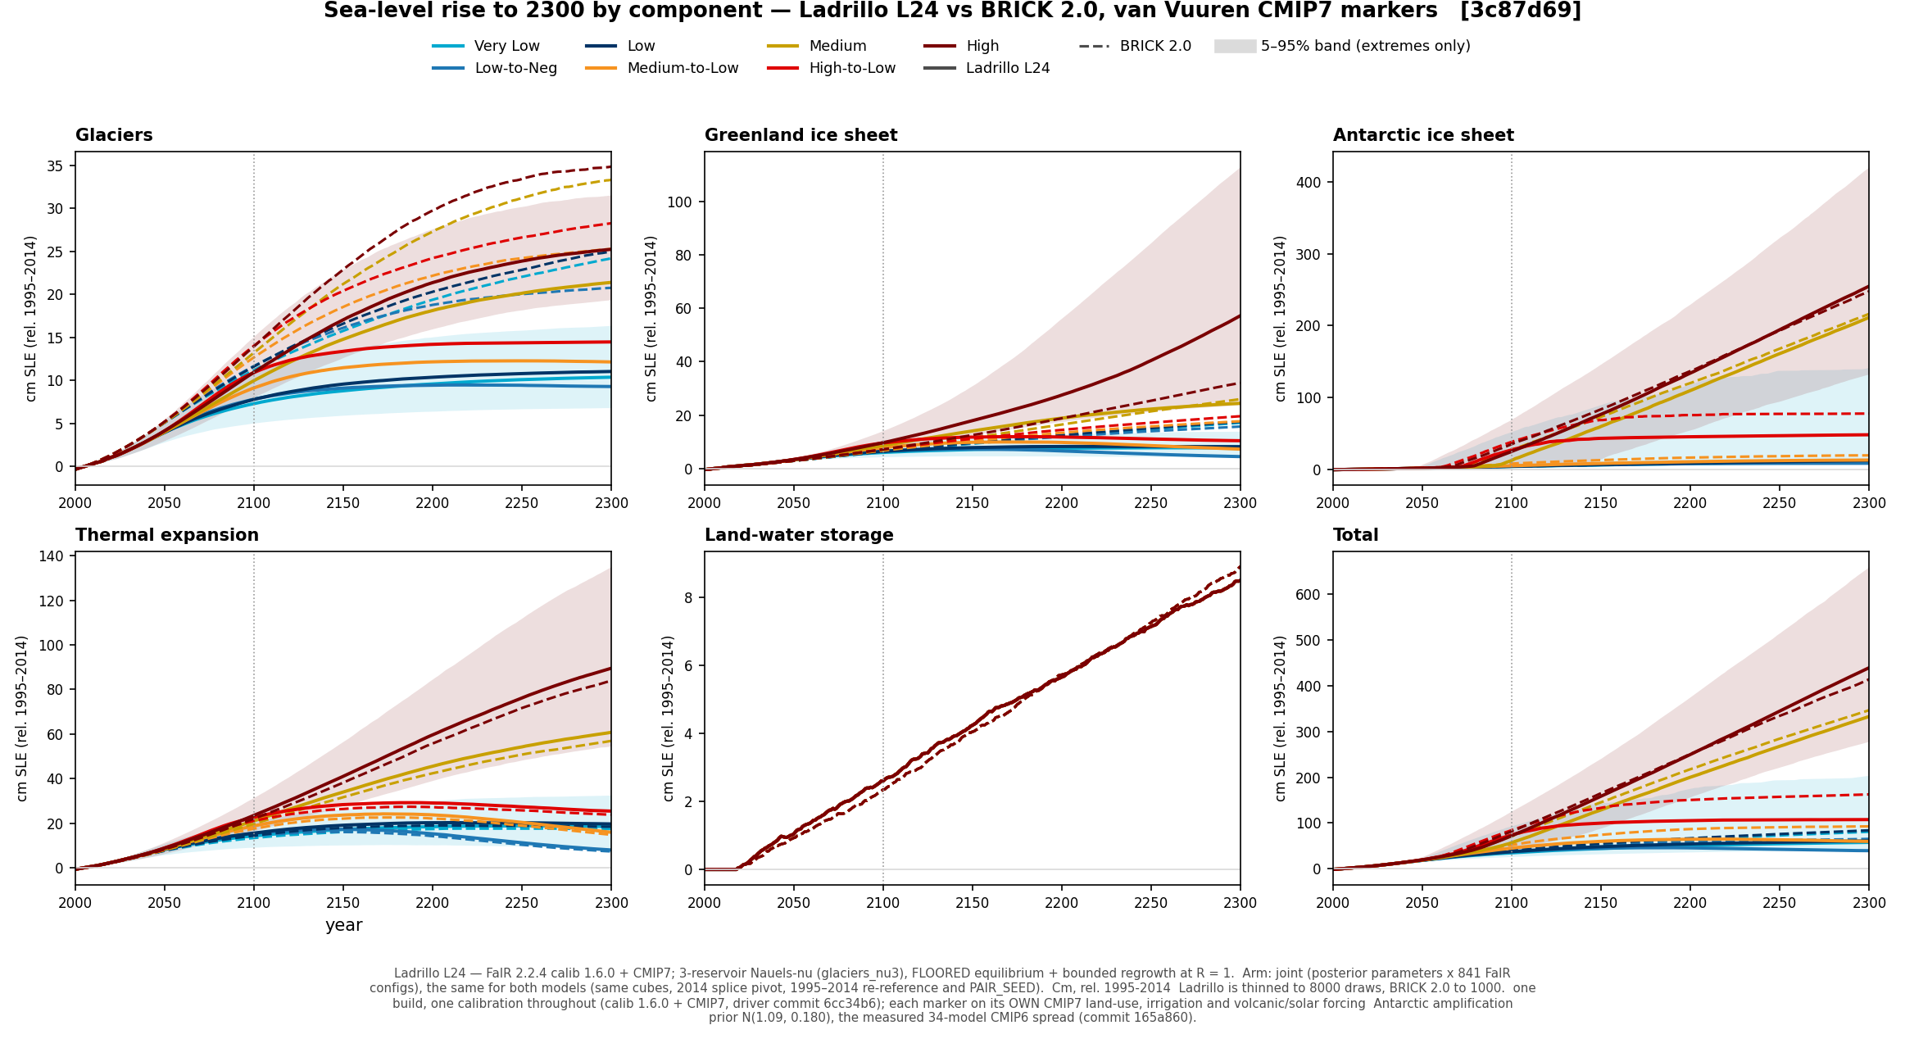
FIG 5. Component trajectories across the van Vuuren markers, joint band.
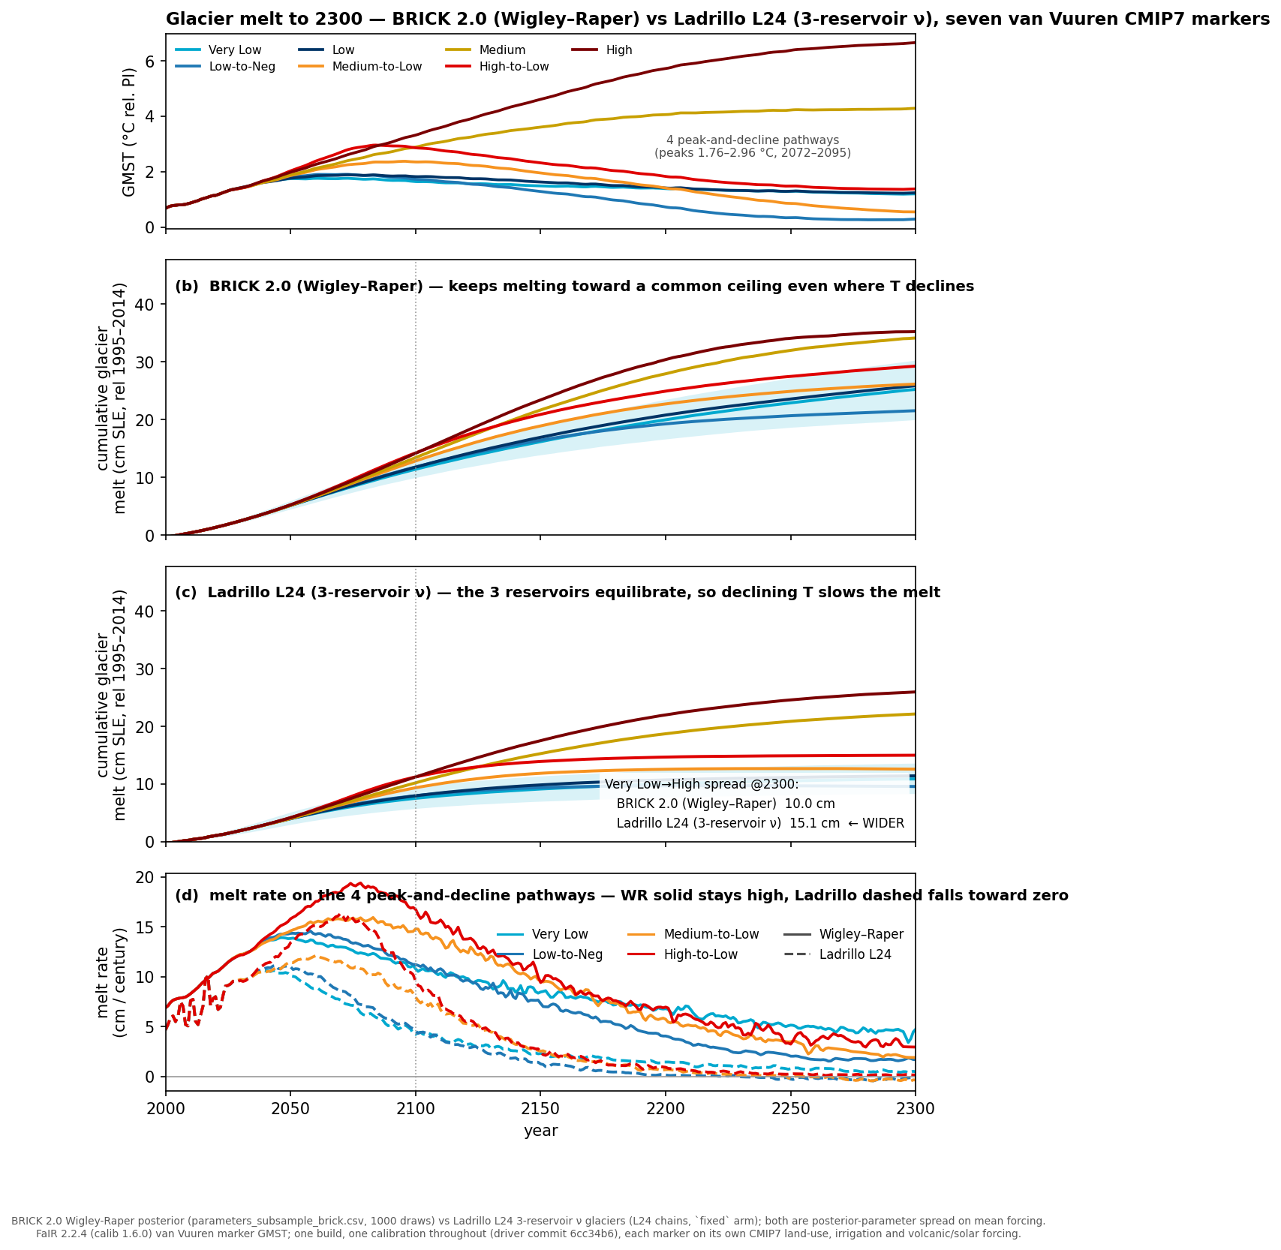
FIG 6. Glacier contribution over time, comparing Ladrillo to BRICK2.0. This is where glacier regrowth is visible in Ladrillo for overshoot scenarios, whereas the Wigley-Raper formulation continues melting.

Secondary: the SSPs
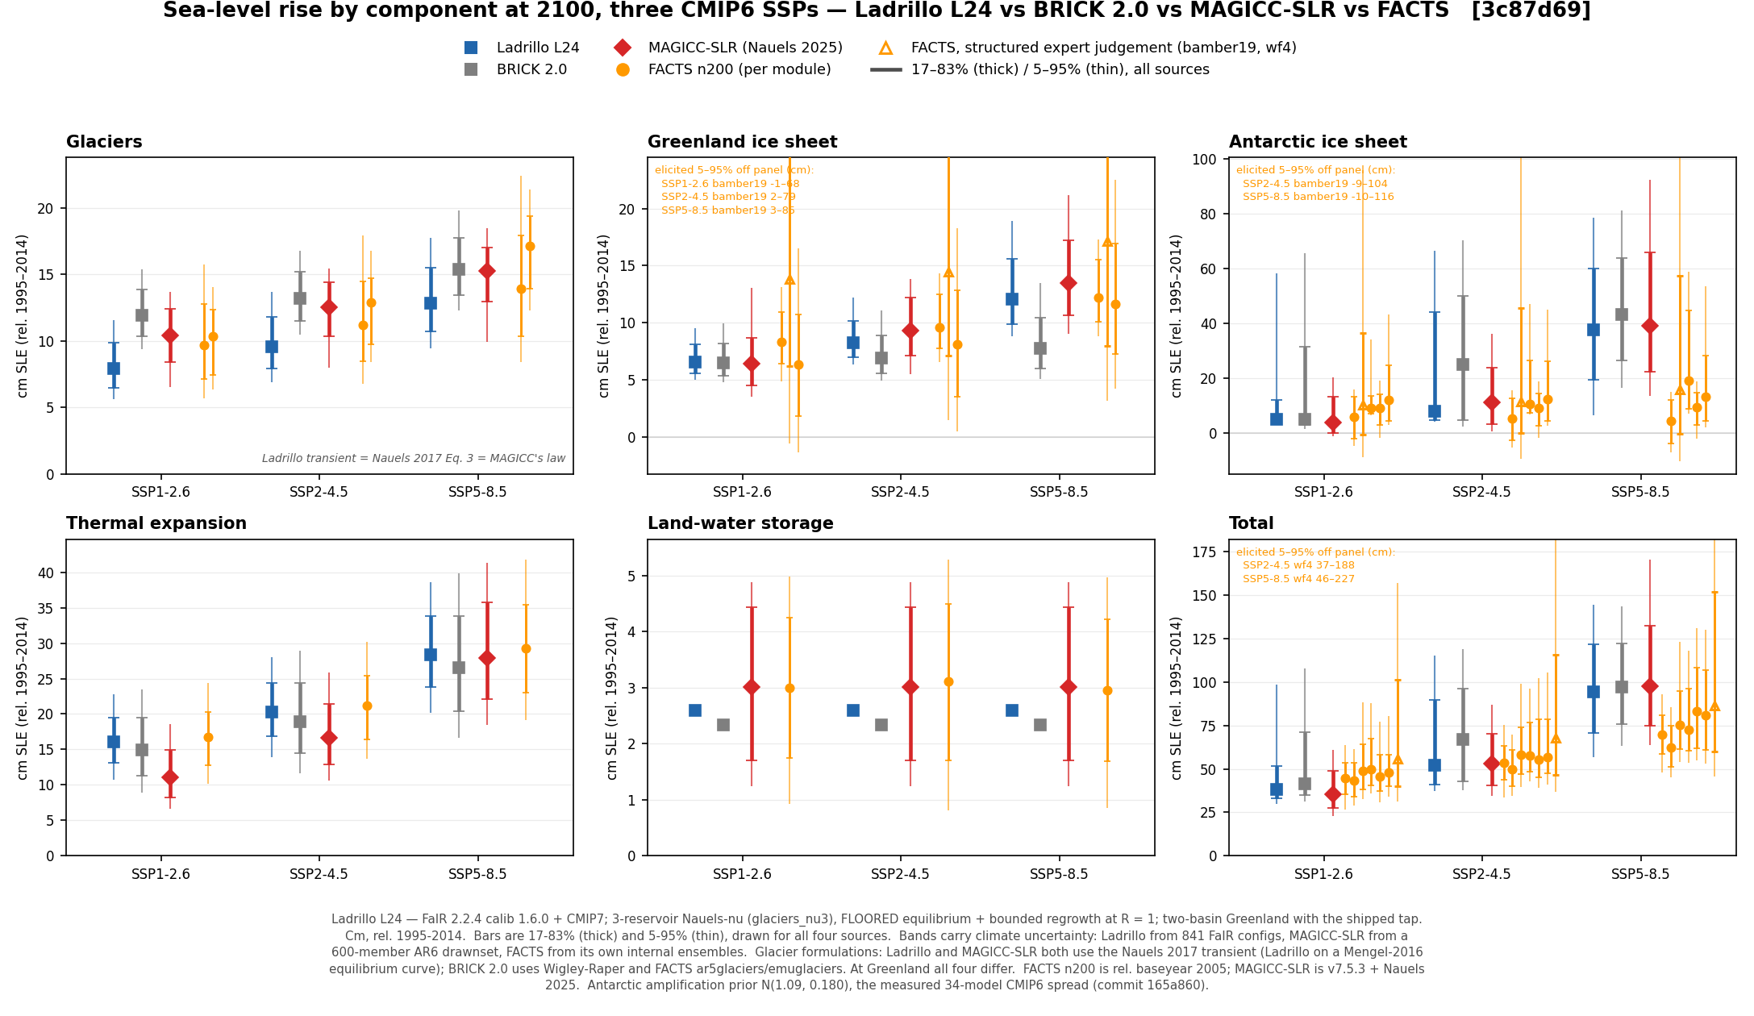
FIG 7. The SSP comparison at 2100.
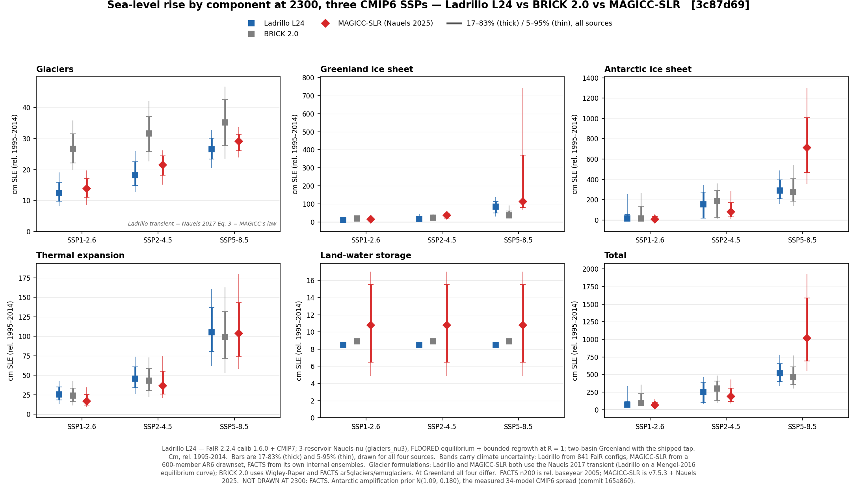
FIG 8. The SSP comparison at 2300, where only MAGICC-SLR and BRICK 2.0 extend.
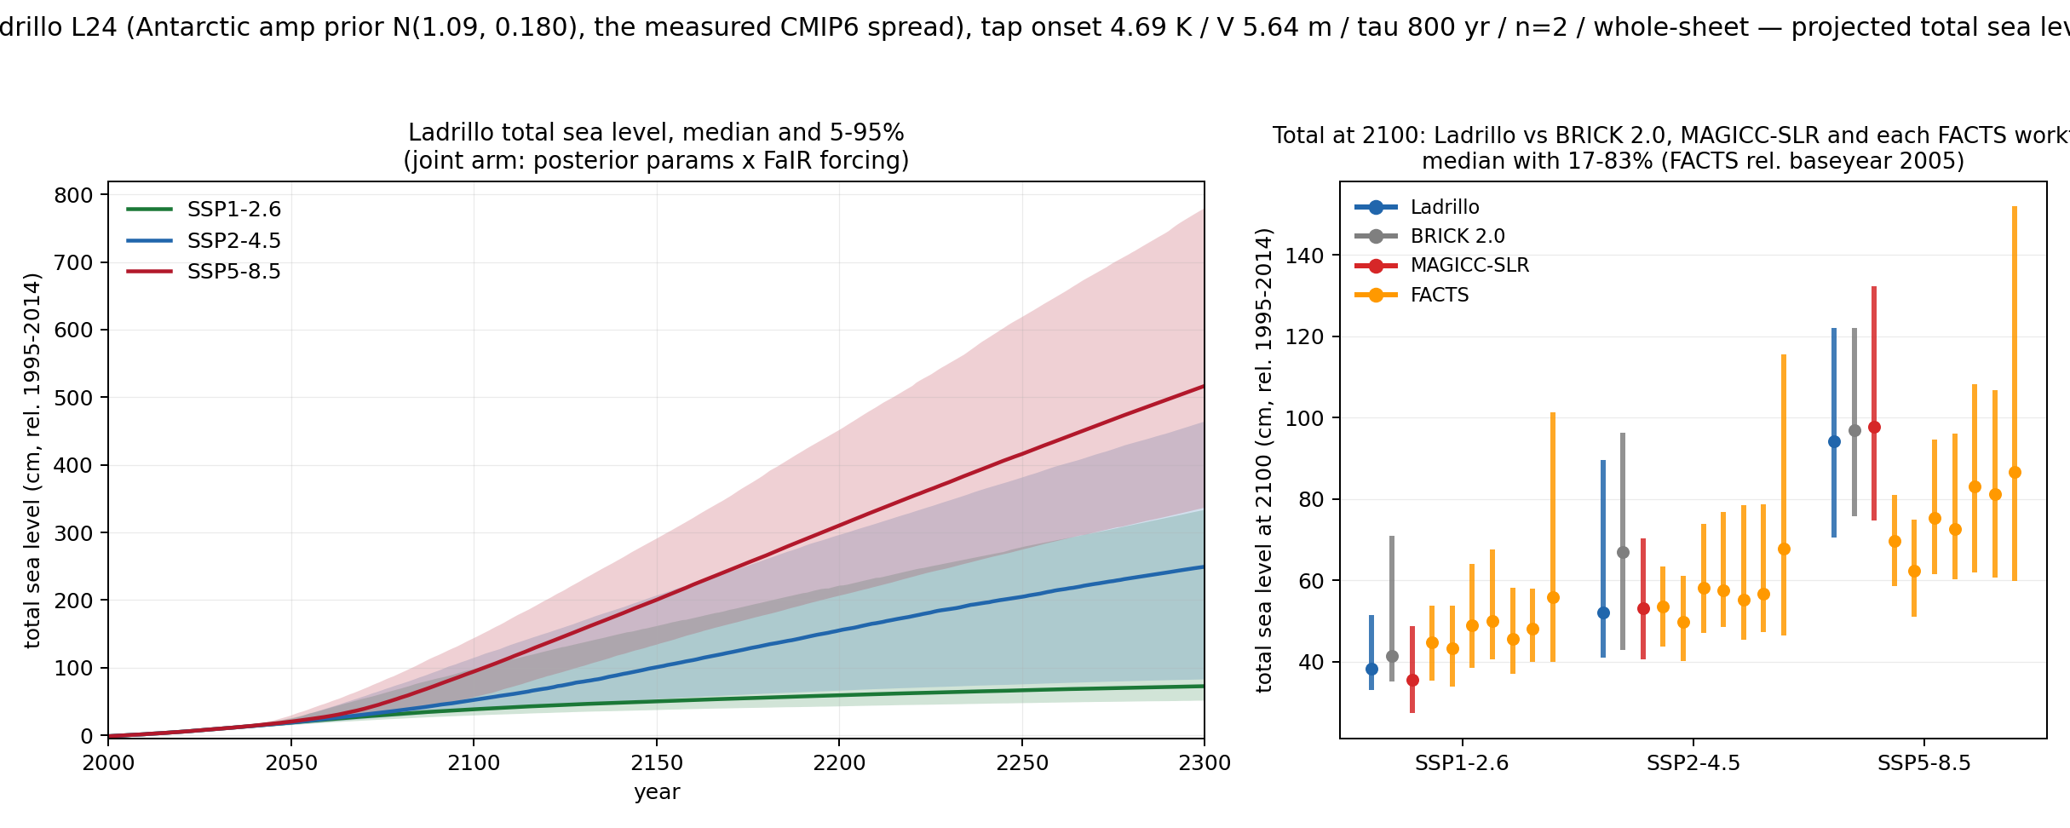
FIG 9. Total sea level by SSP, Ladrillo L24 joint band. Totals at 2300: 72.6 cm (SSP1-2.6), 249.2 cm (SSP2-4.5), 516.7 cm (SSP5-8.5).

Ladrillo compared to MAGICC on MAGICC's own climate
Comparing two sea-level models on different climate drivers confounds the module with the forcing. Ladrillo was therefore re-run on MAGICC's climate to test which differences were due to sea level module versus climate module.

Physical intuition — how Ladrillo behaves by scenario class
High scenarios. Ladrillo is comparable to the other models at 2100. By 2300 it separates upward from BRICK 2.0 (due largely to Antarctic threshold behavior) but stays below MAGICC-SLR's steeper rise (439 cm vs. 570 cm, median). Its 2300 spread is dominated by the prior for antarctic_lambda.
Low scenarios. Ladrillo sits at the low end of the comparison set on level — at vvVL its 2300 total median is 58 cm, above only MAGICC-SLR's 46 cm and below BRICK 2.0's 81 and FACTS's 148. On spread it is narrower than both BRICK 2.0 and FACTS on every component; MAGICC-SLR is the narrow outlier throughout (2300 total 5–95% width 67 cm against Ladrillo's 163, BRICK 2.0's 182 and FACTS's 259), and it is only against MAGICC-SLR that Ladrillo's Antarctic and thermal-expansion bands are the wider ones.
Peak-and-decline scenarios. The glacier change is evident here because it allows regrowth, though on Ladrillo's own FaIR climate that regrowth is very small: measured from each marker's peak to 2300, it reaches only 0.18 cm at vvLN and 0.13 cm at vvML, and is essentially nil on the other markers. The capacity is larger than the realised amount — driven instead by MAGICC's colder climate, the same module regrows 2.2 cm at vvLN — so what limits regrowth here is how far the scenario cools, not the module's willingness to regrow.
MAGICC regrows substantially more than Ladrillo. About ¾ of the regrowth difference is model structure and ¼ the climate module**.** Measured on realised regrowth (peak-to-2300) at vvLN, the scenario where regrowth is largest: MAGICC regrows 8.59 cm against Ladrillo's 0.18 cm, and driving Ladrillo's module with MAGICC's own climate decreases the gap by 2.02 cm. When driving the two models with MAGICC’s own temperature, Ladrillo’s committed equilibrium regrowth is also somewhat less than MAGICC’s, but MAGICC reaches its regrowth limits in the two coldest van Vuuren scenarios. So while the gap with MAGICC is mainly a rate effect (at 1.5 K the SLOWP and R19 regions have median response times of ~270 yr and ~470 yr, the latter very poorly constrained at 80–3200 yr across the posterior; all three blocks respond about three times faster at 3 K) this rate effect is compounded by an equilibrium effect.

