Hifazat – Safety App

Group Members (2 person max):
Qira Ahmad 17L-4169
Muhammad Saroosh Humayun 17L-4093
Theme: Personal security app.

Abstract / Summary
We intend to develop a personal security app whose basic purpose will be to send out a “person in distress” signal to pre-selected people, in a time of danger. The trigger for this should be something that is simple to do; like pressing the power or volume button 4 times in succession. This app will serve to rescue people that are in distress of any sort. For example, if they are being threatened, robbed, assaulted, or forced in any manner. It will alert the selected people, that the person is in danger, and will send them further information, such as location, video recording etc., to allow them to help. It will also allow live tracking, fake call scheduling, and will have a directory consisting of numbers to contact, in case of different emergencies.

The amount of crime in Pakistan has always been really high. Yet it seems to evade global crime charts due to the fact that a vast majority of the crime goes unreported. The reason behind this is an extremely incompetent and equally corrupt legal system. According to The Pakistan Crime & Safety Report of 2020 by OSAC, Lahore alone had approximately 84,000 counts of reported crime in 2019. Our application serves to make it easier for people to take appropriate measures in case they are subjected to a crime.

Functional requirements and Architectural analysis
- An SoS feature that can be activated by an action such as: pressing the power button 4 times in succession. This feature will send the user’s live location, a 30 second video recording from the user’s phone after they initiate the SoS, and a custom, pre-assigned distress message, to a maximum of 5 pre-selected people. (The distress message and the people will be customized at the time of initial setup)
- A location sharing feature, that allows the user’s live location to be requested by select people, whenever they want to. The person requesting the location and the person whose location is requested will both have to be users of the app, and will have to be a part of each other’s trusted people, in-app.
- A tab with contact numbers of authorities, in case of different emergencies. Listing numbers such as: Police, Fire brigade, Ambulance and Suicide prevention helpline. Each number will have a tap to call feature, meaning that the user will be able to call the appropriate authority, upon one tap on their listing.
- A fake call scheduler. This feature can be useful to escape situations when someone senses impending danger, as opposed to immediate danger. One could schedule a fake call at a given time, which will make the phone ring, and the UI will show a caller id as if they are being called, allowing them to escape.

We will be using the latest android API for this app and will also use a built-in database to store information such as location details, and trusted contacts’ info etc.

Similar Apps
List down existing apps on Play store/Appstore similar to your project functionality
 | AppName | Download Link | No of Downloads
1 | bSafe | https://play.google.com/store/apps/details?id=com.bipper.app.bsafe&hl=en&gl=US | 500K+
2 | The UrSafe App | https://play.google.com/store/apps/details?id=com.ursafe&hl=en&gl=US | 10K+
3 | Sister | https://play.google.com/store/apps/details?id=com.wavelt.sister&hl=en&gl=US | 10K+

Appendix – Mockups
Show UI mockups to illustrate your project idea. You may use some online prototyping tool for mockups at this stage. Keep the overall proposal limited to a maximum of two pages.
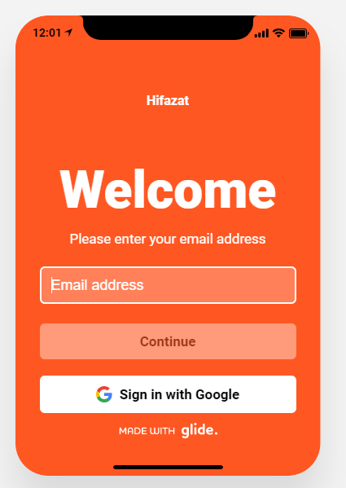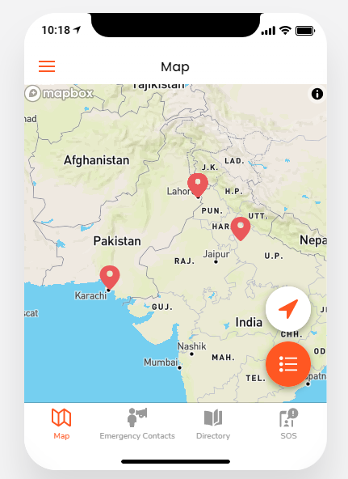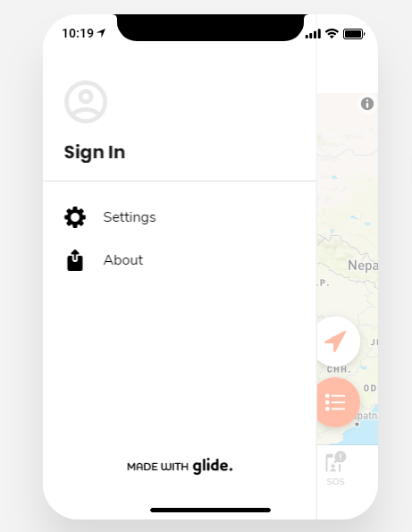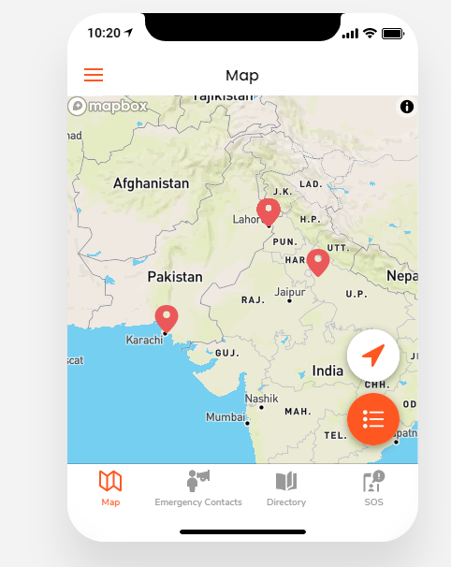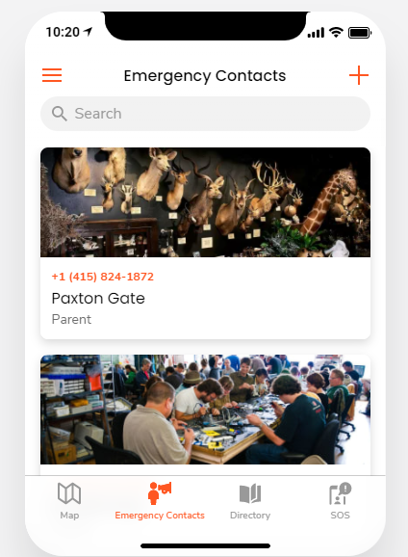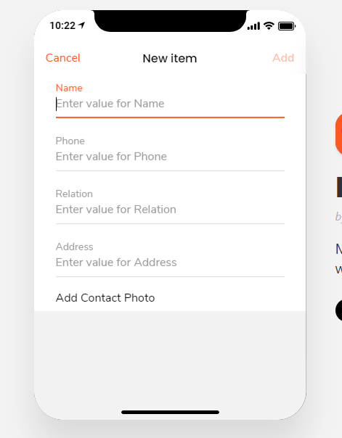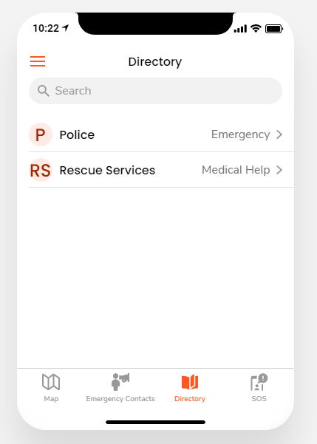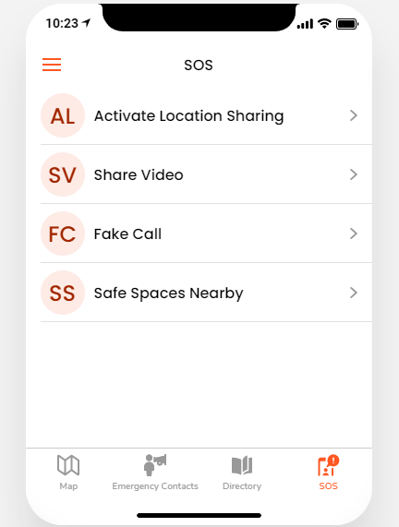
Mockup Link: https://hifazat.glideapp.io/

