# Twenty Thousand Leagues under the Sea, by Jules Verne

*Twenty Thousand Leagues Under the Sea* is a classic science fiction novel by French writer Jules Verne published in 1870. It tells the story of [Captain Nemo](http://en.wikipedia.org/wiki/Captain_Nemo) and his submarine *Nautilus* as seen from the perspective of Professor Pierre Aronnax.

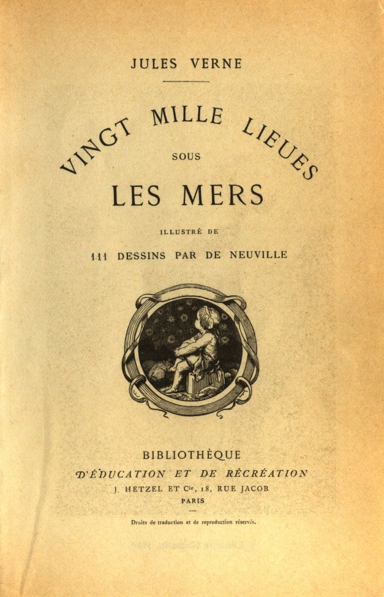

(http://upload.wikimedia.org/wikipedia/commons/4/4e/20000_title_0a.jpg)

* [Wikipedia entry](http://en.wikipedia.org/wiki/Twenty_Thousand_Leagues_Under_the_Sea)

## Excerpt

Part One

Chapter I: A Shifting Reef

The year 1866 was signalised by a remarkable incident, a mysterious and puzzling phenomenon, which doubtless no one has yet forgotten. Not to mention rumours which agitated the maritime population and excited the public mind, even in the interior of continents, seafaring men were particularly excited. Merchants, common sailors, captains of vessels, skippers, both of Europe and America, naval officers of all countries, and the Governments of several States on the two continents, were deeply interested in the matter.

For some time past vessels had been met by "an enormous thing," a long object, spindle-shaped, occasionally phosphorescent, and infinitely larger and more rapid in its movements than a whale.

* [From Project Gutenberg](http://www.gutenberg.org/ebooks/164)

## About Jules Verne

**Jules Gabriel Verne** (February 8, 1828 – March 24, 1905) was a French author who pioneered the science fiction genre. Verne wrote about [space](http://en.wikipedia.org/wiki/Outer_space), [air](http://en.wikipedia.org/wiki/Aircraft), and [underwater](http://en.wikipedia.org/wiki/Submarine) travel before air travel and practical submarines were invented, and before practical means of space travel had been devised.

* [Wikipedia entry](http://en.wikipedia.org/wiki/Jules_Verne)

### Other books by Jules Verne

1. [A Journey to the Centre of the Earth](http://en.wikipedia.org/wiki/A_Journey_to_the_Center_of_the_Earth)
2. [Around the World in Eighty Days](http://en.wikipedia.org/wiki/Around_the_World_in_Eighty_Days)