-:Note to Readers:-

This document is primarily screenshot-based, making it easy to follow and understand. Each step is visually demonstrated, allowing you to grasp the implementation process quickly without spending too much time on lengthy explanations.
I kindly encourage you to go through the screenshots and accompanying notes to see how I implemented and debugged the GA4 add_payment_info event.

Step-by-Step Documentation

Of My Learning Journey

GA4 Recommended Event: add_payment_info

📌 Includes:
✅ HTML Page Setup
✅ GTM Configuration & Preview
✅ Event Debugging in GTM
✅ Data Verification in GA4

✍ Documented by: Md. Saiful Alam
This document showcases my expertise in Tracking Setup and Conversion Tracking by demonstrating the GA4 add_payment_info event implementation. The goal is to present my learning journey and hands-on experience to potential buyers on Fiverr who are looking for a skilled tracking specialist.
Through this step-by-step guide, I illustrate how to:
- Implement the add_payment_info event using an HTML page.
- Configure event tracking in Google Tag Manager (GTM).
- Use GTM preview mode for debugging and verification.
- Ensure the event is successfully received in GA4.
With detailed screenshots and a structured approach, this document serves as proof of my ability to set up accurate eCommerce tracking and event-based conversion tracking. If you're looking for a professional to configure GA4, GTM, or other marketing pixels, feel free to explore my Fiverr services.
HTML page to implement the event : add_payment_info
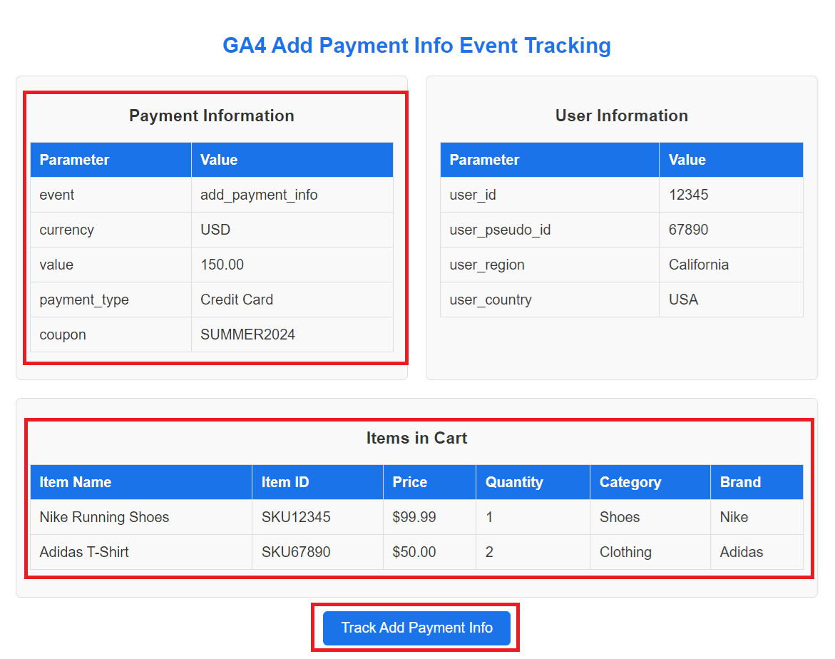
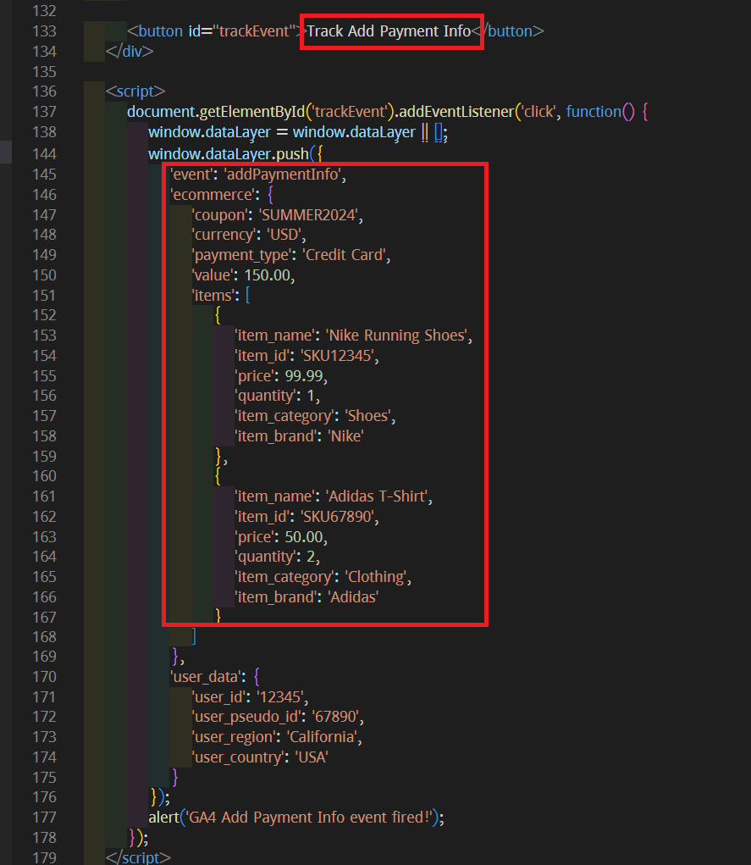
DataLayer in the html code

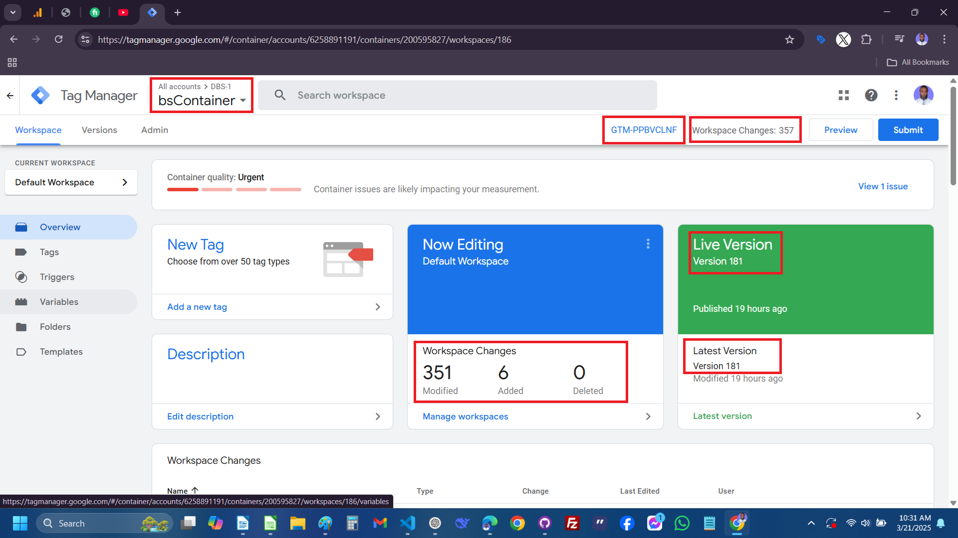
GTM Container

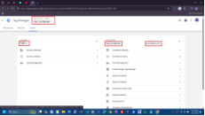
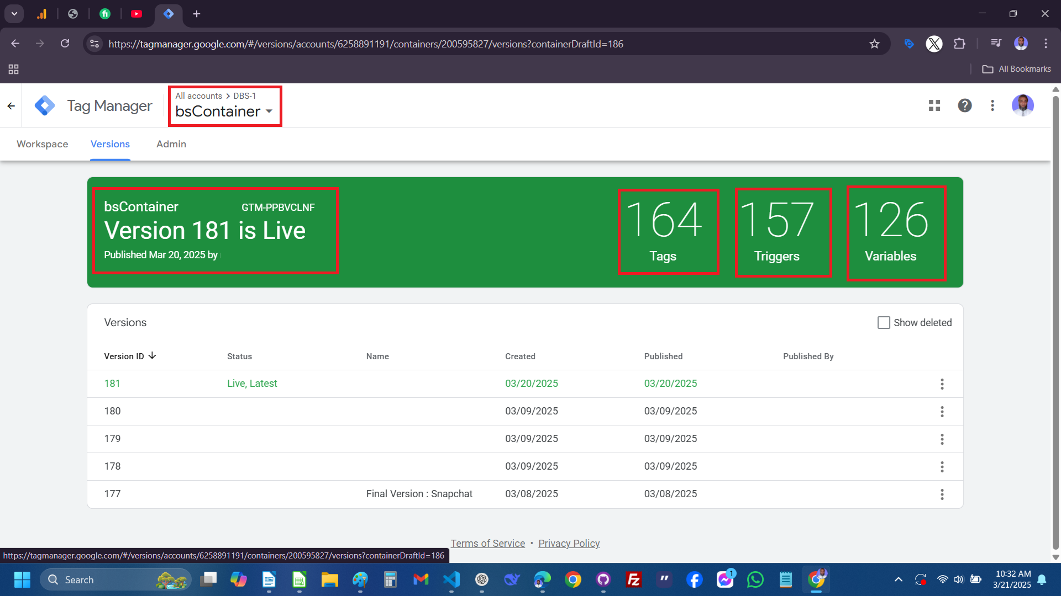
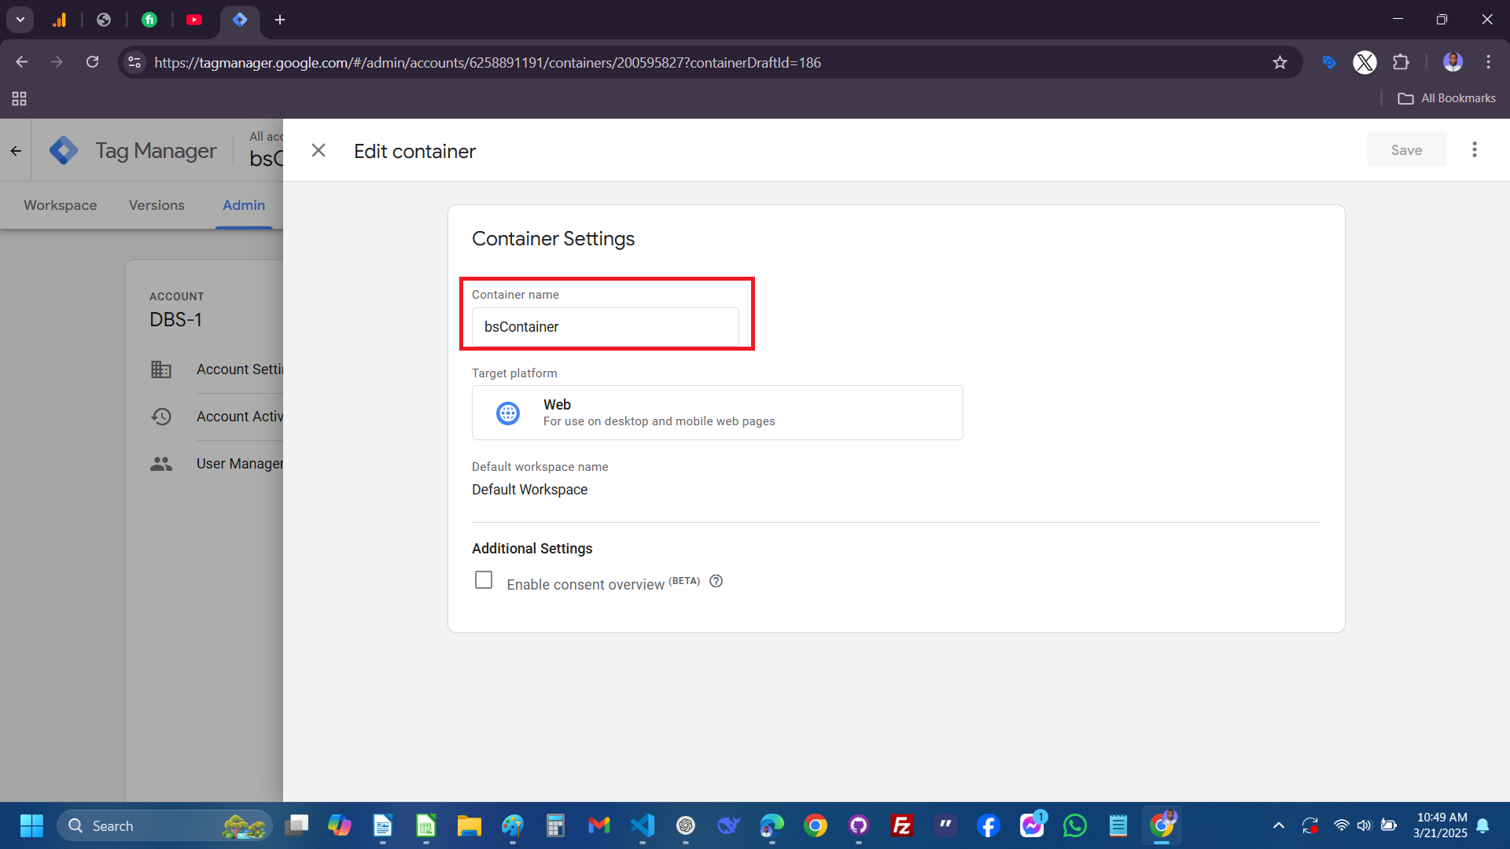
Setting up GTM Container

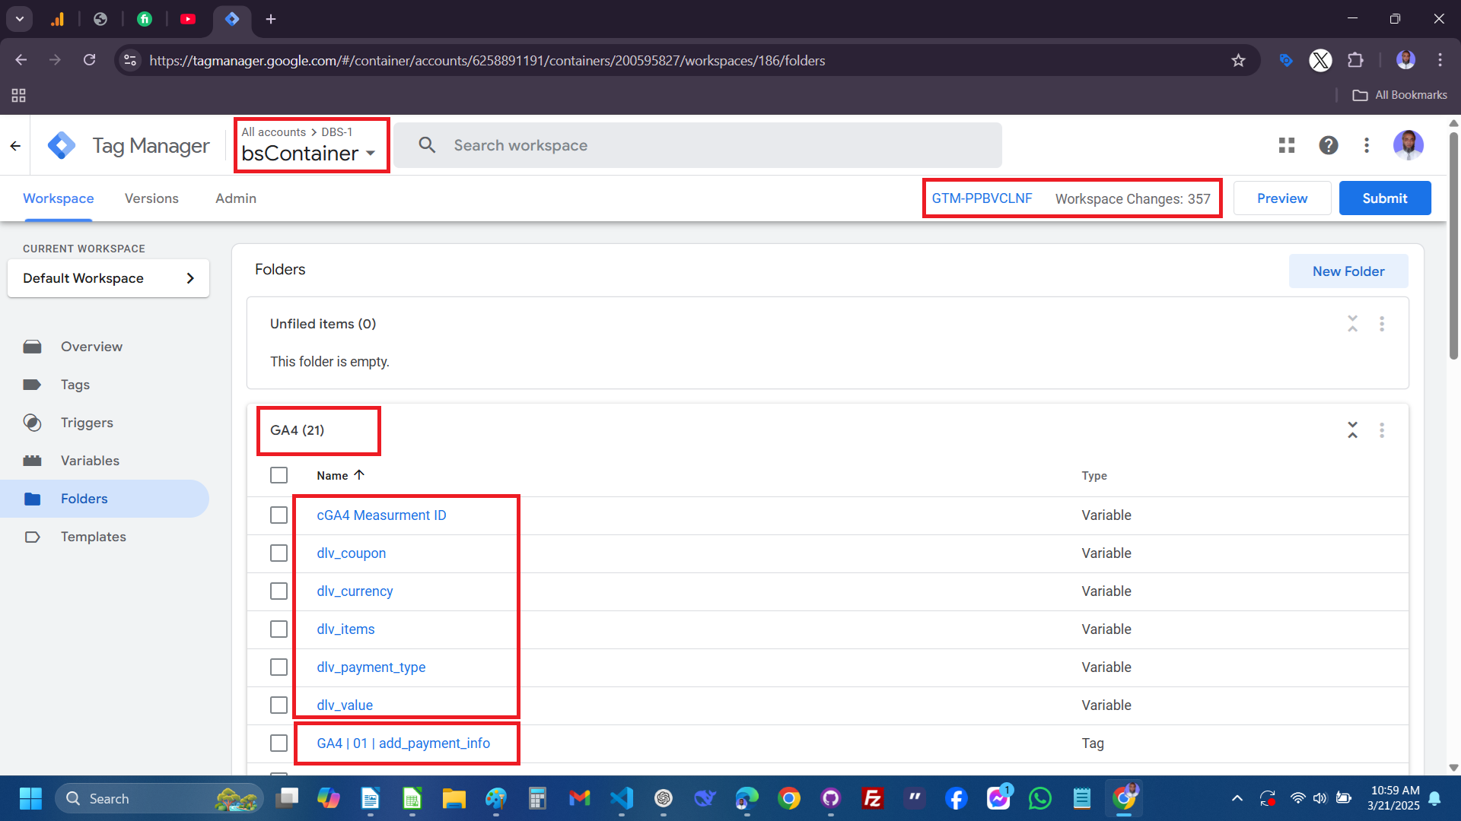
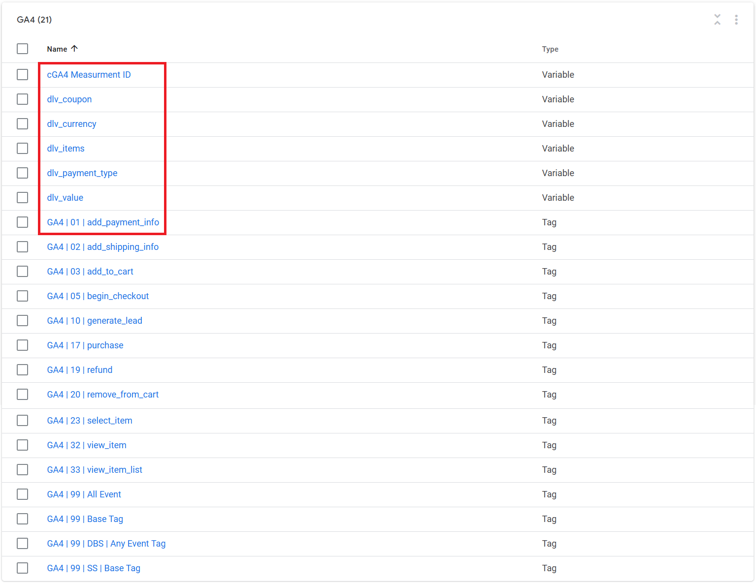
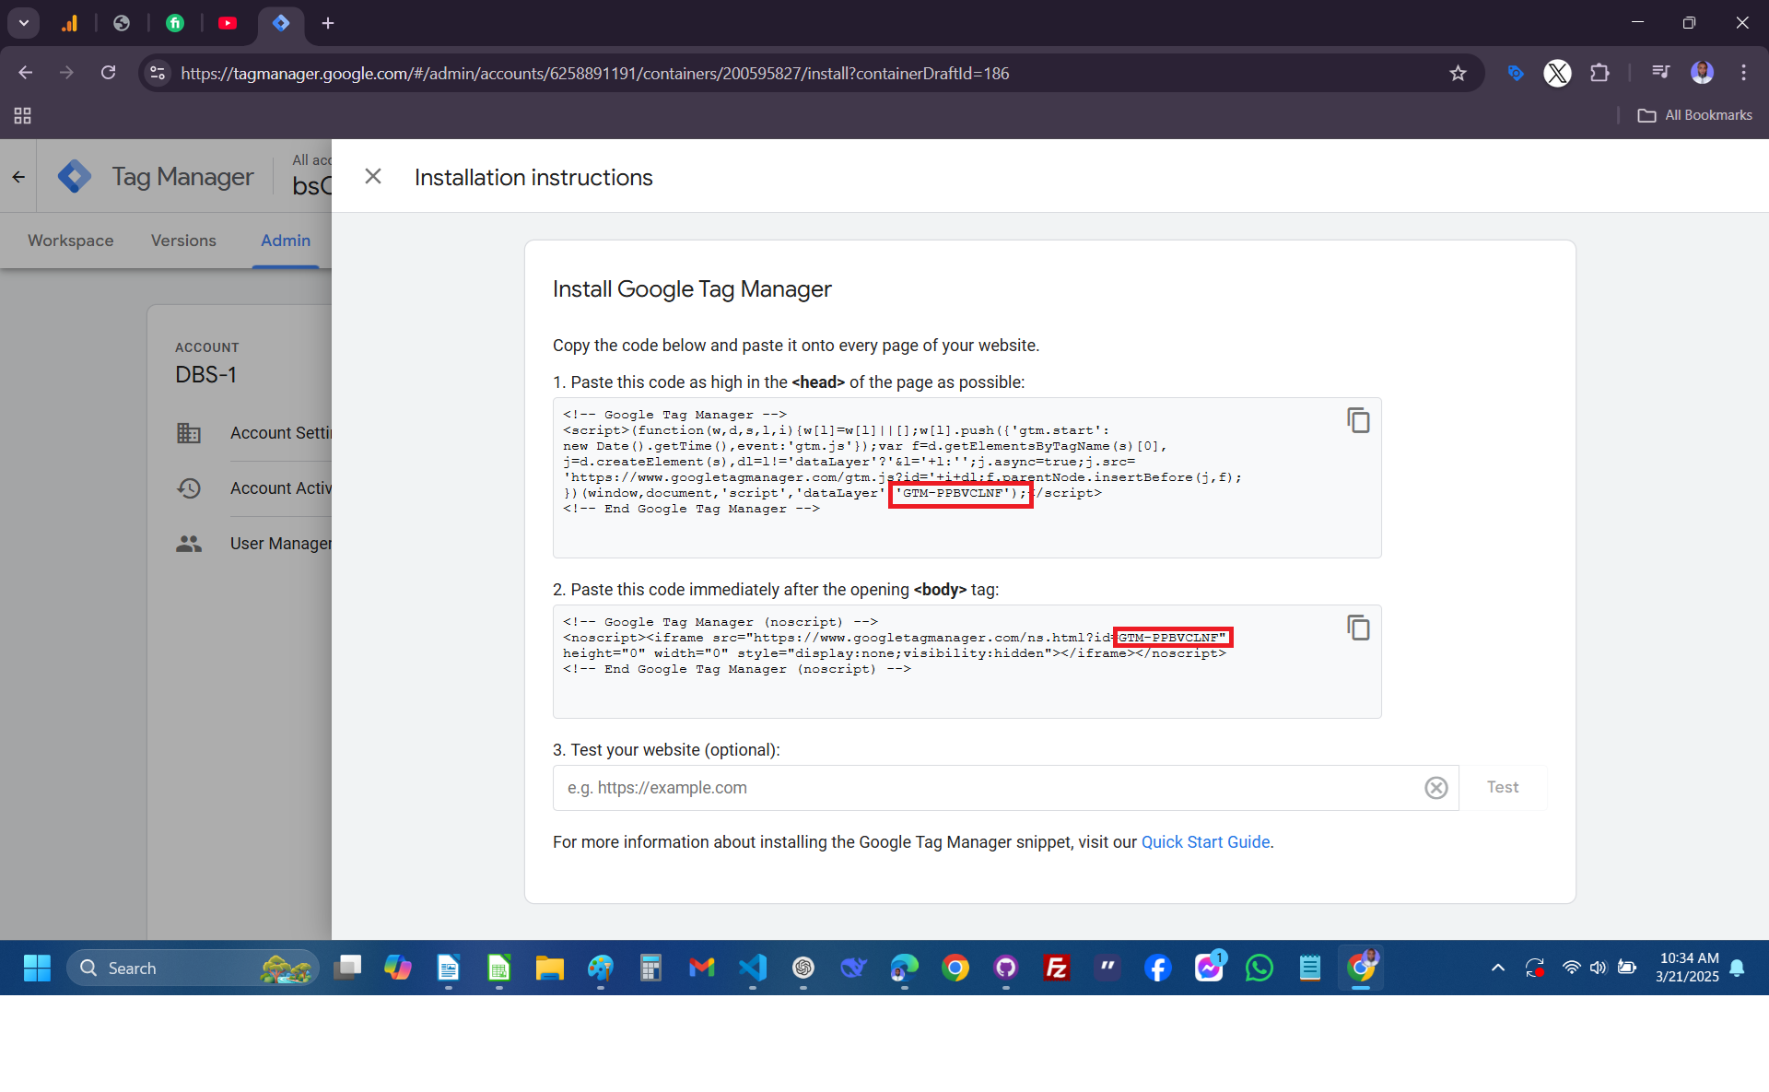
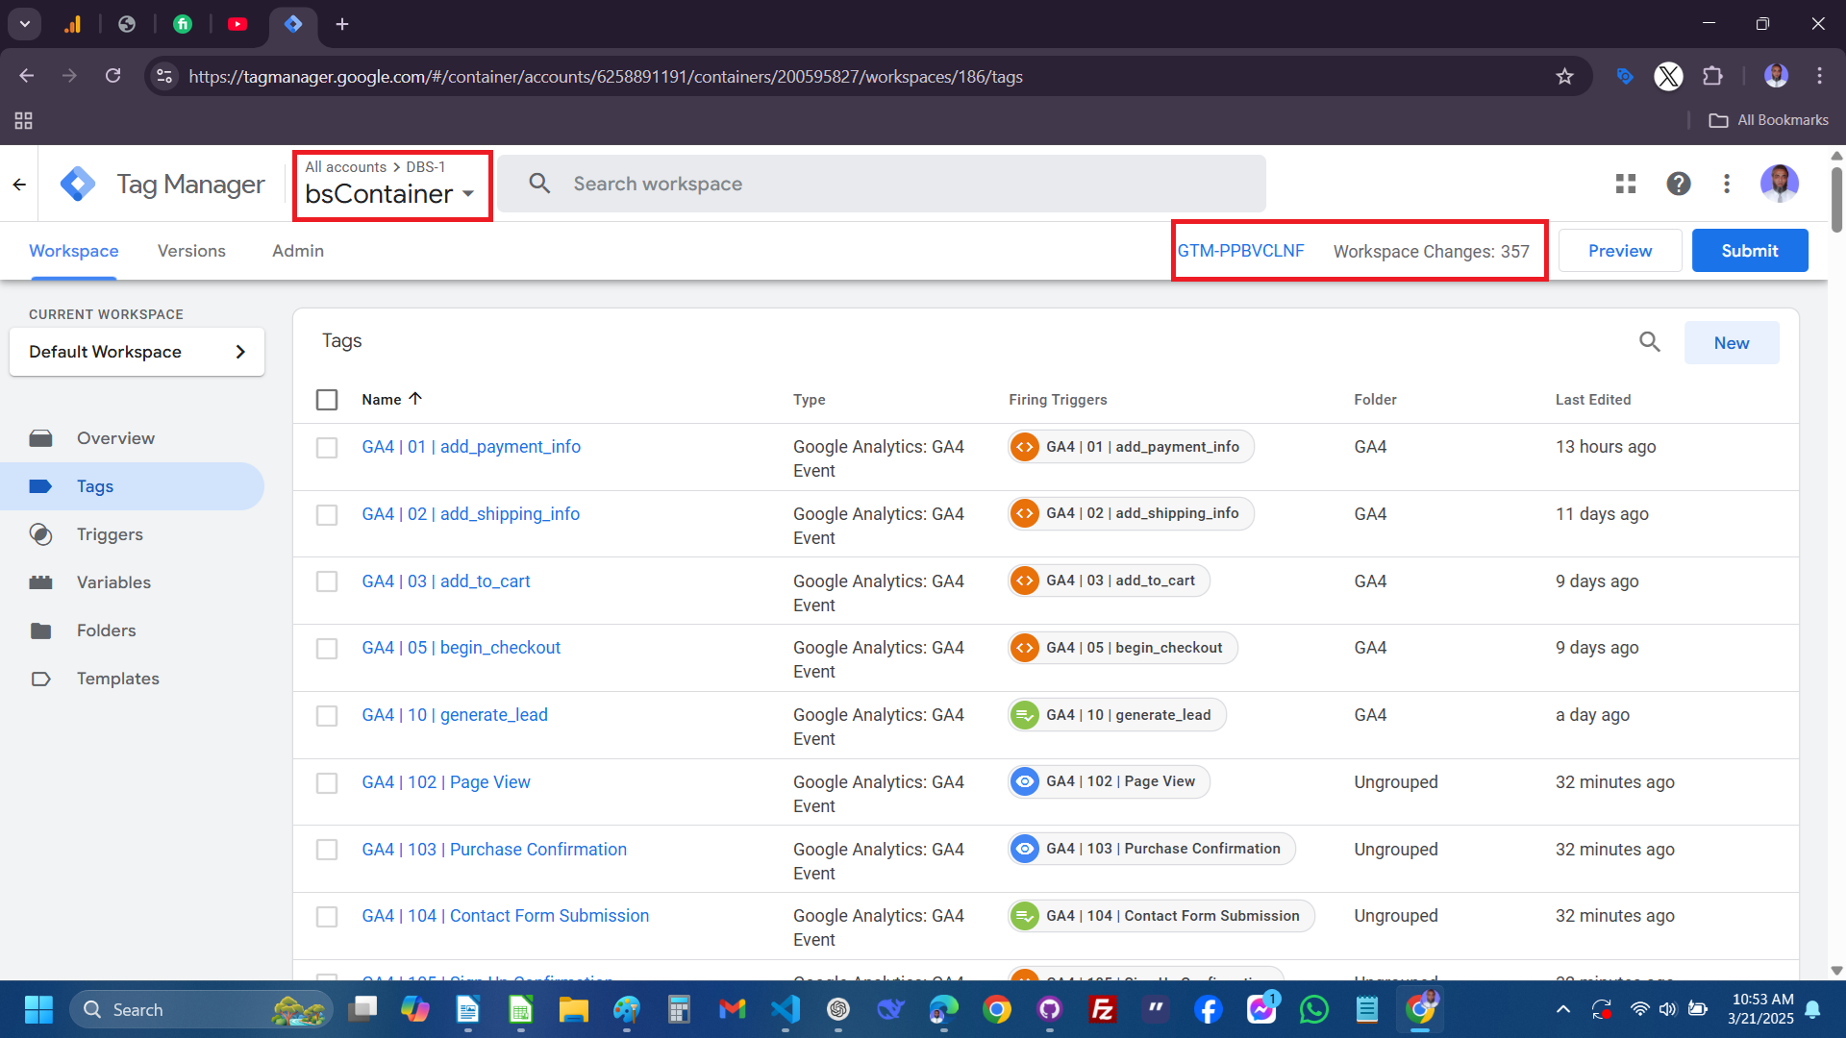
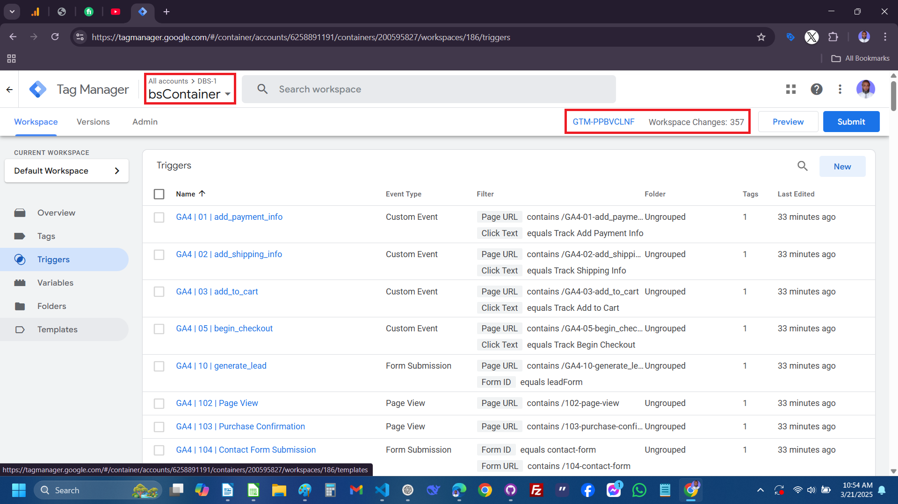
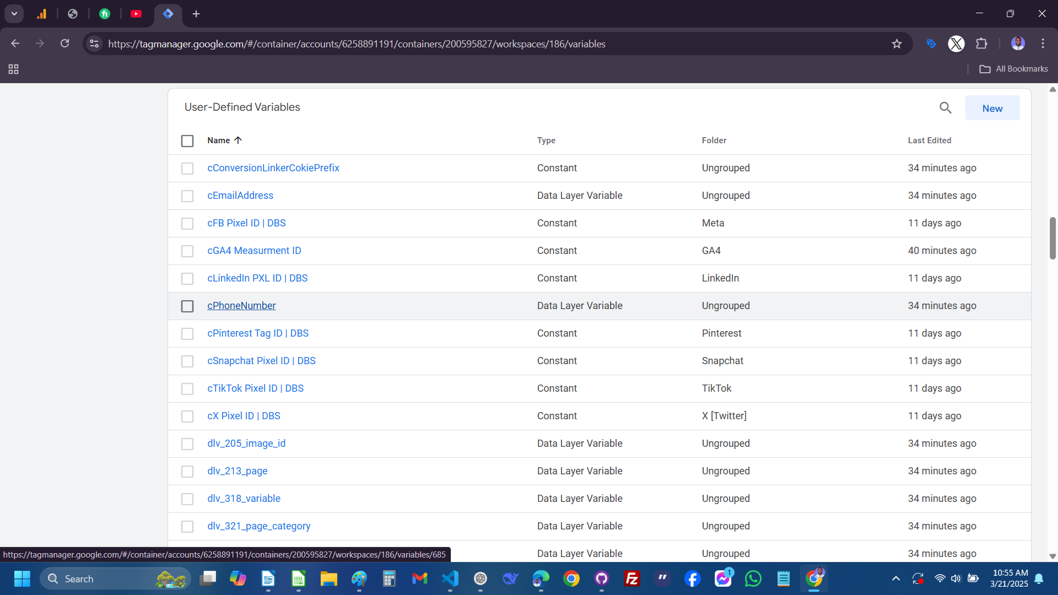
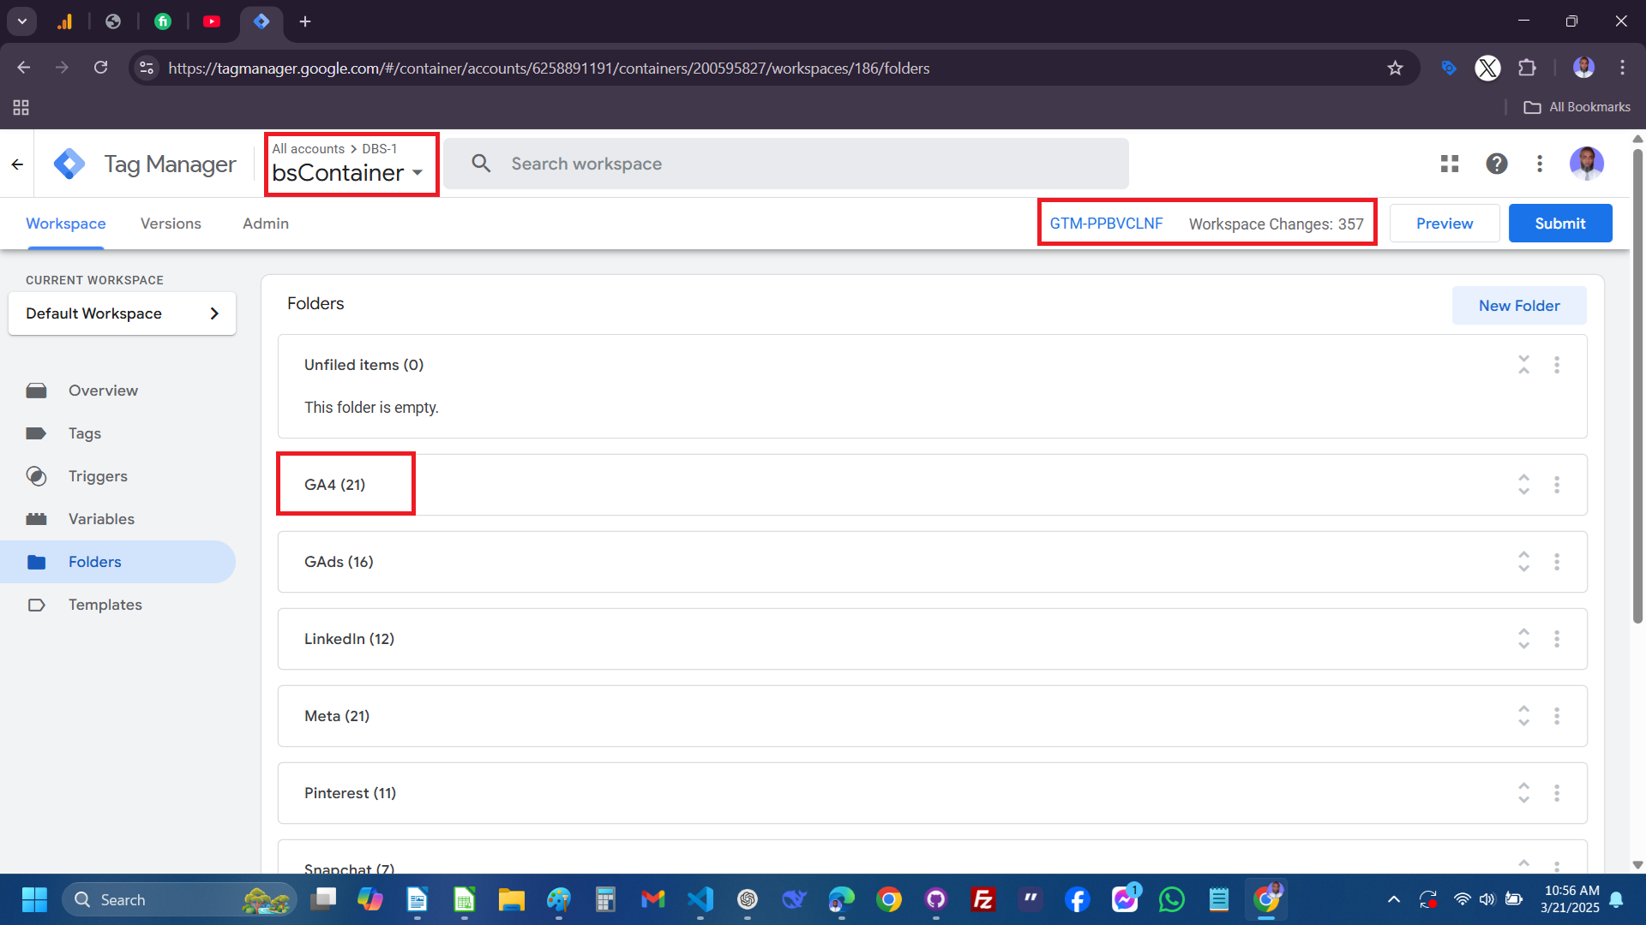
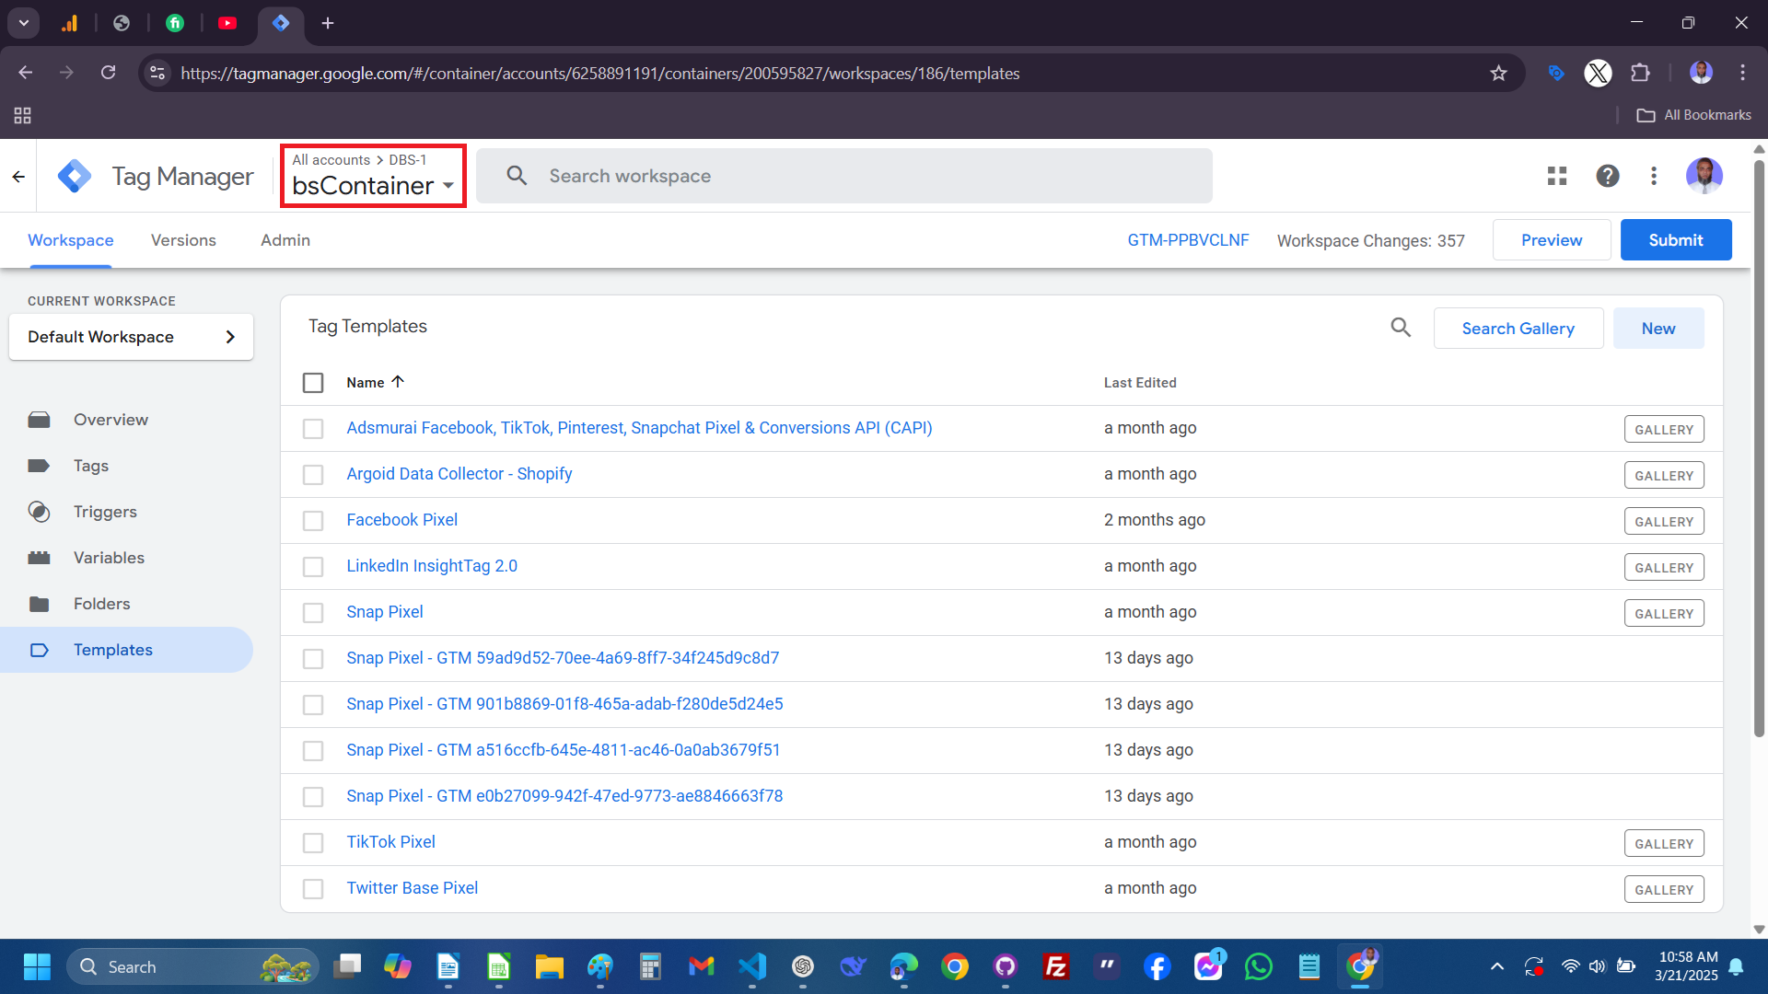

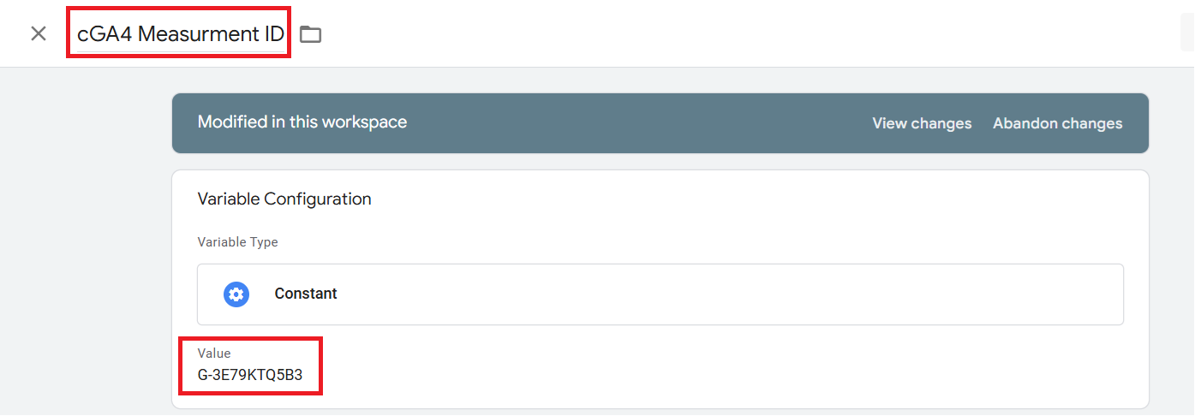
Configuring : Data Layer Variable
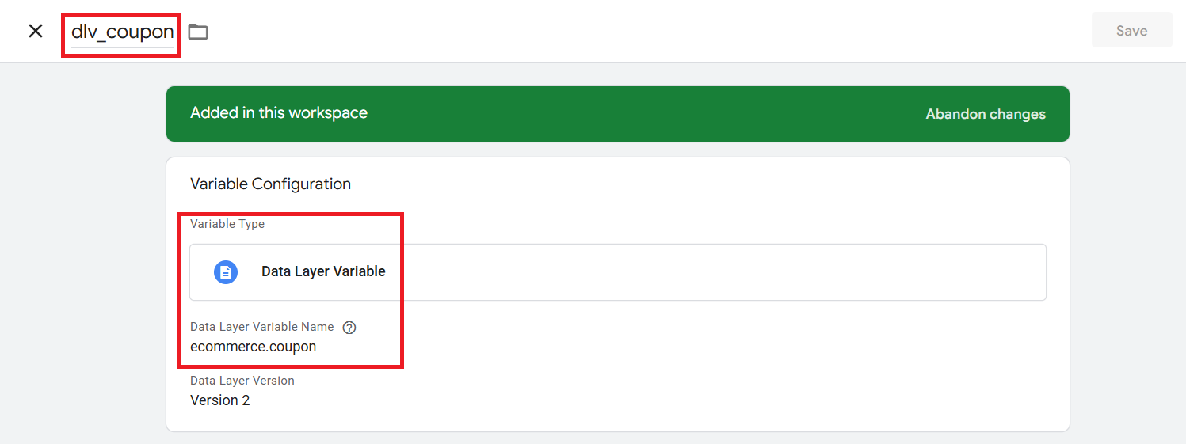
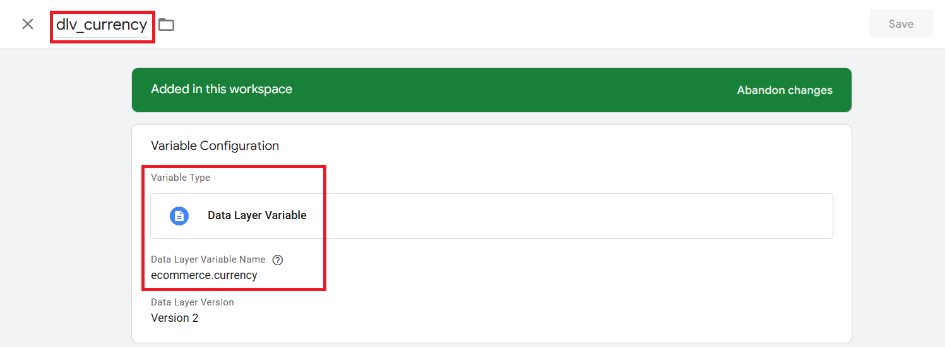
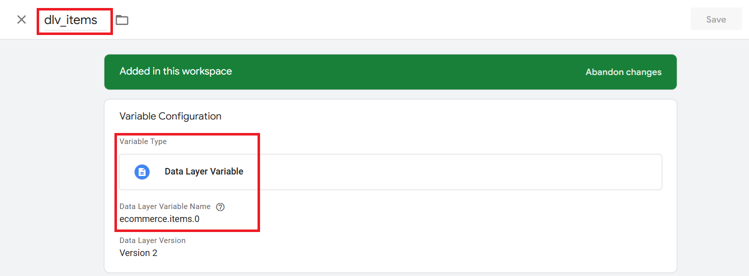

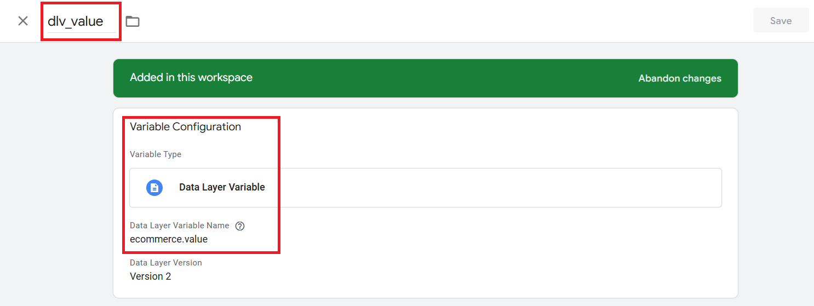

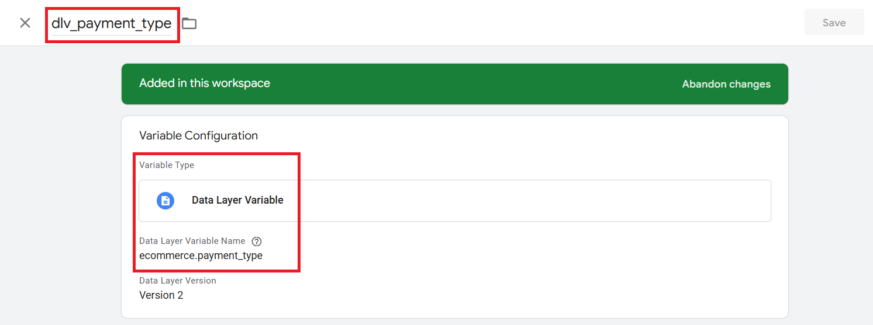

Configuring : Tag for the event add_payment_info
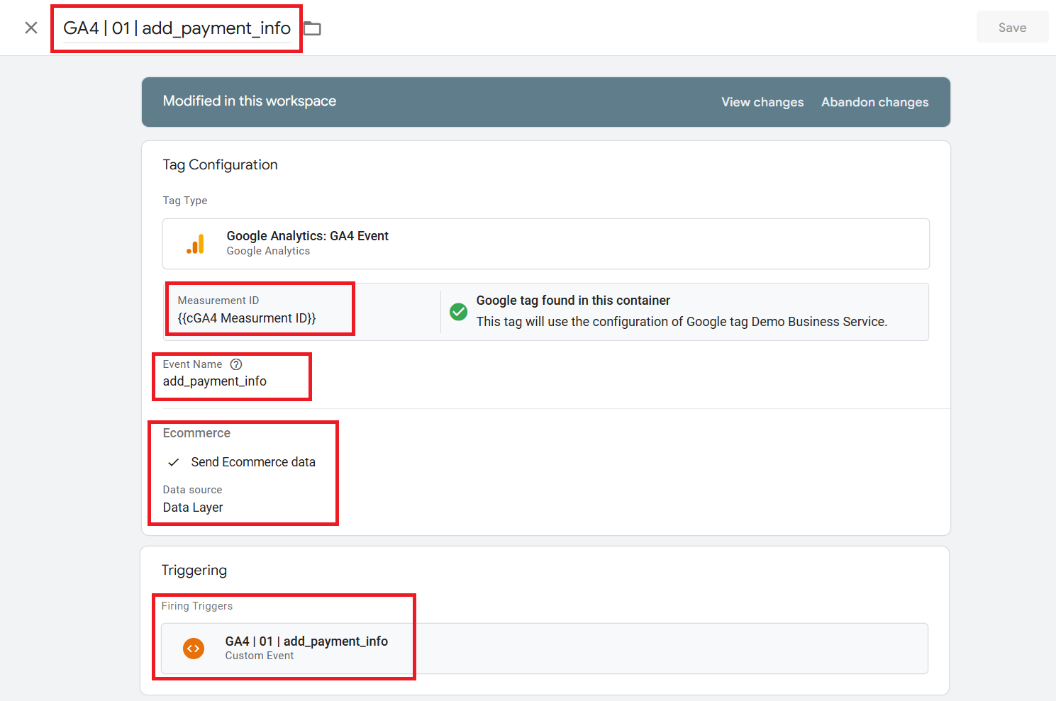
Configuring : Trigger for firing the event add_payment_info

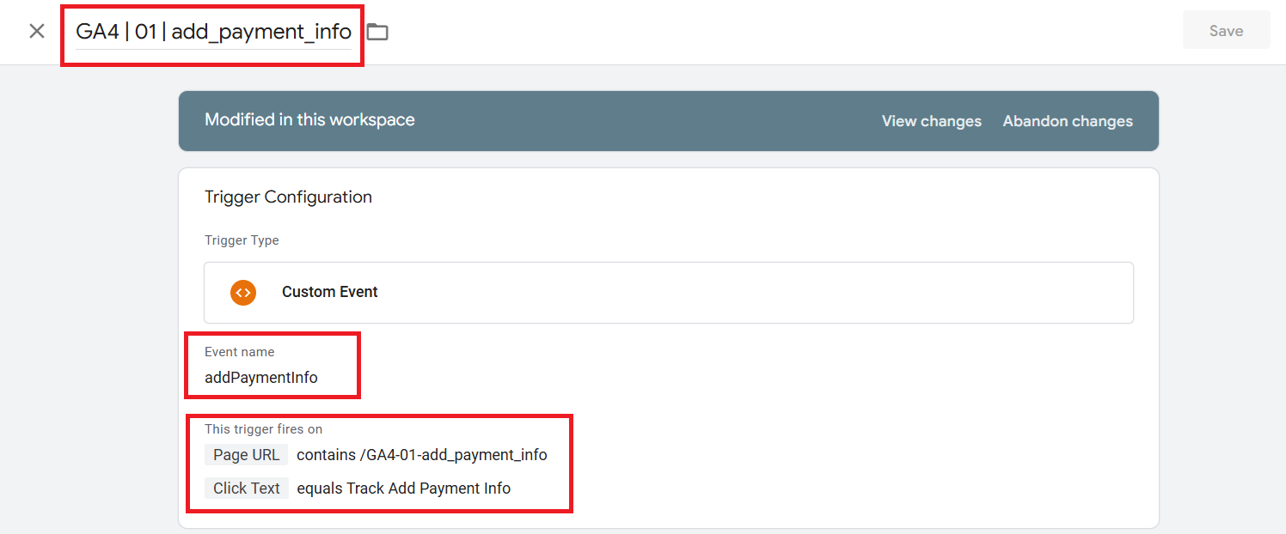

Previewing : Tag Manager container GTM-PPBVCLNF
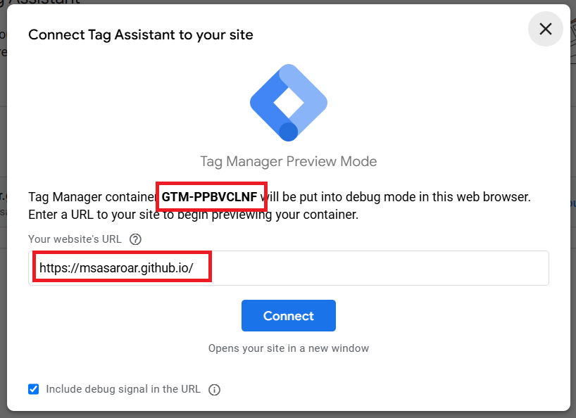
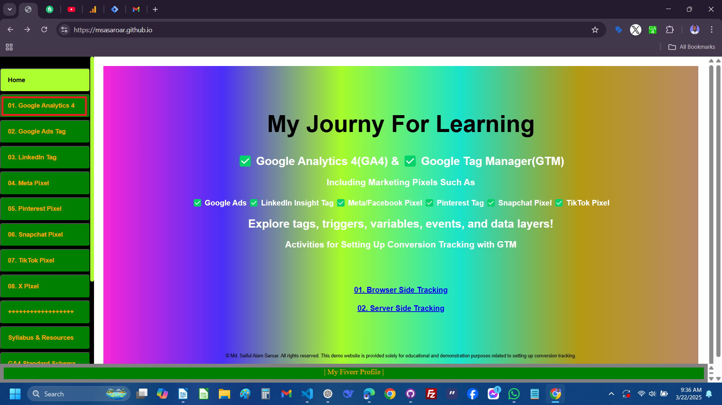
Landing page of my demo site for learning

Selecting the event to demonstrate

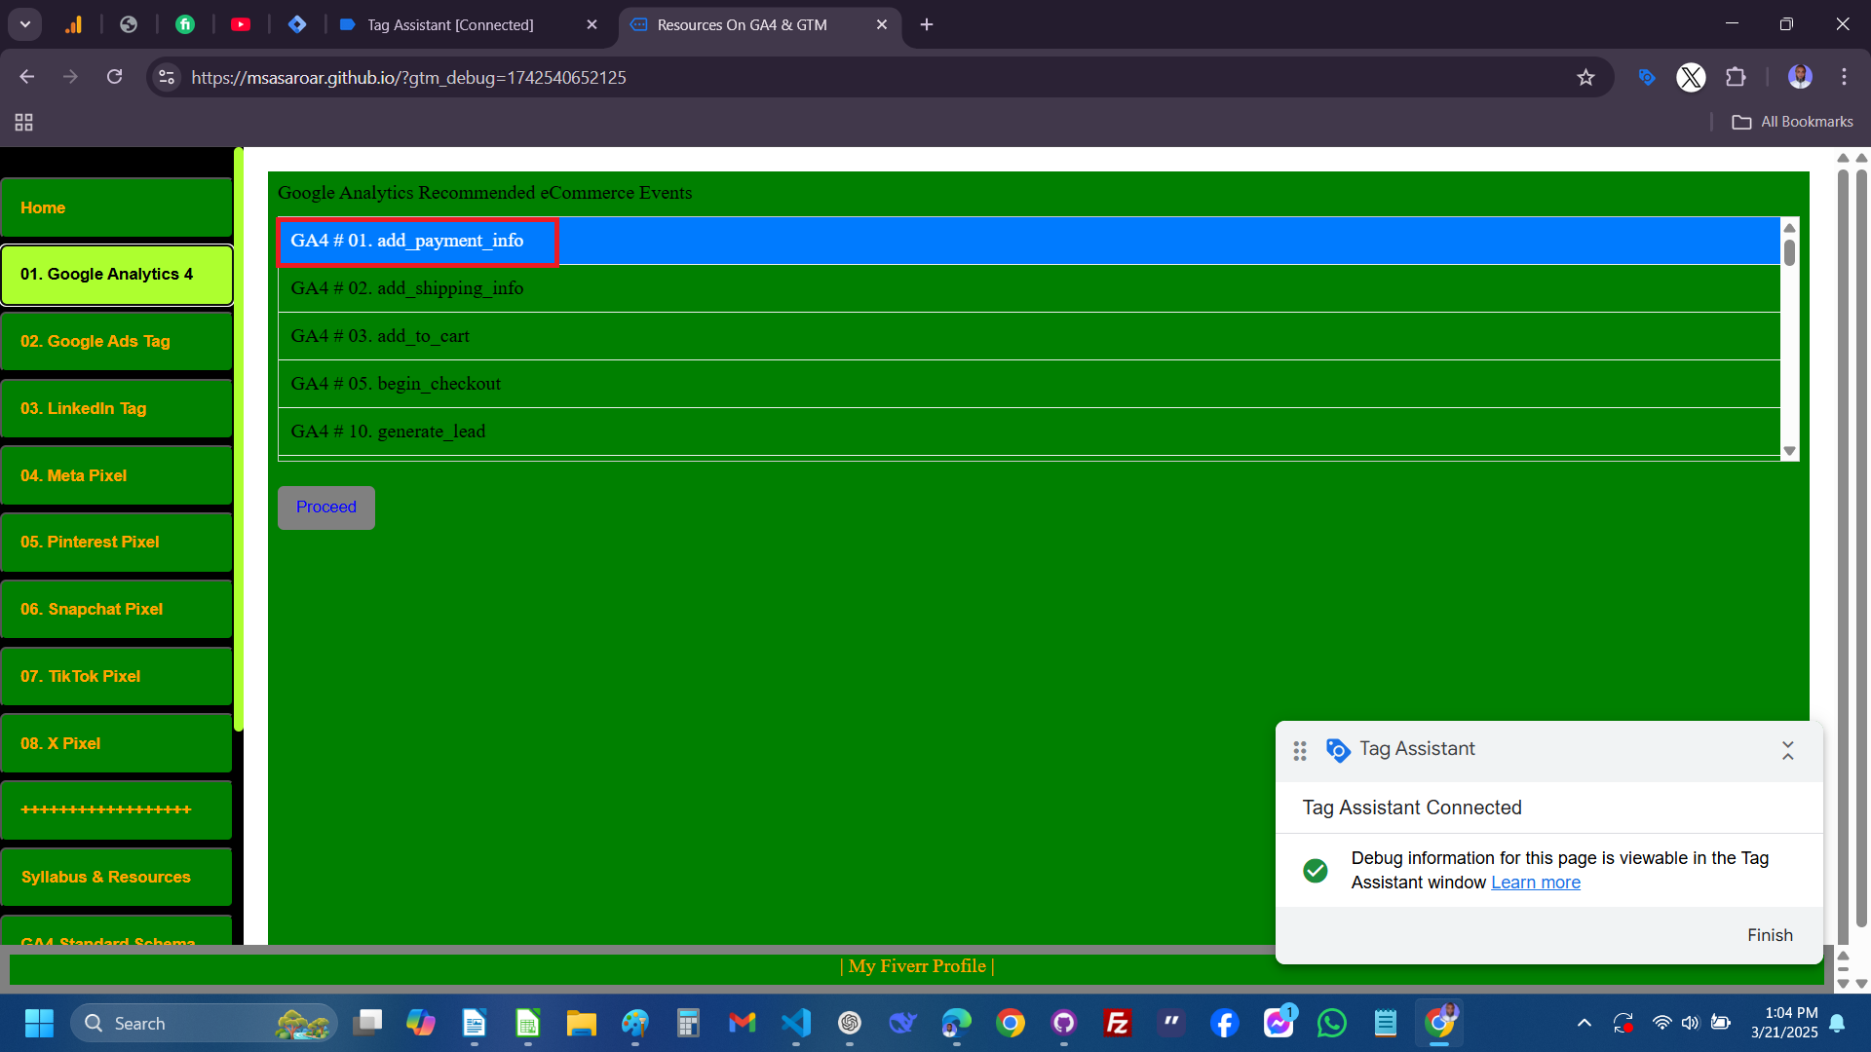
UI to fire the add_payment_info

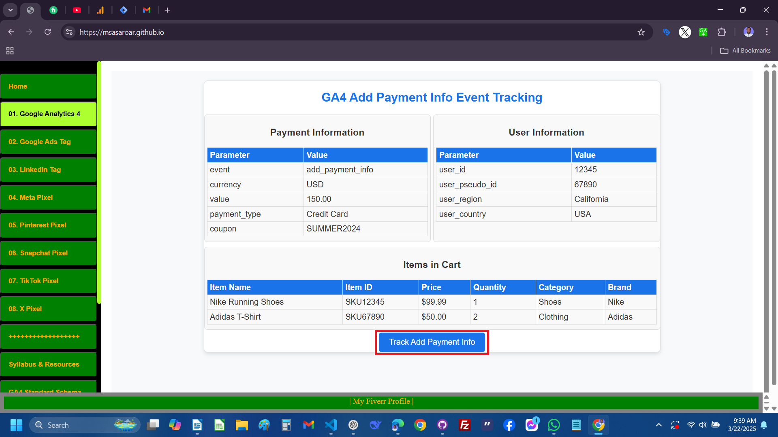

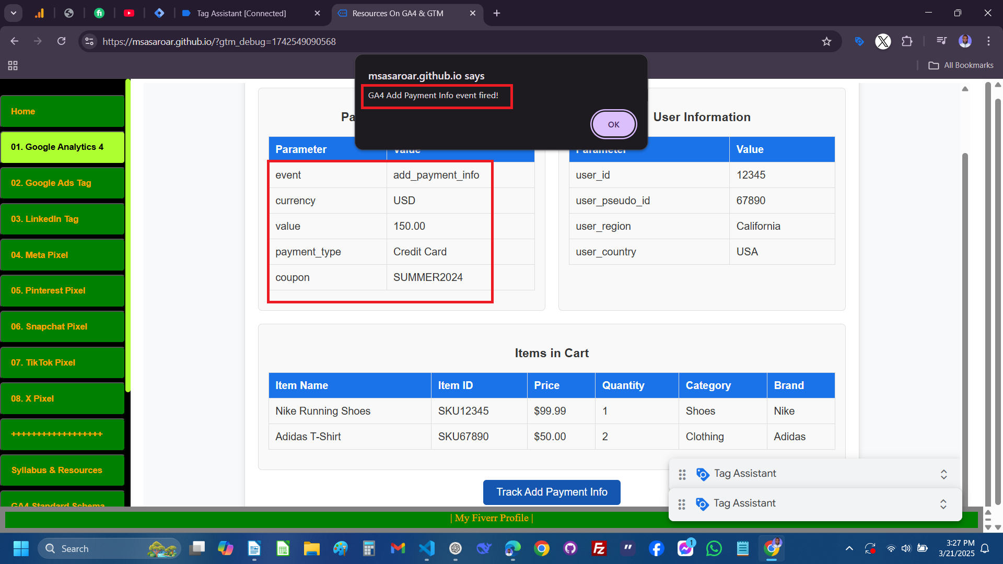

Screenshoot : GTM container after firing the event.

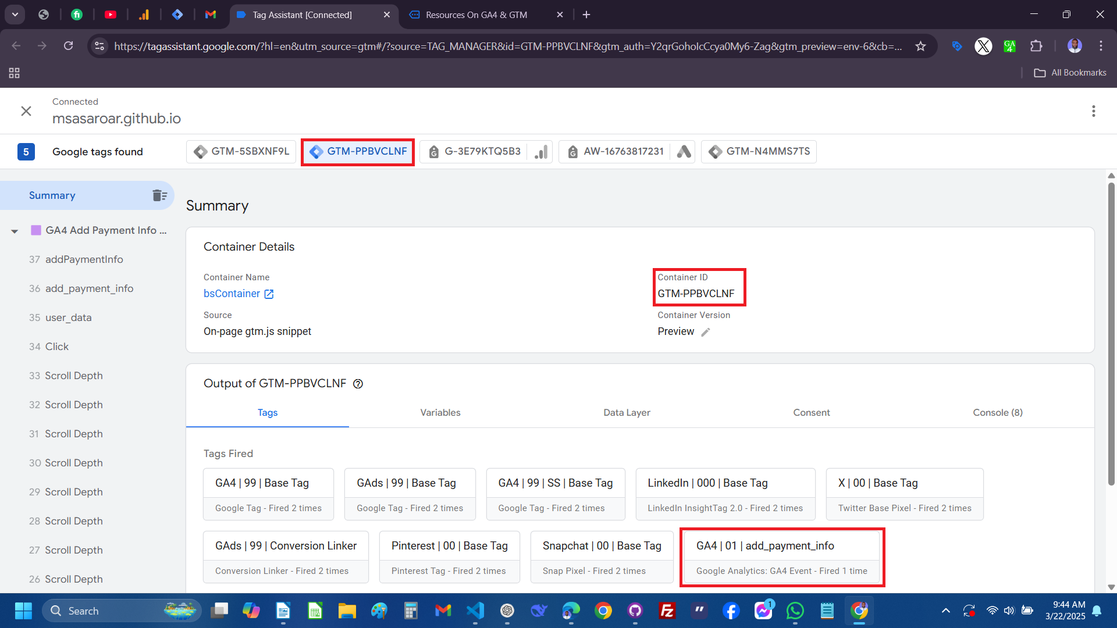

Screenshoot : GTM container after firing the event.

Screenshoot : Data Layer pushed to GTM container.

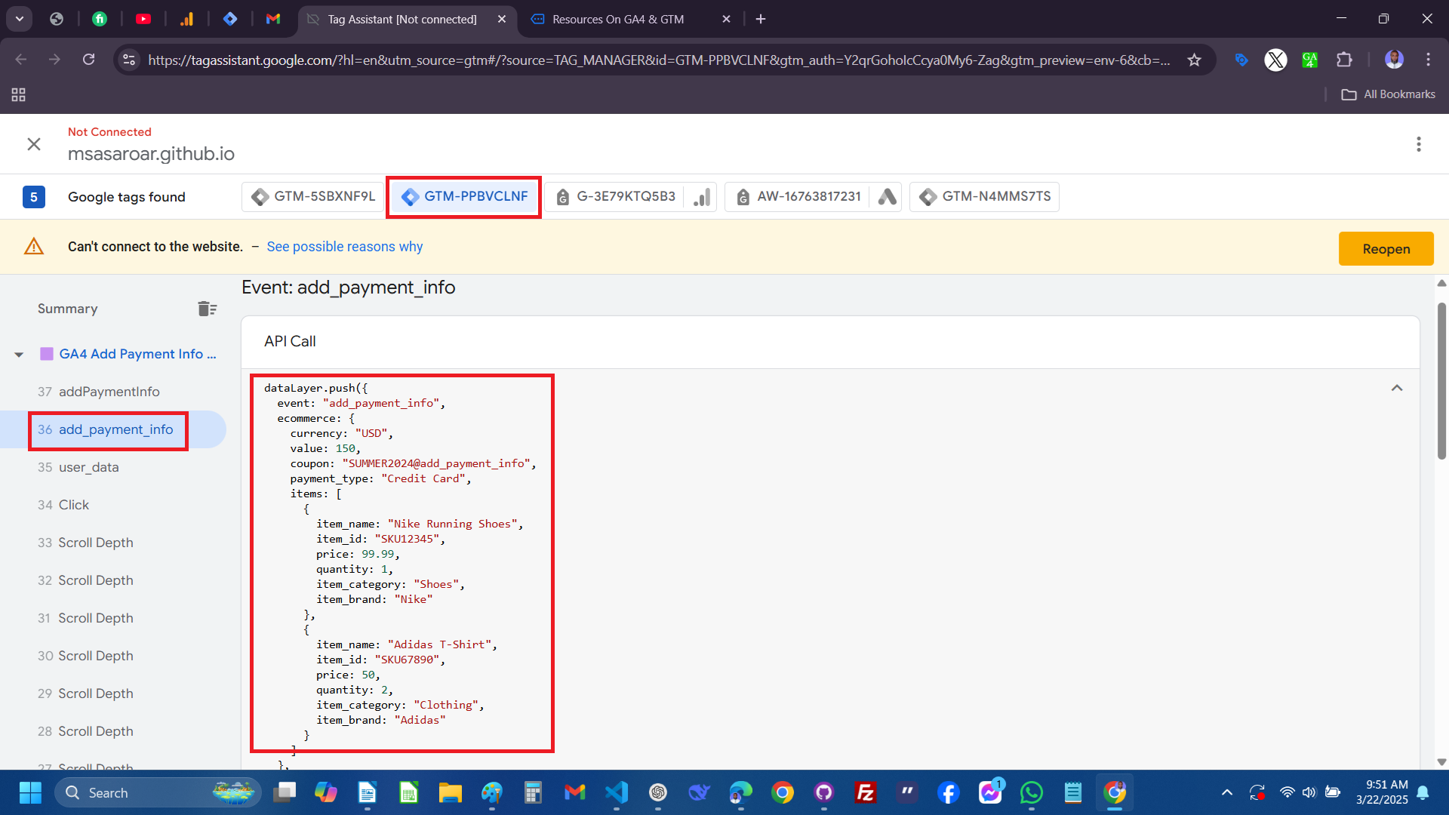
Screenshoot : Marking add_payment_info as a key event.
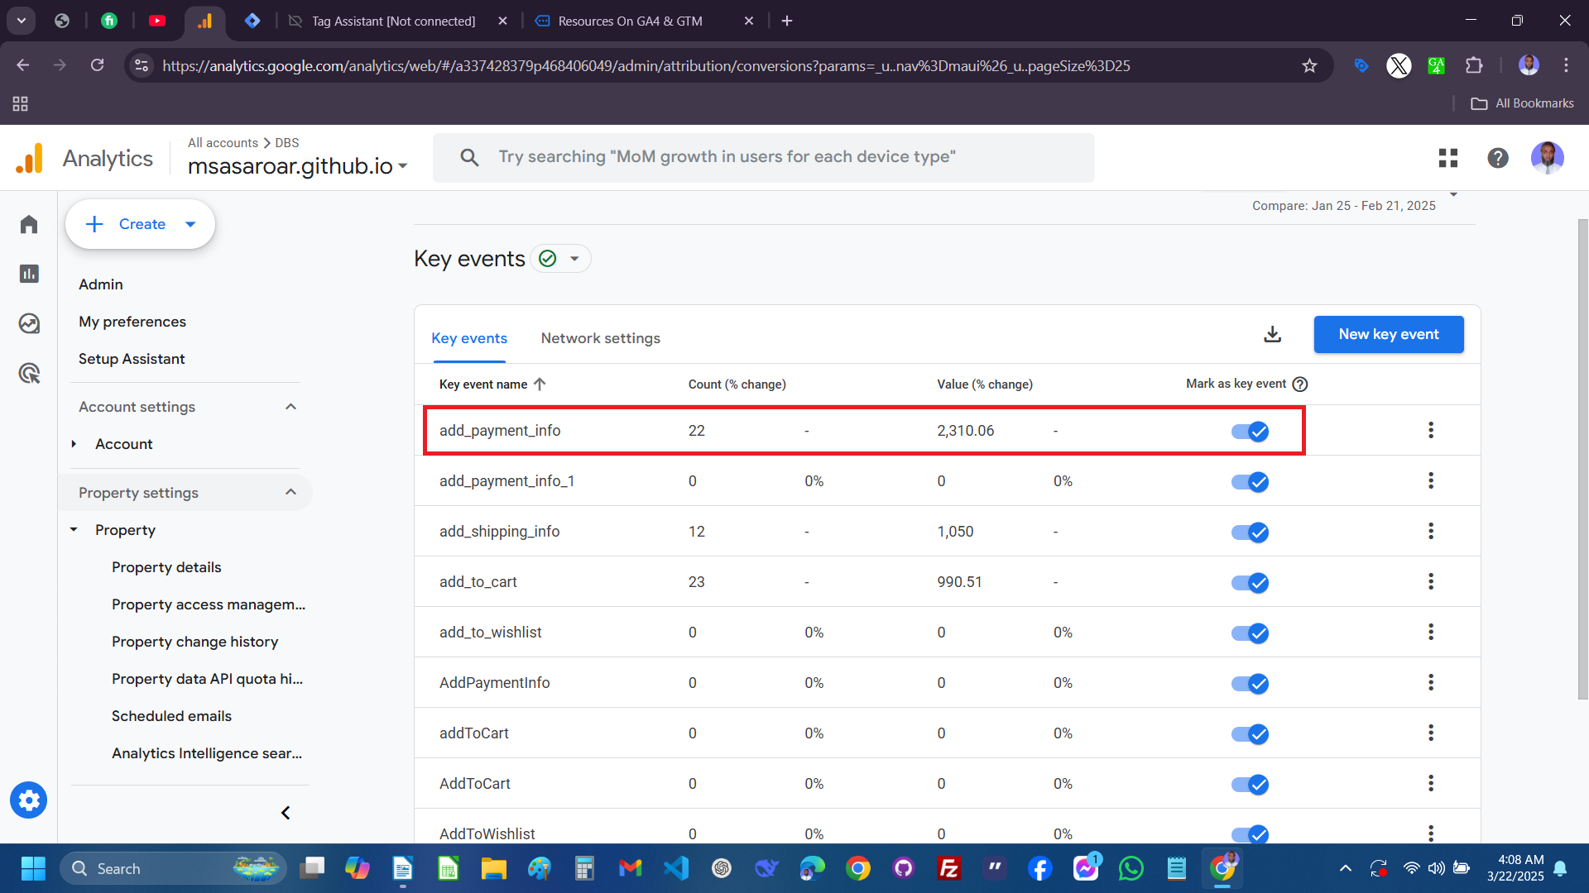
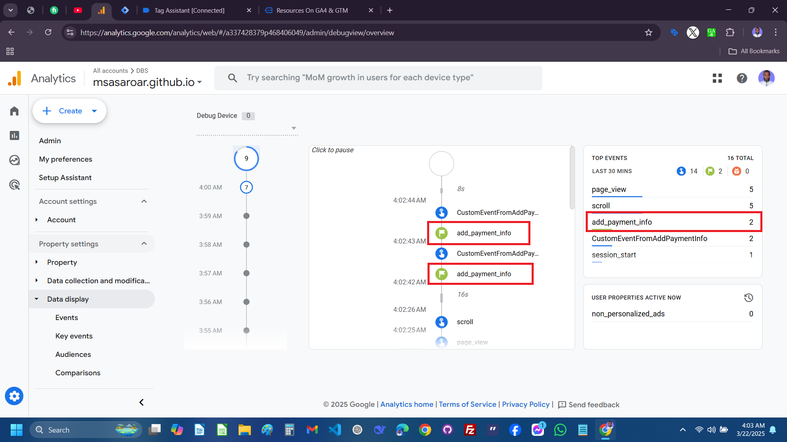
Screenshoot : Debug View on Google Analytics

Screenshoot : Event Parameter received in Google Analytics
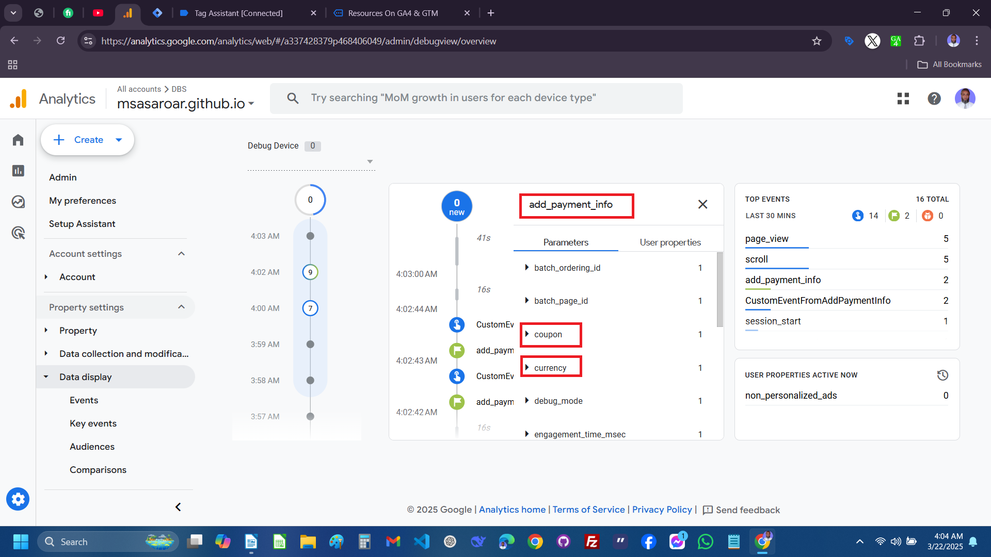

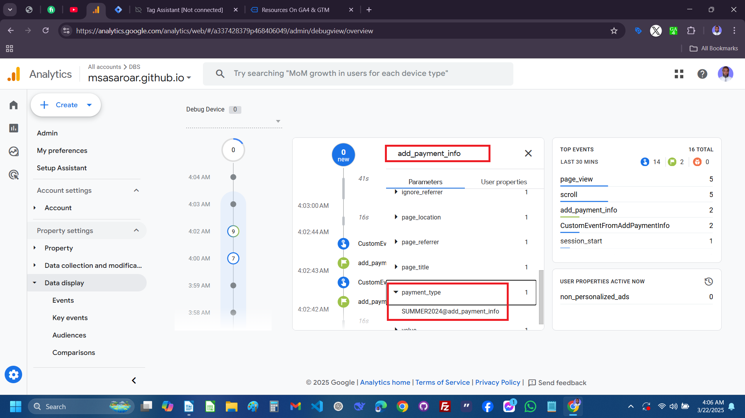
Screenshoot : Affected reports on Google Analytics
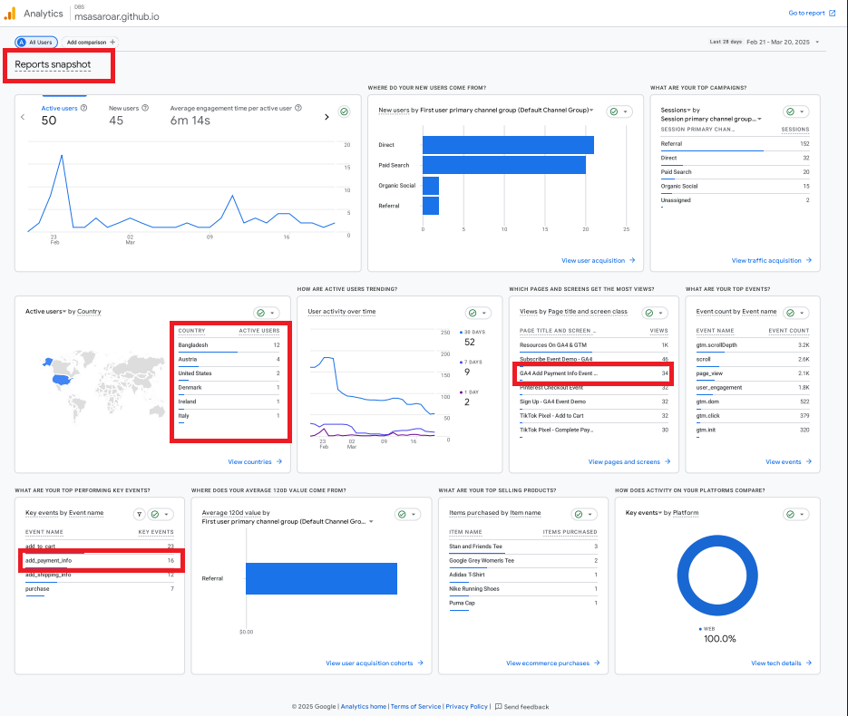
Screenshoot : Affected reports on Google Analytics

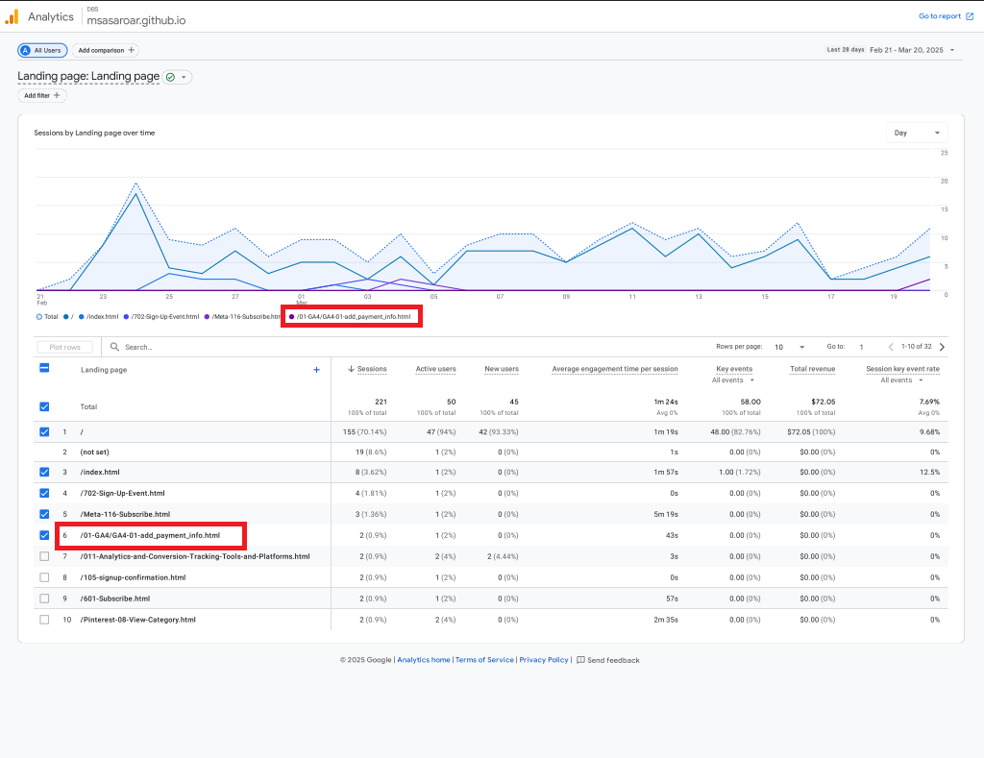

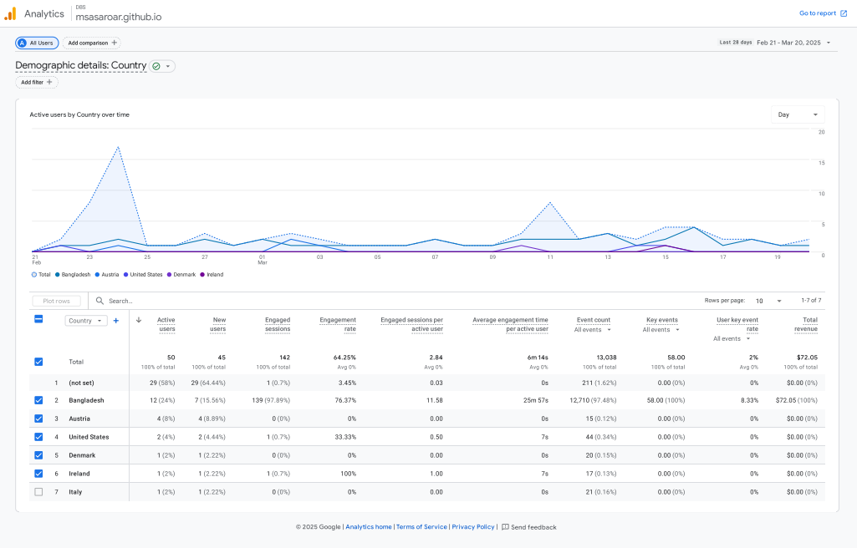
Screenshoot : Affected reports on Google Analytics
Screenshoot : Affected reports on Google Analytics
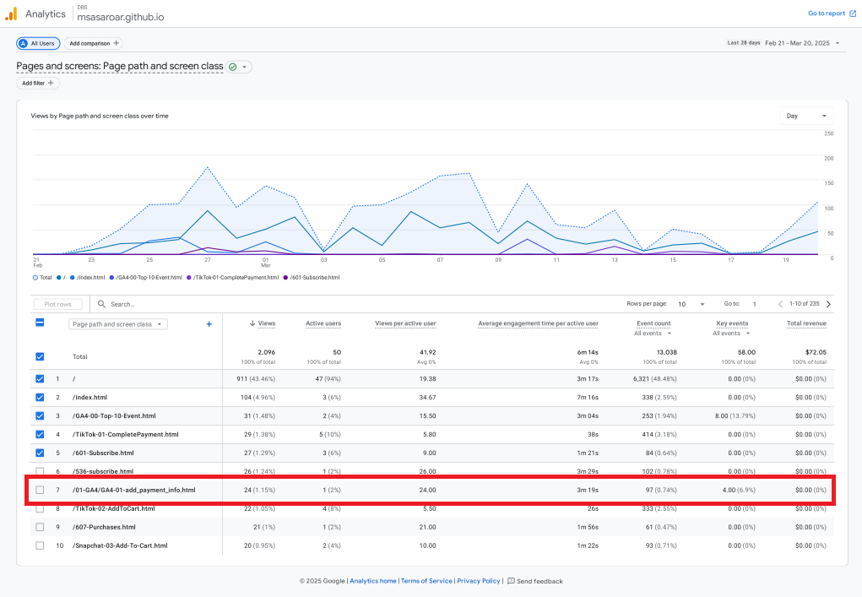

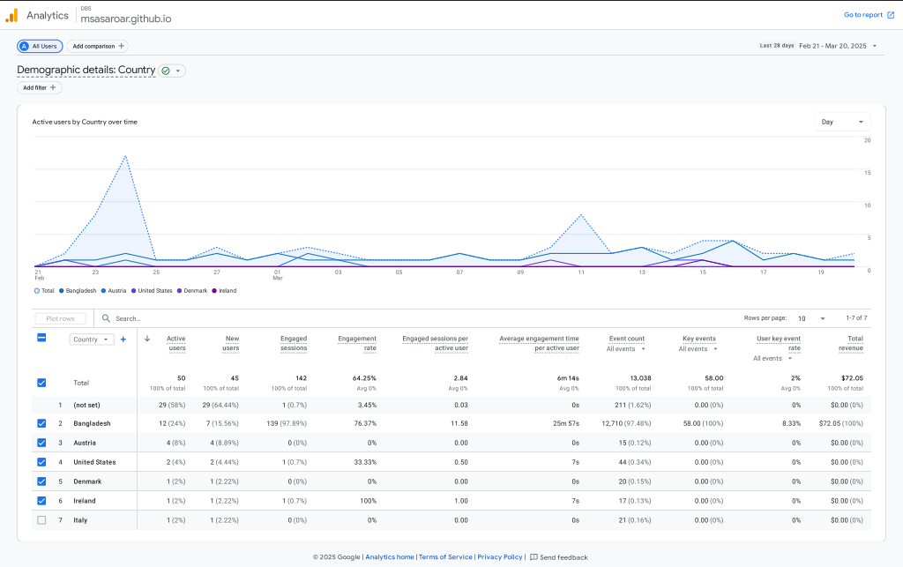
Screenshoot : Affected reports on Google Analytics
Screenshoot : Affected reports on Google Analytics
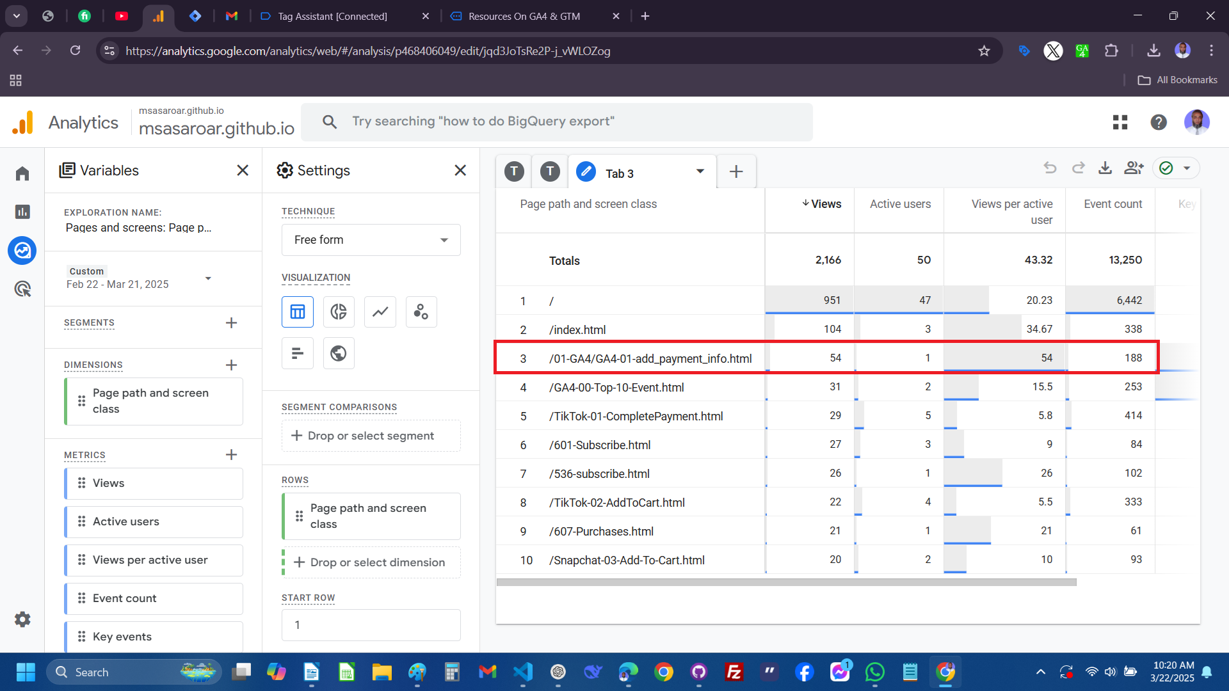

-:END OF THE DOCUMENT:-

