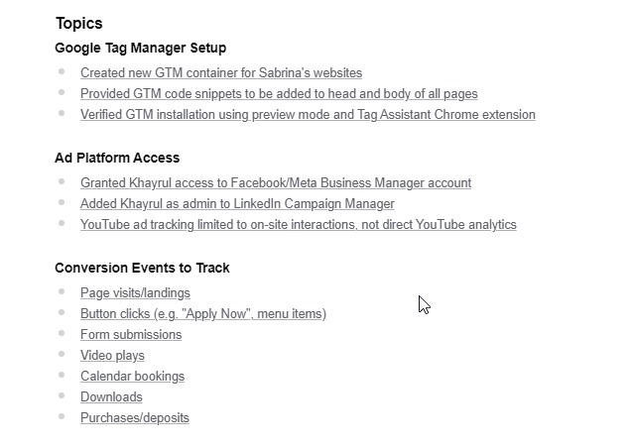
Website URL: https://pulsepointpath.com/

Task Requirements Event List
- Page visits/landings $10
Note: Tracking page visits is relatively simple, as it involves setting up basic triggers in Google Tag Manager (GTM) or Google Analytics 4 (GA4). Since this requires minimal configuration, the price is set at $10.
Task Duration: Approximately 30 minutes

- Button clicks (e.g. "Apply Now", menu items) $90 (6 buttons)
  - /advisory-board $15
  - /awards $15
  - /capital-readiness-scorecard $15
  - /solutions $15
  - /retreat $15
  - /podcast898807 $15
Note: Button click tracking is straightforward, especially for static buttons. The setup requires defining click triggers in GTM, so the price remains low at $15 per button. In total $90
Task Duration: Approximately 3-4 hours

- Form submissions $150
Note: Form tracking is complex because forms can be built using different technologies (Ajax, JavaScript, iframes, etc.). Some require custom event listeners or dataLayer integrations. Since the setup varies based on form structure, the price is higher at $150.
Task Duration: Approximately 5-6 hours

- Video plays $150
Note: Video tracking requires setting up event listeners for platforms like YouTube, Vimeo, or embedded HTML5 videos. Additional configurations are needed to capture events such as play, pause, and completion, which increases the effort and justifies the $200 price
Task Duration: Approximately 5-6 hours
- Calendar bookings $200
Note: Booking tracking requires integration with third-party scheduling tools like Calendly, Acuity, or embedded calendars. Since this often involves API integrations or webhook setups, the price is higher at $200
Task Duration: Approximately 7-8 hours

- Downloads $150
Note: Download tracking is slightly more complex than button clicks, as it requires monitoring file types (PDF, CSV, ZIP, etc.) and ensuring proper event tracking in GA4. This justifies the $150 price point.
Task Duration: Approximately 5-6 hours

- Purchases/deposits $250
Note: Purchase and deposit tracking involves setting up enhanced eCommerce tracking in Facebook Pixel, LinkedIn, GA4, Google Ads, or any one platform. This includes capturing transaction details, dynamic values, and deduplication for accurate reporting. Due to its complexity, the price is $250.
Task Duration: Approximately 12-14 hours

Let's first calculate the original total cost:
10+90+150+150+200+150+250=1000

Since The tracking needs to be done for two platforms (Facebook & LinkedIn), the cost would normally be $1000 × 2 = $2000.
However, as a repeated client discount of 50% is applied on the second platform, the additional charge is $1000 × 50% = $500.
Thus, the final total is:
1000+500=1500
✅ Total Price: $1500

Cheers,
Khayrul Bashar & Naimur Rahman

