2) Key in command for clocking: REP
Fill up as follows:
SC = 7A
CC =1 ie. means call complete and close
Total = 010 (for 1 hour)
Travel = 10 (for 1 hour)
Stop time (as applicable)
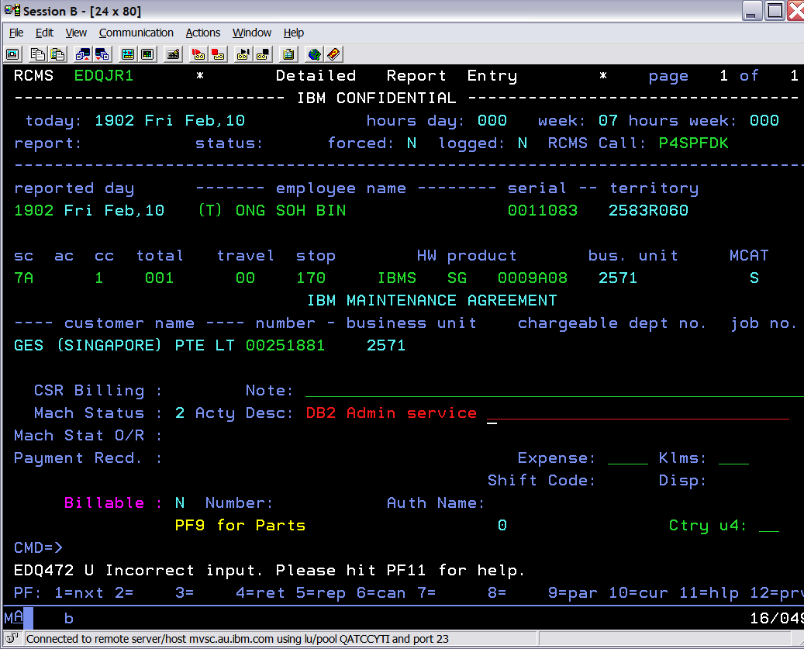
Key in command ‘c’ to save to go onto the next screen.
3) For the Parts used field, update the Parts used field to n
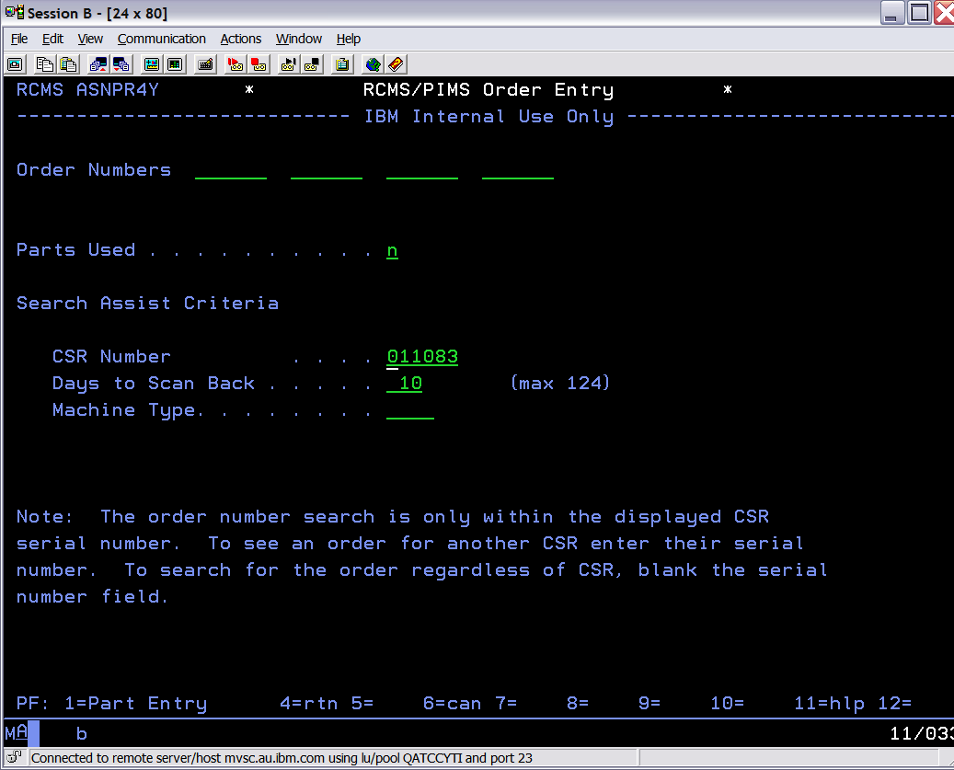

4) F4 for return to previous screen

5) Command C for saving
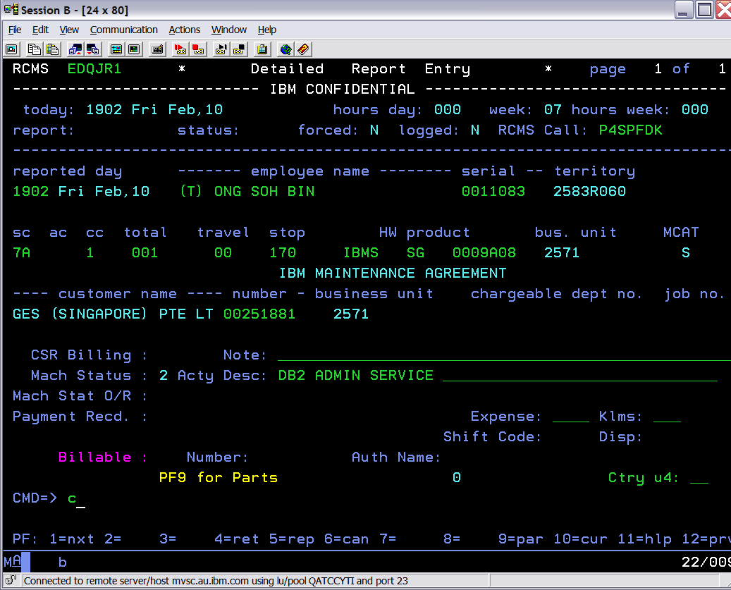

To check Clocking, red. F1 for next record, F12 for previous record
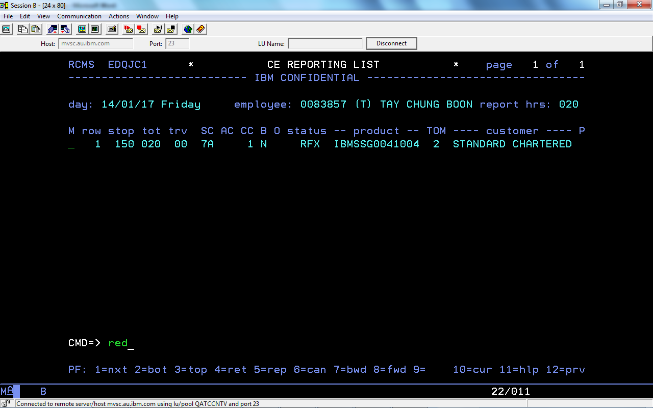

Type ’d’ at the first column M to delete the record.

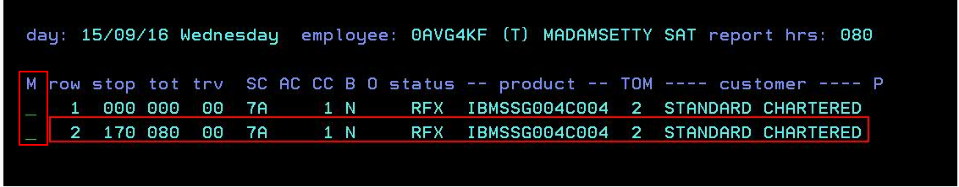

SCB 60 Hours

Note: after Red to check F1 is for Next date & F12 is backward to see the report
