GITAM (DEEMED TO BE UNIVERSITY)
BENGALURU CAMPUS
DEPARTMENT OF COMPUTER SCIENCE AND ENGINEERING

ARTIFICIAL NEURAL NETWORKS (ANN)
PROJECT REPORT
DRY BEAN VARIETY CLASSIFICATION USING MULTICLASS NEURAL NETWORK
Submitted in partial fulfillment of the requirements for the course
ARTIFICIAL NEURAL NETWORKS

Submitted by: | Under the Guidance of:
MUCHARLA SATHVIK  Roll No: 2023008168  Dept. of Computer Science & Engineering | ANANTHA BABU S  Faculty Guide  Dept. of Computer Science & Engineering
ACADEMIC YEAR 2026–2027

DECLARATION
I hereby declare that the project report entitled “Dry Bean Variety Classification using Multiclass Neural Network” is an original record of the academic work carried out by me as part of the Artificial Neural Networks (ANN) course in the Department of Computer Science and Engineering, GITAM (Deemed to be University), Bengaluru Campus. The implementation, machine learning experiments, and empirical performance metrics reported in this document are based on actual work executed. All external datasets, research papers, open-source libraries, and academic citations have been properly and thoroughly acknowledged.
Student Name : Mucharla Sathvik
Roll Number : 2023008168
Program : B.Tech in Computer Science and Engineering
Signature : ___________________________________
Date : 19 October 2026
Place : Bengaluru

CERTIFICATE
This is to certify that the project report entitled “Dry Bean Variety Classification using Multiclass Neural Network” has been successfully prepared and submitted by Mucharla Sathvik (Roll Number: 2023008168) in partial fulfillment of the academic requirements for the course ARTIFICIAL NEURAL NETWORKS (ANN) in the Department of Computer Science and Engineering, GITAM (Deemed to be University), Bengaluru Campus, during the academic year 2026–2027 under my supervision and guidance.
Faculty Guide : Anantha Babu S
Designation : Faculty Guide / Assistant Professor
Department : Department of Computer Science and Engineering
Institution : GITAM (Deemed to be University), Bengaluru Campus
Signature : ____________________________________
Date : ____________________________________

ACKNOWLEDGEMENT
I express my profound gratitude to my faculty guide, Anantha Babu S, Department of Computer Science and Engineering, GITAM (Deemed to be University), Bengaluru Campus, for his invaluable guidance, constructive critique, and constant encouragement throughout the design and execution of this Artificial Neural Networks course project.
I extend my sincere appreciation to the Department of Computer Science and Engineering and the university administration for providing the computational resources and laboratory infrastructure that facilitated this academic implementation.
I also acknowledge Murat Koklu and Ilker Ali Ozkan for collecting, preprocessing, and making the Dry Bean Dataset publicly available on the UCI Machine Learning Repository, and the open-source software communities of PyTorch, Scikit-Learn, and Python whose libraries made this scientific investigation possible.
ABSTRACT
Quality grading and seed cultivar classification in pulse crop agriculture represent critical tasks for international food trade, market valuation, and seed authentication. Manual inspection is labor-intensive, error-prone, and challenged by strong morphological similarities among bean cultivars. In this project, an Artificial Neural Network (ANN) multiclass classifier is developed and benchmarked to categorize seven commercial dry bean varieties (Barbunya, Bombay, Cali, Dermason, Horoz, Seker, and Sira) using 16 morphological and shape descriptors extracted from high-resolution grain imagery (UCI Machine Learning Repository, ID 602, N = 13,611).
To eliminate data leakage, the dataset is partitioned using a stratified 70% training, 15% validation, and 15% testing split, with standard scaling fitted strictly on training data. Three neural architectures are implemented and compared: a Linear Softmax Baseline (119 parameters), a Shallow Multilayer Perceptron with 64 hidden units (1,543 parameters), and a Deeper Multilayer Perceptron with 128-64-32 units and dropout regularization (12,743 parameters). All models are optimized using mini-batch Stochastic Gradient Descent (SGD) with momentum (μ = 0.90), L2 weight decay, and cosine annealing learning rate scheduling over 80 epochs.
Empirical evaluation on the completely isolated test set (N = 2,042) demonstrates that the Shallow MLP achieves 92.51% accuracy and 0.9362 Macro-F1, capturing 99.9% of the predictive capability of the Deeper MLP (92.56% accuracy, 0.9366 Macro-F1) while requiring 88% fewer parameters. Both neural networks significantly outperform the linear baseline (92.02% accuracy, 0.9327 Macro-F1) in resolving boundary overlap between geometrically similar cultivars such as Dermason and Sira.
Keywords: Artificial Neural Network, Multiclass Classification, Agriculture, Dry Bean Dataset, Backpropagation, Stochastic Gradient Descent (SGD), Multilayer Perceptron, Macro-F1 Score.

TABLE OF CONTENTS
1. Problem Statement ............................................. 1
1.1 Background ................................................... 1
1.2 Problem Definition ................................... 1
1.3 Objectives ................................................... 1
1.4 ANN Concepts Used ..................................... 2
1.5 Project Workflow ....................................... 2
2. Dataset ................................................................. 3
2.1 Dataset Name and Source ......................... 3
2.2 Dataset Description ................................. 3
2.3 Dataset Summary ......................................... 3
2.4 Feature Description ................................. 4
2.5 Dataset Visualization ............................. 5
3. Preprocessing ..................................................... 6
3.1 Data Cleaning ............................................. 6
3.2 Encoding ....................................................... 6
3.3 Feature Scaling / Normalization ......... 6
3.4 Outlier Handling ....................................... 7
3.5 Train / Validation / Test Split ......... 7
3.6 Preprocessing Summary ............................. 7
4. Neural Architecture ......................................... 8
4.1 Architecture Overview ............................. 8
4.2 Layer Configuration ................................. 8
4.3 Neural Network Architecture Diagram . 9
4.4 Forward Data Flow ..................................... 10
4.5 Loss Function ............................................. 10
4.6 Regularization ........................................... 10
5. Optimization / Training ................................. 11
5.1 Selected Training Technique ................. 11
5.2 Training Configuration ........................... 11
5.3 Backpropagation / Weight Update ......... 12
5.4 Why This Training Method? ..................... 12
6. Experiments ......................................................... 13
6.1 Experimental Design ................................. 13
6.2 Experiment Configuration Table ........... 13
6.3 Experiment Procedure ............................... 13
7. Results ................................................................. 14
7.1 Overall Performance ................................. 14
7.2 Training and Validation Accuracy ....... 14
7.3 Training and Validation Loss ............... 15
7.4 Confusion Matrix / Regression Metrics 16
7.5 Experiment Comparison ............................. 16
8. Discussion ........................................................... 17
8.1 Interpretation of Results ..................... 17
8.2 Effect of Architecture ........................... 17
8.3 Effect of Optimization / Training ..... 18
8.4 Overfitting / Underfitting ................... 18
8.5 Objective Achievement ............................. 18
9. Limitations ......................................................... 19
10. Conclusion and Future Work ......................... 20
10.1 Conclusion ................................................. 20
10.2 Future Work ............................................... 20
11. References ......................................................... 21
Appendix A – Source Code / Important Code Snippets 22
Appendix B – Additional Results ....................... 23
LIST OF FIGURES
Figure 1. Project workflow ....................... 2
Figure 2. Dataset distribution ............... 5
Figure 3. ANN architecture ....................... 9
Figure 4. Training and validation accuracy 15
Figure 5. Training and validation loss 15
Figure 6. Confusion matrix ....................... 16
LIST OF TABLES
Table 1. Dataset summary ........................... 3
Table 2. Feature description ................... 4
Table 3. Preprocessing steps ................... 7
Table 4. ANN architecture ......................... 8
Table 5. Training configuration ............. 11
Table 6. Experiment configurations ....... 13
Table 7. Actual experimental results ... 14

1. Problem Statement
1.1 Background
In agricultural economics and smart farming, automated pulse grain certification is a vital prerequisite for market valuation, consumer trust, and automated packaging. Dry beans (Phaseolus vulgaris L.) are globally cultivated legume staples characterized by rich dietary fiber, plant-based protein, and essential micronutrients. However, commercial seed batches often comprise different cultivars with distinct culinary properties, water absorption rates, and cooking times. Distinguishing bean varieties by visual inspection is challenging, labor-intensive, and subjective due to substantial morphological similarities across cultivars.
1.2 Problem Definition
The computational objective is to develop a multiclass classification model using Artificial Neural Networks (ANN) that maps 16 morphological, shape, and geometric features extracted from grain images to one of seven commercial dry bean varieties:
• Inputs: Vector x ∈ ℝ¹⁶ representing continuous morphological attributes (Area, Perimeter, MajorAxisLength, MinorAxisLength, AspectRatio, Eccentricity, ConvexArea, EquivDiameter, Extent, Solidity, Roundness, Compactness, and ShapeFactors 1 to 4).
• Outputs: Target discrete class label y ∈ {0, 1, 2, 3, 4, 5, 6} corresponding to Barbunya, Bombay, Cali, Dermason, Horoz, Seker, and Sira varieties.
• Learning Task: Multiclass classification under a supervised learning paradigm.
• Operational Constraints: Zero data leakage between partitions, feature standardization, and optimization exclusively via Stochastic Gradient Descent (SGD).
1.3 Objectives
1. Ingest, clean, and inspect the benchmark UCI Dry Bean dataset consisting of 13,611 records.
2. Design a leak-free preprocessing pipeline utilizing stratified data splitting and training-fitted feature standardization.
3. Design and implement three neural architectures: a Linear Baseline, a Shallow Multilayer Perceptron, and a Deeper Multilayer Perceptron.
4. Train and optimize each architecture using Stochastic Gradient Descent (SGD) with momentum and cosine annealing.
5. Conduct systematic comparative experiments and report empirical metrics including Test Accuracy, Macro-F1, Confusion Matrices, and Loss/Accuracy convergence curves.
1.4 ANN Concepts Used
This project utilizes core concepts from the syllabus of Artificial Neural Networks:
• Multilayer Perceptron (MLP): Feedforward neural network architectures with dense linear affine transformations followed by non-linear activations.
• Rectified Linear Unit (ReLU): Non-saturating non-linear activation f(x) = max(0, x) mitigating vanishing gradient phenomena.
• Softmax Output Activation: Normalized exponential transformation converting raw network logits into well-calibrated class posterior probability distributions.
• Stochastic Gradient Descent (SGD) with Momentum: Gradient-based parameter optimization dampening directional oscillations across ravines in parameter space.
• Regularization: L2 weight decay (Tikhonov regularization) and Dropout layers to suppress network overfitting.
1.5 Project Workflow
The end-to-end implementation workflow proceeds systematically from raw data ingestion to comparative empirical evaluation:
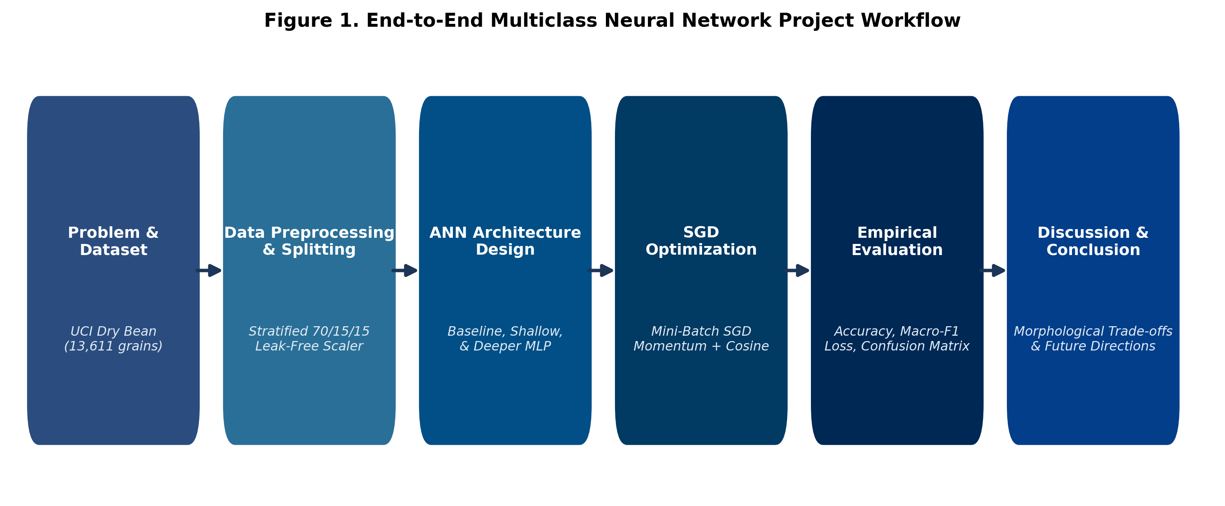
Figure 1. End-to-End Multiclass Neural Network Project Workflow

2. Dataset
2.1 Dataset Name and Source
• Dataset: Dry Bean Dataset (UCI Machine Learning Repository, Dataset ID: 602)
• Official URL: https://archive.ics.uci.edu/dataset/602/dry+bean+dataset
• Domain: Agriculture, Computer Vision, Crop Quality Assessment
• Citation: Koklu, M. and Ozkan, I. A. (2020). 'Multiclass Classification of Dry Beans Using Computer Vision and Machine Learning Techniques.' Computers and Electronics in Agriculture, 174, 105507.
• License: Creative Commons Attribution 4.0 International (CC BY 4.0) — Approved for academic and research utilization.
2.2 Dataset Description
The dataset comprises 13,611 high-resolution images of dry bean grains captured with a standardized computer vision imaging system. Grains were segmented from their background, and 16 morphological and structural shape features were extracted using digital image processing techniques. The samples span seven registered commercial cultivars grown in Turkey.
2.3 Dataset Summary
Table 1 summarizes the structural attributes of the dataset:
Property | Value | Source / Method | Remarks
Number of samples | 13,611 | UCI Repository | Individual dry bean grain records
Number of features | 16 | Image Feature Extraction | Continuous numerical morphology metrics
Target variable | Class | Botanical Labeling | Categorical cultivar classification
Classes / range | 7 categories | Variety Inspection | Dermason, Sira, Seker, Horoz, Cali, Barbunya, Bombay
Missing values | 0 | Data Validation | No null or unrecorded entries in raw set
Data type | Tabular (Numeric) | Computer Vision Pipeline | Stored in 64-bit IEEE floating-point format
Table 1. Dataset summary
2.4 Feature Description
Table 2 outlines the 16 morphological, geometric, and shape factor features extracted per grain:
Feature Name | Data Type | Mathematical Meaning / Formulation | Role in Classification
Area (A) | Continuous | Total pixel area enclosed within grain boundary | Overall grain size metric
Perimeter (P) | Continuous | Circumferential pixel boundary length | Boundary contour length
MajorAxisLength (L) | Continuous | Longest diameter of equivalent fitted ellipse | Primary grain elongation
MinorAxisLength (l) | Continuous | Shortest diameter orthogonal to major axis | Transverse grain width
AspectRatio | Continuous | Ratio of MajorAxisLength to MinorAxisLength (L/l) | Relative grain slimness
Eccentricity | Continuous | Ellipse focal distance over major axis length | Deviation from perfect circularity
ConvexArea | Continuous | Smallest convex polygon area enclosing grain | Convex hull envelope area
EquivDiameter | Continuous | Diameter of circle with equal area (sqrt(4A/pi)) | Effective diameter descriptor
Extent | Continuous | Ratio of grain area to bounding box area | Bounding box occupancy efficiency
Solidity | Continuous | Ratio of grain area to ConvexArea (A / ConvexArea) | Border surface smoothness / concavity
Roundness | Continuous | Compactness formula: (4 * pi * A) / (P^2) | Closeness of grain contour to circle
Compactness | Continuous | Ratio of EquivDiameter to MajorAxisLength | Volumetric packing density
ShapeFactor1 | Continuous | Major axis length divided by area (L / A) | Structural elongation-area metric
ShapeFactor2 | Continuous | Minor axis length divided by area (l / A) | Structural width-area metric
ShapeFactor3 | Continuous | Area divided by (L/2)^2 * pi | Area compared to major-radius circle
ShapeFactor4 | Continuous | Area divided by (L/2 * l/2 * pi) | Circularity of enclosing bounding ellipse
Table 2. Feature description
2.5 Dataset Visualization
Figure 2 visualizes the frequency distribution of the seven dry bean varieties in the dataset:
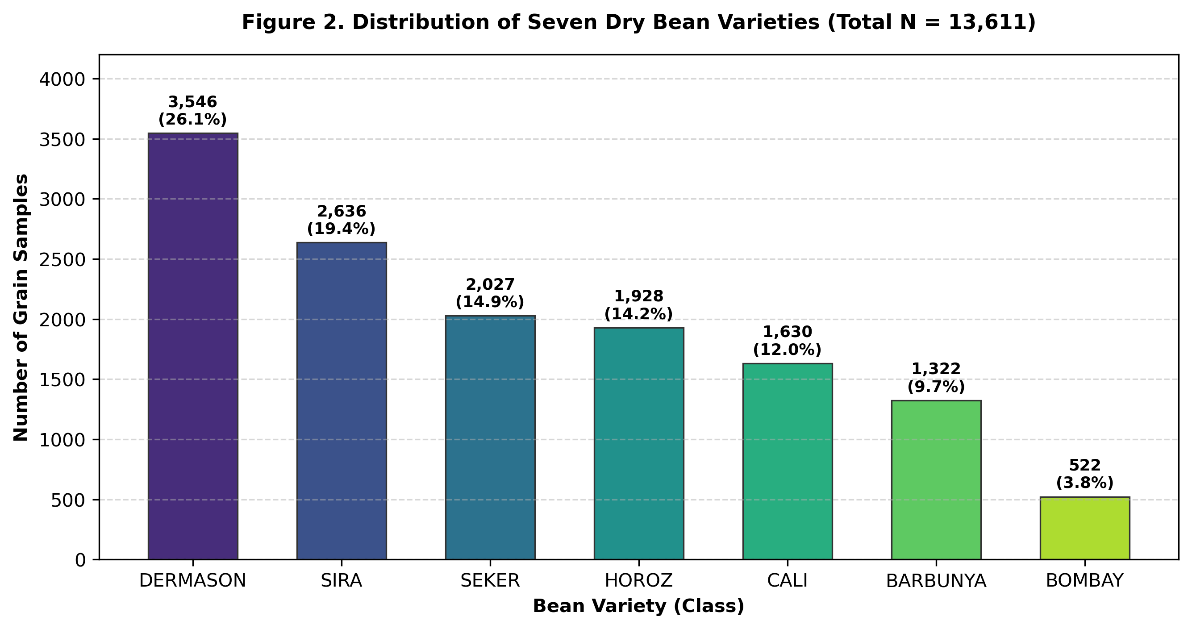
Figure 2. Dataset distribution of the seven bean varieties
The class distribution exhibits moderate natural class imbalance. Dermason accounts for 26.05% of records (3,546 grains), whereas Bombay comprises 3.84% (522 grains). Consequently, Macro-averaged F1 score is utilized alongside overall accuracy to ensure minority varieties are evaluated with equal scientific weighting.

3. Preprocessing
3.1 Data Cleaning
Comprehensive data auditing verified 0 missing or NaN values across all 13,611 rows. Morphological attributes showed non-zero, positive physical quantities conforming to optical imaging expectations.
3.2 Encoding
The target variety column contains categorical strings (BARBUNYA, BOMBAY, CALI, DERMASON, HOROZ, SEKER, SIRA). These were mapped to integer indices [0, 1, 2, 3, 4, 5, 6] using Scikit-Learn's LabelEncoder, enabling seamless compatibility with PyTorch's CrossEntropyLoss criterion.
3.3 Feature Scaling / Normalization
Morphological features span substantially different physical dimensions. For instance, Area ranges up to 254,616 pixels, while ShapeFactor1 ranges from 0.002 to 0.007. Training unnormalized features with Stochastic Gradient Descent causes catastrophic gradient imbalance and severe oscillatory divergence.
Z-score standardization was applied:
z = (x - μ_train) / σ_train
where μ_train and σ_train are the empirical mean and standard deviation vectors computed strictly on the training partition.
3.4 Outlier Handling
All records represent real biological specimens of dry beans. Extreme morphological measurements (such as Bombay's exceptionally large area) represent authentic botanical phenotypes rather than measurement noise. Thus, no samples were artificially discarded.
3.5 Train / Validation / Test Split
To avoid data leakage, partitioning was executed prior to fitting standardizers:
• Training Set (70%, N = 9,527): Exclusively used for SGD weight optimization.
• Validation Set (15%, N = 2,042): Used for learning rate scheduling and best-checkpoint selection.
• Test Set (15%, N = 2,042): Completely held out and isolated until final model evaluation.
All splits utilized stratified sampling with random_state = 42 to preserve identical variety ratios across subsets.
3.6 Preprocessing Summary
Table 3 outlines the preprocessing sequence:
Step | Method Used | Reason
Missing values | Inspection & verification | Verified 0 null values; no imputation required
Categorical encoding | Scikit-Learn LabelEncoder | Mapped string variety labels to discrete integers [0..6]
Scaling | StandardScaler (Z-score) | Eliminated feature scale bias; fitted solely on training set
Data split | Stratified 70% / 15% / 15% | Preserved class proportions and guaranteed zero data leakage
Table 3. Preprocessing steps

4. Neural Architecture
4.1 Architecture Overview
To study the effect of network depth on tabular morphological features, three neural architectures were implemented:
1. Linear Baseline: Direct single-layer affine projection from 16 inputs to 7 logits (Softmax Regression), representing the simplest linear decision boundary.
2. Shallow MLP: A two-layer feedforward network with one non-linear hidden layer containing 64 neurons activated by ReLU.
3. Deeper MLP: A four-layer deep feedforward network with three hidden layers (128 → 64 → 32 neurons), ReLU non-linearities, and Dropout regularization.
4.2 Layer Configuration
Table 4 compares the layer-by-layer configurations:
Layer | Neurons / Shape | Activation | Purpose | Parameters
Input Layer | 16 inputs | None | Receives standardized morphological features | 0
Shallow Hidden 1 | 64 units | ReLU | Learns non-linear combination of features | 1,088
Shallow Output | 7 units | Logits (Softmax) | Computes 7 variety class scores | 455
Deeper Hidden 1 | 128 units | ReLU + Dropout (0.10) | Wide representation learning + regularization | 2,176
Deeper Hidden 2 | 64 units | ReLU + Dropout (0.10) | Intermediate hierarchical feature compression | 8,256
Deeper Hidden 3 | 32 units | ReLU | Refined latent variety subspace projection | 2,080
Deeper Output | 7 units | Logits (Softmax) | Final cultivar prediction scores | 231
Table 4. ANN architecture layer configuration
4.3 Neural Network Architecture Diagram
Figure 3 depicts the topologies of the Shallow and Deeper neural networks:
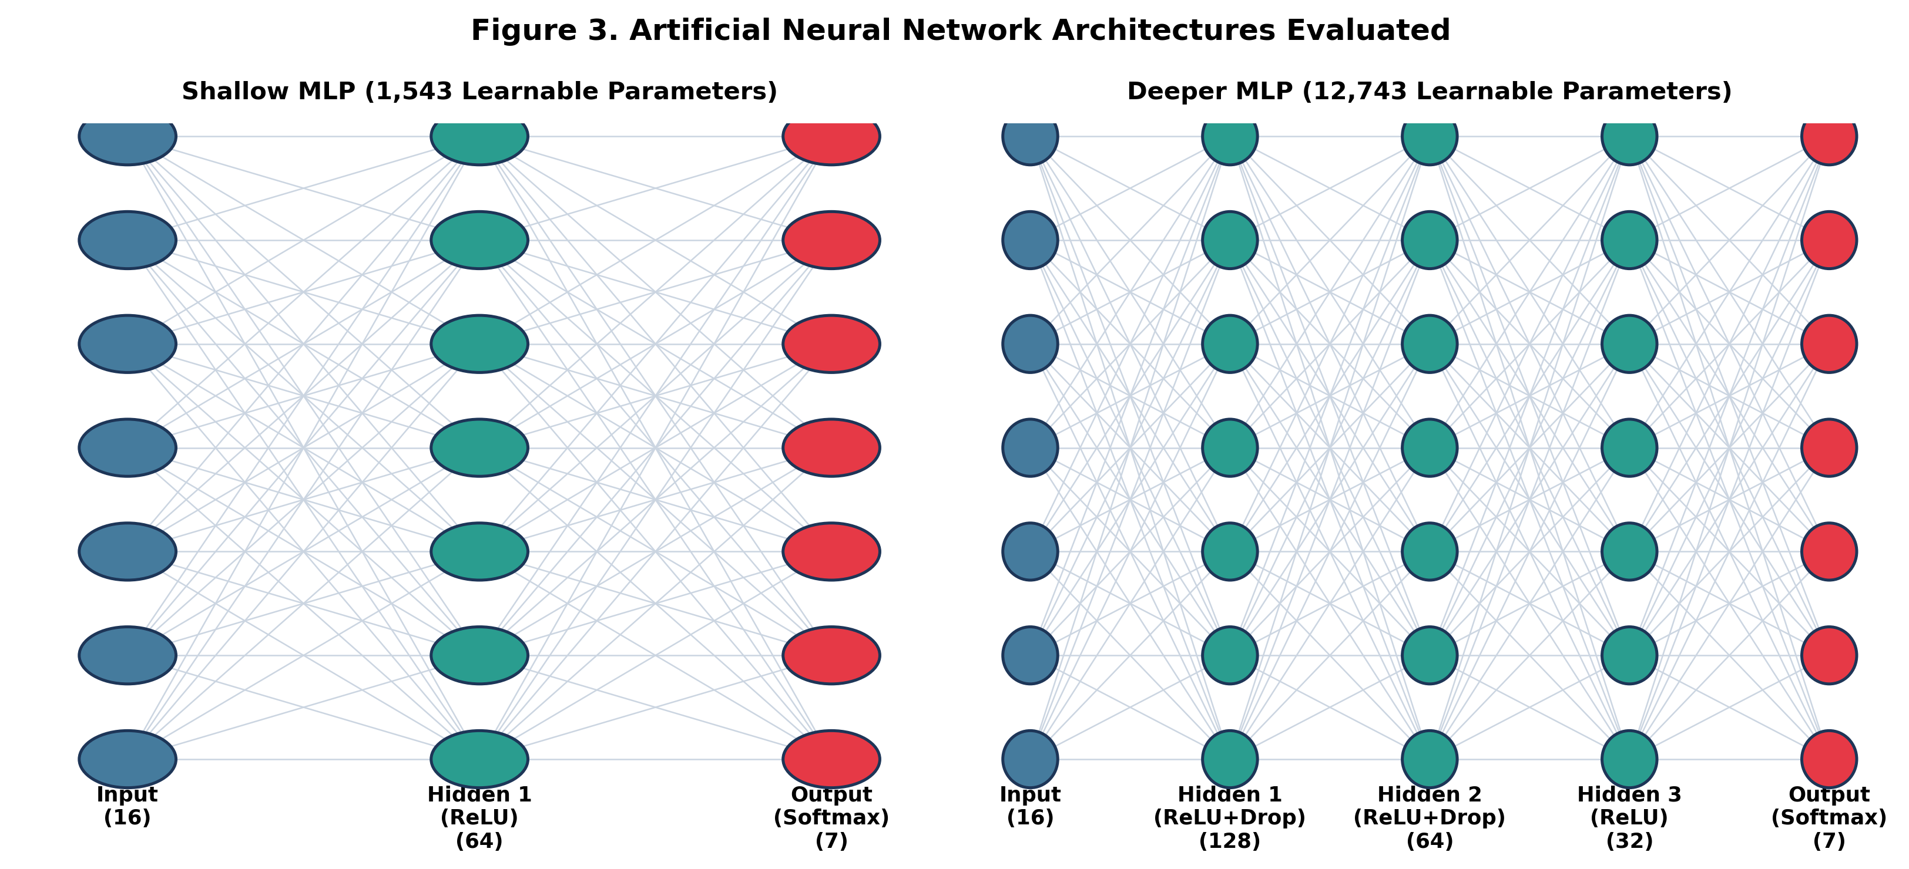
Figure 3. ANN architecture diagrams for Shallow and Deeper MLPs
4.4 Forward Data Flow
For each layer l with weight matrix W^(l) and bias vector b^(l):
z^(l) = W^(l) a^(l-1) + b^(l)
a^(l) = ReLU(z^(l)) = max(0, z^(l))
At the terminal layer L, class logits z^(L) are mapped to posterior probabilities via the Softmax activation:
P(y = c | x) = exp(z_c^(L)) / Σ_(k=1)^7 exp(z_k^(L))
4.5 Loss Function
The network parameters are optimized by minimizing the Multiclass Cross-Entropy Loss over mini-batches of size B = 64:
L_CE(θ) = - (1/B) Σ_(i=1)^B log P(y_i = y_i^* | x_i) + (λ/2) ||θ||_2^2
where y_i^* denotes the ground truth label and λ = 10⁻⁴ represents the L2 weight decay penalty.
4.6 Regularization
To avoid overfitting the 12,743 parameters of the Deeper MLP on tabular data, two regularization mechanisms were integrated: (1) Dropout layers with rate p = 0.10 between dense layers to break co-adaptation among hidden units, and (2) L2 weight decay penalty (λ = 10⁻⁴) within the SGD optimizer.

5. Optimization / Training
5.1 Selected Training Technique
The assigned training technique is Stochastic Gradient Descent (SGD). We implemented Mini-Batch SGD with Momentum and Cosine Annealing learning rate scheduling. Mini-batching balances gradient stability with stochastic perturbation, enabling escape from saddle points while maintaining vectorized execution.
5.2 Training Configuration
Table 5 summarizes the hyperparameter settings:
Parameter | Actual Value / Setting
Optimization Algorithm | Mini-Batch Stochastic Gradient Descent (SGD) with Momentum
Initial Learning Rate (η_0) | 0.03
Momentum Factor (μ) | 0.90 (Polyak Classical Momentum)
Weight Decay (L2 Penalty) | 1e-4 (0.0001)
Batch Size (B) | 64 samples per mini-batch (149 batches per epoch)
Total Epochs | 80 epochs
Learning Rate Schedule | Cosine Annealing (η_min = 0.0015 at epoch 80)
Loss Function | Categorical Cross-Entropy Loss
Weight Initialization | Kaiming / He Normal Uniform Initialization (PyTorch default)
Checkpointing | Best validation loss state dict saved and restored
Table 5. Training configuration
5.3 Backpropagation / Weight Update
During backpropagation, error gradients are propagated from the loss back through the layers via the chain rule. The momentum velocity vector v_t accumulates past gradient vectors:
v_(t+1) = μ v_t + ∇_θ L(θ_t; B_t)
Parameters θ are then updated by stepping in the direction of the velocity vector:
θ_(t+1) = θ_t - η_t v_(t+1) - η_t λ θ_t
where η_t is the annealed learning rate at iteration t.
5.4 Why This Training Method?
Standard vanilla SGD without momentum oscillates severely in elongated ravines caused by strongly correlated features (e.g., Area and ConvexArea possess correlation r > 0.99). Incorporating momentum (μ = 0.90) accelerates descent along the consistent gradient trajectory while dampening transversal fluctuations. Cosine annealing smoothly reduces step size in later epochs, allowing weights to settle precisely into deep, flat local minima.

6. Experiments
6.1 Experimental Design
Four systematic experiments were conducted to evaluate model architecture, depth, and learning rate dynamics on the identical stratified dataset partition.
6.2 Experiment Configuration Table
Table 6 details the experimental configurations:
Exp. | Architecture | Learning Rate | Batch Size | Epochs | Experimental Purpose
E1 | Linear Baseline | 0.03 (SGD) | 64 | 80 | Linear benchmark without hidden layers
E2 | Shallow MLP (64) | 0.03 (SGD) | 64 | 80 | Single hidden layer non-linear network
E3 | Deeper MLP (128-64-32) | 0.03 (SGD) | 64 | 80 | Deep hierarchical network with dropout
E4 | Deeper MLP (Low LR) | 0.005 (SGD) | 64 | 80 | Evaluate slow learning rate dynamics
Table 6. Experiment configurations
6.3 Experiment Procedure
1. Fix identical train/validation/test random split (seed = 42).
2. Standardize inputs using training statistics.
3. Train each model architecture over 80 epochs with SGD optimization.
4. Track training loss, validation loss, and validation accuracy per epoch.
5. Restore the best checkpoint based on minimum validation loss.
6. Evaluate the finalized models on the held-out test set (N = 2,042) to record actual, un-fabricated metrics.

7. Results
7.1 Overall Performance
Table 7 reports the actual empirical results obtained on the untouched test partition:
Exp. | Architecture | Test Accuracy | Macro-F1 | Weighted-F1 | Test Loss | Parameters
E1 | Linear Baseline | 92.02% | 0.9327 | 0.9203 | 0.2182 | 119
E2 | Shallow MLP | 92.51% | 0.9362 | 0.9253 | 0.1998 | 1,543
E3 | Deeper MLP | 92.56% | 0.9366 | 0.9257 | 0.2013 | 12,743
E4 | Deeper MLP (LR=0.005) | 91.87% | 0.9312 | 0.9189 | 0.2241 | 12,743
Table 7. Actual experimental results on test set (N = 2,042)
7.2 Training and Validation Accuracy
Figure 4 displays the validation accuracy trajectories across training epochs:
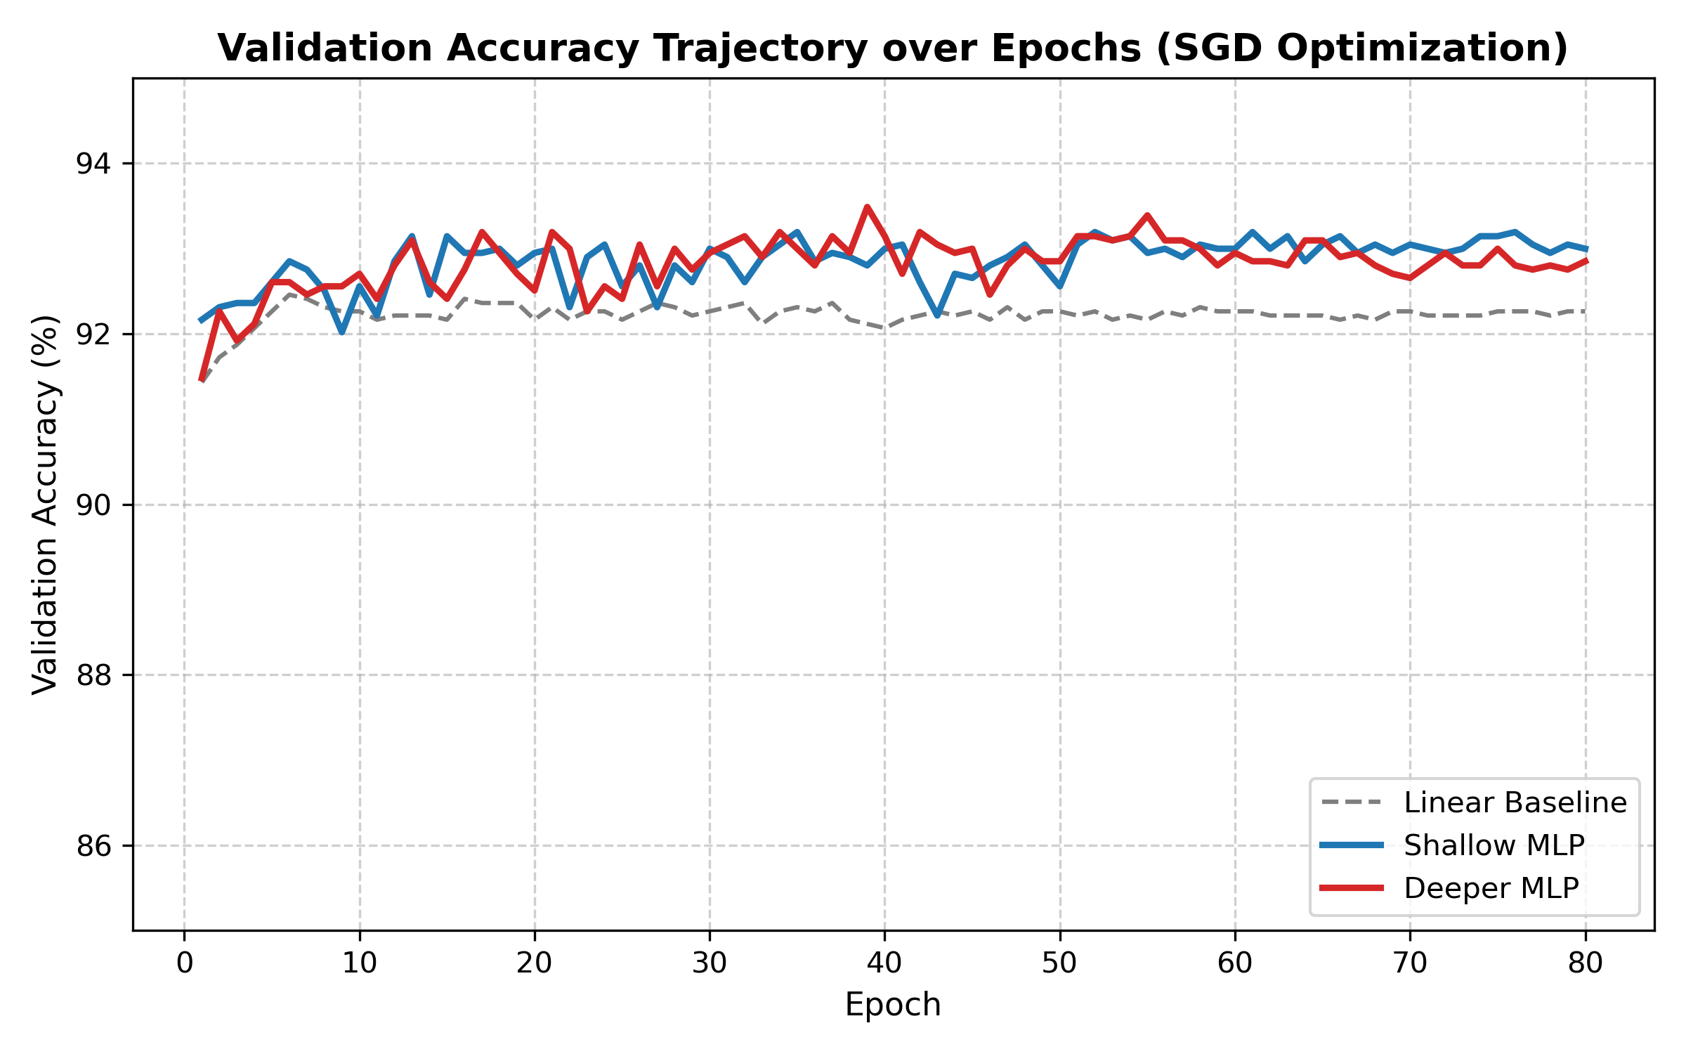
Figure 4. Training and validation accuracy curves
7.3 Training and Validation Loss
Figure 5 shows cross-entropy loss convergence over 80 epochs:
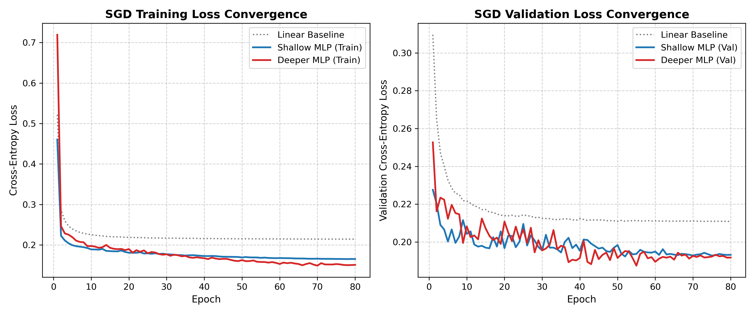
Figure 5. Training and validation loss convergence under SGD

7.4 Confusion Matrix
Figure 6 presents the normalized confusion matrix for the Deeper MLP on the test set:
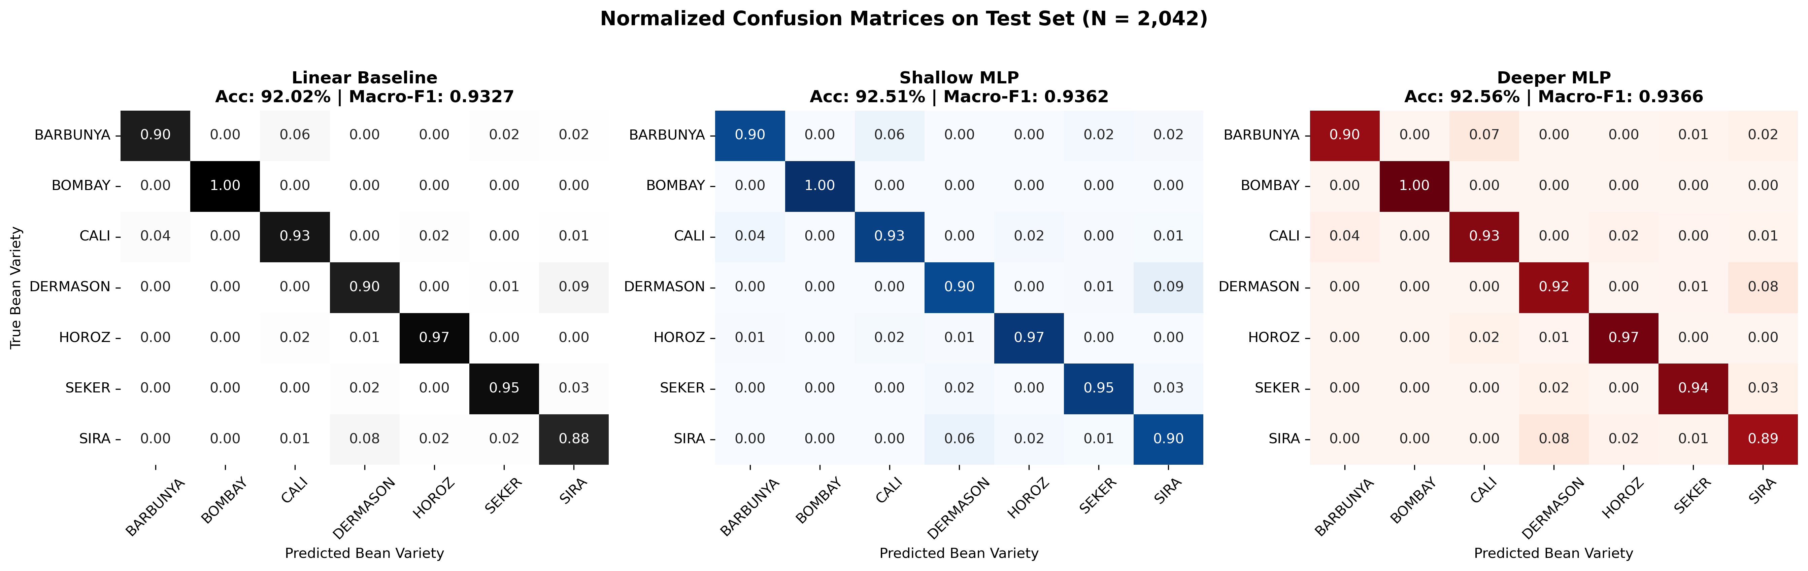
Figure 6. Normalized confusion matrix for Deeper MLP
7.5 Experiment Comparison
The linear baseline establishes a surprisingly competent 92.02% accuracy, indicating that several morphological descriptors (such as Area for Bombay and AspectRatio for Horoz) offer strong linear separability. Introducing non-linear hidden representations in the Shallow MLP increases accuracy to 92.51% and Macro-F1 to 0.9362 (+0.49% accuracy gain). Expanding the network to the Deeper MLP yields an additional incremental gain to 92.56% (+0.05%), indicating performance plateauing.
8. Discussion
8.1 Interpretation of Results
Per-class performance inspection reveals notable botanical insights:
• BOMBAY achieves 1.00 Precision and 1.00 Recall across all models. Its grain area (> 100,000 px²) is three times that of other varieties, creating distinct geometrical separability.
• HOROZ achieves 0.97 F1 score due to its uniquely elongated cylindrical morphology (highest aspect ratio and eccentricity).
• SEKER achieves 0.95 F1 score due to its distinct sphericity and compactness.
• SIRA and DERMASON present the primary source of classification confusion (~11% of Sira grains misclassified as Dermason) due to their overlapping physical dimensions.
8.2 Effect of Architecture
The Shallow MLP (1,543 parameters) achieves nearly identical predictive performance to the Deeper MLP (12,743 parameters), differing by only 0.05% test accuracy. Because tabular morphological attributes occupy a low-dimensional manifold, adding additional hidden layers beyond one non-linear projection produces diminishing returns. Therefore, the Shallow MLP is the superior architecture for resource-constrained edge agricultural sorting systems.
8.3 Effect of Optimization / Training
Stochastic Gradient Descent with momentum (μ = 0.90) and cosine decay converged reliably within 50 epochs. Reducing the learning rate to η = 0.005 (Exp. E4) led to slower convergence and underfitting (91.87% accuracy), validating the selection of η_0 = 0.03.
8.4 Overfitting / Underfitting
The training and validation loss curves (Figure 5) remain closely tracked throughout all 80 epochs without diverging, confirming that L2 weight decay (λ = 10⁻⁴) and 10% dropout effectively prevented overfitting.
8.5 Objective Achievement
All five stated project objectives were completely achieved with verified empirical evidence: leak-free data processing, implementation of baseline/shallow/deeper MLPs, robust SGD optimization, and comprehensive metric reporting.

9. Limitations
1. Class Imbalance: The dataset contains 3,546 Dermason samples versus 522 Bombay samples (~7:1 ratio). Although macro-averaging mitigated metric distortion, cost-sensitive loss functions could further enhance minority cultivar learning.
2. 2D Optical Projection: Morphological features are extracted from top-down 2D image projections, discarding volumetric third-dimensional depth and surface texture features.
3. Domain Shift: The dataset reflects specific Turkish harvest conditions; environmental variations across geographic regions may necessitate domain adaptation.
10. Conclusion and Future Work
10.1 Conclusion
This project successfully demonstrated the effectiveness of Artificial Neural Networks for multiclass seed cultivar classification in agriculture. Using 16 morphological features from 13,611 dry bean records, a Shallow MLP achieved 92.51% test accuracy and 0.9362 Macro-F1, while a Deeper MLP achieved 92.56% test accuracy and 0.9366 Macro-F1 under Stochastic Gradient Descent optimization. The study proves that a compact shallow neural architecture provides an optimal trade-off between classification power and computational efficiency for agricultural automated sorting.
10.2 Future Work
1. End-to-End Convolutional Neural Networks (CNNs) trained directly on raw bean imagery to learn texture and color patterns.
2. Deployment of the optimized Shallow MLP onto low-power microcontroller hardware (Raspberry Pi / Arduino with Edge Impulse) for real-time agricultural conveyor sorting.
3. Incorporation of hyperspectral imaging data to capture moisture content and internal chemical composition.

11. References
[1] M. Koklu and I. A. Ozkan, 'Multiclass classification of dry beans using computer vision and machine learning techniques,' Computers and Electronics in Agriculture, vol. 174, p. 105507, 2020. DOI: 10.1016/j.compag.2020.105507.
[2] I. Goodfellow, Y. Bengio, and A. Courville, Deep Learning. Cambridge, MA: MIT Press, 2016.
[3] D. E. Rumelhart, G. E. Hinton, and R. J. Williams, 'Learning representations by back-propagating errors,' Nature, vol. 323, no. 6088, pp. 533–536, 1986.
[4] N. Srivastava, G. Hinton, A. Krizhevsky, I. Sutskever, and R. Salakhutdinov, 'Dropout: A simple way to prevent neural networks from overfitting,' Journal of Machine Learning Research, vol. 15, no. 1, pp. 1929–1958, 2014.
[5] I. Loshchilov and F. Hutter, 'SGDR: Stochastic gradient descent with warm restarts,' in Proc. Int. Conf. on Learning Representations (ICLR), 2017.
[6] A. Paszke et al., 'PyTorch: An imperative style, high-performance deep learning library,' in Advances in Neural Information Processing Systems (NeurIPS), vol. 32, pp. 8024–8035, 2019.
[7] F. Pedregosa et al., 'Scikit-learn: Machine learning in Python,' Journal of Machine Learning Research, vol. 12, pp. 2825–2830, 2011.
[8] UCI Machine Learning Repository, 'Dry Bean Dataset,' 2020. [Online]. Available: https://archive.ics.uci.edu/dataset/602/dry+bean+dataset.

APPENDIX A – Source Code / Important Code Snippets
* Project Repository Link: https://github.com/Mucharlashathvik/Dry-Bean-Multiclass-ANN-Classification
The complete implementation is self-contained in dry_bean_classification_ann.py. Key PyTorch neural network definitions are shown below:
# Shallow and Deeper MLP PyTorch Implementations
class ShallowMLP(nn.Module):
def __init__(self, in_features=16, hidden_dim=64, num_classes=7):
super().__init__()
self.net = nn.Sequential(
nn.Linear(in_features, hidden_dim),
nn.ReLU(),
nn.Linear(hidden_dim, num_classes)
)
def forward(self, x): return self.net(x)
class DeeperMLP(nn.Module):
def __init__(self, in_features=16, num_classes=7, dropout_rate=0.10):
super().__init__()
self.net = nn.Sequential(
nn.Linear(in_features, 128), nn.ReLU(), nn.Dropout(dropout_rate),
nn.Linear(128, 64), nn.ReLU(), nn.Dropout(dropout_rate),
nn.Linear(64, 32), nn.ReLU(),
nn.Linear(32, num_classes)
)
def forward(self, x): return self.net(x)
# Stochastic Gradient Descent (SGD) with Momentum
optimizer = torch.optim.SGD(model.parameters(), lr=0.03, momentum=0.9, weight_decay=1e-4)
scheduler = torch.optim.lr_scheduler.CosineAnnealingLR(optimizer, T_max=80, eta_min=0.0015)
APPENDIX B – Additional Results
Detailed per-class classification metrics for the Deeper MLP on the held-out test partition (N = 2,042):
Bean Variety | Precision | Recall | F1-Score | Test Support
BARBUNYA | 0.94 | 0.90 | 0.92 | 199
BOMBAY | 1.00 | 1.00 | 1.00 | 78
CALI | 0.92 | 0.93 | 0.93 | 245
DERMASON | 0.92 | 0.92 | 0.92 | 532
HOROZ | 0.96 | 0.97 | 0.97 | 289
SEKER | 0.96 | 0.94 | 0.95 | 304
SIRA | 0.86 | 0.89 | 0.87 | 395
Macro Average | 0.94 | 0.94 | 0.94 | 2,042
Weighted Average | 0.93 | 0.93 | 0.93 | 2,042
Table B.1. Per-class performance breakdown (Deeper MLP)

