Name - Atul Kumar Agrawal

Branch - Computer Science and Engineering

Roll no - 1602040031

____________________________________________________________________________

**Q1**. **Name different project management software. Explain each one briefly.**

Ans. Project Management Software is software used by a wide range of industries for project planning, resource allocation and scheduling. It enables project managers as well as entire teams to control their budget, quality management and all documentation exchanged throughout a project. This software also serves as a platform for facilitating collaboration among project stakeholders.

Some of the project management softwares are:

**i. Zoho Projects** : Zoho projects is an extensive project management software with a clean and straightforward interface. This software covers the following areas everything from Project Planning (breaking down projects into manageable units) and Gantt Charts (to visual the

progress of tasks) to Reporting Tools, Collaboration Software (to ease contact between consultants, vendors, employees and clients) and Document Management.

**Ii. LiquidPlanner** : LiquidPlanner is a project management software that adapts to your business automatically. This software also offers cross-project visibility, showing insights into progress, risks and budgets for all projects at once. It’s advanced analytics help users manage project performance, view costs and profits, and monitor resource utilisation, client portfolios and baseline trends.

**Iii. Teamwork Projects :** Teamwork Projects is a great project management software for the

project management power user. The app is quite flexible and includes various intuitive features such as Task Management, Messaging, File Storage, Time Tracking tools, and more.

**Iv. Wrike :** Wrike is a cloud-based collaboration and project management software. This tools helps its users keep track of day-to-day operations and ensures that the project is finished within a certain frame and pre-determined cost. It also provides the option to

transform emails into tasks.

**v.ProofHub :** ProofHub is an online project management app that places an emphasis on simplicity. This project management software is intended mainly for small and growing businesses. Projects are assigned to groups and clients, who are able to discuss, share and

edit. Proofhub also offers to create custom roles for users to create Gantt charts. Some of the subcomponents of ProofHub are Custom Roles, Task management, Workflows and Boards, Gantt Charts, Reports, Time tracking, Discussions, Chat, Calendar, File management, Notes, and in-app notifications.

**Q2. Illustrate the use of Crystal Ball software for risk analysis with one example.**

**Ans.**

E. g. In August, Walton Bookstore must decide how many of next year’s nature calendars to order. Each calendar costs the bookstore $7.50 and is sold for $10. After February, all unsold calendars are returned to the publisher for a refund of $2.50 per calendar. Suppose Walton predicts demand will be somewhere between 100 and 300. Simulate and forecast the profit.

Step 1: Set up the spreadsheet

In this step, you need to define the values on which you want to run your risk analysis.

Demand = d ~ Uniform[100, 300]

Order Quantity = Q (decision variable)

For random inputs, just enter any number (e.g., 200 in B17).

Calculate performance measure (Profit) as a function of the random input(s)

(Demand).

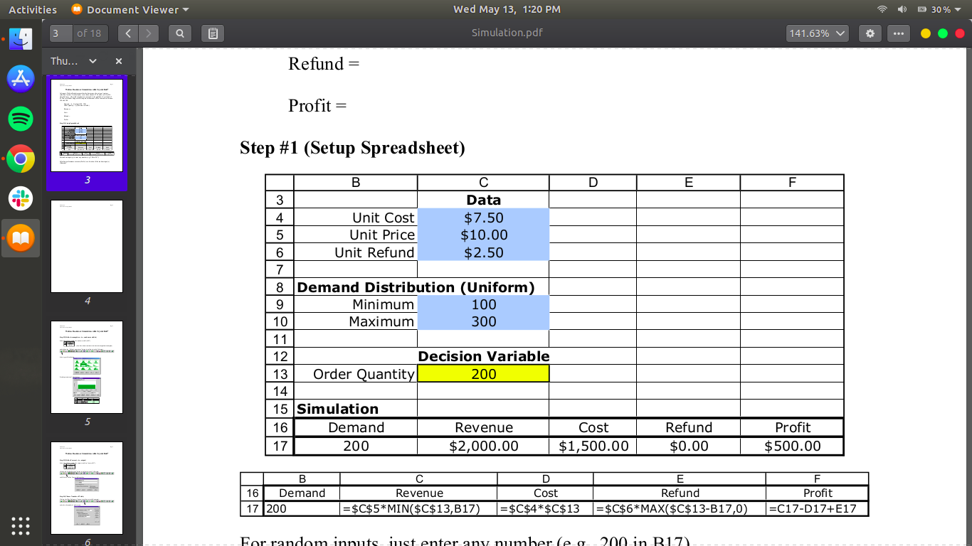

Step 2: Define Assumptions - Random Variables

Select the cell that contains the random variable (B17), below Demand, and click on the “Define Assumptions” button in the toolbar (or in the Cell menu. Select the type of distribution and provide parameters of the distributions. For each uncertain variable (one that has a range of possible values), you define the possible values with a probability distribution. The type of distribution you select is based on the conditions surrounding that variable. Distribution types include:

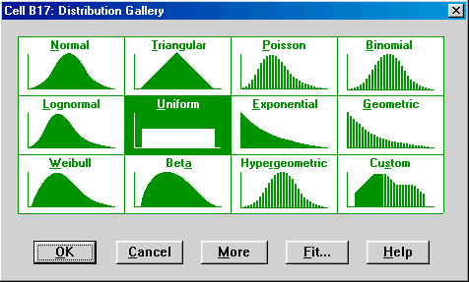

Step 3: Define Forecast - Output

Select the cell that contains the output variable to forecast (F17), below Profit and click on the “Define Forecast” button in the toolbar (or in the Cell menu) and fill in the Define Forecast dialogue box.

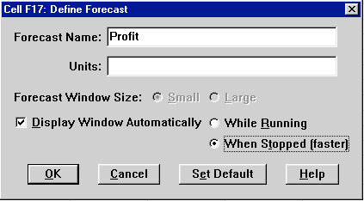

Step 4: Choose a number of Trials

Click on the “Run Preferences” button in the toolbar (or in the Run menu) and select the number of trials to run.

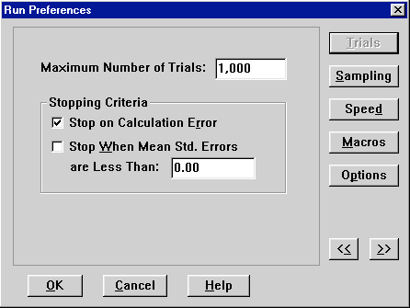

Step 5: Run Simulation and View Results:

Click on the “Start Simulation” button in the toolbar (or Run in the Run menu). The results of the simulation can be viewed in a variety of different ways (frequency chart, cumulative chart, statistics, and percentiles). Choose different options under the View menu in the forecast window.

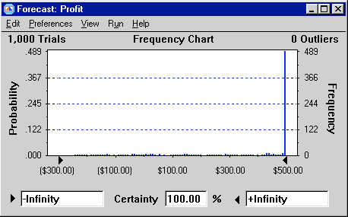

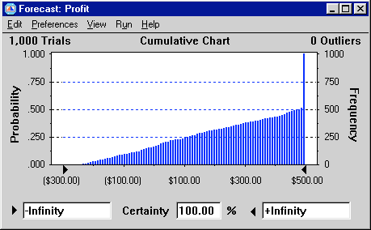

The results can be copied into a worksheet or Word document (choose Copy under the Edit menu in the simulation output window.

**Q3. Write a short note on Contract Management.**

**Ans.** Contract management is the process of managing contract creation, execution, and analysis to maximize operational and financial performance at an organization, all while reducing financial risk. Organizations encounter an ever-increasing amount of pressure to reduce costs and improve company performance. Contract management proves to be a very time-consuming element of business, which facilitates the need for an effective and automated contract management system. The stages of contract management are intended to ensure that the parties work together to achieve the objectives of the contract. Contract management is based on the idea that the contract is an agreement, a partnership with rights and obligations that must be met by both sides to achieve the goal. Contract management is aimed not at finding fault, but rather at identifying problems and finding solutions together with all contracting parties involved.

The process includes several of the following steps:

1. **Initial requests**: The contract management process begins by identifying contracts and pertinent documents to support the contract's purpose.

2. **Authoring contracts**: Writing a contract by hand is a time-consuming activity but through the use of automated contract management systems, the process can become quite streamlined.

3. **Negotiating the contract**: Upon completion of drafting the contract, employees should be able to compare versions of the contract and note any discrepancies to reduce negotiation time.

4. **Approving the contract**: The instance in which most bottlenecks occur is getting management approval. Users can pre-emptively combat this by creating tailored approval workflows, including parallel and serial approvals to keep decisions moving at a rapid pace.

5. **Execution of the contract**: Executing the contract allows users to control and shorten the signature process through the use of electronic signature and fax support.

6. **Obligation management**: This requires a great deal of project management to ensure deliverables are being met by key stakeholders and the value of the contract isn't deteriorating throughout its early phases of growth.

7. **Revisions and amendments**: Gathering all documents pertinent to the contract's initial drafting is a difficult task. When overlooked items are found, systems must be in place to amend the original contract.

8. **Auditing and reporting**: Contract management does not simply entail drafting a contract and then pushing it into the filing cabinet without another thought. Contract audits are important in determining both organizations' compliance with the terms of the agreement and any possible problems that might arise.

9. **Renewal**: Using manual contract management methods can often result in missed renewal opportunities and business revenue lost. Automating the process allows an organization to identify renewal opportunities and create new contracts.

**Q4. Briefly describe the methods of project termination.**

**Ans.** The methods of project termination are:

• **Extinction :** Project is stopped due to either its successful or unsuccessful

conclusion. Auditing, the team on new assignments, assets transferred

as per policy.

• **Addition** : Applies to an in-house project. The transition or transfer of the resources such as the project personnel, materials and equipment to the newly created unit within the parent organization. The project is a major success. When the project is successful it is institutionalized. It becomes the formal part of the parent organization.

• **Integration** : Resources and team members are reintegrated within the

organization’s existing structure. Team members leave parent

organisations.

• **Starvation** : It is also known as the withdrawal of “life support”. The project is terminated by budget decrement. Used when it is politically dangerous to cancel a project. The reason for this termination is generally to shadow the failure of non-accomplishment of the goals. This can save the face of senior management and avoid embarrassment.

**Q5. Explain how project procurement management is done? Show the life cycle and post mortem analysis.**

**Ans.** Project Procurement Management is part of the project management process in which products or services are acquired or purchased from outside suppliers in order to obtain or purchase goods and services for projects. These relationships are often created based on a contract so that the needed items or services are received on time and meet the standards requested by the purchasing company. The lifecycle of procurement management includes five steps:

**i. Specification:**

This step involves the purchasing department in communicating with the project manager to develop and approve a list of procurement items necessary for project implementation. The department must specify the approved items to external vendors.

**ii. Selection:**

This step of the project procurement process requires the department to find potential suppliers which can procure the necessary items, according to the specifications. For this purpose, the department needs to set vendor selection criteria, which may include such measures as Delivery, Service Quality, Cost, and Part Performance.

**iii. Contracting:**

The department must communicate with the suppliers on delivery dates and payment conditions in order to ensure “on-time” delivery of the ordered items within the stated project budget. All the conditions should be listed in a procurement contract. Also, a detailed delivery schedule should be negotiated with the procurers and approved by the purchasing department.

**iv. Control:**

The success of the procurement management process depends on how the purchasing department controls the delivery and payment processes. Through arranging regular meetings with the vendors, tracking delivery progress, reviewing the ordered items against the approved product specifications, and making necessary changes to the procurement contract, the department can control the process and ensure successful accomplishment.

**v. Measurement and Monitoring:**

The final step of the project procurement management process refers to using a system of performance indicators and measures for assessing the effectiveness and success of the entire process.

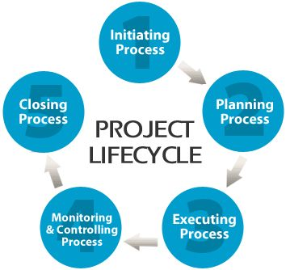

***Post-mortem analysis*** of a project usually performed at the conclusion of

a project, to determine and analyse elements of the project that were

successful or unsuccessful.

**Q6. What is critical chain planning? What are the functions of the Planning Department?**

**Ans.**

Critical chain project management (CCPM) is a method of planning and managing projects that emphasizes the resources (people, equipment, physical space) required to execute project tasks. It was developed by Eliyahu M. Goldratt. It differs from more traditional methods that derive from the critical path and PERT algorithms, which emphasize task order and rigid scheduling. A critical chain project network strives to keep resources levelled, and requires that they be flexible in start times.

The functions of the planning department are:

1. Market Survey

2. Project Capacity

3. Selection of Site

4. Plant Layout

5. Design and Drawing

6. Material Requirement

7. Operation Planning

8. Machine Loading

9. Sub-Contract Consideration

10. Equipment Requirement

11. Organization Layout and Staff Requirement

**Q7. What is the difference between scheduling and sequencing in project management?**

**Ans.**

|  |  |
| --- | --- |
| **Scheduling** | **Sequencing** |
| Scheduling is the process in which people are assigned to time to accomplish different tasks. | Sequencing is the process of prioritizing the tasks to be done in the chain. Hence the next task is started once the previous one is completed. |
| It improves delivery performance and reduces manufacturing time and cost. | It neither improves the  delivery performance nor  reduces the manufacturing  time and cost but it defines the logical sequence of tasks to  obtain the greatest efficiency  given all project constraints |
| There are three types of schedule:  ● Master project schedule  ● Milestone schedule  ● A detailed project schedule | Three tools are important:  ● Precedence diagramming method  (PDM)  ● The Dependency determination  ● The Leads and lags |

**Q8. Compare between deterministic and probabilistic estimates.**

**Ans.**

**Deterministic schedules** -

1. These are networks of tasks connected to each other with dependencies that describe the work to be performed, that work's duration and the planned completion of the project. Each task has a planned duration.
2. Each task has a predecessor and a successor. The only task that should not have a predecessor is the start of the project and the only task without a successor is the completion of the project. This forms a closed network with no widows or orphans.
3. The longest path through the network is the critical path.
4. The total duration of the project is a fixed value - it is deterministic.

**Probabilistic schedules** -

1. These are networks with all the elements of a deterministic plan, but the duration of the tasks are random variables.
2. The duration is not random, but they are random variables drawn from a probability distribution.
3. Three-point estimates "can" be used to describe these random variables. It is not necessary to use the three-point estimate approach, but it is an easy starting point.
4. The total duration of the project is a random number