

May-June 2019

***Project Report***

**Canteen Management System**

**Summer Training Project Report**

Integrated Test Range (ITR) DRDO, Chandipur

Under the Guidance OF

**Mr. A. Patra**

SC- ‘D’, CAN, ITR

Submitted By,

* **Biswajit Mohanty**
* **Satyajeet Behera**
* **Tarun Kumar Behera**
* **Deepak Kumar Bag**
* **Nilesh Kumar Parida**

# DECLARATION

We, the group constituting ***Biswajit Mohanty, Satyajeet Behera, Tarun Kumar Behera, Deepak Kumar Bag, Nilesh Kumar Parida*** do hereby certify that the project report entitled ***“Canteen Management System (CMS)”*** being submitted to Integrated Test Range, DRDO, Chandipur, Balasore, is an original piece of work done and the same has not been submitted elsewhere for any other purpose.

*Sign.*

**(Nilesh Kumar Parida)**

1602041045

6th Semester, CSE Veer Surendra Sai University of Technology, Burla

CERTIFICATE

This is to certify that the project report entitled ***“Canteen Management System (CMS)”,*** submitted by the group constituting ***Biswajit Mohanty, Satyajeet Behera, Tarun Kumar Behera, Deepak Kumar Bag, Nilesh Kumar Parida*** for the award of Summer Training in ITR, DRDO, Balasore, Odisha, India, is a bonafide record of work carried out by them under my guidance. Neither this project report nor any part of it has been submitted for any degree or academic award elsewhere.

**Mr. A. Patra, SC – ‘D’** **Mr. P.N. Nanda, SC- ‘F’**

(Project Guide) (Group Director, HRD)

Acknowledgement

## The completion of this Summer Training represents not only our work and effort but also support and guidance of many others.

I would like to express my special thanks to **Dr. B.K. Das, Sc- ‘H’ (OS),** Director**, ITR, DRDO** whose motivational speech always encourage me and also **HRD** group for having me to carry out this Summer Training under **CAN** group.

## I would like to express my deepest appreciation to **Mr. Anup Kumar Sahoo Sc- ‘F’,** Group Director, CAN, for support and guidance in various fields towards the completion of training with success.

I would also like to thank **Mr. A. Patra, Sc- ‘D’** & **Mr. Vivek Kumar Singh STA- ‘B’, CAN** group for assigning me with the projects **“Fundamentals of Networking”**. Their guidance, effort and useful suggestion encouraged me to complete all the things successfully with in time.

I would like to express my deep sense of gratitude to **Mrs. Manorama Parida, JRF, CAN**

## whose advice & suggestion give me knowledge of Network Architecture related to CAN.

Again, I would like to thank my parents and relatives for their heart pledge support and love towards . They have encouraged me and helped me in this Summer Training.

Biswajit Mohanty Satyajeet Behera

Tarun Kumar Behera Deepak Kumar Bag Nilesh Kumar Parida

CONTENTS

1. Acknowledgement
2. Introduction To DRDO
3. Integrated Test Range (ITR)
4. Campus Area Network (CAN)
5. Canteen Management System (CMS)
   1. Mandates to the CAN group
   2. Customer Features
   3. Canteen Admin Features
6. Problem Statement & Objective
   1. Problem Statement
      1. Verbal Communication
      2. Menu Display
   2. Objective
7. Requirements
   1. External Interface Requirements
   2. Minimum Hardware Requirement
   3. Software Requirement
8. Diagrams
9. Screenshots
10. Maintenance, Additions & Future implementation Goals

Introduction To DRDO

Defense Research and Development Organization (DRDO) was established in 1958 by amalgamating Defense Science Organization and some of the technical development establishments. A separate Department of Defense Research and Development was formed in 1980 which now administers DRDO and its 50 laboratories/establishments. DDRO is currently directed by A.P.J. Abdul Kalam, who was previously director of the Defense Research and Development Laboratory (DRDL) responsible for India's missile development program.

The Defense Research and Development Laboratory (DRDL), Hyderabad was established in 1962 as part of the major strategy to develop Missile Systems, with the responsibilities to design, develop and produce various missile systems and subsystems required by services from 1962. By 1983 the DRDL successfully established the basic technological resources required for the development of missile systems such as solid, liquid & ramjet propulsion technology, control & guidance engineering and design & fabrication facilities etc. These efforts led to the sanction of a major program called Integrated Guided Missiles Development Program (IGMDP) in July 1983. This program included development of five different types of missile systems to meet the futuristic requirements of the Armed Forces.

# Integrated Test Range (ITR)

Integrated Test Range started as a project under Integrated Guided Missile Development Program (IGMDP) in 1982, for setting up Range facilities for evaluating the performance of rockets, missiles and other flight test vehicles. Starting out with the launch of the Trishul class of missiles, we went on to launch the historic AE-01 test vehicle, an achievement that put ITR on the World Map. Since then, we have taken up a number of challenges including the performance evaluation of the multi-role, multi-capability missile Akash, the Nag - anti tank missile, Prithvi the most precise surface to surface missile with multiple warhead capabilities and the large-scale technology demonstrator Agni. With our versatile technical capabilities, we even supported missions the ITR wasn't designed for. For instance, the evaluation of Pilot-less Target Aircraft, the Pinaka Rocket and Drop Tests of altitude sensing warhead.

ITR become a Peace Establishment in Feb'92. Between 1992 and 2002, ITR has grown in stature and capability, having conducted over 275 important campaigns including 30 major missions of National Importance. Several precision tracking instruments are deployed all around the coast line to provide effective coverage of the Flight from different launch complexes. Central Computer is the nerve center of pre-mission, mission and post-mission activities. Before the mission, it computes the vertical and horizontal safety parameters and conducts pre-mission checks. During mission, it acquires real-time data, validates and processes them, computes the trajectory and plot them on Range Safety Display. All the relevant data are handed over to project for further analysis.

Recently, ITR has extended its stretch by activating a new launch complex LC-IV at the Island at a distance of about 100 Km from Chandipur. Island complex with a stretch of 413 Acres and a built-up area of 120 acres comprises of launch pad, VIB, SPS, Block House, Magazine and other ancillary facilities to support major missions. Additional Range Instrumentation Network are deployed at the Mainland Complex which has an area of 263 Acres out of which the built- up area is 70 Acres. Few Instrumentation Stations are also provided at Sharadprasad Complex where the area is 210 Acres out of which built up area is 2 Acres. The historic test firing of A'-01 was conducted from this new launch complex on 11 Apr 99 where all the Range facilities were stretched to their maximum capability to provide vital data to the project. Till date, those facilities of LC-IV even support all the major missions conducted from Chandipur Complex.

# Campus Area Network (CAN)

Integrated Test Range is an ISO– 9001 Organization. Here the entire processes are well-documented and requires meticulous adherence to the laid down procedures. Moreover, this organization is striving hard to convert the entire management into e-management. Further all work centres are network for automatic data communication using all possible mode of communication network. Keeping these objectives in view and combining all the work centres like Admin, Finance, HRD, Director’s Secretariat, Integrated Material Management and other directorates into an integrated network through Campus Area Network i.e., CAN.

The Campus Area Network is responsible for developing software packages for automating different management activities for e-administration and paper-less office through online services.

# Canteen Management System (CMS)

### Mandates to the CAN group: -

* Add Registration (Employees & Visitors)
* Add Visitors
* Include Private Canteen
* Database & Admin Access for Private Canteen
* Optimize Front-End
* Improvise Manager Page View

#### Customer

|  |  |  |  |
| --- | --- | --- | --- |
| * Registration   + Employee Number   + Name   + Contact No.   + Department   + Designation   + Set Password | * Login   + Employee Number   + Password | * Profile Page   + Employee Number   + Name   + Contact No.   + Department   + Change Password | * Change Password   + Current Password   + New Password   + Re-enter New Password |

* Forget Password
* Meal Booking (9:00AM-10:30AM)
  + Annapurna (dropdown list)
* Private (dropdown list)

|  |  |
| --- | --- |
| * Show Today’s menu * No. of Meals (radio button) max:5 * No. of Special Dish1(radio button) * No. of Special Dish2(radio button) * Calculate Total Amount | * Show Today’s menu * No. of Meals (radio button) max:5 * No. of Special Dish1(radio button) max:5 * No. of Special Dish2(radio button) max:5 * Calculate Total Amount |

* + Order Now
  + Issue Token Number
* **Canteen Admin (Private & Annapurna)**

|  |  |  |
| --- | --- | --- |
| * Login   + Manager Id   + Password | * Manage Bill   + Clear Menu   + Add Menu   + Add Price | * View Orders   + Order Table |

Problem Statement & Objective

The challenge encountered by the manual system in canteens in the ITR campus is efficiency and customer satisfaction. The experience of ordering in most fast food canteen is not pleasant for customers. Customers have to make long queues before placing the order and when the order is placed, they have to wait near the counter until the order is prepared. Another problem is efficiency that food canteen should maintain in their standard operation and keep with the quality of their product and services no matter how much crowd is present in canteen but they have to maintain efficiency that food canteen should maintain in their standard operation and keep with the quality of their product. However, we think that there are some issues concerning the traditional way to order food in canteens.

The major issues are as follows:

1. **Verbal communication:** Verbal communication between cashier and customer or we can say telephonic communication: The verbal communication between two parties for placing order and the information about bill should also result in error means error also occurs in understanding what the person wants to say and especially in busy hours in canteens. When the place is very crowded and noisy, miscommunications are common. The problem is even worse if the cashier and the customer do not speak the native language.
2. **Menu display:** The menu in more canteens usually attached to a wall behind the counter and the customers are not aware of that new items because the menu is not up-to-date. Furthermore, not all item on the menu list has a graphical illustration to help customers to take Decision easily what they want. The print is sometimes small that it’s not visible to the customers.

##### OBJECTIVE:

Our objective is to make a platform independent website to maintain a database of all orders ordered from various sources and all the different services required by each of them. Established canteen automation practises should provide the needed connectivity and accountability between those two operational units, and when managed properly, enhances the effectiveness of both operations.

1. **Registration** 2. **Order** 3. **Update**

The above are the modules of canteen automation system

# Requirements

**SPECIFIC REQUIREMENTS:**

**EXTERNAL INTERFACE REQUIREMENTS**: The external system is to assume full responsibility for storage for functions as well as warehouse management and warehouse control for an entire warehouse .The interfaces in this section are specified are specified by documenting : the name and descriptions of each scheme , source or input , destination or output , ranges , accuracy and tolerances , units of measure , timing , display formats , and organization , and data formats. The user interface required to be developed for the system should be user – friendly and attractive. The interface between the user and the system will be WIMP (Windows, Icons, Menu, Pointers) keeping in mind that the system is to be run through a web browser. All operations will be off point and click nature with all navigation performed through windows of the system specifically buttons and menus.

##### Minimum HARDWARE REQUIREMENT:

1. 20 GB HDD

2.256 MB RAM

1. PENTIUM 4 PROCESSOR
2. INPUT DEVICES: KEYBOARD, MOUSE
3. OUTPUT DEVICES MONITOR, PRINTER

##### SOFTWARE REQUIREMENT

OPERATING SYSTEM: Window XP and above

BROWSER: Chrome or any other latest web page supporting browser

PRODUCT SCOPE: This system will help to manage and run the canteen management in ITR campus systematically. In this management system, we will provide a website that can be used by the staff members in ITR campus to order food. Customers can also give feedback in this website. So that owner of the system can evaluate the whole system. This will ultimately lead to hire less waiters and create an opportunity to appoint more chefs and better kitchen place to server food faster. Also, the required information’s about employees will be saved in the system which can be accessed by the system admin.

PRODUCT FUNCTIONALITY: Whole functions will be performed through this order.

* 1. Food order via website 2.Take order

3.serve food 4.payment 5.Available good 6.Required Good

7.Customer information 8.Customer Review

Language: PHP, JavaScript, HTML

# Diagrams

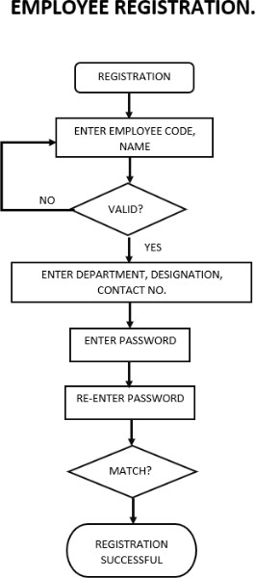 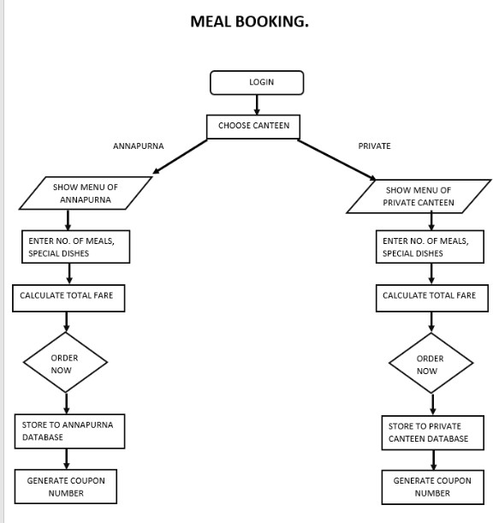

# Screenshots

User Frontend:

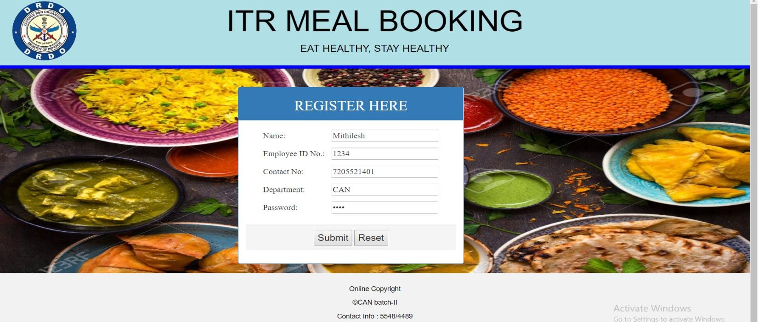

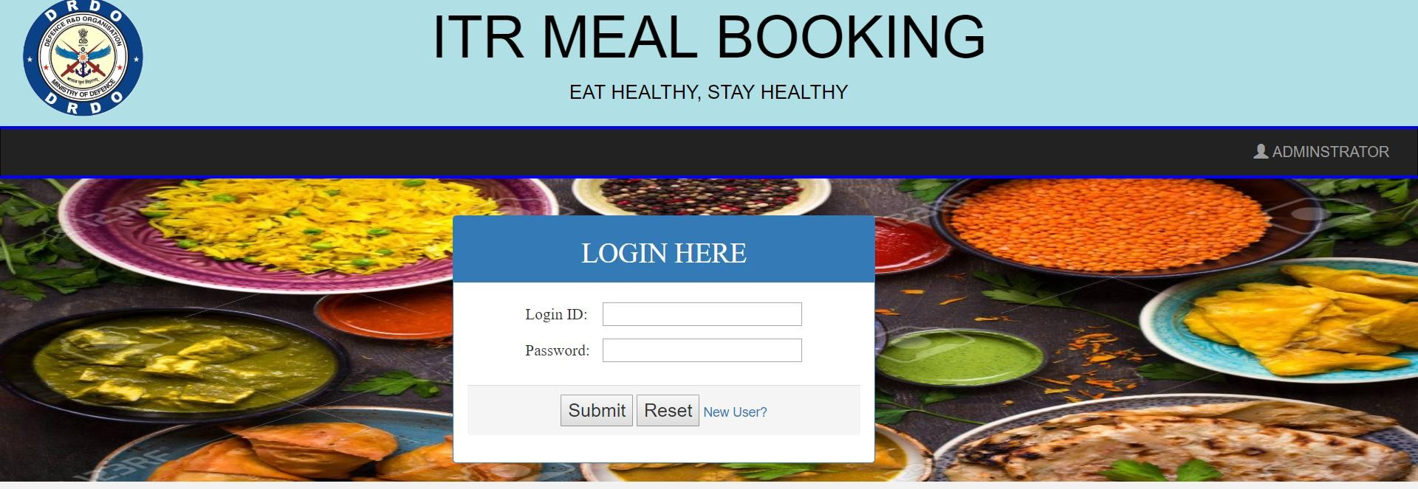

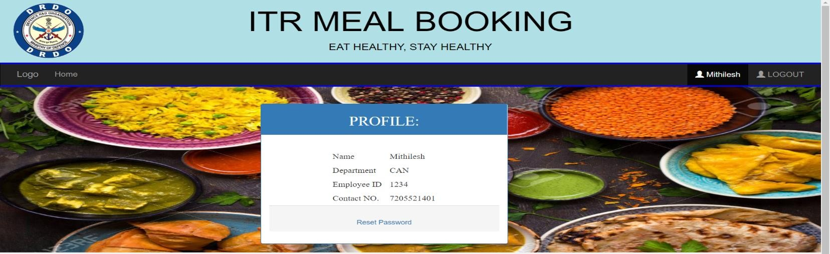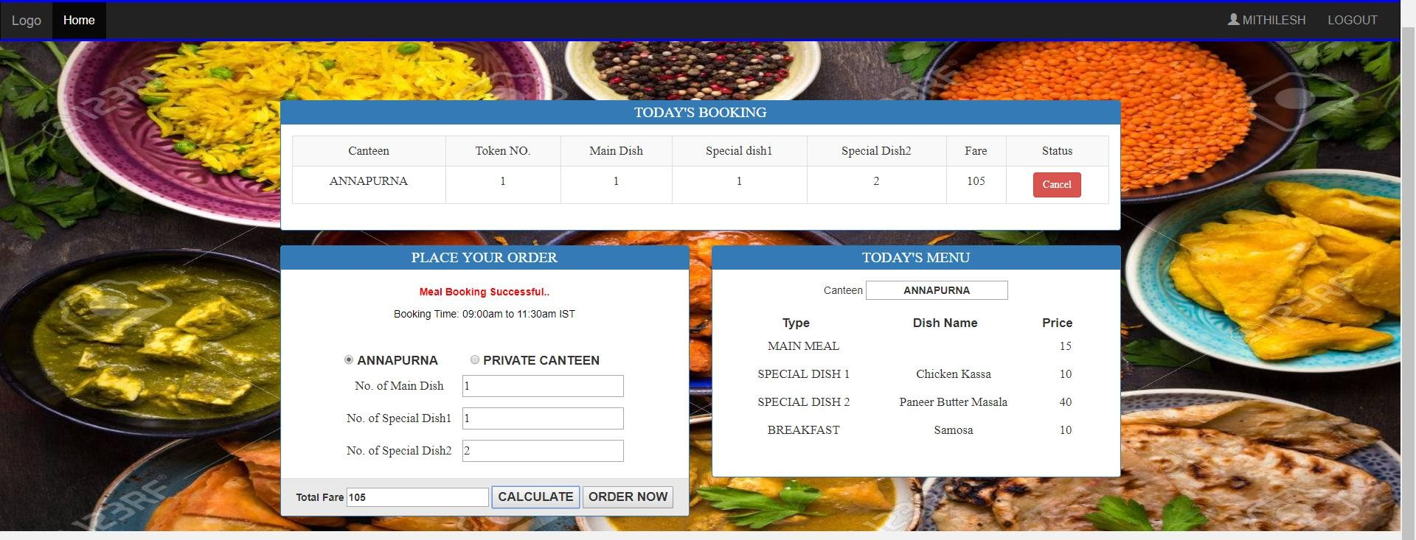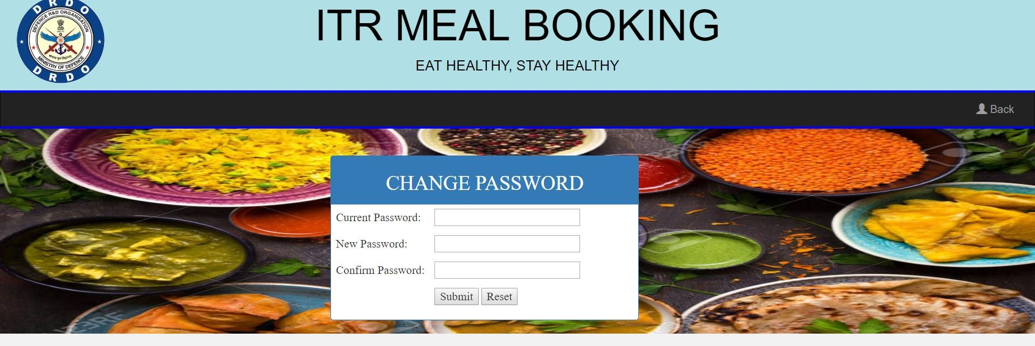

Admin Update Page:

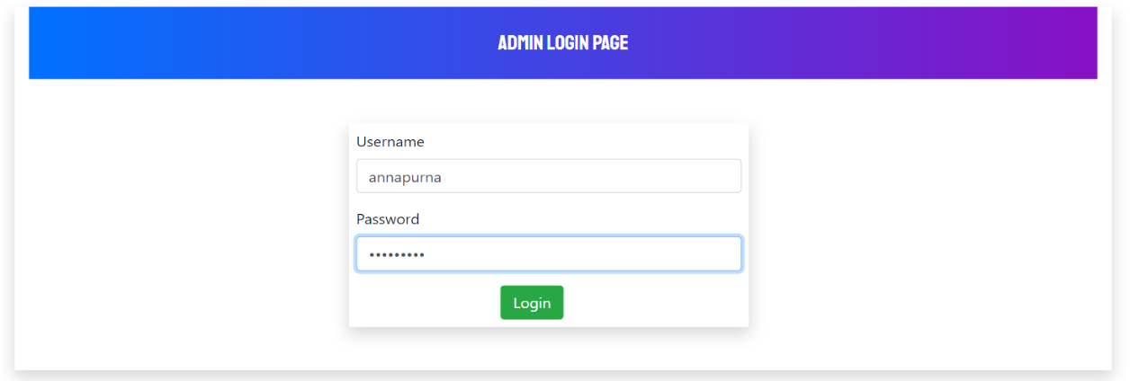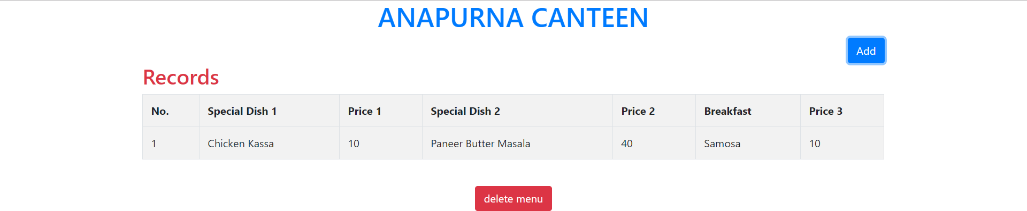

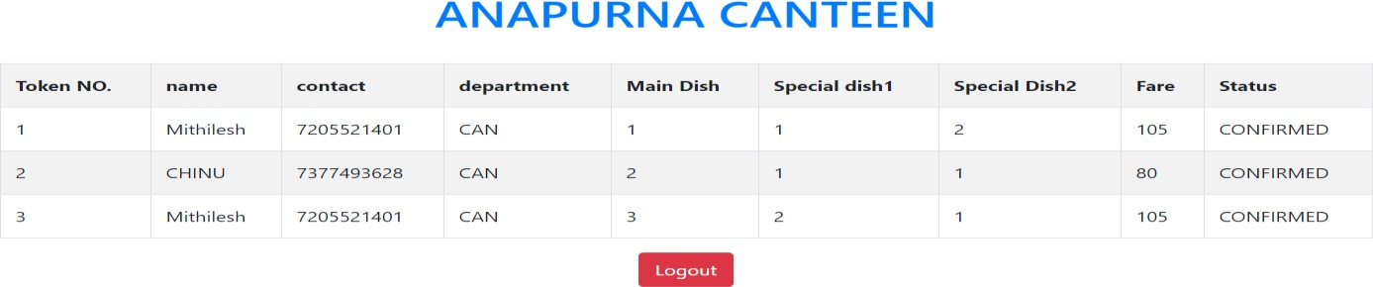

# Maintenance & Additions

Canteen Management System can be easily maintained. Any addition or deletion is mostly automatic time based or done by the canteen manager. The menu needs to be added by the admin by logging into their respective accounts.

**Future Implementation Goals:**

* **Edit Menu:** Once Order is placed; the quantity of items can be updated in due time.
* **Payment Option:** A token-based payment system is planned to incorporated. The user can buy token/credits in bulk from the canteen offices, which will be credited to their respective accounts through which they can book meals.
* **Customer Feedback.**

**\*\*\*\*\*\*\*\*\*\*\*\*\*\*\*\*\*\*\*\*\*\*\*\*Thank You\*\*\*\*\*\*\*\*\*\*\*\*\*\*\*\*\*\*\*\*\*\*\*\*\*\*\*\***