INTEGRATED TEST RANGE,CHANDIPUR

BRIEF ORIENTATION REPORT

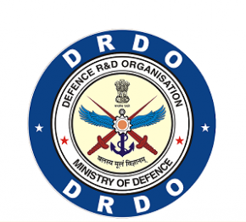

Name -Atul Kumar Agrawal
Branch – Computer Science and Engineering
Semester - 6th
College- Veer Surendra Sai University of Technology,Burla,Sambalpur
Application id : 103

DAY 1: 20 May 2019

ITR (Integrated test Range), is situated in Chandipur,Balasore,Odisha.A number of Indian missiles have been tested and launched from the ITR, including nuclear-capable Prithvi, Agni and Shaurya ballistic missiles, as well as Akash and Barak 8 surface-to-air missiles ,started in 1986.
There are 5 missile programmes under Integrated Guided Missile Development Programme (IGMDP):
1. AGNI (ballistic missile with different ranges)
2. PRITHVI (Short range surface-to-surface missile)
3. AKASH (Medium range surface-to-air missile)
4. TRISHUL (Short range low-level surface-to-air missile)
5. NAG (Third-generation anti-tank missile)

Other missiles of India:
1.Mission Shakti : Anti-Satellite Missile
2.Brahmos(Supersonic cruise)
3.Nirbhag(Subsonic)
4.Astra

Missile tracking technology are divided into three types:
1. Active (Radar – RF signal)
2. Passive (Telemetry,EOTS)
3.Telecommand

Radar – Radar stands for Radio Detection and Ranging.It is used to track the route of the missile, to determine angle,degree,range,velocity,location,acceleration,elevation using Radio waves .
It consists of transmitter prducing electromagnetic waves in radio or microwave domain , a transmitting antenna and a receiving antenna. These radio waves gets reflected from the desired objected to the receiver and gets detected.

Telemetry: It is an automated communications process by which measurements and other data are collected at remote or inaccessible points and transmitted to receiving equipment for monitoring.
Tele = remote , Metry = measure.
It can use both wireless media (radio, ultrasonic or infrared) and wired media (optical fibres, computer networks) to communicate.Many modern telemetry systems take advantage of the low cost and ubiquity of GSM networks by using SMS to receive and transmit telemetry data.

EOTS (Electro-Optical Tracking System) : It uses IR (Infrared)an CCD(Closed circuit devices) camera producing a high speed video of around 10,000 frames per second.
It is a very long range camera which has image processing capabaities.

TELECOMMAND : It is the counterpart of telemetry. A command from the ground station is sent to the distant object for communication.
It is used to destroy the missile if it goes out of its path and have possilbility of causing damage.
The Object in concern has an on-board computer .
Commands used are stop,abort and destroy.

Important Characteristics in any mission
1. Timing (Ceasium – Rheodium clock)
2. Data
3. Flow
4. Communication
5. Security

Flight Analysis:
1. Deviation
2. Safety corridor (Destroy if beyond safe range)
3. Simuation
4. Trajectory analysis

Some other important systems are :
1. INS – Inertial Navigation System
2. GPS – Global Positoning System (Accuracy of around 10m)
3. DGPS – Differential GPS (used by US army – has very high accuracy of about 1m)

Communications:
C8C16,Multiplexers
Satellites
Below Island
Under the sea – Fiber Optics
CCTV – closed circuit television
UAV – Unmanned Aerial Vehicle
PTA – Pilotless Target Aircraft

DAY 2 : 21 May 2019

A.TELEMETRY
B.RADAR

A. TELEMETRY
Tele = remote , Metry = measure.

Types: Carbon Telemetry, Hygen Telemetry ,face directed, A-Band, S-Band,Ground Telemetry, PCM telemetry etc.

It gives complete health of the missile from lift off to touch down and is used to track objects which are at remote or inaccessible locations like nuclear reactors,unmanned aircraft etc.
It is fitted on the device to which it has be tracked.
It uses wireless data transfer mechanisms (e.g., using radio, ultrasonic, or infrared systems).
It also encompasses data transferred over other media such as a telephone or computer network, optical link or other wired communications like power line carriers. Many modern telemetry systems take advantage of the low cost and ubiquity of GSM networks by using SMS to receive and transmit telemetry data.

It can measure :
1.Propulsion :Combustion chamber,Oxidiser,Air-Bottle Pressures
2. Structures: Vibration,Temperature Strain
3.Navigation: Velocity,Acceleration,Range
4.Control:Actuator command,Feedback Signals
5.Electrical:Battery Voltage,Relay Status,Flight Termination System

Limitations of Telemetry
Plasma Blackout may occur where there is no communication between ground systems and the missile.
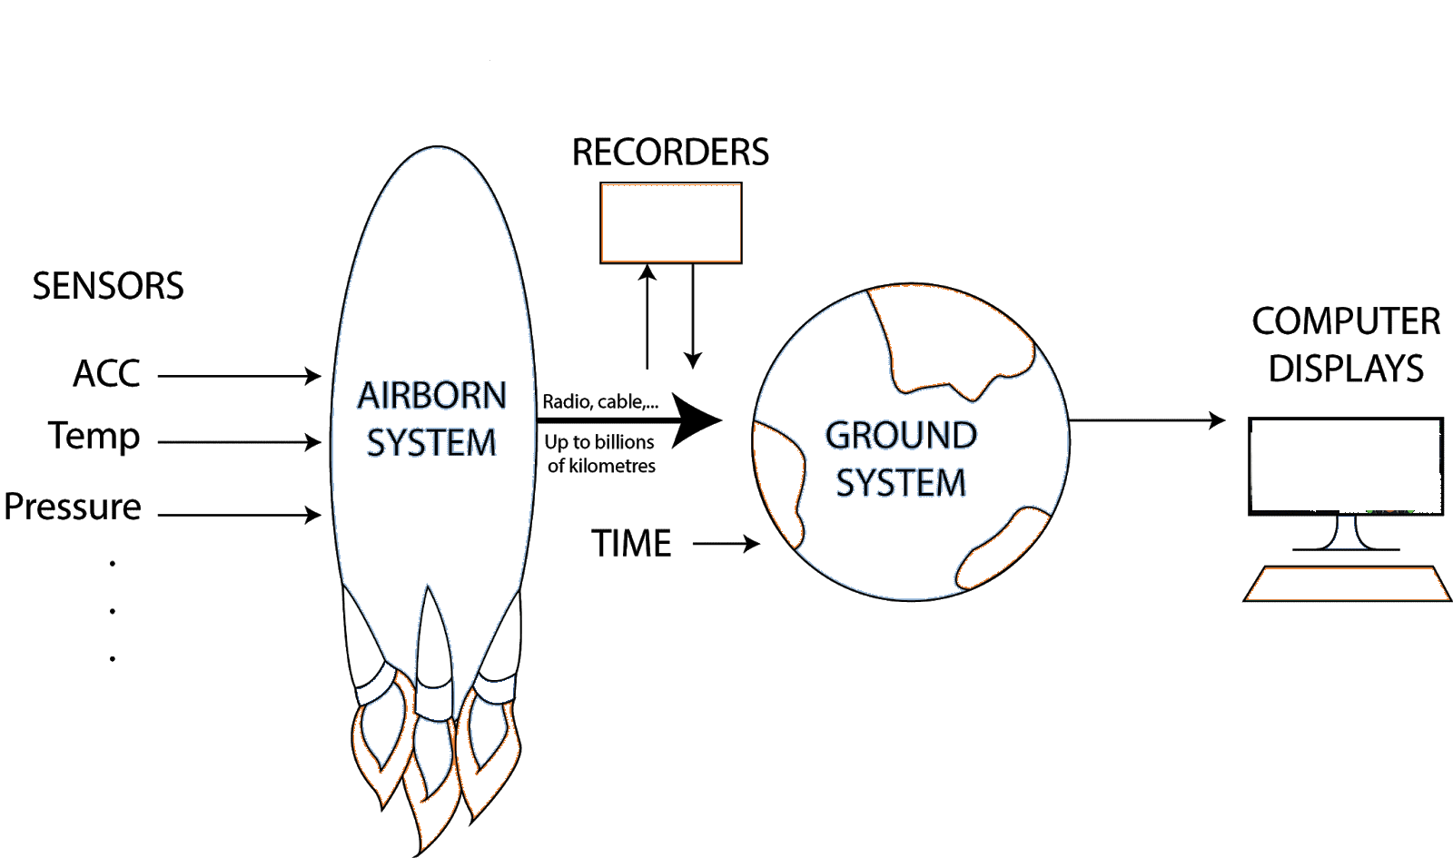

B.RADAR (Radio Detection and Ranging)
It uses radio frequency waves (Electromagnetic waves) which when gets reflected from the object to be tracked, giving the position of the object.
It is a line-of-sight tracking system.
Radar gives many data like angle, degree,range,velocity, acceleration, elevation, height, impact of hit etc.
It has a range of around 3000 K.M.

It works in various frequency bands like L-band, X-band,S-band(Kama-I,II,II),C-band etc.

Modes of operation :
1.Transponder mode (Range-2800 KM,accuracy-8m,angle-1.5 arc min) : It amplifies the signal and sends the signal back(for long range).
2.Skin mode (50 KM, accuracy- 16m, angle- 1.5 arc min)
3.Beacon mode(2000 KM)

Types of Radar:
OTH(over the horizon),Phased array instrumentation radar(Not Parabolic)- can track multiple objects, parabolic radar

Locations of Radar : LC4, Paradeep, Konark, Port Blair,Chandipur(Kama-I,N)

Application of RADAR
1.Air Traffic control
2. Navigation
3.Ship Safety
4.Remote Sensing
5.Law and Enforcement
6.Military
7.Space Applications etc.

Advantages of RADAR
- All weather Operation
- Long Range Tracking
-Line of sight problem is not faced by radar systems

Limitations of RADAR
It can’t be used for objects close to the surface because of various obstacles like buildings,trees etc which creates noise in the signal.

DAY 3 : 22 May 2019

EOTS (Electro-Optical Targeting System) :

It uses fast image tracking IR optical camera producing high speed video (10,000 frames per second) with gimbal mounted to rotate around 360 degrees.
It is very precise(in cms) and accurate.
It can measure the initial trajectory of the missile which can’t be detected by radar.
It can be used in quadcopter,UAV(Unmanned aerial vehicle),FPGA boards,Robotics,Humanoid,Tank etc.

Objectives of EOTS
1. Initial trajectory
2.Bias Estimation
3.Range Safety Support
4.Vehicle indepedent data
5.Attitude measurement
6.Miss distance computation

Limitations of EOTS
Range is less (around 400-500 KM)
Minimum 2 EOTS system is required to track a body.

CAN and DATA CENTER

CAN- campus area Network
Net + working = Networking : Communication from one device to another.
All the nodes are connected to each other.
It always remains online using VRRP(Virtual Redundancy Routing Protocol) Technology which is a type of Master-Slave Technology.

USES
1.Resource Sharing (Photos,Videos,Movies,Messages etc.)
2.Communication
Network Types : LAN,WAN,MAN
Intranet: private network that can be accessed and used only by authorised people.
Internet: public network
Services of CAN
1.Employee information system
2.Leave Management
3.Finance Management
4.Library Management
5.Mailing Service
6.IMMG system
7.Health care system
8.Online video lectures

DAY 4 : 23 May 2019

COMMUNICATION SYSTEM IN RANGE

Sites to be communicated : Konark(p#1),Makalpada(p#2),Dhamra(Dhamraport,MLC), Chandipur(Site A,Site B,Sarat Prasad),LC-I,II,III,IV,Hyderabad,MR ship,PXE,Site-C,4000,5000,14000,17000,MS-34,DRDO-HQ(Delhi).

ITR communication network includes: EOTS,RADAR,Telemetry,Telecommand,Data Processing,Flight Safety etc.
CDT : Count Down Time measured in T-x days in realtime.
Hotline: Direct connection between two points without number dialing.
Services
(i)Voice : BSNL,EPBAX,Hotline,C-8,Wireless PTT sets in VHF and UHF bands
(ii)Data : All sensors data(radar,telemetry,EOTS),CDM data from central computer to all sensors,display data,ATD and Cdt info in the range.
(iii)Video : Conferencing,Streaming,Surveilance over Ethernet LAN/WAN.

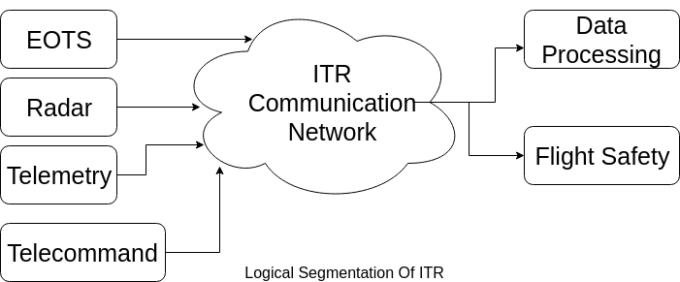

Target Systems for test and evaluation

Waves : Transverse and Longitudnal

Longitudnal waves: Needs a medium to travel
eg. Sound waves

Transverse waves: It is a type of electromagnetic wave in which both electric and magnetic components are perpedicular to each other and doesn’t require any medium to travel and can travel in vaccum.
eg. Light wave

DAY 5 : 24 May 2019

Mission Coordination and Management

Types of Missiles:

1.Based on Launch Platform
a.Surface to surface(AGNI)
b.Surface to air(AKASH)
c.Air to air
d.Anti Tank Guided missile

2.Based on range
a.Short (300 km)
b.Medium (1500 km)
c.Intermediate (1500 -5000 km)
d.Intercontinental (>5000 km)

3.Based on Trajectory
a.Ballistic Missile(Projectile Motile - parabolic path)
b.Cruise Missile(flat-constant altitude from surface)

4.Other types
a.Strategic Missile(Offensive/Damaging)
b.Tactical Missile(for defense)
c.Air defence Missile
d.Target Launch Vehicle(UAV)
e.User Trial
f.Cruise Missile(Supersonic and subsonic)

Air to air: launched from an aircraft to destroy another aircraft.
Surface to air: launched from surface to destroy another aircraft.
Surface to surface: launched from surface to another surface.

Boost phase of missile: Initially,a continuous force is imparted to the missile for more range travel.

Components of Missile:
1.Airframe(body of the missile)
2.Propulsion(force to travel) – contains
a.Air breathing Engines(Turbojets)
b.Turbo Fans
c.Ramjet
3.Rocket Engine with solid or liquid propellent
4.Warhead(to be carried)
5.Flight Control System(wings,fins and canards)
6.Guidance system
-Beam riding guidance
-Command guidance
7.Warhead
-Explosives
-Nuclear
-Chemical
-Biological
8.Fuze
-Impact fuze
-Proximity fuze

POWER SYSTEM

Objective: Clean,Uninterrupted,regulated,reliable and quality power supply.

Components
-DG sets(10-400 kva)
-UPS(10-160 kva)
-Battery(7 Ah -425 Ah)
-Power distribution network
fundamental frequency = 1st harmonic = 50hz.
Power factor ,p=VI cos Φ

Linear devices: parameters of these circuits are not changed with respect to the voltage and current is called the linear circuit.
eg. Resistors,Inductors and capacitors

Non Linear Devices : parameters of these circuits differ with respect to the voltage and current.
i.e. Its V-I graph is non linear.
eg.IGBT,SCR

Transient voltage: sudden increase in voltage for short duration of time– may cause damage to devices.

Objectives of power system:
-generation of power
-conditioning of power (voltage,frequency is calculated)
-Monitoring of power
-Distribution of power
Parameters: voltage,frequency,load,quality,ground to neutral voltage(<2V)
Power sources: diesel generator,solar power etc.
Components of UPS:
-Rectifier/Converter
-Inverter
-Battery
-Static switch/Mechanical Relay
-Monitor and control hardware/software
Uses of UPS:
i.Interruption of power supply
ii.Low voltage
Iii.High Voltage

Types of UPS:
-Offline :used in homes
-Online: used in ITR,drdo
-Line interactive : used in homes

Types of Batteries:
-Flooded lead acid battery
-Tubular lead acid battery (used in homes):+ve plate is made of polyster sediments which produces no sulphation and has more life.
-SMF lead acid battery
-GEL lead acid battery
-Lithium ion Battery (used in mobile phones,power banks)

SMF battery: Shield maintainance field battery (also called valve battery).It uses oxygen automatic recombination process when H2 and O2 is liberated.
Electrolyte: H2SO4
Cation : Pb

Types of Power:
-Active power
-Passive power
-Apparant power

Monitoring systems:-
-Measuring devices
-Power analyser(Input= V,I Output=Power (in kw))
-Event Logger
-Multimeter
-Clamp meter
-Earth tester(Earth resistor i mmeasured in ohms)
- Megger(For insulation resistors in megaohms)

Protective Devices:-
-MCB(Miniature circuit breaker)/MCCB
-ECCB(Earth leakage circuit breaker) to prevent shock
-RCBO(Residual current breaker with overlaod=MCB+ECCB)
-SPD(Surge Protection device nano sec to milli sec)-It supreses the transient voltage

MCB types :-
Type B,C,D

Lightning Protection:-
-Frankline rod
-Advance Lightning Protection(ESE type)
-MESH type

Earthing:-
- Plate
- Pipe
- Chemical

