1. Team Name: msatul1303_c23b

2. Project Name: Ped Bachao, ped Ka Khayal rakho

3. Problem statement: Ecology, Environment, Climate Change and Disaster Management

Problem: Every year the plantation is being done in many parts of Odisha. Many saplings planted with so much enthusiasm and fanfare on different events die an untimely death due to lack of care and maintenance.

Statement: Citizens are showing more significant interest in the planting of trees due to the increase in awareness on environment among the people. Further, more and more individuals and institutions are coming forward for tree planting. In many functions, planting of a tree has become an indispensable part. It is quite encouraging to see that, especially during rainy season, Government or non-Government organizations, individuals and institutions go for the planting of trees with much enthusiasm and fanfare. Government organizations also distribute sapling free or at nominal cost to individuals and institutions to encourage tree planting. In the process, millions of trees are planted every year.

However, many saplings planted with so much enthusiasm and fanfare die an untimely death due to lack of care and support. It needs a little attention and protection against grazing, dry condition, and hazards of other biotic and abiotic factors. Saplings raised by the nurseryman with lot of care and skill in picking the best quality seed, its proper treatment for better germination, adequate mixture of soil and manure, watering and weeding for six months or even prolonged period for two to three years in case of tall saplings, conditioning of plants to withstand adversity of nature etc. All these labour and time is wasted when the seedlings die due to lack of care.

Planting a tree is just the beginning. It had to be taken care of and nurtured as a kid. In this age of GIS, to watch the trees we plant, we have to locate it in Google map and create a database with Geospatial reference. Thereby we can identify our plant and know about its present condition. This data has to be accessible through a simple Smartphone application by all citizens. A suitable App or other solutions need to be developed to Geo-Tag the trees and have a database of such plantations with Geospatial reference.

Solution expected:

Track the trees we plant.

Locate it on the Google map.

Create a database of such plants/trees with geo-spatial reference.

Locate the plant/tree and know the present condition.

Stakeholders: Forest Department, Other Government Departments, International institutions, non-Governmental organizations.

4. Solution: The proposed system designed will of an app, a database and a few sensors which send data to the database. Each user will login through the app and maintain its own profile and details of the planted saplings and will get updates from the sensors. Users will get option to add their farms’ coordinates along with image and other necessary data. The app will also contain basic information about how to prevent plant death and information about what nutrients and conditions are proper for plant growth. The farm location is to be uploaded by the user in the app which can then be accessed using the app through google maps for geotagging. This data will be transferred to the database over a cellular network/Wi-Fi which will be accessible through the app. The app will be designed to remind the user regularly water the plant and check its health and report if any irregularity is detected. Accelerometer and vibration sensors are employed to detect if the tree is being cut down or any other damage being done in real time. These sensors will be designed to send data every hour to the database. Immediate alert will be issued to the user to take action if any discrepancies are found in the collected data. It will also regularly update the user with the weather data fetched from the meteorological department website or any other relevant sources. Soil/moisture sensors will be used to detect whether proper amount of moisture is present in the soil or not and know the humidity of soil to find if it is proper for the plant’s growth. Soil Temperature Sensor to detect the proper temperature of the soil, electrochemical sensors to monitor the pH and soil nutrients. The sensors will be connected in an IOT network so that their data can be collected regularly which is anomaly sent to the cloud and can be monitored remotely. A smart sprinkler for drip irrigation will be placed in the soil so that whenever the soil water level drops below a threshold value, the sprinkler becomes on and automatically waters the field. When the nutrient level goes low the user will get a notification about which nutrient/mineral is deficient and how to resolve it. Solar cells can be used to run the components.

5. Architecture: 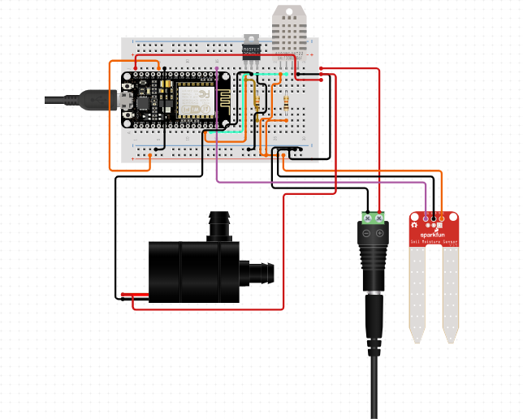

6. Features:

* Smart Agriculture
* Automatic Irrigation System
* Use of advanced technology like GIS towards Agriculture and Agricultural Ontologies to provide semantic understanding for computing devices.
* Water conservation
* Automated system for longer lasting solution.
* More sensor integration and cost effective
* Range of sensors is more and more sensors can be added for triggering applications.
* Design of proper base station
* Cellular structure and frequency planning to give better coverage
* Use of GPS and GNSS to allow farmers to locate their precise position in a field allows for the creation of maps of the spatial variability of as many variables as can be measured (e.g. crop yield, terrain features/topography, organic matter content, moisture levels, nitrogen levels, pH, EC, Mg, K, and others).
* Precision agriculture is used along with IOT

7. Github link: <https://github.com/msatul1305/ped_bachao>

YouTube link: <https://www.youtube.com/watch?v=7lwuTfKTNXo&t=3s>

8. Member details:

1. Atul Kumar Agrawal Branch: computer Science and Engineering Year: Third

2. Suchita Sriramka Branch: Electronics and Telecommunications Engineering Year: Third

3. Kashish Rath Branch: Electrical and Electronics Engineering Year: Third

4. Suman Rath Branch: Electrical Engineering Year: Third